First mechanosynthesis of Piperlotines A, C and derivatives through solvent-free Horner-Wadsworth-Emmons reaction

Oscar Abelardo Ramírez-Marroquín^{1*} ● Flavio Manzano-Pérez¹ ● Adolfo López-Torres¹ ● Alejandro Hernández-López² ● Abimelek Cortés-Pacheco¹ ● Miguel Angel Reyes-González³
¹Instituto de Química Aplicada, Universidad del Papaloapan, Tuxtepec, México.
²Instituto de Biotecnología, Universidad del Papaloapan, Tuxtepec, México.
³Facultad de Ciencias Químicas, Universidad Autónoma de Nuevo León, San Nicolás de los Garza Nuevo León, México.

CONTENTS
Spectral information of compound 1 (NMR ¹H, ¹³C, HMRS) | p. 2
Spectral information of compound 2 (NMR ¹H, ¹³C, ³¹P, HRMS) | p. 4
Spectral information of compound 3a (NMR ¹H, ¹³C, HRMS) | p. 6
Spectral information of compound 3b (NMR ¹H, ¹³C, HRMS) | p. 8
Spectral information of compound 3c (NMR ¹H, ¹³C, HRMS) | p. 10
Spectral information of compound 3d (NMR ¹H, ¹³C, HRMS) | p. 12
Spectral information of compound 3e (NMR ¹H, ¹³C, HRMS) | p. 14
Spectral information of compound 3f (NMR ¹H, ¹³C, HRMS)  Spectral information of compound 3g (NMR ¹H, ¹³C, HMRS)  Spectral information of compound 3h (NMR ¹H, ¹³C, HMRS)  Spectral information of compound 3h (NMR ¹H, ¹³C, HMRS) | p. 16  p. 18  p. 20  p. 22

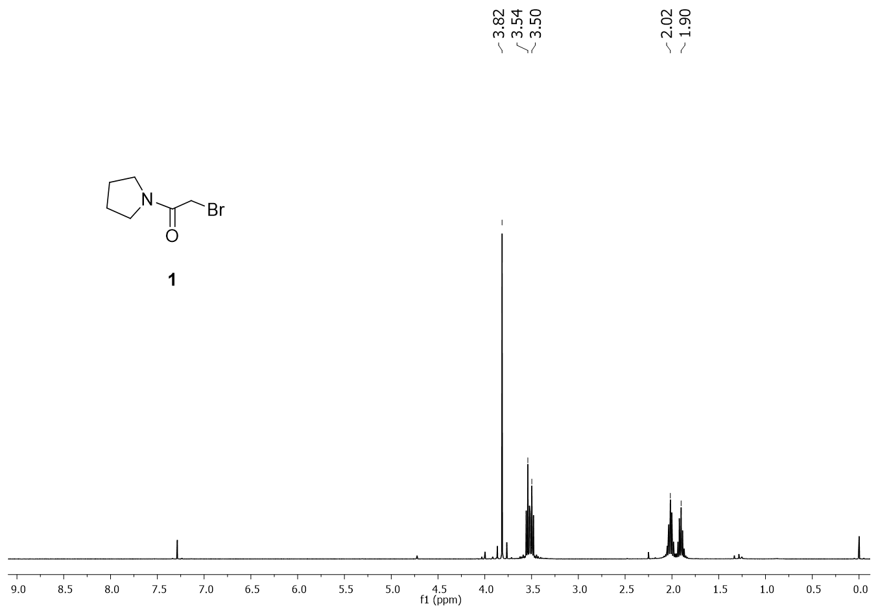
Fig. 1 ¹H NMR spectra of N-(bromoacetyl)pyrrolidine 1.
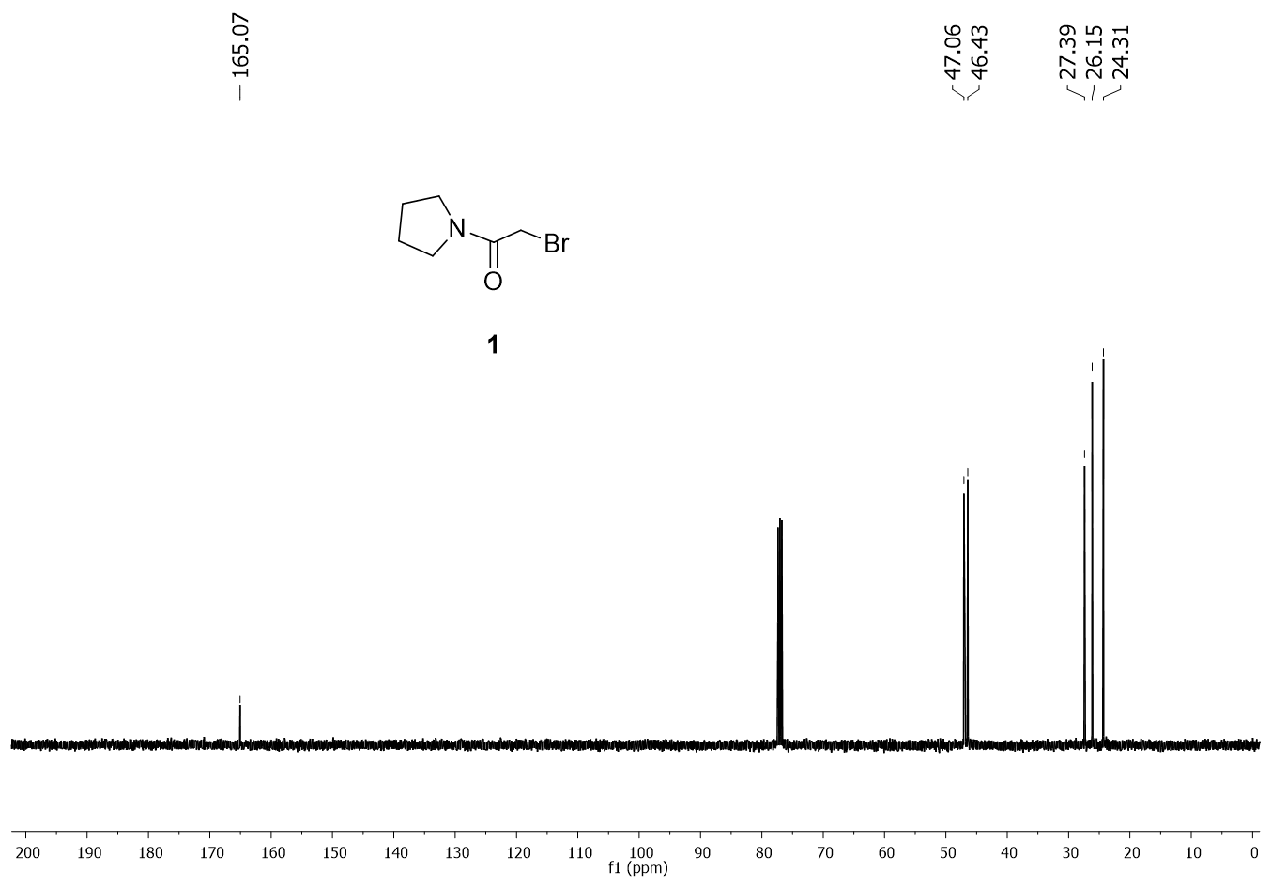
Fig. 2 ¹³C NMR spectra of N-(bromoacetyl)pyrrolidine 1.
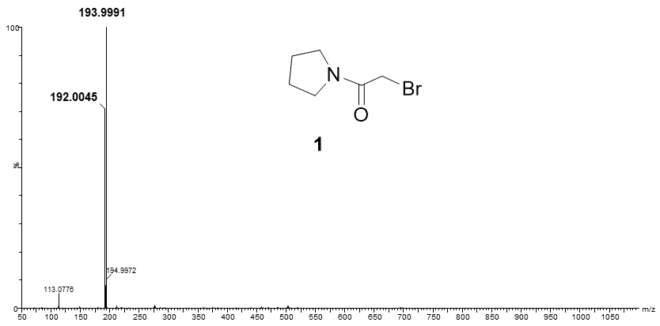
Fig. 3 HRMS spectra of N-(bromoacetyl)pyrrolidine 1.

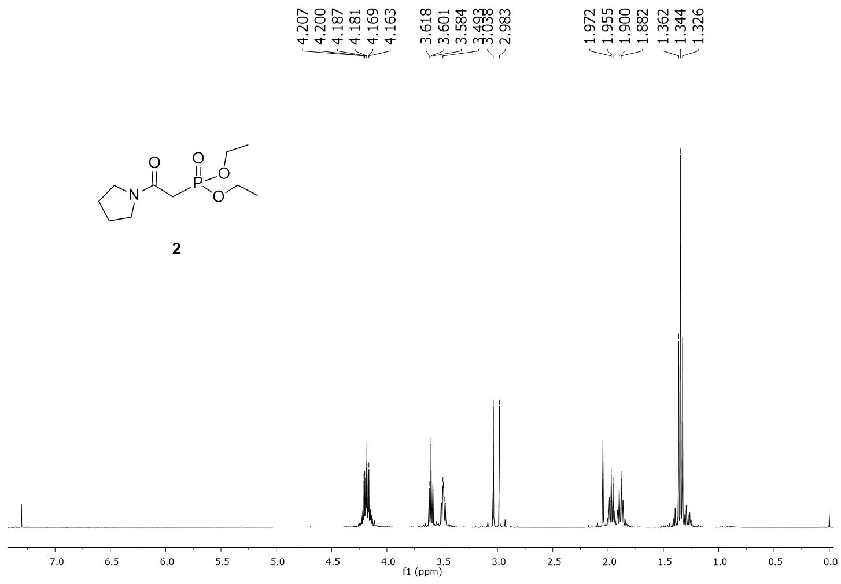
Fig. 4 ¹H NMR spectra of diethyl (2-oxo-2-(pyrrolidin-1-yl)ethyl)phosphonate 2.
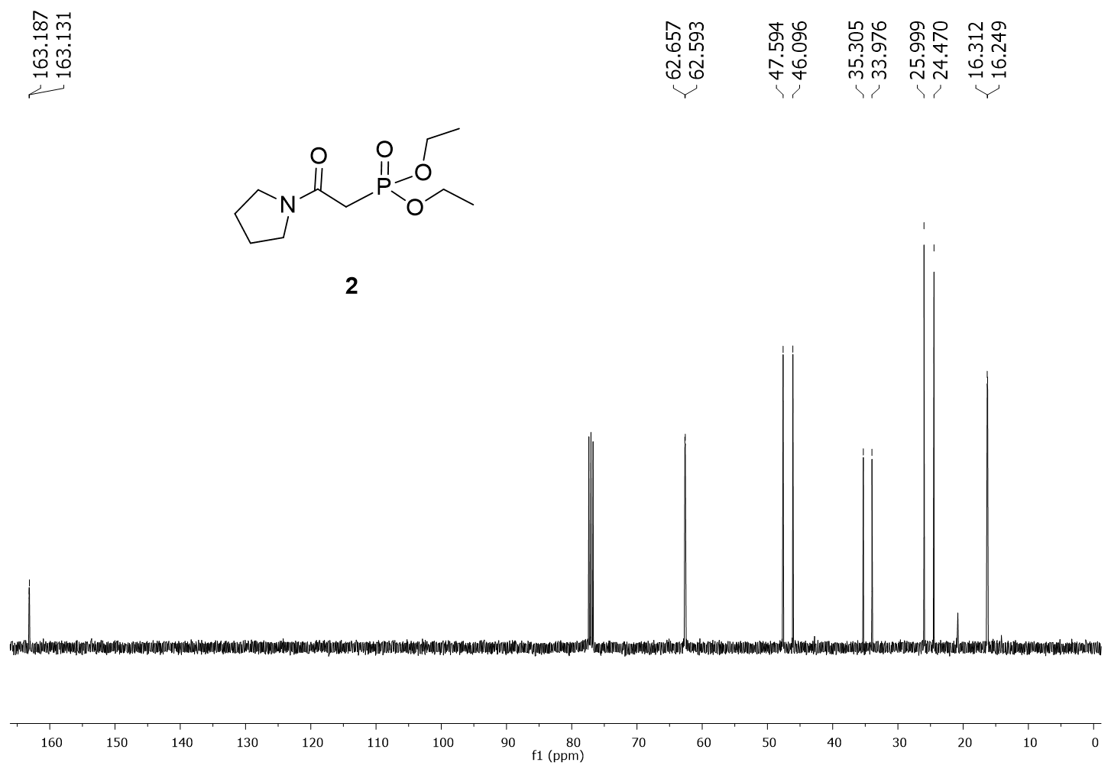
Fig. 5 ¹³C NMR spectra of diethyl (2-oxo-2-(pyrrolidin-1-yl)ethyl)phosphonate 2.
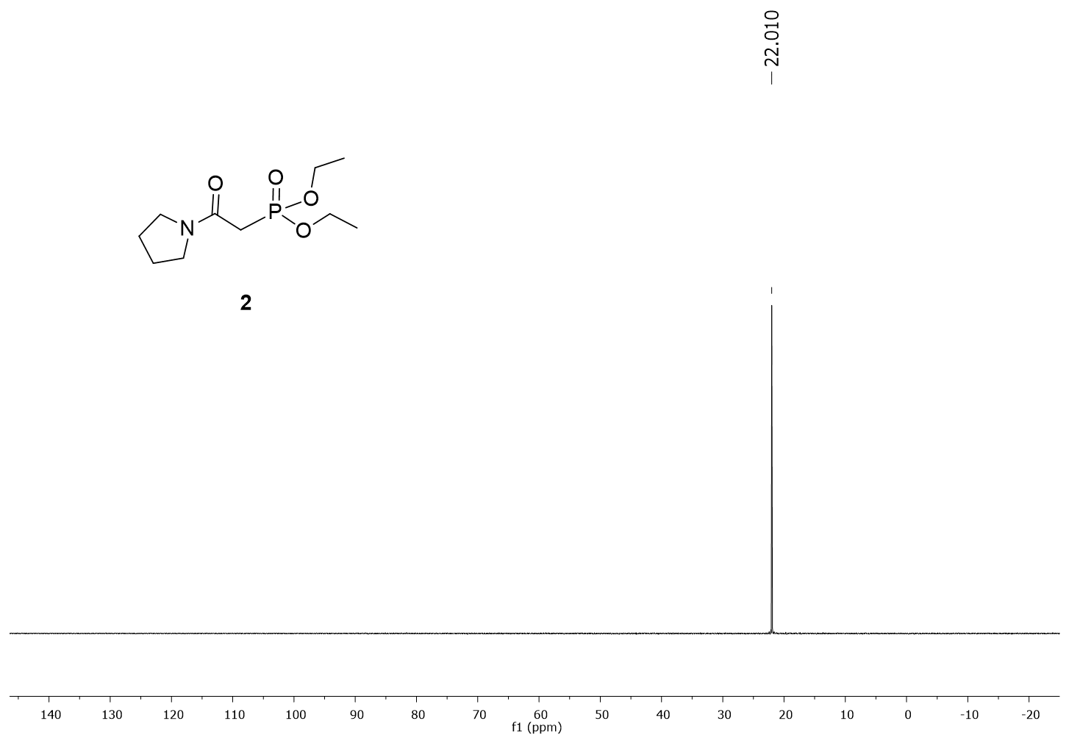
Fig. 6 ³¹P NMR spectra diethyl (2-oxo-2-(pyrrolidin-1-yl)ethyl)phosphonate 2.
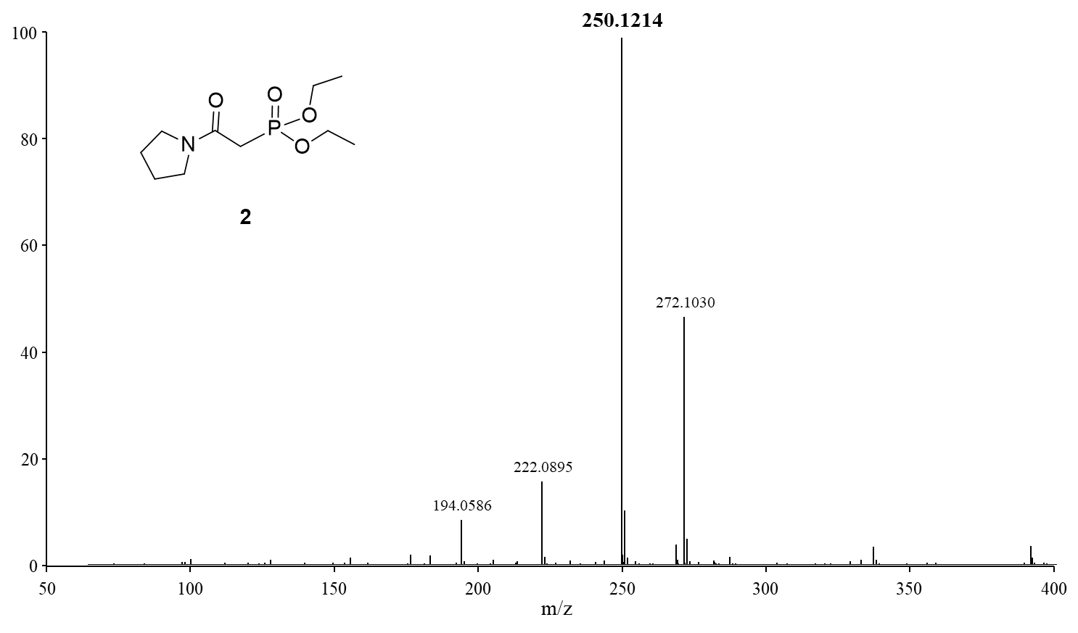
Fig. 7 HRMS spectra of diethyl (2-oxo-2-(pyrrolidin-1-yl)ethyl)phosphonate 2.

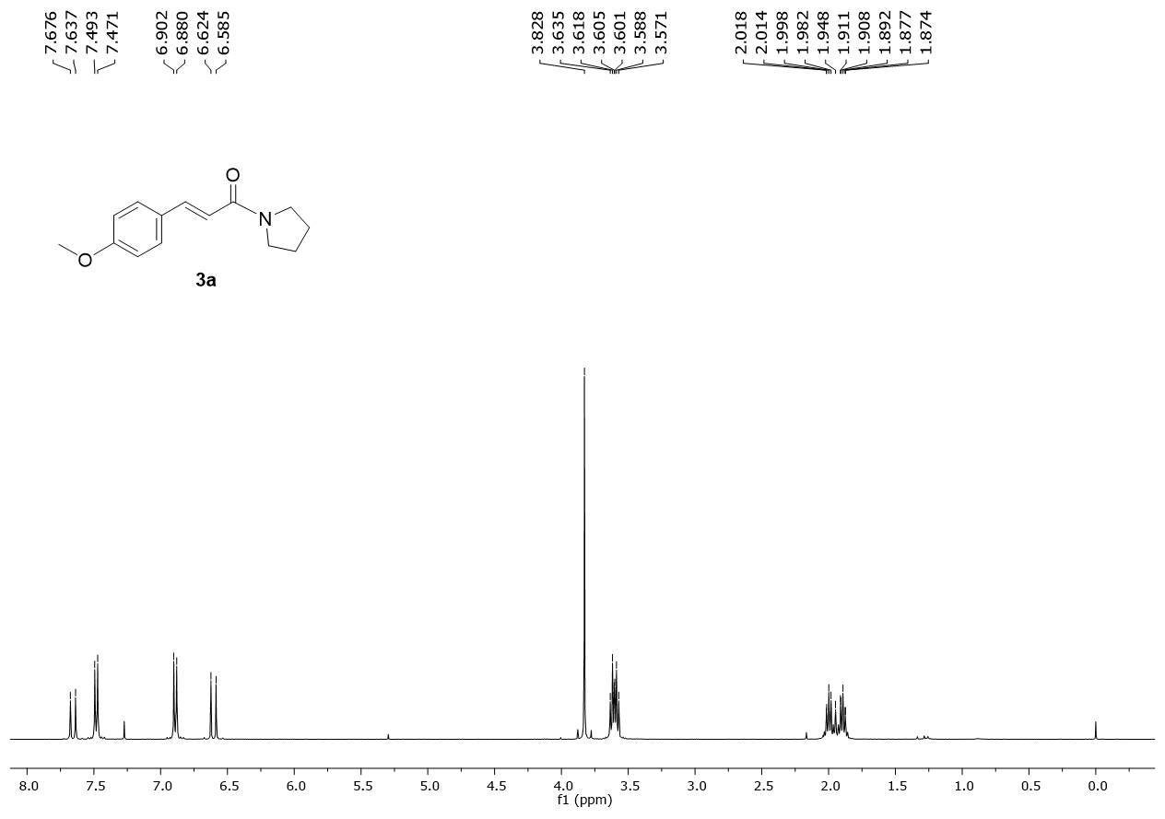
Fig. 8 ¹H NMR spectra of (E)-3-(4-methoxyphenyl)-1-(pyrrolidin-1-yl)prop-2-en-1-one 3a.
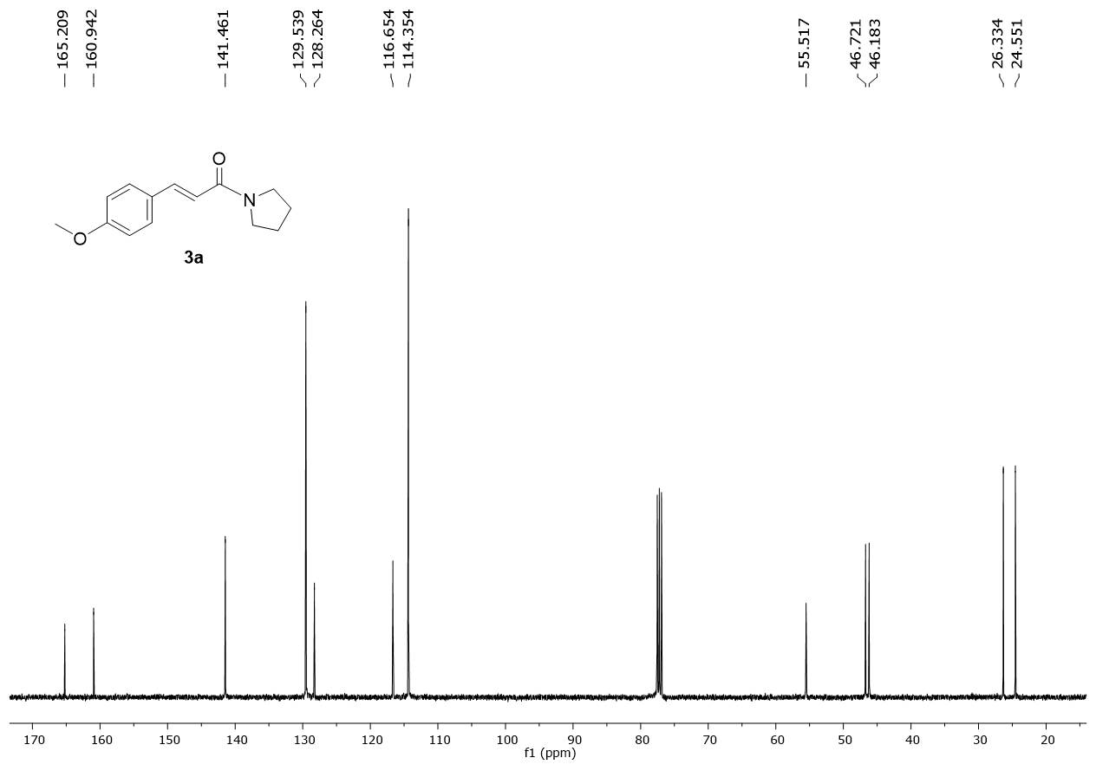
Fig. 9 ¹³C NMR spectra of (E)-3-(4-methoxyphenyl)-1-(pyrrolidin-1-yl)prop-2-en-1-one 3a.
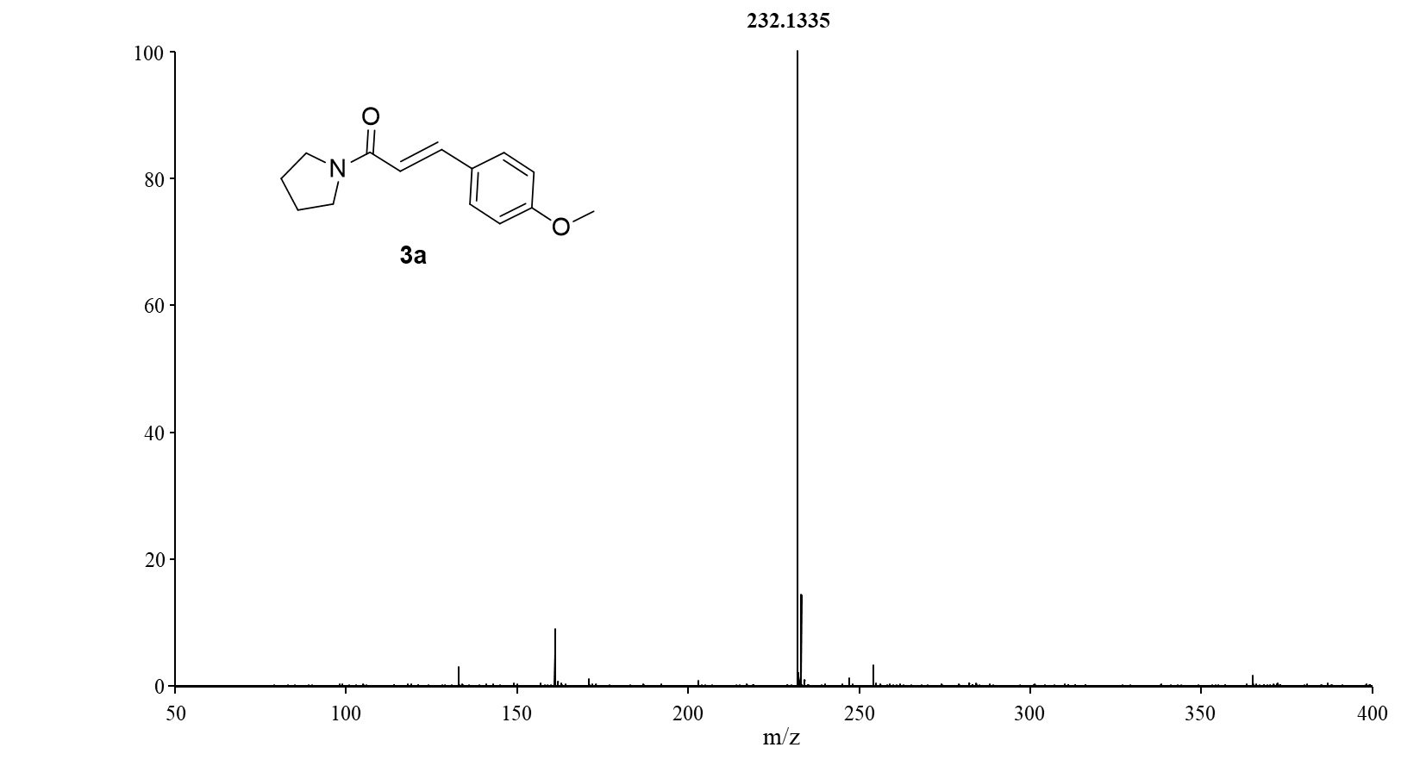
Fig. 10 HRMS spectra of (E)-3-(4-methoxyphenyl)-1-(pyrrolidin-1-yl)prop-2-en-1-one 3a.
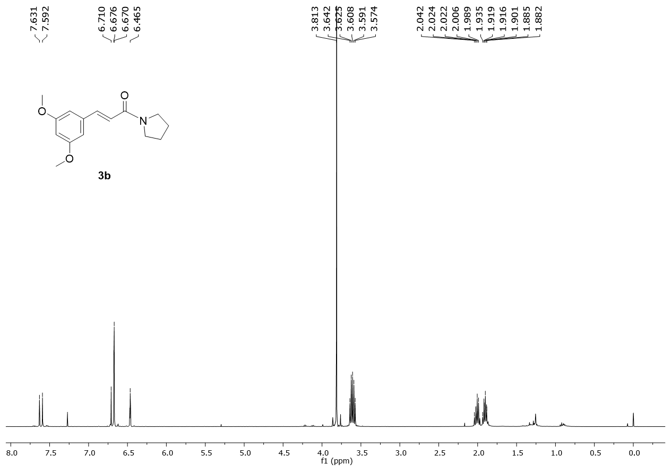
Fig. 11 ¹H NMR spectra of (E)-3-(3,5-dimethoxyphenyl)-1-(pyrrolidin-1-yl)prop-2-en-1-one 3b.
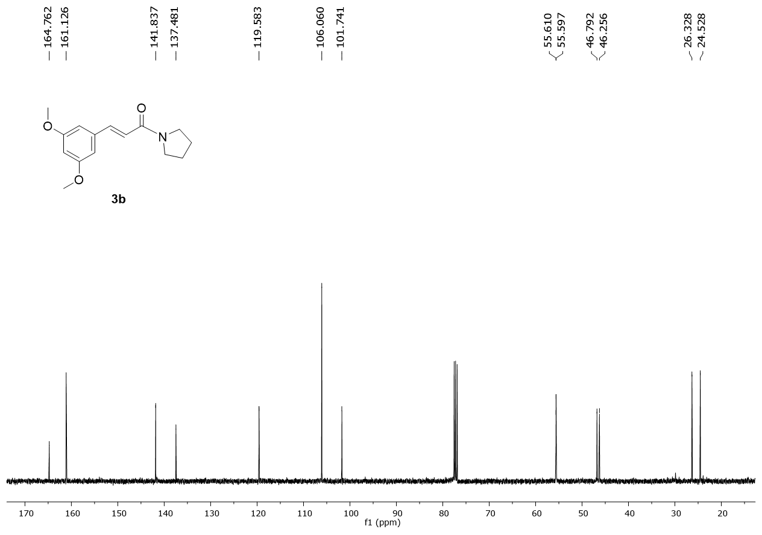
Fig. 12 ¹³C NMR spectra of (E)-3-(3,5-dimethoxyphenyl)-1-(pyrrolidin-1-yl)prop-2-en-1-one 3b.
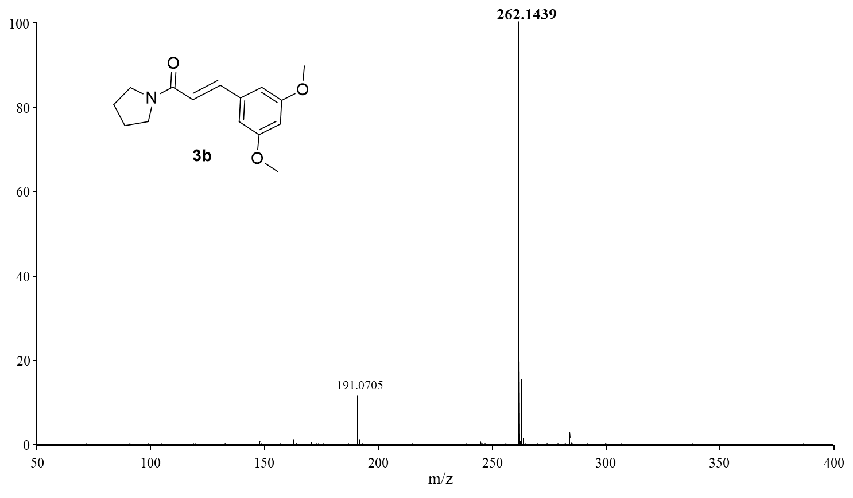
Fig. 13 HRMS spectra of (E)-3-(3,5-dimethoxyphenyl)-1-(pyrrolidin-1-yl)prop-2-en-1-one 3b.
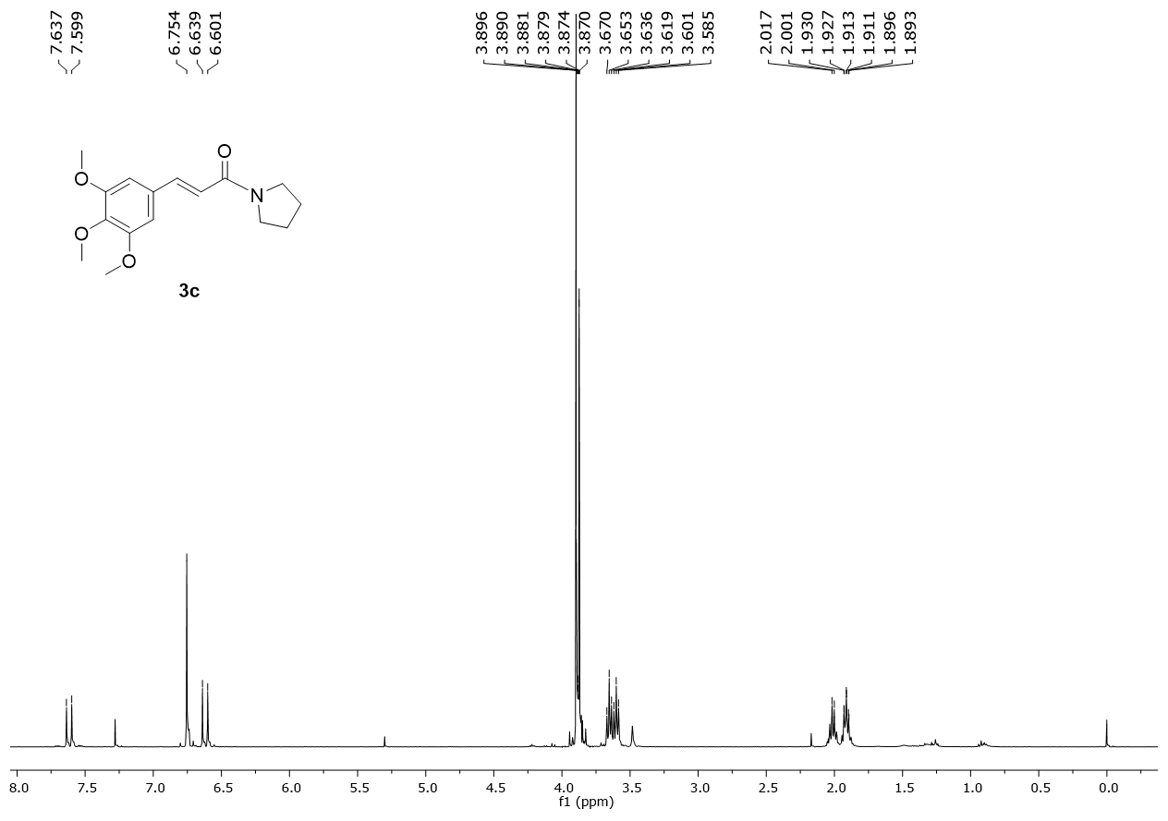
Fig.14 ¹H NMR spectra of (E)-1-(pyrrolidin-1-yl)-3-(3,4,5-trimethoxyphenyl)prop-2-en-1-one 3c.
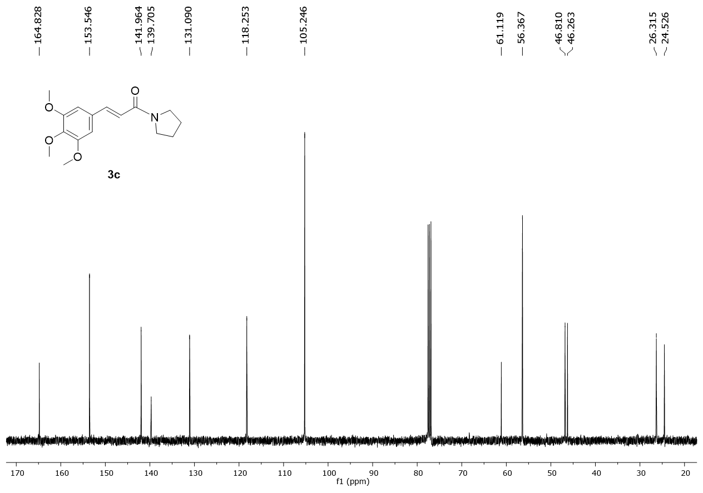
Fig. 15 ¹³C NMR spectra of (E)-1-(pyrrolidin-1-yl)-3-(3,4,5-trimethoxyphenyl)prop-2-en-1-one 3c.
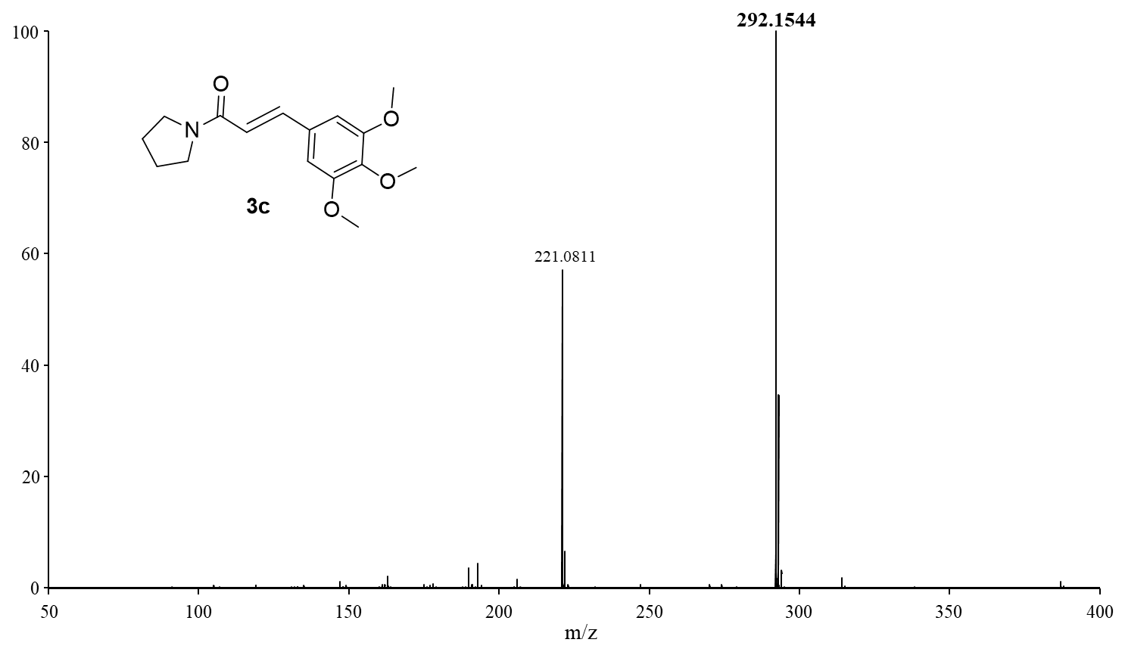
Fig. 16 HRMS spectra of (E)-1-(pyrrolidin-1-yl)-3-(3,4,5-trimethoxyphenyl)prop-2-en-1-one 3c.

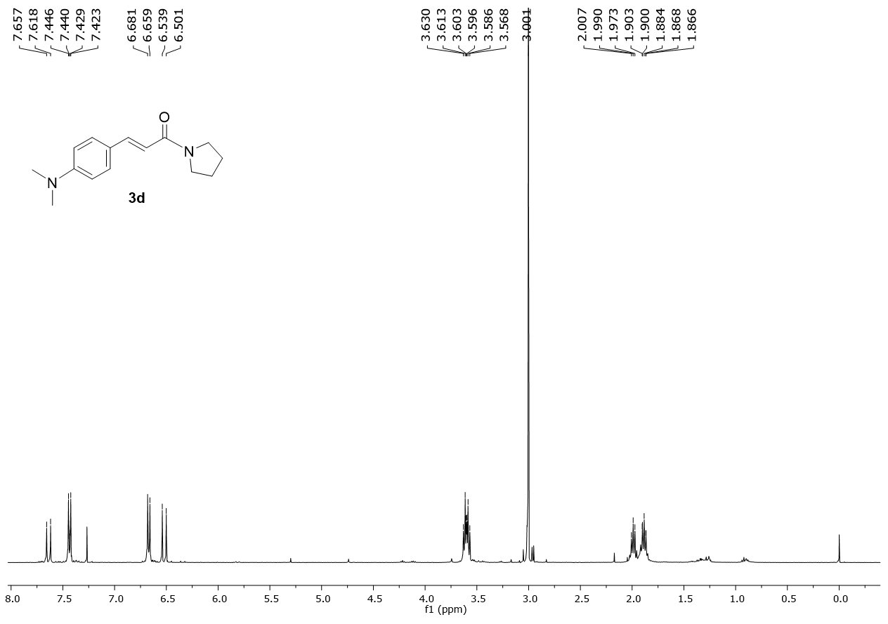
Fig. 17 ¹H NMR spectra of (E)-3-(4-(dimethylamino)phenyl)-1-(pyrrolidin-1-yl)prop-2-en-1-one 3d.
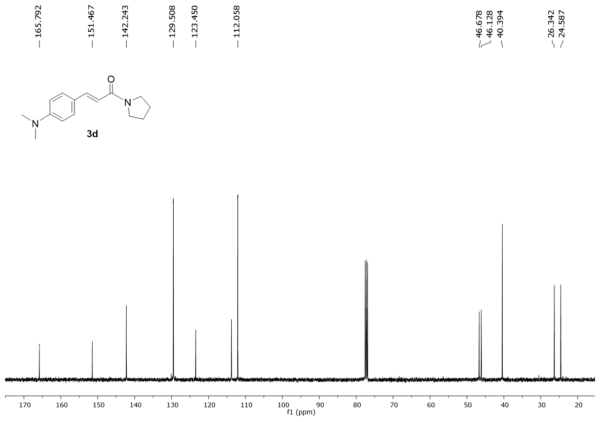
Fig. 18 ¹³C NMR spectra of (E)-3-(4-(dimethylamino)phenyl)-1-(pyrrolidin-1-yl)prop-2-en-1-one 3d.
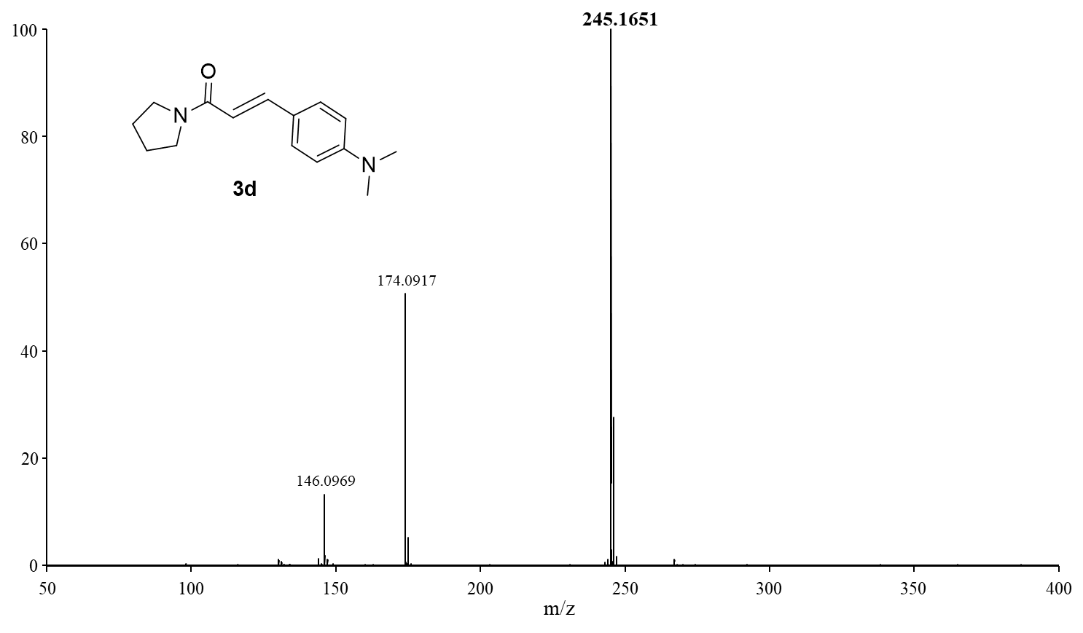
Fig. 19 HRMS spectra of (E)-3-(4-(dimethylamino)phenyl)-1-(pyrrolidin-1-yl)prop-2-en-1-one 3d.

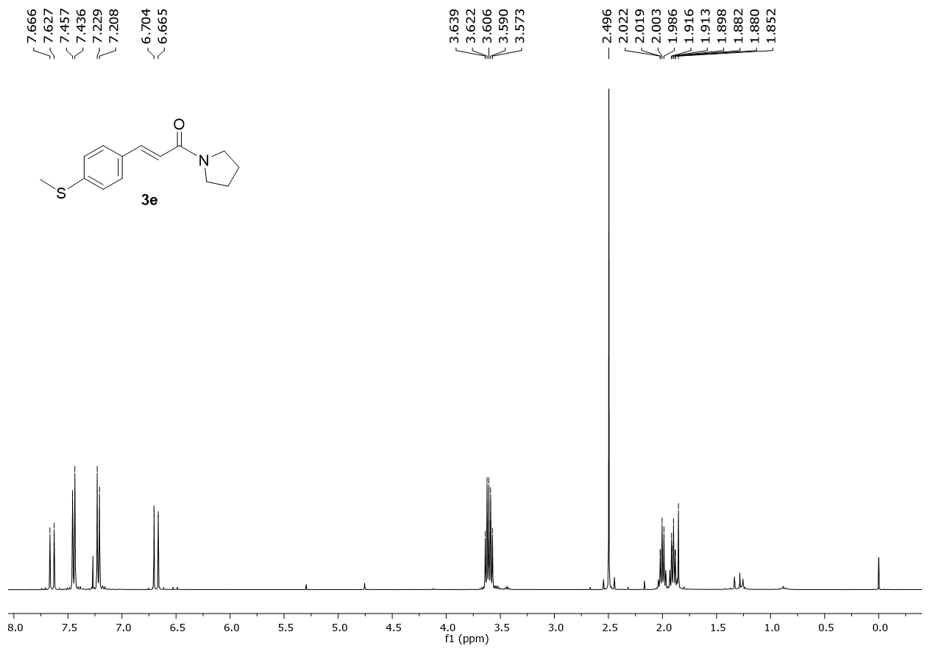
Fig. 20 ¹H NMR spectra of (E)-3-(4-(methylthio)phenyl)-1-(pyrrolidin-1-yl)prop-2-en-1-one 3e.
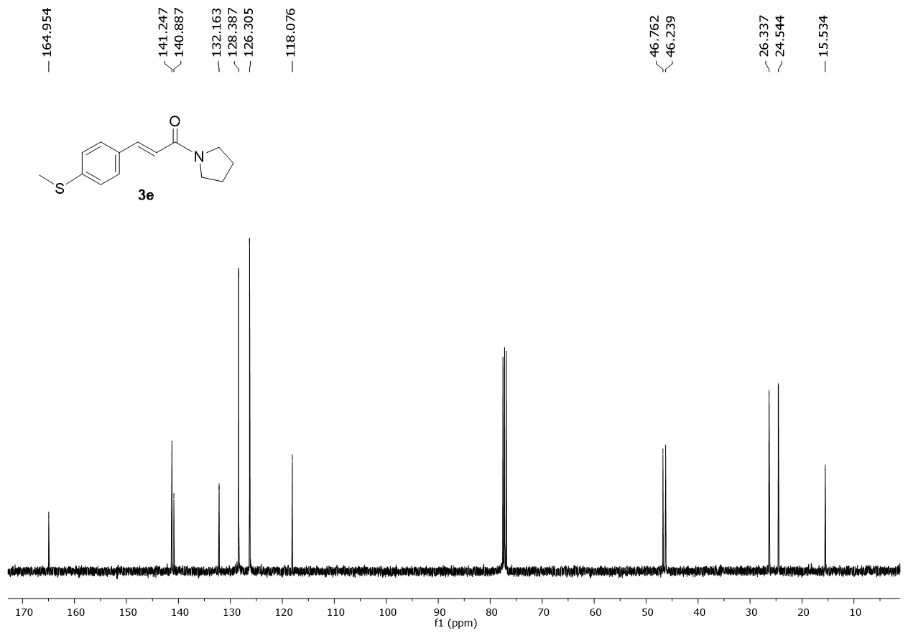
Fig. 21 ¹³C NMR spectra of (E)-3-(4-(methylthio)phenyl)-1-(pyrrolidin-1-yl)prop-2-en-1-one 3e.
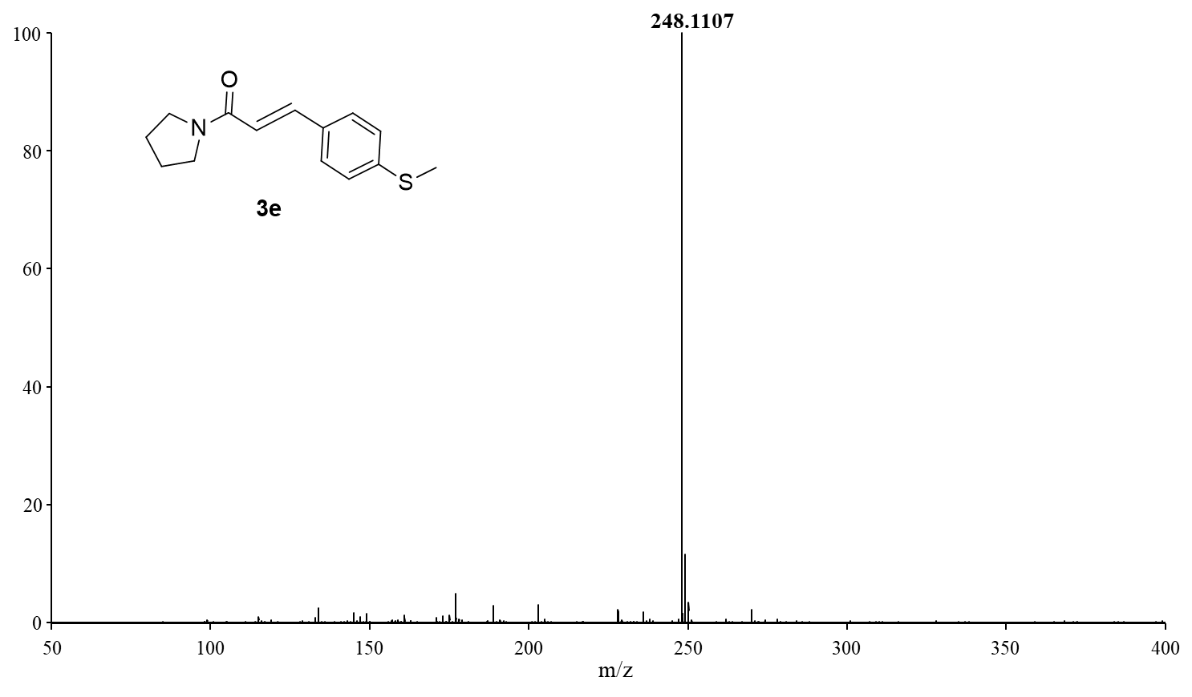
Fig. 22 HRMS spectra of (E)-3-(4-(methylthio)phenyl)-1-(pyrrolidin-1-yl)prop-2-en-1-one 3e.

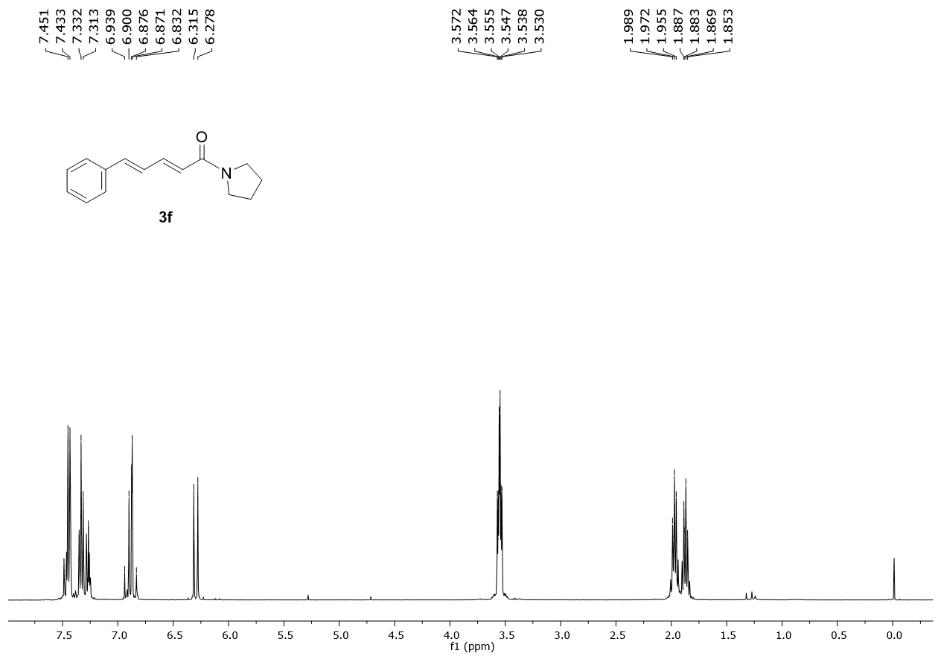
Fig. 23 ¹H NMR spectra of (2E,4E)-5-phenyl-1-(pyrrolidin-1-yl)penta-2,4-dien-1-one 3f.
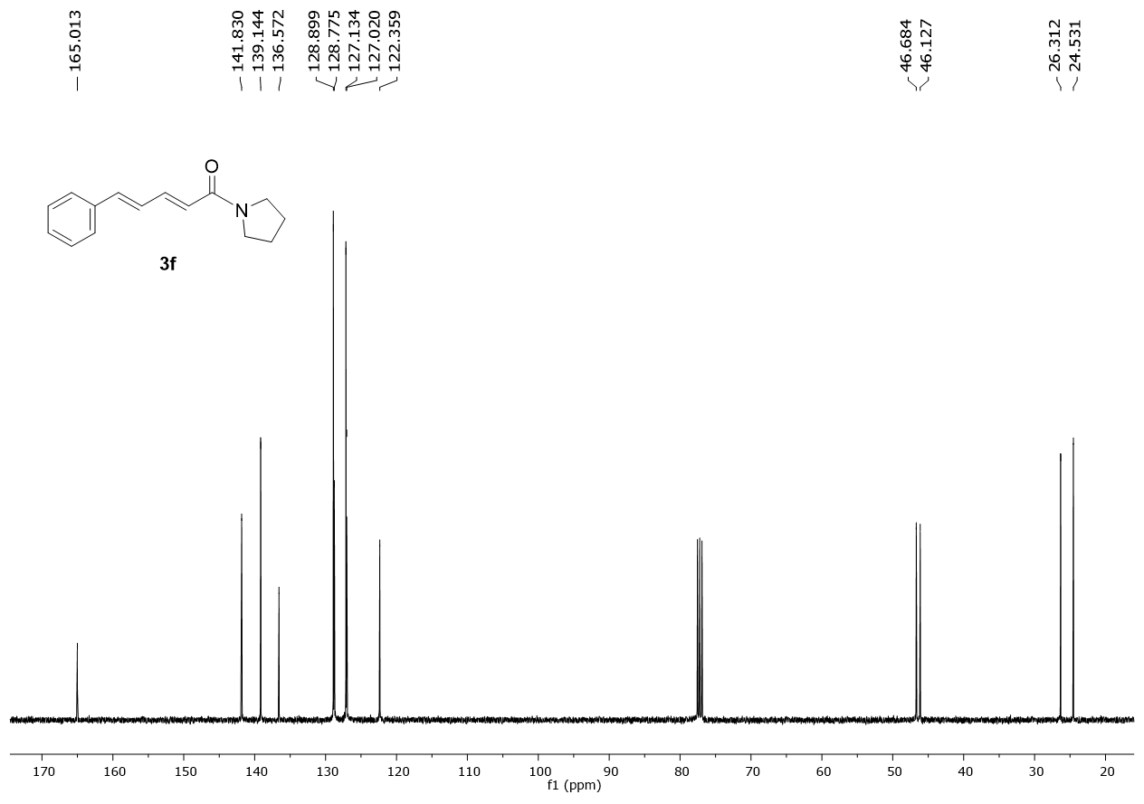
Fig. 24 ¹³C NMR spectra of (2E,4E)-5-phenyl-1-(pyrrolidin-1-yl)penta-2,4-dien-1-one 3f.

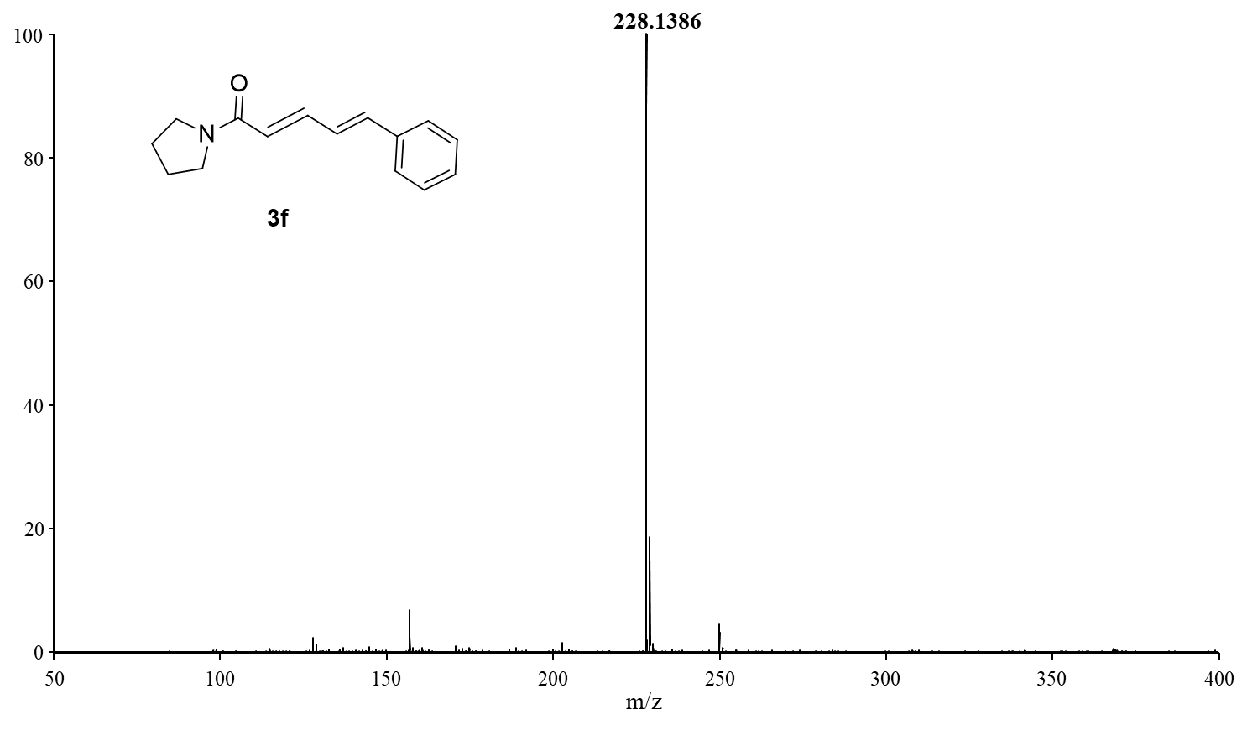
Fig. 25 HRMS spectra of (2E,4E)-5-phenyl-1-(pyrrolidin-1-yl)penta-2,4-dien-1-one 3f.

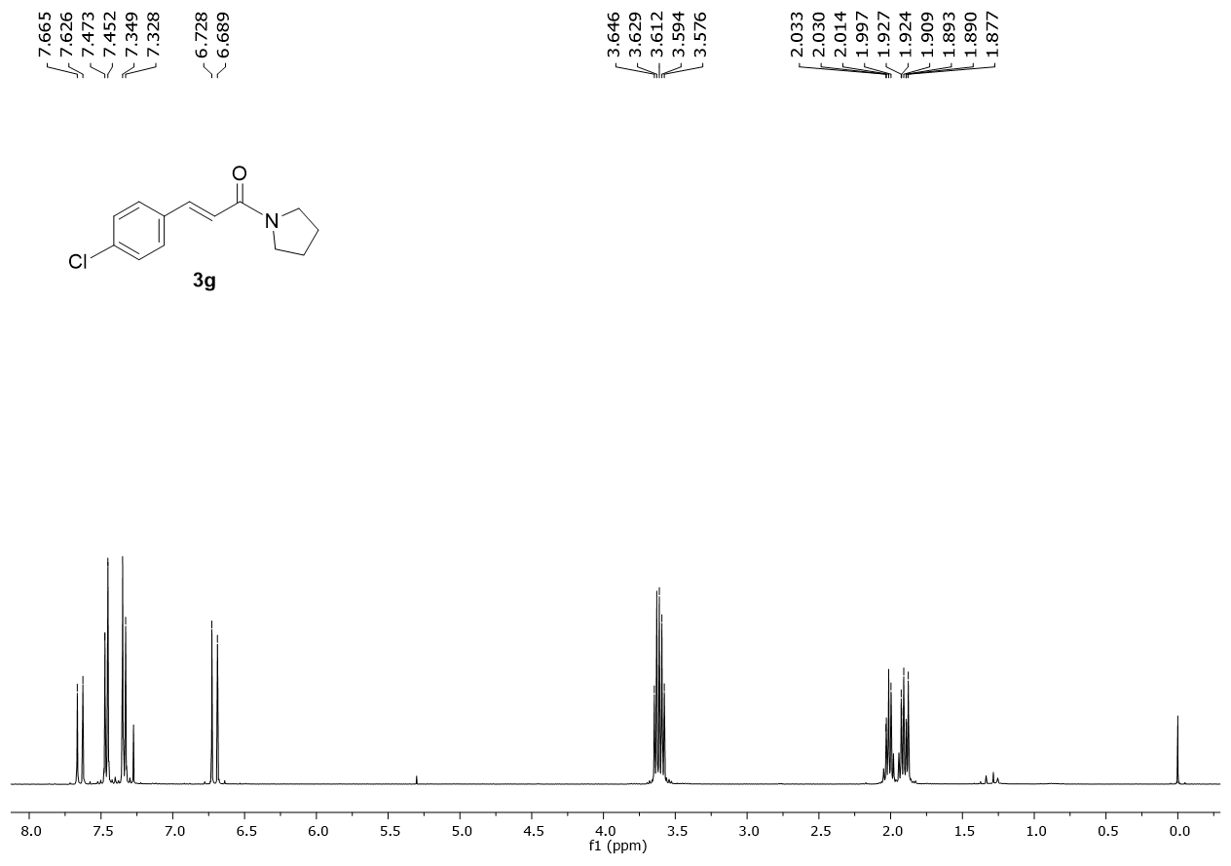
Fig. 26 ¹H NMR spectra of (E)-3-(4-chlorophenyl)-1-(pyrrolidin-1-yl)prop-2-en-1-one 3g.
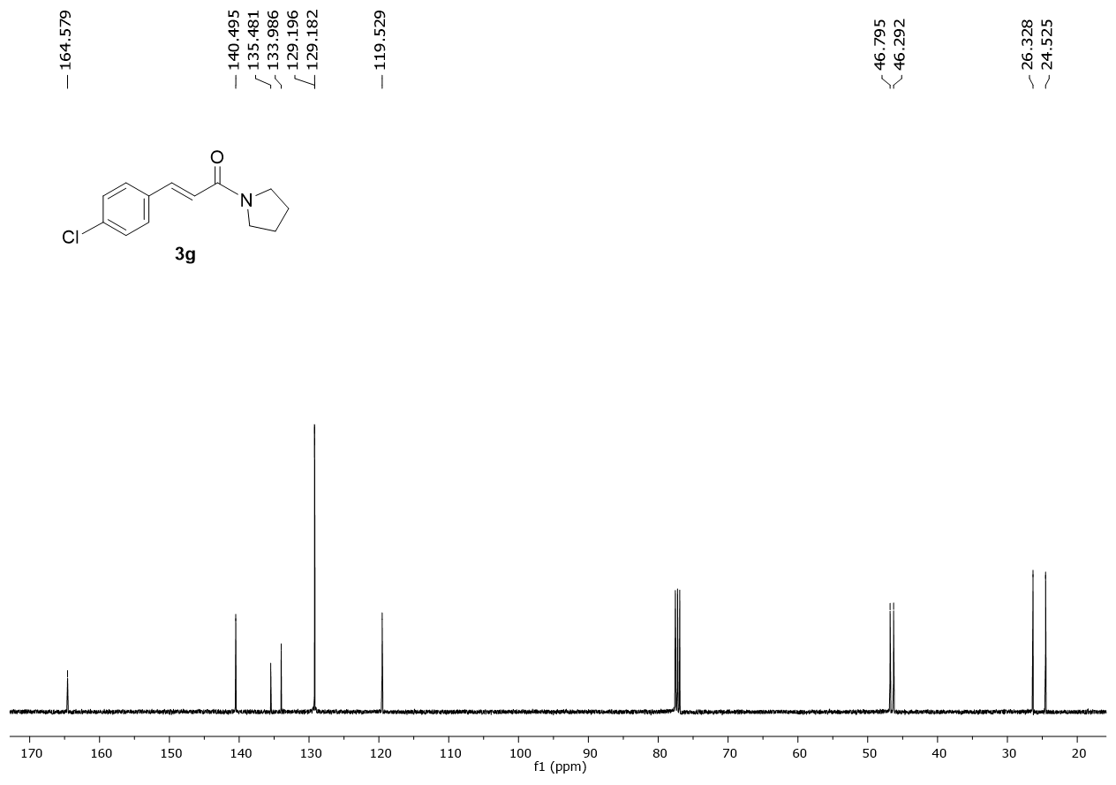
Fig. 27 ¹³C NMR spectra of (E)-3-(4-chlorophenyl)-1-(pyrrolidin-1-yl)prop-2-en-1-one 3g.

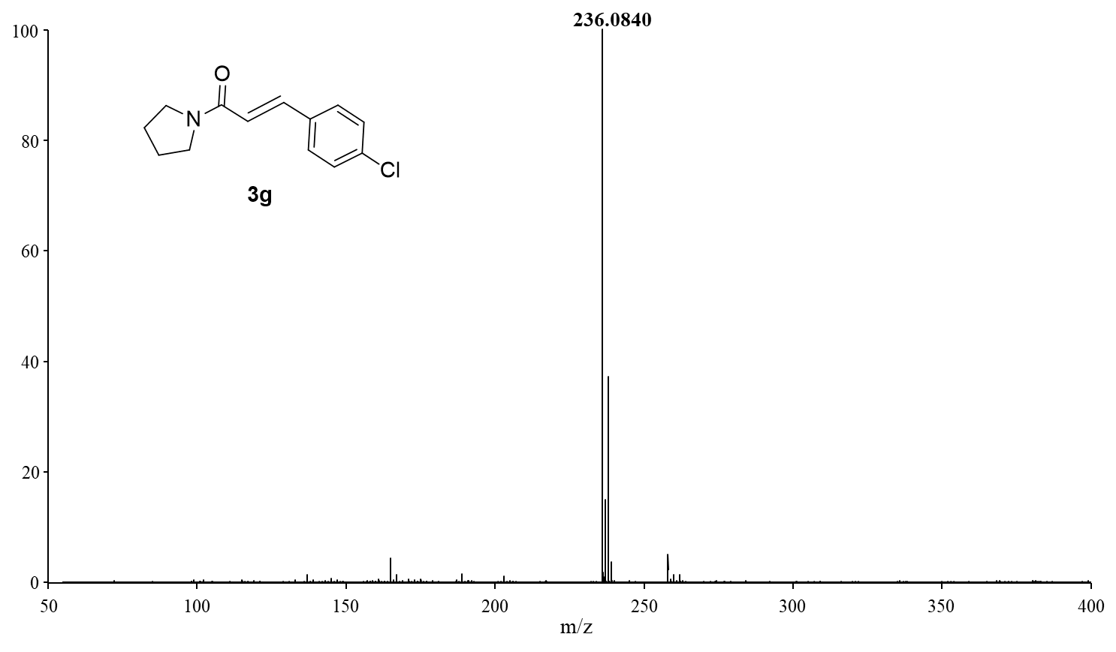
Fig. 28 HRMS spectra of (E)-3-(4-chlorophenyl)-1-(pyrrolidin-1-yl)prop-2-en-1-one 3g.

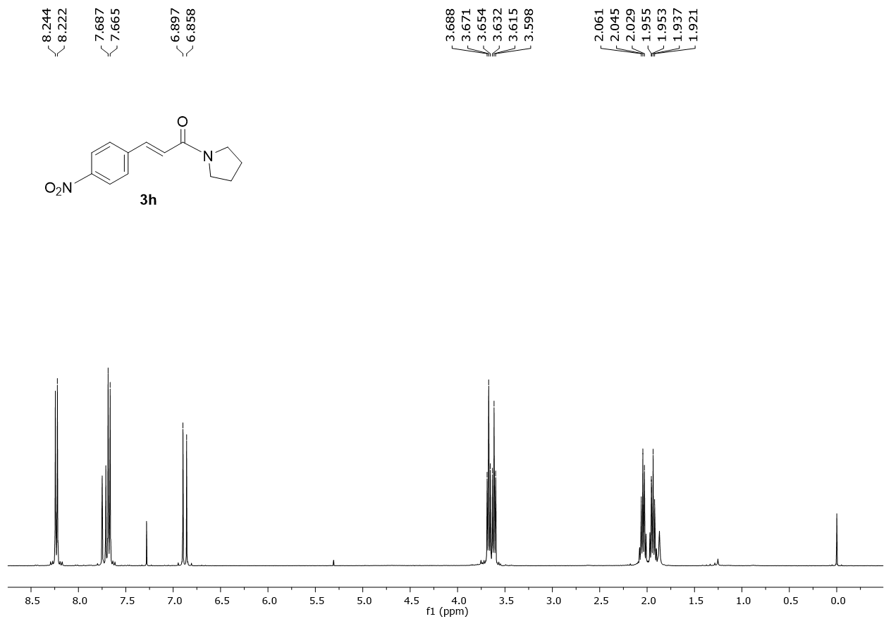
Fig. 29 ¹H NMR spectra of (E)-3-(4-nitrophenyl)-1-(pyrrolidin-1-yl)prop-2-en-1-one 3h.
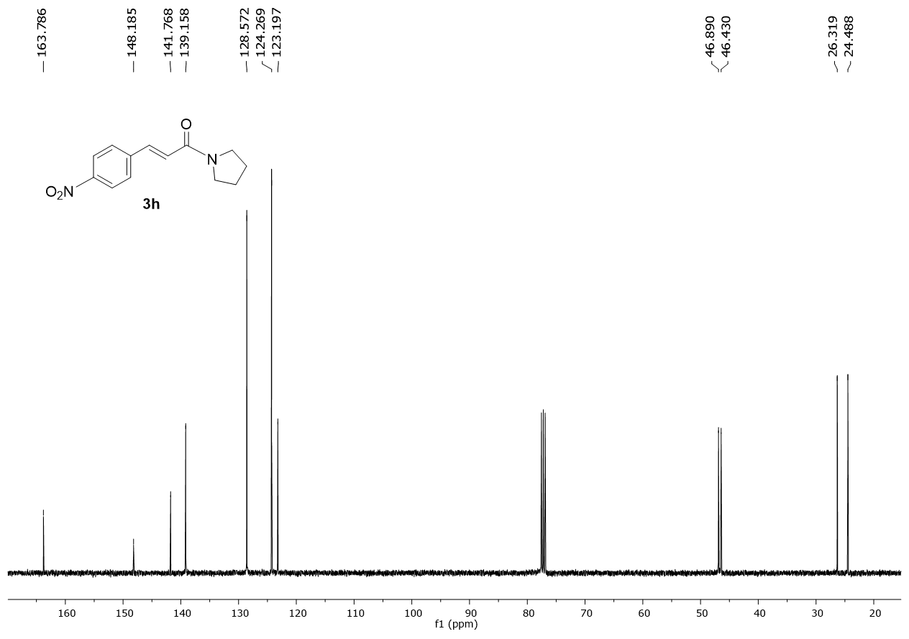
Fig. 30 ¹³C NMR spectra of (E)-3-(4-nitrophenyl)-1-(pyrrolidin-1-yl)prop-2-en-1-one 3h.

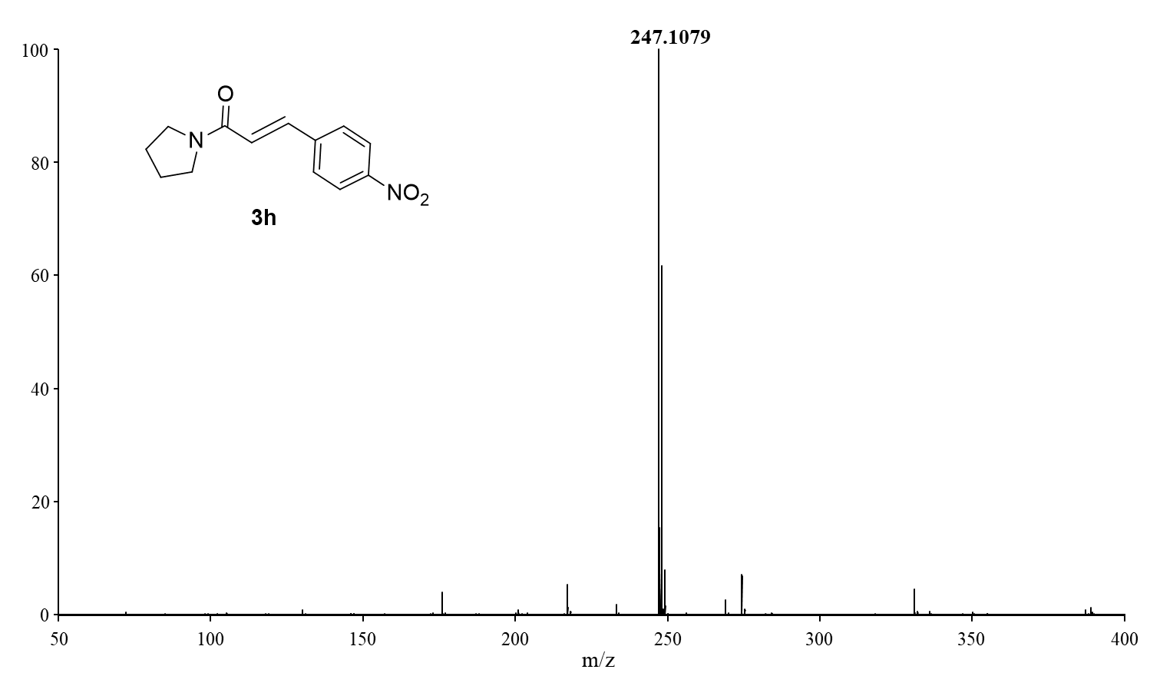
Fig. 31 HRMS spectra of (E)-3-(4-nitrophenyl)-1-(pyrrolidin-1-yl)prop-2-en-1-one 3h.
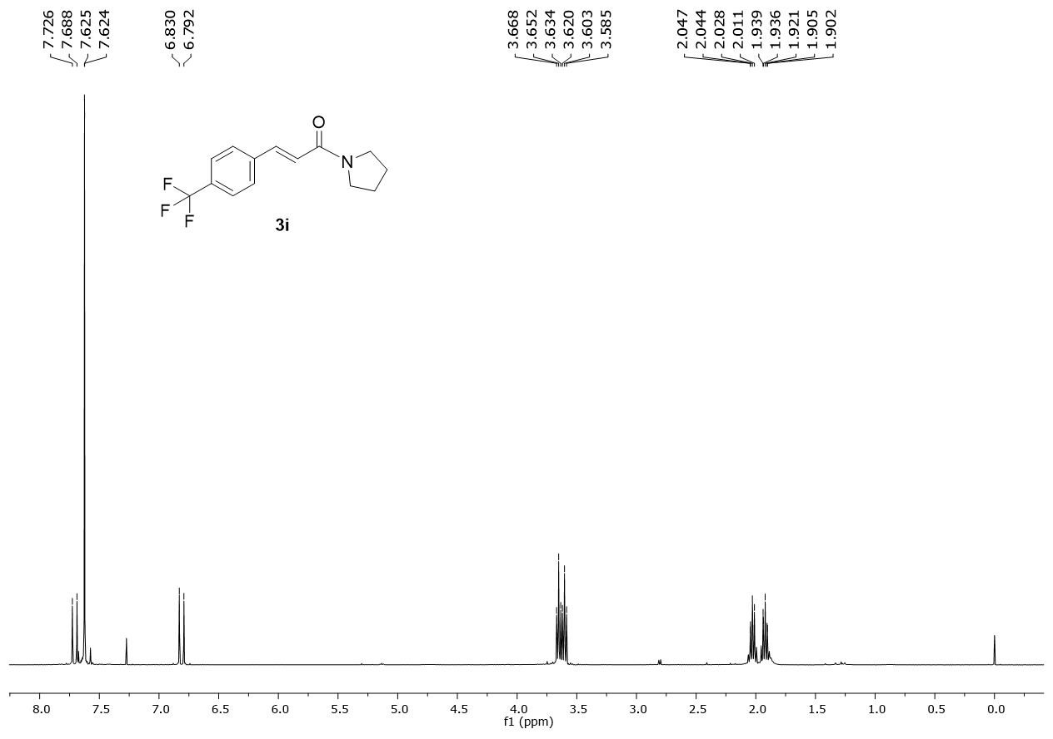
Fig. 32 ¹H NMR spectra of (E)-1-(pyrrolidin-1-yl)-3-(4-(trifluoromethyl)phenyl)prop-2-en-1-one 3i.
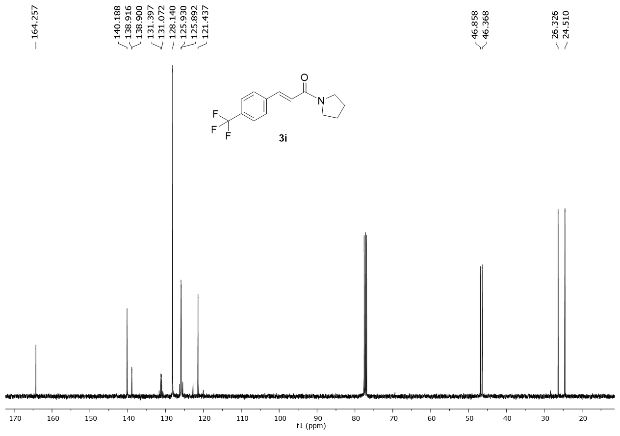
Fig. 33 ¹³C NMR spectra of (E)-1-(pyrrolidin-1-yl)-3-(4-(trifluoromethyl)phenyl)prop-2-en-1-one 3i.

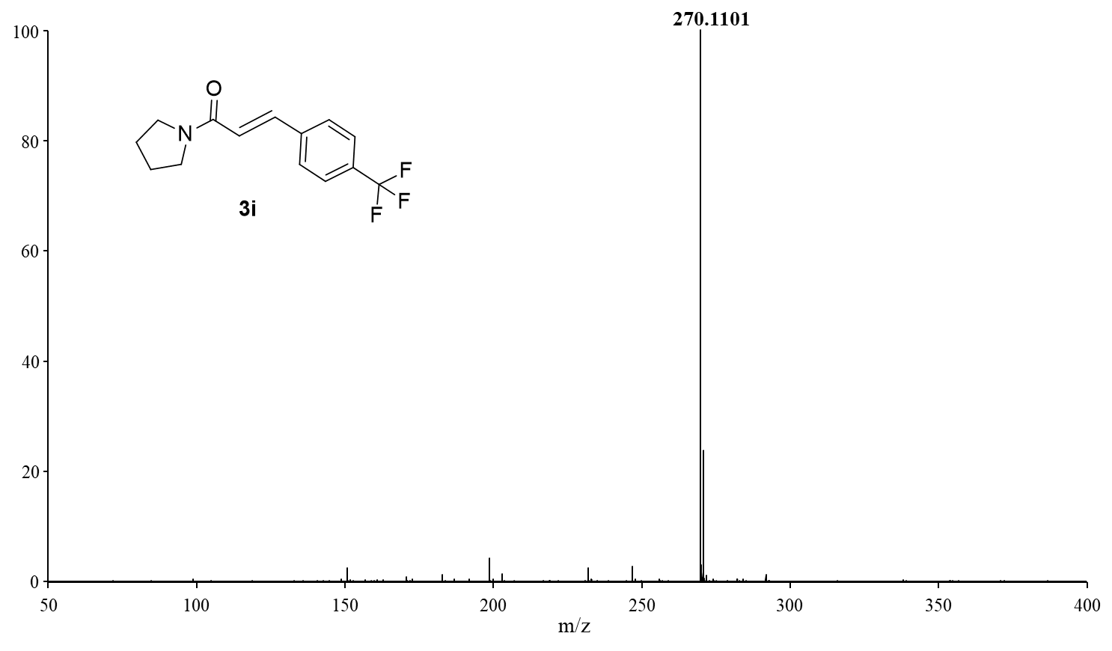
Fig. 34 HRMS spectra of (E)-1-(pyrrolidin-1-yl)-3-(4-(trifluoromethyl)phenyl)prop-2-en-1-one 3i.

