SYNTHESIS OF CYCLO-PLAI USING A COMBINATION OF SOLID- AND SOLUTION PHASE METHOD

Orin Inggriani Napitupulu,¹ Dadan Sumiarsa,¹ Nurlelasari,¹ Desi Harneti,¹ Unang Supratman,^{1,2} Rani Maharani^{1, 2,} *

¹Department of Chemistry, Faculty of Mathematics and Natural Sciences, Universitas Padjadjaran, Jalan Raya Bandung-Sumedang Km 21 Jatinangor 45363 West Java Indonesia
²Laboratorium Sentral, Universitas Padjadjaran, Jalan Raya Bandung-Sumedang Km 21 Jatinangor 45363 West Java Indonesia
*Corresponding author: r.maharani@unpad.ac.id

PLAI LINEAR (H-PRO-LEU-ALA-ILE-OH)
¹H NMR (500 MHz, CD₃OD dopped with D₂O)
8.75 (1H, d, J=5.0 Hz, NH), 8.43 (1H, d, J=5.0 Hz, NH), 8.26 (1H, d, J=5.0 Hz, NH), 4.47 (2H, q, CH-α), 4.37 (1H, q, CH-α), 4.30 (1H, q, CH-α), 3.32 (2H, q, H-δ Pro), 2.82 (1H, s, NH-Pro), 2.49-2.42 (1H, m, H-β Pro), 2.16-2.11 (1H, m, H-β Ile), 2.07-2.02 (2H, m), 1.93-1.88 (1H, m, H-β Pro), 1.74-1.69 (1H, m, H-γ Leu), 1.63 (2H, t, H-β Leu), 1.55-1.50 (1H, m, H-γ, Ile), 1.36 (3H, d, J=8.0 Hz, H-β Ala), 1.29-1.24 (1H, m, H-γ Ile), 0.98 (3H, d, J=7.5 Hz, H-γ’ Ile), 0.95 (6H, q, J=10.0 Hz H-δ Leu), 0.93 (3H, t, J=8.5 Hz, H-δ, Ile)
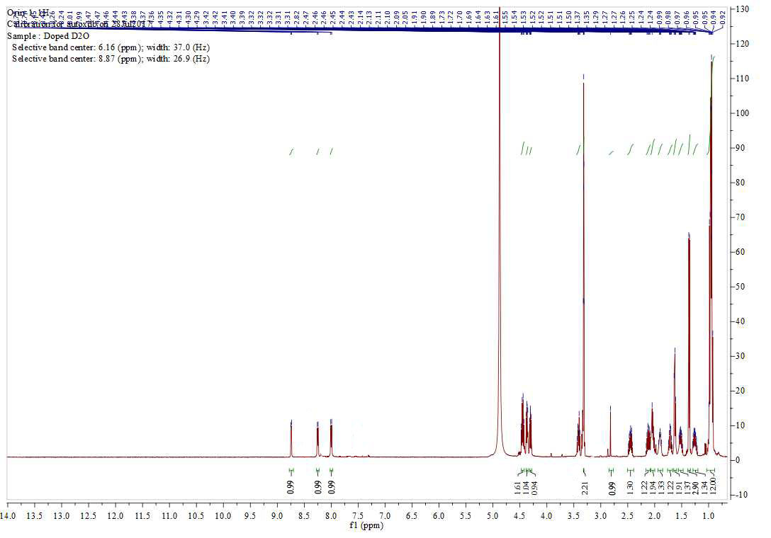
¹³C NMR (125 MHz, CD₃OD, doped with D₂O)
173.3 (C=O Leu), 173.2 (C=O Ala), 173.1 (C=O Pro), 172.6 (COOH Ile), 59.5 (C-α Ile), 56.7 (C-α Pro), 52.1 (C-α Leu), 48.7 (C-α Ala), 46.0 (C-δ Pro), 40.5 (C-β Leu), 37.1 (C-β Ile), 29.6 (C-β Pro), 24.9 (C-γ Ile), 24.5 (C-γ Leu), 23.6 (C-δ Leu), 22.0 (C-δ Leu), 20.4 (C-γ Pro), 16.6 (C-β Ala), 14.6 (C-γ’ Ile), 10.4 (C-δ Ile)
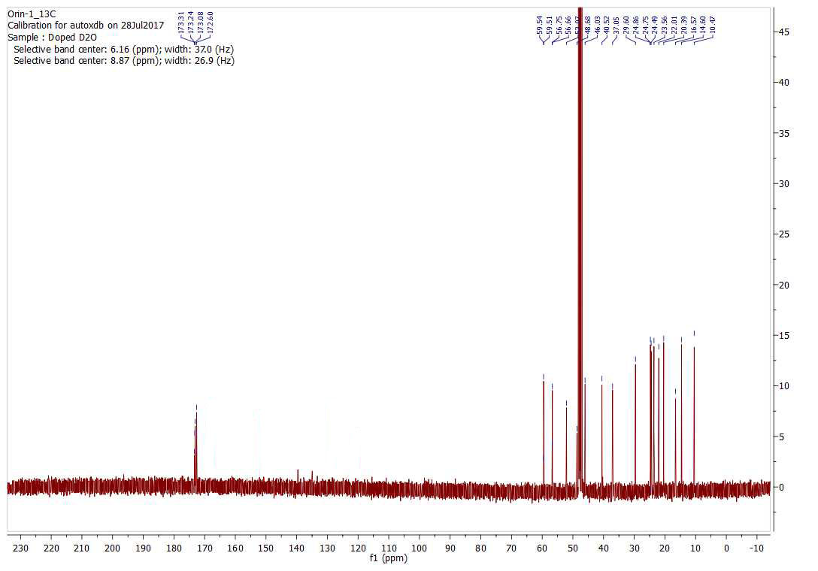

CYCLO-PLAI (Cyclo-PRO-LEU-ALA-ILE)
¹H NMR 500 MHz CDCl₃
8.87, d, J=5.0 Hz, 1H (-NH), 8.69, d J=5.0 Hz, 1H (-NH), 7.55, d, J=5.0 Hz, 1H (-NH), 4.40, t, J=7.5 Hz, 2H (H-α, Pro, Ile), 4.33, q, 1H (H-α, Ala), 4.27, t, J=7.0 Hz, 1H (H-α, Leu), 3.38, t, J=7.5 Hz, 2H (H-δ, Pro), 2.45-2.39, m, 1H; 2.11-2.07, m, 1H (H-β, Pro), 2.04-1.99, m, 2H (H-γ, Pro), 1.89-1.85, m, 1H (H-γ, Leu), 1.59, t, J=8.45 Hz 2H (H-β, Leu), 1.70-1.65, m, 1H (H-β, Ile), 1.51-1.46, m, 1H (H-γ, Ile), 1.24-1.18, m, 1H (H-γ, Ile), 1.32, d, J=8.15 Hz, 3H (H-β, Ala), 0.95, d, J=7.5 Hz, 3H (H-γ’, Ile), 0.92, d, J=10.0 Hz, 3H (H-δ, Leu), 0.91, d, J=10.0 Hz, 3H (H-δ, Leu), 0.90, t, J=8.5 Hz, 3H (H-δ, Ile).

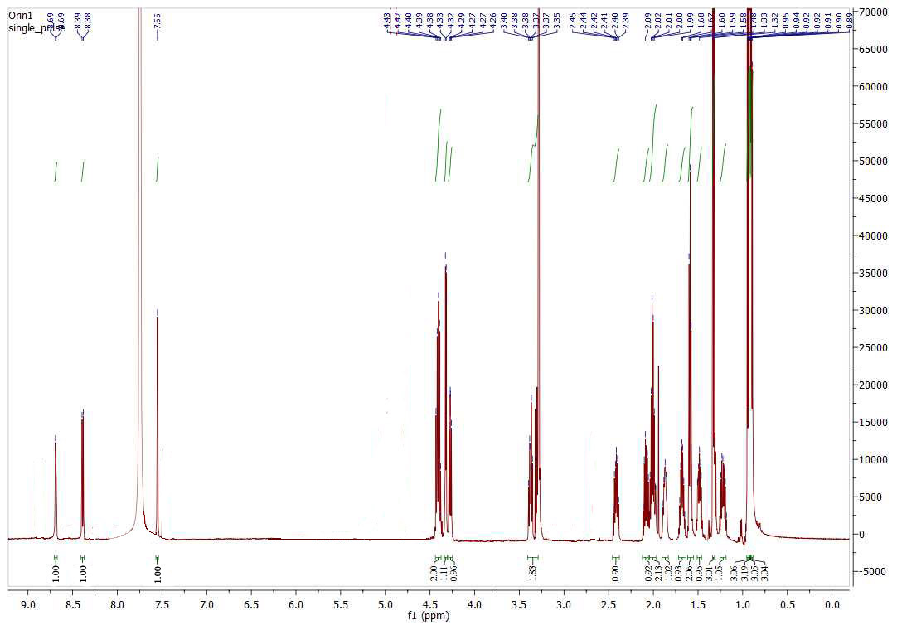

¹³C NMR 150 MHz CDCl₃
173.4 (C=O Leu), 173.3 (C=O Ala), 172.7 (C=O Pro), 168.4 (C=O, Ile), 59.6 (C-α Ile), 56.8 (C-α Pro), 48.8 (C-α Ala), 52,1 (C-α Leu), 46.1 (C-δ Pro), 29.7 (C-β Pro), 20.4 (C-γ Pro), 24.6 (C-γ Leu), 40.6 (C-β Leu), 37.1 (C-β Ile), 24.8 (C-γ Ile), 16.6 (C-β Ala), 14.7 (C-γ’ Ile), 23.7; 22.1 (C-δ Leu), 10.6 (C-δ Ile).

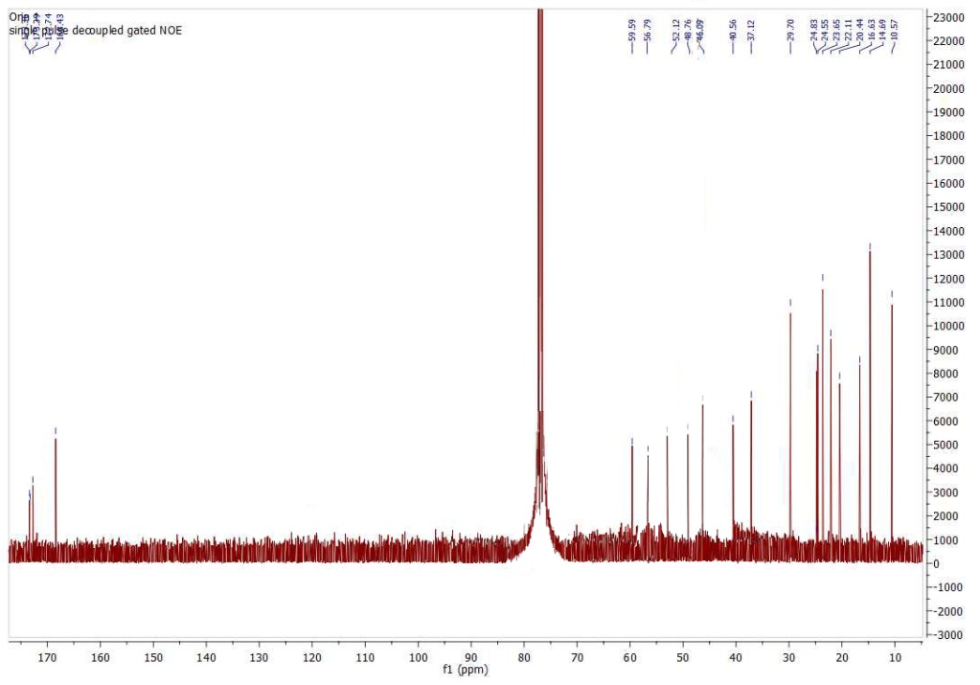

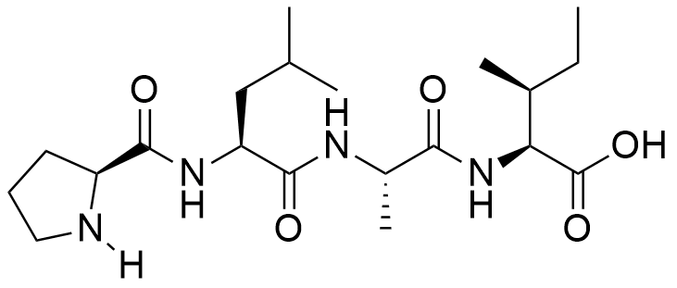
Figure 1. Analitycal RP-HPLC profile of PLAI linear (R_{t} = 4.08 min), λ₂₁₀ nm, gradient MeCN:H₂O 5-95%, 1 ml/min.
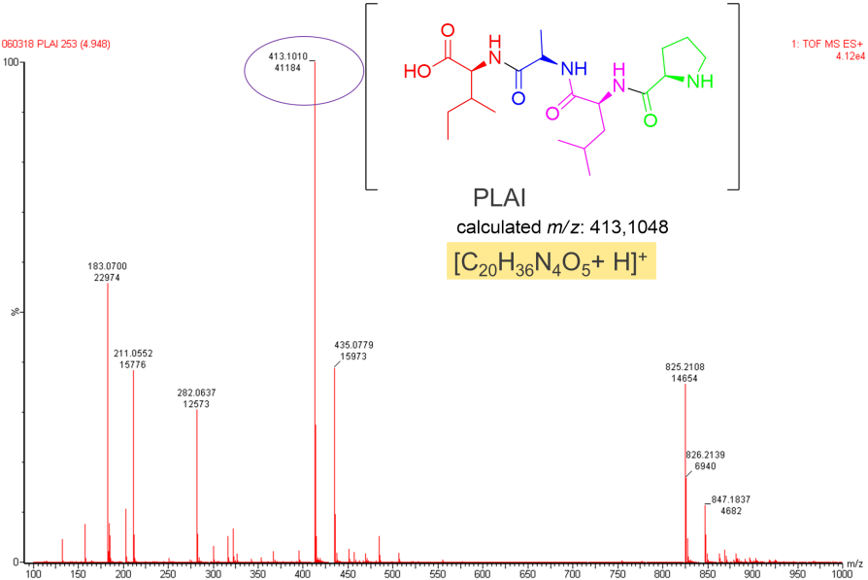
Figure 2. Mass spectra of PLAI linear (HRTOFMS-ES+) calculated mass: 413.1048 [C₂₀H₃₆N₄O₅ + H⁺]

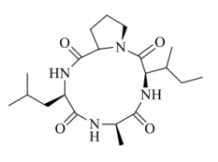
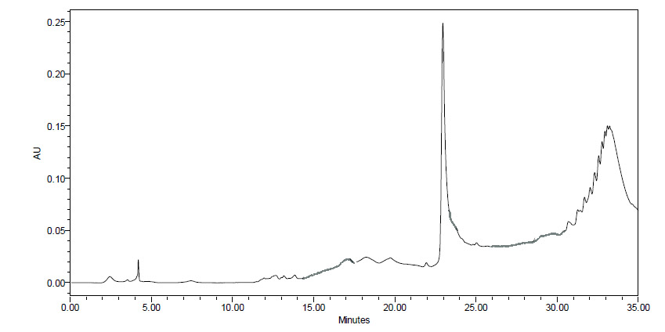
Figure 3. Analitycal RP-HPLC profile of c-PLAI (R_{t} = 23.4 min), λ₂₁₀ nm, gradient MeCN:H₂O 5-95%, 1 ml/min.

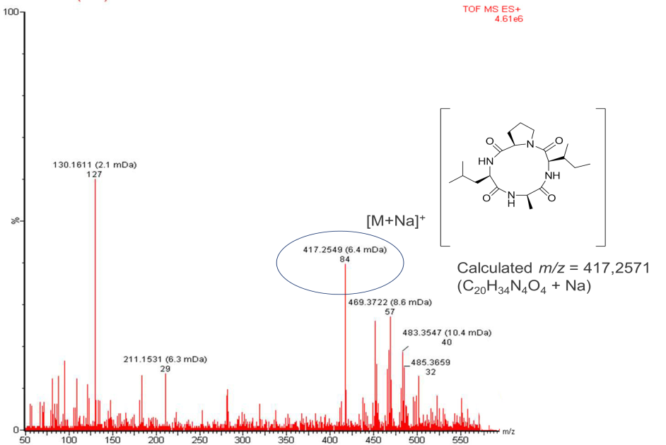
Figure 4. Mass spectra of c-PLAI (HRTOFMS-ES+)
calculated mass: 417.2571 [C₂₀H₃₄N₄O₄ + Na⁺]

