Supporting Information

Contamination and potential health risks of Heavy metals in permafrost-affected soils and lichens: A case-study in Yamal Peninsula, Russia Arctic

Xiaowen Ji^{a*}, Vyacheslav Polyakov^{b,c}, Evgeny Abakumovª

ª Department of Applied Ecology, Saint Petersburg State University, 16-line, 29, Vasilyevskiy Island, 199178, Russian Federation
^{b} Arctic and Antarctic Research Institute, Beringa 38, St. Petersburg, 199397, Russian Federation
^{c} Department of Soil Science and Agrochemistry, Faculty of Agriculture, Saint-Petersburg State Agrarian University, Petersburg Highway 2, Pushkin, St. Petersburg, 196601, Russian Federation

Table S1. Characterizations of soils collected from Yamal Peninsula.
No. site | Horizon | Depth (cm) | CN | PH-H20 | PH-KCl | TOC (%) | BR (mg CO₂ 100 g⁻¹ 24h⁻¹)
M1 | LP (1) | 0-5 | 8.76 | 7.22 | 5.57 | 0.63 | 57.1
 | LP (2) | 5-20 | 8.36 | 7.08 | 5.54 | 0.78 | 109.6
M2 | LP (1) | 0-5 | 9.43 | 7.35 | 8.14 | 0.16 | 93.1
 | LP (2) | 5-20 | 13.98 | 6.92 | 5.48 | 5.75 | 127.5
M3 | LP (1) | 0-5 | 15.13 | 6.37 | 5.56 | 0.63 | 125
 | LP (2) | 5-20 | 9.56 | 6.4 | 5.76 | 7.77 | 115.5
M4 | LP (1) | 0-5 | 12.07 | 6.17 | 5.52 | 13.51 | 93.5
 | LP (2) | 5-20 | 10.06 | 6.27 | 6.00 | 10.02 | 175.4
M5 | LP (1) | 0-5 | 12.69 | 7.01 | 5.99 | 5.13 | 43.5
 | LP (2) | 5-20 | 11.36 | 7.35 | 5.9 | 2.49 | 50.2
M6 | LP | 0-20 | 9.88 | 7.19 | 6.17 | 0.54 | 62.1
M7 | Um | 0-3 | 10.96 | 5.74 | 5.45 | 1.72 | 52.5
 | Um | 3-4 | 12.59 | 4.52 | 5.39 | 2.90 | 85.3
 | CR | 4-25 | 10.03 | 6.88 | 5.36 | 0.80 | 118.7
M8 | O | 0-4 | 13.63 | 6.96 | 5.98 | 3.01 | 52.2
 | Um | 3-20 | 14.51 | 6.36 | 5.98 | 7.44 | 140.4
M9 | CR | 0-25 | 12.64 | 6.09 | 5.40 | 20.85 | 109.1
 | tu | 25-30 | 11.34 | 6.24 | 5.20 | 11.61 | 98.4
M10 | St | 0-25 | 4.79 | 6.73 | 5.48 | 0.14 | 139.8
F1 | AC | 0-5 | 15.87 | 5.74 | 3.87 | 2.13 | 75.6
 | AC | 5-20 | 14.21 | 4.64 | 3.69 | 1.46 | 70.2
F2 | Um | 0-3 | 19.91 | 5.73 | 4.59 | 4.35 | 130.2
 | PZ | 3-4 | 16.86 | 5.92 | 3.84 | 7.46 | 83.3
 | St | 4-25 | 9.79 | 5.43 | 3.57 | 0.53 | 43.1
F3 | hi | 0-5 | 14.96 | 5.89 | 5.63 | 11.97 | 115.1
 | GL | 5-22 | 14.32 | 5.92 | 4.31 | 3.25 | 76.2
E1 | hi | 0-25 | 13.31 | 5.04 | 4.68 | 10.49 | 129.7
E2 | hi | 0-5 | 28.55 | 4.93 | 3.73 | 4.64 | 135.9
 | CR | 5-40 | 13.32 | 6.32 | 4.33 | 2.52 | 64.8
E3 | hi | 0-10 | 24.98 | 4.32 | 2.92 | 2.21 | 170.2
E4 | hi | 0-15 | 20.96 | 5.52 | 3.61 | 1.50 | 144.8
 | GL(1) | 15-25 | 12.06 | 8.52 | 4.06 | 0.91 | 37.1
 | GL(2) | 25-45 | 11.65 | 6.52 | 4.20 | 0.93 | 77.2
A1 | TC | 0-9 | 12.26 | 8.26 | 7.87 | 0.51 | 34.6
 | rd | 9-50 | 11.12 | 6.50 | 4.44 | 0.75 | 31.1
A2 | fo | 0-9 | 15.85 | 8.03 | 6.51 | 1.04 | 65.2
 | AR | 9-50 | 1.83 | 6.07 | 5.68 | 0.03 | 120.5
A3 | Um | 0-2 | 12.40 | 5.70 | 5.71 | 0.88 | 73.2
 | BF | 2-30 | 9.35 | 7.55 | 5.71 | 0.59 | 51.2
 | G | 30-50 | 2.02 | 6.39 | 5.71 | 0.05 | 62.4

Table S2. Geoaccumulation index (I_{geo}) and pollution load index (PLI) of heavy metals in soil samples collected from 30 sites in the Yamal Peninsula.
No. site | Cu | Pb | Cd | Zn | Ni | Mn | Hg | Cr | PLI
M1 | -2.10 | -3.05 | 2.61 | -2.13 | 4.90 | 0.05 | 6.05 | -6.41 | 4.958
M2 | -2.39 | -5.43 | 2.53 | -5.39 | 4.90 | -2.39 | 6.75 | -0.56 | 2.562
M3 | -1.70 | -1.64 | 2.64 | -0.73 | 5.01 | 0.18 | 8.44 | -7.59 | 25.154
M4 | -2.00 | -1.10 | 2.49 | -0.85 | 4.79 | 0.93 | 9.74 | -4.76 | 126.580
M5 | -1.70 | -1.83 | 2.31 | -1.35 | 4.53 | -0.13 | 8.26 | -6.94 | 15.121
M6 | -2.38 | -3.05 | 2.40 | -1.96 | 4.66 | 0.33 | 6.22 | -7.92 | 2.824
M7 | -1.96 | -2.34 | 2.57 | -1.71 | 4.37 | 0.37 | 6.86 | -6.59 | 8.753
M8 | -2.34 | -3.08 | 2.57 | -1.42 | 0.67 | -0.47 | 7.05 | -6.76 | 1.366
M9 | -1.28 | -1.26 | 2.75 | -0.96 | 4.53 | 2.17 | 9.54 | -4.35 | 241.735
M10 | -4.24 | -4.21 | -2.50 | -3.59 | -2.70 | -2.93 | 5.61 | -8.94 | 0.001
F1 | -1.41 | -2.44 | 0.68 | -1.35 | 1.20 | -0.39 | 7.05 | -4.25 | 3.720
F2 | -1.01 | -2.46 | 0.82 | -1.22 | 2.20 | -0.27 | 8.09 | -6.83 | 4.026
F3 | 0.44 | -2.58 | 0.68 | -1.71 | 1.20 | -0.39 | 7.05 | -5.36 | 4.305
E1 | 1.54 | -2.46 | 0.82 | -1.32 | 1.20 | -0.01 | 9.00 | -7.01 | 9.409
E2 | -4.80 | -3.62 | -1.64 | -2.46 | -2.67 | -0.15 | 8.75 | -6.40 | 0.056
E3 | -4.87 | -4.42 | -2.16 | -3.36 | -1.85 | -2.20 | 9.18 | -5.58 | 0.026
E4 | -4.94 | -3.97 | -2.06 | -2.80 | -2.65 | -1.55 | 8.69 | -7.87 | 0.013
A1 | -3.28 | -2.74 | -0.83 | -1.67 | -2.67 | -1.50 | 5.37 | -7.25 | 0.033
A2 | 0.09 | -3.02 | 0.36 | -1.54 | -1.05 | -0.22 | 6.96 | -6.72 | 0.853
A3 | -4.55 | -4.02 | -2.26 | -2.90 | -3.01 | -2.61 | 6.86 | -8.85 | 0.003

Table S3. Rotated component matrix for soil samples in Yamal Peninsula.
 | Component
 | F1 | F2 | F3
TOC | 0.793 | -0.307 | 0.139
Cu | 0.240 | -0.529 | 0.593
Pb | 0.894 | -0.120 | -0.125
Cd | 0.737 | 0.601 | 0.006
Zn | 0.800 | -0.260 | -0.071
Ni | 0.666 | 0.679 | -0.011
Mn | 0.743 | 0.114 | -0.124
Hg | 0.582 | -0.435 | 0.122
Cr | -0.078 | 0.511 | 0.771
Variance explained (%) | 44.569 | 19.355 | 11.303

Table S4. The concentrations (mg kg⁻¹) ± standard deviation and TFs of heavy metals in lichens.
 | Cu | Pb | Cd | Zn | Ni | Mn | Hg | Cr
Concentration | 21±4 | 6.6±1.6 | 3.4±1.7 | 22±4 | 1100±400 | 540±160 | 26±11 | 2.037±0.3
TF | 1.40 | 0.83 | 0.92 | 0.69 | 1.22 | 0.57 | 1.86 | 2.21

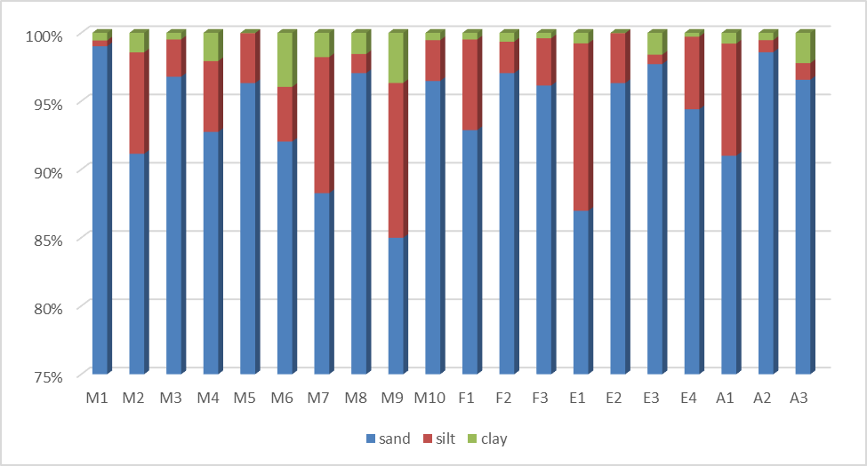
Figure S1. Soil particle size distribution (%) from soil samples collected from Yamal Peninsula.

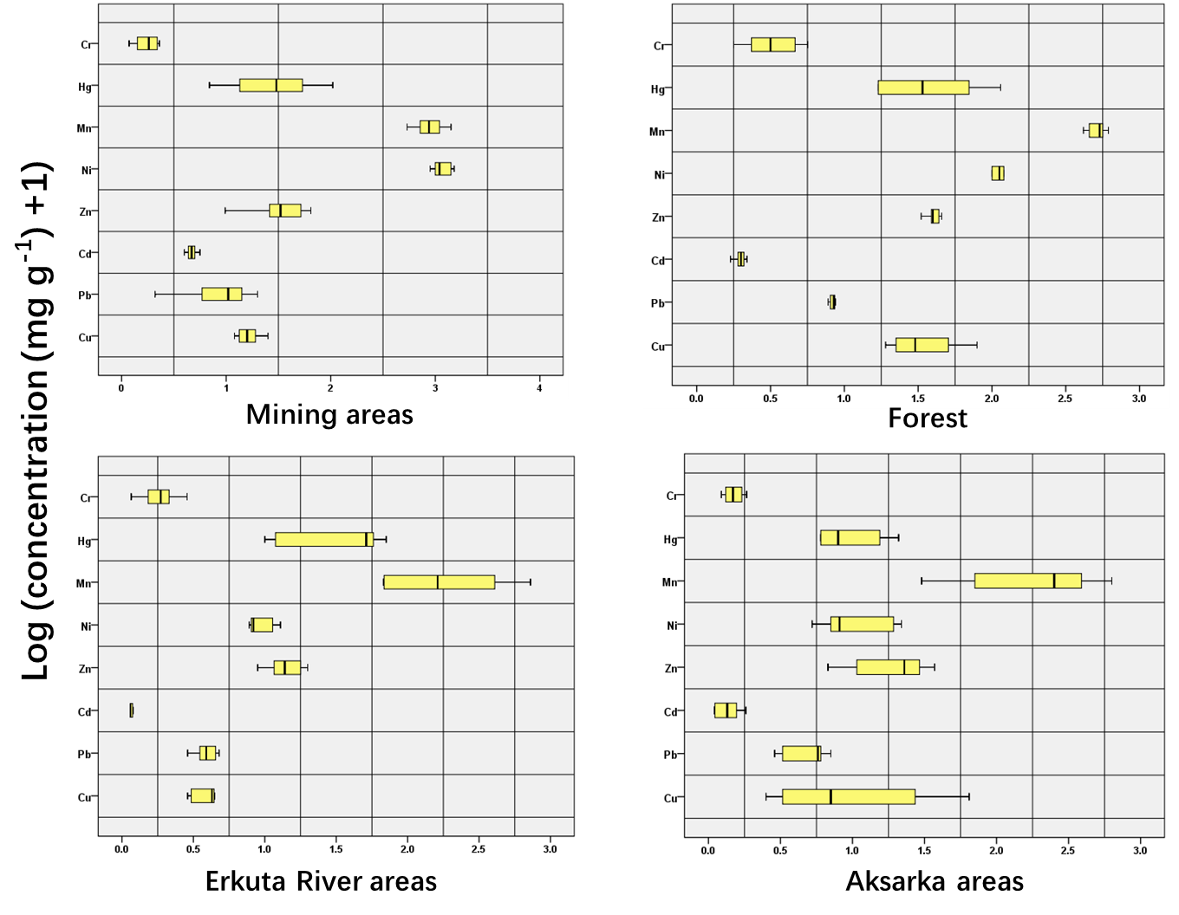
Figure S2. Boxplot comparison of log-transformed concentrations (mg kg⁻¹) for 7 heavy metals in soils from different sampling areas in the Yamal Peninsula.

