Supporting information

Facile Synthesis of 2-Nitromethyl Aromatic Ketones by Insertion of Benzynes into the C-C bond of α-Nitroketones

Ji-Hong Hu,ª Hong-Jie Zheng*^{b}

ª Department of Food and Wine, Sichuan Technology and Business College, Dujianyan, Chengdu, Sichuan Province, P. R. China
^{b}Chengdu R&D Center, Porton Fine Chemical Ltd., No. 88, Keyuan South Road, High-tech Zone, Chengdu, Sichuan Province, P. R. China

Corresponding author: scucioc0205@163.com

Contents
General procedure for synthesis of α-nitroketone substrates 2
¹H-NMR Spectra of substrates (2a-2i) 3
General procedure for synthesis of 2-nitromethyl aromatic ketones 8
Characterization data for insertion products (3aa-3bi). 8
¹H and ¹³C NMR Spectra of insertion products (3aa-3bi) 12
Reference 24

General procedure for synthesis of α-nitroketone substrates (compound 2):
The α-nitroketones were prepared as the method described in literatures.^{[1-6]} To an ethanol solution (20 ml) of aldehyde (3.00 g) and nitromethane (4.00 g) was added CH₃COONa (0.2 g) as catalyst, and the reaction mixture was stirred at room temperature for 24 h. The mixture was evaporated under vacuum and the residue was stirred with 30mL ethyl acetate, filtered and concentrated to provide the intermediate nitroalcohols, which could be used for the next step without purification. Further oxidation of nitroalcohol with PCC (pyridinium chlorochromate) was taken in CH₂Cl₂: 2.00 g PCC was added to a solution of CH₂Cl₂ containing 5 mmol nitroalcohol and stirred at room temperature for 24 h. The mixture was filtered and concentrated under reduced pressure to get crude product. The crude one was purified by flash chromatography. Alternatively, PDC (pyridinium dichromate) was used instead of PCC in preparation of 2f.

Scheme 1. Preparation of α-nitroketones (2a-2i).

¹H-NMR Spectra of substrates (2a-2i)
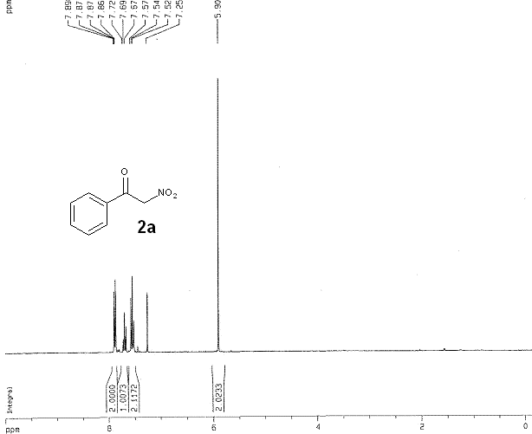

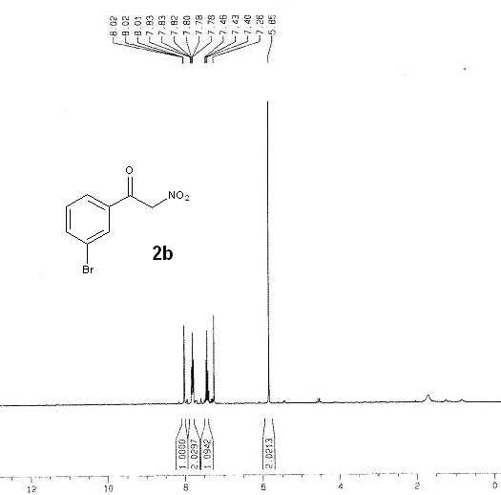
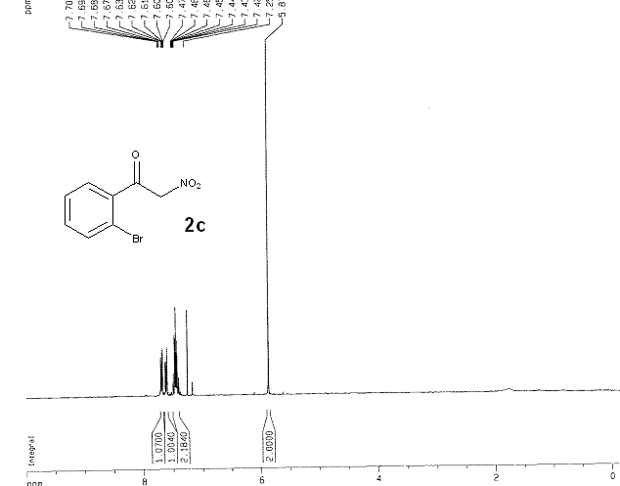

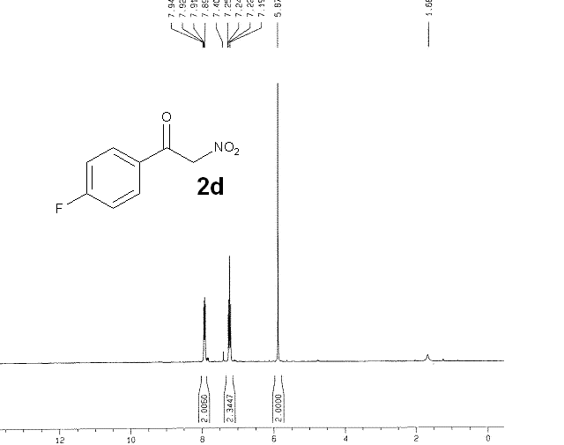

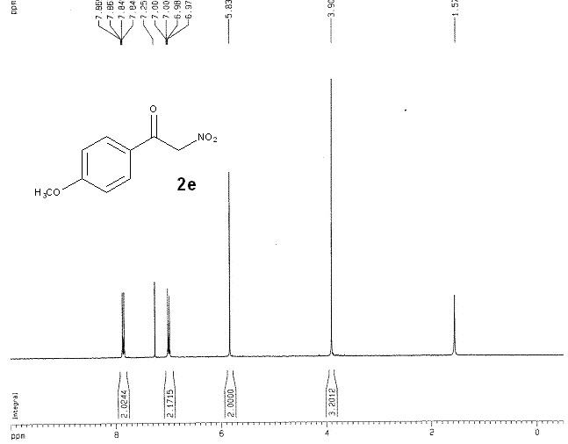

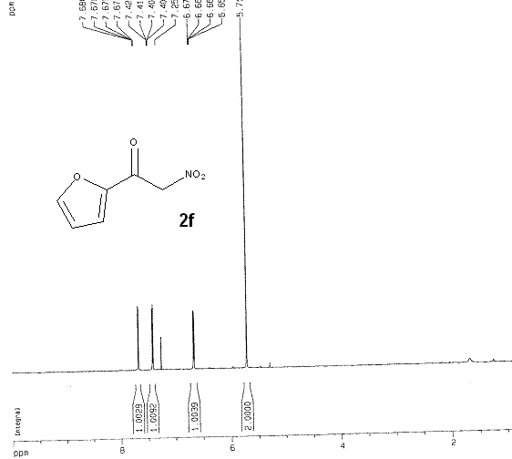

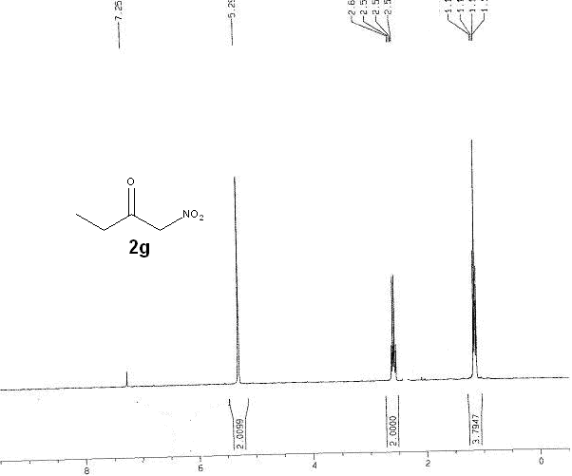
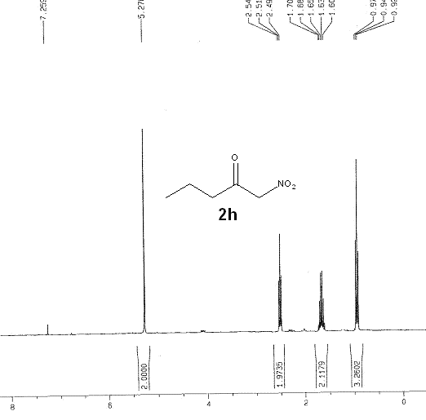

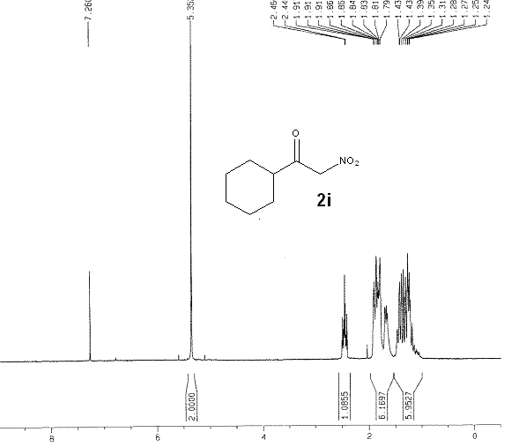

General procedure for synthesis of 2-nitromethyl aromatic ketones (compound 3)
To a flame-dried sealed tube was charged with anhydrous acetonitrile (4 mL), α-nitroketone 2 (0.4 mmol), benzyne precursor 1a or 1b (0.5 mmol, 1.25 equiv) and potassium fluoride (75 mg, 1.0 mmol, 2.5 equiv) sequentially. The mixture was heated at 80 °C till benzyne precursor 1a or 1b was consumed completely. After completion of the reaction, the mixture was quenched with brine (4 mL). The aqueous layer was extracted with ethyl acetate (3 × 5 mL), and the organic phases were combined, dried over anhydrous Na₂SO₄, filtered and concentrated under reduced pressure to get crude product, which was subjected to flash chromatography for further purification.
Scheme 2. Preparation of compound 3 by Insertion reaction

Characterization data for insertion products (3aa-3bi).

(2-(nitromethyl)phenyl)(phenyl)methanone(3aa).
Purification by flash chromatography (20:1 hexanes/EtOAc eluent) to get the desired insertion product (85 mg, 71% yield) as a clear oil: ¹H NMR (300 MHz, CDCl₃): δ ppm 7.80-7.83 (m, 2H), 7.58-7.64 (m, 2H), 7.46-7.53 (m, 5H), 5.75 (s, 2H); ¹³C NMR (75 MHz, CDCl₃): δ ppm 197.12, 138.84, 137.24, 133.36, 132.50, 131.44, 130.72, 130.43, 129.32, 129.22, 128.46, 76.27; HRMS (EI) calc'd for [C₁₄H₁₂NO₃]: m/z 242.0812, found 242.0817.

(3-bromophenyl)(2-nitromethyl)phenyl)methanone (3ab).
Purification by flash chromatogramphy (20:1 hexanes/EtOAc eluent) to get the desired insertion product (94 mg, 59% yield) as a clear oil: ¹H NMR (300 MHz, CDCl₃): δ ppm 7.96 (s, 1H), 7.51-7.75 (m, 6H), 7.33-7.38 (m, 1H), 5.75 (s, 2H); ¹³C NMR (75 MHz, CDCl₃): δ ppm 195.63, 139.06, 138.05, 136.19, 133.07, 132.71, 131.85, 130.66, 130.02, 129.41, 129.02, 122.79, 76.27; HRMS (EI) calc'd for [C₁₄H₁₁BrNO₃] : m/z 319.9917, found 319.9901, 321.9902.

(2-bromophenyl)(2-nitromethyl)phenyl)methanone (3ac).
Purification by flash chromatography (20:1 hexanes/EtOAc eluent) to get the desired insertion product (52 mg, 33% yield) as a clear oil: ¹H NMR (300 MHz, CDCl₃): δ ppm 7.61-7.65 (m, 2H), 7.47-7.50 (m, 3H), 7.37-7.42 (m, 3H), 5.90 (s, 2H); ¹³C NMR (75 MHz, CDCl₃): δ ppm 197.02, 146.30, 136.47, 133.44, 133.34, 133.18, 133.06, 132.95, 131.87, 130.15, 129.96, 129.88, 127.36, 119.99, 77.00; HRMS (EI) calc'd for [C₁₄H₁₁BrNO₃]: m/z 319.9917, found 319.9903, 321.9905.

(4-fluorophenyl)(2-nitromethyl)phenyl)methanone (3ad).
Purification by flash chromatography (10:1 hexanes/EtOAc eluent) to get the desired insertion product (80 mg, 61% yield) as a white solid, melting point: 63-65℃. ¹H NMR (300 MHz, CDCl₃): δ ppm 7.83-7.87 (m, 2H), 7.50-7.59 (m,4H), 7.12-7.18 (m, 2H), 5.74 (s, 2H); ¹³C NMR (75 MHz, CDCl₃): δ ppm 195.61, 165.92, 138.61, 133.43, 133.39, 133.18, 133.06, 132.65, 131.52, 130.39, 129.31, 129.15, 115.68, 76.24; HRMS (EI) calc'd for [C₁₄H₁₀FNNaO₃]: m/z 282.0542, found 282.0517.

(4-methoxyphenyl)(2-nitromethyl)phenyl)methanone (3ae).
Purification by flash chromatography (10:1 hexanes/EtOAc eluent) to get desired insertion product (42 mg, 31% yield) as a white solid, melting point: 57-59℃. ¹H NMR (300 MHz, CDCl₃): δ ppm 7.80-7.82 (m, 2H), 7.50-7.57 (m, 4H), 6.94-6.96 (m, 2H), 5.70 (s, 2H), 3.90 (s, 3H); ¹³C NMR (75 MHz, CDCl₃): ¹³C NMR (75 MHz, CDCl₃): δ ppm 195.66, 163.97, 133.2, 132.91, 132.35, 130.97, 130.10, 129.15, 128.94, 114.10, 76.35, 55.55; HRMS (EI) calc'd for [C₁₅H₁₄NO₄]: m/z 272.0917, found 272.0911.

Furan-2-yl(2-nitromethyl)phenyl)methanone(3af).
Purification by flash chromatography (10:1 hexanes/EtOAc eluent) to get the desired insertion product (86 mg, 75% yield) as an oil. ¹H NMR (300 MHz, CDCl₃): δ= 7.71-7.78 (m, 2H), 7.51-7.59 (m, 3H), 7.14-7.16 (m, 1H), 6.59-6.60 (m, 1H), 5.71 (s, 2H); ¹³C NMR (75 MHz, CDCl₃): δ ppm 183.20, 151.95, 148.16, 134.45, 132.65, 131.77, 130.01, 129.50, 128.99, 122.24, 112.50, 76.14.; HRMS (EI) calc'd for [C₁₂H₉NNaO₄]: m/z 254.0429, found 254.0480.

1-(2-(nitromethyl)phenyl)propan-1-one(3ag).
Purification by flash chromatography (10:1 hexanes/EtOAc eluent) to get the desired insertion product (91 mg, 95% yield) as a white solid, melting point 46-48℃. ¹H NMR (300 MHz, CDCl₃): δ ppm 7.91-7.94 (m, 1H), 7.54-7.58 (m, 2H), 7.37-7.40 (m, 1H), 5.75 (s, 2H), 2.98-3.05 (q, J=7.2Hz, 2H), 1.16-1.21 (t, J=7.2Hz, 3H); ¹³C NMR (75 MHz, CDCl₃): δ ppm 203.34, 137.21, 133.29, 132.28, 130.14, 129.64, 128.90, 77.33, 33.60, 8.08; HRMS (EI) calc'd for [C₁₀H₁₂NO₃]: m/z 194.0812, found 149.0803.

1-(2-(nitromethyl)phenyl)butan-1-one (3ah).
Purification by flash chromatography (10:1 hexanes/EtOAc eluent) to get the desired insertion product (96 mg, 93% yield) as a white solid: ¹H NMR (300 MHz, CDCl₃): δ ppm 7.90-7.94 (m, 1H), 7.56-7.59 (m, 2H), 7.37-7.40 (m, 1H), 5.75 (s, 2H), 2.93-2.98 (t, J=7.2Hz, 2H), 1.67-1.77 (m, 2H), 0.95-1.00 (t, J=7.5Hz, 3H); ¹³C NMR (75 MHz, CDCl₃): δ ppm 202.97, 137.3, 133.29, 132.27, 130.11, 129.74, 128.92, 77.31, 42.28, 17.50, 13.72.; HRMS (EI) calc'd for [C₁₁H₁₄NO₃]: m/z 208.0968, found 208.0954.

Cyclohexyl(2-(nitromethyl)phenyl)methanone (3ai).
Purification by flash chromatography (10:1 hexanes/EtOAc eluent) to get the desired insertion product (118 mg, 96% yield) as a clear oil: ¹H NMR (300 MHz, CDCl₃): δ ppm 7.86-7.89 (m, 1H), 7.55-7.58 (m, 2H), 7.39-7.42 (m, 1H), 5.70 (s, 2H), 3.17-3.20 (m, 1H), 1.63-1.89 (m, 5H), 1.20-1.42 (m, 6H); ¹³C NMR (75 MHz, CDCl₃): δ ppm 206.42, 137.18, 133.37, 132.04, 130.00, 129.34, 129.23, 77.17, 47.48, 29.04, 25.78, 25.72; HRMS (EI) calc'd for [C₁₄H₁₇NNaO₃]: m/z 270.1106, found 270.1134.

1-(4,5-dimethyl-2-(nitromethyl)phenyl)propan-1-one (3bg).
Purification by flash chromatography (25:1 hexanes/EtOAc eluent) to get the desired insertion product (82 mg, 84% yield) as a clear oil: ¹H NMR (300 MHz, CDCl₃): δ ppm (s, 1H), 7.13 (s, 1H), 5.68 (s, 2H), 2.96-3.03 (q, J=7.2Hz, 2H), 2.29-2.37 (m, 5H), 1.15-1.18 ( t, J=6.8Hz, 3H); ¹³C NMR (75 MHz, CDCl₃): δ ppm 202.93, 141.70, 138.70, 134.80, 134.71, 131.35, 126.54, 77.26, 33.34, 19.68, 8.18; HRMS (EI) calc'd for [C₁₂H₁₅NNaO₃]: m/z 244.0950, found 244.0974.

1-(4,5-dimethyl-2-(nitromethyl)phenyl)butan-1-one (3bh).
Purification by flash chromatography (25:1 hexanes/EtOAc eluent) to get the desired insertion product (97 mg, 83% yield) as a clear oil: ¹H NMR (300 MHz, CDCl₃): δ ppm 7.69 (s, 1H), 7.12 (s, 1H), 5.68 (s, 2H), 2.91-2.95 (t, J=7.2Hz, 2H), 2.28-2.37 (m, 6H), 1.68-1.75 ( m, 3H), 0.95-1.00 (t, J=7.5Hz); ¹³C NMR (75 MHz, CDCl₃): δ ppm 202.52, 141.74, 138.71, 134.76, 134.68, 131.41, 126.62, 77.26, 43.03, 19.72, 17.10, 13.76; HRMS (EI) calc'd for [C₁₁H₁₄NO₃]: m/z 208.0968, found 208.0956.

Cyclohexyl(4,5-dimethyl-2-(nitromethyl)phenyl)methanone (3bi).
Purification by flash chromatography (10:1 hexanes/EtOAc eluent) to get the desired insertion product (110 mg, 80% yield) as a clear oil: ¹H NMR (300 MHz, CDCl₃): δ ppm 7.63 (s, 1H), 7.15 (s, 1H), 5.63 (s, 2H), 3.18-3.23 (m, 1H), 2.36 (s, 3H), 2.32 ( s, 3H), 1.79-1.86 (m, 5H), 1.22-1.45 (m, 5H); ¹³C NMR (75 MHz, CDCl₃): δ ppm 206.12, 141.42, 138.61, 134.81, 130.70, 128.95, 126.99, 77.09, 47.15, 29.11, 25.81, 25.72, 19.74, 19.70; HRMS (EI) calc'd for [C₁₆H₂₁NNaO₃]: m/z 298.1419, found 258.1402.

¹H and ¹³C NMR Spectra of insertion products (3aa-3bi)
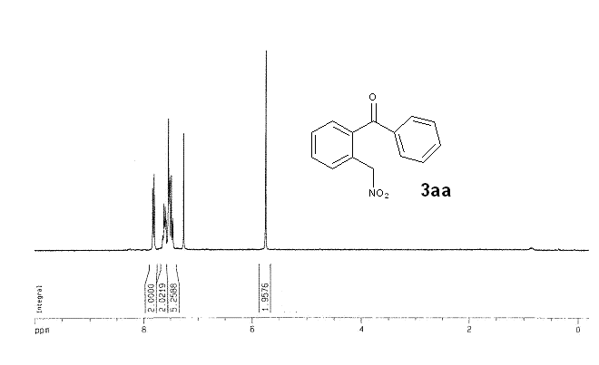

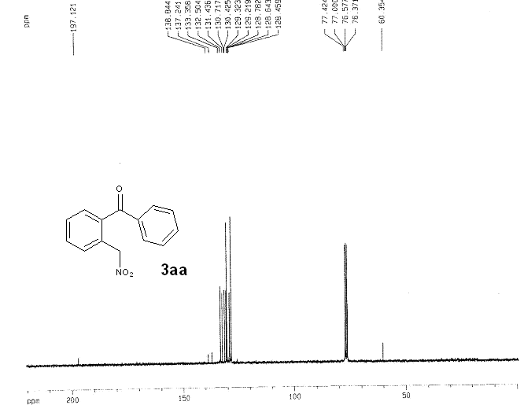

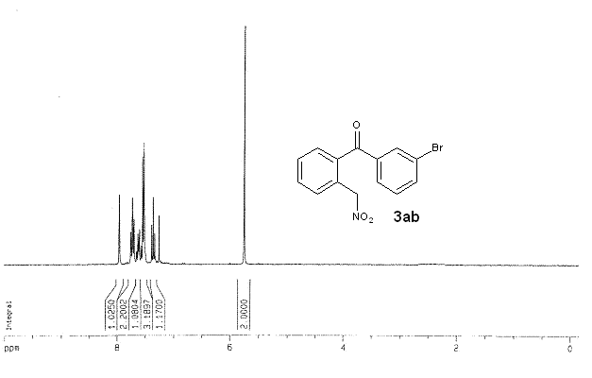

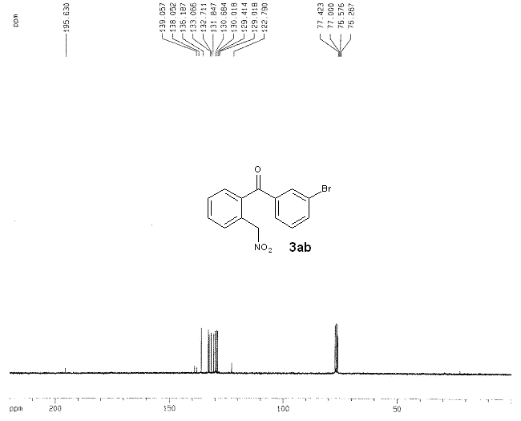

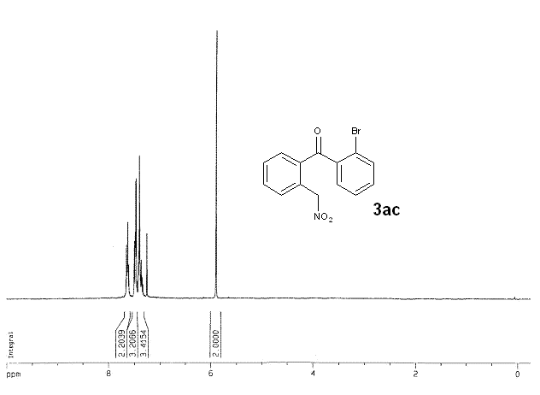

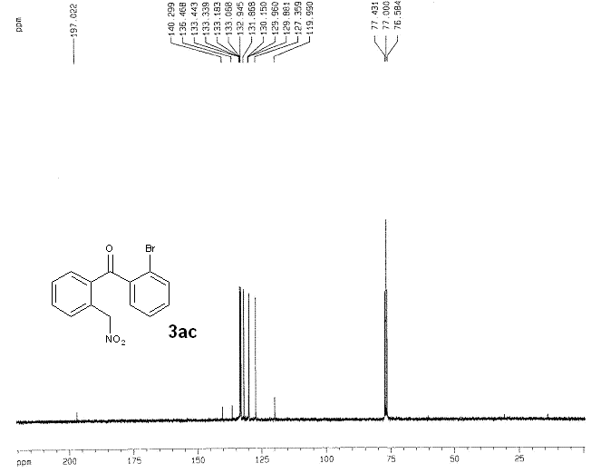

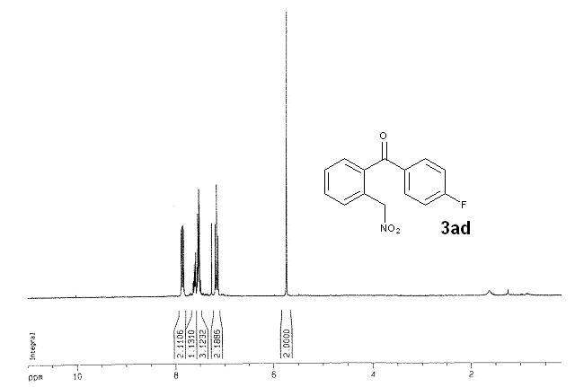

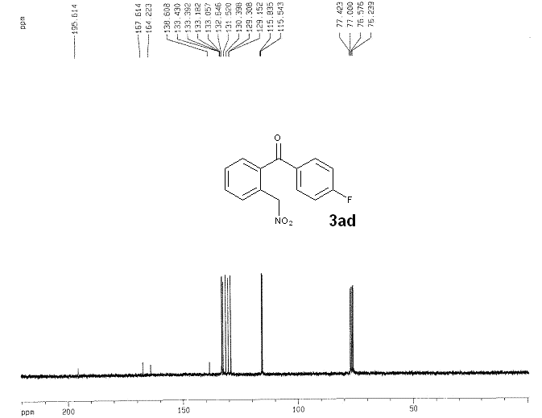

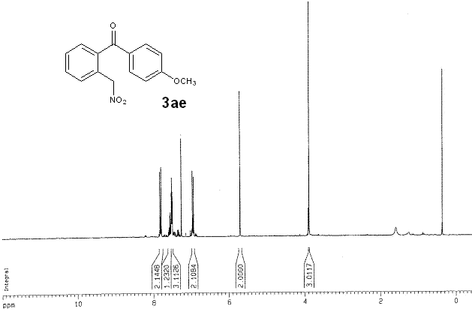

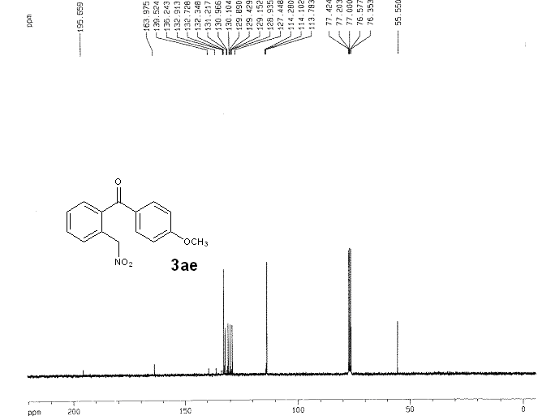

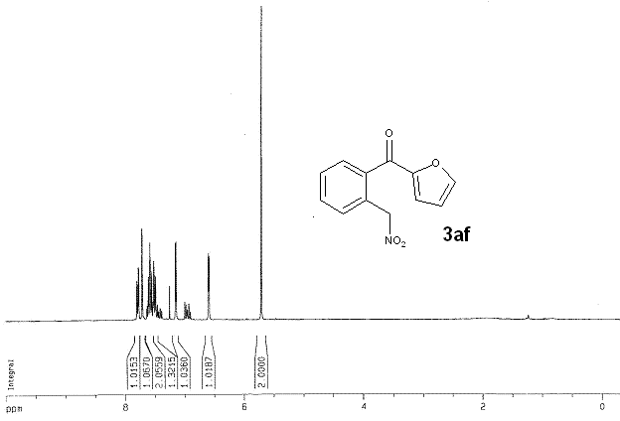

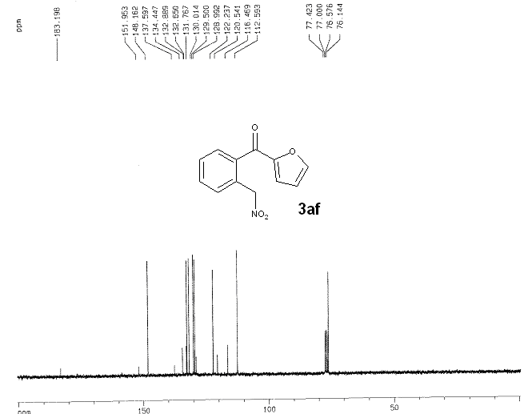

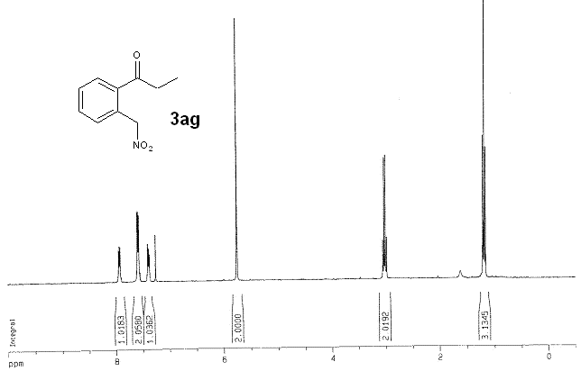

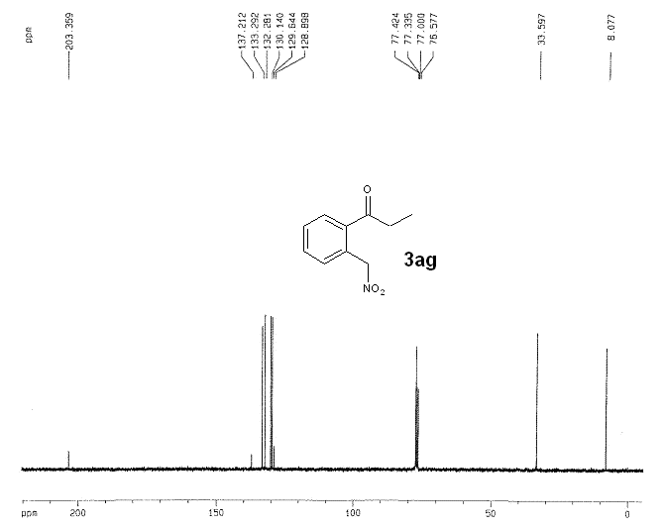

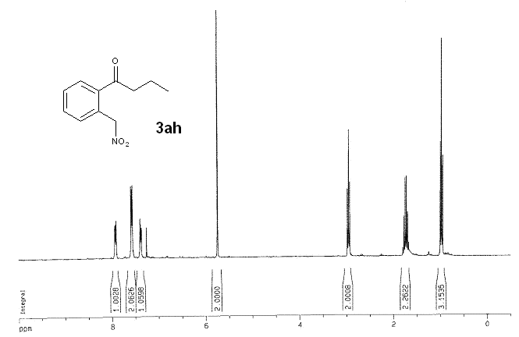

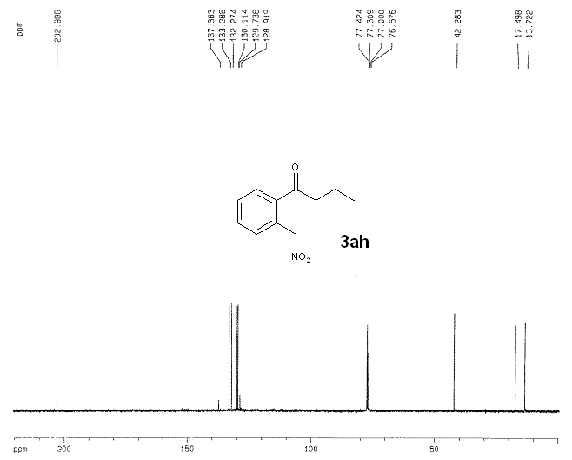

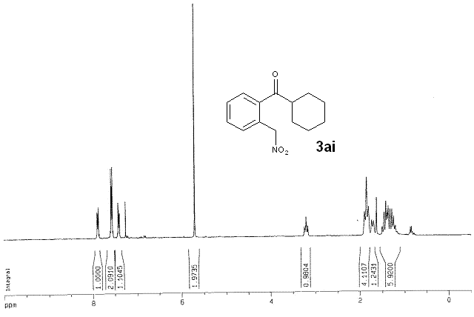

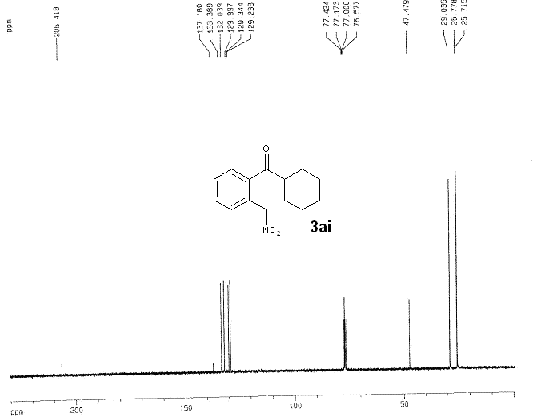

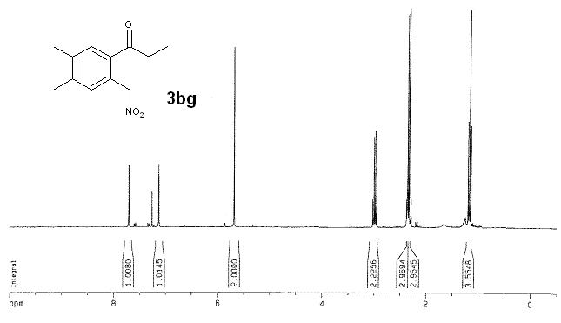

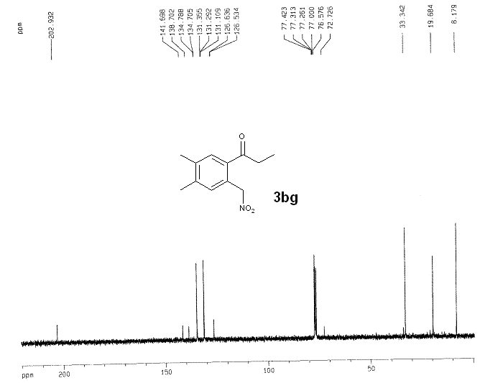

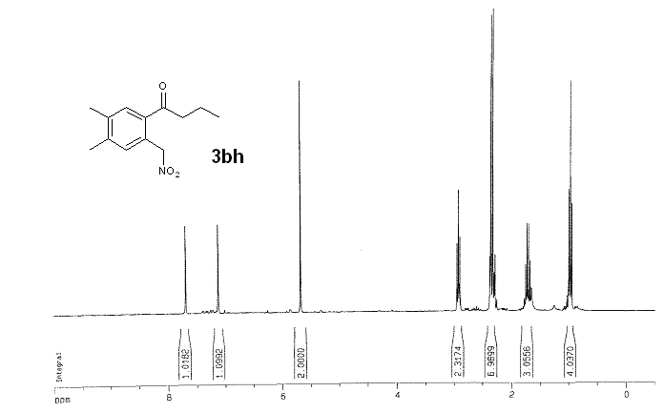

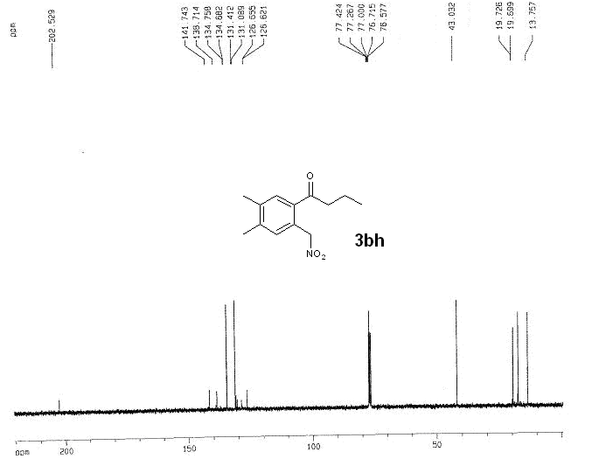

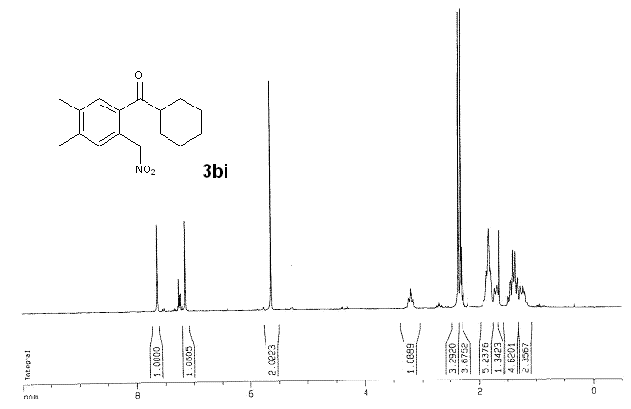

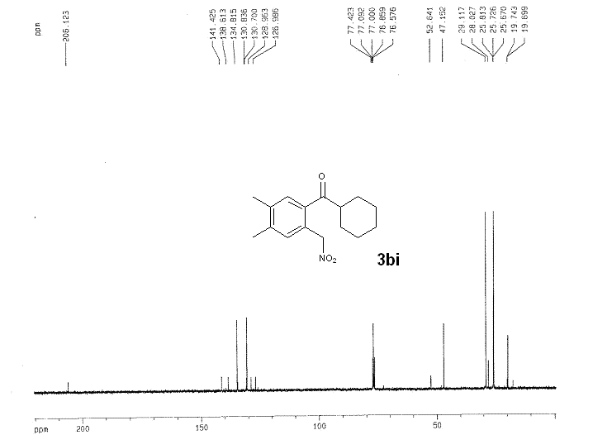

Reference
[1] Margherita. P.; Elena. C. M.; Laura. R.; Alessandra. P.; Maurizio B. Synthesis, 2018, 50, 1430 – 1438. DOI: 10.1055/s-0036-1591911.
[2] Jyoti. S. M.; Prodeep. P. Synthetic Communications, 2016, 46, 257-262. DOI: 10.1080/00397911.2015.1135348.
[3] Rajendra. M.; Chandan. G.; Subhas. C. P. Organic Letters, 2017, 19, 662-665. DOI: 10.1021/acs.orglett.6b03823.
[4] Liu, X. W.; Yan. Y.; Wang. Y. Q.; Wang. C., Sun. J. Chemistry - A European Journal, 2012, 18, 9204-9207. DOI: 10.1002/chem.201201192.
[5] Melot. J. M.; Francoise. T. B.; Andre. F. Tetrahedron Letters, 1986, 27, 493-496. DOI: 10.1016/S0040-4039(00)85513-6.
[6] Zhou. M; Dong. D.; Zhu. B. L.; Geng. H. L.; Wang, Y.; Zhang, X. M. Organic Letters, 2013, 15, 5524 – 5527. DOI: 10.1021/ol4026843.

