Supporting Information
A practical access to new pyrrolizine carboxylates via KHMDS-catalysed carbocyclisations
Muhammet Yildirimª *, Garba Suleiman^{b}

Address:^{a *} Department of Chemistry, Faculty of Arts and Sciences, Bolu Abant İzzet Baysal University, 14030, Bolu, TURKEY.
^{b} Faculty of Science, Department of Chemistry, Yobe State University, P.M.B. 1144,Damaturu, Yobe State, NIGERIA.

Email: Assoc.Prof.Muhammet YILDIRIM – muhammetyildirim@ibu.edu.tr
* Corresponding author

General procedures, experimental details, ¹H-, ¹³C-NMR and HRMS data of precursors and spectra for precursors (3a-f, 4a-t) and products (5a-f, 6a-r and 6a’-r’)

General Remarks
All the reactions were carried out under inert atmophere in flame-dried recation flasks and monitored with TLC precoated plates (60,F₂₅₄,Merck 5735 and 5554). The precursors and the products were purified by CC using silica gel 60 (Merck-109385) or neutral alumina (Merck-101077) and the eluent was the mixtures of ethyl acetate (EA) and hexanes (H). All reagents, solvents were purchased from commercial suppliers with analytical grade (Merck, Sigma-Aldrich, TCI) and used as received. ¹H- and ¹³C- NMR spectra were recorded on VARIAN NMR spectrometers (400 MHz for proton and 100 MHz for carbon) and a JEOL-ECS400 Delta2 NMR spectrometer (400 MHz for proton and 100 MHz for carbon) spectrometer at ambient temperature. All chemical shifts (δ) are reported in parts per million (ppm) downfield from TMS; J values are given in Hz. The abbreviations used for NMR signals are: s =singlet, d =doublet, t =triplet, q =quartet, quint =quintet, sep =septet, hep=heptet, m =multiplet, dd= doublet of doublets, dq= doublet of quartets, td= triplet of doublets, qd=quartet of doublets, ddd= doublet of doublet of doublets, dtd= doublet of triplet of doublets, tdt= triplet of doublet of triplets, dddd= doublet of doublet of doublet of doublets. IR spectra were recorded on a SHIMADZU FTIR-8400S instrument using KBr or NaCl discs. HRMS were run on a Waters Lct Premier XE oa-TOF Mass Spectrometer. Specific rotations were run by a Rudolph Research Analytical Autopol I Automatic polarimeter. Melting points were determined on a MELTEMP apparatus and are uncorrected.
General Procedure for the Preparation of N-propargyl proline esters (3a-f)
Method A– Step 1¹
To a stirred suspension of L-proline 1 (5.1mmol) in alcohol (20 mL) at 0ºC was added thionyl chloride (5.5mmol) dropwise over 20min, the resulting mixture was refluxed for 8 h. After completion of the reaction, the solvent was removed in vacuo to afford 2(5.6mmol) as a hydrochloric salt which was then dissolved in 10mL of DCM under inert atmosphere before triethylamine (10.2mmol) and propargyl bromide (8.4mmol) were added at 0ºC. The reaction mixture was stirred at same temperature for1 h, then at room temperature overnight. After the disappearance of the starting materials as indicated by TLC, the reaction was quenched with water (10ml), extracted with DCM (2×20mL), washed with H₂O, sat. NaHCO₃ solution and brine. The combined organics were dried over Na₂SO₄ and concentrated in vacuo to give N-propargyl esters 3 as oily products. The products was used in the next step without further purification.
General Procedure for Synthesis of N-alkynyl substituted proline esters (4a-i) via Sonogashira coupling
Method A –Step 2^{2, 3}
To a stirred suspension of proline ester 3 (5.0 mmol), Pd(PPh₃)₄ (5mmol%) in DIPA (5 ml), under an inert atmosphere, was added CuI (5mmol%) and 4-iodophenyl derivative (5.0 mmol)successively. After stirring at 50ºC for 2-3 h under N₂, the mixture was hydrolyzed with a saturated aqueous solution of ammonium chloride, extracted with diethyl ether and dried over Na₂SO₄.The compound was purified using silica gel column chromatography to afford the N-alkynyl substituted proline ester 4 in good to moderate yields.
General Procedure for the Synthesis of N-alkynyl substituted proline esters (4j-t) via A³ coupling
Method B^{4, 5}
Formaldehyde (0.25 mmol, 1.25 equiv.), acetylene (0.25 mmol, 1.25 equiv.), sodium bicarbonate (0.2 mmol, 1 equiv.), and CuCl (0.02 mmol) were stirred for 18h with proline ester hydrochloride (2) (0.2 mmol) at 35°C under N₂. Reaction mixture was diluted with ethyl acetate, eluted through a short plug of silica and Celite, dried over Na₂SO₄, filtered, and evaporated under reduced pressure. The compound was purified using silica gel column chromatography to afford the N-alkynyl substituted proline ester 4 in good to moderate yields.
General Procedure for the Preparation of diiodo addition products (5a-f)
A solution of compound 3 (1.0 mmol) in DCM (10 mL) at 0ºC was stirred for 15 min and iodine (3.0 equiv.) was added into the solution under inert atmosphere. The resulting solution was warmed up to room temperature and reaction progress was controlled by TLC until the starting material was completely consumed. The reaction mixture was treated with a saturated solution Na₂S₂O₃ and extracted with DCM (3x15 mL). Combined organic phases were washed with brine (15 mL). After drying over Na₂SO₄, the solvent was rotaevaporated and the residue was purified through a silica column using EtOAc/hexane (1:7) as an eluent to afford compound 5.
General Procedure for the Preparation of carbocyclisation products (6a-r)
A solution of 0.5 M KHMDS (0.25 mmol) in toluene was added dropwise to a solution of N-propargyl proline ester (0.5 mmol) in dry toluene (5 mL) under inert atmosphere. The resulting solution was stirred at 0ºC, then at room temperature until the starting material was completely consumed (about 0.5-1 hour). The solvent was rotaevaporated under reduced pressure and the residue was purified through neutral alumina column using EtOAc/hexane mixture as an eluent.
Characterization Data for Precursor Compounds (3a-f, 4a-t)
Following Method A-Step 1;
Ethyl 1-(prop-2-yn-1-yl)pyrrolidine-2-carboxylate (3a): Yield: 562 mg, 71%. Light yellow oil. R_{f}: 0.45 (33% EA/hexane). IR (KBr): ν_{max}/cm⁻¹ = 3290 (C≡C-H), 2978-2823(alip. CH), 2102 (C≡C), 1739 (ester C=O), 1639 (C-N), 1184 (C-O) cm⁻¹; ¹H NMR (400 MHz, CDCl₃) δ4.21-4.13 (m, 2H), 3.60 (t, 2H, J = 2.4 Hz), 3.42-3.38 (dd, 1H, J = 9.2;6.4 Hz), 3.07-3.02 (m, 1H), 2.74-2.68 (m, 1H),2.19 (t, 1H, J = 2.2 Hz), 2.02-1.74 (m, 2H), 1.25 (t, 3H, J=7.2 Hz); ¹³C NMR (100 MHz, CDCl₃) δ173.5 (ester C=O), 78.3(C≡C), 73.3(≡C-H), 62.5, 60.9, 52.3, 41.2, 29.6, 23.2, 14.3.HRMS (TOF-MS APCI⁺): MH⁺, found 182.1202. C₁₀H₁₆NO₂requires 182.1181.
Propyl 1-(prop-2-yn-1-yl)pyrrolidine-2-carboxylate (3b): Yield: 800mg, 86%. Light yellow oil. R_{f}: 0.41 (33% EA/hexane).¹H NMR (400 MHz, CDCl₃) δ 4.14-4.03 (m, 2H),3.62-3.61 (t, 2H, J = 2.8 Hz),3.45-3.41 (dd, 1H, J = 8.4;6.0 Hz), 3.08-3.03 (m, 1H), 2.76-2.70 (q, 1H, J=8.8 Hz),2.21 (t, 1H, J=2.2 Hz), 2.19-2.13(m, 1H,),2.03-1.78 (m, 3H), 1.72-1.63 (sep, 2H, J=7.2 Hz), 0.94 (t, 3H, J=7.2 Hz); ¹³C NMR (100 MHz, CDCl₃) δ 173.6 (ester C=O), 78.4(C≡C), 73.1(≡C-H), 66.3, 62.4, 52.1, 41.1, 29.5, 23.2, 22.0, 10.3.m/z (TOF-MS ES⁺) 196 (100, MH⁺), 194 (5); HRMS (TOF-MS ES⁺): MH⁺, found 196.1329. C₁₁H₁₈NO₂requires 196.1338.
Isopropyl 1-(prop-2-yn-1-yl)pyrrolidine-2-carboxylate (3c): Yield: 742mg, 84%. pale yellow oil. R_{f}: 0.40 (33% EA/hexane).¹H NMR (400 MHz, CDCl₃) δ5.11-5.02 (hep,1H, J= 2.0 Hz), 3.64-3.62 (dd, 2H, J=3.6, 2.0), 3.42-3.38 (dd, 1H, J = 8.8;6.4 Hz), 3.10-3.05 (m, 1H),2.78-2.71 (q, 1H, J=8.8 Hz), 2.22 (t, 1H, J = 2.4 Hz), 2.21-2.09 (m, 1H), 2.01.-1.77 (m, 2H), 1.26 (t, 6H, J=6.0 Hz);¹³C NMR (100 MHz, CDCl₃) δ 172.9 (ester C=O), 78.3(C≡C), 73.5(≡C-H), 68.5, 67.8, 62.5, 52.2, 41.1, 29.4, 23.0, 21.8.m/z (TOF-MS ES⁺) 196 (100, MH⁺), 154 (5); HRMS (TOF-MS ES⁺): MH⁺, found 196.1337. C₁₁H₁₈NO₂requires 196.1338.
Butyl 1-(prop-2-yn-1-yl)pyrrolidine-2-carboxylate (3d): Yield:1004mg, quantitative. Pale yellow oil. R_{f}: 0.53 (33% EA/hexane).¹H NMR (400 MHz, CDCl₃) δ 4.11-3.98 (m,2H), 3.53-3.51 (dd, 2H, J=3.9, 2.4 Hz), 3.36-3.32 (dd, 1H, J = 9.0, 6.7 Hz), 3.02-2.93 (m, 1H), 2.68-2.61 (dd, 1H, J=16.6, 8.9 Hz), 2.14 (t, 1H, J = 2.4 Hz), 2.11-2.02 (dtd, 1H, J= 11.8, 8.9,6.9 Hz), 1.93.-1.69 (m, 3H), 1.60-1.49 (m, 2H),1.33-1.24 (dq, 2H, J=14.7, 7.4 Hz), 0.84 (3H, t, J=7.4 Hz);¹³C NMR (100 MHz, CDCl₃) δ 173.5 (ester C=O), 78.3(C≡C), 73.2(≡C-H), 72.9, 64.6, 62.3, 52.5, 41.0, 30.6, 23.1, 19.1, 13.7. m/z (TOF-MS ES⁺) 210 (100, MH⁺), 208 (30), 189 (1); HRMS (TOF-MS ES⁺): MH⁺, found 210.1494. C₁₂H₂₀NO₂ requires 210.1494.
Sec-butyl 1-(prop-2-yn-1-yl)pyrrolidine-2-carboxylate (3e): Yield: 501mg, 84%. Pale yellow oil. R_{f}: 0.54 (33% EA/hexane).¹H NMR (400 MHz, CDCl₃) δ 4.87-4.79 (m,2H), 3.56-3.54 (m, 2H, J=3.9, 2.4 Hz), 3.35-3.30 (dd, 1H, J = 9.0, 6.7 Hz), 3.02-2.95 (m, 1H), 2.69-2.63 (dd, 1H, J=17.1, 8.3 Hz), 2.16-2.13 (dt, 1H, J = 3.3, 1.7 Hz), 2.13-2.04 (m, 1H), 1.94.-1.68 (m, 3H), 1.61-1.42 (m, 2H),1.15 (t, 3H, J=6.2 Hz), 0.86-0.79 (3H, t, J=7.5, 3.5 Hz);¹³C NMR (100 MHz, CDCl₃) δ173.4 (ester C=O), 78.3(C≡C), 73.2(≡C-H), 72.6, 62.6, 52.0, 40.9, 29.6, 28.9, 23.0, 19.7, 9.8. m/z (TOF-MS ES⁺) 210 (100, MH⁺), 208 (15); HRMS (TOF-MS ES⁺): MH⁺, found 210.1494. C₁₂H₂₀NO₂ requires 210.1491.
Methyl 1-(prop-2-yn-1-yl)pyrrolidine-2-carboxylate (3f): Yield:3250mg, 85%.Yellow oil. R_{f}: 0.36 (33% ethyl acetate/hexane).IR (KBr): ν_{max}/cm⁻¹ = 3294 (C≡C-H), 2953-2821 (alip. CH), 2102 (C≡C), 1735 (ester C=O), 1437, 1174-1132(C-O) cm⁻¹; ¹H NMR (400 MHz, CDCl₃) δ 3.66 (s, 3H), 3.53-3.51 (t, 2H, J=2.5 Hz), 3.38-3.34 (dd, 1H, J = 9.1, 6.7 Hz), 3.01-2.92 (m, 1H), 2.68-2.61 (td, 1H, J=9.0, 7.6 Hz), 2.15 (t, 1H, J = 2.4 Hz), 2.13-2.02 (m, 1H), 1.96-1.69 (m, 3H); ¹³C NMR (100 MHz, CDCl₃) δ174.4 (ester C=O), 78.2 (C≡C), 73.3 (≡C-H), 62.4, 52.1, 51.9, 41.3 , 29.5, 23.2. HRMS (TOF-MS ES⁺): MH⁺, found 168.1018. C₉H₁₄NO₂ requires 168.1025.
Following Method A-Step 2;
Ethyl 1-(3-(4-methoxyphenyl)prop-2-yn-1-yl)pyrrolidine-2-carboxylate (4a): Yield: 403mg, 64%. Yellow oil. R_{f}: 0.38 (33% EA/hexane). ¹H NMR (400 MHz, CDCl₃) δ7.38-7.34 (d, arom. 2H, J= 8.8 Hz), 6.84-6.80 (d, arom. 2H, J=8.8 Hz), 4.25-4.13 (m, 2H), 3.80 (s, CH₃O, 3H), 3.78 (s, CH₂O-, 2H), 3.49-3.45 (dd, 1H, J = 8.8;6.4 Hz), 3.15-3.11 (m, 1H), 2.81-2.75 (q, 1H, J= 8.8 Hz), 2.20-2.13(m, 1H), 2.03-1.81 (m, 3H), 1.27 (t, 3H, J=7.2 Hz); ¹³C NMR (100 MHz, CDCl₃) δ173.7 (ester C=O), 159.4, 133.1, 115.2, 113.8, 85.1(C≡C), 82.7(C≡C), 62.9, 60.7, 55.2, 52.5, 42.2, 29.6, 23.3, 14.2. m/z (TOF-MS ES⁺) 288 (100, MH⁺), 246 (1), 156 (5); HRMS (TOF-MS ES⁺): MH⁺, found 288.1602. C₁₇H₂₂NO₃ requires 288.1600.

Ethyl 1-(3-(p-tolyl)prop-2-yn-1-yl)pyrrolidine-2-carboxylate (4b): Yield: 360mg, 60%.R_{f}: 0.49 (33% EA/hexane). ¹H NMR (400 MHz, CDCl₃) δ 7.33-7.31 (d, arom. 2H, J= 8.4), 7.11-7.08 (d, arom. 2H, J=8.0 Hz), 4.26-4.14 (m, 2H), 3.80 (s, CH₂O, 2H), 3.51-3.47 (dd, 1H, J = 8.8;6.4 Hz), 3.16-3.11 (m, 1H), 2.82-2.76 (q, 1H, J= 7.6 Hz), 2.34 (s, CH₃-, 3H), 2.20-2.15 (m, 1H), 2.02-1.81 (m, 3H), 1.28 (t, 3H, J=7.2 Hz); ¹³C NMR (100 MHz, CDCl₃) δ 173.7 (ester C=O), 138.1, 131.6, 129.0, 119.9, 85.4(C≡C), 83.4(C≡C), 62.9, 60.7, 52.5, 42.2, 29.6, 23.3, 21.4, 14.2.m/z (TOF-MS ES⁺) 272 (100, MH⁺), 246 (1); HRMS (TOF-MS ES⁺): MH⁺, found 272.1660. C₁₇H₂₂NO₂ requires 272.1651.
Isopropyl 1-(3-(4-methoxyphenyl)prop-2-yn-1-yl)pyrrolidine-2-carboxylate (4c):Yield: 450mg, 60%. Brown oil. R_{f}: 0.47 (33% EA/hexane). ¹H NMR (400 MHz, CDCl₃) δ7.37-7.34 (d, arom. 2H, J= 8.8 Hz),6.84-6.80 (d, arom. 2H, J=8.8 Hz), 5.11-5.03 (sep, 1H, J= 6.0 Hz), 3.80-3.78 (d, CH₃O, 3H, J= 5.6 Hz), 3.46-3.42 (dd, 1H, J = 8.8;6.0 Hz), 3.15-3.11 (m, 1H), 2.81-2.75 (q, 1H, J= 8.4 Hz), 2.20-2.10 (m, 1H), 1.99-1.79 (m, 3H), 1.26-1.24 (dd, 6H, J=10.0, 2.0 Hz); ¹³C NMR (100 MHz, CDCl₃) δ 173.2 (ester C=O), 159.4, 133.1, 115.2, 113.8, 84.9(C≡C), 82.7(C≡C), 67.9, 62.9, 55.2, 52.4, 42.0, 29.5, 23.2, 21.8. m/z (TOF-MS ES⁺)302 (100, MH⁺), 300 (1), 295 (1); HRMS (TOF-MS ES⁺): MH⁺, found 302.1767. C₁₈H₂₄NO₃ requires 302.1756.
Isopropyl 1-(3-(p-tolyl)prop-2-yn-1-yl)pyrrolidine-2-carboxylate (4d) : Yield: 585mg, 82%. Yellow oil. R_{f}: 0.58 (33% EA/hexane).¹H NMR (400 MHz, CDCl₃) δ 7.34-7.32 (d, arom. 2H, J= 8.0 Hz), 7.12-7.10 (d, arom. 2H, J=8.0 Hz), 5.13-5.03 (quint, 1H, J= 6.4 Hz), 3.81 (s, CH₂, 2H), 3.48-3.44 (dd, 1H, J = 9.2;6.0 Hz), 3.16-3.12 (m, 1H),2.83-2.77 (q, 1H, J= 8.8 Hz), 2.35 (s, CH₃-, 3H), 2.22-2.11 (m, 1H), 2.02-1.79 (m, 3H), 1.27-1.23 (dd, 6H, J=6.4, 4.0 Hz); ¹³C NMR (100 MHz, CDCl₃) δ 173.2 (ester C=O), 138.1, 131.6, 129.0, 120.0, 85.3(C≡C), 83.5(C≡C), 67.9, 62.9, 52.5, 42.1, 29.6, 23.2, 21.4. m/z (TOF-MS ES⁺) 286 (100, MH⁺), 284 (10), 279 (1); HRMS (TOF-MS ES⁺): MH⁺, found 286.1812. C₁₈H₂₄NO₂ requires 286.1807.
Isopropyl 1-(3-(4-ethoxyphenyl)prop-2-yn-1-yl)pyrrolidine-2-carboxylate (4e): Yield: 578mg, 73%.Dark red oil. R_{f}: 0.53 (33% EA/hexane).¹H NMR (400 MHz, CDCl₃) δ 7.33-7.31 (d, arom. 2H, J= 9.2 Hz), 6.80-6.77 (d, arom. 2H, J=9.2 Hz), 5.09-4.99 (quint, 1H, J=6.4 Hz), 4.01-3.96 (q, 2H, J=7.2 Hz), 3.76 (s, CH₂O, 2H), 3.44-3.39 (dd, 1H, J = 9.2;6.4 Hz), 3.12-3.08 (m, 1H),2.78-2.70 (q, 1H, J= 8.8. Hz), 2.18-2.08 (m, 1H), 1.95-1.74 (m, 3H), 1.38 (t, 3H, J=7.6 Hz), 1.23-1.21 (dd, 6H, J=6.4, 2.4 Hz); ¹³C NMR (100 MHz, CDCl₃) δ 173.3 (ester C=O), 158.9, 133.2, 115.2, 114.5, 85.3, 82.7, 68.1, 63.6, 63.0, 52.6, 42.2, 29.7, 23.4, 21.9, 14.8. m/z (TOF-MS ES⁺) 316 (100, MH⁺), 309 (1), 298 (1); HRMS (TOF-MS ES⁺): MH⁺, found 316.1913. C₁₉H₂₆NO₃ requires 316.1915.
Propyl 1-(3-(4-methoxyphenyl)prop-2-yn-1-yl)pyrrolidine-2-carboxylate (4f): Yield: 666 mg, 73%. Yellow-green oil. R_{f}: 0.55 (33% EA/hexane). ¹H NMR (400 MHz, CDCl₃) δ 7.34-7.32 (d, arom. 2H, J= 7.3 Hz), 6.80-6.78 (d, arom. 2H, J=8.9 Hz), 4.15-4.00 (m, 2H), 3.76 (s, CH₂O, 2H), 3.76 (s, CH₃O, 3H), 3.49-3.42 (dd, 1H, J = 8.6, 7.1 Hz), 3.10 (t, 1H, J = 6.8 Hz),2.78-2.72 (q, 1H, J= 7.8 Hz), 2.01-1.87 (m, 2H), 1.83-1.76 (m, 1H), 1.68-1.59 (m, 2H), 0.90 (t, 3H, J=7.4 Hz); ¹³C NMR (100 MHz, CDCl₃) δ 173.9 (ester C=O), 159.5, 133.4, 115.2, 113.9, 85.3(C≡C), 82.7(C≡C), 66.3, 62.8, 55.4, 52.5, 42.3, 29.7, 23.2, 22.0, 10.4. m/z (TOF-MS ES⁺) 302 (100, MH⁺), 303 (15); HRMS (TOF-MS ES⁺): MH⁺, found 302.1759. C₁₈H₂₄NO₃ requires 302.1756.
Propyl 1-(3-(p-tolyl)prop-2-yn-1-yl)pyrrolidine-2-carboxylate (4g): Yield: 752mg, 73%. Brown oil. R_{f}: 0.58 (33% EA/hexane). ¹H NMR (400 MHz, CDCl₃) δ7.31-7.28 (d, arom. 2H, J= 8.0 Hz), 7.09-7.07 (d, arom. 2H, J=8.0 Hz), 4.13-4.02 (m, 2H), 3.78 (s, CH₂O, 2H), 3.49-3.46 (dd, 1H, J = 9.1;6.7 Hz), 3.13-3.09 (m, 1H), 2.80-2.74 (dd, 1H, J= 16.6, 8.9 Hz), 2.31 (s, 2H), 2.20-2.11 (m, 1H), 2.01-1.88 (m, 2H), 1.84-1.78 (m, 1H), 1.69-1.60 (m, 2H), 0.91 (t, 3H, J=7.4 Hz); ¹³C NMR (100 MHz, CDCl₃) δ 173.9 (ester C=O), 138.2, 131.7, 129.1, 120.0, 85.4(C≡C), 83.4(C≡C), 66.4, 62.9, 52.4, 42.2, 29.7, 23.3, 21.9, 21.5, 10.5. m/z (TOF-MS ES⁺) 286 (100, MH⁺), 287(20), 288 (1); HRMS (TOF-MS ES⁺): MH⁺, found 286.1809. C₁₈H₂₄NO₂ requires 286.1807.
Butyl 1-(3-(4-methoxyphenyl)prop-2-yn-1-yl)pyrrolidine-2-carboxylate (4h): Yield: 394mg, 80%. Dark-brown oil. R_{f}: 0.58 (33% EA/hexane). ¹H NMR (400 MHz, CDCl₃) δ7.36-7.34 (d, arom. 2H, J= 8.9 Hz), 6.82-6.80 (d, arom. 2H, J=8.9 Hz),4.18-4.07 (m, 2H), 3.79 (s,3H), 3.78 (d, CH₂O, 2H, J = 1.1 Hz), 3.49-3.45 (dd, 1H, J = 9.1, 6.6 Hz), 3.14-3.09 (m, 1H), 2.80-2.74 (m, 1H), 2.21-2.11 (m, 1H), 2.03-1.78 (m, 3H), 1.66-1.58 (m, 2H), 1.41-1.32 (dq, 2H, 14.7, 7.4 Hz), 0.92 (t, 3H, J=7.4 Hz); ¹³C NMR (100 MHz, CDCl₃) δ173.8 (ester C=O), 159.5, 138.2, 133.2, 114.2, 84.9(C≡C), 82.6(C≡C), 64.4, 62.8, 55.5, 52.3, 42.1, 30.9, 29.7, 23.0, 19.1, 14.0. m/z (TOF-MS ES⁺) 316 (100, MH⁺), 143(5); HRMS (TOF-MS ES⁺): MH⁺, found 316.1906. C₁₉H₂₆NO₃ requires 316.1915.
Butyl 1-(3-(p-tolyl)prop-2-yn-1-yl)pyrrolidine-2-carboxylate (4i): Yield: 130mg, 65%. Dark-brown oil. R_{f}: 0.63 (33% EA/hexane). ¹H NMR (400 MHz, CDCl₃) δ7.32-7.30 (d, arom. 2H, J= 8.1 Hz), 7.10-7.08 (d, arom. 2H, J=8.0 Hz), 4.18-4.08 (m, 2H), 3.79 (d, CH₂O, 2H, J=1.3 Hz), 3.50-3.46 (dd, 1H, J = 9.1, 6.6 Hz), 3.14-3.09 (m, 1H), 2.81-2.75 (dd, 1H, J= 16.5, 8.9 Hz), 2.33 (s,3H), 2.21-2.12 (m, 1H),2.04-1.76 (m, 3H), 1.66-1.59 (m, 2H), 1.41-1.32 (m, 2H), 0.93 (t, J=7.4 Hz); ¹³C NMR (100 MHz, CDCl₃) δ173.9 (ester C=O),138.2,131.6, 128.9, 119.9, 85.3(C≡C), 83.4(C≡C), 64.6, 63.0, 52.3, 42.3, 30.6, 29.7, 23.5, 21.3, 19.1, 13.7. m/z (TOF-MS ES⁺) 300 (100, MH⁺), 301 (20), 302 (5); HRMS (TOF-MS ES⁺): MH⁺, found 300.1964. C₁₉H₂₆NO₂ requires 300.1959.
Following Method B;
Ethyl 1-(3-phenylprop-2-yn-1-yl)pyrrolidine-2-carboxylate (4j): Yield: 540mg, 70%. Yellow oil. R_{f}: 0.49 (33% EA/hexane).IR (KBr): ν_{max}/cm⁻¹ = 3055 (arom. C-H), 2978-2816 (alip. CH), 2229 (C≡C), 1739 (ester C=O), 1597 (arom C=C), 1489, 1442, 1180 (C-O) cm⁻¹; ¹H NMR (400 MHz, CDCl₃) δ 7.42-7.38 (m, arom. 2H), 7.29-7.24 (m, arom. 3H), 4.25-4.12 (m, 2H),3.79 (s, CH₂O, 2H), 3.48-3.44 (dd, 1H, J = 9.2;6.4 Hz), 3.14-3.10 (m, 1H), 2.80-2.74 (q, 1H, J= 8.8. Hz), 2.21-2.10 (m, 1H), 2.02-1.76 (m, 3H), 1.25 (t, 3H, J=7.2 Hz); ¹³C NMR (100 MHz, CDCl₃) δ 173.3 (ester C=O), 131.5, 127.8, 122.7, 113.8, 85.4(C≡C), 84.3(C≡C), 63.0, 60.8, 52.6, 42.3, 29.7, 23.4, 14.5. m/z (TOF-MS ES⁺) 258 (100, MH⁺), 256 (1), 246 (1); HRMS (TOF-MS ES⁺): MH⁺, found 258.1496. C₁₆H₂₀NO₂ requires 258.1494.
Propyl 1-(3-phenylprop-2-yn-1-yl)pyrrolidine-2-carboxylate (4k):Yield: 461 mg, 85%. Pale yellow oil. R_{f}: 0.64 (33% EA/hexane).7.43-7.39 (m, arom. 2H), 7.30-7.26 (m, arom. 3H), 4.15-4.03 (m, 2H), 3.80 (d, CH₂O, 2H, J=1.7 Hz), 3.55-3.47 (dd, 1H, J = 9.1, 6.6 Hz), 3.15-3.09 (m, 1H), 2.82-2.75 (td, 1H, J= 8.9, 7.6 Hz), 2.22-2.09 (m, 1H), 2.05-1.76 (m, 3H), 1.71-1.61 (m, 2H), 0.93 (t, 3H, J=7.4 Hz); ¹³C NMR (100 MHz, CDCl₃) δ 173.7 (ester C=O), 131.9, 128.4, 122.8, 85.5(C≡C), 84.1(C≡C), 66.2, 62.9, 60.8, 52.5, 42.2, 29.6, 23.3, 21.9, 10.3. m/z (TOF-MS ES⁺) 272 (100, MH⁺), 302 (30), 310(10); HRMS (TOF-MS ES⁺): MH⁺, found 272.1645. C₁₇H₂₂NO₂ requires 272.1651.
Isopropyl 1-(3-phenylprop-2-yn-1-yl)pyrrolidine-2-carboxylate (4l): Yield:1310 mg, 81%. Pale yellow oil. R_{f}: 0.60 (33% EA/hexane).¹H NMR (400 MHz, CDCl₃) δ 7.42-7.39 (m, arom. 2H), 7.29-7.25 (m, arom. 3H), 5.10-5.00 (quint, 1H, J=6.0 Hz), 3.79 (s, CH₂O-, 2H), 3.44-3.40 (dd, 1H, J = 8.8;6.4 Hz), 3.14-3.09 (m, 1H), 2.80-2.73 (q, 1H, J= 8.8. Hz), 2.19-2.09 (m, 1H), 2.02-1.75 (m, 3H), 1.24-1.22 (dd, 6H, J=6.4, 2.0 Hz); ¹³C NMR (100 MHz, CDCl₃) δ 173.0 (ester C=O), 131.8, 128.3, 128.1, 123.2, 113.8, 85.3(C≡C), 84.4(C≡C), 68.1, 63.1, 52.6, 42.2, 29.7, 23.4, 21.9. m/z (TOF-MS ES⁺) 272 (100, MH⁺), 246 (1); HRMS (TOF-MS ES⁺): MH⁺, found 272.1649. C₁₇H₂₂NO₂ requires 272.1651.
Butyl 1-(3-phenylprop-2-yn-1-yl)pyrrolidine-2-carboxylate (4m): Yield: 1200 mg, 84%. Pale yellow oil. R_{f}: 0.66 (33% EA/hexane).¹H NMR (400 MHz, CDCl₃) δ7.43-7.40 (m, arom. 2H), 7.30-7.27 (m, arom. 3H), 4.18-4.08 (m, 2H), 3.80 (d, CH₂O, 2H, J=1.8 Hz), 3.50-3.46 (dd, 1H, J = 9.1, 6.6 Hz), 3.15-3.10 (m, 1H), 2.80-2.76 (dt, 1H, J= 8.9, 4.4 Hz), 2.22-2.11 (m, 1H), 2.05-1.86 (m, 2H), 1.86-1.77 (m, 1H), 1.66-1.58 (m, 2H), 1.41-1.32 (dq, 2H, J=14.6, 7.4 Hz), 0.91 (t, 3H, J=7.4 Hz); ¹³C NMR (100 MHz, CDCl₃) δ 173.6 (ester C=O), 131.9, 128.0, 123.0, 85.4(C≡C), 84.0(C≡C), 64.4, 62.8, 52.6, 42.1, 30.6, 29.4, 23.0, 18.8, 13.9. m/z (TOF-MS ES⁺) 286 (100, MH⁺), 287 (20), 288 (5); HRMS (TOF-MS ES⁺): MH⁺, found 286.1797. C₁₈H₂₄NO₂ requires 286.1807.
sec-butyl 1-(3-phenylprop-2-yn-1-yl)pyrrolidine-2-carboxylate (4n): Yield:1230 mg, 86%. Pale yellow oil. R_{f}: 0.69 (33% EA/hexane).¹H NMR (400 MHz, CDCl₃) δ 7.42-7.39(m, arom. 2H), 7.29-7.26 (m, arom. 3H), 4.90 (hep, 1H, J=6.3 Hz), 3.79 (d, CH₂O, 2H, J=3.8 Hz), 3.47-3.43 (dd, 1H, J = 9.0, 6.6 Hz), 3.14-3.10 (m, 1H), 2.81-2.74 (dd, 1H, J= 16.5, 8.7 Hz), 2.21-2.09 (m, 1H), 2.02-1.85 (m, 2H), 1.84-1.75 (m, 1H), 1.66-1.48 (m, 2H), 1.21-1.19(dd, 3H, J=6.3, 2.7 Hz), 0.88 (t, 3H, J=7.5 Hz); ¹³C NMR (100 MHz, CDCl₃) δ 173.3 (ester C=O), 131.7, 128.2, 122.9, 85.2(C≡C), 84.3(C≡C), 72.2, 62.9, 52.4, 42.1, 29.6, 28.7, 23.1, 19.3, 9.7. m/z (TOF-MS ES⁺) 286 (100, MH⁺), 288 (55), 289 (10); HRMS (TOF-MS ES⁺): MH⁺, found 286.1800. C₁₈H₂₄NO₂ requires 286.1807.
Ethyl 1-(hept-2-yn-1-yl)pyrrolidine-2-carboxylate (4o): Yield: 619 mg, 87%. Colorless oil. R_{f}: 0.49 (33% EA/hexane). IR (KBr): ν_{max}/cm⁻¹ = 2958-2820 (alip. CH), 2256 (C≡C), 1743 (ester C=O), 1458, 1442, 1180 (C-O) cm⁻¹;¹H NMR (400 MHz, CDCl₃) δ 4.20-4.13 (m, 2H), 3.52-3.51 (m, 2H), 3.38-3.34 (dd, 1H, J = 9.2;6.8 Hz), 3.04-3.00 (m, 1H), 2.69-2.62 (q, 1H, J= 9.2 Hz), 2.18-2.05(m, 3H), 1.98-1.71 (m, 3H), 1.48-1.33 (m, 4H), 1.25 (t, 3H, J=7.6 Hz), 0.87 (t, 3H, J=7.6 Hz); ¹³C NMR (100 MHz, CDCl₃) δ 173.9 (ester C=O), 85.6 (C≡C), 74.3(C≡C), 62.8, 60.7, 52.4, 41.7, 31.1, 29.7, 23.3, 22.0, 18.4, 14.2, 13.7.m/z (TOF-MS ES⁺) 238 (100, MH⁺), 224 (1); HRMS (TOF-MS ES⁺): MH⁺, found 288.1811. C₁₄H₂₄NO₂ requires 238.1807.
Isopropyl 1-(hept-2-yn-1-yl)pyrrolidine-2-carboxylate (4p): Yield: 954mg, 76%. Pale yellow oil. R_{f}: 0.46 (33% EA/hexane).¹H NMR (400 MHz, CDCl₃) δ5.04-4.95 (m, 1H), 3.49 (t,2H, J=2.2 Hz), 3.31-3.27 (dd, 1H, J=9.0, 6.5 Hz), 3.01-2.96 (td, 1H, J=7.9,2.9Hz), 2.66-2.59 (dd, 1H, J=17.1,8.3Hz), 2.14-2.04 (m, 3H), 1.92-1.80 (m, 2H), 1.78-1.70 (m, 1H), 1.43-1.31 (m,4H), 1.20-1.18 (m, 6H), 0.85 (t, 3H, J=7.2 Hz);¹³C NMR (100 MHz, CDCl₃) δ 173.4 (ester C=O), 85.4 (C≡C), 74.3(C≡C), 67.9, 62.9, 52.3, 41.4, 31.1, 29.6, 23.3, 22.0, 21.8, 18.2, 13.5.m/z (TOF-MS ES⁺) 252 (100, MH⁺), 253 (20); HRMS (TOF-MS ES⁺): MH⁺, found 252.1965. C₁₅H₂₆NO₂ requires 252.1963.
Butyl 1-(hept-2-yn-1-yl)pyrrolidine-2-carboxylate (4r): Yield: 721 mg, 75%. Pale yellow oil. R_{f}: 0.40 (33% EA/hexane). ¹H NMR (400 MHz, CDCl₃) δ4.15-4.05 (m, 2H), 3.52 (t,2H, J=2.2 Hz), 3.39-3.35 (dd, 1H, J=9.0, 6.7 Hz), 3.04-3.00 (m, 1H), 2.69-2.63 (m, 1H), 2.18-2.08 (m, 3H), 1.96-1.83 (m, 2H), 1.80-1.74 (m, 1H), 1.63-1.56 (m,2H), 1.48-1.30 (m, 6H), 0.93-0.85 (m, 6H);¹³C NMR (100 MHz, CDCl₃) δ174.1 (ester C=O), 85.5 (C≡C), 74.2(C≡C), 64.6, 62.7, 52.4, 41.6, 30.9, 30.7, 29.6, 23.3, 22.0, 19.2, 18.5, 13.8, 13.7.m/z (TOF-MS ES⁺) 266 (100, MH⁺), 267 (20); HRMS (TOF-MS ES⁺): MH⁺, found 266.2131. C₁₆H₂₈NO₂ requires 266.2120.
Isopropyl 1-(4-methoxy-4-oxobut-2-yn-1-yl)pyrrolidine-2-carboxylate (4s): Yield: 280 mg, 55%. Yellow oil. R_{f}: 0.42 (33% EA/hexane).¹H NMR (400 MHz, CDCl₃) δ 5.07-5.00 (m, 1H), 3.77-3.74 (m, MeO-, 3H), 3.36-3.32 (m, 1H), 3.07-3.03 (m, 1H), 2.74-2.67 (q, 1H, J= 8.0 Hz), 2.19-2.08 (m, 1H), 1.98-1.77 (m, 3H), 1.27 (td, 6H, J=6.4, 2.8 Hz).
4-methylpentyl 1-(1-(phenylethynyl)cyclohexyl)pyrrolidine-2-carboxylate (4t): Yield: 200 mg, 27%. Colorless oil. R_{f}: 0.88 (33% EA/hexane).¹H NMR (400 MHz, CDCl₃) δ7.43-7.41(dd, 2H, J=7.0, 2.8 Hz), 7.29-7.25 (dd, 3H, J=5.1, 2.1 Hz), 4.97-4.88 (m, 1H), 3.79-3.75 (ddd, CH-O-, 1H, J= 9.9, 6.0, 2.8 Hz), 3.25-3.17 (m, 1H), 3.07-3.03 (m, 1H), 2.88-2.78 (m, 1H), 2.10-1.74 (m, 6H), 1.72-1.27 (m, 12H), 1.19-1.17 (d, 4H, J=6.3 Hz), 0.91-0.87 (td, 3H, J=7.2, 1.7 Hz).

Example Spectra for Precursors (3, 4):
¹H-NMR Spectrum of 3a
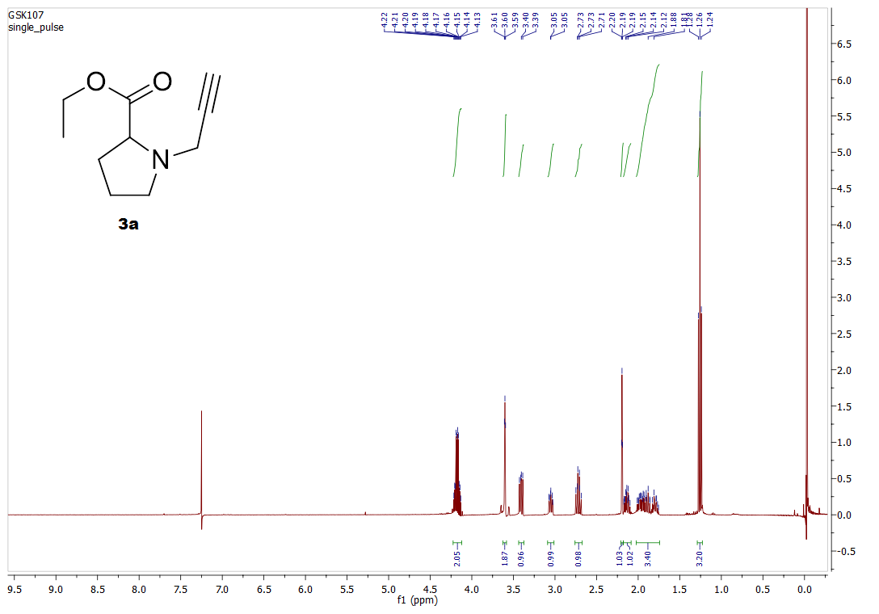

¹³C-NMR Spectrum of 3a
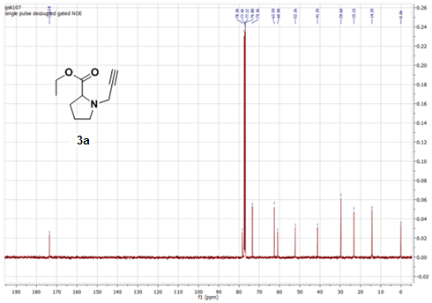
HRMS Spectrum for 3a
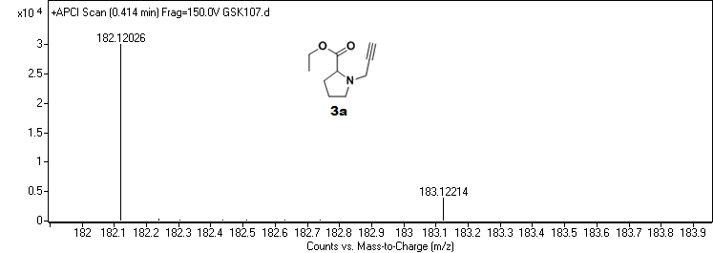

¹H-NMR Spectrum of 4a
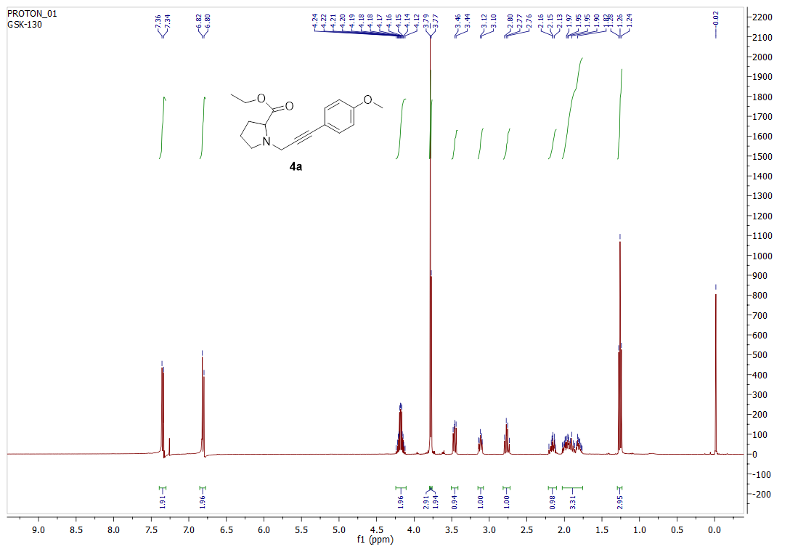

¹³C-NMR Spectrum of 4a
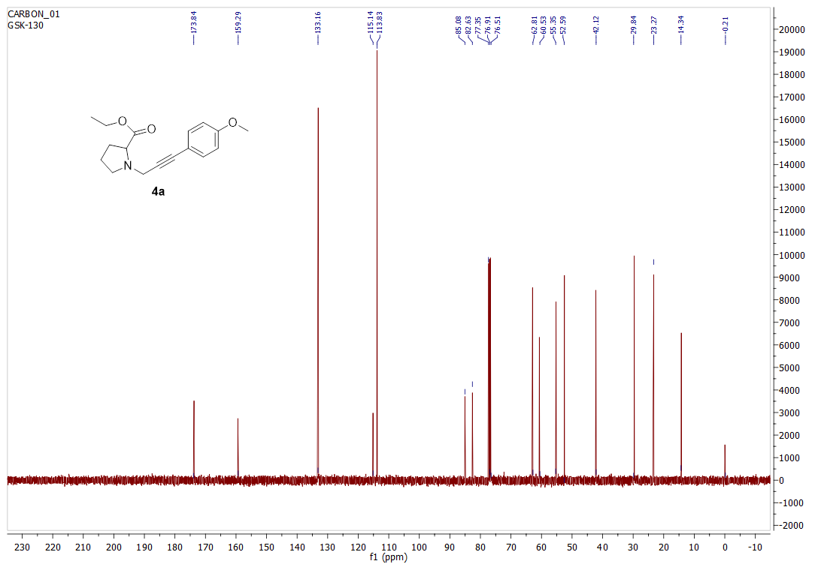

HRMS Spectrum for 4a
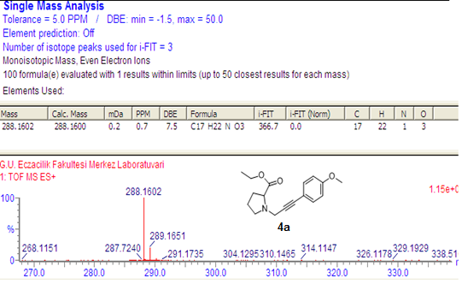

¹H-NMR Spectrum of 4p
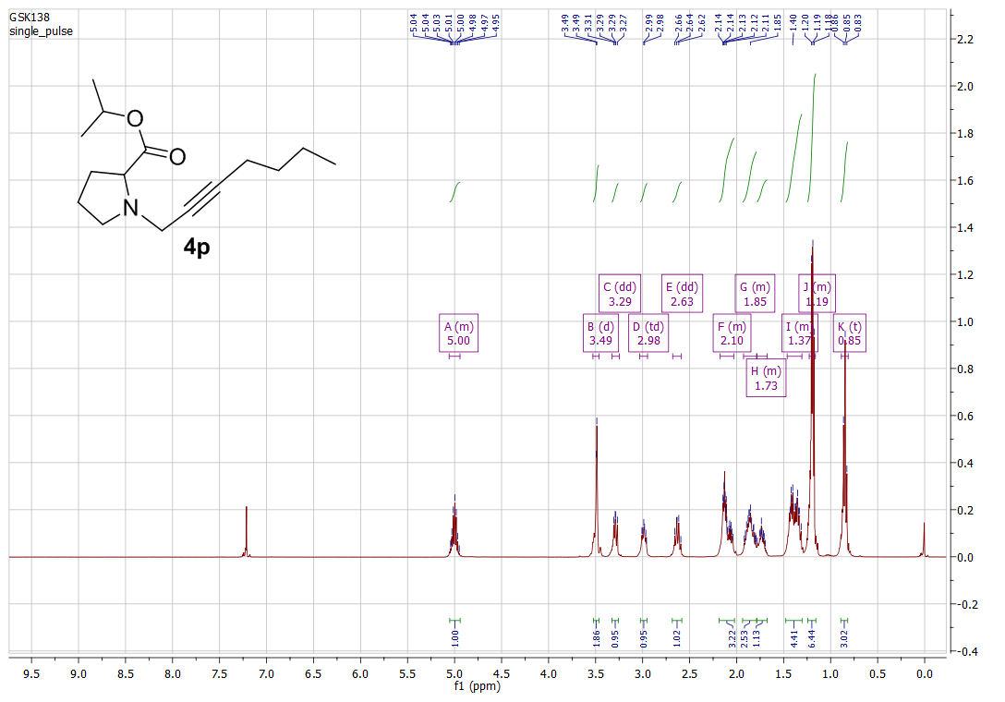
¹³C-NMR Spectrum of 4p
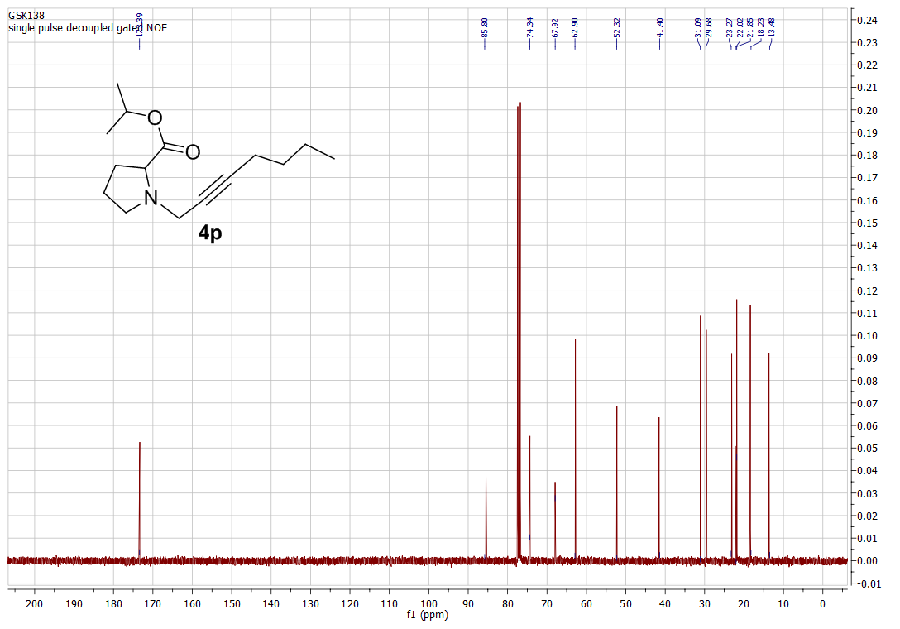

Spectra for Products (5a-f, 6a-r and 6a’-r’):
¹H-NMR Spectrum of 5a
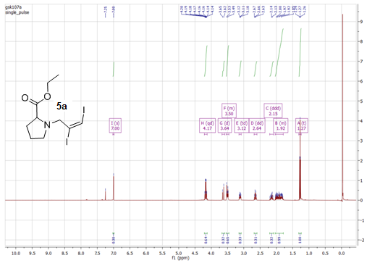

¹³C-NMR Spectrum of 5a
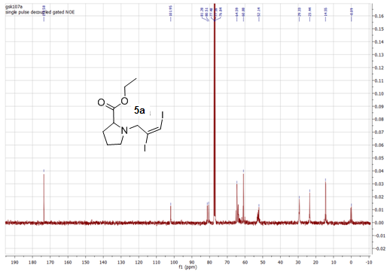

HRMS Spectrum for 5a
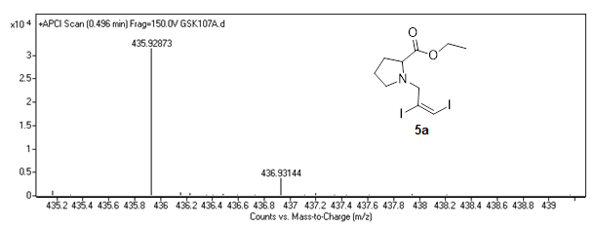

¹H-NMR Spectrum of 5b
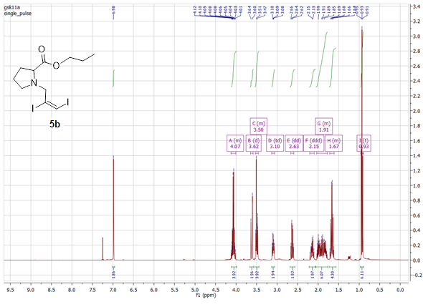

¹³C-NMR Spectrum of 5b
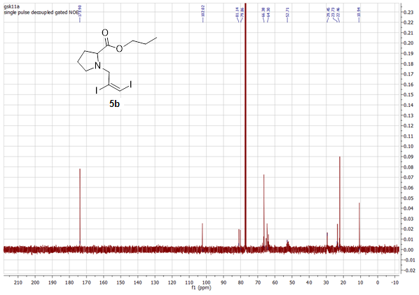

¹H-NMR Spectrum of 5c
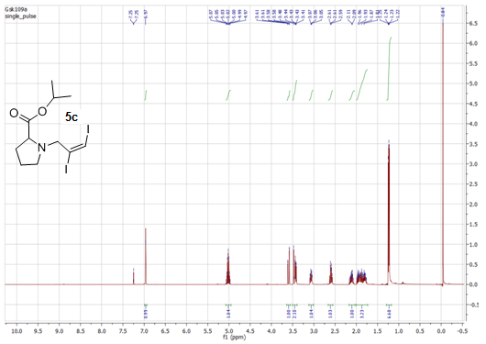

¹³C-NMR Spectrum of 5c
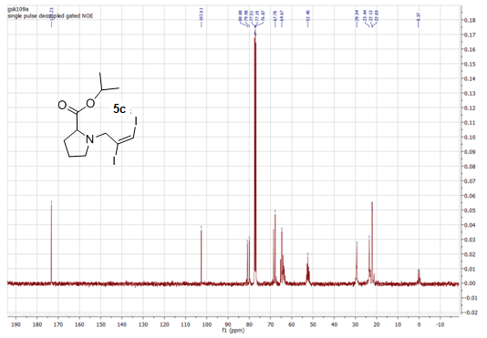

¹H-NMR Spectrum of 5d
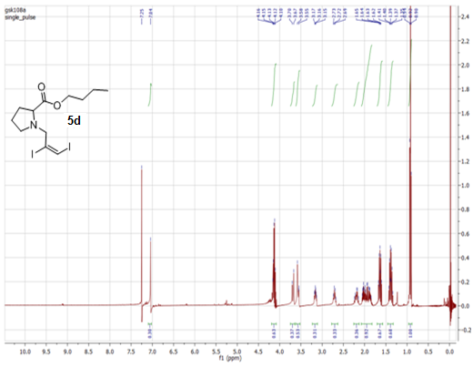

¹³C-NMR Spectrum of 5d
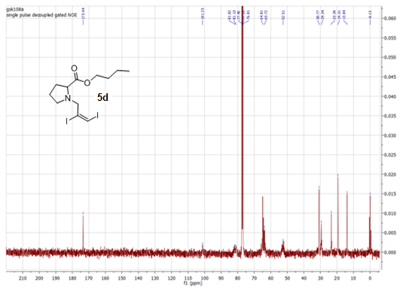

¹H-NMR Spectrum of 5e
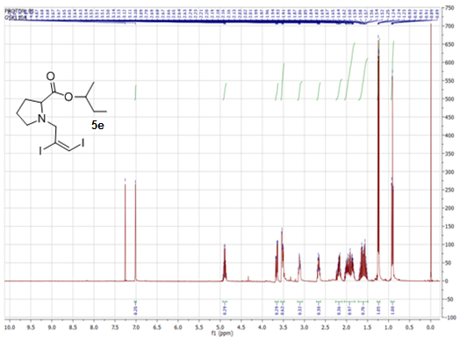

¹³C-NMR Spectrum of 5e
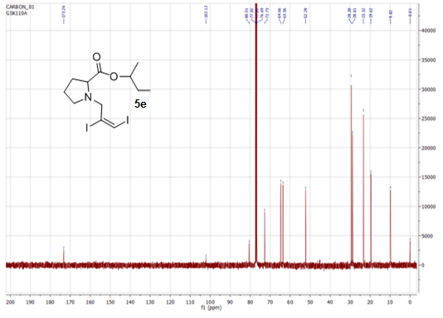

¹H-NMR Spectrum of 5f
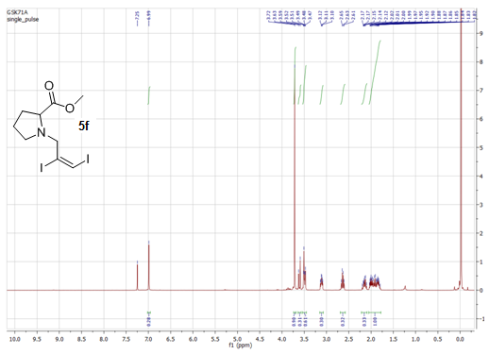
¹³C-NMR Spectrum of 5f
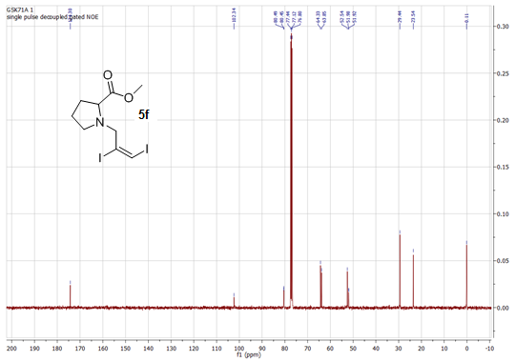

¹H-NMR Spectrum of 6a,6a’ isomer mixture

¹³C-NMR Spectrum of 6a,6a’ isomer mixture

HRMS Spectrum for 6a,6a’ isomer mixture
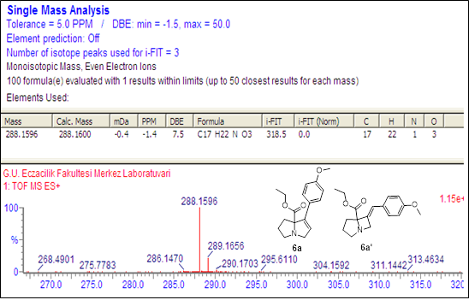

¹H-NMR Spectrum of 6b,6b’ isomer mixture

¹³C-NMR Spectrum of 6b,6b’ isomer mixture
¹H-NMR Spectrum of 6c,6c’ isomer mixture

¹³C-NMR Spectrum of 6c,6c’ isomer mixture

¹H-NMR Spectrum of 6d,6d’ isomer mixture

¹³C-NMR Spectrum of 6d,6d’ isomer mixture
¹H-NMR Spectrum of 6e,6e’ isomer mixture

¹³C-NMR Spectrum of 6e,6e’ isomer mixture
¹H-NMR Spectrum of 6f

¹³C-NMR Spectrum of 6f
¹H-NMR Spectrum of 6g

¹³C-NMR Spectrum of 6g
¹H-NMR Spectrum of 6h

¹³C-NMR Spectrum of 6h
¹H-NMR Spectrum of 6i,6i’ isomer mixture

¹³C-NMR Spectrum of 6i,6i’ isomer mixture
¹H-NMR Spectrum of 6j,6j’ isomer mixture

¹³C-NMR Spectrum of 6j,6j’ isomer mixture
¹H-NMR Spectrum of 6k,6k’ isomer mixture

¹³C-NMR Spectrum of 6k,6k’ isomer mixture
¹H-NMR Spectrum of 6l,6l’ isomer mixture

¹³C-NMR Spectrum of 6l,6l’ isomer mixture
¹H-NMR Spectrum of 6m,6m’ isomer mixture

¹³C-NMR Spectrum of 6m,6m’ isomer mixture
¹H-NMR Spectrum of 6n,6n’ isomer mixture

¹³C-NMR Spectrum of 6n,6n’ isomer mixture

¹H-NMR Spectrum of 6o,6o’ isomer mixture

¹³C-NMR Spectrum of 6o,6o’ isomer mixture

¹H-NMR Spectrum of 6p,6p’ isomer mixture

¹³C-NMR Spectrum of 6p,6p’ isomer mixture
¹H-NMR Spectrum of 6r,6r’ isomer mixture

¹³C-NMR Spectrum of 6r,6r’ isomer mixture
References
1. Moore, J.L., S.M. Taylor, and V.A. Soloshonok. Arkivoc, 2005. 6: p. 287-292.
2. Alami, M.d., F. Ferri, and G. Linstrumelle. Tetrahedron letters, 1993. 34(40): p. 6403-6406.
3. Bera, K., et al. The Journal of organic chemistry, 2011. 76(9): p. 3539-3544.
4. Uhlig, N. and C.-J. Li. Organic letters, 2012. 14(12): p. 3000-3003.
5. Shi, L., et al. Organic letters, 2004. 6(6): p. 1001-1003.

