CLEAN COPY – SUPPLEMENTAL MATERIAL FILE

Supplemental Table 1. Phenotypic characteristics of P. aeruginosa isolates (n=56).
Isolate phenotype | N (%)
Mucoidy (yes) | 13 (23)
Metallic sheen (present) | 10 (18)
Colony lysis (present) | 6 (11)
Pigment: Absent | 21 (38)
Blue-green | 15 (28)
Yellow | 6 (11)
Red | 6 (11)
Brown | 8 (14)

Supplemental Table 2. Frequency distribution of MIC’s of quality-control strains among categories on target, within target range or off range among 10 repeated measurements.
 | Pseudomonas aeruginosa ATCC27853
 | EUCAST target (range) in mg/L¹ | on target | within target range |  | off range
colistin | 1-2 (0.5-4) | 10 | - |  | -
piperacillin-tazobactam | 2-4 (1-8)² | 10 | - |  | -
ceftolozane-tazobactam | 0.5 (0.25-1)² | 8 | 2 |  | -
ceftazidime-avibactam | 1-2 (0.5-4)² | 10 | - |  | -
meropenem | 0.5 (0.25-1) | 9 | 1 |  | -
 | Escherichia coli NCTC13846
 | EUCAST target (range) in mg/L¹ | on target | within target range |  | off range
colistin | 4 (2-8) | 10 | - |  | -
¹Derived from: http://www.eucast.org/fileadmin/src/media/PDFs/EUCAST_files/QC/v_7.0_EUCAST_QC_tables_routine_and_
extended_QC.pdf, accessed June 2017. ²P. aeruginosa ATCC 27853 cannot be used to check for the inhibitor component of ceftazidime-avibactam, or piperacillin-tazobactam

Supplemental Table 3. Colistin MIC cross tabulation tables between VIZION™ and visual MIC readout after 24 and 48 h incubation.

24 hours |  |  | VIZION MIC readout (mg/L)
 |  | 0.25 |  | 0.50 | 1 | 2 | 4 | 8 | >8
Visual MIC readout (mg/L) | 0.25 | 4 |  | 1 | 1
 | 0.50 | 2 |  | 2
 | 1 |  |  | 1 | 9 | 1
 | 2 |  |  |  | 1 | 25 | 1
 | 4 |  |  |  |  |  | 1
 | 8 |  |  |  |  |  |  | 1
 | ≥8 |  |  |  |  |  |  | 2 | 4

48 hours |  |  | VIZION MIC readout (mg/L)
 |  | 0.25 |  | 0.50 | 1 | 2 | 4 | 8 | >8
Visual MIC readout (mg/L) | 0.25
 | 0.50 |  |  | 4
 | 1 |  |  | 1 | 12
 | 2 |  |  |  |  | 29
 | 4 |  |  |  |  | 1 |  | 1
 | 8 |  |  |  |  |  |  | 1
 | ≥8 |  |  |  |  |  |  |  | 7

Supplemental Figure 1. Flowchart of study design

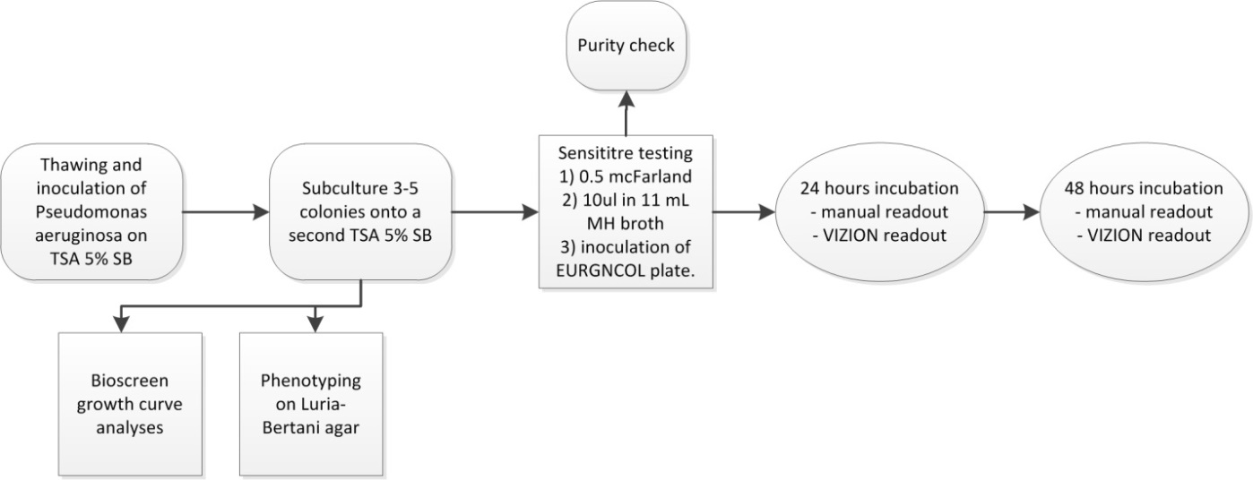

TSA; 5% SB: Tryptone Soya Agar with 5% Sheep Blood, MH; Mueller-Hinton, EURGNCOL; freeze dried 96 well round bottom with antibiotic dilutions, VIZION; readout system and SWIN software provided by ThermoFischer Scientific.

Supplemental Figure 2. Phenotypic diversity of patient derived P. aeruginosa isolates.
1. 2. 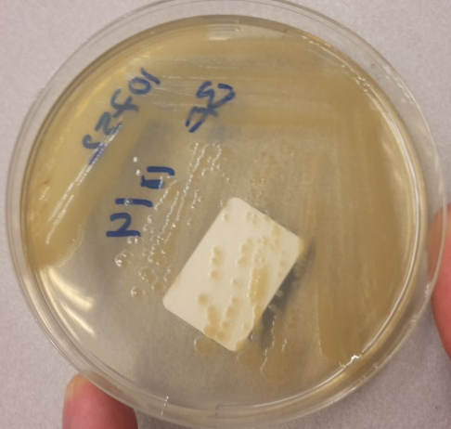
3. 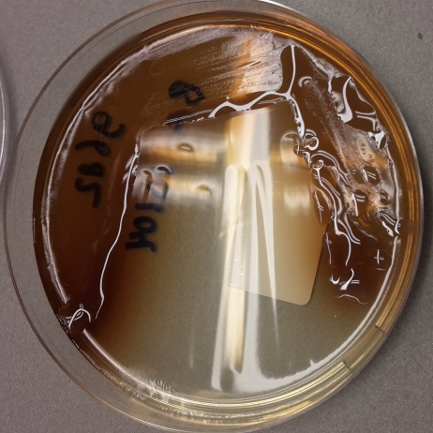 4. 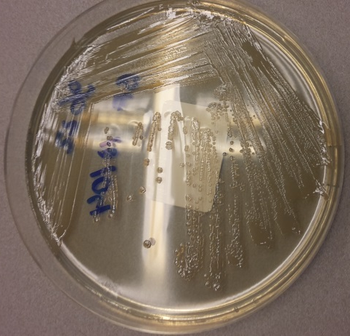
5. 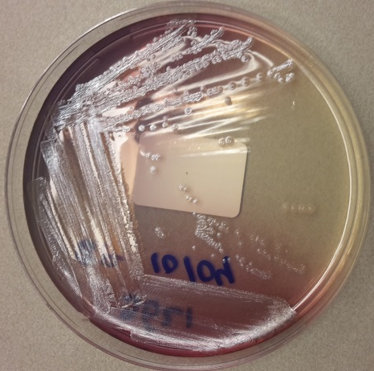 6.
1. Mucoidy absent, pigment blue-green, metallic sheen present, colony lysis absent
2. Mucoidy absent, pigment yellow, metallic sheen absent, colony lysis absent
3. Mucoidy present, pigment brown, metallic sheen absent, colony lysis absent
4. Mucoidy absent, pigment absent, metallic sheen absent, colony lysis absent
5. Mucoidy absent, pigment red, metallic sheen present, colony lysis present
6. Mucoidy absent, pigment blue-green, metallic sheen present, colony lysis present

Extended Material and Methods

Selection of Pseudomonas aeruginosa and quality control isolates
Sixty-one P. aeruginosa isolates, obtained from respiratory secretions from CF patients collected at the University Medical Center Utrecht, the Netherlands (one last isolate per patient), were thawed. All isolates were collected between September 2012 and February 2017. Of these 61 isolates 8 were selected for colistin-resistance. Therefore, the selection does not fully represent consecutive isolates. After thawing, identity of P. aeruginosa was reconfirmed for all isolates using matrix-assisted laser desorption/ionization time of flight mass spectrometry (MALDI-TOF MS). Isolates with no growth in positive control wells of the broth microdilution assay after 24h incubation were excluded (n=5) resulting in 56 isolates available for analyses. P. aeruginosa American Type Culture Collection (ATCC) strain 27853 and E. coli National Collection Type of Cultures (NCTC) strain 13846 were included for quality control. K. pneumoniae ATCC700603, required for quality-control of the inhibitory component of β-lactam-β-lactamase inhibitor combination antibiotic drugs, was not included due to a limited availability of freeze dried antibiotic panels. Laboratory P. aeruginosa strain PA01 was included for analyses concerning growth rate.
Growth curve analysis and phenotypic characterization of Pseudomonas aeruginosa
For growth curve analyses, all isolates were inoculated and subcultured on Trypticase Soy Agar (TSA) with 5% Sheep Blood. Subsequently, from each isolate, 10⁵ CFU/mL were inoculated in Mueller-Hinton (MH) broth in a final volume 200 µl per well. Automated optical density (420-580 nm) in liquid culture was monitored for 48h at 37°Celsius and turbidity measurements were taken every 15 min after shaking the microplates for 10 sec, using the Bioscreen instrument [1].
For phenotypic characterization, all isolates were subcultured on Luria-Bertani agar and initially grown for 48h at 37°Celsius. Subsequently, phenotype assessment was performed and included production of pigments, presence of mucoidy, presence of metallic sheen and presence of colony lysis as previously described by Mayer-Hamblett et al [2].
Antibiotic Susceptibility Testing
Antibiotic susceptibility testing was performed according to manufacturer’s protocol using the commercially available microdilution system Sensititre (ThermoFisher Scientific) that included the nephelometer and inoculation device AIM, the freeze dried 96-well plate EURGNCOL, the readout system VIZION and SWIN software. First, all isolates were thawed, inoculated and subcultured on Trypticase Soy Agar (TSA) with 5% Sheep Blood. Inocula of 0.5 McFarland density were prepared in demineralized water (ThermoFisher) and 10 µl was further diluted in 11 mL cation-adjusted MH broth (ThermoFisher). The final inoculum density was about 10⁵ Colony Forming Units (CFU)/mL. These were dispensed into the EURGNCOL freeze dried 96-well round bottom plate using the AIM auto-inoculator as 50ul suspension per well. The plates contained the following antibiotics in serial twofold dilutions: colistin (0.25–8 mg/L), piperacillin-tazobactam (1-32 mg/L, tazobactam fixed at 4 mg/L), ceftolozane-tazobactam (0.25-8 mg/L, tazobactam fixed at 4 mg/L), ceftazidime-avibactam (1-16 mg/L, tazobactam fixed at 4 mg/L) and meropenem (0.12-16 mg/L). The plates were incubated at 37°Celsius and read at 24 and 48h by visual inspection and by using the VIZION readout system (ThermoFisher). Positive control wells were assessed by visual inspection and categorized as no, faint, fair or good growth. Skipped wells were ignored. The MIC was defined as the lowest concentration of an antimicrobial agent that completely inhibited growth. Regrowth was considered as contamination and ignored. Finally, all isolates were checked for purity by inoculating 10 µl used broth on 5% TSA SB agar and read after 24h incubation at 37°C.
Data analyses
A flowchart of the study design is displayed Supplemental Figure 1. Central estimators and variance measures were calculated for phenotypic characteristics of all P. aeruginosa isolates. Growth curves were quantified by determining the Area Under the Curve. Differences in growth curves were tested using the Wilcoxon rank sum test. EUCAST 2017 breakpoints were used for the assessment of interpretive category results. Reliability, defined as the ability to effectively distinguish low from high MIC-values, and agreement, defined as the degree to MIC-values are identical, were estimated between VIZION and visual inspection after 24 and 48h of incubation. Reliability was expressed in weighted kappa taking into account the possibility of agreement occurring by chance. Agreement was defined by exact, essential (within one twofold dilution) and categorical agreement. For categorical agreement errors were defined as change in the interpretive category result from susceptible to resistant (major error, ME) or from resistant to susceptible (very major error, VME) as compared to visual readout as reference. Minor error (MIE) was defined as an error in which either method reported a result as intermediate and the other method reported a result as susceptible or resistant. Statistical analyses were performed with IBM SPSS version 21.0, Graphpad Prism 7.02 and Excel 2010.

References
[1] Cullen L, Weiser R, Olszak T, Maldonado RF, Moreira AS, Slachmuylders L, et al. Phenotypic characterization of an international Pseudomonas aeruginosa reference panel: strains of Cystic Fibrosis (CF) origin show less in vivo virulence than non-CF strains. Microbiology 2015;161(10):1961-77.
[2] Mayer-Hamblett N, Rosenfeld M, Gibson RL, Ramsey BW, Kulasekara HD, Retsch-Bogart GZ, et al. Pseudomonas aeruginosa in vitro phenotypes distinguish cystic fibrosis infection stages and outcomes. Am J Respir Crit Care Med 2014;190(3):289-97.

