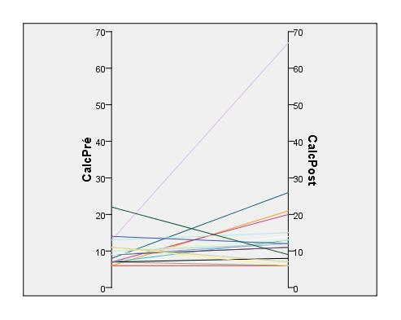
Supplemental Figure S1 - Evolution of calculation speed. (Second) CalcPre/Post : Calculation speed before / after session.

