SUPPLEMENTARY FIGURES, TABLES AND LEGENDS
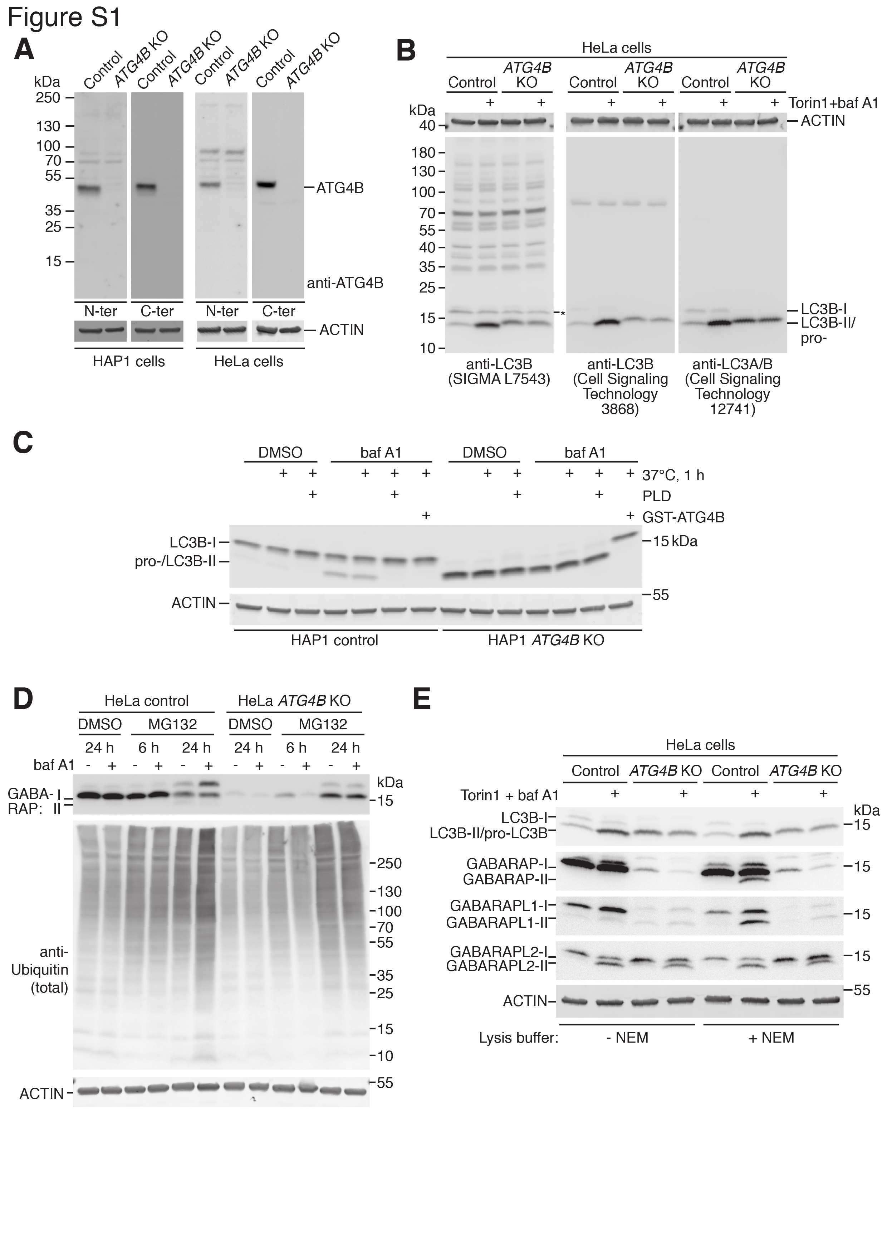
Figure S1. Additional characterization of human ATG4B KO cells. (A) Protein-level validation of CRISPR-Cas9-mediated ATG4B knockout. Lysates from control and ATG4B KO HAP1 and HeLa cells were subject to western blotting using polyclonal ATG4B antibodies raised against the N terminus (SIGMA, A2981) and C terminus (Cell Signaling Technology, 5299) of the protein. (B) Determination of background bands detected by anti-LC3B (SIGMA, L7543). HeLa control and ATG4B KO cells were treated for 3 h with DMSO or 250 nM Torin1 + baf A1 prior to lysis. Samples of the same lysates were run in triplicate on an SDS-PAGE gel before transfer to membrane. The membrane was cut and incubated with 3 different anti-LC3 antibodies as indicated. Asterisk indicates background band detected at the same molecular weight as LC3B-I. (C) PLD band shift assay performed on HAP1 control or ATG4B KO cells treated for 6 h with DMSO or 10 nM baf A1 and lysed in PLD assay buffer lacking NEM. Lysates were subject to in vitro treatment with purified PLD or GST-ATG4B prior to western blotting. (D) Western blot of lysates from HeLa control and ATG4B KO cells treated with the proteasome inhibitor MG132 (10 µM) for 6 or 24 h, in the presence or absence of 10 nM baf A1 added for the final 3 h of treatment. (E) Western blotting of LC3/GABARAP proteins using lysates from HeLa control and ATG4B KO cells treated for 3 h with DMSO or 250 nM Torin1 and 10 nM baf A1. Cells were lysed in the presence or absence of 20 mM NEM.

Figure S2. Original blots for Figure 2D.

Figure S3. Stably expressed GFP-GABARAPL1 WT localizes to puncta in the absence of ATG4B. HAP1 control and ATG4B KO cells stably expressing GFP-GABARAPL1 WT were treated for 3 h with DMSO or 250 nM Torin1 + 10 nM baf A1 prior to fixation and confocal imaging. Scale bar: 10 µm.

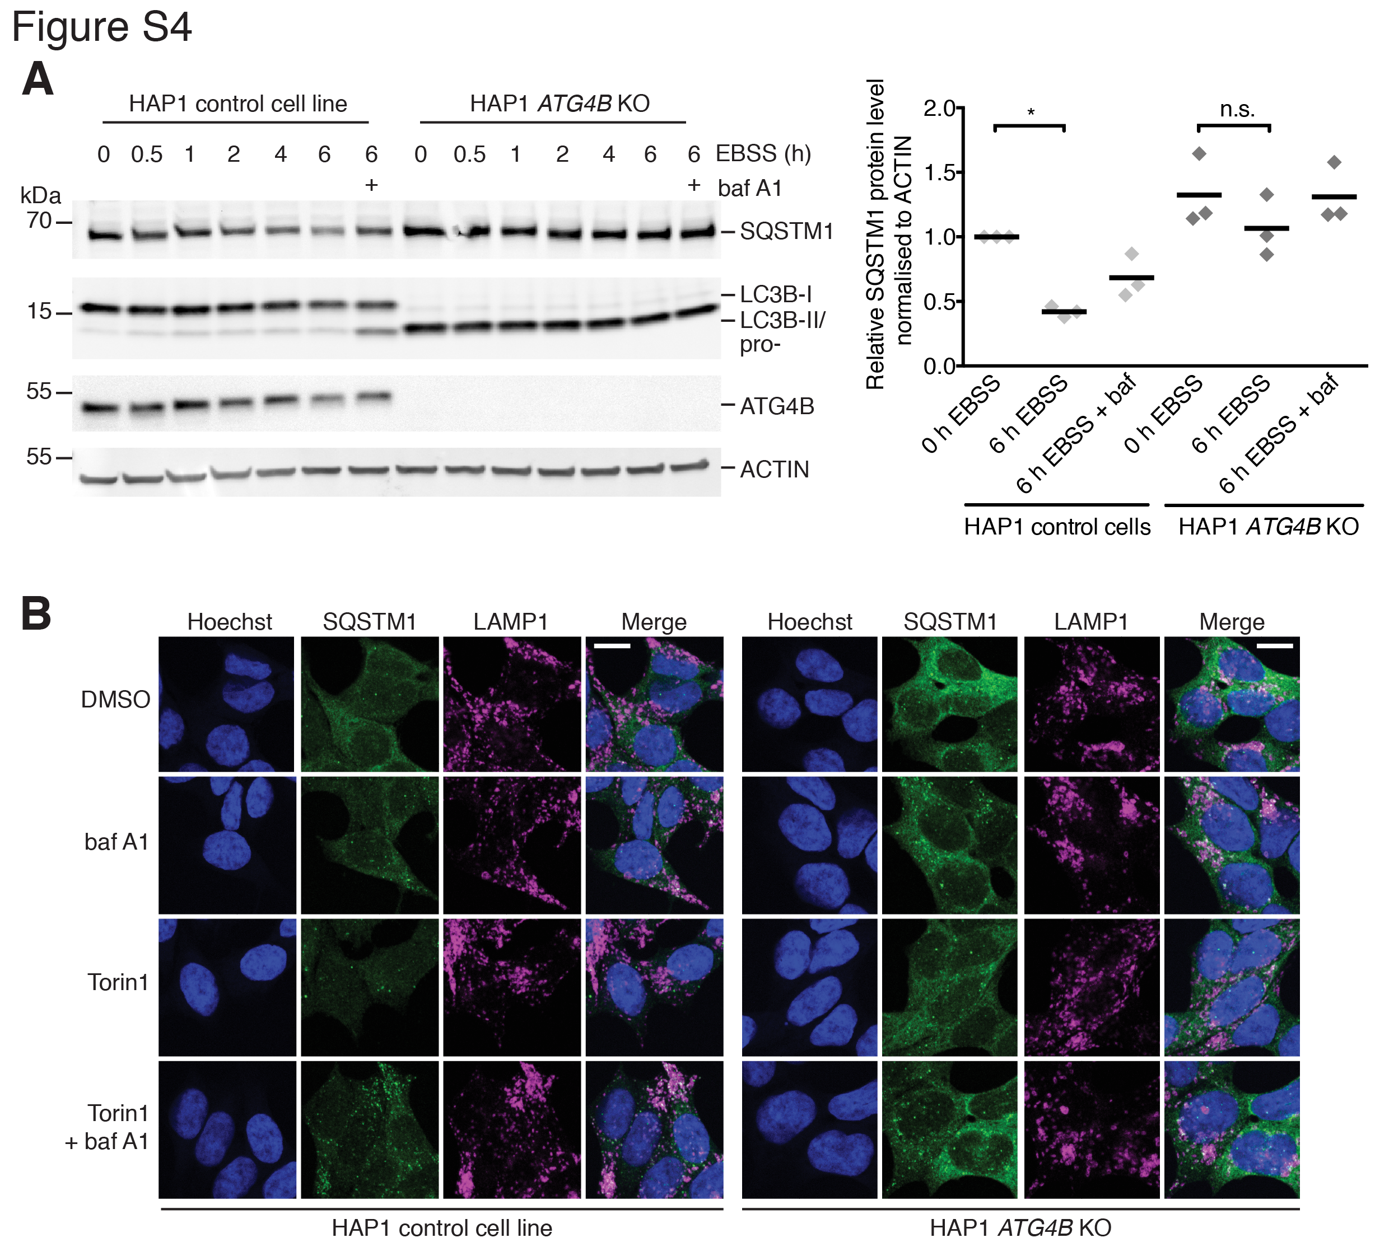

Figure S4. Defect in starvation and Torin1-induced SQSTM1 degradation in HAP1 cells lacking ATG4B. (A) Western blot of lysates (lacking NEM) from HAP1 control and ATG4B KO cells starved for incremental time points by washing twice with PBS and incubating with EBSS (or in the presence of 10 nM baf A1). Representative blots are shown on the left hand side. Protein level of SQSTM1 from 3 independent experiments was quantified by densitometry and plotted (right panel) after normalizing against the ACTIN protein level. Individual data points are shown and mean is displayed as a line. * P ≤ 0.05, n.s. P > 0.05 (Sidak’s multiple comparison test). (B) Immunocytochemistry of endogenous SQSTM1 and LAMP1 in control and ATG4B KO HAP1 cells. Cells were treated for 3 h with DMSO or 250 nM Torin1 + 10 nM baf A1 prior to fixation and staining. Scale bar: 10 µm.

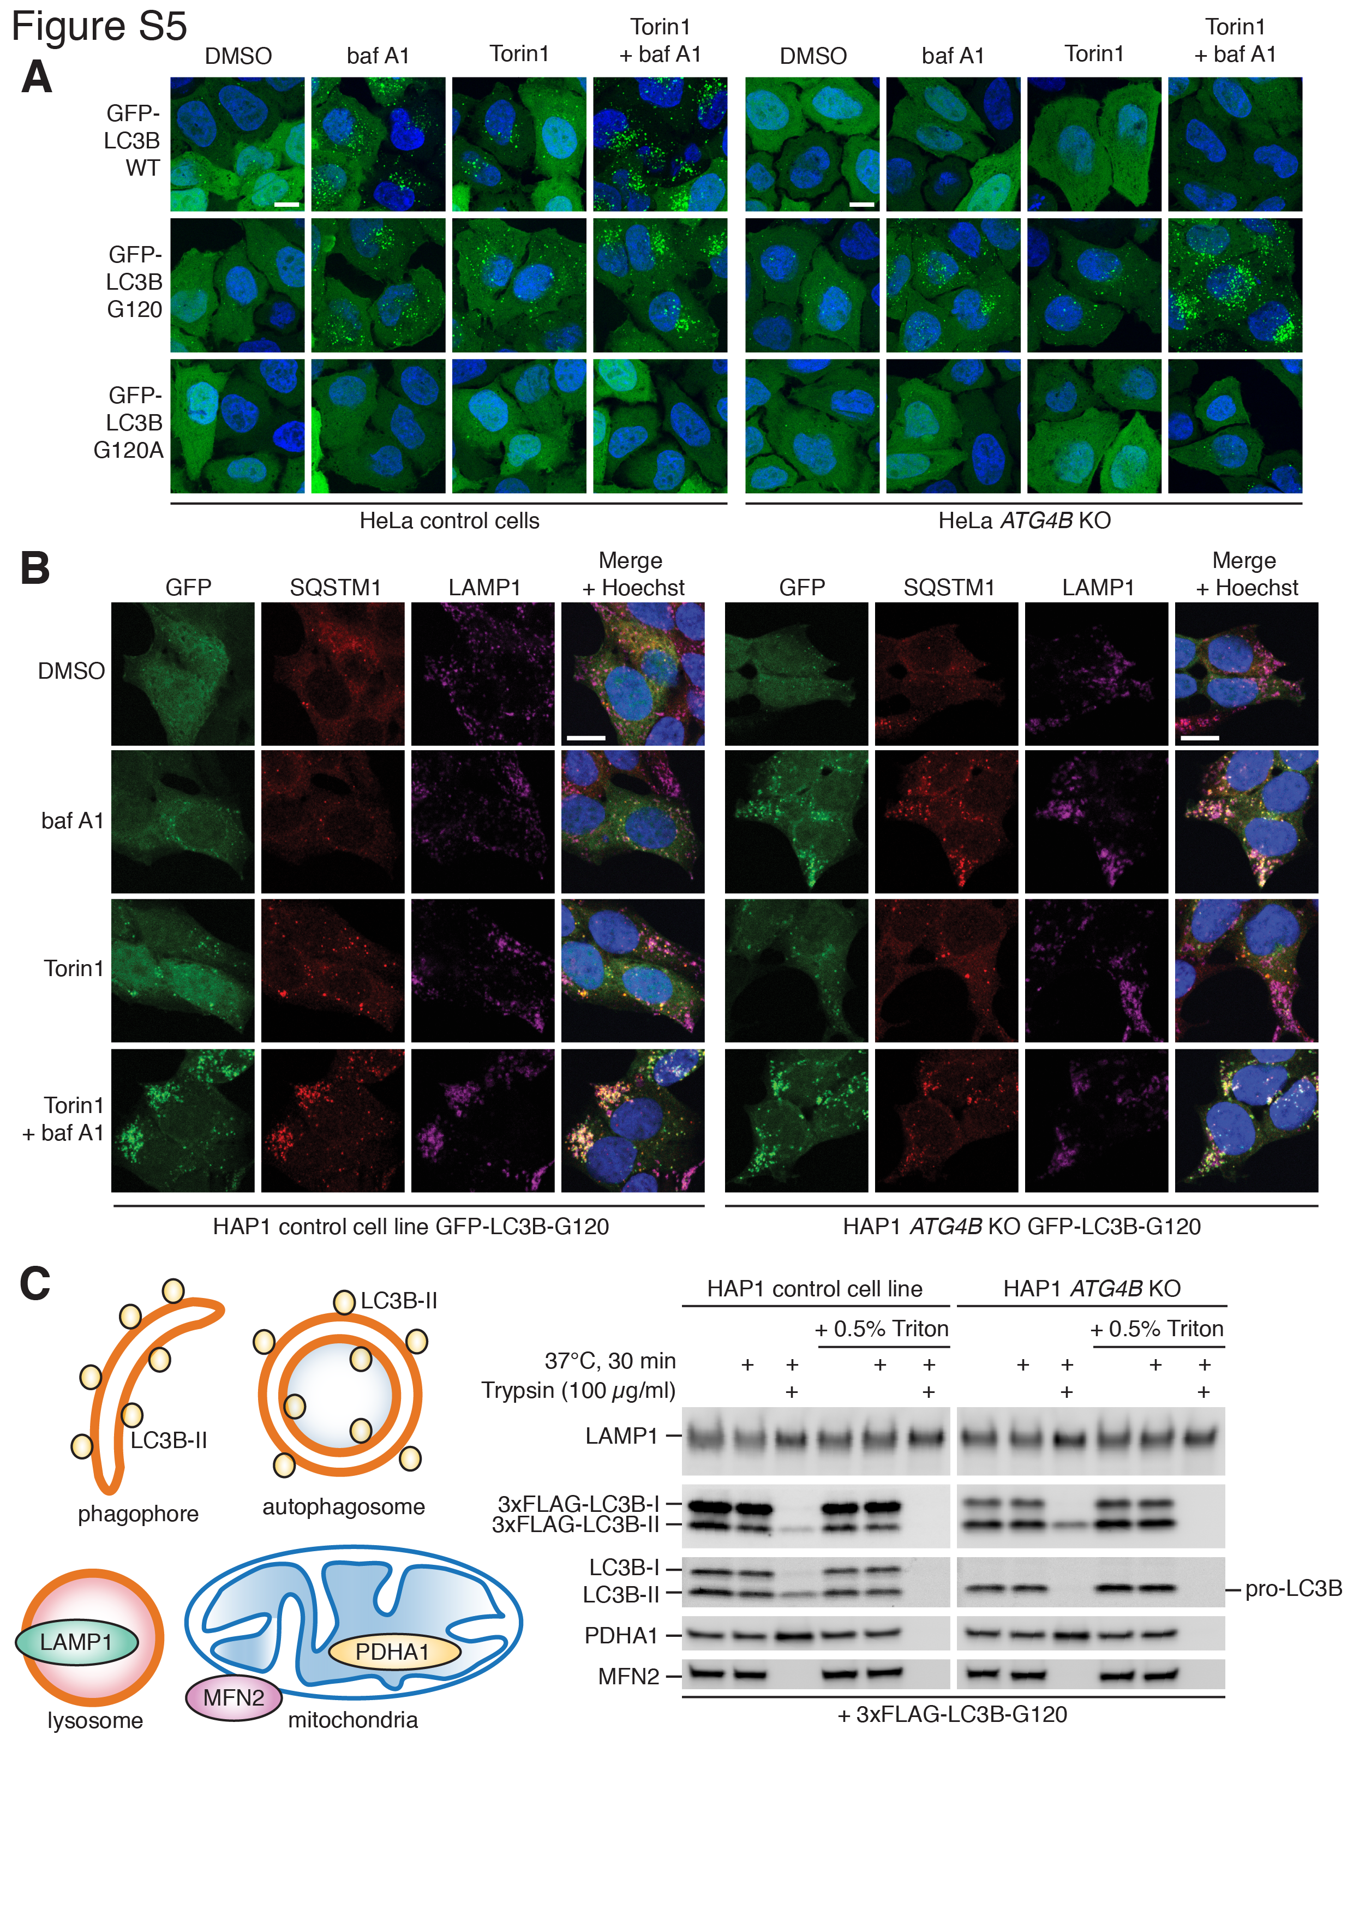

Figure S5. Additional characterization of primed LC3B expression in ATG4B deficient HAP1 and HeLa cells. (A) Confocal microscopy of GFP-tagged LC3B mutants stably expressed in HeLa control and ATG4B KO cells treated for 3 h with combinations of DMSO or 250 nM Torin1 with or without 10 nM baf A1. Scale bar: 10 µm. (B) Immunocytochemistry of endogenous SQSTM1 and LAMP1 in HAP1 control and ATG4B KO cells stably expressing GFP-LC3B-G120. Cells were treated for 3 h with combinations of DMSO or 250 nM Torin1 with or without 10 nM baf A1 for 3 h prior to fixation and staining. Scale bar: 10 µm. (C) Protease protection assay of homogenates from HAP1 control and ATG4B KO cells transfected with a plasmid encoding 3xFLAG-LC3B-G120 and treated for 3 h with 250 nM Torin1 and 10 nM baf A1. Diagrams (right hand side) show subcellular localization of target proteins detected by western blotting (left hand side).

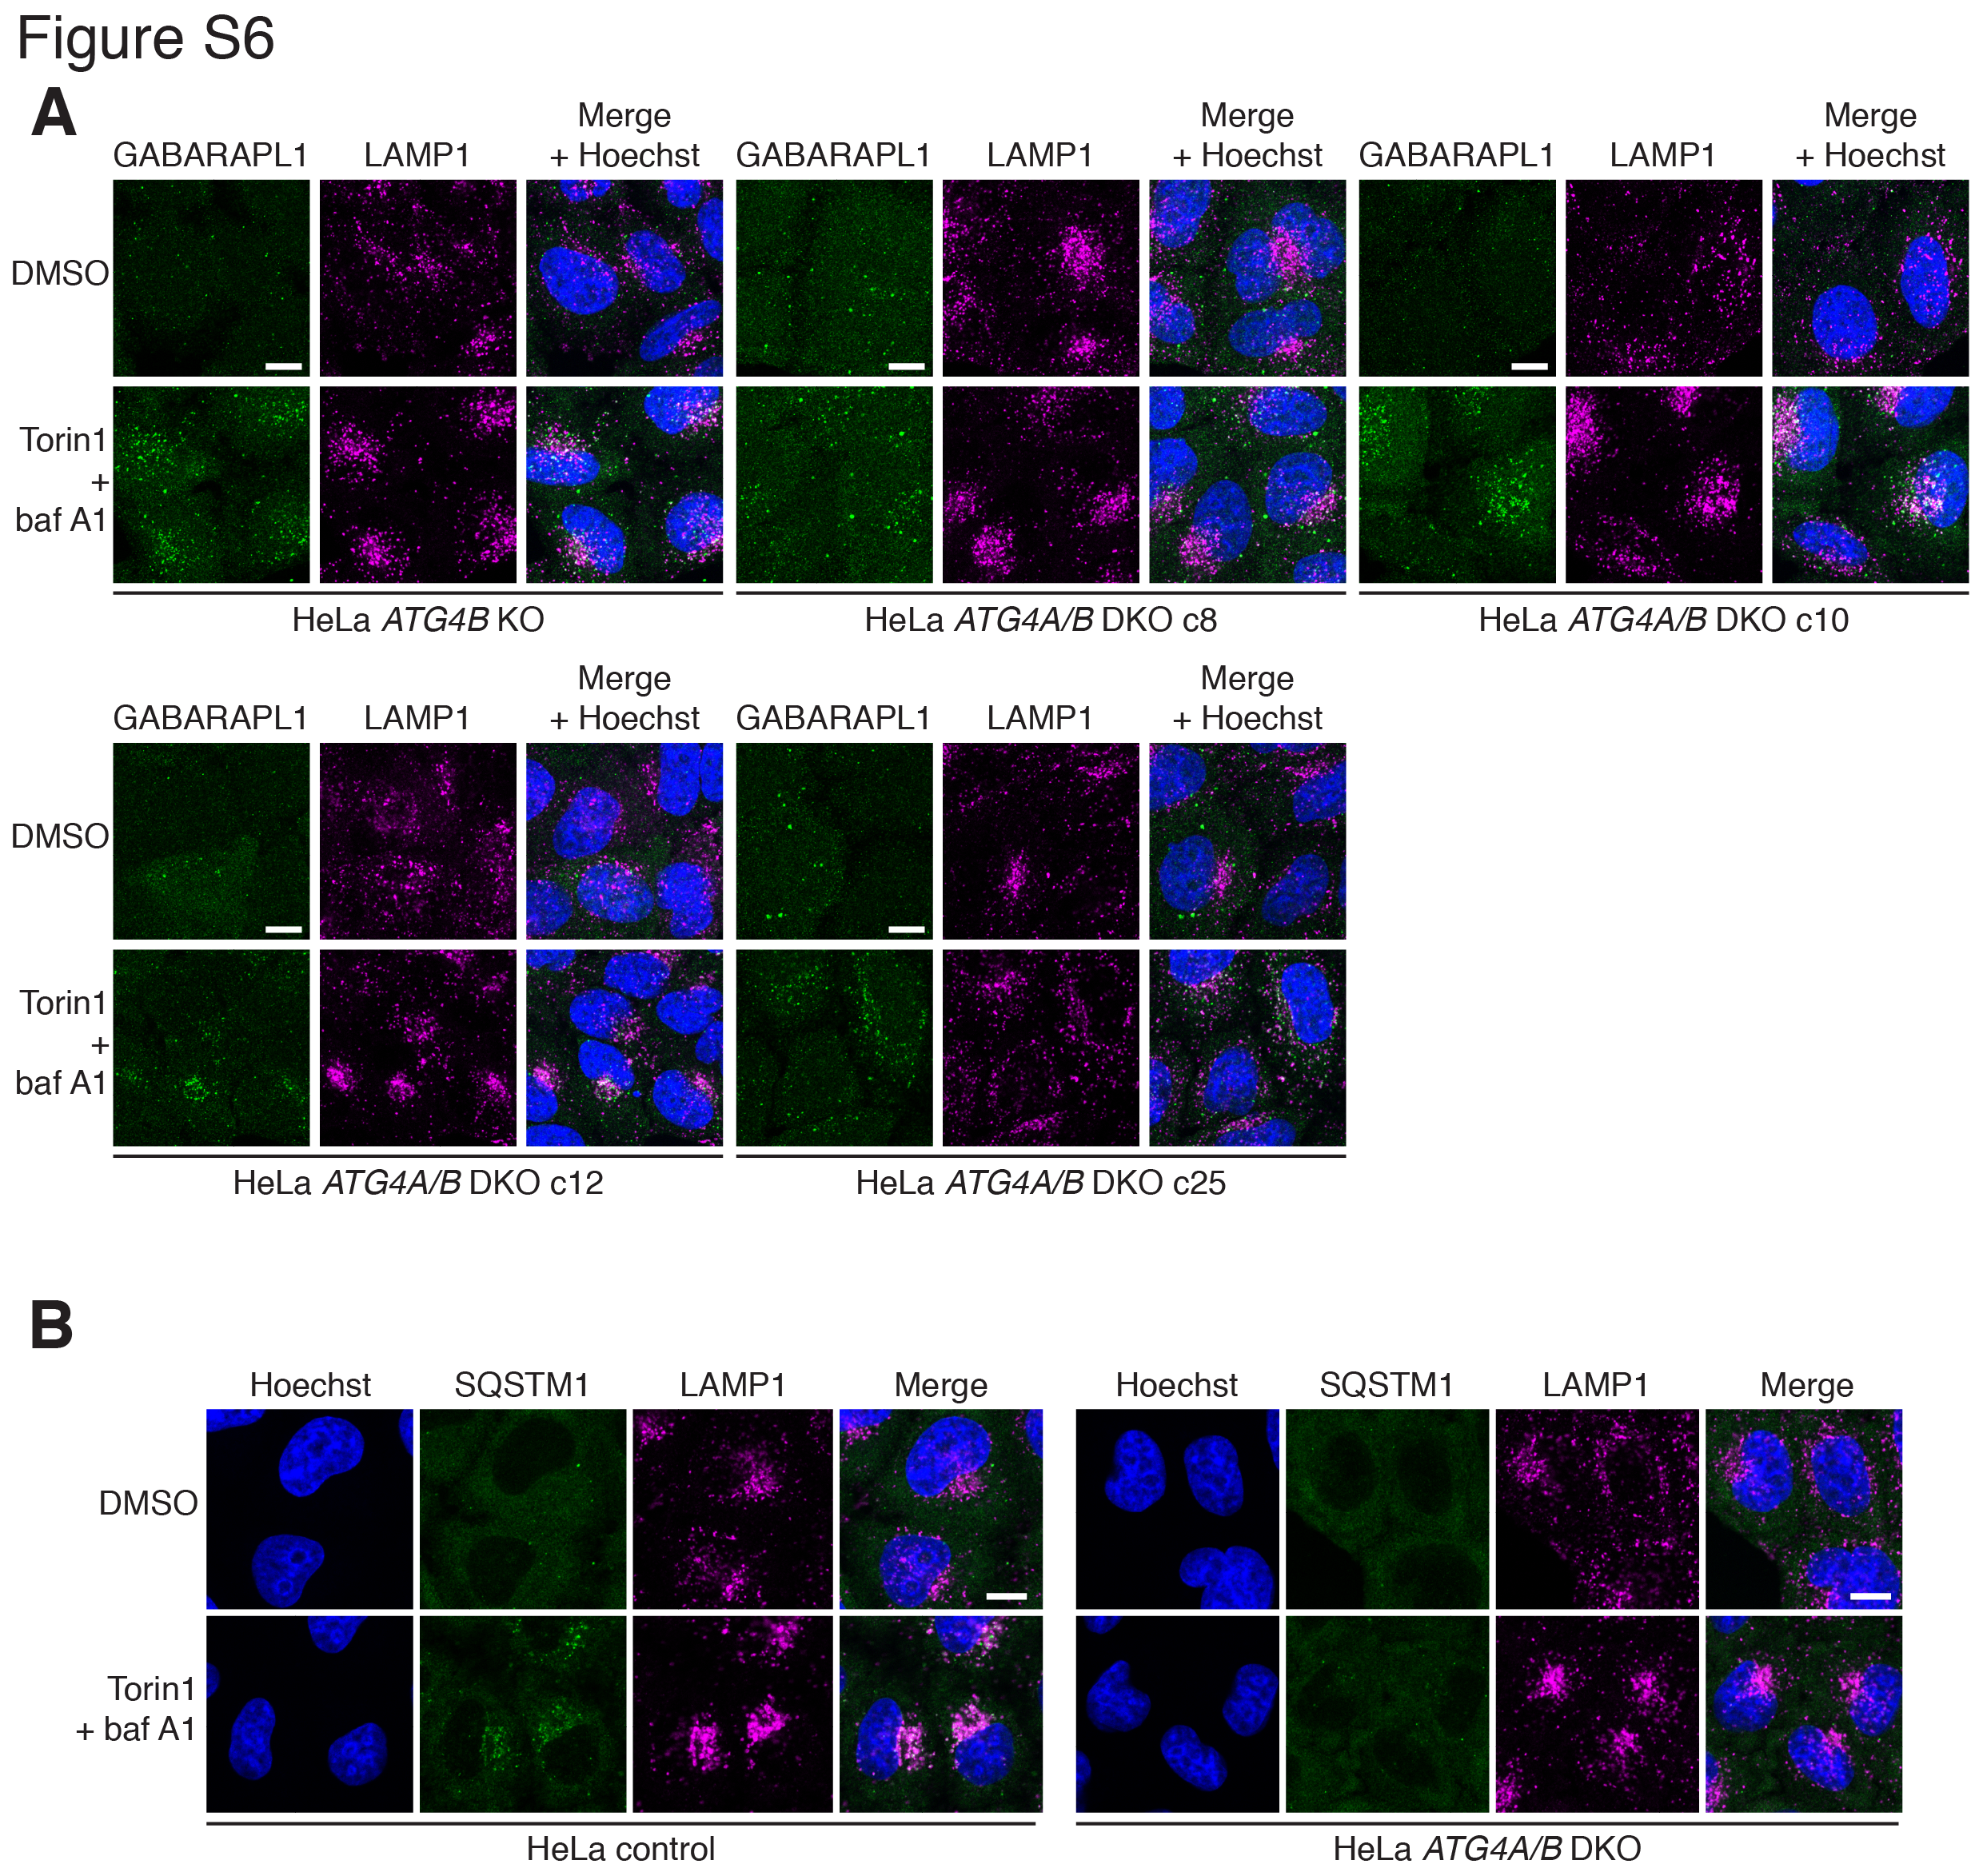

Figure S6. Additional characterization of HeLa ATG4A/B DKO cells. (A) Immunocytochemistry of endogenous GABARAPL1 and LAMP1 in HeLa ATG4B KO and different clones of ATG4A/B DKO cells treated for 3 h with DMSO or 250 nM Torin1 + 10 nM baf A1. Scale bar: 10 µm. (B) Immunocytochemistry of endogenous SQSTM1 and LAMP1 in HeLa control and ATG4A/B DKO (c25) cells treated with DMSO or 250 nM Torin1 + 10 nM baf A1 for 3 h. Scale bar: 10 µm.

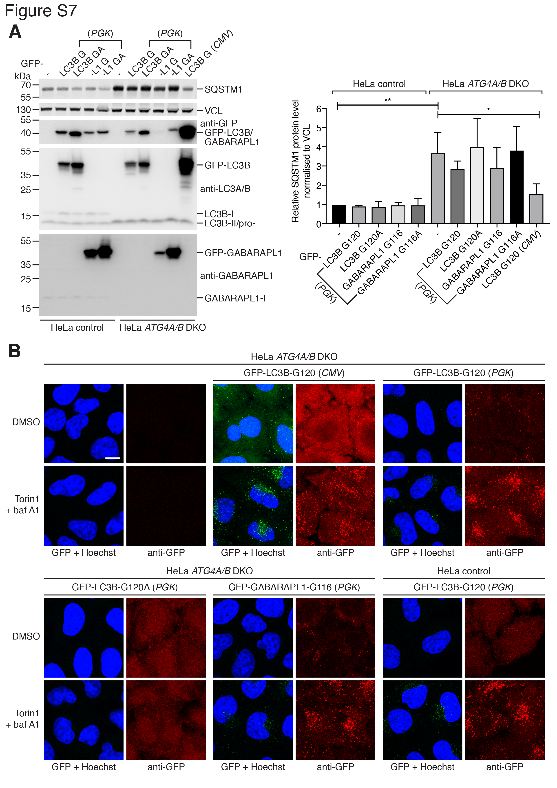

Figure S7. Validation of HeLa cells stably expressing reduced levels of PGK promoter-driven GFP-LC3B or GABARAPL1 bypass mutants. (A) Western blot analysis of HeLa control and ATG4A/B DKO (c25) cells, either untransduced (-) or stably expressing lentiviral-delivered GFP-LC3B-G120/-G120A (G/GA) or GFP-GABARAPL1-G116/-G116A (G/GA) under control of the low expression PGK promoter. As a positive control, ATG4A/B DKO (c25) cells stably expressing CMV-driven GFP-LC3B-G120 (as shown in Figures 7C-E) were assessed in parallel. Densitometry quantification of basal SQSTM1 protein level in each cell line from 3 independent experiments is shown on the right hand side. ** P ≤ 0.01, * P ≤ 0.05, differences between other groups were not significant (P > 0.05, Sidak’s multiple comparison test). (B) Immunocytochemistry of GFP localization in cells shown in Figure S7A treated with DMSO or 250 nM Torin1 + 10 nM baf A1 for 3 h. Native GFP fluorescence (shown in green) was difficult to detect at reduced expression levels. To reveal GFP construct localization, cells were stained using anti-GFP antibody that was detected on a separate channel shown in red. Scale bar: 10 µm.

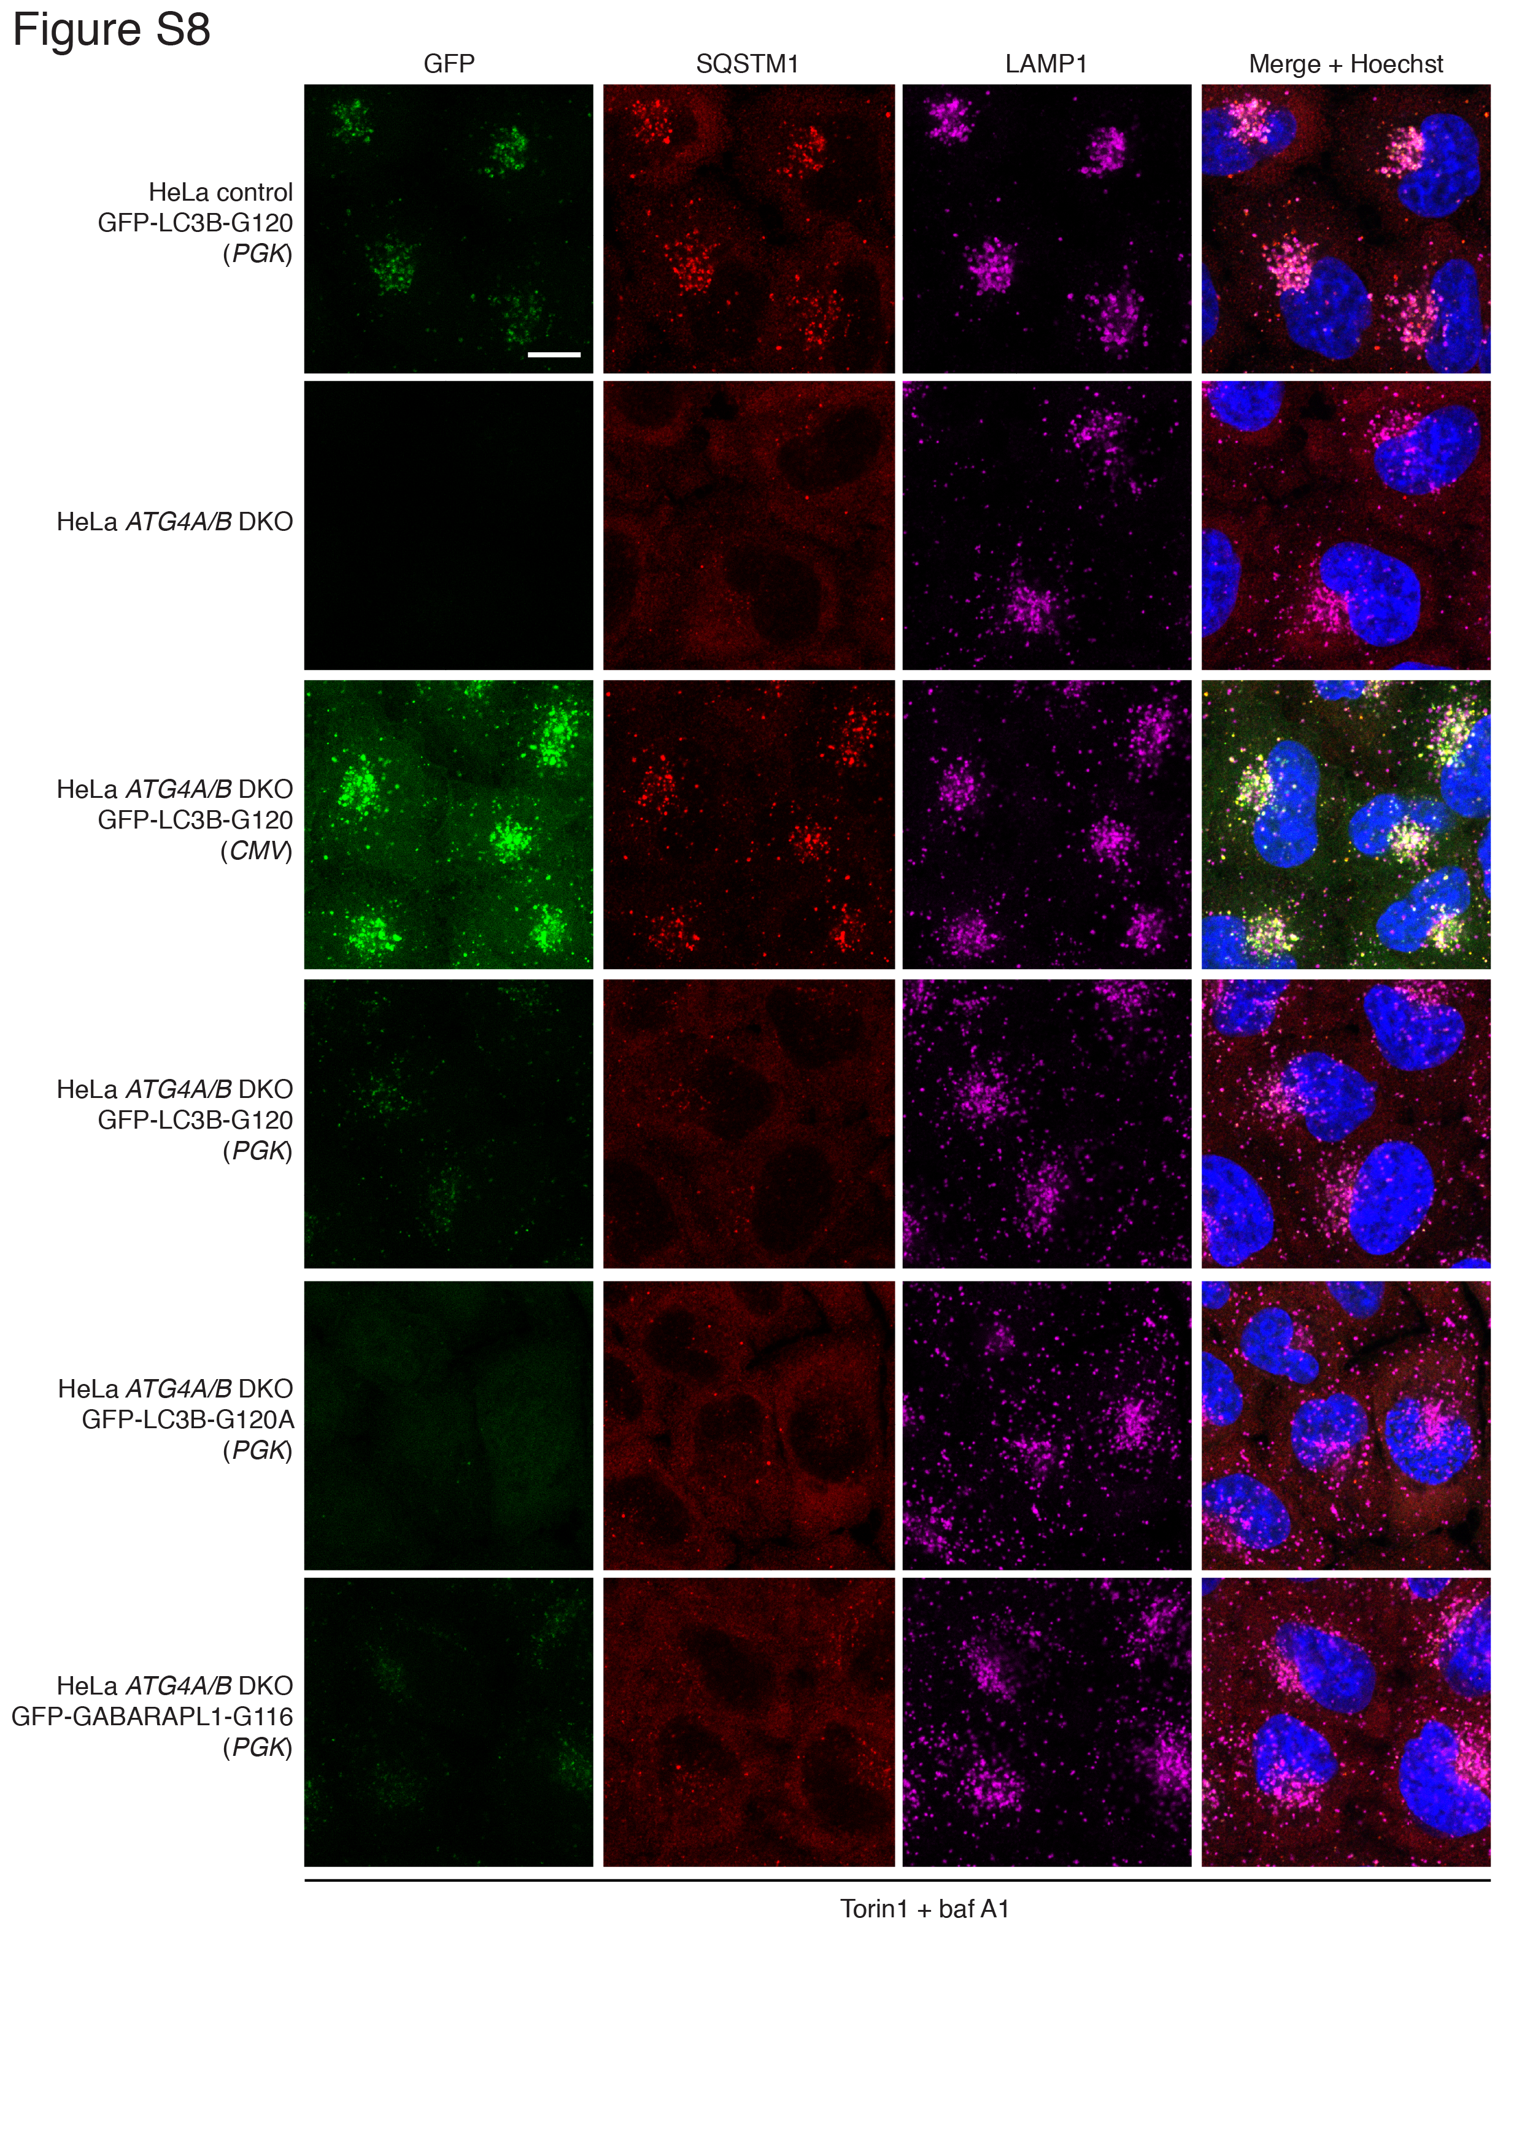
Figure S8. Reduced efficiency of SQSTM1 lysosome delivery in ATG4A/B DKO cells expressing low levels of GFP-tagged LC3B or GABARAPL1 bypass mutants compared to high expression of GFP-LC3B-G120. Immunocytochemistry of endogenous SQSTM1 and LAMP1 in cells shown in Figure S7A treated for 3 h with 250 nM Torin1 + 10 nM baf A1 prior to fixation and staining. Native GFP fluorescence is shown. Scale bar: 10 µm.

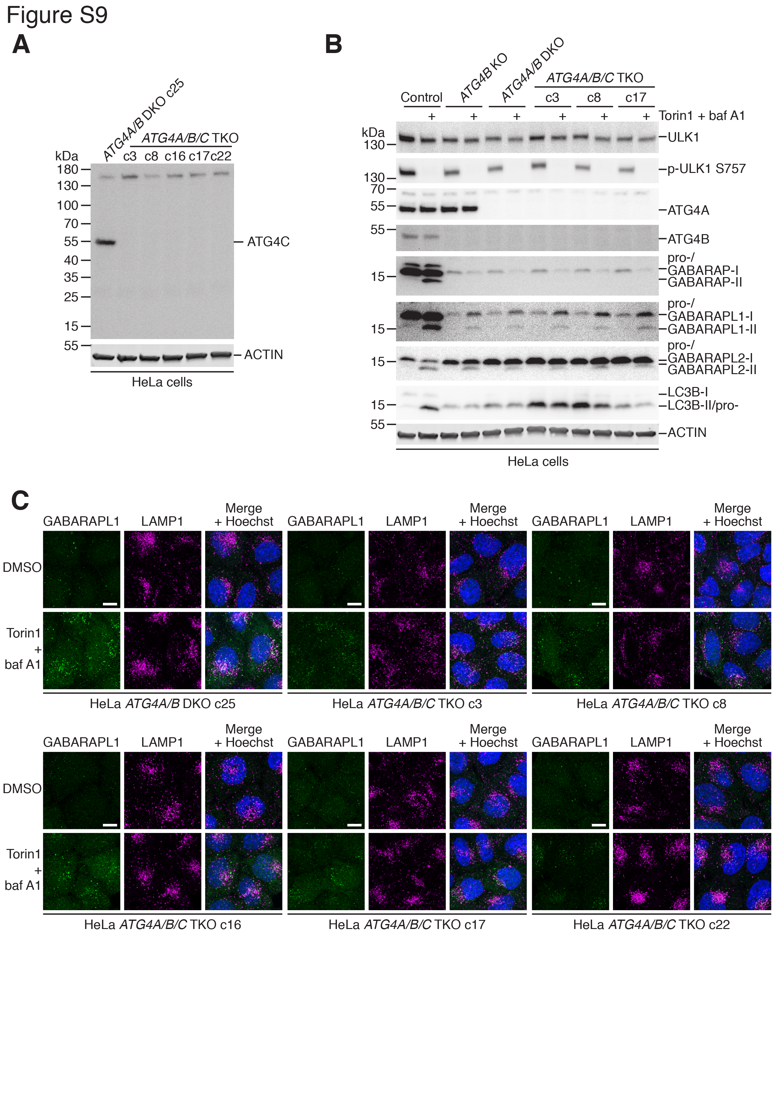

Figure S9. Additional characterization of HeLa ATG4A/B/C TKO cells. (A) Western blot analysis of HeLa ATG4A/B DKO (c25) and different clones of HeLa ATG4A/B/C TKO cells lysed without NEM and probed with anti-ATG4C. (B) Western blot analysis of HeLa control, ATG4B KO, ATG4A/B DKO (c25) cells and different ATG4A/B/C TKO clones treated for 3 h with DMSO or 250 nM Torin1 + 10 nM baf A1. (C) Immunocytochemistry of endogenous GABARAPL1 and LAMP1 in HeLa ATG4A/B DKO cells and different ATG4A/B/C TKO cell clones treated with DMSO or 250 nM Torin1 + 10 nM baf A1 for 3 h. Scale bar: 10 µm.

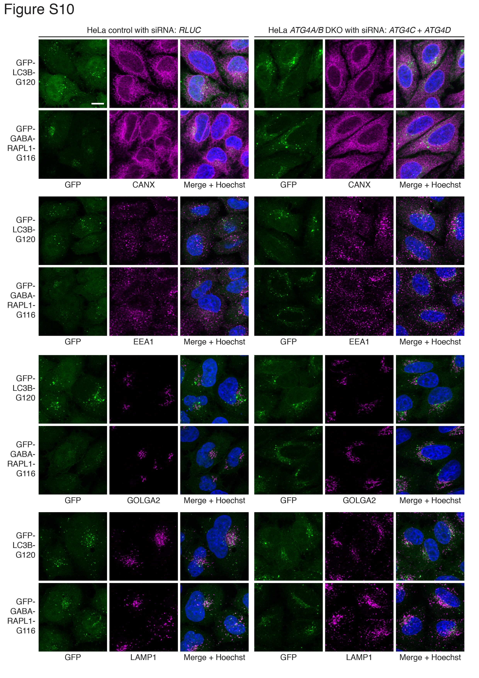

Figure S10. Delipidation by ATG4 isoforms is not necessary to prevent mislocalization of LC3/GABARAP to non-autophagic organelles. HeLa control and ATG4A/B DKO (c25) cells stably expressing GFP-LC3B-G120 or GFP-GABARAPL1-G116 were transfected with siRNA targeting RLUC or ATG4C + ATG4D prior to immunocytochemistry and confocal microscopy to assess GFP localization. Cells were stained with antibodies targeting different organelle markers: CANX (calnexin; endoplasmic reticulum), EEA1 (early endosome antigen 1), GOLGA2 (golgin A2; Golgi) and LAMP1 (lysosomal associated membrane protein 1). Scale bar: 10 µm.

Table S1. Details of genomic loci and oligonucleotides used for CRISPR-Cas9 genome editing in HeLa cells, as well as PCR primers used for genomic validation by Sanger sequencing.
Gene targeted (exon targeted) | Target location (Reference assembly GRCh38) | CRISPR ID/(source) | 19 nucleotide guide sequence | Guide oligo (+) (5' to 3') | Guide oligo (-) (5' to 3') | Forward genomic primer (5' to 3') | Reverse genomic primer (3' to 5')
ATG4A (exon 2) | X:108126133-108126155 | ID: 1195746731 (Sanger CRISPR finder) | ATACCAGCTCATCTGTATC | CACCGATACCAGCTCATCTGTATC | AAACGATACAGATGAGCTGGTATC | GGGGACAAGTTTGTACAAAAAAGCAGGCTACAAAGAAGGCCCCATGGTA | GGGGACCACTTTGTACAAGAAAGCTGGGTTCTAGAATTTGGGGATTCTCCTTT
ATG4B (exon 4) | 2:241653584-241653606 | ID: 949006718  (Sanger CRISPR finder) | CCTAGGTGCCGGCACACCA | CACCGCCTAGGTGCCGGCACACCA | AAACTGGTGTGCCGGCACCTAGGC | GGGGACAAGTTTGTACAAAAAAGCAGGCTTAGTTACTGAGTCCTAAGAGGTGTGTGTTG | GGGGACCACTTTGTACAAGAAAGCTGGGTACATTACTCAAGAAACCCCCAAGTTC
ATG4C (exon 4) | 1:62816613-62816635 | ID: 908305971  (Sanger CRISPR finder) | TAGAGGATCACGTAATTGC | CACCGTAGAGGATCACGTAATTGC | AAACGCAATTACGTGATCCTCTAC | GGGGACAAGTTTGTACAAAAAAGCAGGCTAGGCAGTCAGGAAAATCTAACT | GGGGACCACTTTGTACAAGAAAGCTGGGTCTCAGGGAATTTCATGCAGTTTGT
Non-targeting | N/A | rg_0311  (GeCKO library v2) (Sanjana et al., 2014) | GGCCCGCATAGGATATCGC | CACCGGGCCCGCATAGGATATCGC | AAACGCGATATCCTATGCGGGCCC | N/A | N/A

Table S2. Sequences of primers and DNA templates used to generate Gateway entry clones for LC3/GABARAP coding sequences.
Gene/entry clone | RefSeq of PCR template | Forward primer sequence  (5' to 3') | Reverse primer sequence  (5' to 3')
MAP1LC3A | NM_032514.3 | GGGGACAAGTTTGTACAAAAAAGCAGGCTTAATGCCCTCAGACCGGCCTTTC | GGGGACCACTTTGTACAAGAAAGCTGGGTATTAGAAGCCGAAGGTTTCCTGGGAG
MAP1LC3A (no stop codon) | NM_032514.3 | GGGGACAAGTTTGTACAAAAAAGCAGGCTTAATGCCCTCAGACCGGCCTTTC | GGGGACCACTTTGTACAAGAAAGCTGGGTAGAAGCCGAAGGTTTCCTGG
MAP1LC3A (G120A) | NM_032514.3 | GGGGACAAGTTTGTACAAAAAAGCAGGCTTAATGCCCTCAGACCGGCCTTTC | GGGGACCACTTTGTACAAGAAAGCTGGGTATTAGAAGGCGAAGGTTTCCTGGGAG
MAP1LC3A (G120) | NM_032514.3 | GGGGACAAGTTTGTACAAAAAAGCAGGCTTAATGCCCTCAGACCGGCCTTTC | GGGGACCACTTTGTACAAGAAAGCTGGGTATTAGCCGAAGGTTTCCTGGGAGG
MAP1LC3B | NM_022818.4 | GGGGACAAGTTTGTACAAAAAAGCAGGCTTAATGCCGTCGGAGAAGACC | GGGGACCACTTTGTACAAGAAAGCTGGGTATTACACTGACAATTTCATCCCGAAC
MAP1LC3B (no stop codon) | NM_022818.4 | GGGGACAAGTTTGTACAAAAAAGCAGGCTTAATGCCGTCGGAGAAGACC | GGGGACCACTTTGTACAAGAAAGCTGGGTACACTGACAATTTCATCCCG
MAP1LC3B (G120A) | NM_022818.4 | GGGGACAAGTTTGTACAAAAAAGCAGGCTTAATGCCGTCGGAGAAGACC | GGGGACCACTTTGTACAAGAAAGCTGGGTATTACACTGACAATTTCATCGCGAACGTC
MAP1LC3B (G120A; no stop codon) | NM_022818.4 | GGGGACAAGTTTGTACAAAAAAGCAGGCTTAATGCCGTCGGAGAAGACC | GGGGACCACTTTGTACAAGAAAGCTGGGTACACTGACAATTTCATCGCG
MAP1LC3B (G120) | NM_022818.4 | GGGGACAAGTTTGTACAAAAAAGCAGGCTTAATGCCGTCGGAGAAGACC | GGGGACCACTTTGTACAAGAAAGCTGGGTATTACCCGAACGTCTCCTGGG
MAP1LC3B2 (no stop codon) | NM_001085481.1 | GGGGACAAGTTTGTACAAAAAAGCAGGCTTAATGCCGTCGGAGAAGACC | GGGGACCACTTTGTACAAGAAAGCTGGGTACACTGACAATTTCATCCCG
MAP1LC3C | NM_001004343.2 | GGGGACAAGTTTGTACAAAAAAGCAGGCTTAATGCCGCCTCCACAGAAAATCCC | GGGGACCACTTTGTACAAGAAAGCTGGGTATTAGAGAGGATTGCAGGGTCTGTCC
MAP1LC3C (no stop codon) | NM_001004343.2 | GGGGACAAGTTTGTACAAAAAAGCAGGCTTAATGCCGCCTCCACAGAAAATCCC | GGGGACCACTTTGTACAAGAAAGCTGGGTAGAGAGGATTGCAGGGTCTG
MAP1LC3C (G126) | NM_001004343.2 | GGGGACAAGTTTGTACAAAAAAGCAGGCTTAATGCCGCCTCCACAGAAAATCCC | GGGGACCACTTTGTACAAGAAAGCTGGGTATTAGCCAAATGTCTCCTGGGAGGC
GABARAP | NM_007278.1 | GGGGACAAGTTTGTACAAAAAAGCAGGCTTAATGAAGTTCGTGTACAAAGAAGAG | GGGGACCACTTTGTACAAGAAAGCTGGGTATTACAGACCGTAGACACTTTCGTC
GABARAP (no stop codon) | NM_007278.1 | GGGGACAAGTTTGTACAAAAAAGCAGGCTTAATGAAGTTCGTGTACAAAGAAGAG | GGGGACCACTTTGTACAAGAAAGCTGGGTACAGACCGTAGACACTTTCG
GABARAP (G116A) | NM_007278.1 | GGGGACAAGTTTGTACAAAAAAGCAGGCTTAATGAAGTTCGTGTACAAAGAAGAG | GGGGACCACTTTGTACAAGAAAGCTGGGTATTACAGAGCGTAGACACTTTCGTC
GABARAP (G116) | NM_007278.1 | GGGGACAAGTTTGTACAAAAAAGCAGGCTTAATGAAGTTCGTGTACAAAGAAGAG | GGGGACCACTTTGTACAAGAAAGCTGGGTATTAACCGTAGACACTTTCGTCAC
GABARAPL1 | NM_031412.2 | GGGGACAAGTTTGTACAAAAAAGCAGGCTTAATGAAGTTCCAGTACAAGGAGG | GGGGACCACTTTGTACAAGAAAGCTGGGTATTATTTCCCATAGACACTCTCATCAC
GABARAPL1 (no stop codon) | NM_031412.2 | GGGGACAAGTTTGTACAAAAAAGCAGGCTTAATGAAGTTCCAGTACAAGGAGG | GGGGACCACTTTGTACAAGAAAGCTGGGTATTTCCCATAGACACTCTCATC
GABARAPL1 (G116A) | NM_031412.2 | GGGGACAAGTTTGTACAAAAAAGCAGGCTTAATGAAGTTCCAGTACAAGGAGG | GGGGACCACTTTGTACAAGAAAGCTGGGTATTATTTCGCATAGACACTCTCATCAC
GABARAPL1 (G116) | NM_031412.2 | GGGGACAAGTTTGTACAAAAAAGCAGGCTTAATGAAGTTCCAGTACAAGGAGG | GGGGACCACTTTGTACAAGAAAGCTGGGTATTACCCATAGACACTCTCATCACTG
GABARAPL2 | NM_007285.6 | GGGGACAAGTTTGTACAAAAAAGCAGGCTTAATGAAGTGGATGTTCAAGGAGG | GGGGACCACTTTGTACAAGAAAGCTGGGTATTAGAAGCCAAAAGTGTTCTCTCC
GABARAPL2 (no stop codon) | NM_007285.6 | GGGGACAAGTTTGTACAAAAAAGCAGGCTTAATGAAGTGGATGTTCAAGGAGG | GGGGACCACTTTGTACAAGAAAGCTGGGTAGAAGCCAAAAGTGTTCTCTC
GABARAPL2 G116A | NM_007285.6 | GGGGACAAGTTTGTACAAAAAAGCAGGCTTAATGAAGTGGATGTTCAAGGAGG | GGGGACCACTTTGTACAAGAAAGCTGGGTATTAGAAGGCAAAAGTGTTCTCTCC
GABARAPL2 (G116) | NM_007285.6 | GGGGACAAGTTTGTACAAAAAAGCAGGCTTAATGAAGTGGATGTTCAAGGAGG | GGGGACCACTTTGTACAAGAAAGCTGGGTATTAGCCAAAAGTGTTCTCTCCGC

Table S3. Mutations detected by Sanger sequencing of PCR-amplified genomic DNA in main CRISPR KO HeLa clones used in this study.
Cell name | Main clone | Parental cell | Gene targeted using CRISPR | Mutations detected in targeted gene (no. of Sanger sequence reads detected/total)
HeLa ATG4B KO | N/A | HeLa | ATG4B | NM_013325.4:c.262_264del (13/19)  NM_013325.4:c.263_264insCT (6/19)
HeLa ATG4A/B DKO | c25 | HeLa ATG4B KO | ATG4A | NM_052936.4:c.73_83del (5/5)
HeLa ATG4A/B/C TKO | c22 | HeLa ATG4A/B DKO c25 | ATG4C | NM_032852.3:c.216delT;223A>C (1/4)  NM_032852.3:c.181_247del (1/4)  NM_032852.3:c.216_217insT (1/4)  NM_032852.3:c.213_215del (1/4)

