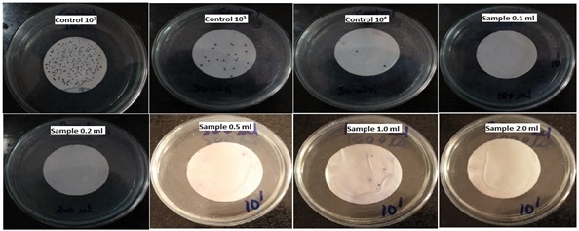
Figure S1:.Effect of coagulant on E.coli removal

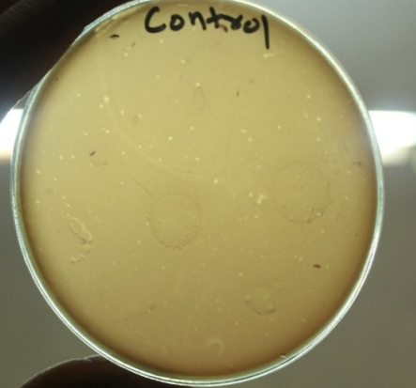
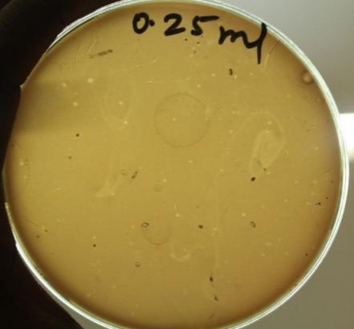
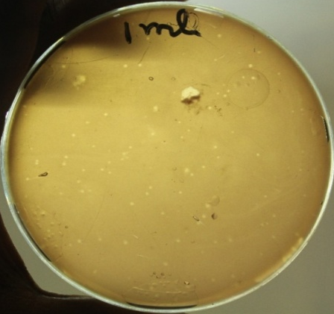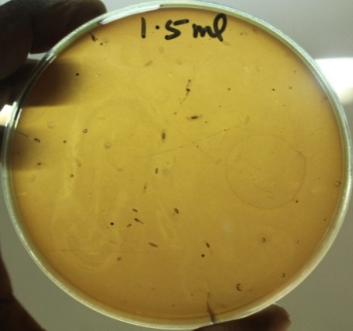
Figure S2:Effect of coagulant on coliphage removal

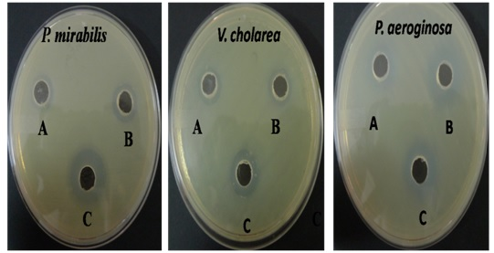
A-0.1% Aqueous Extract ; B-1%Aqueous Extract;
C-Positive Control Amphicloxacillin
Figure S3 : Antibacterial activity of the aqueous extract of Strychnos potatorum

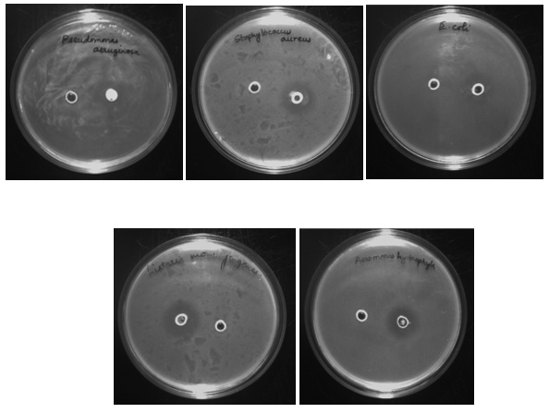
Figure S4:Antibacterial activity of Methyl Palmitoleate

