**Effect of Stirring Speed on the Average Particle Diameter of P(St-MMA-AA)**

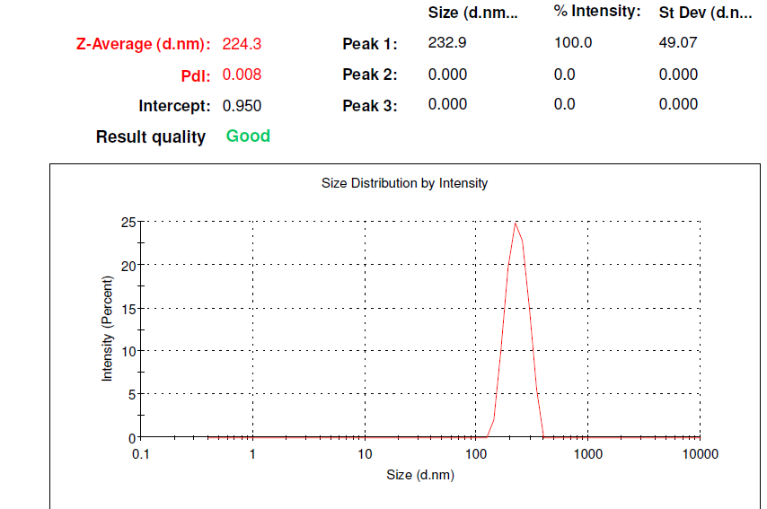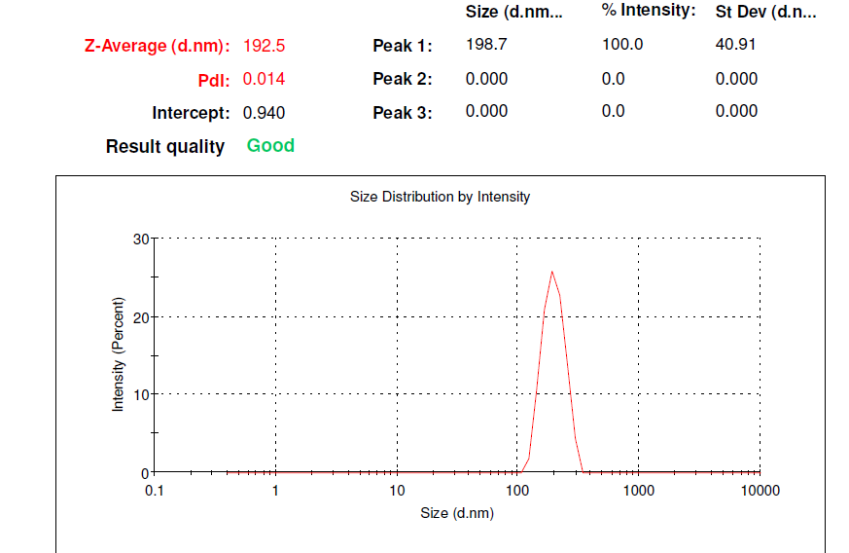

**(b)**

**(a)**

**SI Figure 1:** Size Distribution Report by Intensity of (a) P(St-MM-AA)1(b) P(St-MM-AA)2

**Effect of surfactant concentration on the Average Particle Diameter of P(St-MMA-AA)**

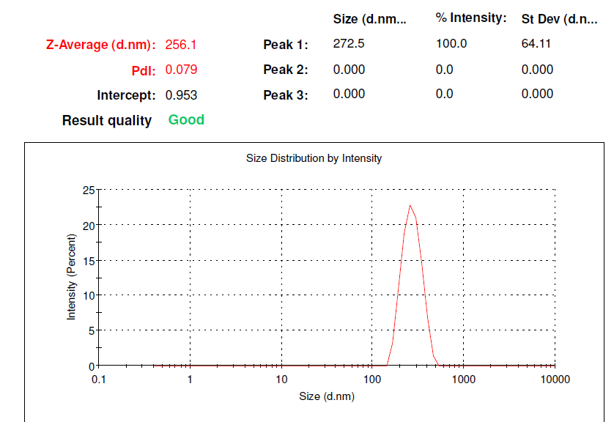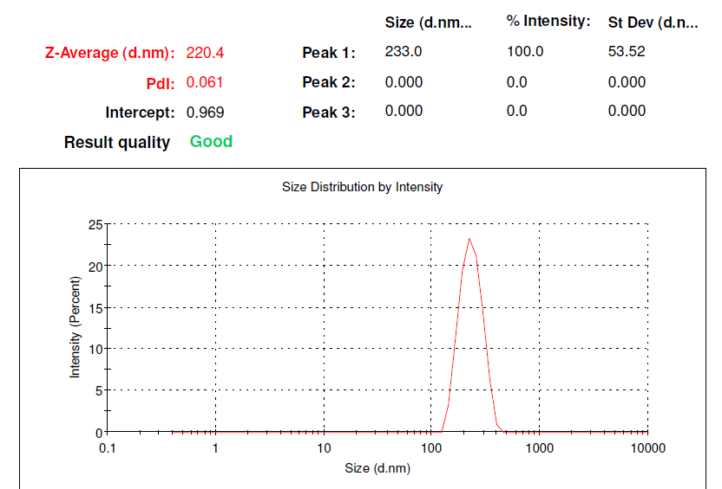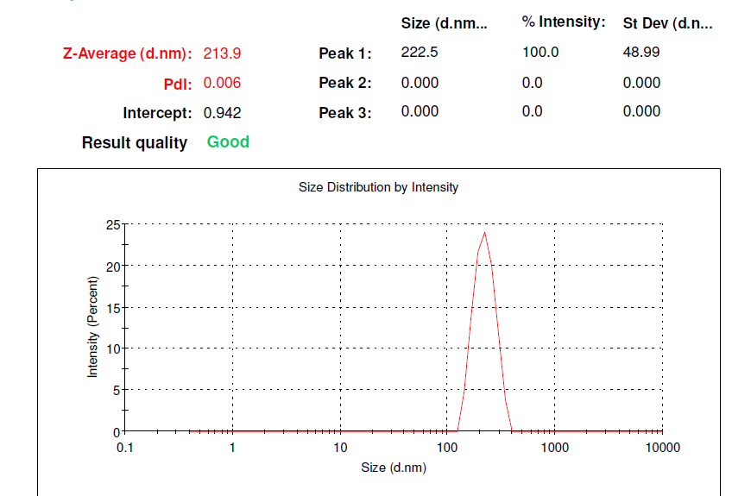

**(a)**

**(c)**

**(b)**

**SI Figure 2:** Size Distribution Report by Intensity of (a) P(St-MM-AA)3 (b) P(St-MM-AA)4 (c) P(St-MM-AA)5

**Effect of Monomer Concentration on the Average Particle Diameter of P(St-MMA-AA)**

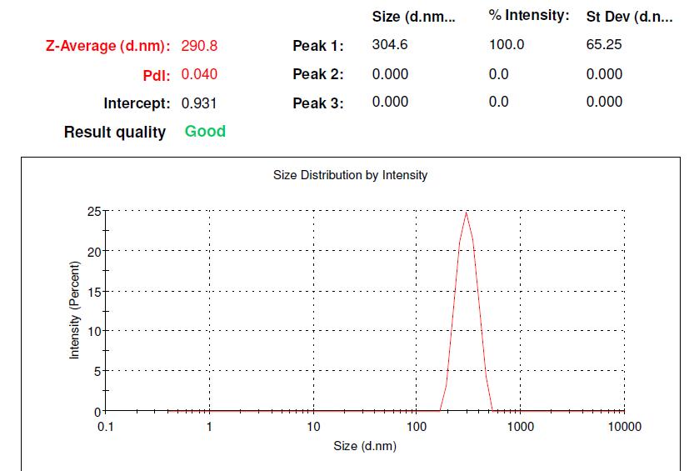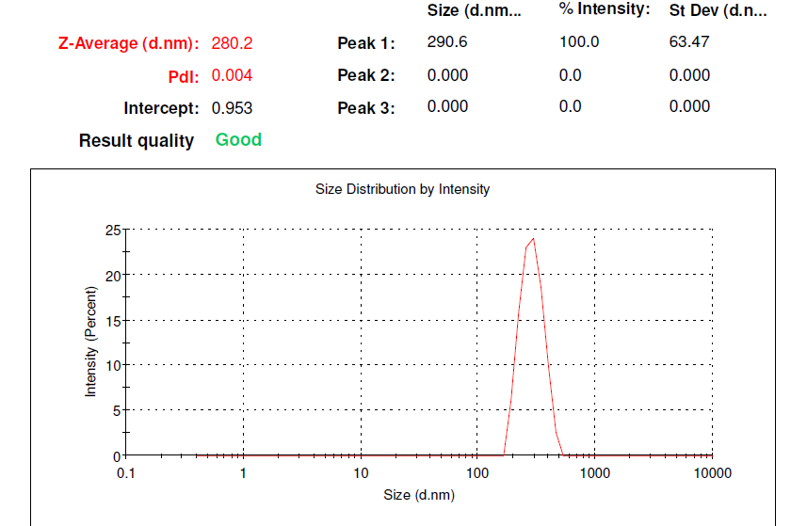

**(a)**

**(b)**

**(c)**

**SI Figure 3**: Size Distribution Report by Intensity of (a) P(St-MM-AA)6(b) P(St-MM-AA)7(c) P(St-MM-AA)8

Effect of Temperature on the Average Particle Diameter of P(St-MMA-AA)

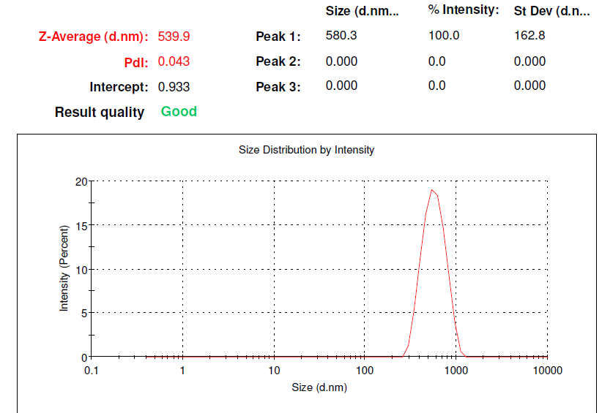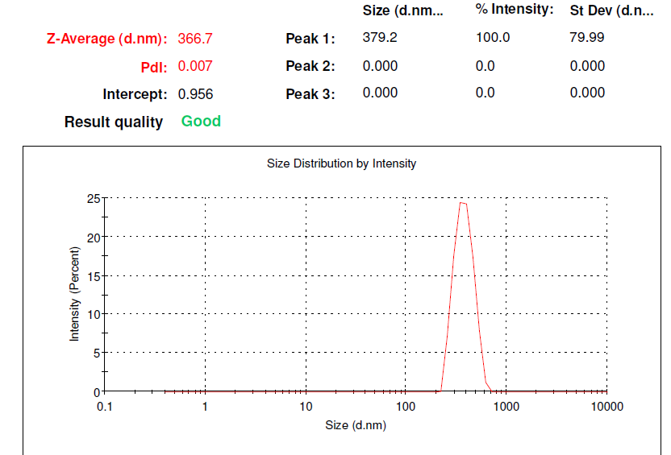

**(a)**

**(b)**

**SI Figure 4:** Size Distribution Report by Intensity of (a) P(St-MM-AA)9(b) P(St-MM-AA)10

**Effect of Initiation Concentration on the average particle diameter of P(St-MMA-AA)**

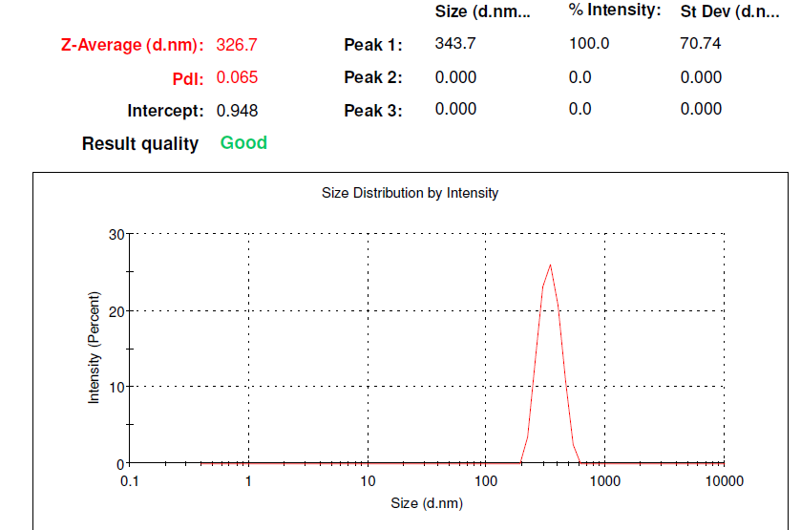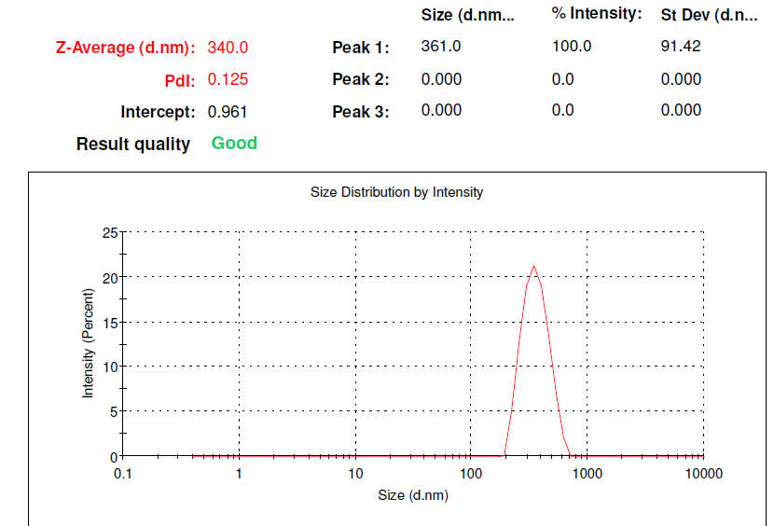

**(a)**

**(b)**

**SI Figure 5**: Size Distribution Report by Intensity of (a) P(St-MM-AA)11(b) P(St- MM-AA)12



**SI Figure 6**: Photograph of the assembled **P(St-MMA-AA)**film