**Supporting Information**

**Steroids from the seeds of *Datura metel***

Bing-You Yang, Hai-Bing Jiang, Yan Liu, Jing Chen*, Hai-Xue Kuang*

Key Laboratory of Chinese Materia Medica, Heilongjiang University of Chinese Medicine, Ministry of Education, Harbin 150040, People’s Republic of China

Corresponding Author

*Tel:+86 451 87267188; E-mail: [hxkuang@yahoo.com](mailto:hxkuang@yahoo.com)

*Tel: +86 451 82193627; E-mail: chenjing6385@163.com

Caption:

**Fig.S1.** 1H-NMR Spectrum of Compound **1**

**Fig.S2.** 13C-NMR Spectrum of Compound **1**

**Fig.S3.** HR-ESI-MS Spectrum of Compound **1**

**Fig.S4.** HSQC Spectrum of Compound **1**

**Fig.S5.** 1H-1H COSY Spectrum of Compound **1**

**Fig.S6.** HMBC Spectrum of Compound **1**

**Fig.S7.** NOESY Spectrum of Compound **1**

**Fig.S8.** IR Spectrum of Compound **2**

**Fig.S9.** 1H-NMR Spectrum of Compound **2**

**Fig.S10.** 13C-NMR Spectrum of Compound **2**

**Fig.S11.** HR-ESI-MS Spectrum of Compound **2**

**Fig.S12.** HSQC Spectrum of Compound **2**

**Fig.S13.** 1H-1H COSY Spectrum of Compound **2**

**Fig.S14.** HMBC Spectrum of Compound **2**

**Fig.S15.** NOESY Spectrum of Compound **2**

**Fig.S16.** IR Spectrum of Compound **2**

**Tab.S1.** The13C-NMR data of Compounds **3**-**8**

**Tab.S2.** Inhibitory on NO production in LPS-induced RAW 264.7 cells of compounds **1**-**8**

**Fig.S1.** 1H-NMR Spectrum of Compound **1**

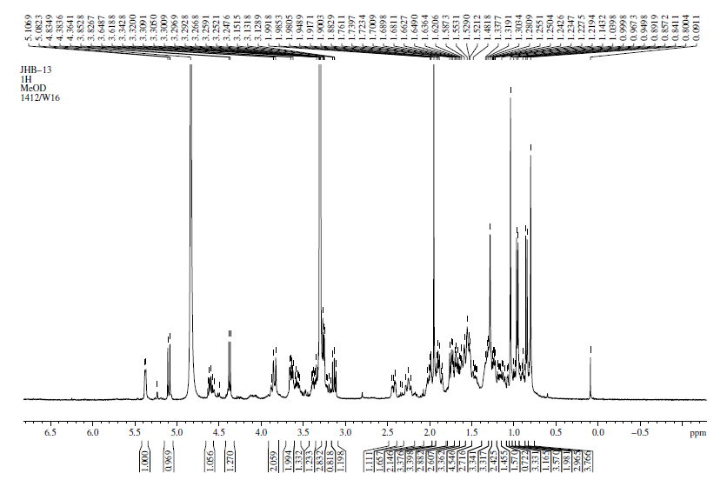

**Fig.S2.** 13C-NMR Spectrum of Compound **1**

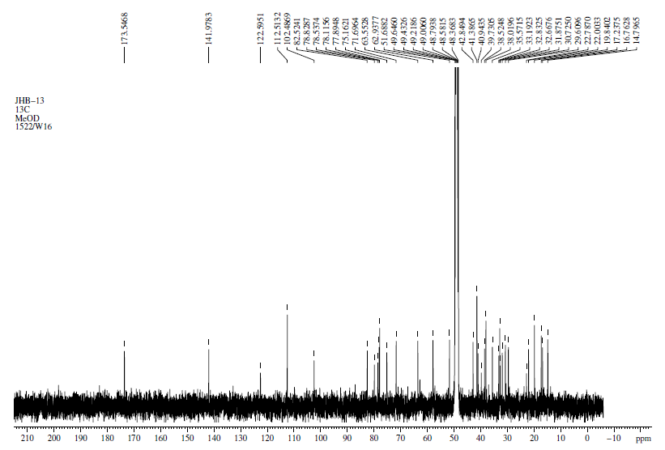

**Fig.S3.** HR-ESI-MS Spectrum of Compound **1**



**Fig.S4**. HSQC Spectrum of Compound **1**

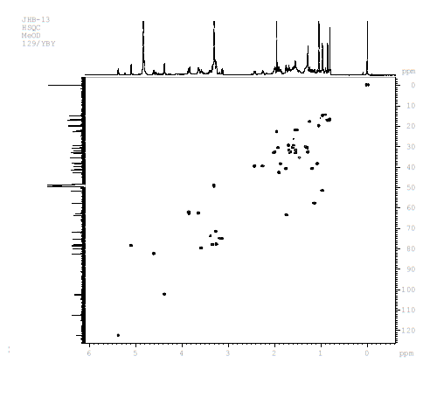

**Fig.S5**. 1H-1H COSY Spectrum of Compound **1**

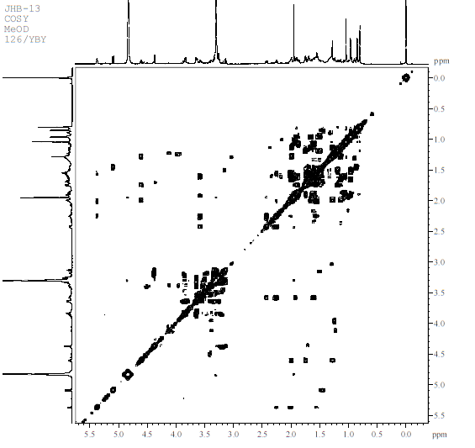

**Fig.S6**. HMBC Spectrum of Compound **1**

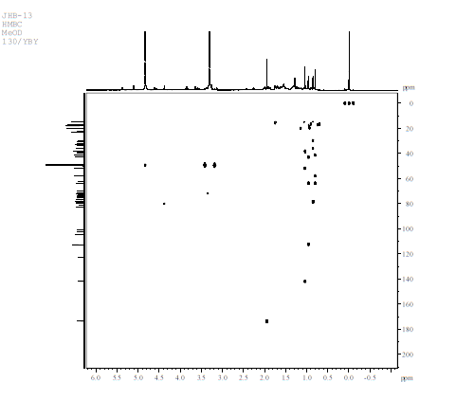

**Fig.S7**.NOESY Spectrum of Compound **1**

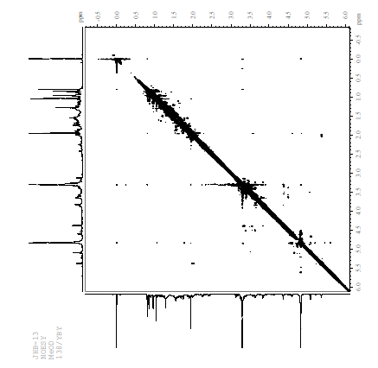

**Fig.S8**.IR Spectrum of Compound **1**

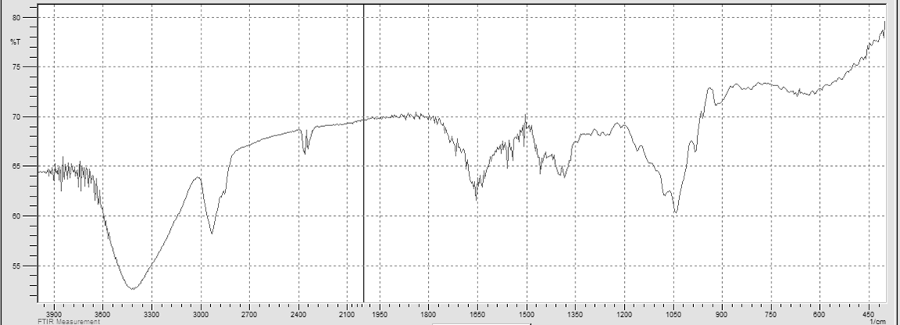

**Fig.S9.** 1H-NMR Spectrum of Compound **2**

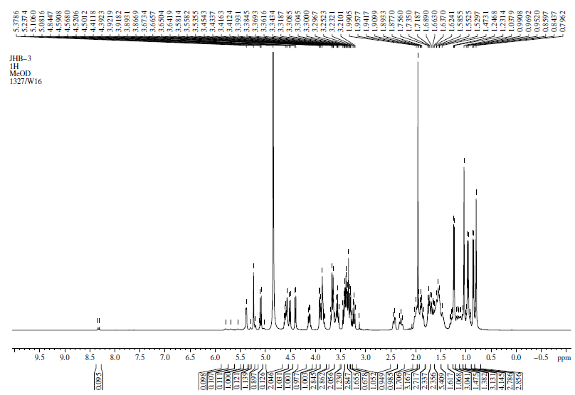

**Fig.S10.** 13C-NMR Spectrum of Compound **2**

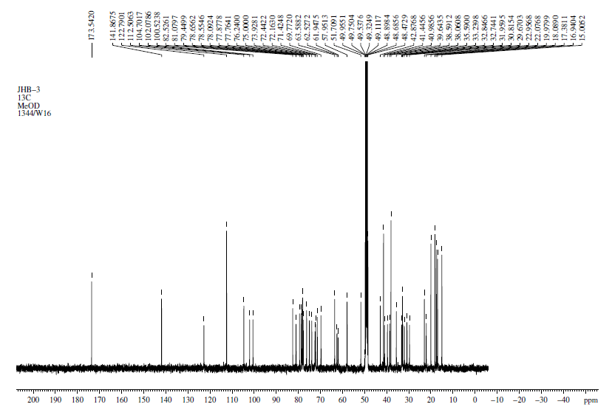

**Fig.S11.** HR-ESI-MS Spectrum of Compound **2**



**Fig.S12**. HSQC Spectrum of Compound **2**

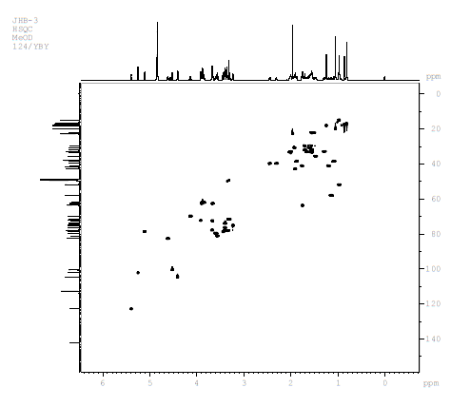

**Fig.S13.** 1H-1H COSY Spectrum of Compound **2**

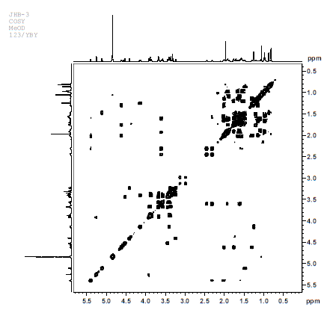

**Fig.S14.** HMBC Spectrum of Compound **2**

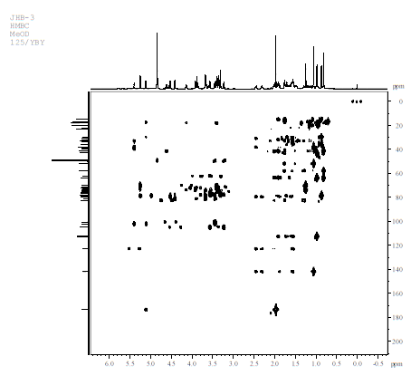

**Fig.S15.** NOESY Spectrum of Compound **2**

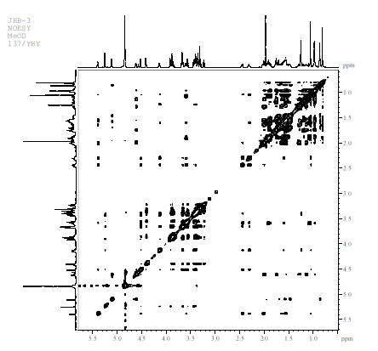

**Fig.S16.**IR Spectrum of Compound **2**

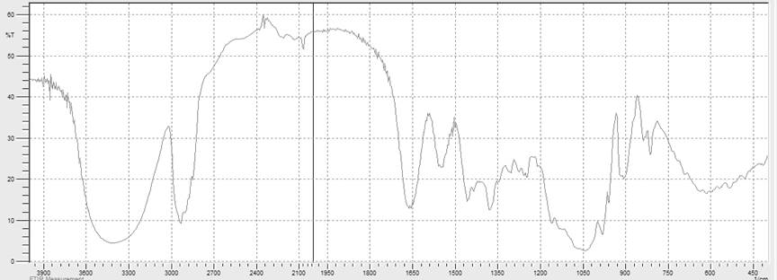

**Table S1** 13C-NMR Data of **3**-**8** (100 MHz in 13C NMR, in MeOD)

|  |  |  |  |  |  |  |  |  |  |  |  |  |  |  |  |  |  |  |  |  |
| --- | --- | --- | --- | --- | --- | --- | --- | --- | --- | --- | --- | --- | --- | --- | --- | --- | --- | --- | --- | --- |
| **No.** | **3** | **4** | **5** | **6** | **7** | **8** | **No.** | **3** | **4** | **5** | **6** | **7** | **8** | **No.** | **3** | **4** | **5** | **6** | **7** | **8** |
| **1** | 41.4 | 73.6 | 38.6 | 73.6 | 38.5 | 38.5 | **25** | 39.3 | 134.2 | 36.3 | 134.2 | 35.5 | 35.5 | **6'** |  |  | 17.9 |  | 17.9 | 17.9 |
| **2** | 33.2 | 39.1 | 30.8 | 39.1 | 30.7 | 30.7 | **26** | 65.1 | 71.6 | 104.3 | 71.6 | 78.5 | 78.5 | **Glc 1''** | 104.64 |  |  |  |  |  |
| **3** | 78.6 | 66.7 | 79.3 | 66.7 | 79.2 | 79.2 | **27** | 64.4 | 17.9 | 18.4 | 17.9 | 17.2 | 17.2 | **2''** | 75.1 |  |  |  |  |  |
| **4** | 38.6 | 42.4 | 39.5 | 42.4 | 39.4 | 39.4 | **28** |  | 19.5 |  | 19.5 |  |  | **3''** | 79.4 |  |  |  |  |  |
| **5** | 141.9 | 144.3 | 141.9 | 144.3 | 141.8 | 141.8 | **OCH3** |  |  | 56.8 |  |  |  | **4''** | 71.4 |  |  |  |  |  |
| **6** | 122.6 | 127.4 | 122.7 | 127.4 | 122.6 | 122.6 | **NHCO** |  |  |  |  | 173.5 | 173.5 | **5''** | 78.1 |  |  |  |  |  |
| **7** | 30.8 | 65.9 | 33.2 | 65.9 | 33.1 | 33.1 | **CH3** |  |  |  |  | 22.8 | 22.7 | **6''** | 61.9 |  |  |  |  |  |
| **8** | 32.8 | 39.0 | 32.8 | 39.0 | 32.7 | 32.8 | **Glc 1** | 100.4 | 102.5 | 100.4 | 102.5 | 100.4 | 100.4 | **Xyl 1** |  |  | 107.4 |  |  | 107.3 |
| **9** | 51.7 | 35.1 | 51.7 | 35.1 | 51.6 | 51.6 | **2** | 77.9 | 75.1 | 79.4 | 75.1 | 79.3 | 79.4 | **2** |  |  | 75.3 |  |  | 75.2 |
| **10** | 38.0 | 43.3 | 38 | 43.3 | 38 | 38.2 | **3** | 76.2 | 78.2 | 77.9 | 78.2 | 77.9 | 77.8 | **3** |  |  | 77.9 |  |  | 77.8 |
| **11** | 21.9 | 21 | 22.0 | 21.0 | 21.9 | 21.9 | **4** | 82.2 | 71.8 | 79.3 | 71.8 | 79.9 | 79.3 | **4** |  |  | 71.0 |  |  | 71.0 |
| **12** | 39.5 | 40.6 | 40.9 | 40.6 | 40.9 | 40.9 | **5** | 77.8 | 78.0 | 76.8 | 78.0 | 76.5 | 76.8 | **5** |  |  | 67.0 |  |  | 66.9 |
| **13** | 40.9 | 43.7 | 41.5 | 43.7 | 41.3 | 41.3 | **6** | 62.5 | 62.6 | 62.0 | 62.6 | 61.9 | 61.9 | **6** |  |  | 17.9 |  |  | 17.9 |
| **14** | 57.8 | 50.7 | 57.8 | 50.7 | 57.8 | 57.8 | **Rha 1** | 102.1 |  | 102.4 |  | 102.2 | 102.3 |  |  |  |  |  |  |  |
| **15** | 32.7 | 28.9 | 32.8 | 28.9 | 32.6 | 32.6 | **2** | 72.2 |  | 72.1 |  | 72.1 | 72.0 |  |  |  |  |  |  |  |
| **16** | 81.0 | 25.2 | 82.5 | 25.2 | 82.4 | 82.5 | **3** | 72.4 |  | 72.4 |  | 72.3 | 72.3 |  |  |  |  |  |  |  |
| **17** | 63.7 | 54.4 | 63.9 | 54.4 | 63.4 | 63.5 | **4** | 73.9 |  | 73.9 |  | 73.8 | 73.9 |  |  |  |  |  |  |  |
| **18** | 16.7 | 12.1 | 16.8 | 12.1 | 16.7 | 16.7 | **5** | 69.7 |  | 69.8 |  | 69.7 | 69.7 |  |  |  |  |  |  |  |
| **19** | 19.8 | 18.9 | 19.8 | 18.9 | 19.8 | 19.8 | **6** | 17.9 |  | 17.8 |  | 17.8 | 17.8 |  |  |  |  |  |  |  |
| **20** | 42.9 | 42.4 | 42.9 | 42.4 | 42.8 | 42.8 | **Rha 1'** |  |  | 101.8 |  | 102.9 | 101.7 |  |  |  |  |  |  |  |
| **21** | 14.8 | 13.0 | 14.9 | 13.0 | 14.8 | 14.7 | **2'** |  |  | 82.2 |  | 72.4 | 82.1 |  |  |  |  |  |  |  |
| **22** | 110.9 | 70.7 | 113.1 | 70.7 | 112.4 | 112.5 | **3'** |  |  | 72.2 |  | 72.1 | 72.1 |  |  |  |  |  |  |  |
| **23** | 31.9 | 35.7 | 31.9 | 35.7 | 31.8 | 31.8 | **4'** |  |  | 74.1 |  | 73.7 | 74.0 |  |  |  |  |  |  |  |
| **24** | 24.3 | 127.9 | 28.9 | 127.9 | 29.5 | 29.5 | **5'** |  |  | 70.3 |  | 70.6 | 70.3 |  |  |  |  |  |  |  |

**Tab.S2.** Inhibitory on NO production in LPS-induced RAW 264.7 cells of compounds **1-8**

|  |  |  |  |
| --- | --- | --- | --- |
| **Drugs** | **IC50 (μM)** | **Drugs** | **IC50 (μM)** |
| Dexamethasoneb | 19.6±2.4 |  |  |
| Compound **1** | 38.9±3.6 | Compound **5** | ＞50 |
| Compound **2** | 30.2±4.7 | Compound **6** | 44.8±6.3 |
| Compound **3** | 41.1±3.5 | Compound **7** | 43.3±5.7 |
| Compound **4** | ＞50 | Compound **8** | ＞50 |
| *IC50 was defined as the concentration that resulted in a 50% inhibition on NO production. The IC50 greater than 50 μM was deemed inactive. b Positive control. | | | |