Supporting Information

Convenient and efficient Suzuki–Miyaura and Heck–Mizoroki cross–coupling reactions catalyzed by 1,3,4–trisubstituted–1,2,3–triazolium iodide and palladium salt systems

Shahini C. R.ª, Gautam Acharª, Srinivasa Budagumpiª, Ramesh B. Dateerª, Helge Müller–Bunz^{b}, Matthias Tacke^{b}, Siddappa A. Patilª*

ªCentre for Nano and Material Sciences, Jain University, Jain Global Campus, Kanakapura, Ramanagaram, Bangalore 562112, India
^{b}School of Chemistry, University College Dublin, Belfield, Dublin 4, Ireland

*Corresponding author: Dr. Siddappa A. Patil
Tel: +91 80 27577254
Fax: +91 80 27577211
E–mail: p.siddappa@jainuniversity.ac.in / patilsiddappa@gmail.com

¹H- NMR spectra of coupled products
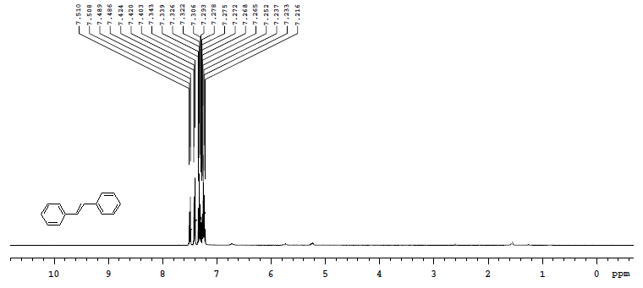
Figure SP1. ¹H NMR spectrum of 1,2-diphenylethene.

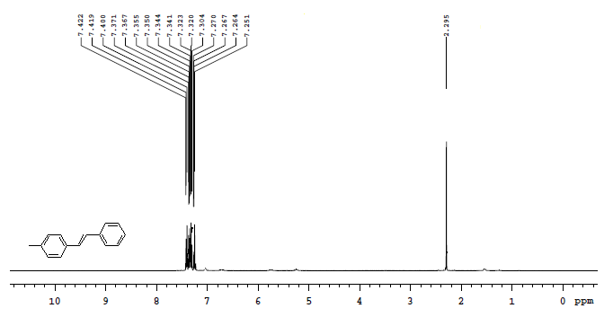
Figure SP2.¹H NMR spectrum of 1-methyl-4-styrylbenzene.

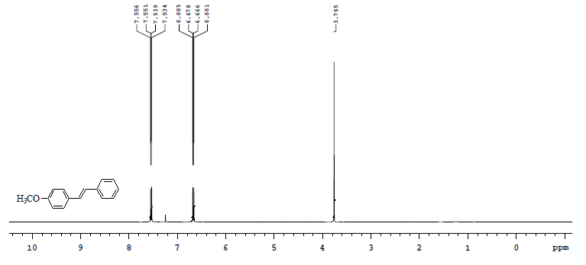
Figure SP3. ¹H NMR spectrum of 1-methoxy-4-styrylbenzene.

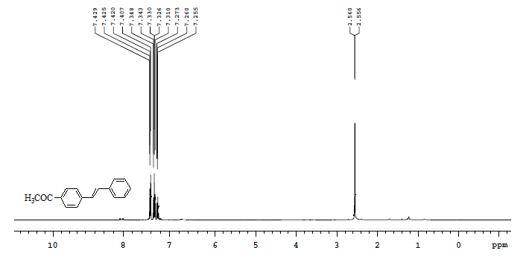
Figure SP4. ¹H NMR spectrum of 1-(4-styrylphenyl)ethanone.

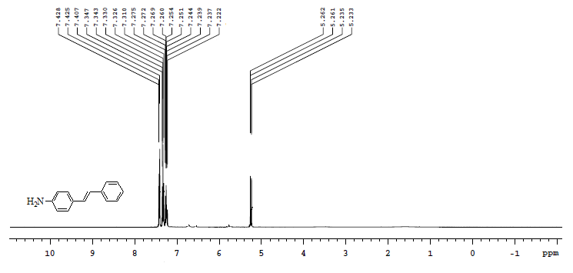
Figure SP5. ¹H NMR spectrum of 4-styrylbenzenamine.

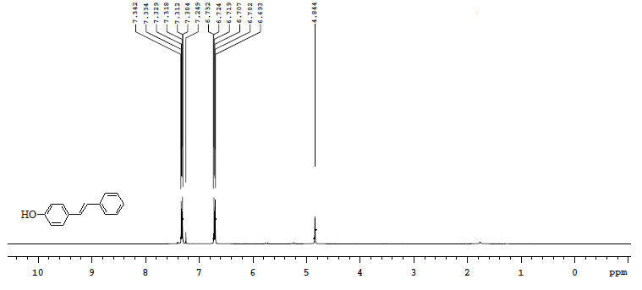
Figure SP6. ¹H NMR spectrum of 4-styrylphenol.

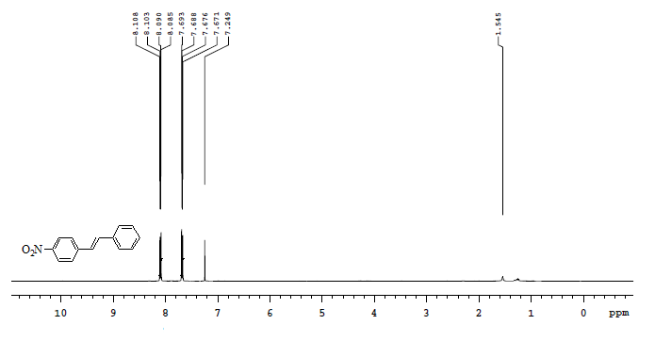
Figure SP7. ¹H NMR spectrum of 1-(4-nitrostyryl)benzene.

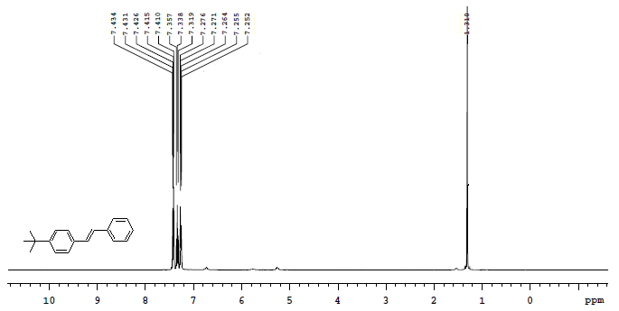
Figure SP8. ¹H NMR spectrum of 1-tert-butyl-4-styrylbenzene.

