Synthesis and characterization of potential impurities of Vigabatrin-An anti epileptic drug
Kishore Karumanchi,^{a, b*} Senthil Kumar Natarajan,ª Sunil Gadde,ª Ramadas Chavakula,ª Raghu Babu Korupolu^{b} and Kishore Babu Bonige^{b}

S.No | Content | Page. No
1 | Full Experimental detail | 2
2 | (2-Aminobut-3-enyl)malonic acid (¹H NMR,¹³C NMR, HRMS, IR) | 3-7
3 | 2-(2-Oxo-5-vinylpyrrolidin-1-yl)acetic acid (¹H NMR,¹³C NMR, HRMS, IR) | 8-12
4 | 4-Aminohexanoic acid (¹H NMR,¹³C NMR, HRMS, IR) | 13-17
5 | 5-Ethyl-2-pyrrolidinone (¹H NMR,¹³C NMR, GCMS, IR) | 18-22
6 | 2,2̕-Oxo-5,5̕-bispyrrolidinyl ether (¹H NMR, HRMS, IR) | 23-26

EXPERIMENTAL SECTION
Preparation of 5-ethyl-2-pyrrolidinone (18)
Ethyl magnesium bromide (2 M, 495 mL, 0.97 mol) was added to a solution of 16 (50 g, 0.39 mol) in THF (150 mL) at -15 to -10°C potion wise over 1h under nitrogen atmosphere. The reaction mixture was warmed slowly to reflux and was stirred for 2 h under reflux. The reaction mixture was cooled to 0 °C and treated cautiously with the mixture of DM water (500 mL) and acetic acid (100 mL). The THF in the reaction mass was distilled out completely under reduced pressure and the aqueous layer was extracted with DCM (500 mL). The organic layer was separated and distilled out completely under reduced pressure to afford 18 as brown syrup. The pure product was obtained by distilling at 120-140 °C at 16 mm of pressure to afford 18 (26 g, 50%) as pale yellow oil. ¹H NMR (500 MHz, CDCl₃): 0.92 (t, 3H, J=7.75 Hz), 1.43-1.58 (m, 2H), 1.67-1.83 (m, 1H), 2.20-2.32 (m, 3H), 3.69 (m, 1H), 6.47 (s, 1H); ¹³C NMR (300 MHz, D₂O): 8.96, 25.79, 28.43, 30.19, 56.62, 181.15; GCMS (m/z) 113; IR (KBr) 3223, 2966, 2933, 2878, 1693, 1462, 1353, 1177, 1131 cm⁻¹.

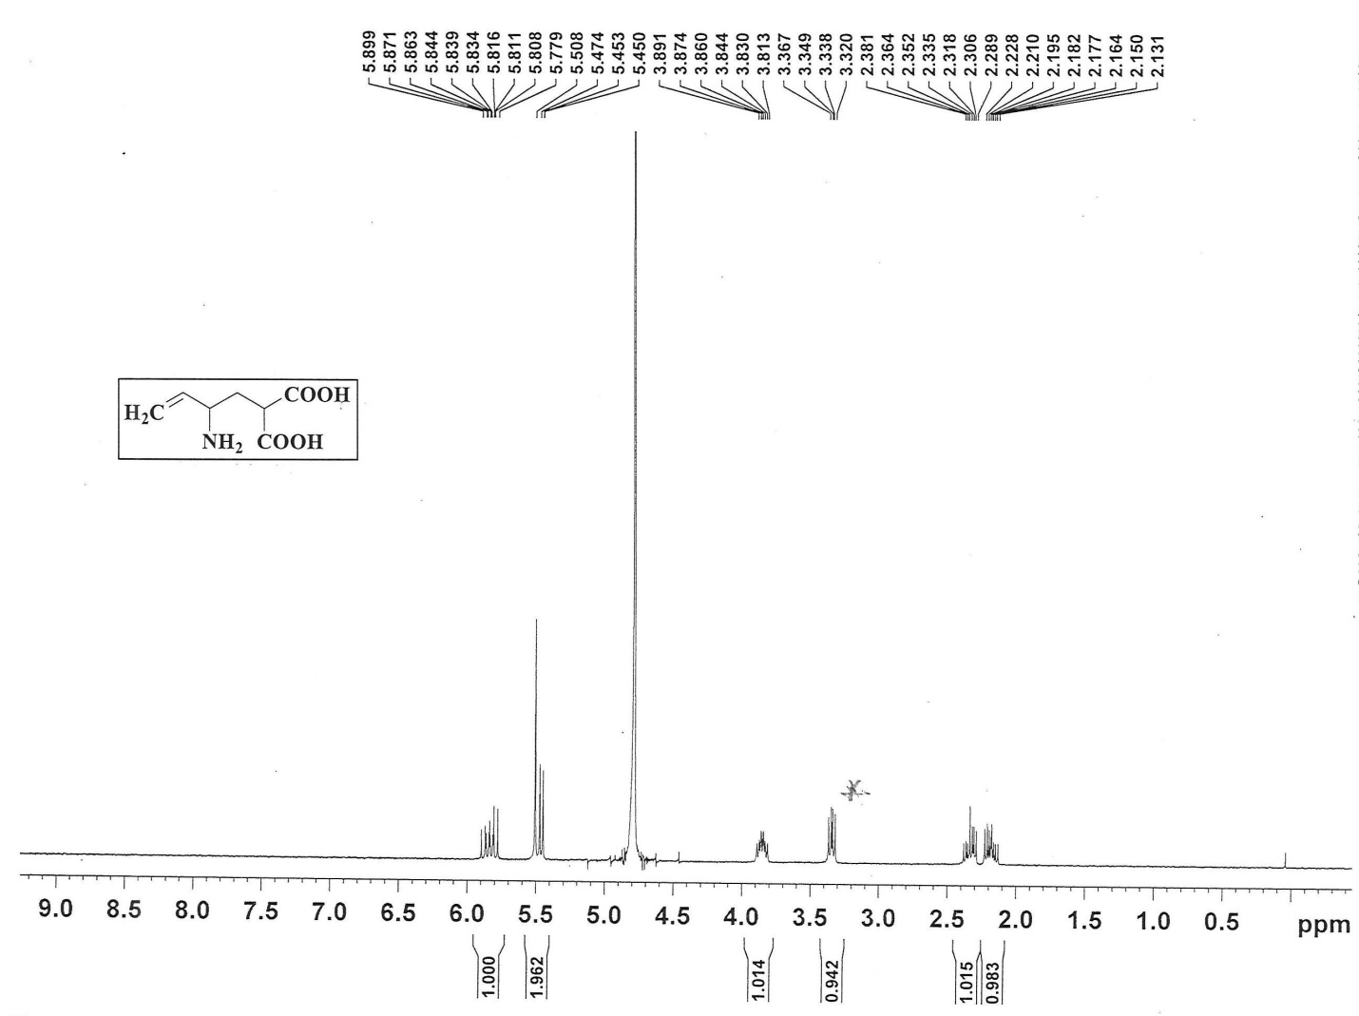
¹H NMR spectrum of compound 2 in D₂O
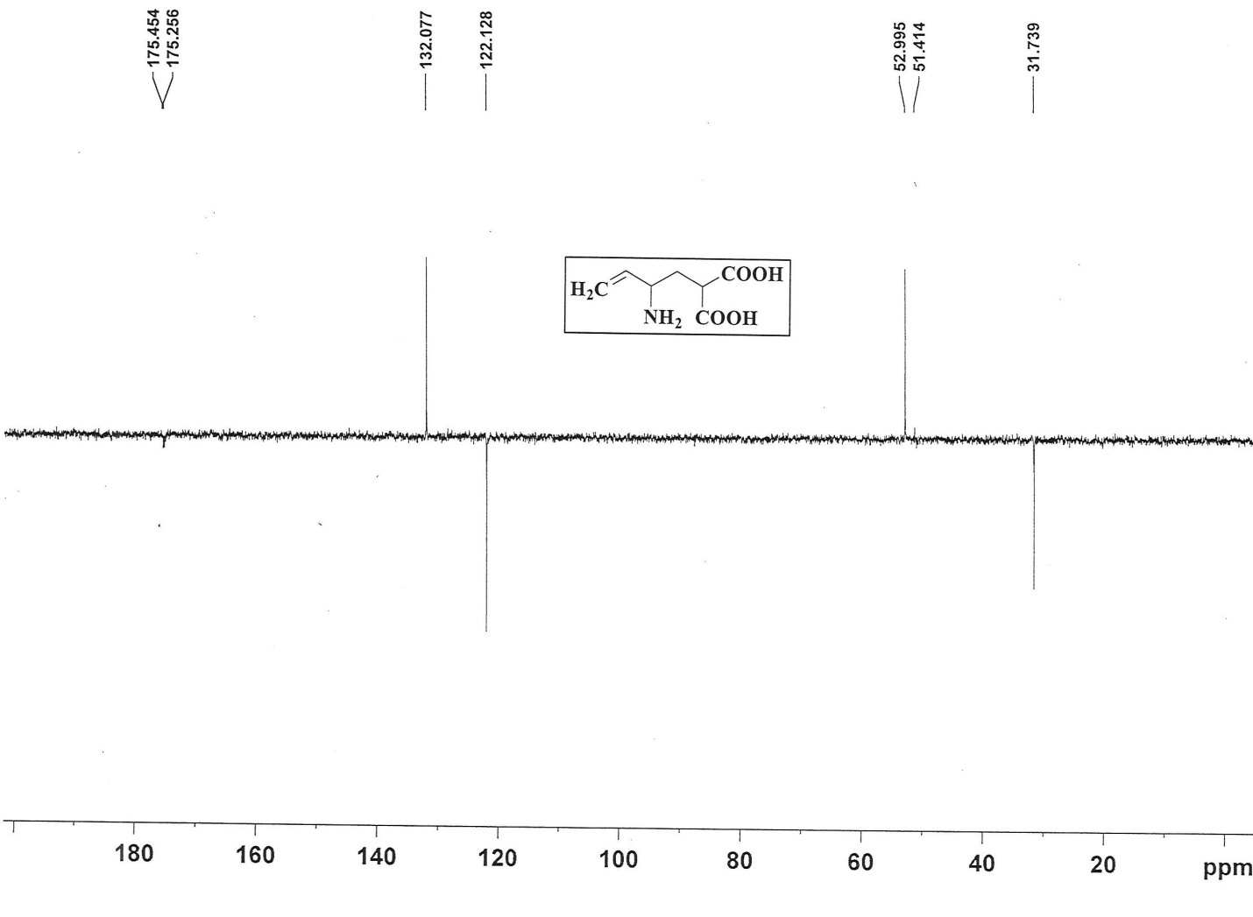
¹³C NMR spectrum of compound 2 in D₂O

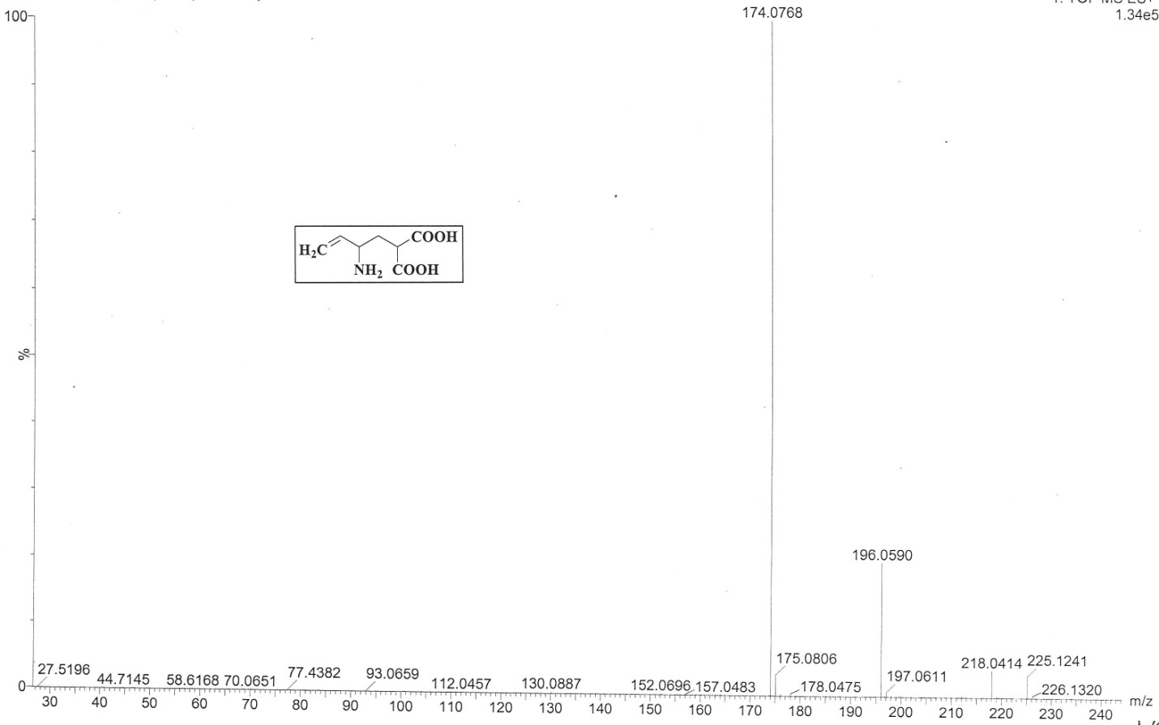
HRMS spectrum of compound 2

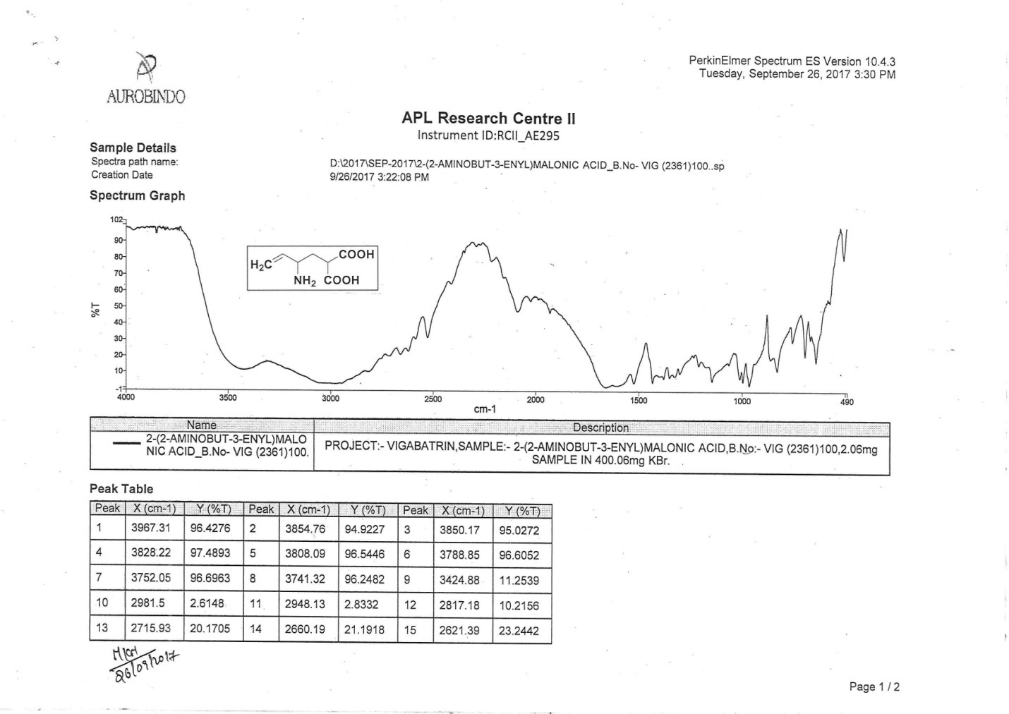
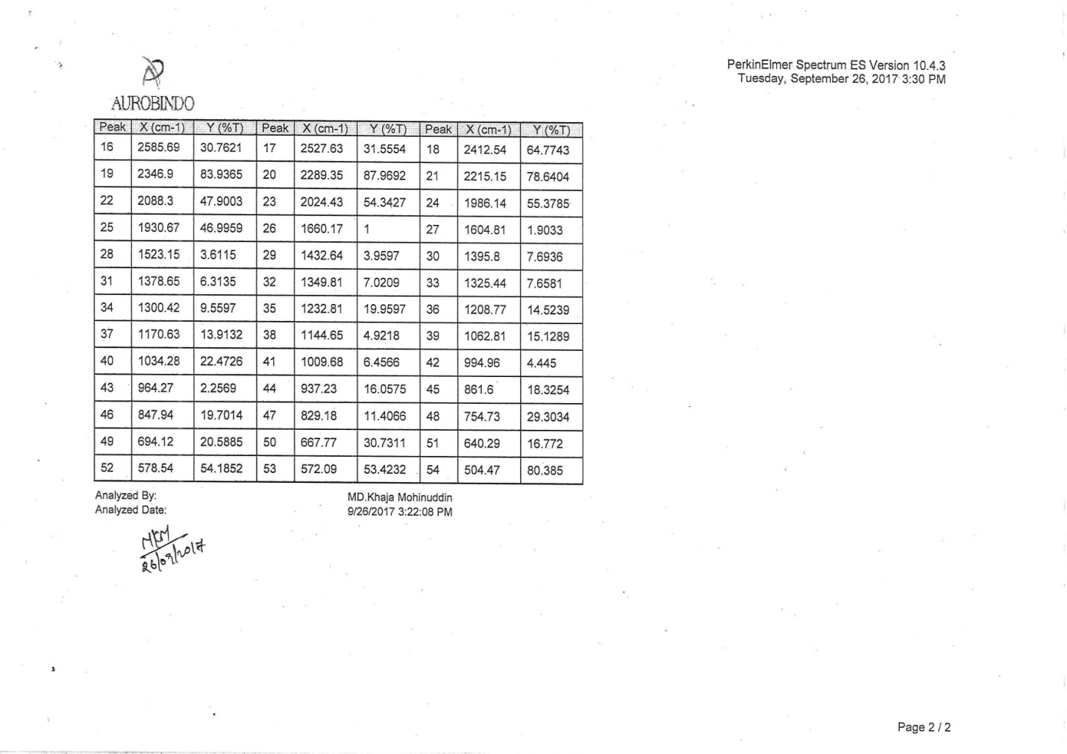
IR spectrum of compound 2

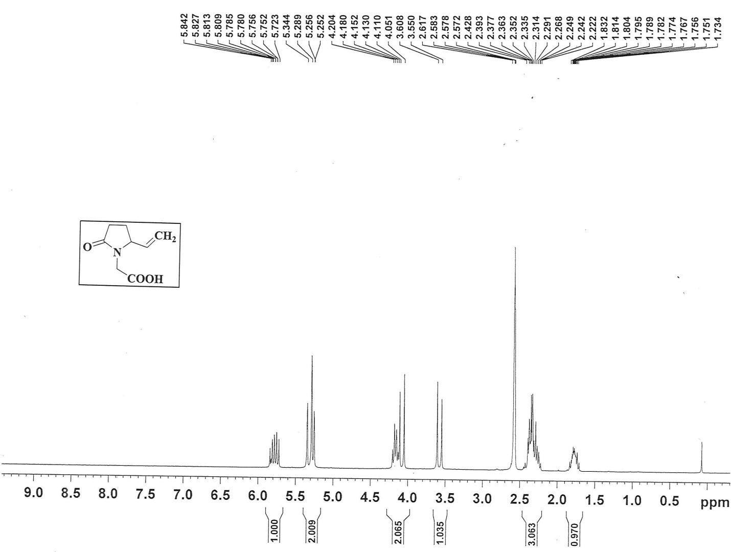
¹H NMR spectrum of compound 3 in DMSO-d6

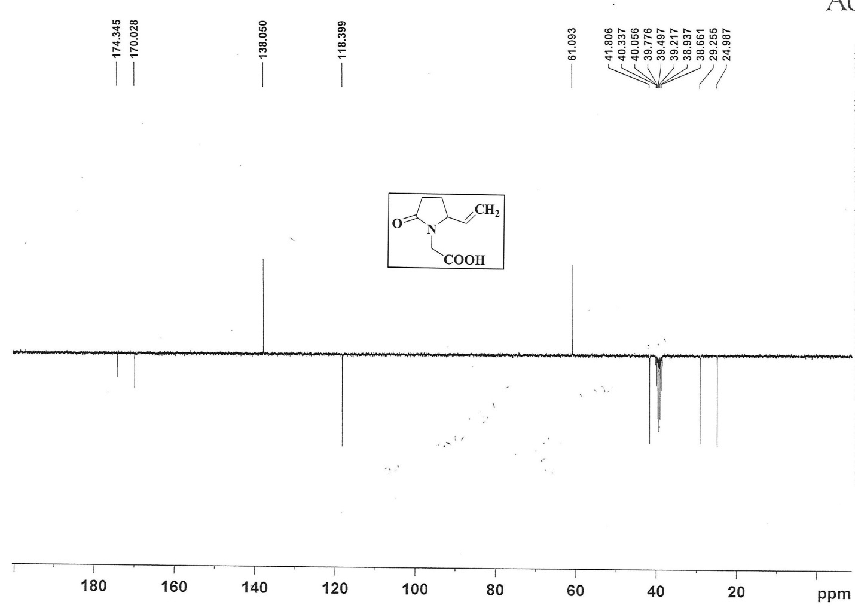
¹³C NMR spectrum of compound 3 in DMSO-d6

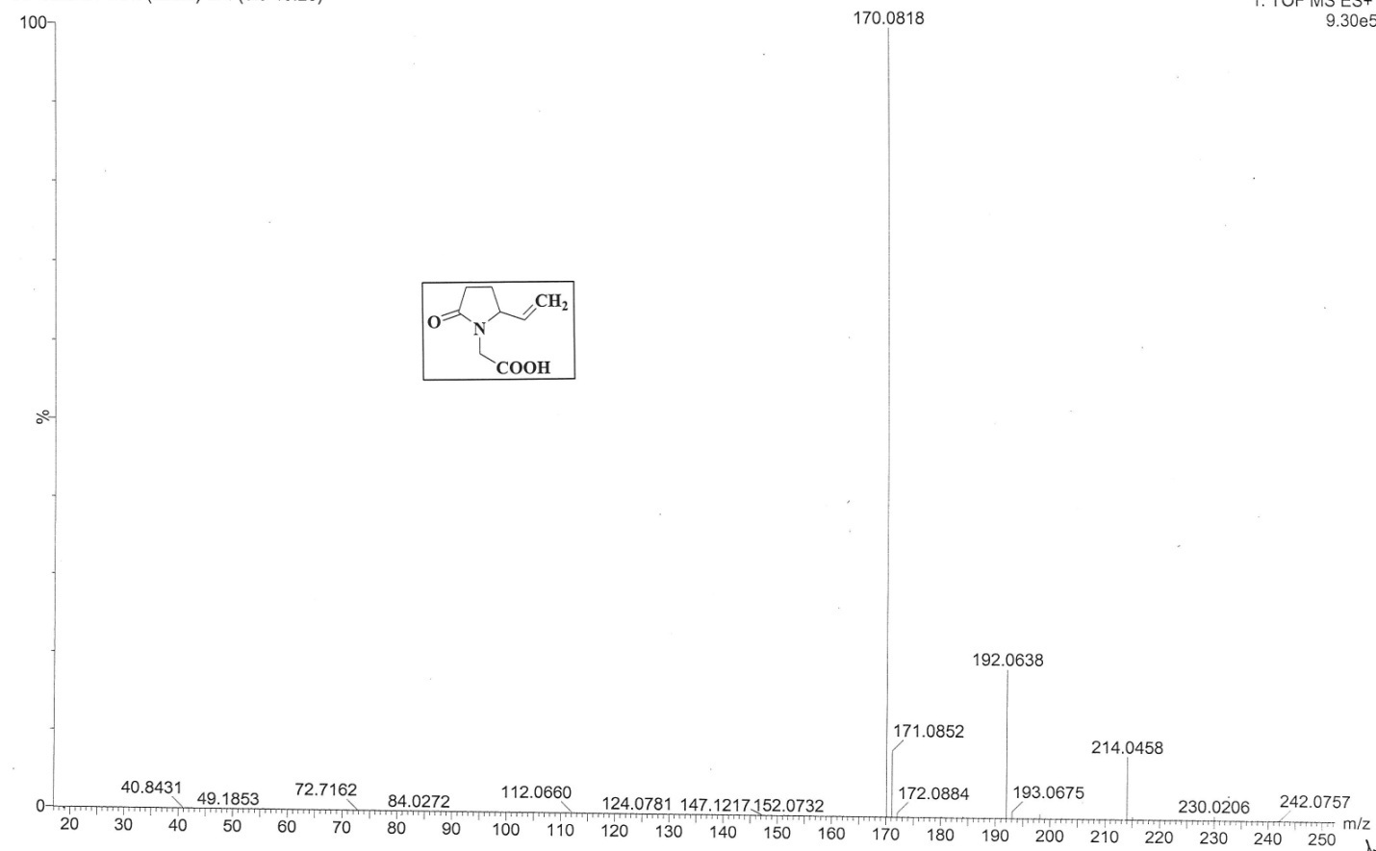
HRMS spectrum of compound 3
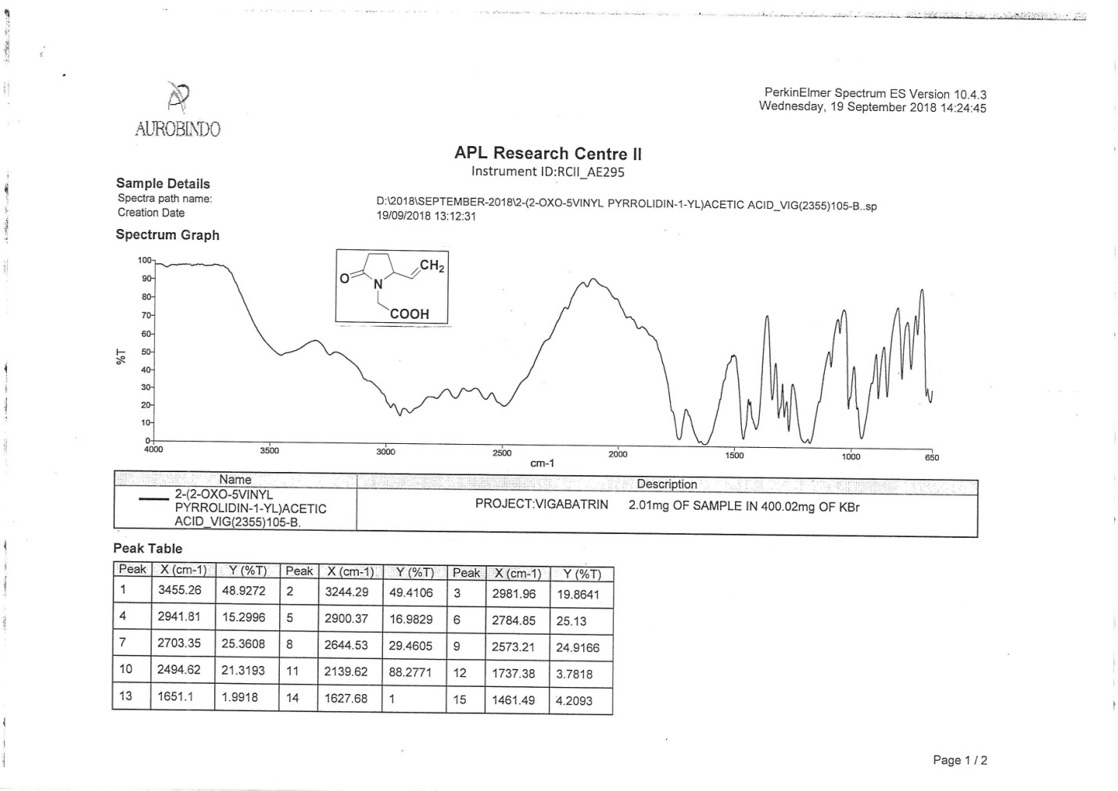
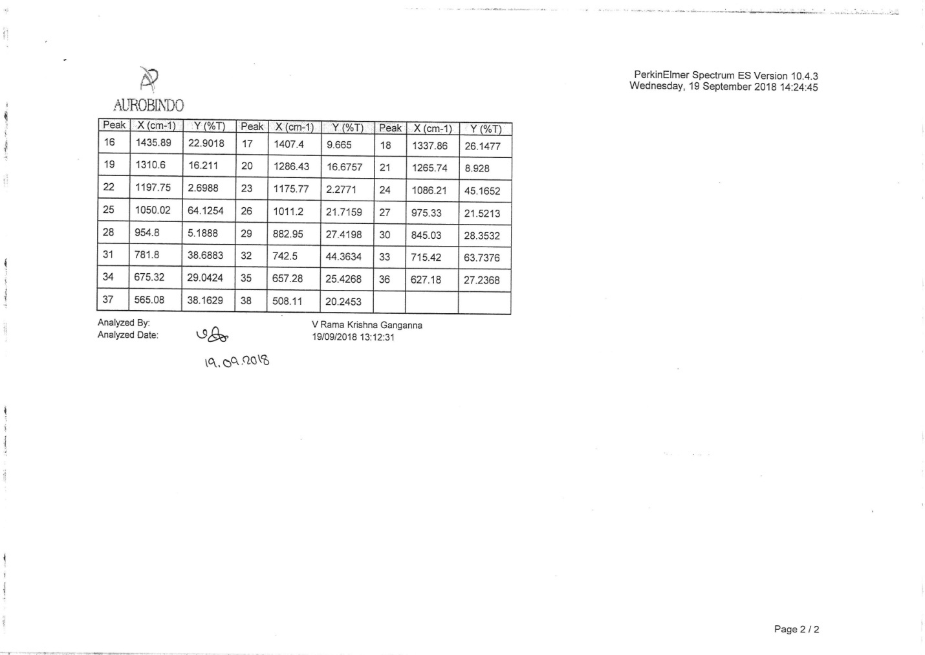
IR spectrum of compound 3

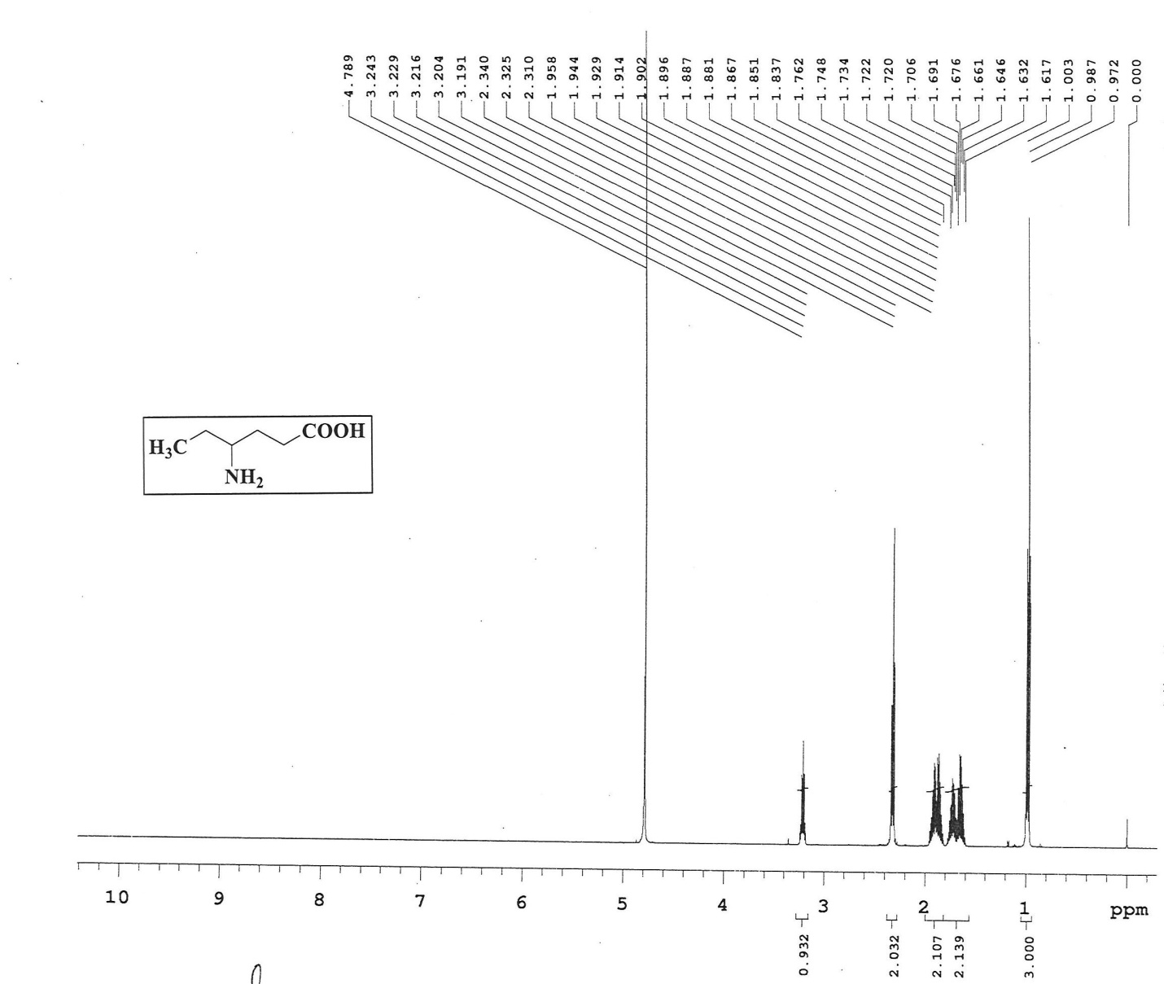
¹H NMR spectrum of compound 4 in D₂O

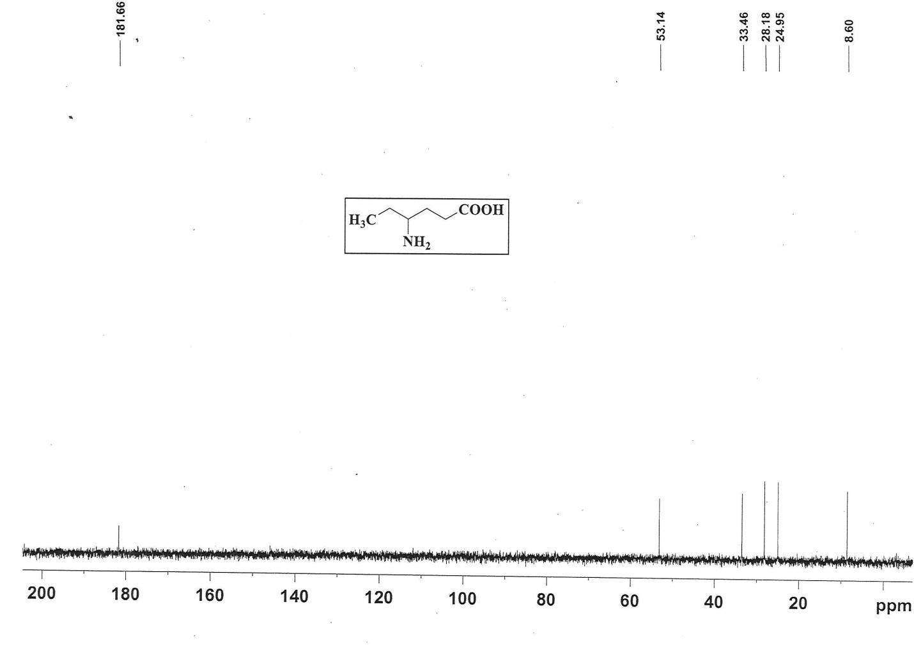
¹³C NMR spectrum of compound 4 in D₂O

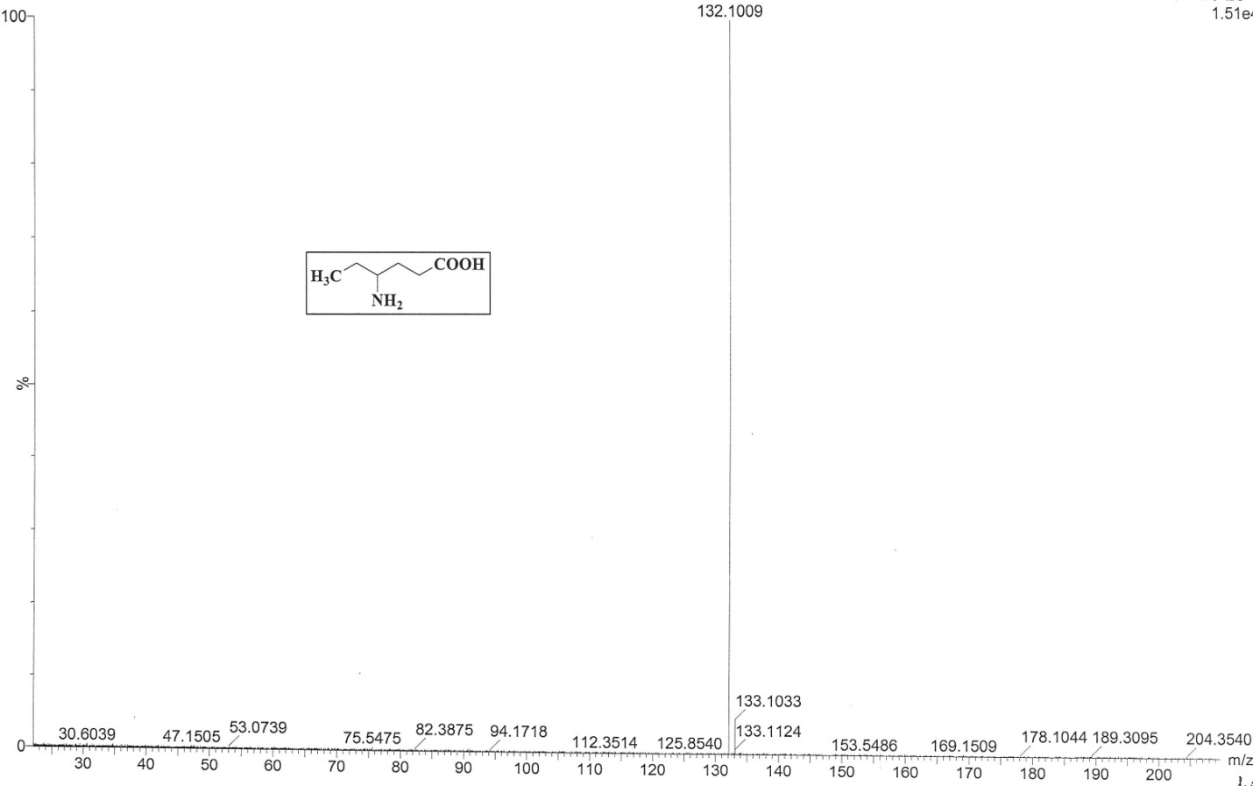
HRMS spectrum of compound 4
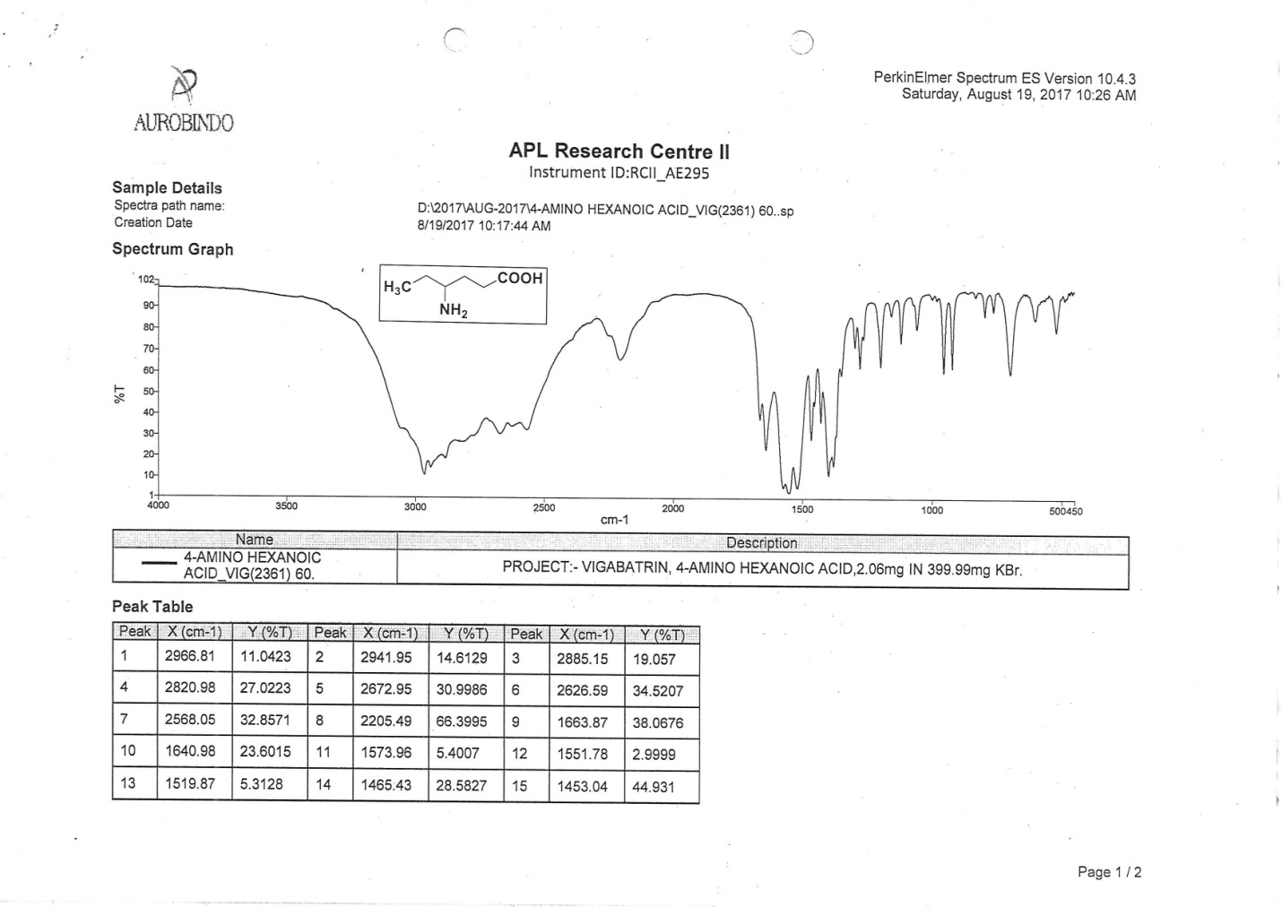
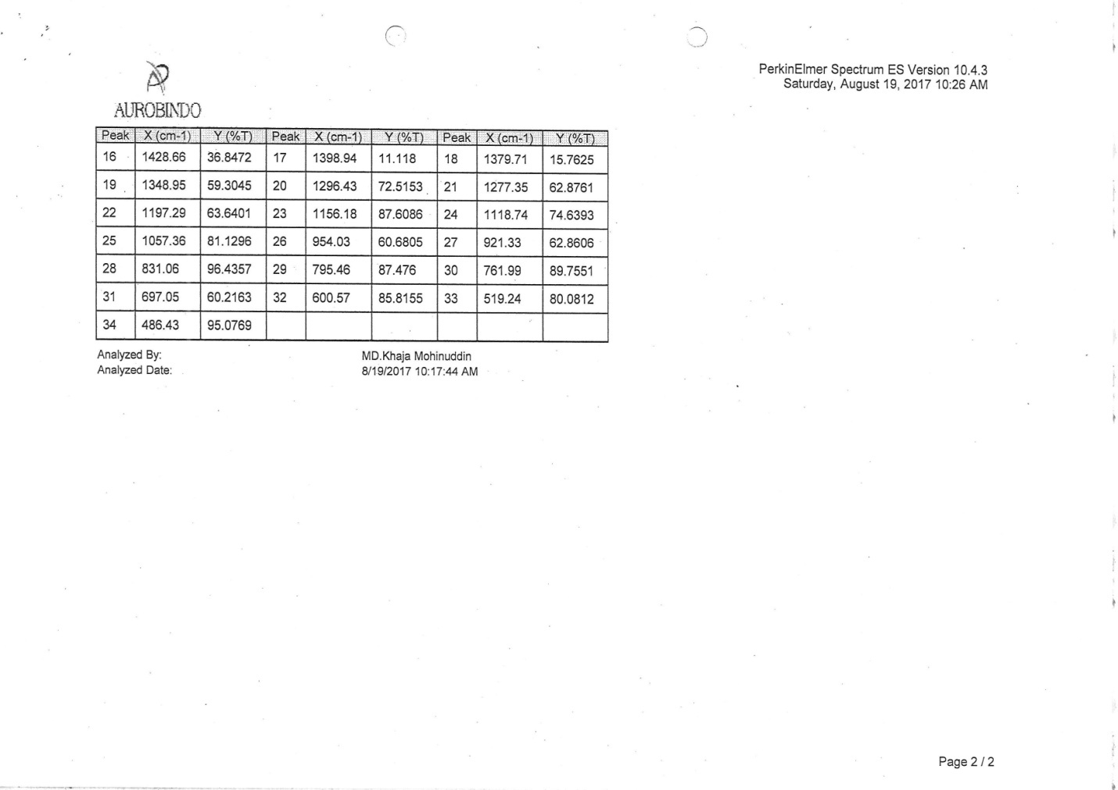
IR spectrum of compound 4

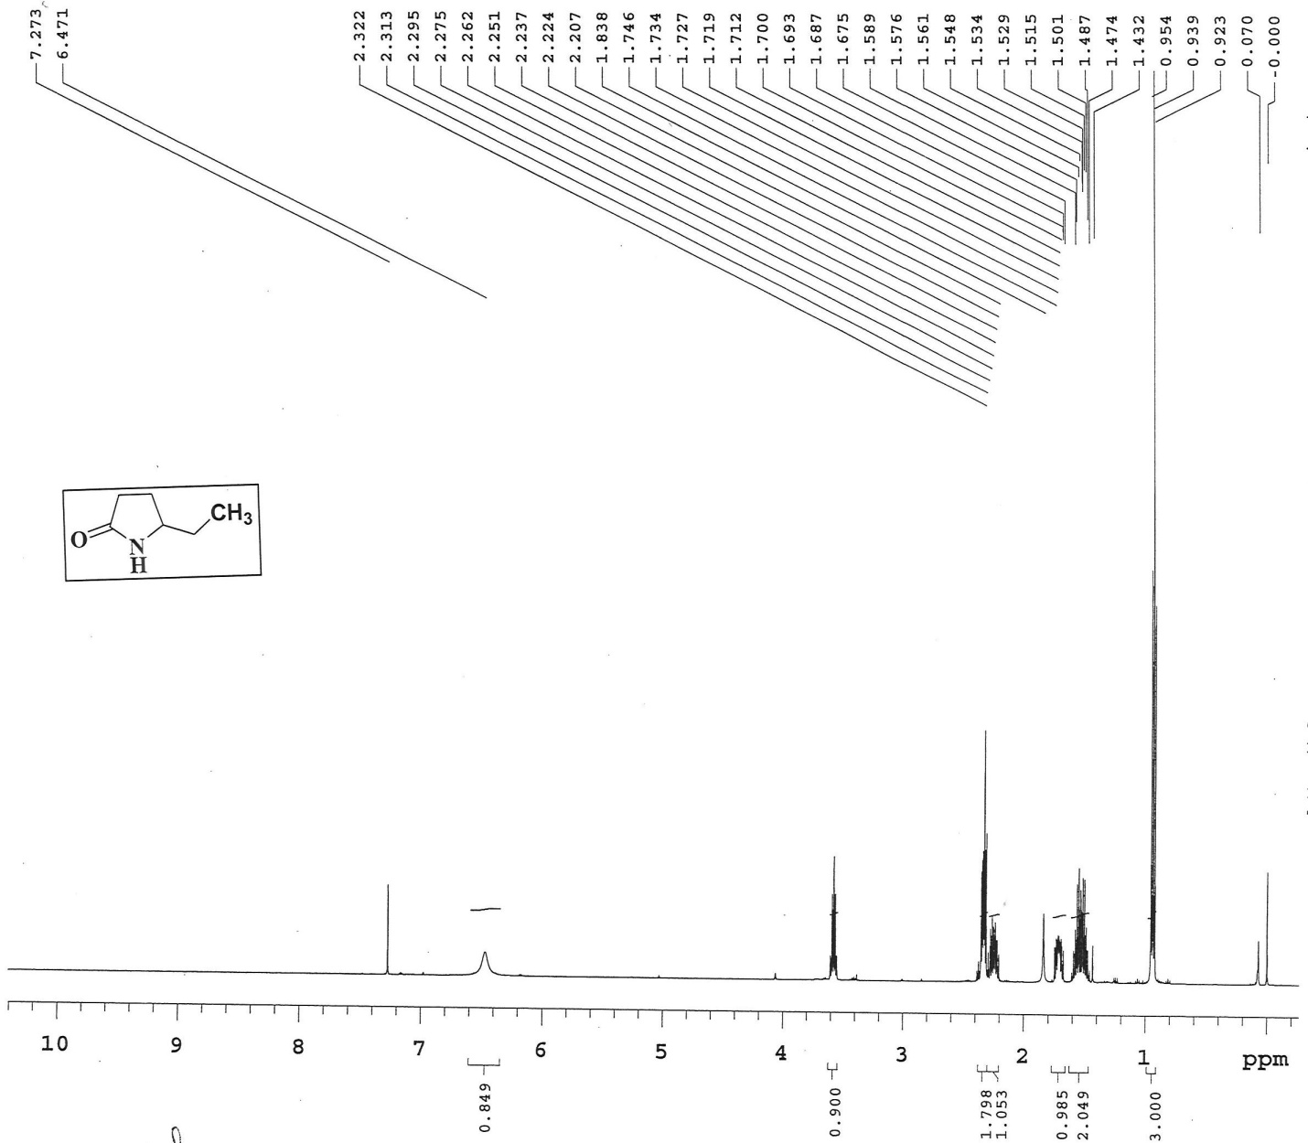
¹H NMR spectrum of compound 18

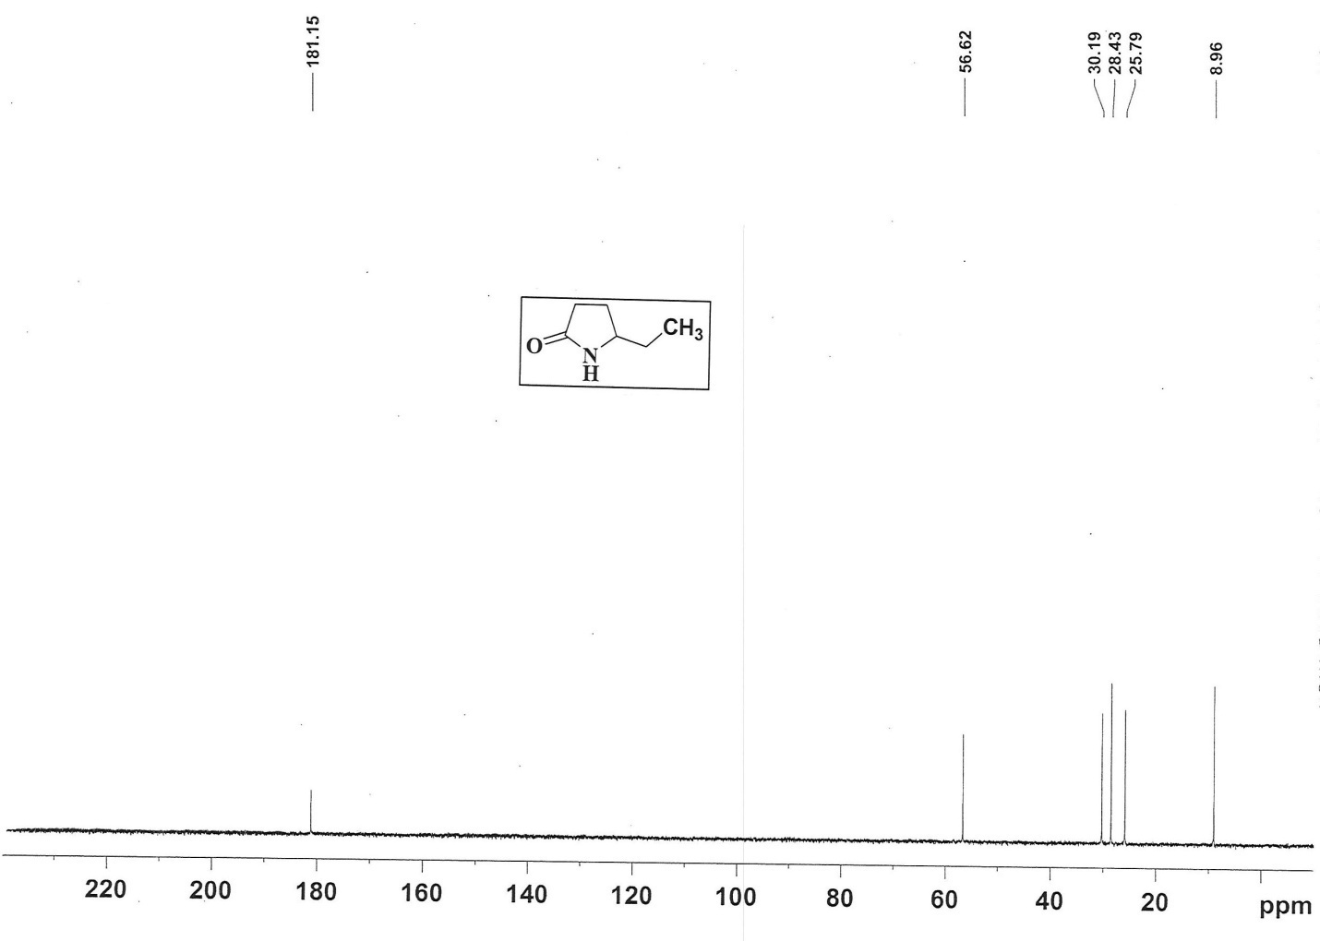
¹³C NMR spectrum of compound 18

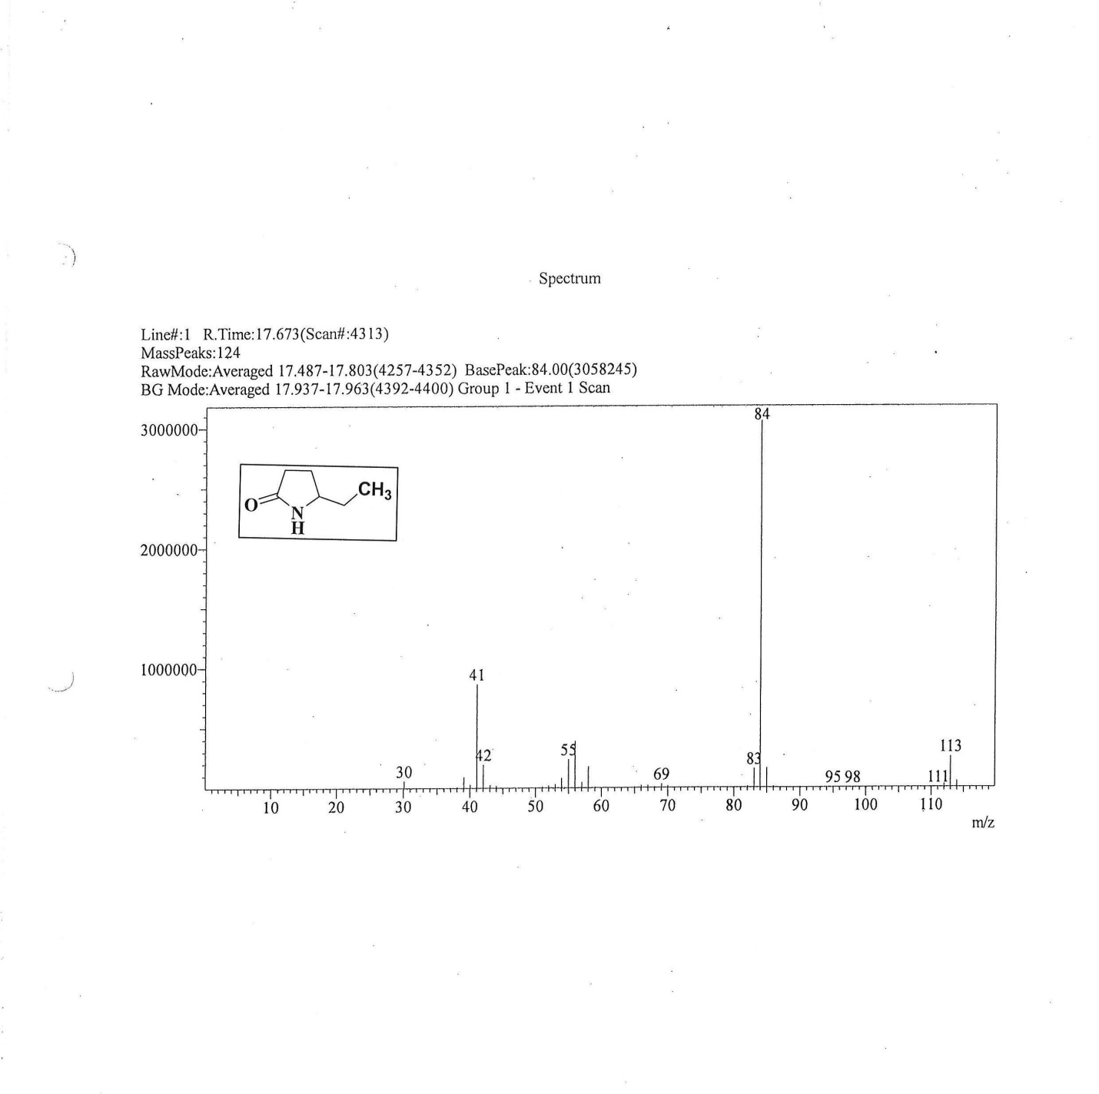
GCMS spectrum of compound 18
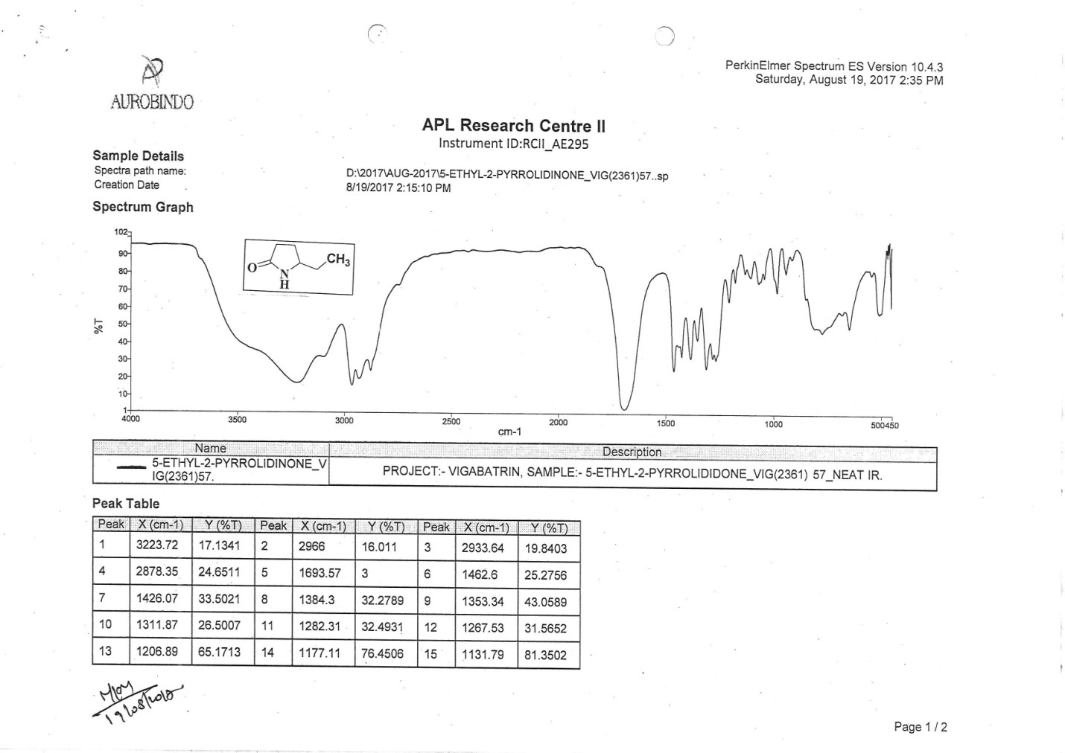
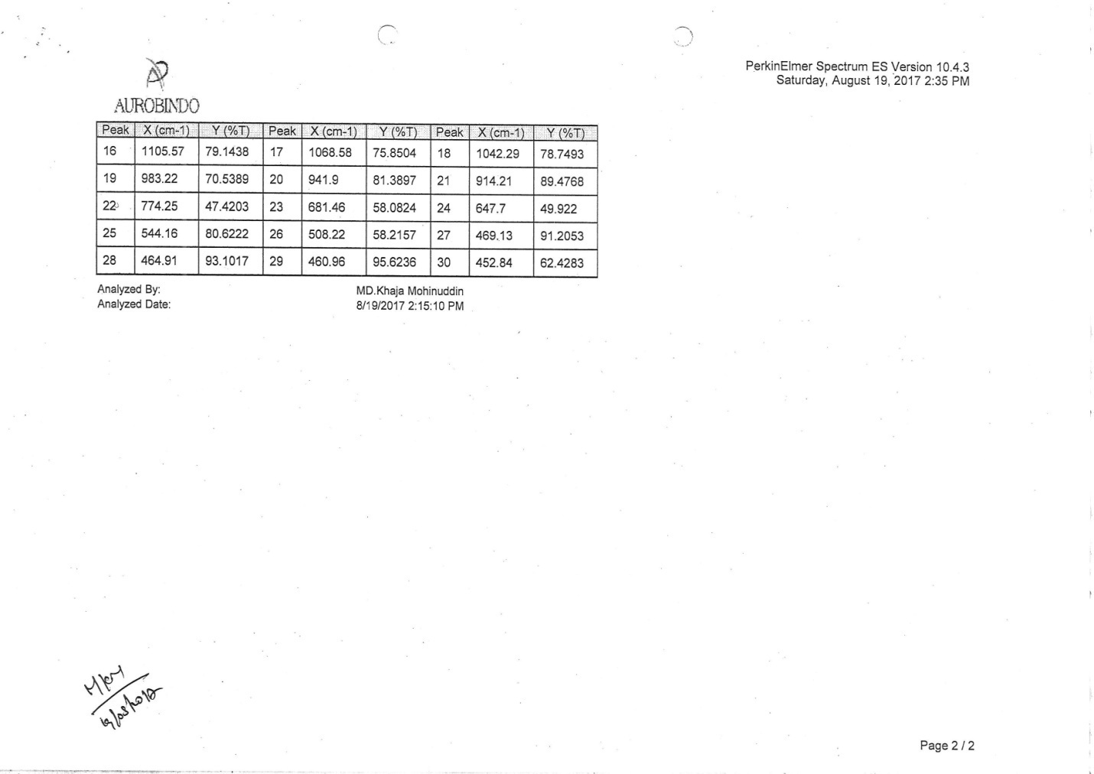
IR spectrum of compound 18

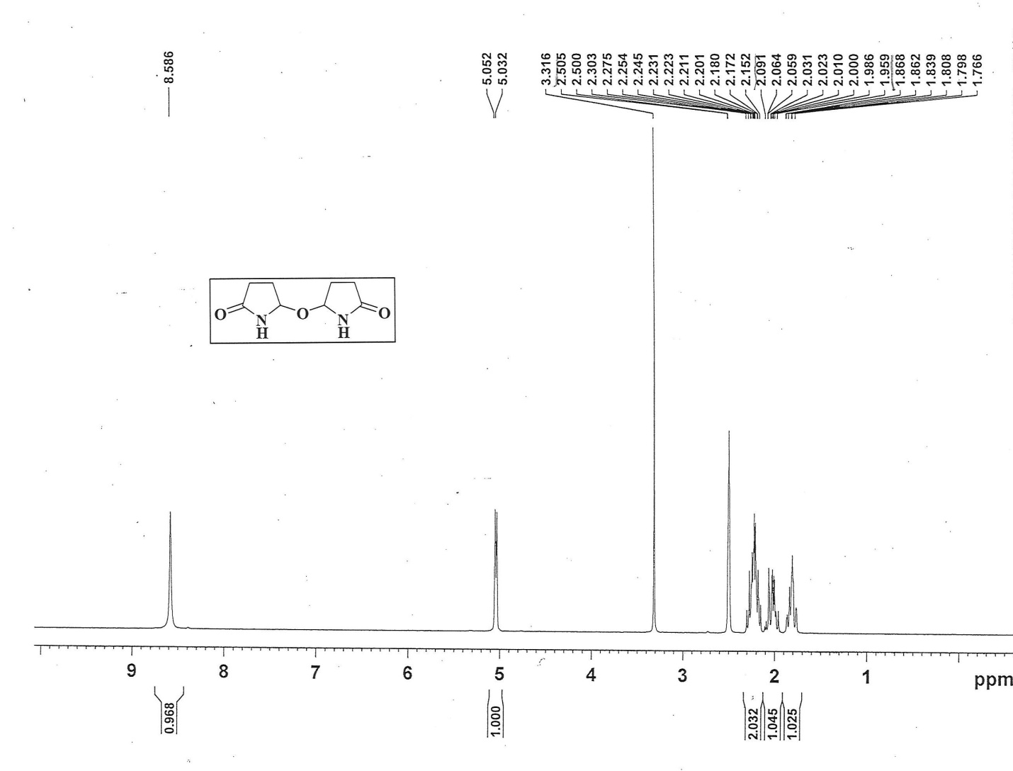
¹H NMR spectrum of compound 5 in DMSO-d6

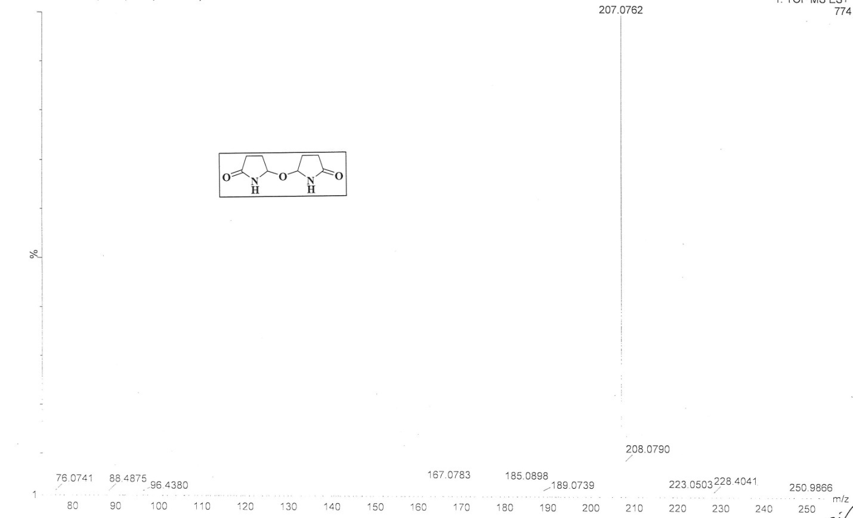

HRMS spectrum of compound 5
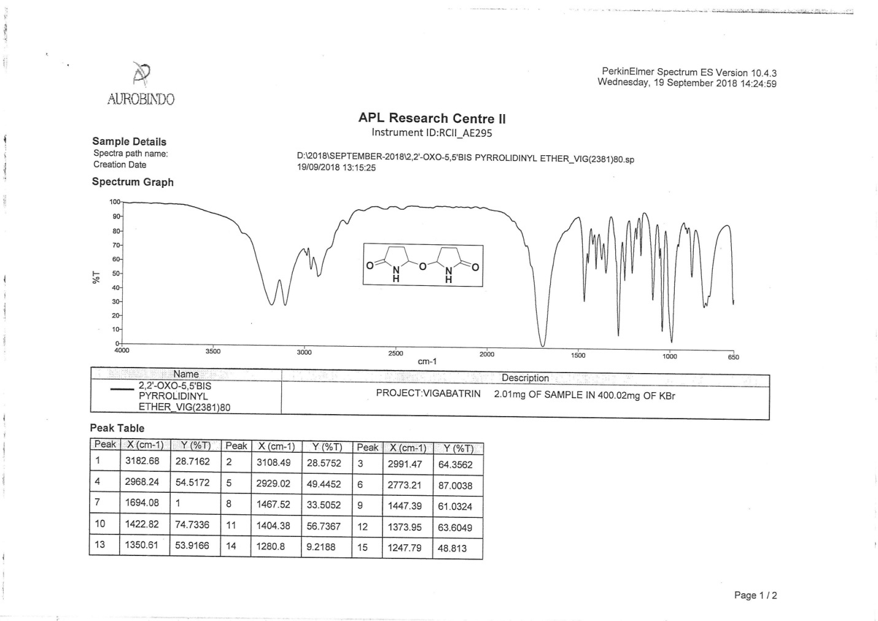
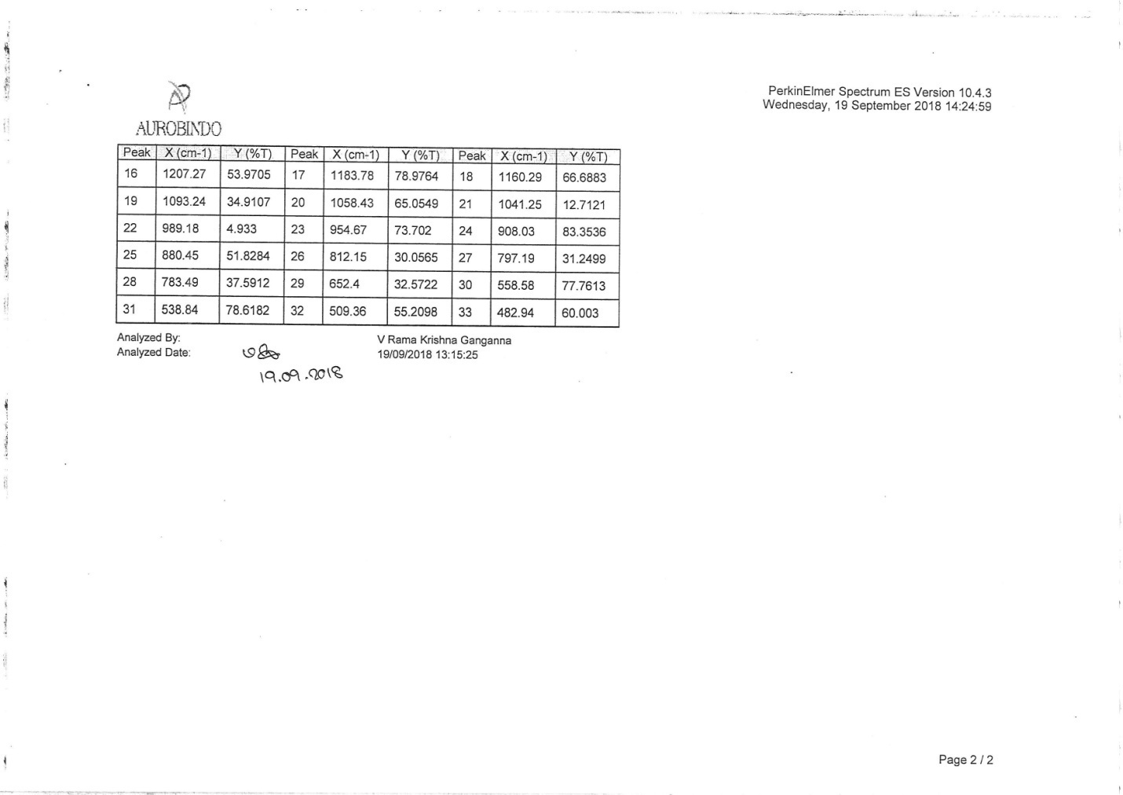
IR spectrum of compound 5

