Online supplementary material

Home ranges and movements of Egyptian Vultures Neophron percnopterus in relation to rubbish dumps in Oman and the Horn of Africa
M. J. McGrady¹, D. L. Karelus^{2#}, H. A. Rayaleh³, M. Sarrouf Willson⁴, B. –U. Meyburg⁵, M. K. Oli², K. Bildstein⁶

Figure S1. Plots showing the average number of revisits to locations and dumpsites as the radius of the area to be counted as a revisit is increased.
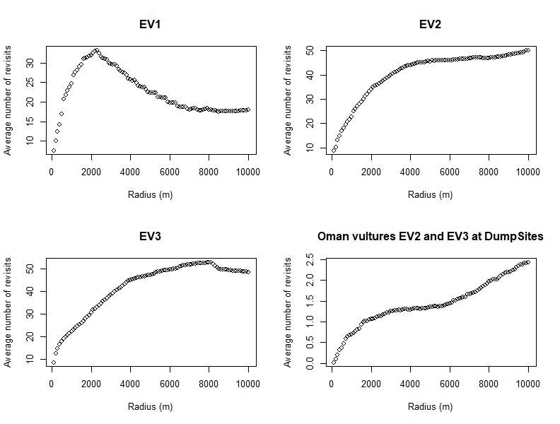

Figure S2. Hourly locations and 95%, 75%, and 50% KDE home ranges of a non-breeding Egyptian Vulture (EV3) tracked in Oman during 21 January 2016 – 4 October 2017. The bandwidth was based on its average hourly step-length, 4565 m.
