**Supplemental Material**

**Heterogeneous esterification kinetics of isopropyl oleate synthesis under non-ionizing excitation using nano-anatase imbued mesoporous catalyst**

Punam Mukhopadhyay, Rajat Chakraborty

*Chemical Engineering Department Jadavpur University, Kolkata-700032, India*

**Statistical Analysis and Optimization**

A statistical analysis had been conducted in order to evaluate optimal factorial conditions for maximum IPO production. Factorial design with corresponding OA conversion as response variable had been represented in Table S1. Process variables viz., IP/OA mole ratio (), precursor load () and reaction temperature () were considered, in order to study their influence on OA conversion ().

Optimum factorial conditions were estimated by calculating S/N ratio values (Eq. 1). “Greater the better” criterion was considered for S/N ratio and has been presented in Table S2. S/N values written in bold letter represent the combination of factorial levels that rendered maximum . Table S2 also demonstrated the delta values for process factors which showed that  was the most influencing factor having highest delta value, followed by  and .

**Table S1.** Taguchi design matrix and response variable for IP-OA esterification using PTx catalyst.

|  |  |  |  |  |
| --- | --- | --- | --- | --- |
| Run No. |  | (wt. %) | (K) | (%) |
| 1 | 3 | 15 | 313 | 86±1 |
| 2 | 3 | 25 | 323 | 93.61±1.5 |
| 3 | 3 | 35 | 333 | 94.2±1.8 |
| 4 | 5 | 15 | 323 | 94±1 |
| 5 | 5 | 25 | 333 | 95±0.5 |
| 6 | 5 | 35 | 313 | 92.5±1.5 |
| 7 | 7 | 15 | 333 | 95.23±1 |
| 8 | 7 | 25 | 313 | 94.5±1 |
| 9 | 7 | 35 | 323 | 93.6±0.8 |

**Table S2.** Response values for process factors

|  |  |  |  |
| --- | --- | --- | --- |
| Factorial Level |  | (wt. %) | (K) |
| 1 | 39.19 | 39.18 | 39.14 |
| 2 | 39.44 | **39.47a** | 39.47 |
| 3 | **39.45a** | 39.45 | **39.48a** |
| Delta | 0.26 | 0.28 | 0.34 |
| Rank | 3 | 2 | 1 |

a: optimum S/N ratio values for maximum oleic acid conversion.

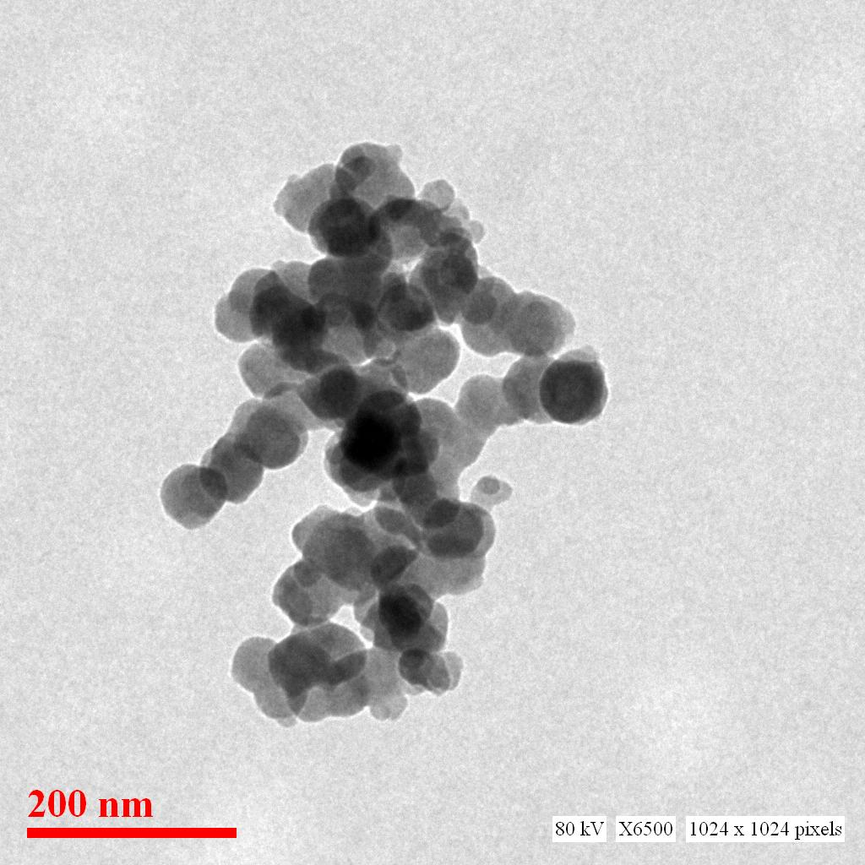

**Figure S1**. TEM image of the spent catalyst after 7th recycle.