Ketene dithioacetal mediated synthesis of 1,3,4,5-tetrasubstituted pyrazole derivatives and their biological evaluation

Pravin S. Bhale,a,b Babasaheb P. Bandgar,a Sakharam B. Dongare, a Sadanand N. Shringare, a Dnyaneshwar M. Sirsat,c Hemant V. Chavand,*

aMedicinal Chemistry Research Laboratory, School of Chemical Sciences, Solapur University, Solapur-413 255, Maharashtra, India.

bDepartment of Chemistry, Yeshwantrao Chavan Mahavidyalaya, Tuljapur, Dist-Osmanabad-413 601, Maharashtra, India.

cDepartment of Chemistry, A. R. A. C. S. College, Vaibhavwadi, Dist-Sindhudurg-416 810, Maharashtra, India.

dDepartment of Chemistry, A.S.P. College, Devrukh, Dist-Ratnagiri-415 804, Maharashtra, India.

Email-[hemantchavan.sus@rediffmail.com](mailto:hemantchavan.sus@rediffmail.com)

**Supplemental Materials**

***Preparation of 3-(1H-indol-3-yl)-3-oxopropanenitrile(1) [[1]]***

Indole (1.17 g, 10mmol) was added to a solution prepared by dissolution of cyanoacetic acid (0.851 g, 10 mmol) in acetic anhydride (10 mL) at 50°C. The solution was heated at 85°C for 5 min. During that time 3-cyanoacetylindole started to crystallize. After five min, the mixture was allowed to cool and collected solid was washed with methanol to obtain pure compound **1** (Yield: 93.0%)

## *Preparation of 2-(1-methyl-1H-indole-3-carbonyl)-3,3-bis(methylthio)acrylonitrile (2) [[2]]*

To a stirred suspension of freshly prepared sodium *tert*-butoxide (3.0mmol) in dry THF (7 mL) at 0°C a solution of substituted 3-(1-methyl-1H-indol-3-yl)-3-oxopropanenitrile **1** (1.0 mmol) and carbon disulfide (1.2 mmol) in dry THF (5 mL) was added through a pressure equalizer funnel, and the mixture was vigorously stirred at 0°C for 1 h. To this suspension, a solution of dimethyl sulfate (1.2mmol) in dry THF (5 mL) was carefully added drop-wise during 10 min at 0°C, and the reaction mixture was allowed to stir at 0°C for 1 h. After completion of the reaction (TLC; hexane/EtOAc, 8:2), the mixture was diluted with ice water. A light yellow colored solid was collected with filtration followed by water washing. The crude solid was purified by recrystallization with ethanol or dichloromethane hexane mixture to obtain pure compound **2**. (Yield: 84%)

***Preparation of 5-(1-methyl-1H-indol-3-yl)-3-(methylthio)-1-phenyl-1H-pyrazole-4-carbonitrile (4):***

A mixture of 2-(1-methyl-1H-indole-3-carbonyl)-3,3-bis(methylthio)acrylonitrile **2** (302 mg, 1.0 mmol) and phenyl hydrazine hydrochloride **2** (144 mg, 1 mmole) in ethanol (10ml) in the presence of catalytic amount of anhydrous K2CO3 was refluxed for 3 h. The reaction mixture was cooled and poured in ice cold water. The faint brownish solid obtained was filtered, washed with water and recrystallized from ethanol to obtain pure compound **4** (Yield: 86%).

***Procedure of the SRB-assay***

Cytotoxicity evaluation was performed as per the procedure reported in literature.[[3]] Tumor cells (human breast cancer cell line MCF-7/K562) were grown in tissue culture flasks in growth medium (RPMI-1640 with 2 mM glutamine, pH 7.4, 10% fetal calf serum, 100 g/mL streptomycin, and 100 units/mL penicillin) at 37oC under the atmosphere of 5% CO2 and 95% relative humidity employing a CO2 incubator. The cells at subconfluent stage were harvested from the flask by treatment with trypsin (0.05% trypsin in PBS containing 0.02% EDTA) and placed in growth medium. The cells with more than 97% viability (trypan blue exclusion) were used for cytotoxicity studies. An aliquot of 100 L of cells were transferred to a well of 96-well tissue culture plate. The cells were allowed to grow for one day at 37oC in a CO2 incubator as mentioned above. The test materials at different concentrations were then added to the wells and cells were further allowed to grow for another 48h. Suitable blanks and positive controls were also included. Each test was performed in triplicate. The cell growth was stopped by gently layering of 50 L of 50% trichloroacetic acid. The plates were incubated at 4oC for an hour to fix the cells attached to the bottom of the wells. Liquids of all the wells were gently pipette out and discarded. The plates were washed five times with doubly distilled water to remove TCA, growth medium, etc and were air-dried. 100 L of SRB solution (0.4% in 1% acetic acid) was added to each well and the plates were incubated at ambient temperature for half an hour. The unbound SRB was quickly removed by washing the wells five times with 1% acetic acid. Plates were air dried, tris-buffer (100 L of 0.01 M, pH 10.4) was added to all the wells and plates were gently stirred for 5 min on a mechanical stirrer. The optical density was measured on ELISA reader at 540 nm. The cell growth at absence of any test material was considered 100% and in turn growth inhibition was calculated. Percent growth calculated on a plate‑by‑plate basis for test wells relative to control wells. Percent growth expressed as the ratio of average absorbance of the test well to the average absorbance of the control wells 100. Using the six absorbance measurements (time zero, control growth [C] and test growth in the presence of drug at the four concentration levels [Ti]), the percentage growth calculated at each of the extracts and standard drug concentration levels. Percentage growth inhibition calculated as [Ti/C] ×100%.

***In vitro anti-inflammatory activity by protein denaturation method***

The reaction mixture (10 ml) consisted of 0.4 ml of egg albumin (from fresh hen’s egg), 5.6 ml of phosphate buffered saline (PBS, pH 6.4) and 4 ml of synthetic derivative (1 mM). Similar volume of double-distilled water served as control. Then the mixtures were incubated at (37oC ± 2) in an incubator for 15 min and then heated at 70oC for 5 min. After cooling, their absorbance was measured at 660 nm by using vehicle as blank. Diclofenac sodium (1 mM) was used as reference drug and treated similarly for the determination of absorbance. The percentage inhibition of protein denaturation was calculated by using the following formula,

% inhibition = 100 x (Vt / Vc - 1)

Where, Vt = absorbance of test sample, Vc = absorbance of control.

***Antioxidant Activity***

***DPPH radical scavenging activity***

The ability of compounds to scavenge DPPH radical was assessed using method reported in literature[[4]] with modification. Briefly, 1 ml of synthesized compounds as 1 mM was mixed with 3.0 ml DPPH (0.5 mmol/L in methanol), the resultant absorbance was recorded at 517 nm after 30 min incubation at 37oC. The percentage of scavenging activity was derived using the following formula,

Percentage inhibition (%) = [(Acontrol – Asample) / Acontrol] x 100

Where, Acontrol is absorbance of DPPH; Asample is absorbance of reaction mixture (DPPH with Sample).

***NO radical scavenging activity***

NO radical scavenging activity of compounds was carried out as per the method reported in literature[4] NO radicals were generated from sodium nitroprusside solution. One ml of 10 mM sodium nitroprusside was mixed with 1 ml of 1 mM synthetic compounds in phosphate buffer (0.2 M pH 7.4). The mixture was incubated at 25oC for 150 min. After incubation the reaction mixture mixed with 1.0 ml of pre-prepared Griess reagent (1% sulphanilamide, 0.1% napthyl ethylenediamine dichloride and 2% phosphoric acid). The absorbance was measured at 546 nm and percentage of inhibition was calculated using the same formula as above. The decreasing absorbance indicates a high nitric oxide scavenging activity.

***Superoxide radical (SOR) scavenging assay***

The superoxide anion scavenging activity was performed by the reported method.[4] The reaction mixture consisting of 1ml of nitro blue tetrazolium (NBT) solution (156 mM NBT in phosphate buffer, pH 7.4), 1 ml NADH solution (468 mM NADH in phosphate buffer, pH 7.4), and 1ml of synthetic compound (1mM) solution was mixed. The reaction was started by adding 1 ml of phenazine methosulfate (PMS) solution (60 mM PMS in phosphate buffer, pH 7.4) to the mixture. The reaction mixture was incubated at 25oC for 5 min and the absorbance was measured at 560 nm against blank sample and compared with standards and percentage of inhibition was calculated using the same formula as above. Decreased absorbance of reaction mixture indicated increased SOR scavenging activity.

***Hydrogen peroxide (H2O2) scavenging activity***

The hydrogen peroxide scavenging assay carried out by the reported method.[[5]] A solution of hydrogen peroxide (40 mM) prepared in phosphate buffer (pH 7.4). The 1 mM concentrations of various synthetic compounds added to a hydrogen peroxide solution (0.6 mL, 40 mM). Absorbance of hydrogen peroxide at 230 nm was determined after 10 min. against a blank solution containing phosphate buffer without drug. The percentage scavenging of hydrogen peroxide of synthetic compounds and standard compounds calculated by using the following formula:

Percentage scavenged (H2O2) = (A0 – A1) /A0  X 100

Where, A0 = the absorbance of control;

A1= the absorbance in presence of the sample of MO and standards.

**Figure S 1:** Antioxidant activity of 1,3,4,5-tetra substituted pyrazole derivatives **(4a-l)**

**Table S 1:** *In vitro* anticancer screening of 1,3,4,5-tetra substituted pyrazole derivatives (**4a-l**) against human breast cancer cell line MCF-7a and monkey normal kidney Vero cell line.



|  |  |  |  |  |  |  |  |  |  |
| --- | --- | --- | --- | --- | --- | --- | --- | --- | --- |
| **Compound** |  | | | **MCF-7** | | | **Vero** | | |
| **R1** | **R2** | **R3** | **LC50b** | **TGIc** | **GI50d** | **LC50** | **TGI** | **GI50** |
| **4a** | H | H | H | >100 | >100 | >100 | >100 | >100 | >100 |
| **4b** | H | CH3 | H | >100 | >100 | 79.0 | >100 | >100 | >100 |
| **4c** | Br | H | H | >100 | >100 | 65.6 | >100 | >100 | >100 |
| **4d** | OCH3 | H | H | >100 | >100 | 99.1 | >100 | >100 | >100 |
| **4e** | H | H | CH3 | >100 | >100 | >100 | >100 | >100 | >100 |
| **4f** | H | CH3 | CH3 | >100 | >100 | 71.6 | >100 | >100 | >100 |
| **4g** | Br | H | CH3 | >100 | >100 | >100 | >100 | >100 | >100 |
| **4h** | OCH3 | H | CH3 | >100 | >100 | 71.0 | >100 | >100 | >100 |
| **4i** | H | H | CN | >100 | >100 | 83.2 | >100 | >100 | >100 |
| **4j** | H | CH3 | CN | >100 | >100 | 47.0 | >100 | >100 | >100 |
| **4k** | Br | H | CN | >100 | >100 | 15.6 | >100 | >100 | >100 |
| **4l** | OCH3 | H | CN | >100 | >100 | 98.7 | >100 | >100 | >100 |
| **Adriamycin** | - | - | - | **>100** | **40.0** | **<0.1** | **>100** | **10.0** | **0.03** |

a Concentrations in µM; bConcentration of drug resulting in a 50% reduction in the measured protein at the end of the drug treatment as compared to that at the beginning) calculated from [(*Ti* - *Tz*)/*Tz*]x100 = -50; cDrug concentration resulting in total growth inhibition (TGI) will calculated from *Ti* = *Tz*; dGrowth inhibition of 50% (GI50) calculated from [(*Ti* - *Tz*)/(*C* - *Tz*)] x 100 = 50.

**Table S 2:** *In vitro* anti-inflammatory and anti-oxidant activity of 1,3,4,5-tetra substituted pyrazole derivatives (**4a-l**)

|  |  |  |  |  |  |
| --- | --- | --- | --- | --- | --- |
| **Comp. No.** | **Anti-inflammatory activity** | **Anti-oxidant activity** | | | |
| **% inhibition (1mM)** | | | |
| **% inhibition (1mM)** | **DPPH** | **NO** | **SOR** | **H2O2** |
| **4a** | 62.57 | 59.65 | 85.71 | 88.23 | 38.53 |
| **4b** | 71.08 | 22.72 | 62.82 | 46.34 | 69.72 |
| **4c** | 50.92 | 60.79 | 37.14 | 60.78 | 58.56 |
| **4d** | 47.23 | 58.52 | 74.28 | 43.13 | 33.29 |
| **4e** | 93.80 | 56.81 | 71.42 | 66.66 | 42.57 |
| **4f** | 60.24 | 24.76 | 61.53 | 82.92 | 68.35 |
| **4g** | 52.14 | 71.59 | 57.14 | 19.60 | 25.10 |
| **4h** | 52.76 | 45.45 | 48.57 | 15.68 | 17.32 |
| **4i** | 56.44 | 44.18 | 51.42 | 66.66 | 47.19 |
| **4j** | 71.08 | 24.54 | 61.53 | 90.24 | 66.64 |
| **4k** | 60.12 | 57.38 | 25.71 | 66.66 | 22.37 |
| **4l** | 68.71 | 48.86 | 48.57 | 74.50 | 65.06 |
| **AA** | - | 44.18 | 42.63 | 74.07 | 47.17 |
| **DS** | 90.21 | - | - | - | - |

Standard: AA = Ascorbic acid; DS: Diclofenac sodium; data represent mean of three replicates

**Spectral data**

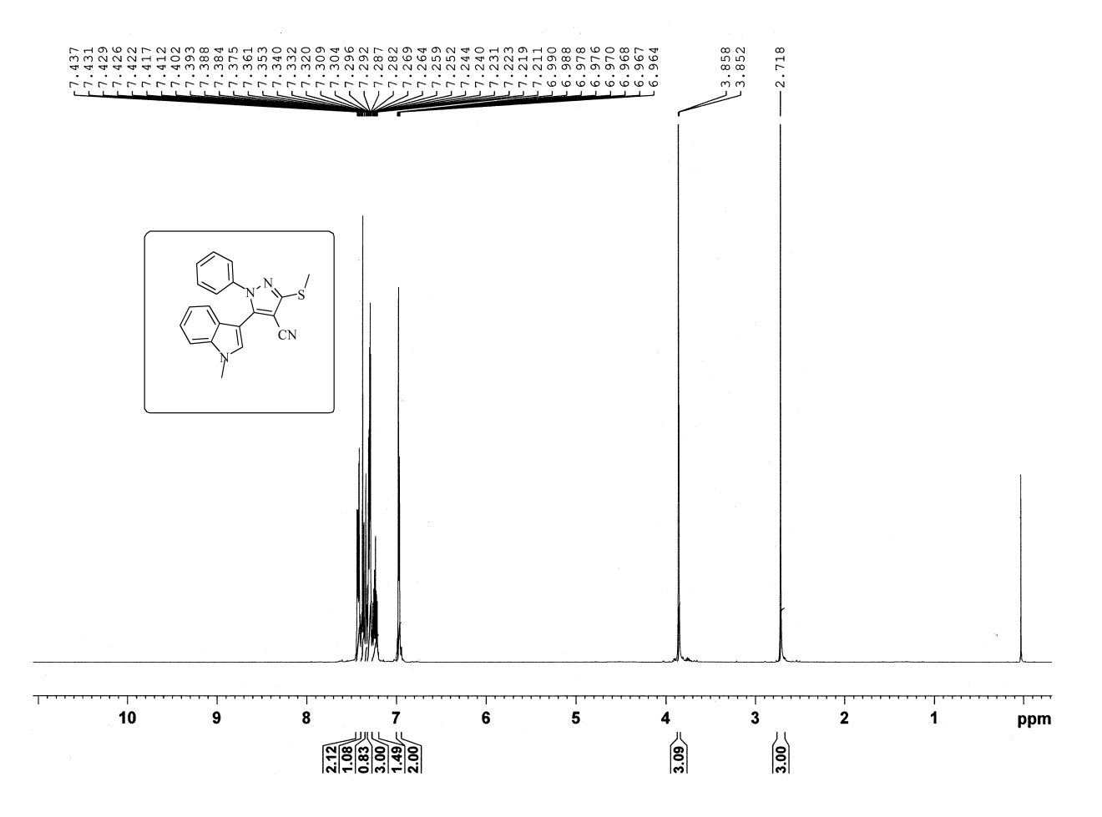

**Figure S 2:** 1H NMR of Compound 4a

D:\My lappy\Desktop\a\161 C Expansion.tif

**Figure S 3:** 1H NMR of Compound 4a (Expansion)

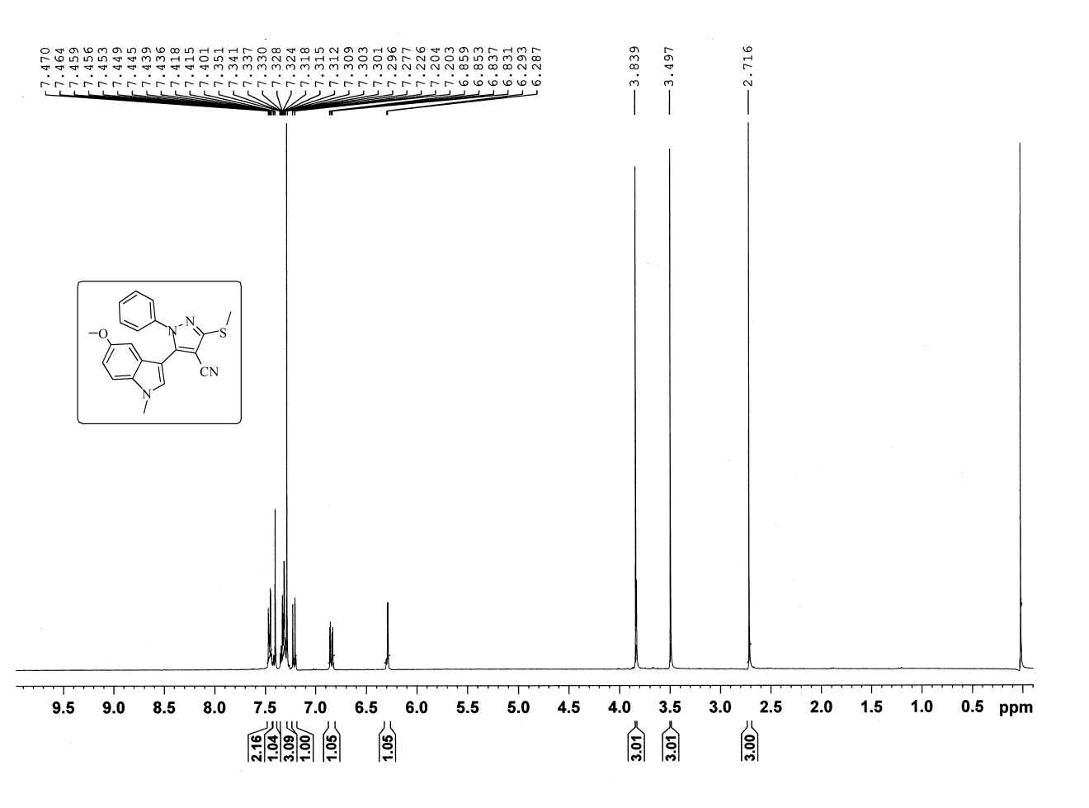

**Figure S 4:** 1H NMR of Compound 4d

D:\My lappy\Desktop\a\164 C Expansion.tif

**Figure S 5:** 1H NMR of Compound 4d (Expansion)

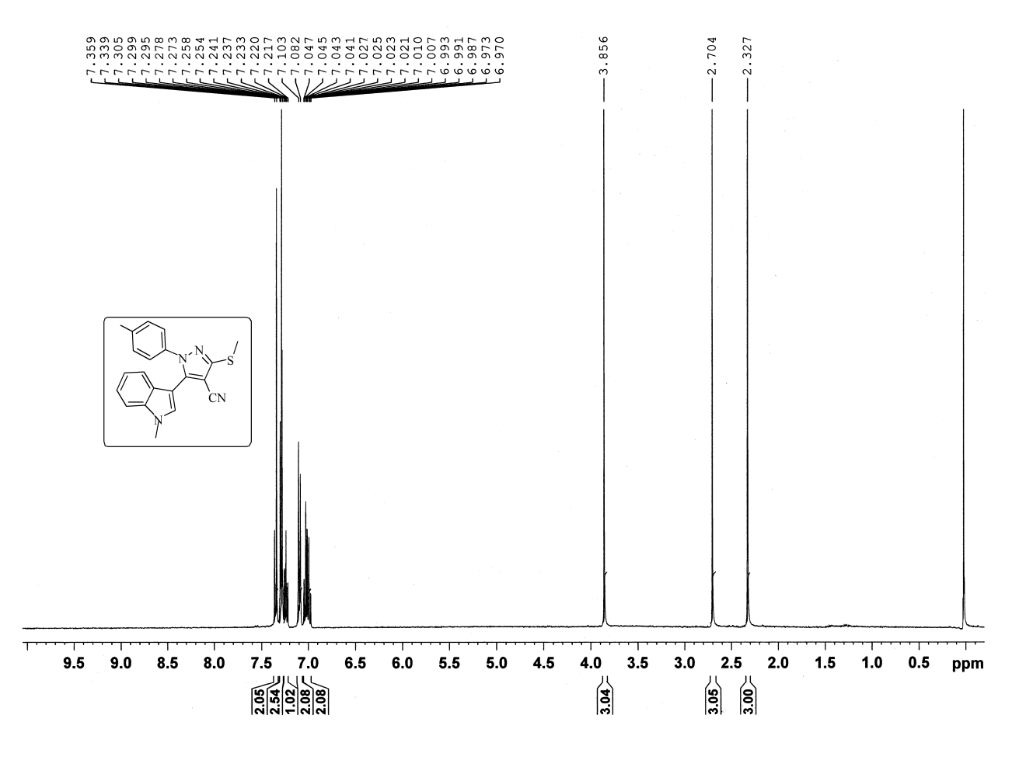

**Figure S 6:** 1H NMR of Compound 4e

D:\My lappy\Desktop\a\165 C Expansion.tif

**Figure S 7:** 1H NMR of Compound 4e (Expansion)

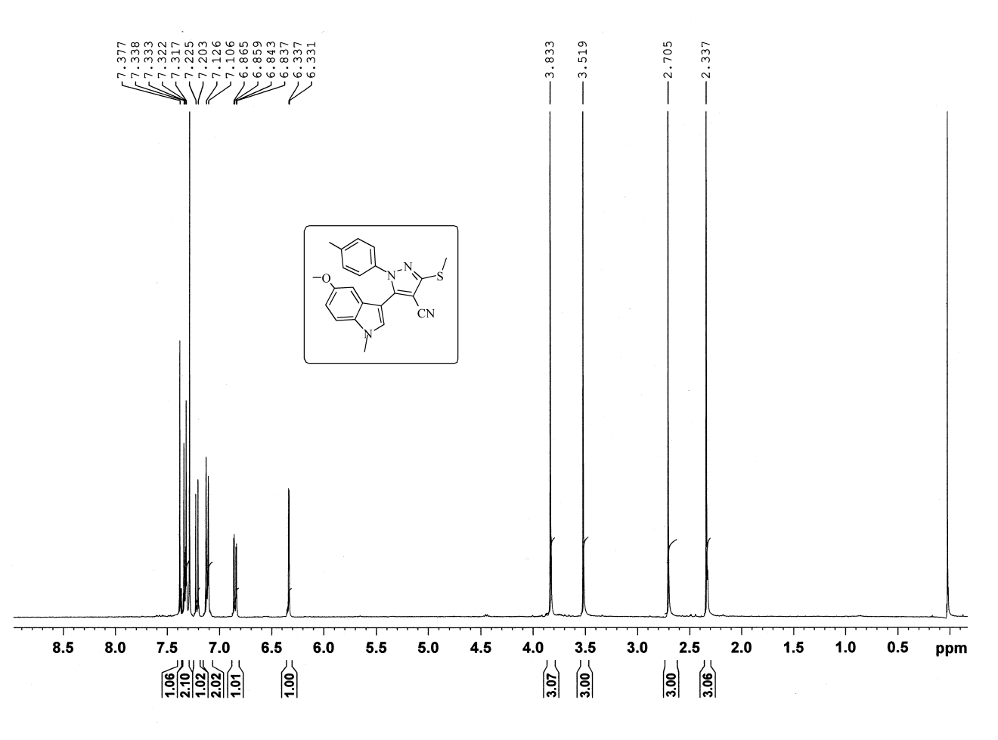

**Figure S 8:** 1H NMR of Compound4h

**D:\My lappy\Desktop\a\168 C Expansion.tif**

**Figure S 9:** 1H NMR of Compound4h (Expansion)

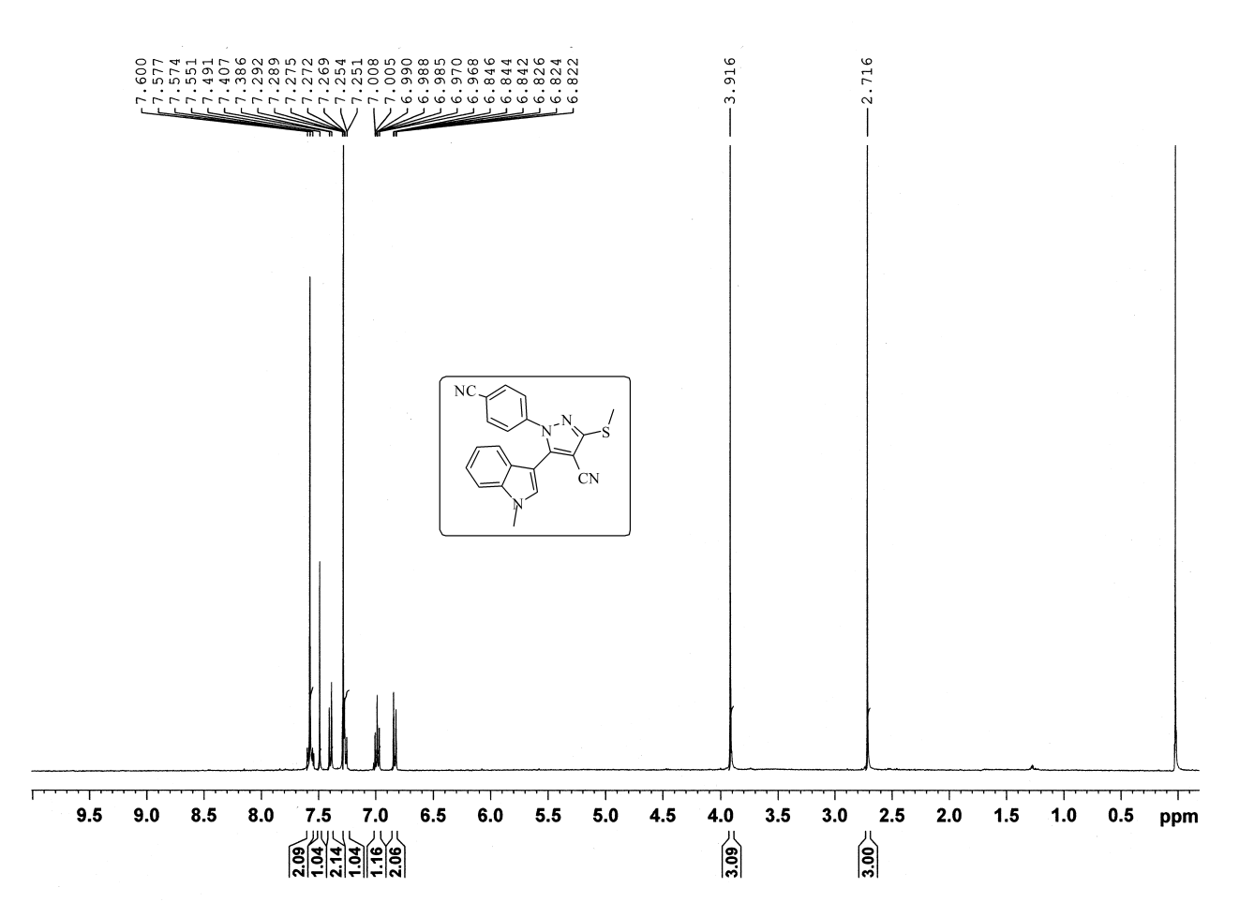

**Figure S 10:** 1H NMR of Compound 4i

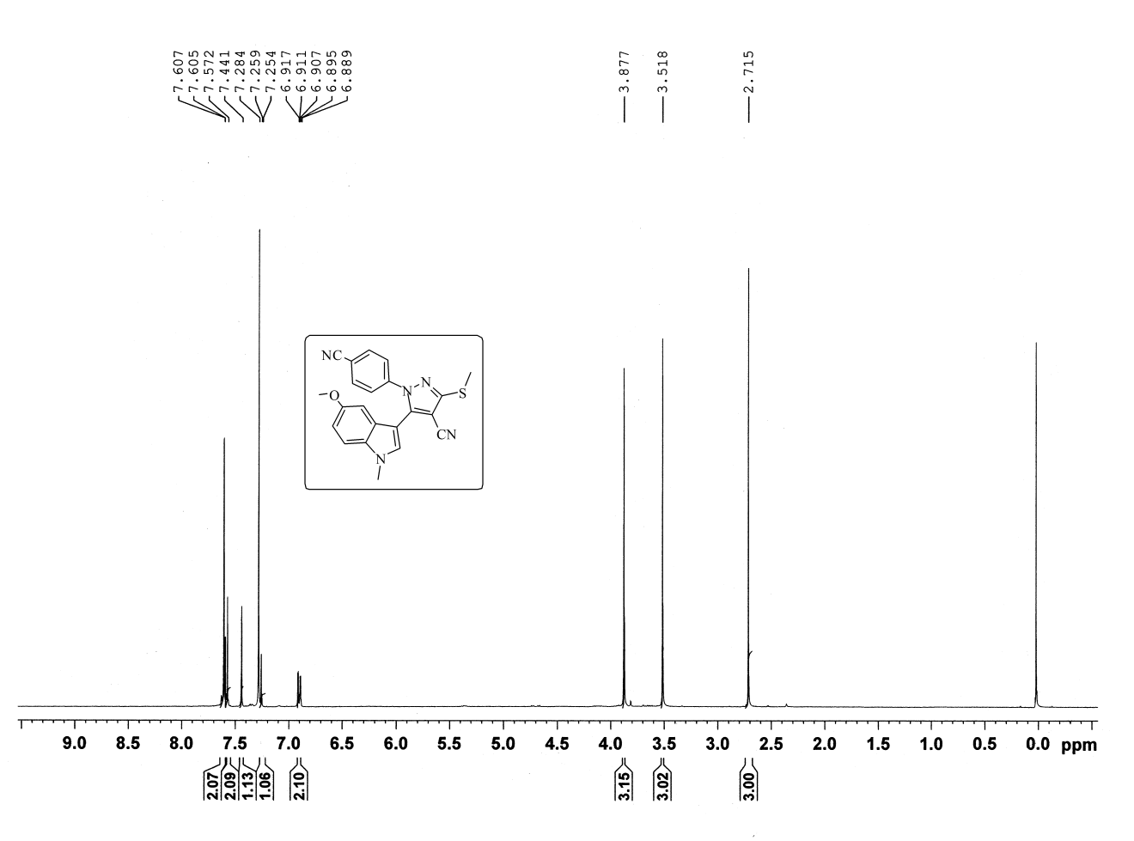

**Figure S 11:** 1H NMR of Compound 4l

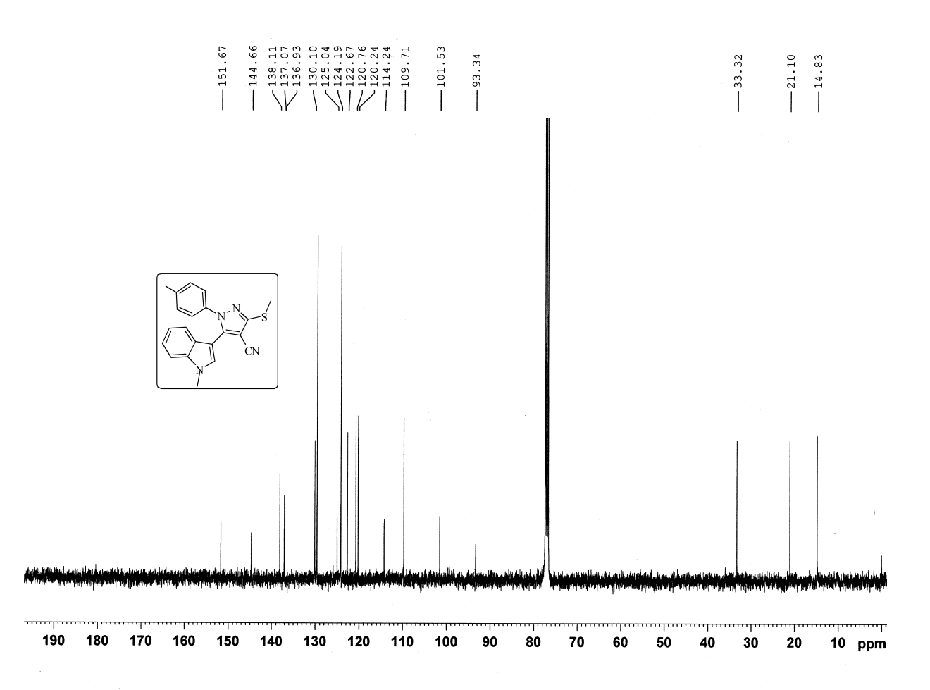

**Figure S 12:** 13C NMR of Compound 4e

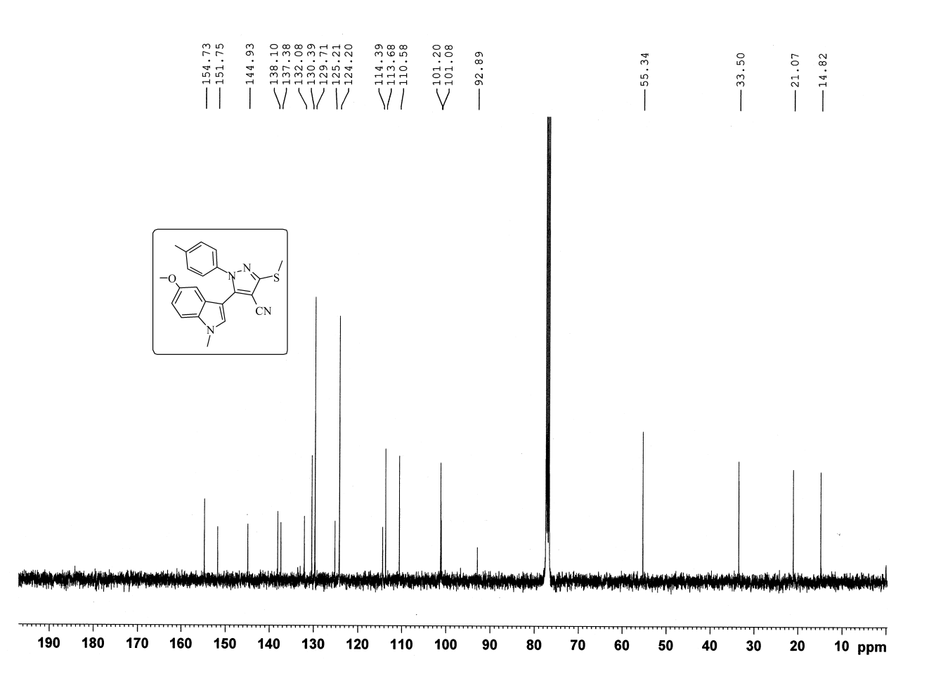

**Figure S 13:** 13C NMR of Compound 4h

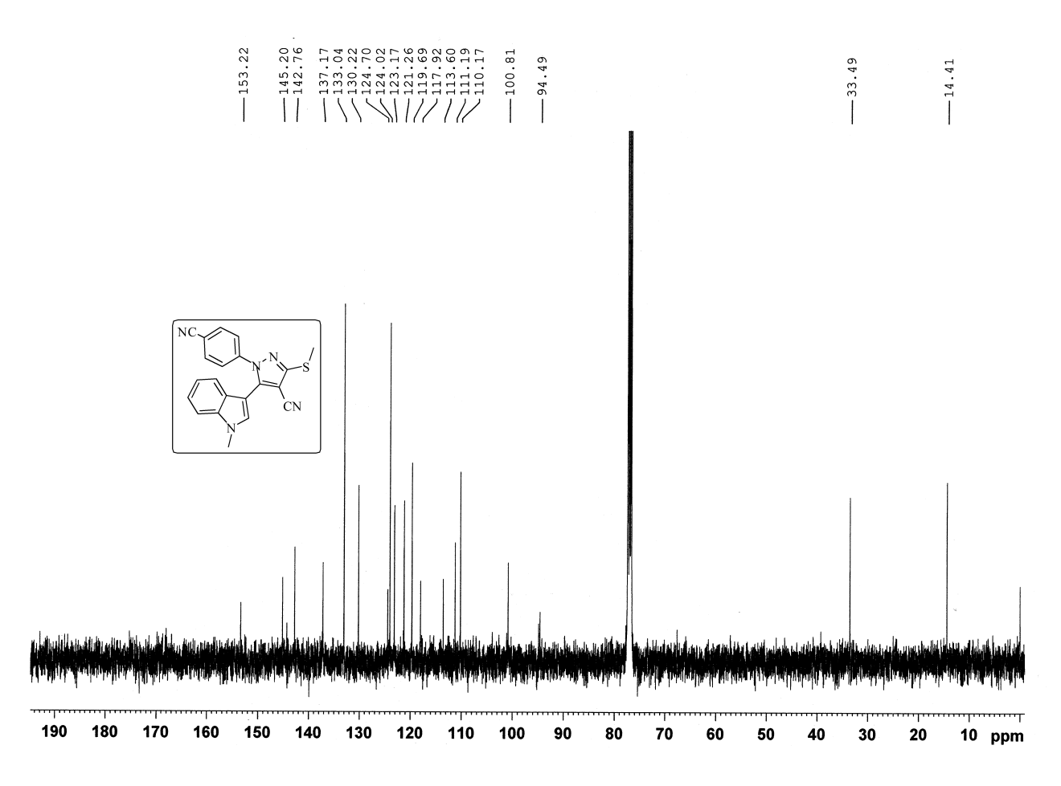

**Figure S 14:** 13C NMR of Compound 4i



**Figure S 15:** HRMS of Compound 4a



**Figure S 16:** HRMS of Compound 4d



**Figure S 17:** HRMS of Compound 4e



**Figure S 18:** HRMS of Compound 4f



**Figure S 19:** HRMS of Compound 4h



**Figure S 20:** HRMS of Compound 4i



**Figure S 21:** HRMS of Compound 4l

**References**

1. [] Slätt, J.; Romero, I.; Bergman, J. Cyanoacetylation of Indoles, Pyrroles and Aromatic Amines with the Combination Cyanoacetic Acid and Acetic Anhydride. *Synthesis*, **2004**, *16*, 2760–2765. DOI: 10.1055/s-2004-831164.
2. []  [Junjappa,](https://www.sciencedirect.com/science/article/pii/S0040402001877486#!) [H.; Ila,](https://www.sciencedirect.com/science/article/pii/S0040402001877486" \l "!) H.; [Asokan](https://www.sciencedirect.com/science/article/pii/S0040402001877486#!), C. V. α-Oxoketene-S,S-, N,S- and N,N-acetals: Versatile intermediates in organic synthesis. [*Tetrahedron*](https://www.sciencedirect.com/science/journal/00404020), **1990**, *46*, 5423-5506. DOI: 10.1016/S0040-4020(01)87748-6.
3. [] Skehan, P.; Storeng, R.; Scudiero, D.; Monks, A.; McMahon, J.; Vistica, D.; Warren, J. T.; Bokesch, H.; Kenney, S. and Boyd, M. R. New Colorimetric Cytotoxicity Assay for Anticancer-Drug Screening. *J. Natl. Cancer Inst.*, **1990**, *82*, 1107-1112. DOI: 10.1093/jnci/82.13.1107.
4. [] Ilhami, G.I.; Haci, A.A.; Mehmet, C. Determination of in vitro antioxidant and radical scavenging activities of propofol. *Chem. Pharm. Bull.* **2005**, *53*, 281–285. PMID: 15744098.
5. [] Robak, J.; Gryglewski, R.J. Flavonoids are scavengers of superoxide anions. *Biochem Pharmaco.* **1988**, *37*, 837–841. PMID: 2830882.