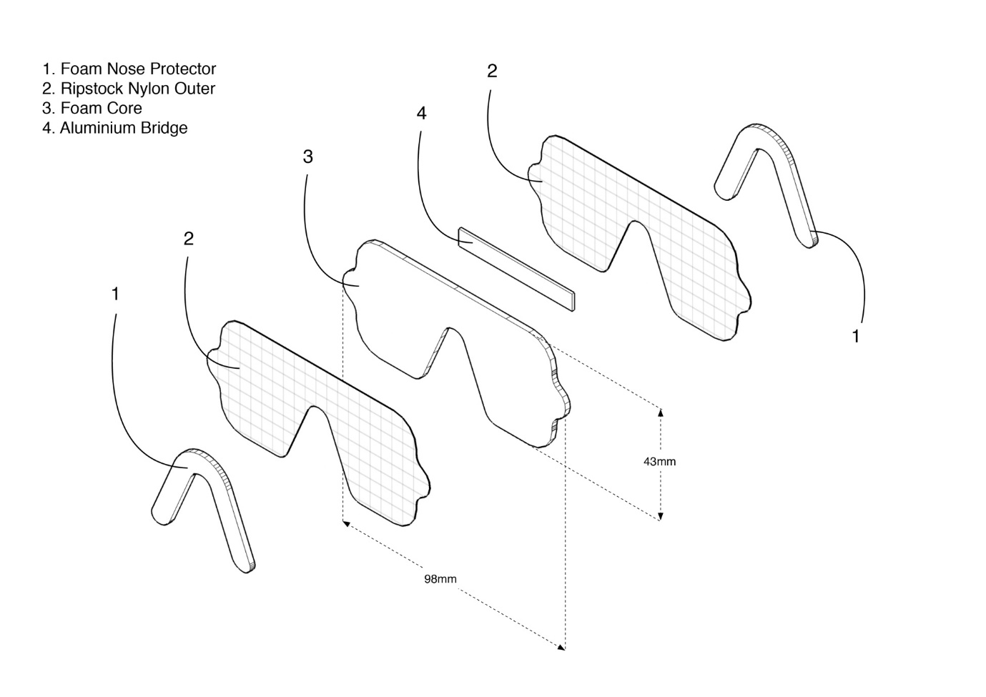
Figure S1. The design for the eye shield (or ‘sunglasses’) used to protect the eyes of live Puffins from the UV light source. Foam ‘nose’ protector (1) aperture size was determined by specimen bill biometrics, ~28.5 mm. Outer layers (2) were made from opaque, water proof dark grey ripstock nylon to prevent any reflection of the UV light source. These were adhered to a foam core with an aluminium bridge (4) which allowed the glasses to be manipulated around the face.

