**SUPPLEMENTARY INFORMATION**

**Table S1.** Species, sex, sample size, age and biometrics (mean ± SD) on the investigated sculpins. F: female. M: male. n/a: not available.

|  |  |  |  |  |  |  |  |
| --- | --- | --- | --- | --- | --- | --- | --- |
| Site | Species | Sex | *n* | Age  (y) | Total length  (cm) | Mass  (g) | Scaled Mass Index  (SMI) |
| 1 | *M. scorpius* | F | 10 | 10.5 ± 2.3 | 36.7 ± 5.3 | 703 ± 210 | 311 ± 55.7 |
|  |  | M | 0 | n/a | n/a | n/a | n/a |
| 2 | *M. scorpius* | F | 5 | 7.8 ± 2.2 | 28.3 ± 6.7 | 365 ± 274 | 309 ± 50.1 |
|  |  | M | 5 | 5.9 ± 2.4 | 25.0 ± 1.9 | 183 ± 26.0 | 267 ± 24.0 |
| 3 | *M. quadricornis* | F | 4 | 7.3 ± 1.0 | 22.1 ± 3.6 | 114 ± 13.7 | 271 ± 114 |
|  |  | M | 6 | 5.6 ± 0.8 | 20.8 ± 0.5 | 122 ± 15.0 | 316 ± 31.5 |

**Table S2.** Work sheet for histological interpretation of a gill sample. Column, rp: Reaction pattern includes C: Circulatory disturbances (red), RC: Regressive changes (yellow), PC: Progressive changes (green), I: Inflammation (blue) and T: Tumour (purple). The histopathological alterations within each reaction pattern is found in the “Alteration” column.



**Table S3.** Work sheet for histological interpretation of a liver sample. Column, rp: Reaction pattern includes C: Circulatory disturbances (red), RC: Regressive changes (yellow), PC: Progressive changes (green), I: Inflammation (blue) and T: Tumour (purple). The histopathological alterations within each reaction pattern is found in the “Alteration” column.



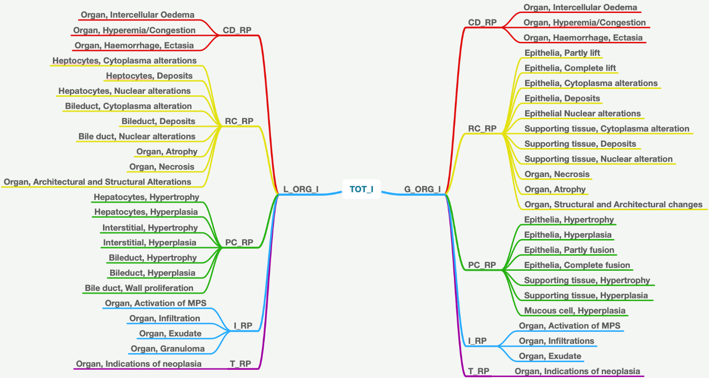

**∑RP_L = L_ORG_I**

**∑RP_G = G_ORG_I**

**L_ORG_I + G_ORG_I = TOT_I**

**Figure S1.** Flow-chart of collecting the specific alterations values for liver (Left side) and gills (Right side) and summarizing them into the different reaction pattern values: CD_RP (Circulatory disturbances), RC_RP (Regressive changes), PC_RP (Progressivce changes), I_RP (Inflammation) and T_RP (Tumor) for both liver and gills . The reaction pattern values summarized provide an organ index for both liver (L_ORG_I) and gills (G_ORG_I) that is summarized to a total histological alteration index (Tot_I), illustrated by the middle of the figure. MPS = activation of the Mononuclear Phagocyte Systems.