Title: Environmental cognitions mediate the causal explanation of land change

Operationalization of the PAD measurements in a case study in Northeast China
The operationalization of PAD measurement is illustrated by reconciling two related case studies on farmers’ decision-making processes from the same region, specifically, in three towns (namely XinDian, BinAn, and ChangAn) in Bin County, Heilongjiang Province (Figure S1) (Yu et al. 2013, Yu et al. 2014).

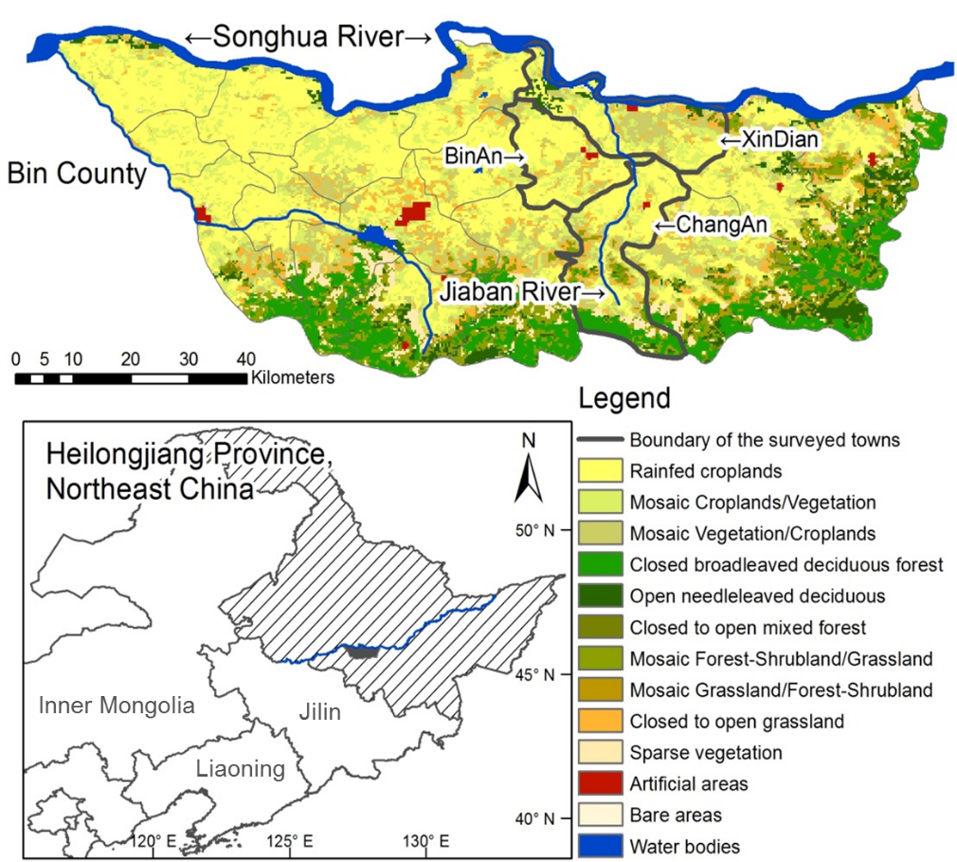
Figure S1. Location and land use of the case study area.

Evidence obtained from a detailed household survey – carried out in April 2012, covering all 24 villages in the three towns, with a final 384 farmer household samples – was selected to present the perceptions, attitude, and decisions respectively. The survey questionnaires regarding these aspects are compiled in Table S1.

The measurement for perceptions was qualitative and only required farmers to report his/her perception on changes of those variables from past to present, e.g., increased/decreased/unchanged. Regarding attitudes, one question was whether this factor (any item from Table S1) has affected decision-making and how important is it? We distinguished two aspects of attitude (i.e. land use right transfer and crop choice) and applied a semi-quantitative measurement to obtain farmers’ attitudes by assigning points, corresponding to different levels of importance. Decisions in the case study are in accordance to land transfer decisions and crop selection/replacement, as they are the most important agricultural land use decisions in the study region.

Table S1. Possible factors and their corresponding attitudes that may influence decisions, in addition to the variables selected for the assessment of perception (marked with “#”).
Category | Factor | Abbr. name
Internal | (1) Education of the family head and the average level of the family | Education
 | (2) Agricultural labourers in the family | Labor
 | (3) Age of the family head and the structure of the family | Age
 | (4) Distributed land area got from the village cooperative | DistriAcreage
 | (5) General land quality of the farmland of the household | LandQuality
 | (6) Actual farming land area that is currently managed by the household | CurrentAcreage
 | (7) The balance of income and expenditure of the family | FamilyBal
 | (8) The income structure of the family | IncomeStruc
Biophysical | (1) Local temperature characteristics | Temperature#
 | (2) Local precipitation characteristics | Precipitation#
 | (3) Local characteristics of the length of growing degree days | GDDs#
 | (4) Local characteristics of agricultural disasters | AgriDisaster#
 | (5) Accessibility for advanced cropping systems and technology | CropSystem
 | (6) The yield for crops | CropYield#
Socioeconomic | (1) The price and costs for agricultural material input | InputPrice
 | (2) The condition of local infrastructure, including irrigation accessibility | Infrastructure
 | (3) The activities organized by local agricultural cooperatives | AgriCoop
 | (4) The price for crops | CropPrice
 | (5) Market accessibility and marketing channel | Market
 | (6) Accessibility for policy and subsidy | Policy

The evidence is compiled following the PAD sequence, and the main interpretations are presented in the main text.

Perceptions: The survey assessed the farmers’ perceptions of four environmental conditions in relation to observed changes between 1980 and 2010. Temperature increase, precipitation decrease, and increased length of the growing season were correctly perceived by 76%, 67%, and 70% of the farmers, respectively (see Table S2). In contrast, the increase in frequency of disasters was perceived correctly by only 42% of the local farmers.

Table S2. Comparison between observed and perceived climate change in Bin County, China.
 | From meteorological/statistical data |  |  | From survey data
 | 1980s | 2010s | Δ | Correct perception | Percentage
Temperature (°C) | 3.2 | 4.6 | 1.4 | Increased | 76%
Growing Season (°C) | 1253 | 1428 | 175 | Prolonged | 70%
Precipitation (mm) | 620 | 510 | -110 | Decreased | 67%
AgriDisaster (%) | 0.41 | 0.49 | 0.083 | Increased | 42%

Attitudes: Farmers’ attitudes towards the factors that may influence their decisions related to land transfer and crop choice were subsequently examined. The importance of a number of potential factors for individual farmers, categorized into internal factors, biophysical factors and socioeconomic factors, were assessed using a five-point scale. These measurements are hereafter referred to as “attitude scores”, as they express the attitude of the farmer towards these factors. Higher scores indicate that factors were more important to farmers in their decision-making. When aggregating scores for the three different categories, all have a higher influence on land transfer than on crop choice decisions. This indicates that most farmers in the region care more about whether to engage in agricultural activities and less about which crop they choose (Table S3 and Table S4).

Table S3. Aggregated analysis of attitude scores.
 | Score average |  | Standard deviation |  | Correlation coefficient  (between land transfer and crop choice) | p-value
 | Land transfer | Crop choice | Land transfer | Crop choice
Internal | 2.18 | 1.50 | 0.37 | 0.29 | 0.34 | 0.415
Biophysical | 2.66 | 2.18 | 0.72 | 0.45 | 0.92 | 0.010
Socioeconomic | 2.35 | 1.61 | 0.90 | 0.84 | 0.92 | 0.009

Decisions: Environmental conditions and attitudes towards various factors eventually yield two types of decisions: leasing more land to expand production and selecting the mix of crops grown on this land. These correspond to land transfer and crop choice, respectively. A quantitative binary-logit analysis was applied to check the relationships between the farmers’ stated attitude scores and their actual decisions (Table S4). The attitude scores with significant coefficients in the logit model are marked with “*” Figure 3 in the main text. These are generally the scores that have a relatively high average attitude score.

Table S4. Average attitude scores for land transfer and crop choice in relation to the actual decisions. Attitude scores significantly related to the actual decision in a logit model are indicated with asterisk(s).
 | Land transfer |  |  |  | Crop choice
 | Variable | Average  score | exp (β) values  in logit model |  | Variable | Average  score | exp (β) values in logit model
 |  |  |  |  |  |  | Rice | Beans | Tobacco
1 | CropYield | 3.78 | 1.265 |  | CropPrice | 3.07 | 0.714 | 1.1 | 1.058
2 | CropPrice | 3.47 | 0.651* |  | CropYield | 2.91 | 0.434* | 0.96 | 1.609
3 | CropSystem | 3.34 | 0.852 |  | CropSystem | 2.49 | 1.049 | 1.27 | 0.182**
4 | Policy | 3.02 | 0.88 |  | FamilyBal | 2.16 | 1.754* | 1.133 | 1.329
5 | DistriAcreage | 2.55 | 1.381* |  | GrowingSeason | 2.08 | 2.36* | 0.99 | 1.696
6 | Infrastructure | 2.52 | 1.625** |  | Temperature | 2.05 | 0.576 | 0.99 | 0.495
7 | CurrentAcreage | 2.47 | 1.411 |  | Policy | 1.89 | 2.215** | 0.8 | 1.275
8 | Education | 2.46 | 0.685** |  | AgriDisaster | 1.81 | 0.671 | 0.9 | 0.184**
9 | FamilyBal | 2.41 | 1.25 |  | Precipitation | 1.72 | 1.269 | 1.221 | 1.011
10 | Precipitation | 2.29 | 1.339 |  | LandQuality | 1.63 | 0.858 | 1.143 | 0.775
11 | LandQuality | 2.29 | 1.198 |  | Education | 1.52 | 1.81 | 0.763 | 1.932
12 | AgriDisaster | 2.23 | 0.762 |  | IncomeStruc | 1.48 | 1.233 | 0.969 | 1.738
13 | InputPrice | 2.18 | 1.025 |  | InputPrice | 1.44 | 0.95 | 0.769 | 1.005
14 | Temperature | 2.16 | 0.947 |  | Infrastructure | 1.39 | 5.066* | 1.265 | 3.525
15 | GrowingSeason | 2.15 | 0.753 |  | Market | 1.37 | 0.145** | 1.335 | 0
16 | Market | 2.03 | 0.934 |  | DistriAcreage | 1.35 | 1.74 | 0.76 | 0.902
17 | Labor | 1.88 | 0.794 |  | CurrentAcreage | 1.35 | 0.661 | 0.993 | 3.308
18 | Age | 1.77 | 1.014 |  | Labor | 1.29 | 0.45 | 1.098 | 0
19 | IncomeStruc | 1.61 | 0.868 |  | Age | 1.25 | 1.057 | 0.963 | 1.683
20 | AgriCoop | 0.86 | 0.759 |  | AgriCoop | 0.54 | 0.167 | 1.04 | 2.203
ROC statistic |  |  | 0.823 |  | ROC statistic |  | 0.898 | 0.665 | 0.897
Nagelkerke R Square |  |  | 0.351 |  | Nagelkerke R Square |  | 0.53 | 0.103 | 0.521
* implies significance at p＜0.1 and ** implies significance at p＜0.05 level

A collection of underlying driving forces of agricultural land change in Northeast China
By applying the literature searching engines, e.g. Web of Science, Google Scholar, etc., a number of studies have sought to explain the causality in agricultural land systems in Northeast China (i.e. Heilongjiang, Jilin, and Liaoning Province), given its importance in becoming the major breadbasket for the country. Climate variables, especially changes in temperature and precipitation, are considered to be the most important factors determining changes in agricultural land systems (e.g., cropland conversions and crop pattern changes) in Northeast China given the recent global warming trend. At the same time, socioeconomic factors such as population, investment, off-farm employment and new policy implementation during the recent institutional reforms are also believed to impact land changes. The 23 relevant studies are listed in Table S5.

The temporal-spatial scales, research questions, and analytical frameworks of these studies are not necessarily consistent to each other, thus the collection and straightforward presentation of reported evidence of case studies only gives a general impression on the identified causes in the focused region. While these studies indicated the great impact brought by the factors from the underlying conditions, the role of human activities and decision-making have not been considered explicitly.

Table S5. Studies presenting underlying driving forces of agricultural land change in Northeast China.
No. | Time period | Major drivers | Reference
1 | 1975-2006 | Infrastructure, precipitation, agricultural population, per capita GDP, settlements | (Cui et al. 2014)
2 | 1958-2010 | Climate warming | (Gao and Liu 2011)
3 | 1900-1980 | Population increase, food production, natural disasters, government policies | (Ge and Dai 2005)
4 | 1989-2005 | Urban wages, failure of agricultural investment | (Jiang et al. 2012)
5 | 1730-1910 | Climate, population | (Lee 2014)
6 | 1980-2010 | Climate change, policy regulation, economic driving forces | (Liu et al. 2014)
7 | 2000-2005 | Climate warming, agricultural policy, agronomic technology | (Liu et al. 2010)
8 | 1995–2000 | Production conditions, economic benefits, climatic conditions | (Liu et al. 2003)
9 | 2000-2008 | Policy, urbanization | (Qin et al. 2013)
10 | 1970s-2000s | Indicators of heat, water resources | (Shi et al. 2014)
11 | 1976-2005 | Institutional strategies, market policies | (Song et al. 2014)
12 | 1976-2005 | Climatic changes, population, groundwater harvesting, fertilizer application | (Song et al. 2012)
13 | 1996-2008 | Extensive use of fertilizers, machinery and pesticide, increased labour and capital input | (Wang et al. 2015b)
14 | 1954-2008 | Climate warming, precipitation decreasing, population, gross domestic product | (Wang et al. 2011)
15 | 1986-2000 | Climate warming, population augment, regional economic development, national and provincial policies | (Wang et al. 2009a)
16 | 1954-2000 | Climatic changes, population, GDP | (Wang et al. 2009b)
17 | 1980-2010 | Climate change | (Xia et al. 2014)
18 | 1999-2008 | Agricultural inputs including fertilizer inputs, pesticide inputs and agricultural plastic sheeting | (Xie et al. 2014)
19 | 1700s-2000s | Migration, wars, regime shift | (Ye et al. 2009)
20 | 1976–2001 | Industry structure, population | (Zang and Huang 2006)
21 | 1900-2000 | Population pressure | (Zhang et al. 2003)
22 | 1990-2009 | Off-farm employment of rural labour force, commercialization of agricultural product, regional comparative advantage | (Zhao et al. 2012)
23 | 1999-2005 | Fragmental terrain, soil salinization, deficiency of water resources, and loss of labour | (Zuo et al. 2013)

A collection of actor characteristics on agricultural land change in China

There are few publications focusing on actors’ characteristics and environmental cognitions in Northeast China. We assume that the influence of actors’ characteristics would have limited disparities across regions. Therefore, we expand the searching coverage to entire China, and we found 18 relevant publications focusing on actors’ characteristics (Table S6).

Table S6. Studies presenting actor characteristics on agricultural land change in China.
No. | Survey time | Major drivers | Reference
1 | 2009 | Education, labor, farming size | (Yan and Huo 2016)
2 | 2012 | Labor, household size, cropland area per labor, income, wage | (Yan et al. 2016)
3 | 2009 | Age, labor, household size, cropland area, total income, income structure | (Hao et al. 2015)
4 | 2011 | Age, labor, labor average age | (Zhang et al. 2014)
5 | 2005 | Gender of household head, income structure | (Yang and Xu 2014)
6 | 2000 | Household size, labor, off-farm labor, cropland area per capital, on-farm income | (Tan et al. 2006)
7 | 2012-2014 | Farming size | (Zhang et al. 2016)
8 | 2013 | Age, female ratio, farming size, off-farm income | (Yang et al. 2016b)
9 | 2014 | Age, Gender of household head, livestock income | (Yang et al. 2016a)
10 | 2014 | Age, agricultural equipment, off-farm income per capital | (Wang et al. 2016)
11 | 2013 | Off-farm labor, female labor, off-farm income | (Hua et al. 2016)
12 | 2007 | Age | (Chen et al. 2016)
13 | 2012 | Age, household children and elderly, education, labor, tractor, cattle, | (Wang et al. 2015c)
14 | 2010 | Education, value of agricultural assets | (Wang et al. 2015a)
15 | 2007-2009 | Household children and elderly, female labor, cropland area, off-farm income, | (Tian et al. 2015)
16 | 2011 | Age, longevity, household size, migrant farmer, land rent farmer, cropland area, plot number, net income per capital, subsidy received | (Bai et al. 2015)
17 | 2000/2008 | Cropland area | (Deininger et al. 2014)
18 | 2009 | Education, cropland area, farming size, off-farm income | (Lu et al. 2012)

Reference
Bai, X. H., H. M. Yan, L. H. Pan, and H. Q. Huang. 2015. Multi-Agent Modeling and Simulation of Farmland Use Change in a Farming-Pastoral Zone: A Case Study of Qianjingou Town in Inner Mongolia, China. Sustainability 7:14802-14833.
Chen, H., D. Lopez-Carr, Y. Tan, J. Xi, and X. Y. Liang. 2016. China's Grain for Green policy and farm dynamics: simulating household land-use responses. Regional Environmental Change 16:1147-1159.
Cui, L., C. Gao, D. Zhou, and L. Mu. 2014. Quantitative analysis of the driving forces causing declines in marsh wetland landscapes in the Honghe region, northeast China, from 1975 to 2006. Environmental Earth Sciences 71:1357-1367.
Deininger, K., S. Q. Jin, and F. Xia. 2014. Moving Off the Farm: Land Institutions to Facilitate Structural Transformation and Agricultural Productivity Growth in China. World Development 59:505-520.
Gao, J., and Y. Liu. 2011. Climate warming and land use change in Heilongjiang Province, Northeast China. Applied Geography 31:476-482.
Ge, Q., and J. Dai. 2005. Farming and forestry land use changes in China and their driving forces from 1900 to 1980. SCIENCE CHINA Earth Sciences 48:1747-1757.
Hao, H. G., X. B. Li, M. H. Tan, J. P. Zhang, and H. Y. Zhang. 2015. Agricultural land use intensity and its determinants: A case study in Taibus Banner, Inner Mongolia, China. Frontiers of Earth Science 9:308-318.
Hua, X. B., J. Z. Yan, H. L. Li, W. F. He, and X. B. Li. 2016. Wildlife damage and cultivated land abandonment: Findings from the mountainous areas of Chongqing, China. Crop Protection 84:141-149.
Jiang, L., X. Deng, and K. C. Seto. 2012. Multi-level modeling of urban expansion and cultivated land conversion for urban hotspot counties in China. Landscape and Urban Planning 108:131-139.
Lee, H. 2014. Climate-induced agricultural shrinkage and overpopulation in late imperial China. Climate Research 59:229-242.
Liu, J., W. Kuang, Z. Zhang, X. Xu, Y. Qin, J. Ning, W. Zhou, S. Zhang, R. Li, C. Yan, S. Wu, X. Shi, N. Jiang, D. Yu, X. Pan, and W. Chi. 2014. Spatiotemporal characteristics, patterns, and causes of land-use changes in China since the late 1980s. Journal of Geographical Sciences 24:195-210.
Liu, J., M. Liu, D. Zhuang, Z. Zhang, and X. Deng. 2003. Study on spatial pattern of land-use change in China during 1995–2000. Science in China Series D: Earth Sciences 46:373-384.
Liu, J., Z. Zhang, X. Xu, W. Kuang, W. Zhou, S. Zhang, R. Li, C. Yan, D. Yu, S. Wu, and N. Jiang. 2010. Spatial patterns and driving forces of land use change in China during the early 21st century. Journal of Geographical Sciences 20:483-494.
Lu, X., X. J. Huang, T. Y. Zhong, X. F. Zhao, Y. X. Chen, and S. Q. Guo. 2012. Comparative analysis of influence factors on arable land use intensity at farm household level: A case study comparing Suyu District of Suqian City and Taixing City, Jiangsu Province, China. Chinese Geographical Science 22:556-567.
Qin, Y., H. Yan, J. Liu, J. Dong, J. Chen, and X. Xiao. 2013. Impacts of ecological restoration projects on agricultural productivity in China. Journal of Geographical Sciences 23:404-416.
Shi, W., F. Tao, J. Liu, X. Xu, W. Kuang, J. Dong, and X. Shi. 2014. Has climate change driven spatio-temporal changes of cropland in northern China since the 1970s? Climatic Change 124:163-177.
Song, K., Z. Wang, J. Du, L. Liu, L. Zeng, and C. Ren. 2014. Wetland degradation: its driving forces and environmental impacts in the Sanjiang Plain, China. Environ. Manage. 54:255-271.
Song, K., Z. Wang, L. Li, L. Tedesco, F. Li, C. Jin, and J. Du. 2012. Wetlands shrinkage, fragmentation and their links to agriculture in the Muleng–Xingkai Plain, China. Journal of Environmental Management 111:120-132.
Tan, S. H., N. Heerink, and F. T. Qu. 2006. Land fragmentation and its driving forces in China. Land Use Policy 23:272-285.
Tian, Q., D. G. Brown, L. Zheng, S. H. Qi, Y. Liu, and L. G. Jiang. 2015. The Role of Cross-Scale Social and Environmental Contexts in Household-Level Land-Use Decisions, Poyang Lake Region, China. Annals of the Association of American Geographers 105:1240-1259.
Wang, C., L. P. Wang, F. X. Jiang, and Z. W. Lu. 2015a. Differentiation of Rural Households' Consciousness in Land Use Activities: A Case from Bailin Village, Shapingba District of Chongqing Municipality, China. Chinese Geographical Science 25:124-136.
Wang, G., Y. Liu, Y. Li, and Y. Chen. 2015b. Dynamic trends and driving forces of land use intensification of cultivated land in China. Journal of Geographical Sciences 25:45-57.
Wang, J. Y., K. Z. Chen, S. Das Gupta, and Z. H. Huang. 2015c. Is small still beautiful? A comparative study of rice farm size and productivity in China and India. China Agricultural Economic Review 7:484-509.
Wang, X., X. B. Li, L. J. Xin, M. H. Tan, S. F. Li, and R. J. Wang. 2016. Ecological compensation for winter wheat abandonment in groundwater over-exploited areas in the North China Plain. Journal of Geographical Sciences 26:1463-1476.
Wang, Z., N. Huang, L. Luo, X. Li, C. Ren, K. Song, and J. M. Chen. 2011. Shrinkage and fragmentation of marshes in the West Songnen Plain, China, from 1954 to 2008 and its possible causes. International Journal of Applied Earth Observation and Geoinformation 13:477-486.
Wang, Z., Z. Liu, K. Song, B. Zhang, S. Zhang, D. Liu, C. Ren, and F. Yang. 2009a. Land use changes in Northeast China driven by human activities and climatic variation. Chinese Geographical Science 19:225-230.
Wang, Z., K. Song, B. Zhang, D. Liu, C. Ren, L. Luo, T. Yang, N. Huang, L. Hu, H. Yang, and Z. Liu. 2009b. Shrinkage and fragmentation of grasslands in the West Songnen Plain, China. Agriculture, Ecosystems & Environment 129:315-324.
Xia, T., W. Wu, Q. Zhou, Q. Yu, P. H. Verburg, P. Yang, Z. Lu, and H. Tang. 2014. Spatio-Temporal Changes in the Rice Planting Area and Their Relationship to Climate Change in Northeast China: A Model-Based Analysis. Journal of Integrative Agriculture 13:1575-1585.
Xie, H., J. Zou, H. Jiang, N. Zhang, and Y. Choi. 2014. Spatiotemporal Pattern and Driving Forces of Arable Land-Use Intensity in China: Toward Sustainable Land Management Using Emergy Analysis. Sustainability 6:3504.
Yan, J. Z., Z. Y. Yang, Z. H. Li, X. B. Li, L. J. Xing, and L. X. Sun. 2016. Drivers of cropland abandonment in mountainous areas: A household decision model on farming scale in Southwest China. Land Use Policy 57:459-469.
Yan, X. H., and X. X. Huo. 2016. Drivers of household entry and intensity in land rental market in rural China Evidence from North Henan Province. China Agricultural Economic Review 8:345-364.
Yang, H., G. B. Villamor, Y. F. Su, M. C. Wang, and J. C. Xu. 2016a. Land-use response to drought scenarios and water policy intervention in Lijiang, SW China. Land Use Policy 57:377-387.
Yang, X. J., and J. T. Xu. 2014. Program sustainability and the determinants of farmers' self-predicted post-program land use decisions: evidence from the Sloping Land Conversion Program (SLCP) in China. Environment and Development Economics 19:30-47.
Yang, Z. H., A. W. Mugera, and F. Zhang. 2016b. Investigating Yield Variability and Inefficiency in Rice Production: A Case Study in Central China. Sustainability 8.
Ye, Y., X. Fang, Y. Ren, X. Zhang, and L. Chen. 2009. Cropland cover change in Northeast China during the past 300 years. Science in China Series D: Earth Sciences 52:1172-1182.
Yu, Q., W. Wu, Z. Liu, P. H. Verburg, T. Xia, P. Yang, Z. Lu, L. You, and H. Tang. 2014. Interpretation of climate change and agricultural adaptations by local household farmers: A case study at Bin County, Northeast China. Journal of Integrative Agriculture 13:1599-1608.
Yu, Q., W. Wu, P. H. Verburg, J. van Vliet, P. Yang, Q. Zhou, and H. Tang. 2013. A survey-based exploration of land-system dynamics in an agricultural region of Northeast China. Agricultural Systems 121:106-116.
Zang, S., and X. Huang. 2006. An aggregated multivariate regression land-use model and its application to land-use change processes in the Daqing region (northeast China). Ecological Modelling 193:503-516.
Zhang, B., H.-s. Cui, L. Yu, and Y.-f. He. 2003. Land reclamation process in northeast China since 1900. Chinese Geographical Science 13:119-123.
Zhang, F., J. Y. Zhan, Q. Zhang, H. M. Yan, and Z. X. Sun. 2016. Allocating agricultural production factors: A scenario-based modeling of wheat production in Shandong Province, China. Physics and Chemistry of the Earth 96:55-63.
Zhang, Y., X. B. Li, and W. Song. 2014. Determinants of cropland abandonment at the parcel, household and village levels in mountain areas of China: A multi-level analysis. Land Use Policy 41:186-192.
Zhao, Y., X. Li, L. Xin, and H. Hao. 2012. Geographic concentration and driving forces of agricultural land use in China. Frontiers of Earth Science 6:48-56.
Zuo, L.-j., X. Wang, F. Liu, and L. Yi. 2013. Spatial Exploration of Multiple Cropping Efficiency in China Based on Time Series Remote Sensing Data and Econometric Model. Journal of Integrative Agriculture 12:903-913.

