Synthesis Of Novel “Hybrid” Structures Based On Phosphorylacetic Acid Hydrazides And Sterically Hindered Phenols
S. V. Bukharov¹, Yu. N. Oludina¹, R. A. Khabibullina¹, A. R. Burilov^{1,2},
E. L. Gavrilova¹, I. A. Krutov¹, R. G. Tagasheva¹.
¹Kazan National Research Technological University, Kazan, Russian Federation
²Arbuzov Institute of Organic and Physical Chemistry, FRC Kazan Scientific Center of RAS, Kazan, Russian Federation
Email: cat_the_chemist@mail.ru
Supplemental Materials
¹H, ¹³C, and ³¹Р NMR spectra were recorded on Bruker Avance-400 (400, 100.6, and 162 MHz, respectively) and Bruker Avance-600 (600 and 150 MHz, respectively) instruments. Chemical shift values are reported relative to the residual signals of protons of deuterated solvent.
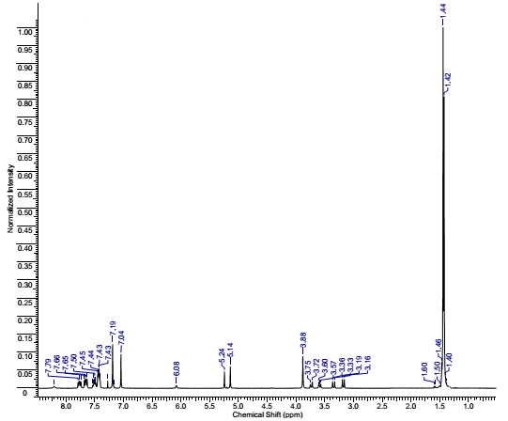
Figure S 1: The ¹H NMR spectrum of the N,N-bis-(3,5-di-tert-butyl-4-hydroxybenzyl)-(diphenylphosphoryl)-ethanehydrazide (6) (CDCl₃)
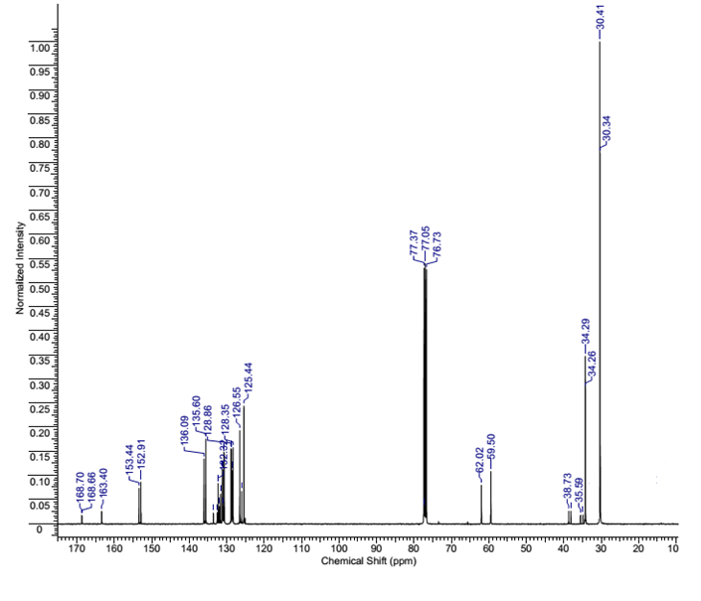
Figure S 2: The ¹³C NMR spectrum of the N,N-bis-(3,5-di-tert-butyl-4-hydroxybenzyl)-(diphenylphosphoryl)-ethanehydrazide (6) (CDCl₃)

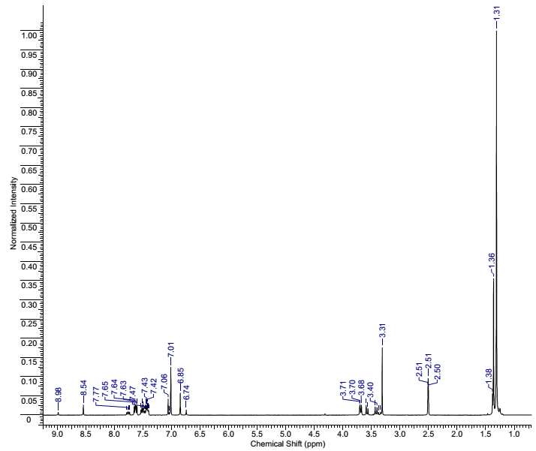
Figure S 3: The ¹H NMR spectrum of the N,N-bis-(3,5-di-tert-butyl-4-hydroxybenzyl)-(diphenylphosphoryl)-ethanehydrazide (6) (DMSO-d6)
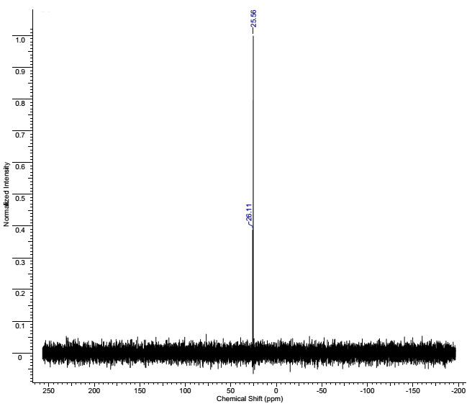
Figure S 4: The ³¹P NMR spectrum of the N,N-bis-(3,5-di-tert-butyl-4-hydroxybenzyl)-(diphenylphosphoryl)-ethanehydrazide (6) (DMSO-d6)

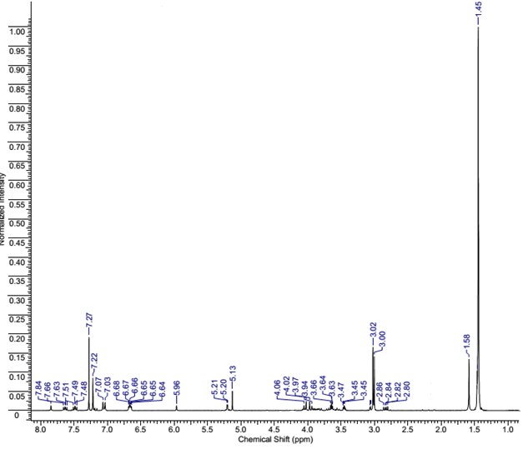
Figure S 5: The ¹H NMR spectrum of the N,N-bis-(3,5-di-tert-butyl-4-hydroxybenzyl)-{[4-(dimethylamino)phenyl]-(2-chloroethoxy)phosphoryl}ethanehydrazide (7) (CDCl₃).

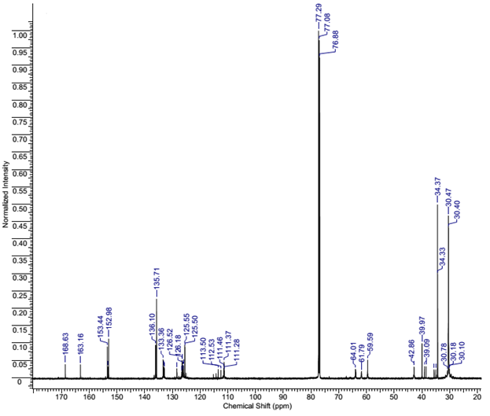

Figure S 6: The ¹³C NMR spectrum of the N,N-bis-(3,5-di-tert-butyl-4-hydroxybenzyl)-{[4-(dimethylamino)phenyl]-(2-chloroethoxy)phosphoryl}ethanehydrazide (7) (CDCl₃).

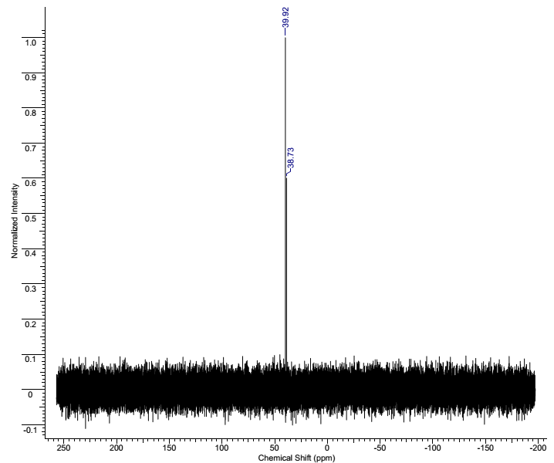
Figure S 7: The ³¹P NMR spectrum of the N,N-bis-(3,5-di-tert-butyl-4-hydroxybenzyl)-{[4-(dimethylamino)phenyl]-(2-chloroethoxy)phosphoryl}ethanehydrazide (7) (CDCl₃).
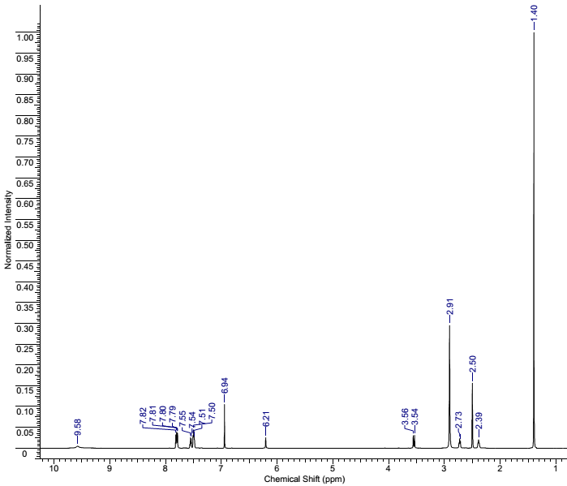
Figure S 8: The ¹H NMR spectrum of the 3- (3,5-di-tert-butyl-4-hydroxyphenyl) N- [2- (diphenylphosphino) acetyl ]–propanehydrazide (8) (DMSO-d6, 100ºC).
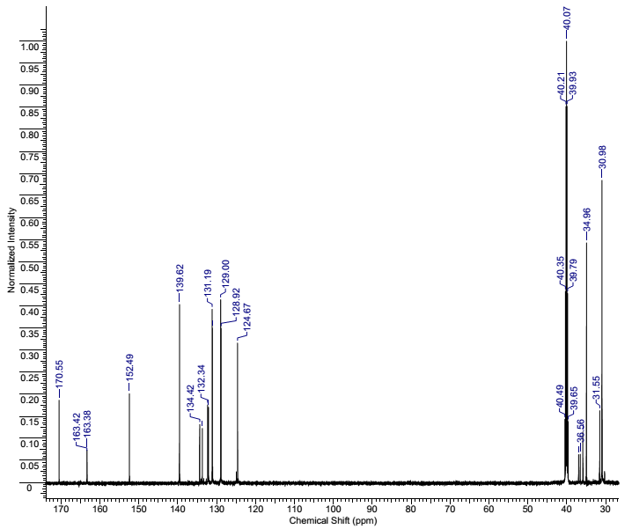
Figure S 9: The ¹³C NMR spectrum of the 3- (3,5-di-tert-butyl-4-hydroxyphenyl) N- [2- (diphenylphosphino) acetyl ]–propanehydrazide (8) (DMSO-d6).

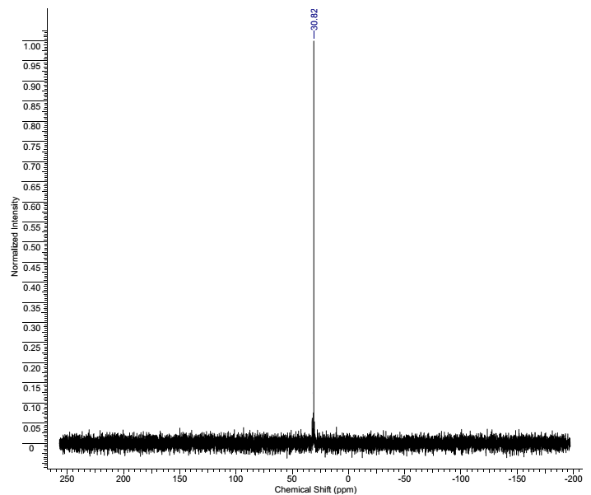
Figure S 10: The ³¹P NMR spectrum of the 3- (3,5-di-tert-butyl-4-hydroxyphenyl) N- [2- (diphenylphosphino) acetyl ]–propanehydrazide (8) (CDCl₃).
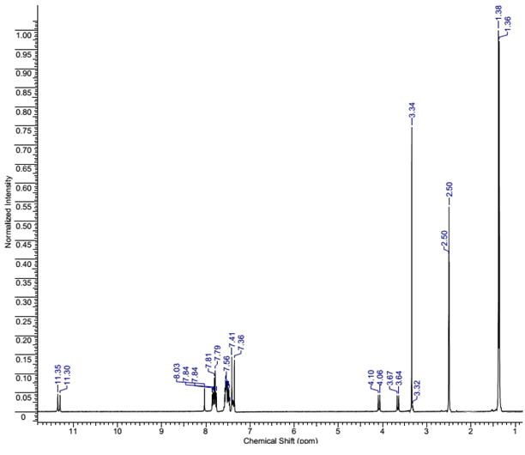
Figure S 11: The ¹H NMR spectrum of the N,N-3,5-di-tert-butyl-4-hydroxybenzylidene(diphenylphosphoryl)-ethanehydrazide (14) (DMSO-d6).
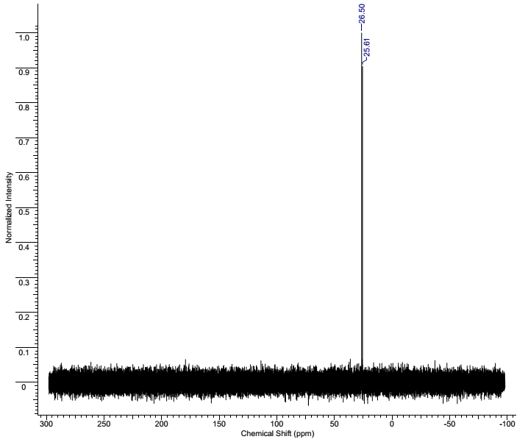
Figure S 12: The ³¹P NMR spectrum of the N,N-3,5-di-tert-butyl-4-hydroxybenzylidene(diphenylphosphoryl)-ethanehydrazide (14) (DMSO-d6).

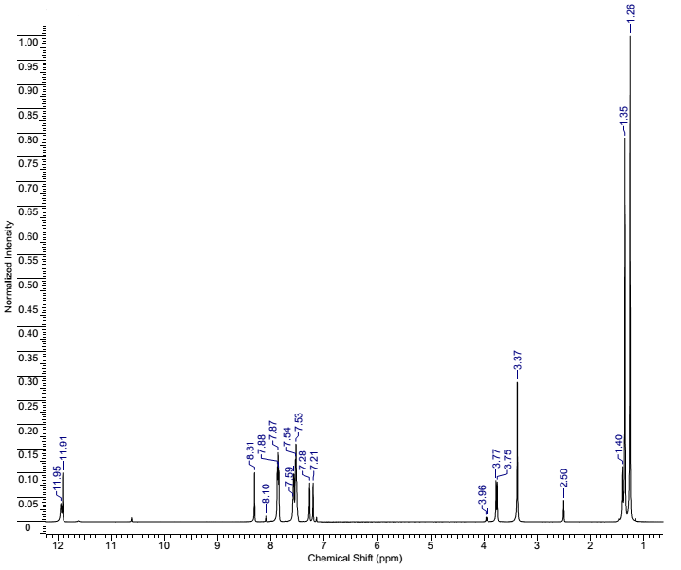
Figure S 13: The ¹H NMR spectrum of the N,N-3,5-di-tert-butyl-2-hydroxybenzylidene(diphenylphosphoryl)-ethanehydrazide (15) (DMSO-d6).
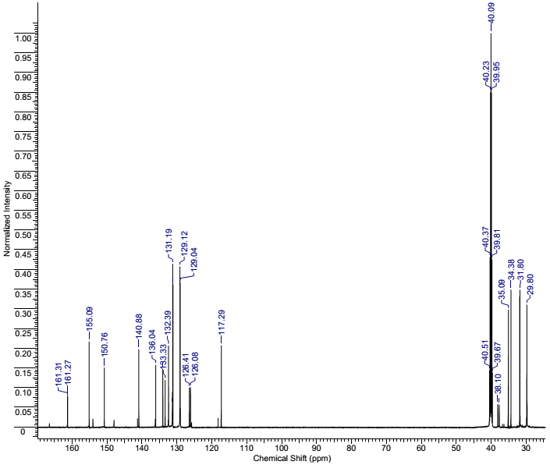
Figure S 14: The ¹³C NMR spectrum of the N,N-3,5-di-tert-butyl-2-hydroxybenzylidene(diphenylphosphoryl)-ethanehydrazide (15) (DMSO-d6).

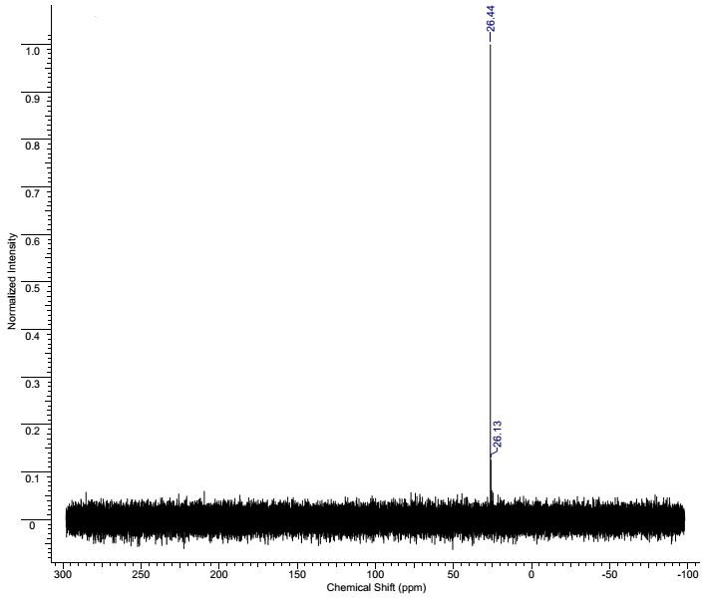
Figure S 15: The ³¹P NMR spectrum of the N,N-3,5-di-tert-butyl-2-hydroxybenzylidene(diphenylphosphoryl)-ethanehydrazide (15) (DMSO-d6).
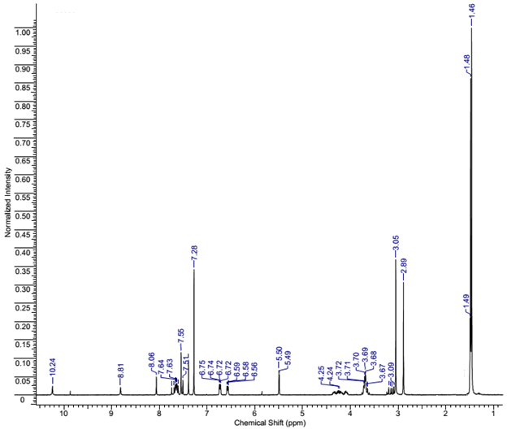
Figure S 16: The ¹H NMR spectrum of the N,N-3,5-di-tert-butyl-4-hydroxybenzylidene{[4-(dimethylamino)phenyl]-2-(chloroethoxy)phosphoryl}ethanehydrazide (16) (CDCl₃)
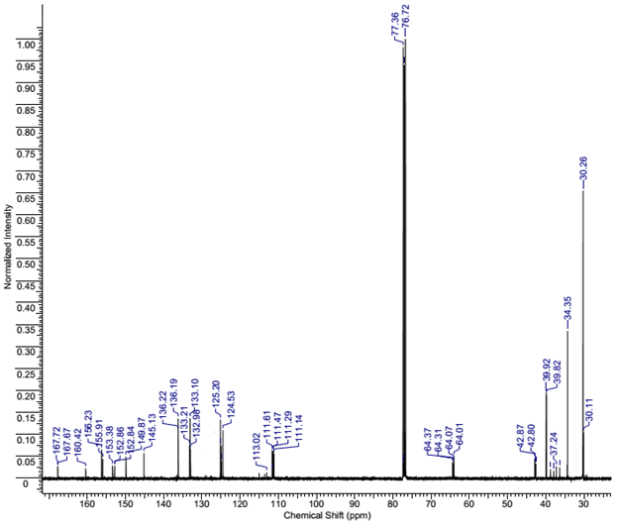
Figure S 17: The ¹³C NMR spectrum of the N,N-3,5-di-tert-butyl-4-hydroxybenzylidene{[4-(dimethylamino)phenyl]-2-(chloroethoxy)phosphoryl}ethanehydrazide (16) (CDCl₃)
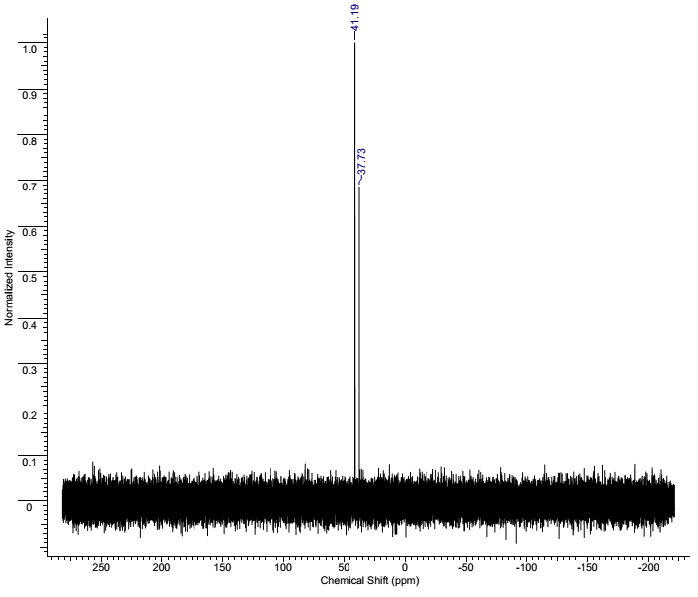
Figure S 18: The ³¹P NMR spectrum of the N,N-3,5-di-tert-butyl-4-hydroxybenzylidene{[4-(dimethylamino)phenyl]-2-(chloroethoxy)phosphoryl}ethanehydrazide (16) (CDCl₃)

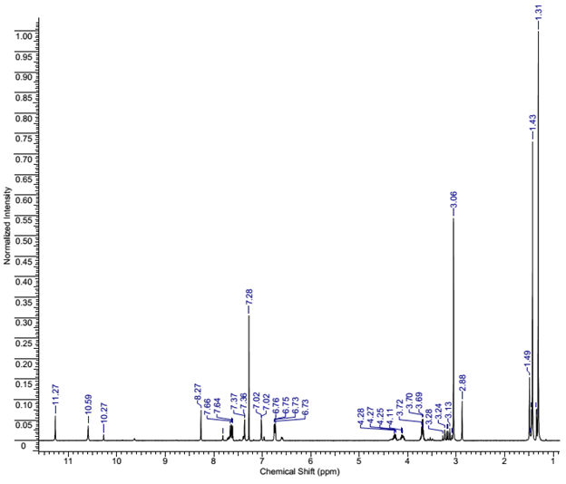
Figure S 19: The ¹H NMR spectrum of the N,N-3,5-di-tert-butyl-2-hydroxybenzylidene{[4-(dimethylamino)phenyl]-2-(chloroethoxy)phosphoryl}ethanehydrazide (17) (CDCl₃)
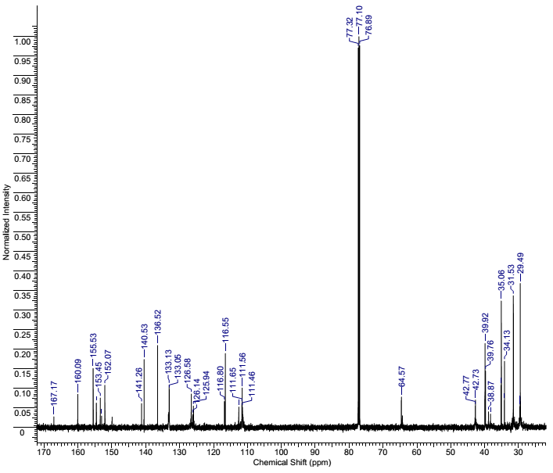
Figure S 20: The ¹³C NMR spectrum of the N,N-3,5-di-tert-butyl-2-hydroxybenzylidene{[4-(dimethylamino)phenyl]-2-(chloroethoxy)phosphoryl}ethanehydrazide (17) (CDCl₃)
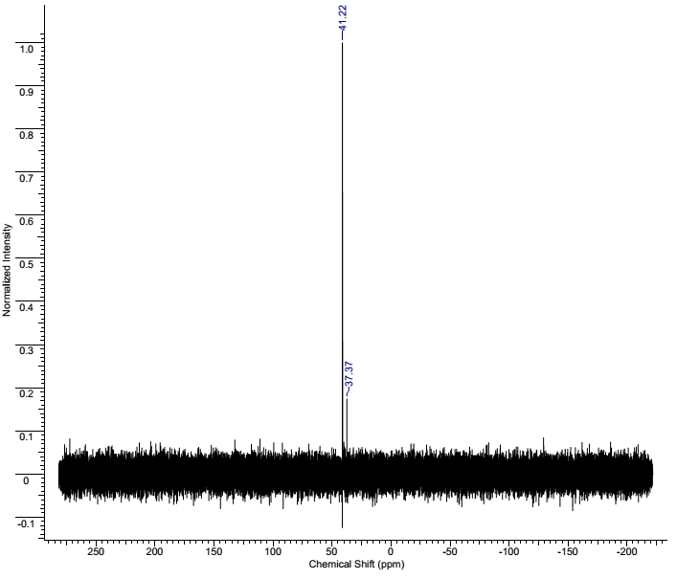
Figure S 21: The ³¹P NMR spectrum of the N,N-3,5-di-tert-butyl-2-hydroxybenzylidene{[4-(dimethylamino)phenyl]-2-(chloroethoxy)phosphoryl}ethanehydrazide (17) (CDCl₃)

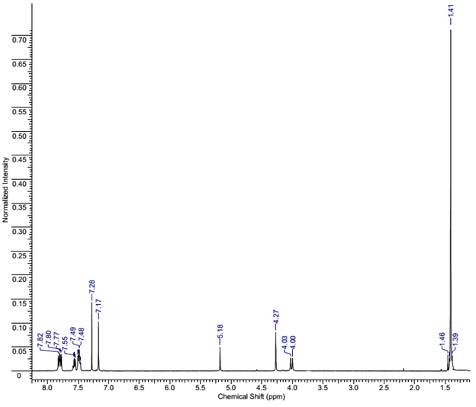
Figure S 22: The ¹H NMR spectrum of the 5-[(Diphenylphosphoryl)methyl]-3(3′,5′-di-tert-butyl-4′-hydroxybenzyl)thio-2,4-dihydro-3H-1,2,4-triazole (18) (CDCl₃)
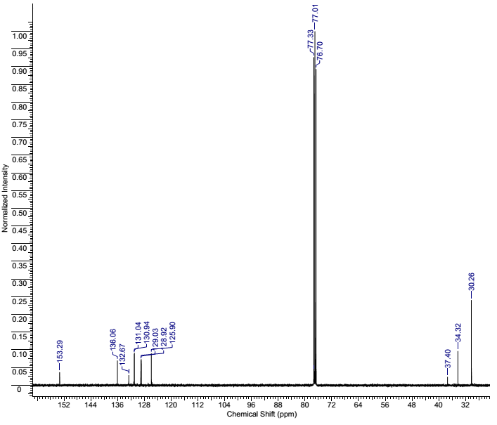
Figure S 23: The ¹³C NMR spectrum of the 5-[(Diphenylphosphoryl)methyl]-3(3′,5′-di-tert-butyl-4′-hydroxybenzyl)thio-2,4-dihydro-3H-1,2,4-triazole (18) (CDCl₃)
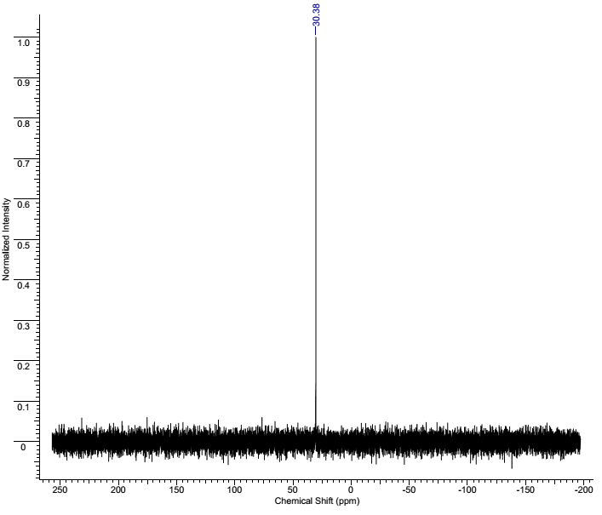
Figure S 24: The ³¹P NMR spectrum of the 5-[(Diphenylphosphoryl)methyl]-3(3′,5′-di-tert-butyl-4′-hydroxybenzyl)thio-2,4-dihydro-3H-1,2,4-triazole (18) (CDCl₃)
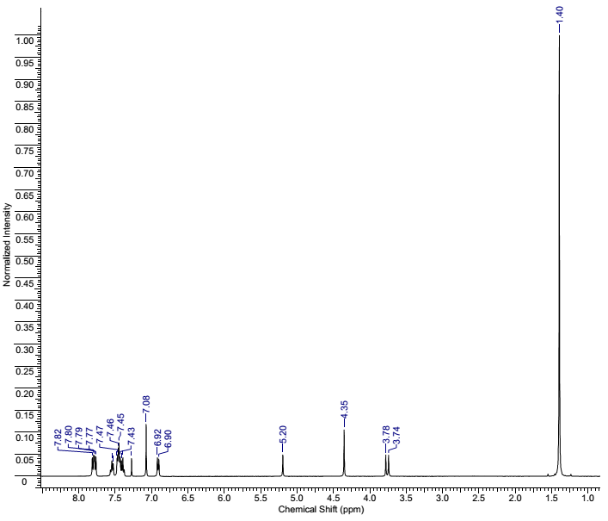
Figure S 25: The ¹H NMR spectrum of the 5-[(Diphenylphosphoryl)methyl]-4-phenyl-3(3′,5′-di-tert-butyl-4′-hydroxybenzyl)thio-2,4-dihydro-3H-1,2,4-triazole (19) (CDCl₃)

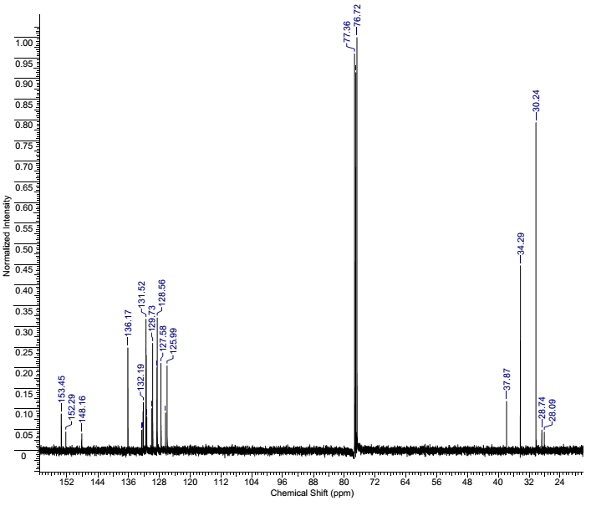
Figure S 26: The ¹³C NMR spectrum of the 5-[(Diphenylphosphoryl)methyl]-4-phenyl-3(3′,5′-di-tert-butyl-4′-hydroxybenzyl)thio-2,4-dihydro-3H-1,2,4-triazole (19) (CDCl₃)
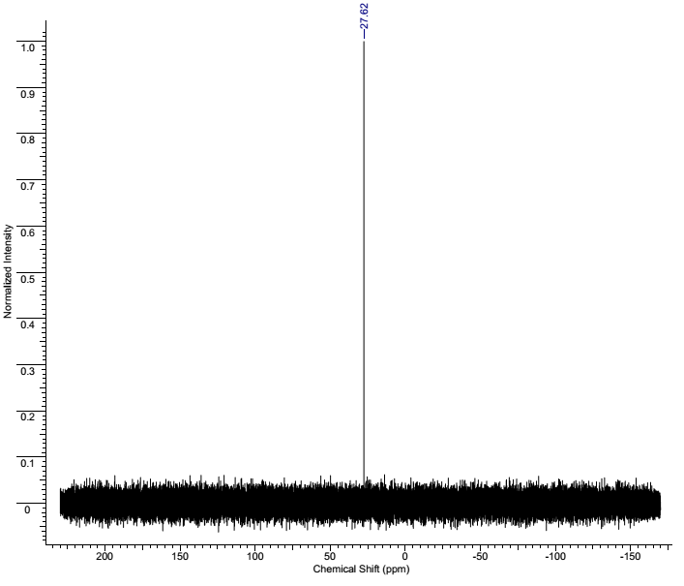
Figure S 27: The ³¹P NMR spectrum of the 5-[(Diphenylphosphoryl)methyl]-4-phenyl-3(3′,5′-di-tert-butyl-4′-hydroxybenzyl)thio-2,4-dihydro-3H-1,2,4-triazole (19) (CDCl₃)

