Nano catalytic synthesis of flavanone phosphonates using domino Knoevenagel-phospha-Michael route
Maryam Zarei, Soheila Ghassamipour*
Department of Chemistry, Marvdasht Branch, Islamic Azad University, Marvdasht, Iran
Email: soheilaghassamipour@miau.ac.ir
Supplemental Materials

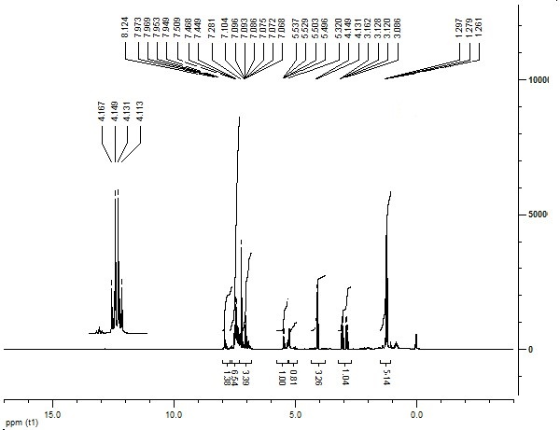

Figure S 1: ¹H-NMR of Diethyl (3,4-dihydro-4-oxo-2-phenyl-2H-chromen-3-yl) (phenyl) methylphosphonate

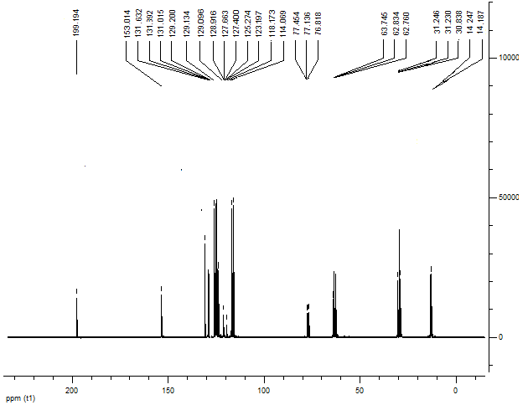

Figure S 2: ¹³C-NMR of Diethyl (3,4-dihydro-4-oxo-2-phenyl-2H-chromen-3-yl) (phenyl)methylphosphonate

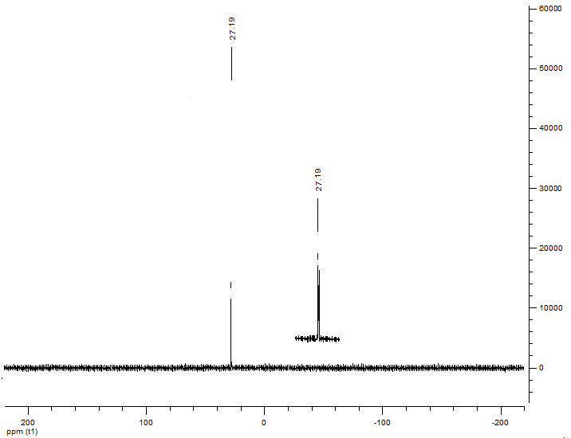
Figure S 3: ³¹P-NMR of Diethyl (3,4-dihydro-4-oxo-2-phenyl-2H-chromen-3-yl) (phenyl)methylphosphonate
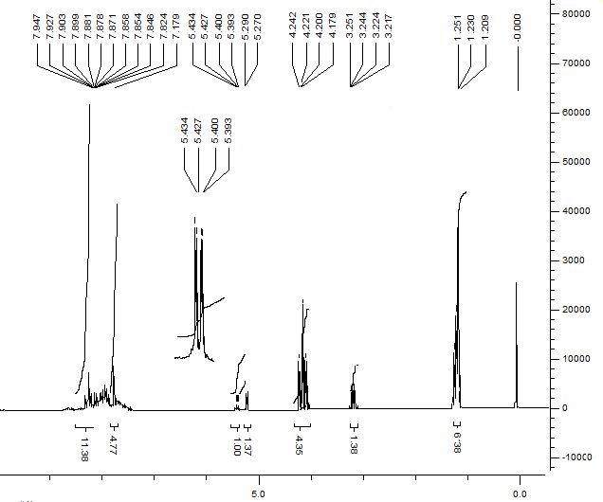
Figure S 4: ¹H-NMR of Diethyl (naphthalen-1-yl)(4-oxo-2-phenylchroman-3-yl) methylphosphonate

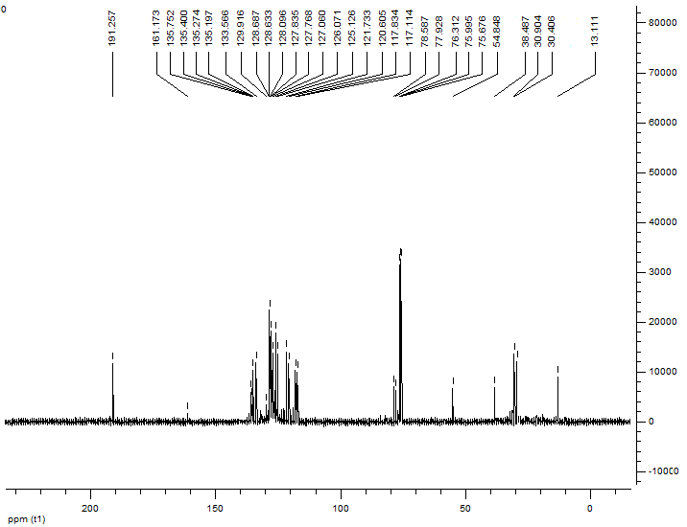

Figure S 5: ¹³C-NMR of Diethyl (naphthalen-1-yl)(4-oxo-2-phenylchroman-3-yl) methylphosphonate

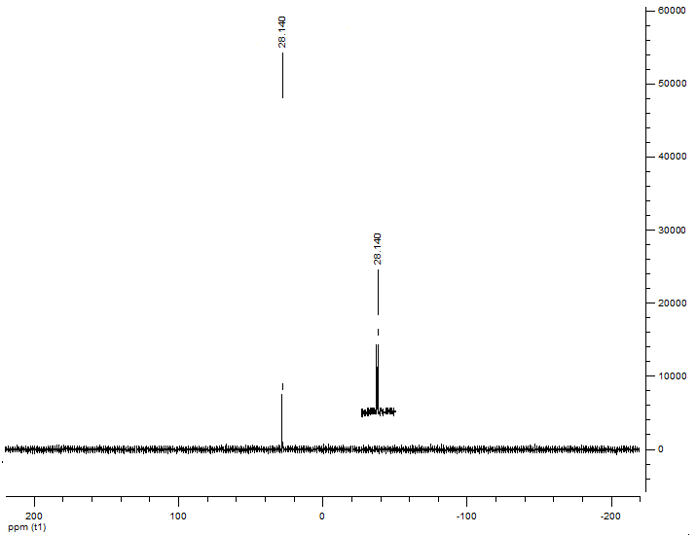
Figure S 6: ³¹P-NMR of Diethyl (naphthalen-1-yl)(4-oxo-2-phenylchroman-3-yl) methylphosphonate

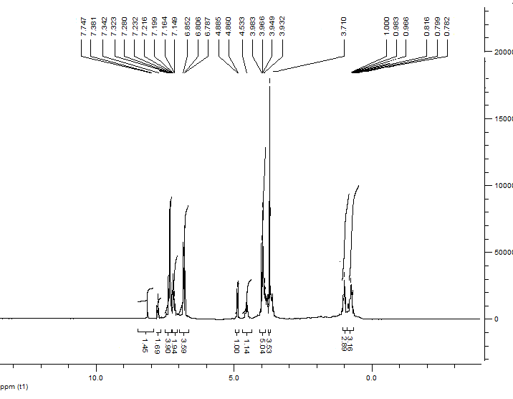
Figure S 7: ¹H-NMR of Diethyl (3,4-dihydro-4-oxo-2-phenyl-2H-chromen-3-yl)(4-methoxyphenyl)methyl phosphonate

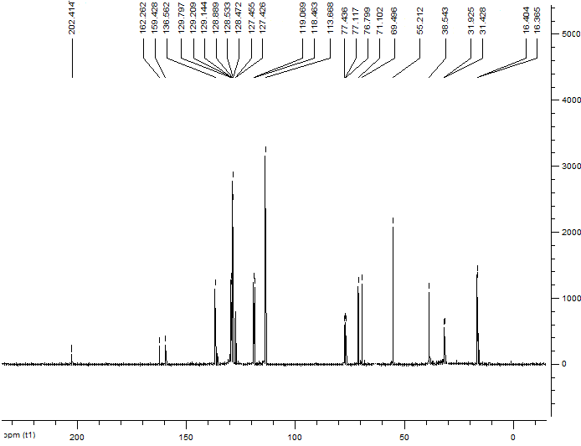

Figure S 8: ¹³C-NMR of Diethyl (3,4-dihydro-4-oxo-2-phenyl-2H-chromen-3-yl)(4-methoxyphenyl)methyl phosphonate
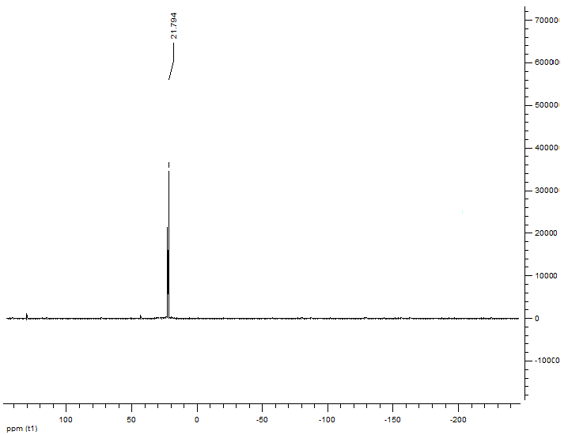

Figure S 9: ³¹P-NMR of Diethyl (3,4-dihydro-4-oxo-2-phenyl-2H-chromen-3-yl)(4-methoxyphenyl)methyl phosphonate
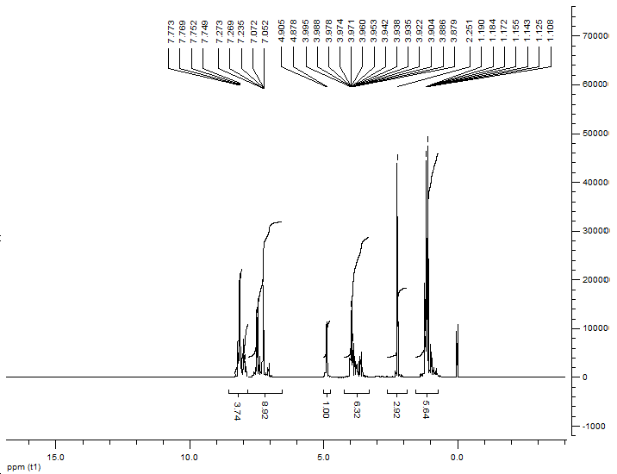
Figure S 10: ¹H-NMR of Diethyl (3,4-dihydro-4-oxo-2-phenyl-2H-chromen-3-yl)(p-tolyl)methylphosphonate
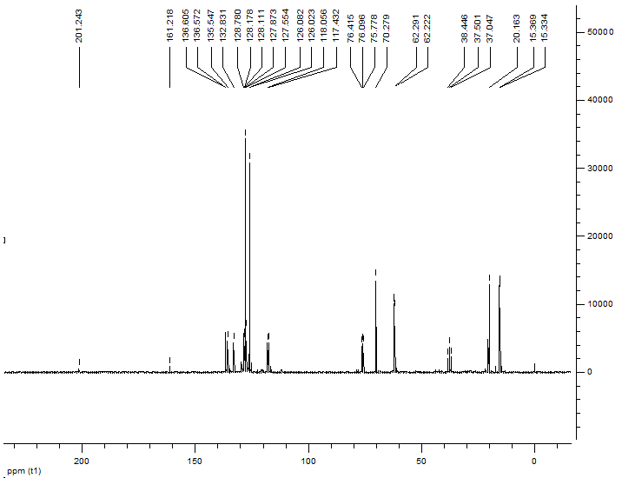

Figure S 11: ¹³C-NMR of Diethyl (3,4-dihydro-4-oxo-2-phenyl-2H-chromen-3-yl)(p-tolyl)methylphosphonate

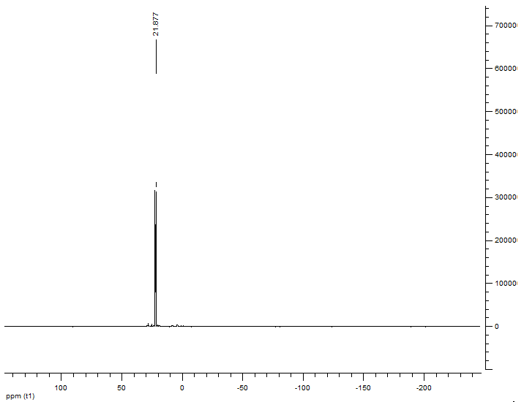

Figure S 12: ³¹P-NMR of Diethyl (3,4-dihydro-4-oxo-2-phenyl-2H-chromen-3-yl)(p-tolyl)methylphosphonate
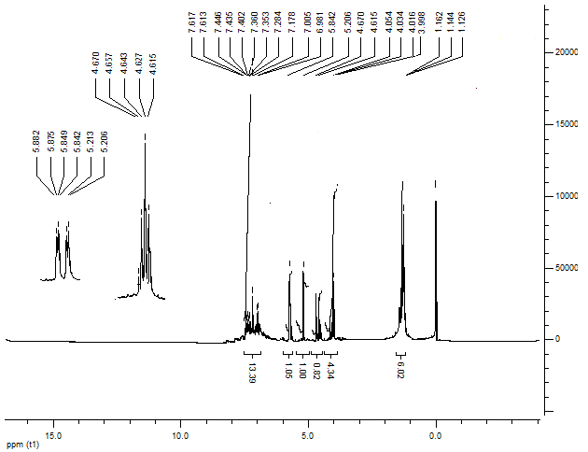
Figure S 13: ¹H-NMR of Diethyl (3,4-dihydro-4-oxo-2-phenyl-2H-chromen-3-yl)(4-nitrophenyl)methylphosphonate
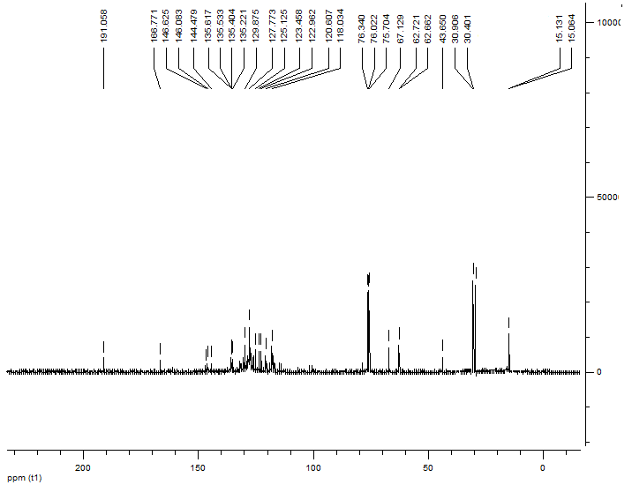

Figure S 14: ¹³C-NMR of Diethyl (3,4-dihydro-4-oxo-2-phenyl-2H-chromen-3-yl)(4-nitrophenyl)methyl phosphonate
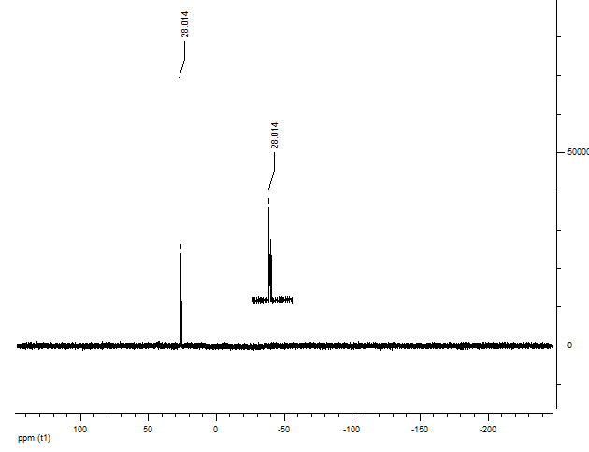
Figure S 15: ³¹P-NMR of Diethyl (3,4-dihydro-4-oxo-2-phenyl-2H-chromen-3-yl)(4-nitrophenyl)methyl phosphonate

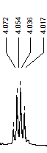
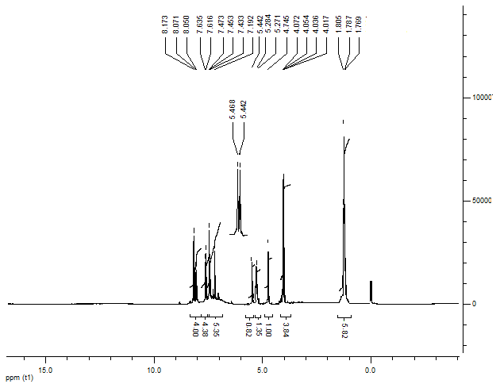

Figure S 16: ¹H-NMR of Diethyl (3,4-dihydro-4-oxo-2-phenyl-2H-chromen-3-yl)(3-nitrophenyl)methylphosphonate

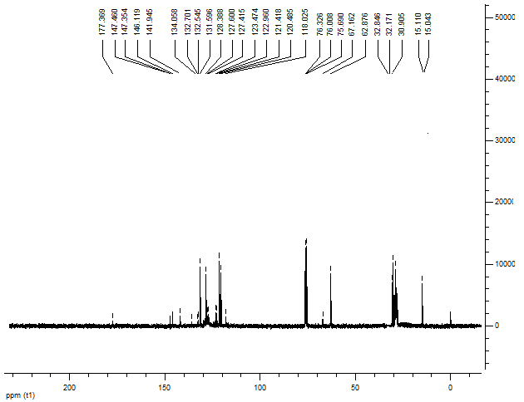
Figure S 17: ¹³C-NMR of Diethyl (3,4-dihydro-4-oxo-2-phenyl-2H-chromen-3-yl)(3-nitrophenyl)methyl phosphonate
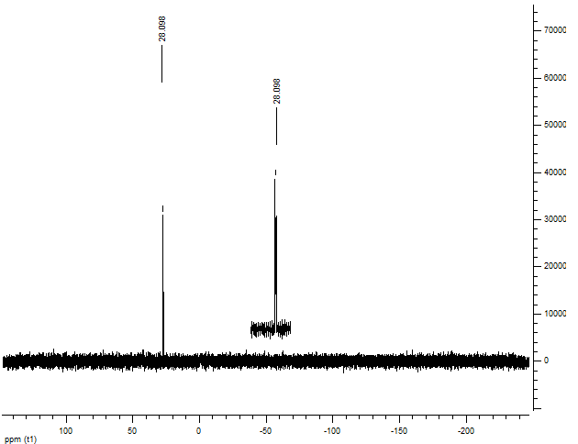

Figure S 18: ³¹P-NMR of Diethyl (3,4-dihydro-4-oxo-2-phenyl-2H-chromen-3-yl)(3-nitrophenyl)methyl phosphonate
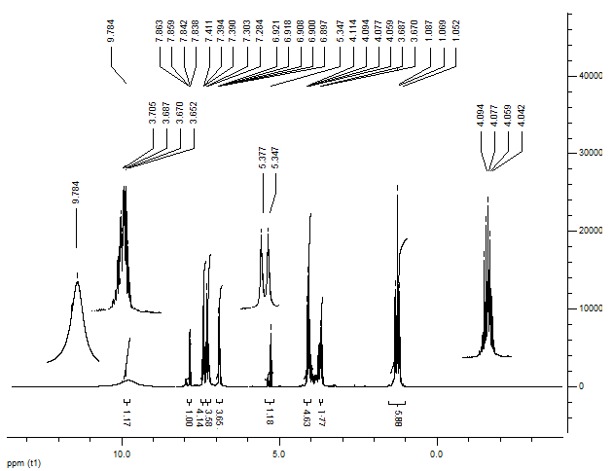
Figure S 19: ¹H-NMR of Diethyl (3,4-dihydro-4-oxo-2-phenyl-2H-chromen-3-yl)(2-hydroxy-5-nitrophenyl)methylphosphonate
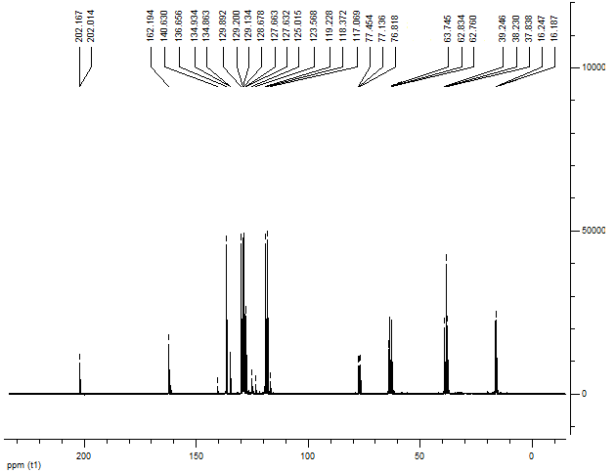

Figure S 20: ¹³C-NMR of Diethyl (3,4-dihydro-4-oxo-2-phenyl-2H-chromen-3-yl)(2-hydroxy-5-nitrophenyl)methylphosphonate

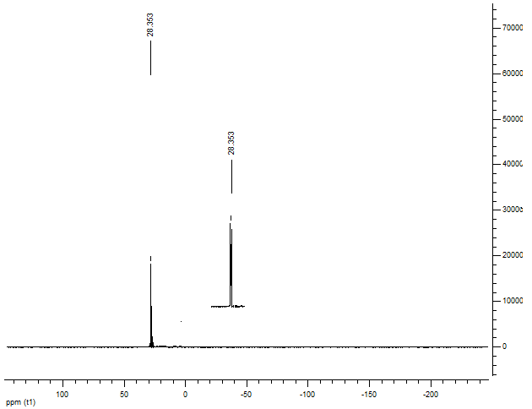

Figure S 21: ³¹P-NMR of Diethyl (3,4-dihydro-4-oxo-2-phenyl-2H-chromen-3-yl)(2-hydroxy-5-nitrophenyl) methylphosphonate
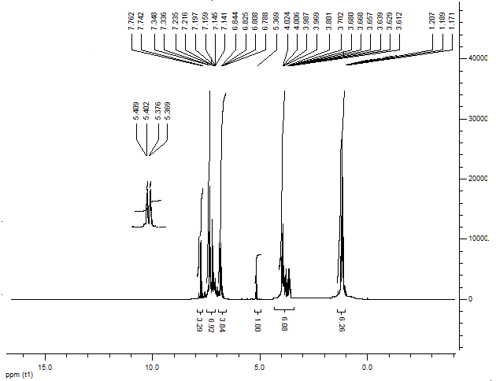

Figure S 22: ¹H-NMR of Diethyl (4-fluorophenyl) (3,4-dihydro-4-oxo-2-phenyl-2H-chromen-3-yl)methyl phosphonate
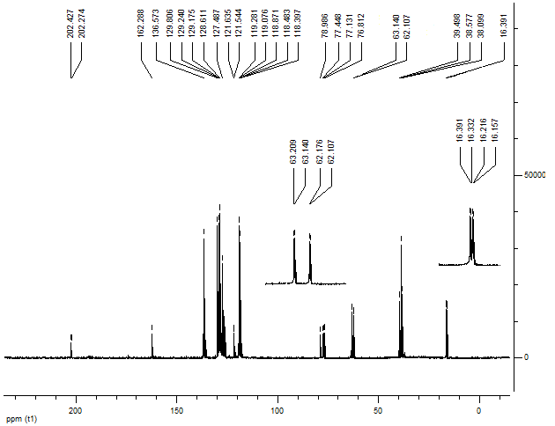

Figure S 23: ¹³C-NMR of Diethyl (4-fluorophenyl) (3,4-dihydro-4-oxo-2-phenyl-2H-chromen-3-yl)methyl phosphonate
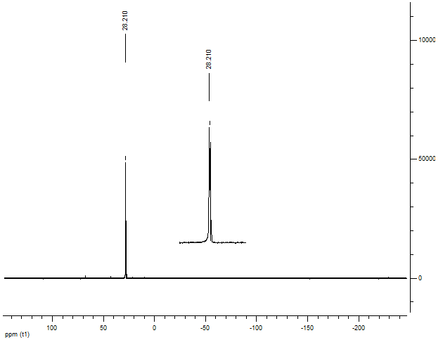
Figure S 24: ³¹P-NMR of Diethyl (4-fluorophenyl) (3,4-dihydro-4-oxo-2-phenyl-2H-chromen-3-yl)methyl phosphonate
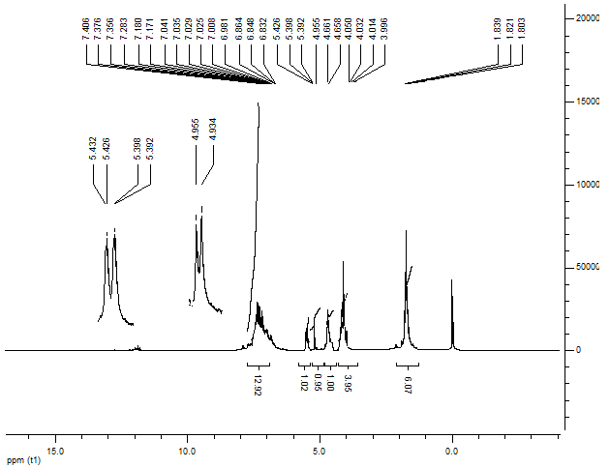
Figure S 25: ¹H-NMR of Diethyl (4-chlorophenyl) (3,4-dihydro-4-oxo-2-phenyl-2H-chromen-3-yl)methylphosphonate
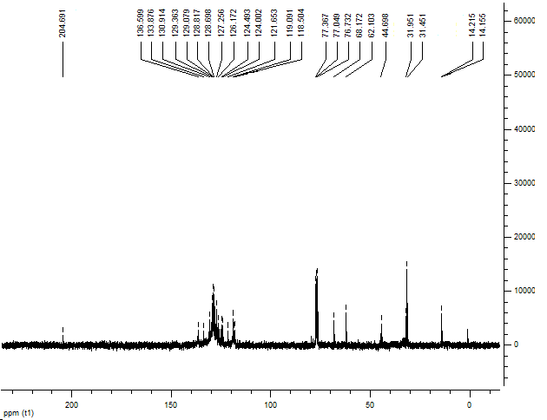
Figure S 26: ¹³C-NMR of Diethyl (4-chlorophenyl) (3,4-dihydro-4-oxo-2-phenyl-2H-chromen-3-yl)methyl phosphonate
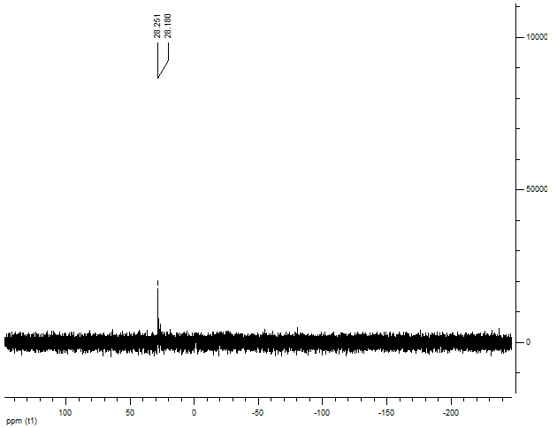

Figure S 27: ³¹P-NMR of Diethyl (4-chlorophenyl) (3,4-dihydro-4-oxo-2-phenyl-2H-chromen-3-yl)methyl phosphonate
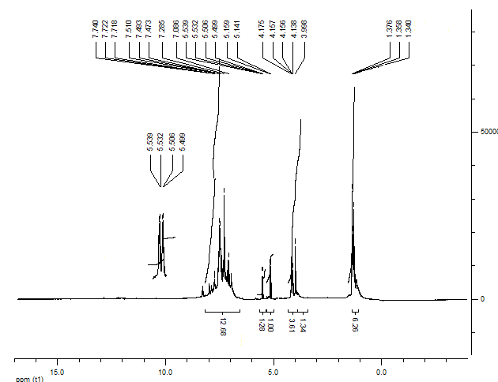
Figure S 28: ¹H-NMR of Diethyl (2,4-dichlorophenyl)(3,4-dihydro-4-oxo-2-phenyl-2H-chromen-3-yl) methylphosphonate
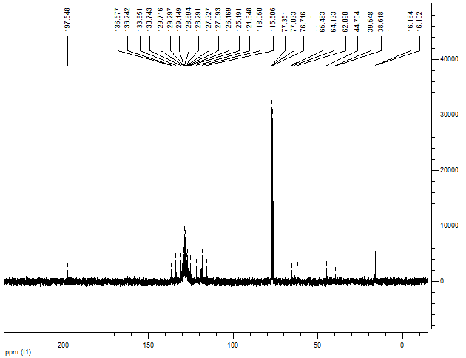
Figure S 29: ¹³C-NMR of Diethyl (2,4-dichlorophenyl)(3,4-dihydro-4-oxo-2-phenyl-2H-chromen-3-yl) methylphosphonate
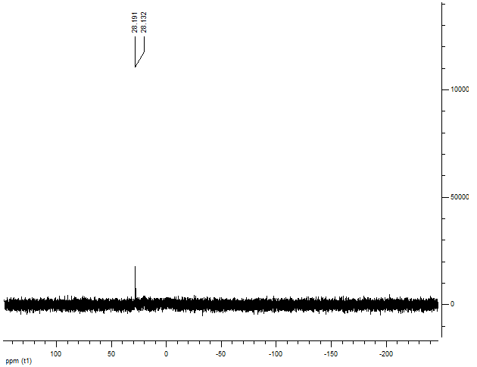

Figure S 30: ³¹P-NMR of Diethyl (2,4-dichlorophenyl)(3,4-dihydro-4-oxo-2-phenyl-2H-chromen-3-yl) methylphosphonate
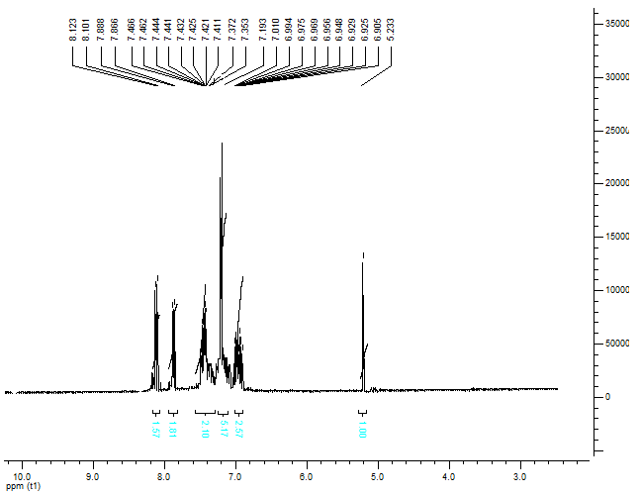
Figure S 31: ¹H-NMR of 3-(4-Nitrobenzylidene)-2,3-dihydro-2-phenylchromen-4-one

