New class of diethyl substituted phosphoramidimidates and phosphonimidates: Synthesis, spectral characterization and antimicrobial activity
Mavallur Varalakshmi*^{,a}, Chamarthi Nagaraju^{b}, Palaa Krishna^{c}
ªDepartment of Humanities and Sciences, Sri Venkateswara College of Engineering and Technology, Chittoor-517127, Andhra Pradesh, India.
^{b}Department of Chemistry, Sri Venkateswara University, Tirupat-517502, Andhra Pradesh, India.
^{c}Department of Chemistry, Geethanjali Institute of Science and Technology, Gangavaram, Nellore, India.
Email: varalakshmi.mavallur@gmail.com
Supplemental Materials
Spectral data:
Diethyl N-2-hydroxyethyl-N'-(pyridin-2-yl)phosphoramidimidate (6a)
Semi-solid, Yield:72%; IR (KBr, cm⁻¹): 1354 (-P=N, str), 3267 (-P-NH, str), 3421 (-OH, str);¹H NMR (CDCl₃, 400 MHz): δ 1.27 (t, J = 6 Hz, 6H, H-16, H-18), 2.99-3.03 (q, 2H, H-3), 3.45 (s, 1H, H-4), 3.57 (t, J = 4.4 Hz, 2H, H-2), 3.88-3.92 (q, 4H, H-15, H-17), 5.22 (s, 1H, H-1), 7.07-7.51 (m, 3H, H-10, H-11, H-12), 8.41 (d, J = 6.8 Hz, 1H, H-13); ¹³C NMR (CDCl₃, 100.6 MHz): δ 15.4 (C₁₆, C₁₈), 34.4 (C₃), 44.2 (C₁₅, C₁₇), 61.3 (C₂), 121.2 (C₁₂), 122.7 (C₁₀), 136.2 (C₁₁), 148.3 (C₁₃), 164.0 (C₉).³¹P NMR (CDCl₃,161.9 MHz,): δ 10.5.MS (m/z): 274 (M+H⁺). Anal.Calcd.forC₁₁H₂₀N₃O₃P: C 48.35, H 7.38, N 15.38; Found: C 48.23, H 7.40, N 15.42.
Diethyl N'-5-bromopyridin-2-yl-N-(2-hydroxyethyl)phosphoramidimidate (6b)
Solid, Yield: 80%; m.p: 187-189 ºC. IR(KBr, cm⁻¹): 1344 (-P=N, str), 3012 (-P-NH, str), 3412 (-OH, str);¹H NMR(CDCl_{3,} 400 MHz): δ 1.26 (t, J = 5.6 Hz, 6H, H-16, H-18), 3.07-3.14 (q, 2H, H₃), 3.20-3.28 (q, 2H, H-2), 3.75 (s, 1H, H-4), 3.84 (s, 1H, H-1), 4.05-4.12 (q, 4H, H-15, H-17), 7.68 (d, J = 7.6 Hz, 1H, H-12), 7.85 (d, J = 7.2 Hz, 1H, H-13), 8.74 (d, J = 6.4 Hz, 1H, H-11);¹³C NMR(CDCl_{3,}100.6 MHz): δ 18.0 (C₁₆, C₁₈), 40.3 (C₃), 48.6 (C₁₅, C₁₇), 66.2 (C₂), 120.3 (C₁₄), 122.6 (C₁₂), 135.5 (C₁₃), 141.5 (C₁₁), 153.4 (C₉); ³¹P NMR (161.9 MHz, CDCl₃): δ 10.6. MS(m/z): 353 (M+H⁺). Anal.Calcd.forC₁₁H₁₉BrN₃O₃P: C 37.52, H 5.44, N11.93; Found: C 37.56, H 5.38, N 11.86.
Diethyl N'-cyclopropylmethyl-N-(2-hdroxyethyl)phosphoramidimidate (6d)
Semi-solid, Yield:65%;IR (KBr, cm⁻¹): 1354 (-P=N, str), 2987 (-P-NH, str), 3481 (-OH, str);¹H NMR(CDCl_{3,} 400 MHz): δ 0.42-0.48 (m, 5H, H-10, H-11, H-12), 1.20-1.26 (m, 2H, H-9), 1.29(t, J = 4.8 Hz, 6H, H-14, H-16), 3.02-3.09 (q, 2H, H-3), 3.15-3.17 (q, 2H, H-2),3.73 (s, 1H, H-4), 3.88 (s, 1H, H-1),4.07-4.13 (q, 4H, H-13, H-15); ¹³C NMR(CDCl_{3,}100.6 MHz): δ13.2 (C₁₀), 3.9 (C₁₁, C₁₂), 19.2 (C₁₄, C₁₆), 38.2 (C₃), 51.4 (C₁₃, C₁₅), 66.4 (C₂), 42.6 (C₉); ³¹P NMR (CDCl₃,161.9 MHz):δ12.6. MS(m/z): 251(M+H)⁺.Anal.Calcd.forC₁₀H₂₃N₂O₃P: C 47.99, H 9.26, N11.19; Found: C 47.89, H 9.30, N 11.25.
Diethyl N-2-hydroxyethyl-N'-(thiazol-2-yl)phosphoramidimidate (6e)
Semi-solid, Yield:72%; IR(KBr, cm⁻¹): 1344 (-P=N, str), 2981 (-P-NH, str), 3535 (-OH, str);¹H NMR (CDCl₃,400 MHz,):δ 1.27 (t, J = 5.6 Hz,6H, H-15, H-17),3.06-3.15 (q, 2H, H-3),3.81-3.84 (t, J = 6.8 Hz, 2H, H-2), 3.92 (s, 1H, H-4),3.96-4.01 (q, 4H, H-14, H-16),5.29 (s, 1H, H-1), 7.55-7.56 (d, J = 2 Hz,1H, H-12),7.77 (d, J = 4.8 Hz, 1H, H-11);¹³C NMR(CDCl₃,100.6 MHz): δ 16.2 (C₁₅, C₁₇), 36.5 (C₃), 45.5 (C₁₄, C₁₆), 62.1 (C₂), 121.4 (C₁₂), 139.1 (C₁₁), 156.3 (C₉); ³¹P NMR(CDCl₃, 161.9 MHz):δ12.8. MS (m/z): 280 (M+H⁺). Anal.Calcd.forC₉H₁₈N₃O₃PS: C 38.70, H 6.50, N15.04; Found: C 38.65, H 6.48, N 15.14.
Diethyl P-morpholino-N-(pyridin-2-yl)phosphonimidate (6f)
Semi-solid, Yield:74%; IR(KBr, cm⁻¹): 1313 (-P=N, str), 1023 (-P-O-C, str);¹H NMR(CDCl₃, 400 MHz):δ1.41 (t, J = 7.6 Hz, 6H, H₁₂, H₁₄), 3.14 (t, J = 7.2 Hz, 4H,H₂, H₄), 3.72 (t, J = 6 Hz, 4H, H-1, H-5),4.09-4.15 (q, 4H, H-11, H-13), 7.24-7.26 (m, 1H, H-20), 7.64-7.68 (m, 1H, H-18), 7.84-7.86 (m, 1H, H-19), 8.56 (m, 1H, H-17); ¹³C NMR(CDCl₃, 100.6 MHz): δ 17.6 (C₁₂, C₁₄), 41.3 (C₂, C₄), 49.4 (C₁₁, C₁₃), 69.4 (C₁, C₅), 121.5 (C₁₈), 123.3 (C₂₀), 139.1 (C₁₉), 146.8 (C₁₇), 154.6 (C₁₅); ³¹P NMR (CDCl₃, 161.9 MHz): δ11.2. MS (m/z): 300 (M+H⁺).Anal.Calcd.forC₁₃H₂₂N₃O₃P: C 52.17, H 7.41, N 14.04; Found: C 52.12, H 7.39, N 14.14.
Diethyl N-5-bromopyridin-2yl-P-morpholinophosphonimidate (6g)
Solid, Yield:73%; m.p:132-134ºC.IR (KBr, cm⁻¹): 1315 (-P=N, str), 1044 (-P-O-C, str);¹H NMR(CDCl₃,400 MHz,): δ 1.26 (t, J= 7.2 Hz, 6H, H-12, H-14), 3.06(t, J= 6 Hz, 4H, H-2, H-4), 3.61(t, J = 4.8 Hz, 4H, H-1, H-5), 4.03-4.08 (q, 4H, H-11, H-13), 7.42 (d, J = 4.4 Hz, 1H, H-19), 7.90 (d, J = 6.8 Hz, 1H, H-18), 8.56 (s, 1H, H-17); ¹³C NMR(CDCl₃, 100.6 MHz): δ 18.0 (C₁₂, C₁₄), 41.6 (C_{2,} C₄), 50.9 (C₁₁, C₁₃), 71.8 (C₁, C₅), 119.2 (C₁₈), 125.2 (C₂₀), 142.7 (C₁₇), 152.7 (C₁₉), 159.5 (C₁₅); ³¹P NMR (CDCl_{3,} 161.9 MHz): δ 14.2. MS (m/z): 378 (M+H⁺).Anal.Calcd.forC₁₃H₂₁BrN₃O₃P: C 41.28, H 5.60, N11.11;Found: C 41.32, H 5.55, N 11.17.
Diethyl P-morpholino-N-(pyrazin-2-yl)phosphonimidate (6h)
Semi-solid, Yield:74%; IR(KBr, cm⁻¹): 1314 (-P=N, str), 1028 (-P-O-C, str); ¹HNMR (CDCl₃, 400 MHz):δ 1.28 (t, J = 5.6 Hz, 6H, H-12, H-14), 3.09-3.14 (q, 4H, H-2, H-4), 3.71 (t, J = 6 Hz, 4H, H-1,H-5), 3.88-3.94 (q, 4H, H-11, H-13), 8.18 (s, 1H, H-16), 8.40 (d, J = 6.8 Hz, 1H, H-19), 8.88 (d, J = 6.4 Hz, 1H, H-18); ¹³C NMR(CDCl₃,100.6 MHz): δ 19.8 (C₁₂, C₁₄), 42.6 (C₂, C₄), 49.5 (C₁₁, C₁₃), 70.2 (C₁, C₅), 142.5 (C₁₈), 146.2 (C₁₉), 152.3 (C₁₆), 157.5 (C₁₅); ³¹P NMR (CDCl₃, 161.9 MHz):δ11.8. MS (m/z): 301 (M+H⁺). Anal.Calcd.forC₁₂H₂₁N₄O₃P: C 48.00, H 7.05, N, 18.66; Found: C 48.11, H 7.01, N 18.58.
Diethyl N-cyclopropylmethyl-P-morpholinophosphonimidate (6i)
Semi-solid, Yield:64%;IR(KBr, cm⁻¹): 1308 (-P=N, str), 1025 (-P-O-C, str);¹H NMR(CDCl₃, 400 MHz):δ 0.32-0.56 (m, 5H, H-16, H-17, H-18), 1.29 (t, J =8 Hz, 6H, H-12, H-14), 1.32-1.35 (m, 2H, H-15), 3.09 (t, J = 6.4 Hz, 4H, H-2, H-4), 3.52 (t, J= 5.6 Hz, 4H, H-1, H-5), 4.12-4.17 (q, 4H, H-11, H-13); ¹³C NMR(CDCl₃,100.6 MHz): δ 3.9 (C₁₇, C₁₈), 14.2 (C₁₆), 20.2 (C₁₂, C₁₄), 42.3 (C₂, C₄),43.5 (C₁₅), 49.1 (C₁₁, C₁₃), 67.5 (C₁, C₅); ³¹P NMR (CDCl₃,161.9 MHz): δ 12.6. MS (m/z): 277 (M+H⁺). Anal.Calcd.forC₁₂H₂₅N₂O₃P: C 52.16, H 9.12, N10.14; Found: C 52.15, H 9.08, N 10.18.
Diethyl P-morpholino-N-(thiazol-2-yl)phosphonimidate (6j)
Semi-solid, Yield:78%; IR(KBr, cm⁻¹): 1272 (-P=N, str), 1018 (-P-O-C, str); ¹H NMR(CDCl₃,400 MHz): δ 1.37 (t, J =7.2 Hz, 6H, H-12, H-14), 3.15 (t, J = 7.2 Hz, 4H, H-2, H-4), 3.65 (t, J =7.2 Hz, 4H, H-1, H-5), 4.24-4.29 (q, 4H, H-11, H-13),7.25 (d, J = 8.8 Hz, 1H, H-18), 7.43 (t, J = 8.4 Hz, 1H, H-17);¹³C NMR(100.6 MHz, CDCl₃): δ 20.7 (C₁₂, C₁₄), 41.6 (C₂, C₄), 49.5 (C₁₁, C₁₃), 69.5 (C₁, C₅), 123.2 (C₁₈), 146.5 (C₁₇), 166.8 (C₁₅); ³¹P NMR (CDCl_{3,}161.9 MHz): δ 6.76. MS (m/z): 304 (M-H⁺). Anal.Calcd.forC₁₁H₂₀N₃O₃PS: C 43.27, H 6.60, N13.76; Found: C 43.30, H 6.58, N 13.81.

BIOLOGICAL ACTIVITY
Antimicrobial activity
Antibacterial activity
The antibacterial activity of the newly synthesized compounds 6(a-j) was carried out using agar disc diffusion method²⁰against the bacterial strainsStaphylococcus aureus, Lactobacillus acidophillus (Gram positive) and Escherichia coliand Vibrio cholerae (Gram negative). Tetracycline was used as a standard drug for the comparison of the activity. The nutrient agar medium in each petri plate was homogenously spread with a bacterial strains and incubated at 25±2 ºC for 24 h. All the test compounds and the standard (each 1.0 mg) were dissolved in DMSO and further diluted to required concentrations. The test solutions with concentration of 200 μg/mL) and negative control (DMSO) were introduced onto the sterile disc (6 mm) and dried completely to saturate. These discs were placed onto the media and then incubated at 25±2 ºC for 24 h. After incubation, zone of inhibition around the disc was calculated edge to edge zone of the disc and was measured in millimeters. All the tests were carried out in duplicate and average was taken as the final result. The results are tabulated in Table S 1.
Antifungal activity:

All the newly synthesized compounds were tested for the antifungal activity against the fungal strains T. longibrachiatum, C. tetani, A. niger and A. fumigates by the poison plate method²¹ using Fluconazole as a standard drug. The fungal strains were incubated in potato dextrose agar at 25 ±1 °C for 5 d to get new mycelium for antifungal assay, and then a mycelia disc of approximately 0.45 cm diameter cut from the culture medium was picked up with a sterilized inoculation needle and inoculated in the center of the PDA plate.The inoculated plates were incubated at 25 ±1 °C for 5 d. DMSO solvent was added as negative control to determine possible inhibitory activity of the solvent, while Fluconazole was used as a positive control.For each treatment, three replicates were carried out and the mean of the diameter of the inhibition zones was calculated. The results are shown in Table S 2.

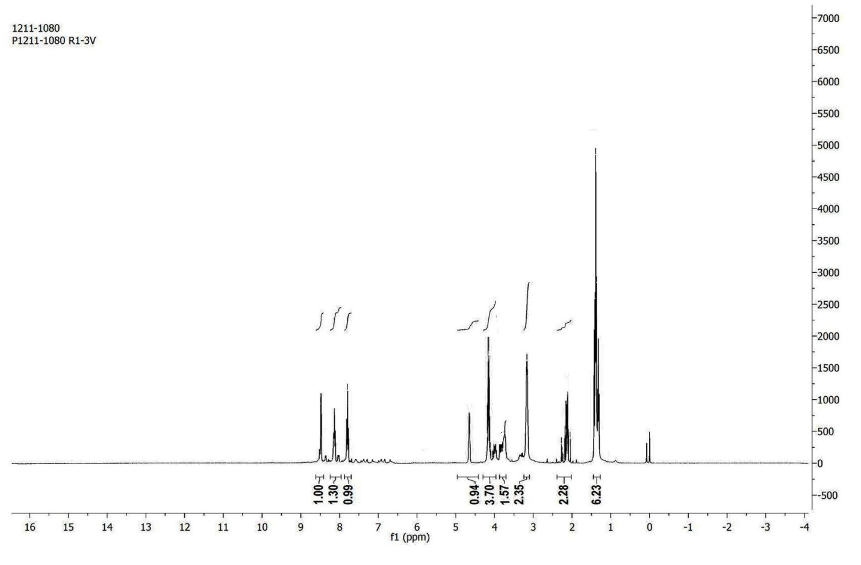
Figure S 1: ¹H NMR spectrum of compound (6c)

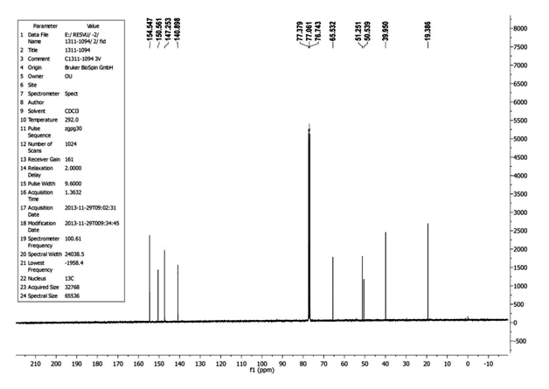
Figure S 2 ¹³C NMR spectrum of compound (6c)

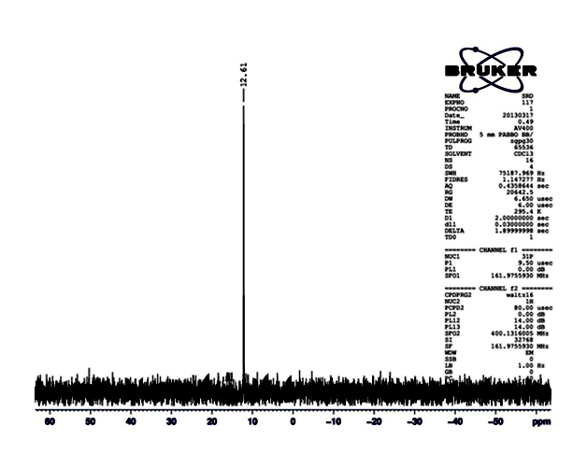
Figure S 3 ³¹P NMR spectrum compound (6c)

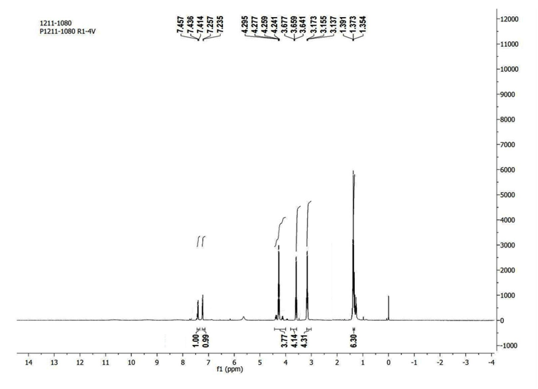
Figure S 4 ¹H NMR spectrum of compound (6j)

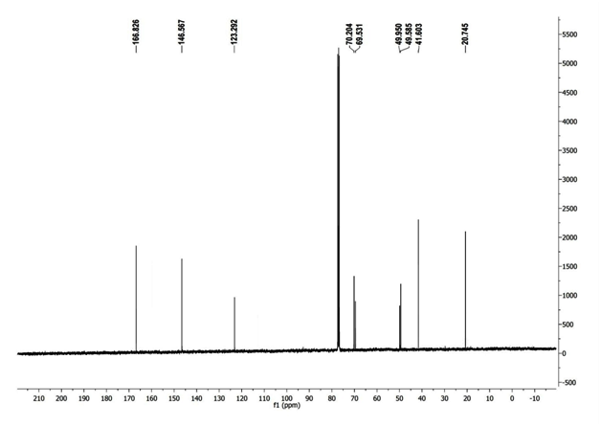
Figure S 5 ¹³C NMR spectrum of compound (6j)

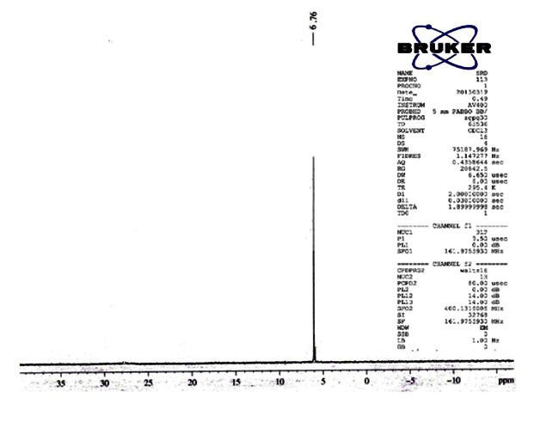
Figure S 6 ³¹P NMR spectrum of compound (6j)

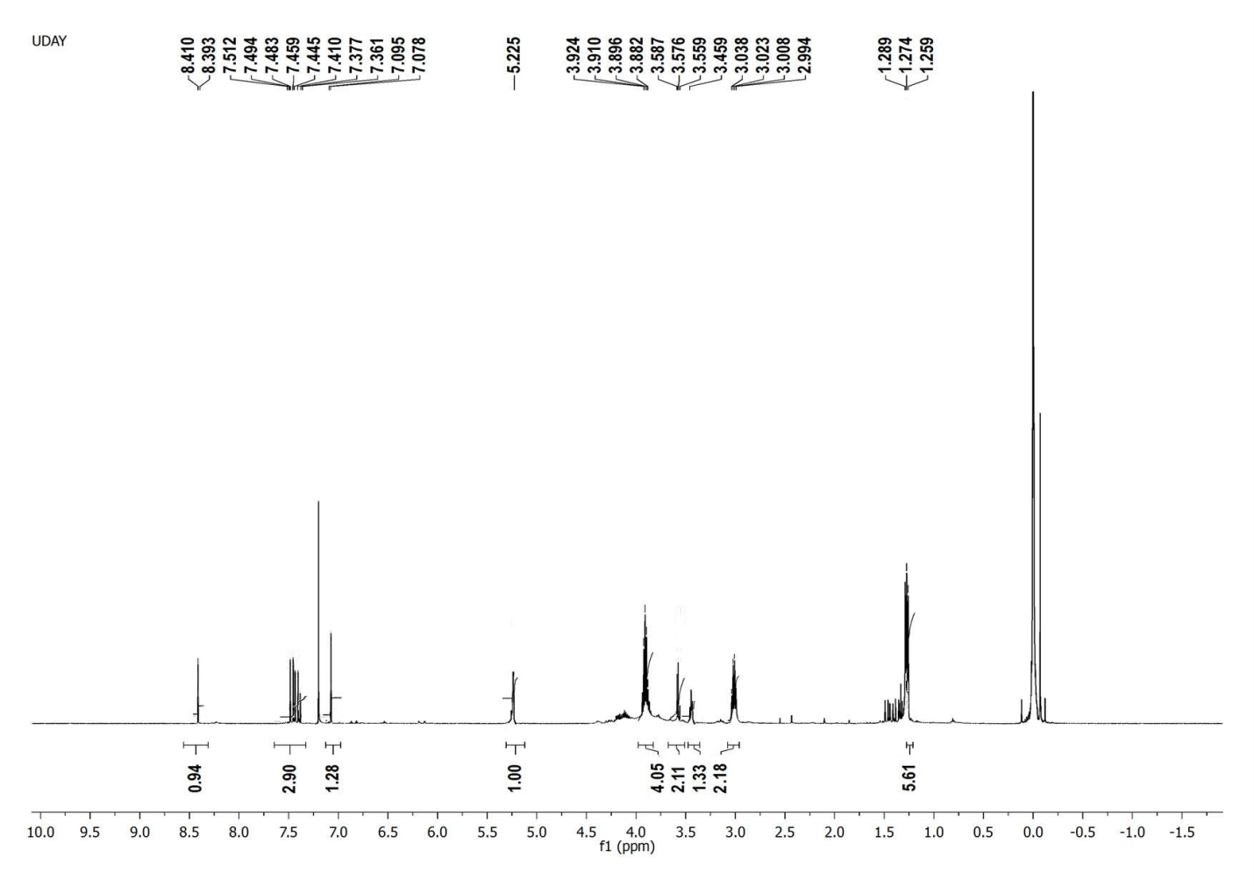
Figure S 7 ¹H NMR spectrum of compound (6a)

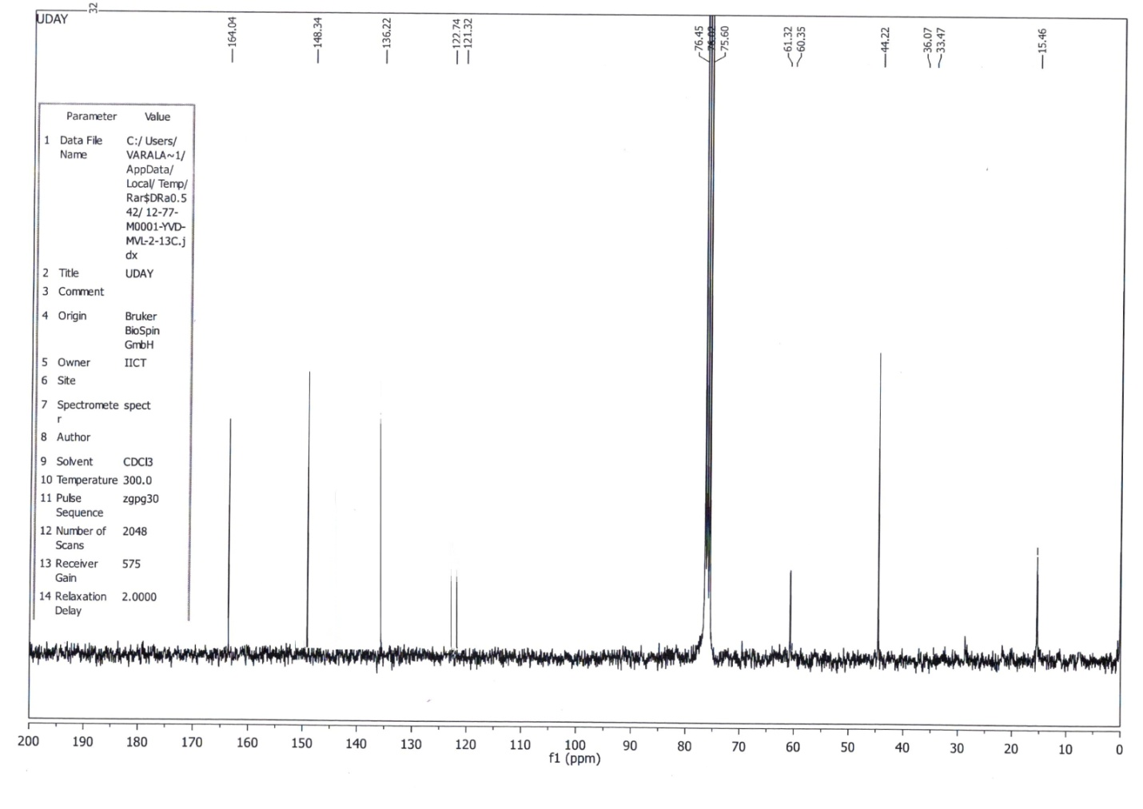
Figure S 8 ¹³C NMR spectrum of compound (6a)

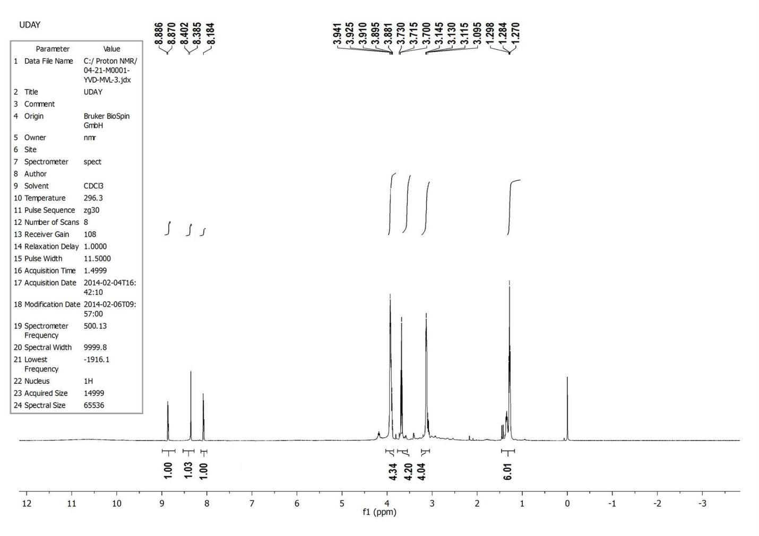
Figure S 9 ¹H NMR spectrum of compound (6h)

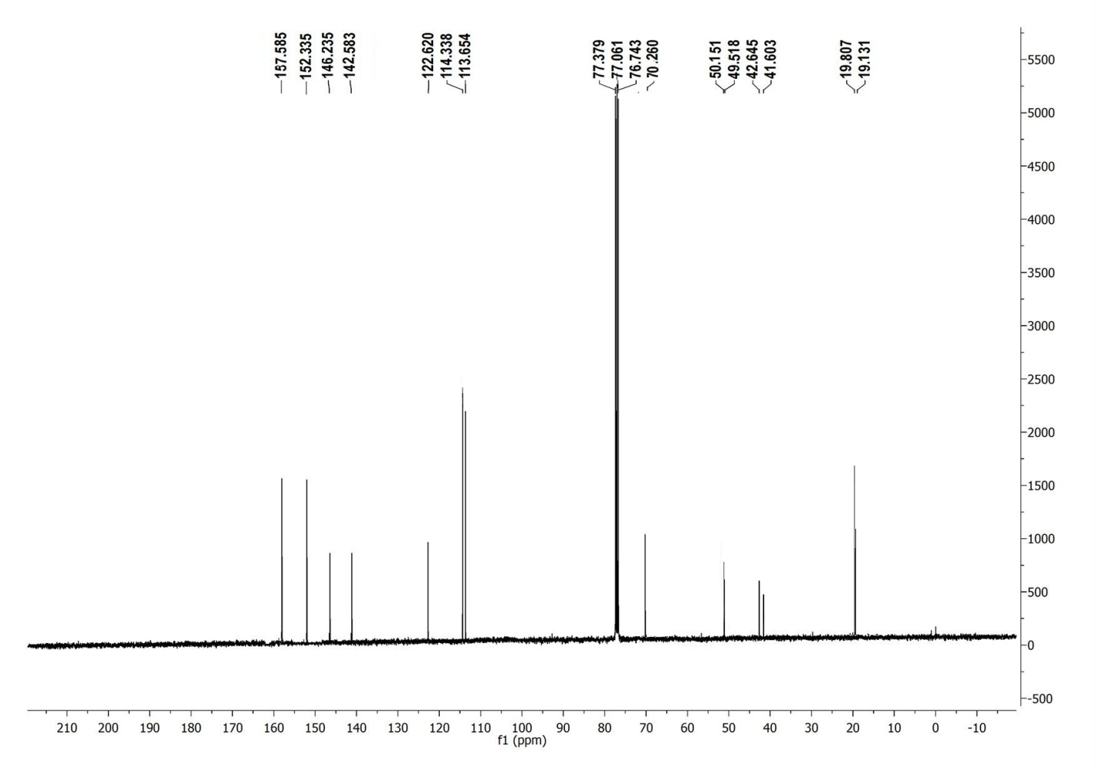
Figure S 10 ¹³C NMR spectrum of compound (6h)

Table S 1: Antibacterial activity of the diethyl substituted phosphoramidimidates and phosphonimidates 6(a-j)

Compd. | Zone of inhibition (mm)
 | G +Ve bacteria |  | G –Ve bacteria
 | S. aureus | L. acidophilus | E. coli | V. cholerae
6a | 18 | 22 | 12 | 17
6b | 23 | 31 | 17 | 25
6c | 22 | 28 | 16 | 24
6d | 19 | 23 | 12 | ND
6e | 23 | 31 | 17 | 25
6f | 18 | 23 | 11 | 16
6g | 23 | 27 | 16 | 23
6h | 22 | 28 | 15 | 20
6i | 16 | 16 | ND | ND
6j | 21 | 26 | 15 | 24
Tetracycline | 25 | 32 | 18 | 27

Table S 2. Antifungal activity of the diethyl substituted phosphoramidimidates and phosphonimidates 6(a-j)
Zone of inhibition (mm)
Compd. | T. longibrachiatum | C. tetani | A. niger | A. fumigates
6a | 9 | 8 | 7 | 5
6b | 15 | 11 | 14 | 9
6c | 15 | 12 | 13 | 9
6d | 8 | ND | 8 | 5
6e | 15 | 12 | 14 | 8
6f | ND | ND | ND | ND
6g | 12 | 10 | 10 | 7
6h | 11 | 11 | 9 | 7
6i | ND | ND | 5 | ND
6j | 12 | 11 | 13 | 9
Fluconazole | 16 | 13 | 15 | 10

