Article title: In silico hit optimization towards AKT inhibition: Fragment-based approach, molecular docking and molecular dynamics study
Author names: Elkin Eduardo Sanabria-Chanagaª, Irene Betancourt-Conde^{b}, Alicia Hernández-Camposª, Alfredo Téllez-Valencia^{b}, Rafael Castillo^{a*}
Affiliations: ªFacultad de Química, Departamento de Farmacia, Universidad Nacional Autónoma de México, Ciudad de México, C.P. 04510, Mexico.
^{b}Facultad de Medicina y Nutrición, Universidad Juárez del Estado de Durango, Av. Universidad y Fanny Anitúa S/N, Durango, Durango, C.P. 34000, Mexico.
Email address: rafaelc@unam.mx
Supporting Information
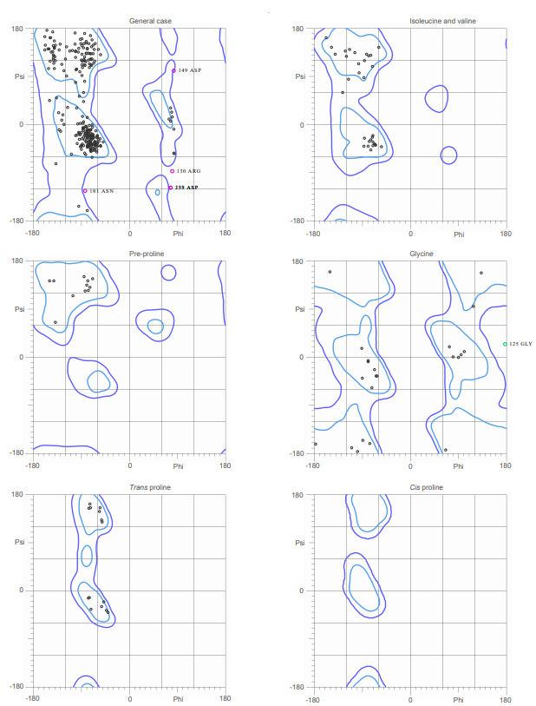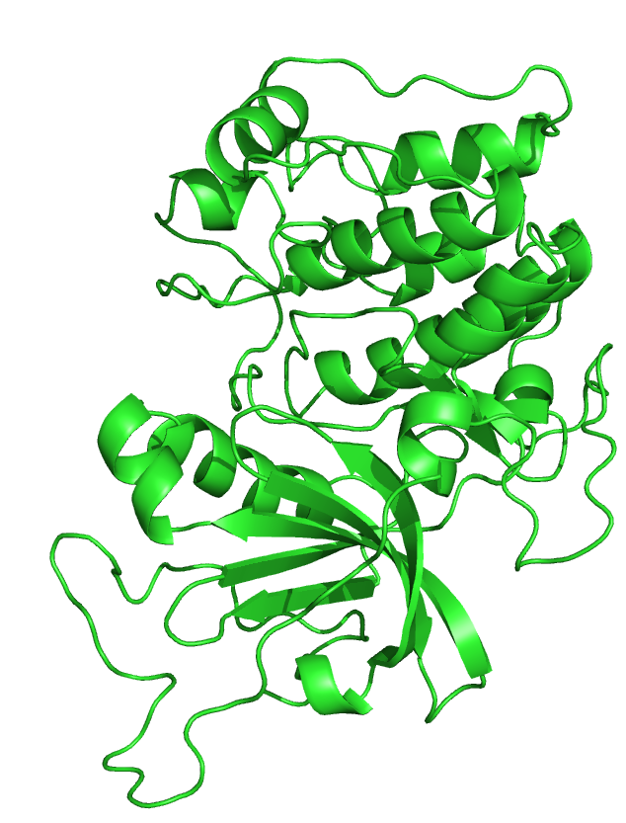
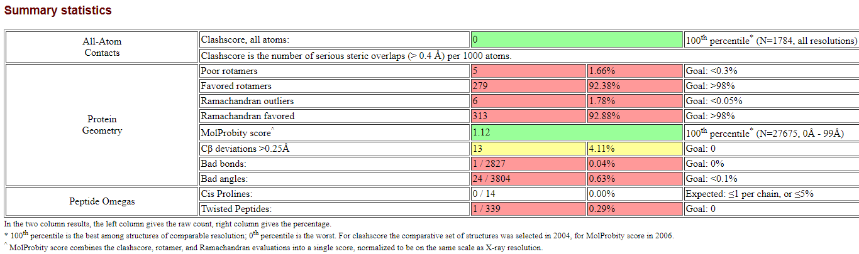
Figure S1. Validation of AKT3homology model.

2E in AKT1

1E in AKT1

3E in AKT1
FragFp
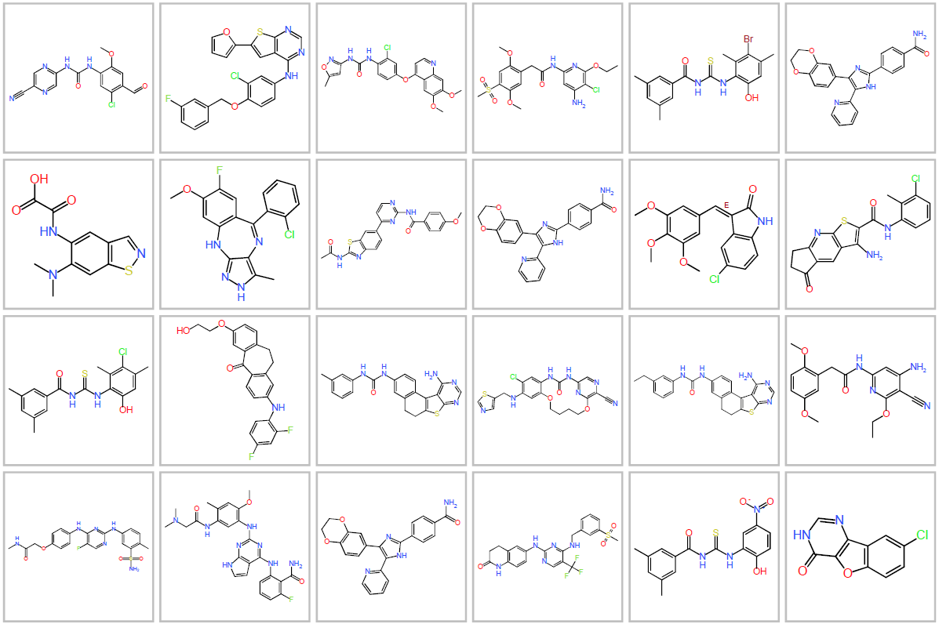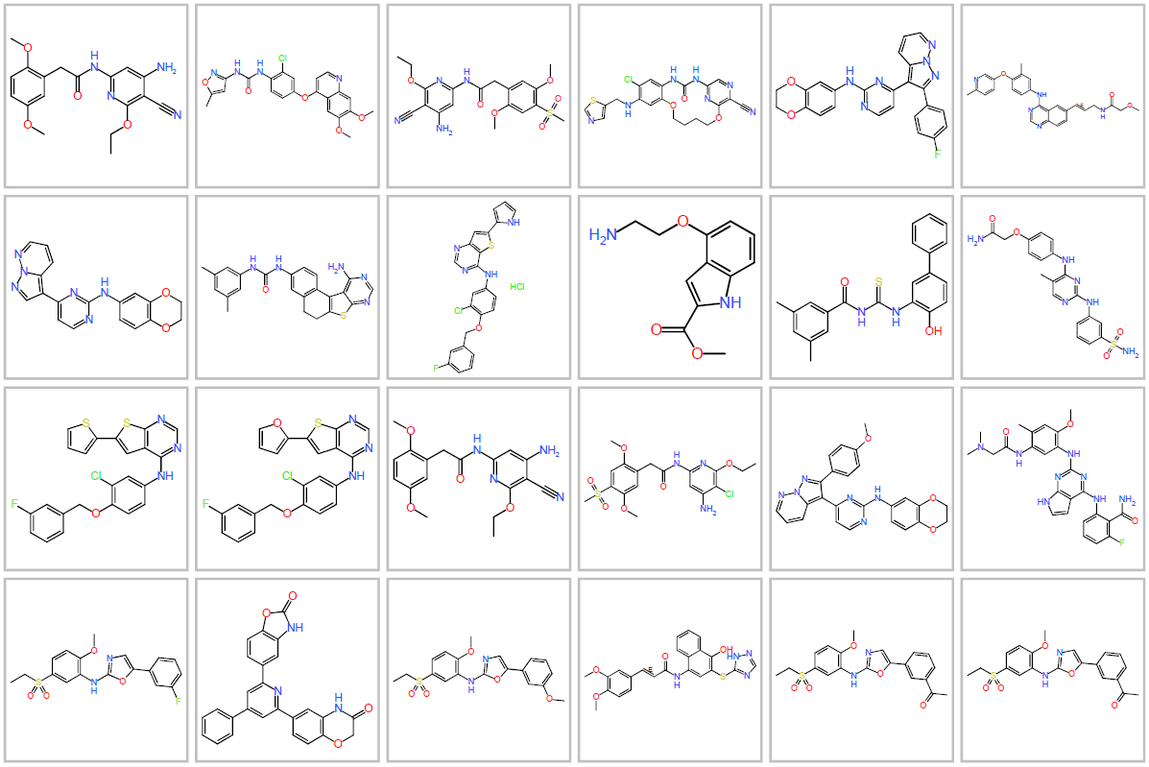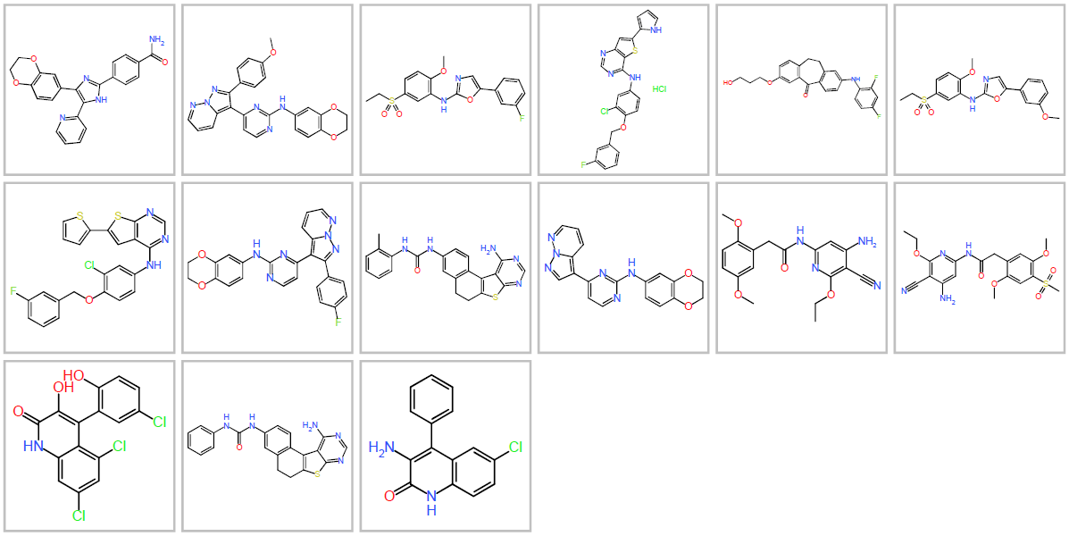
PathFp
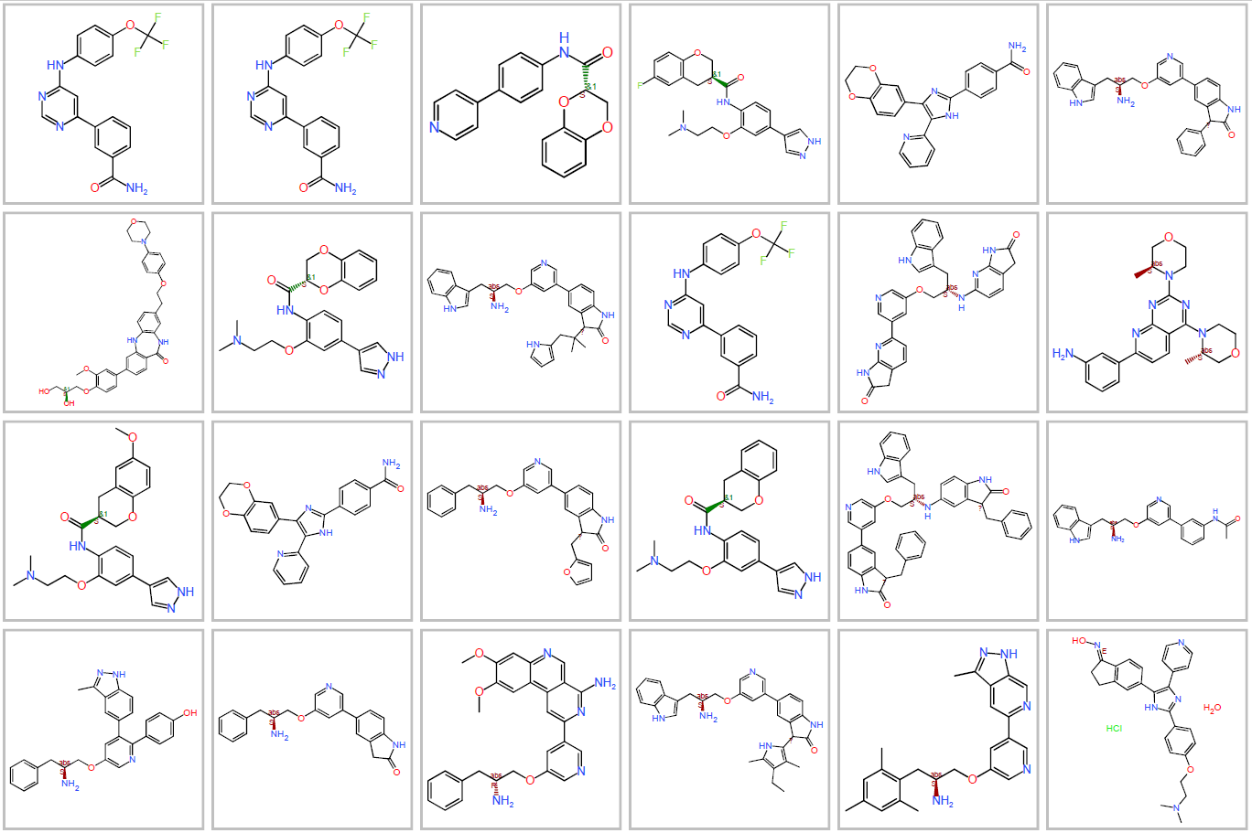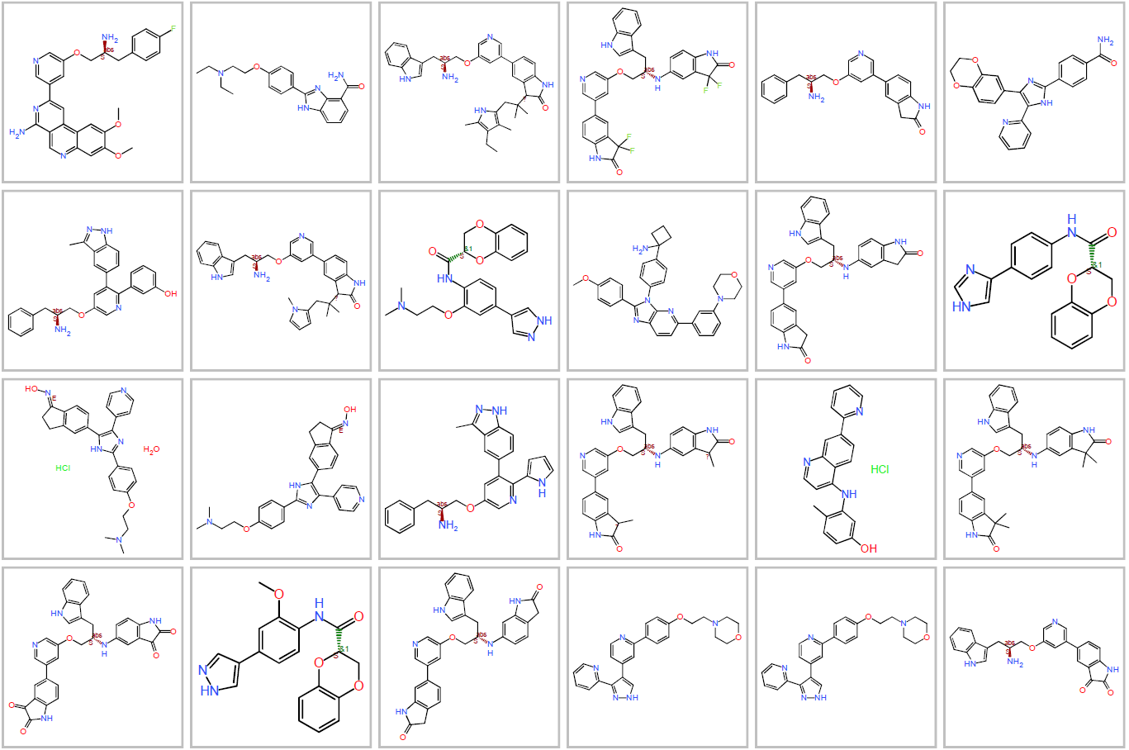
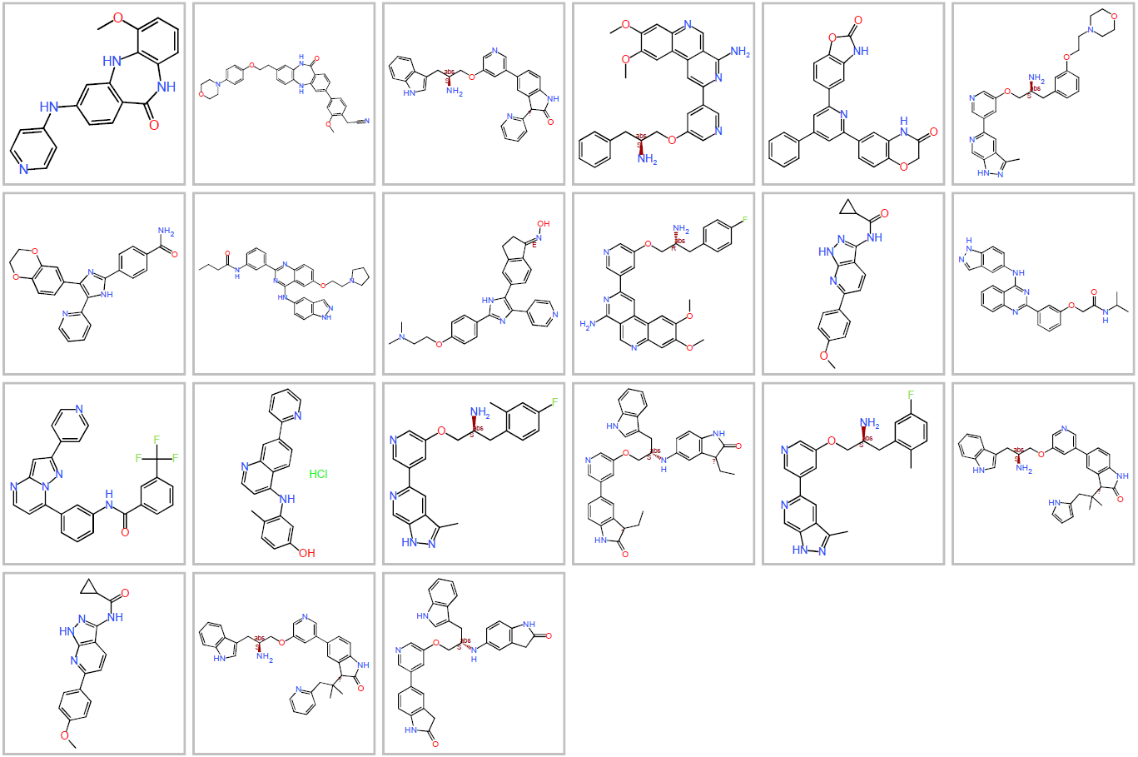
Figura S3.1. Structures with a Tanimoto coefficient of 0.6 for series A using FragFp and PathFp.
FragFp
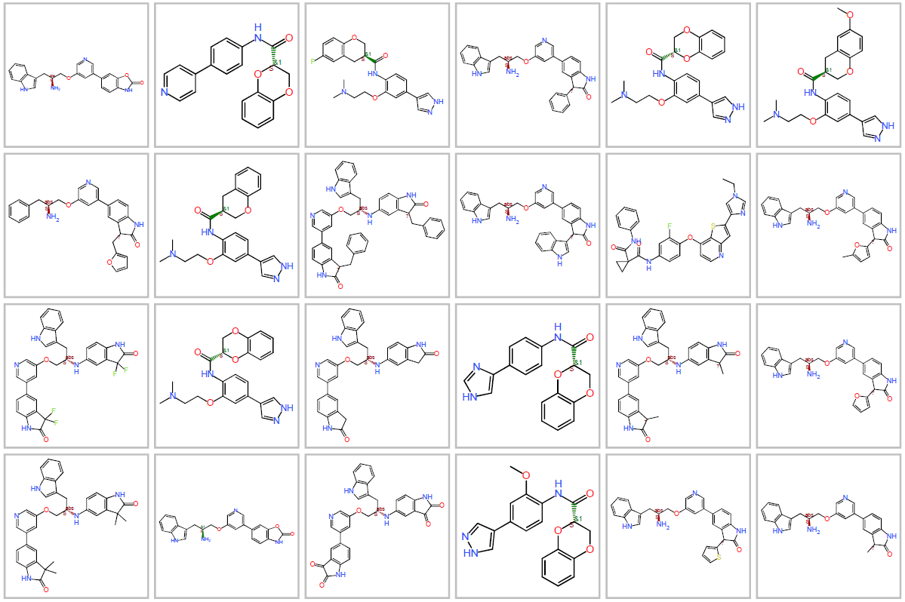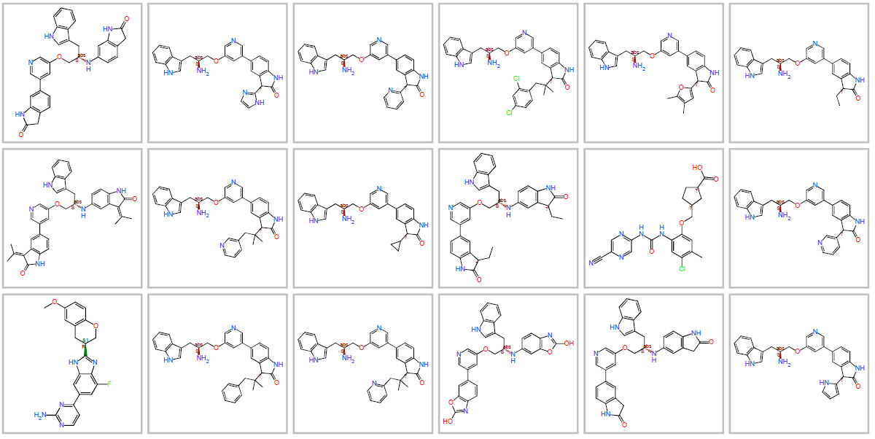

PathFp
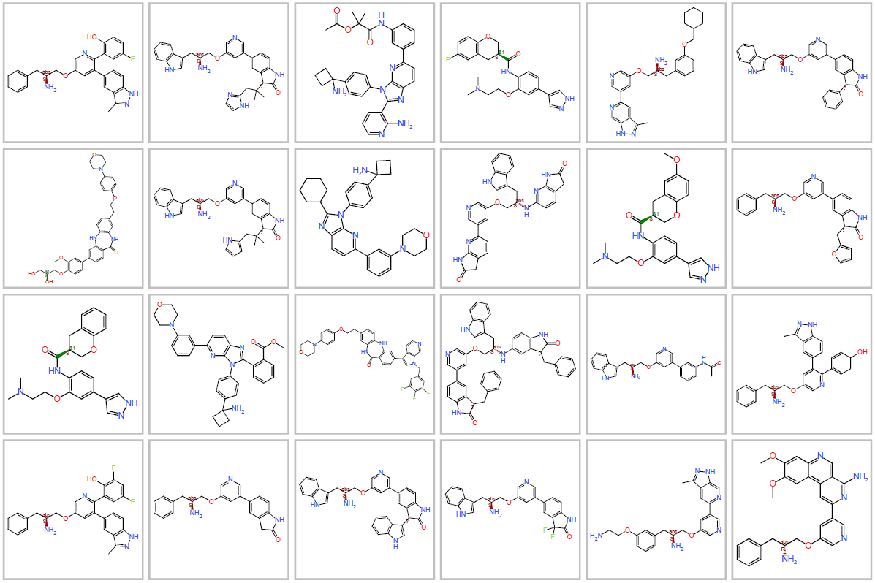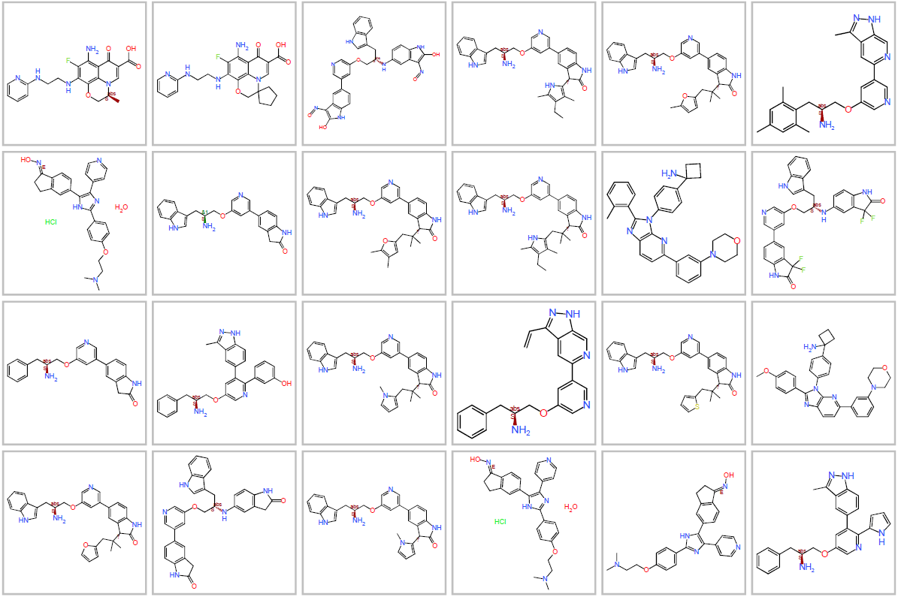
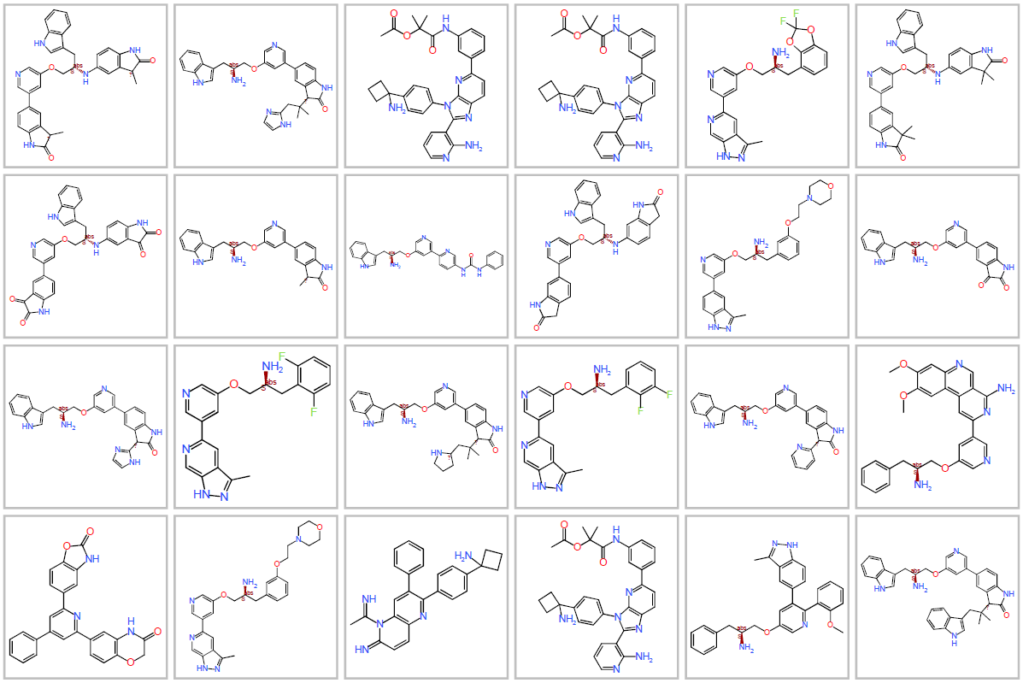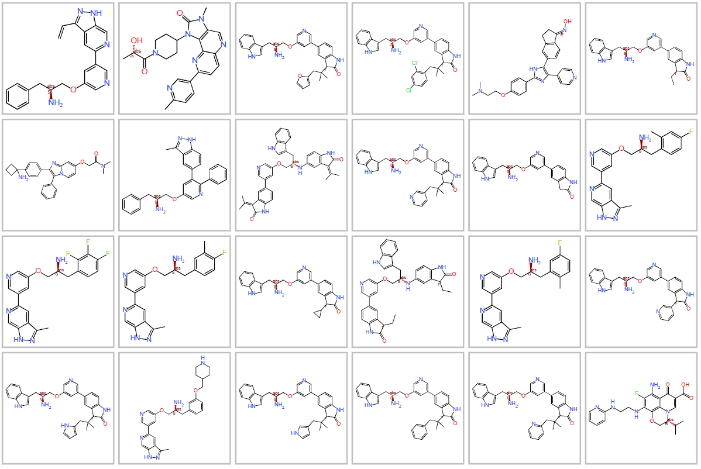
Figura S3.2. Structures with a Tanimoto coefficient of 0.6 for series C using FragFp and PathFp.
FragFp
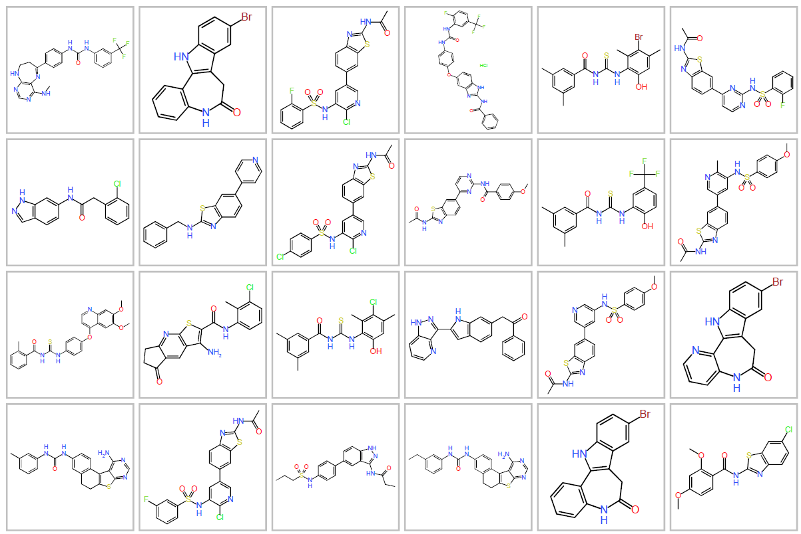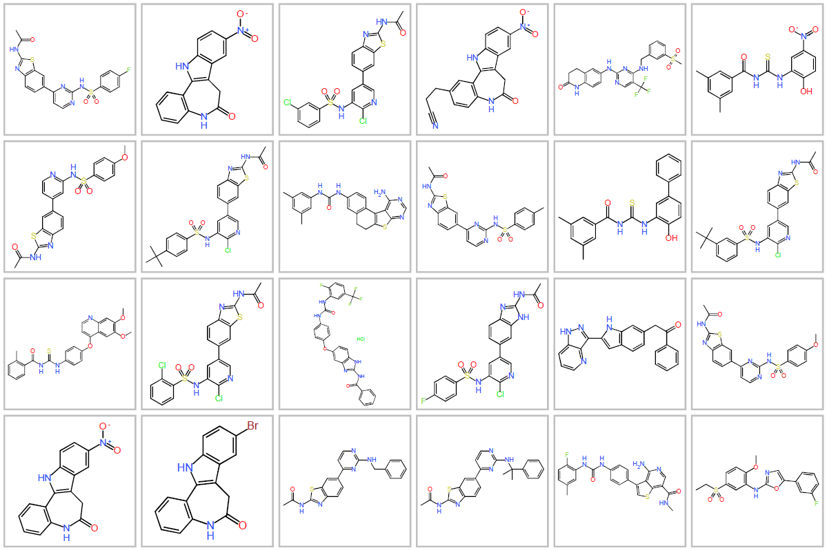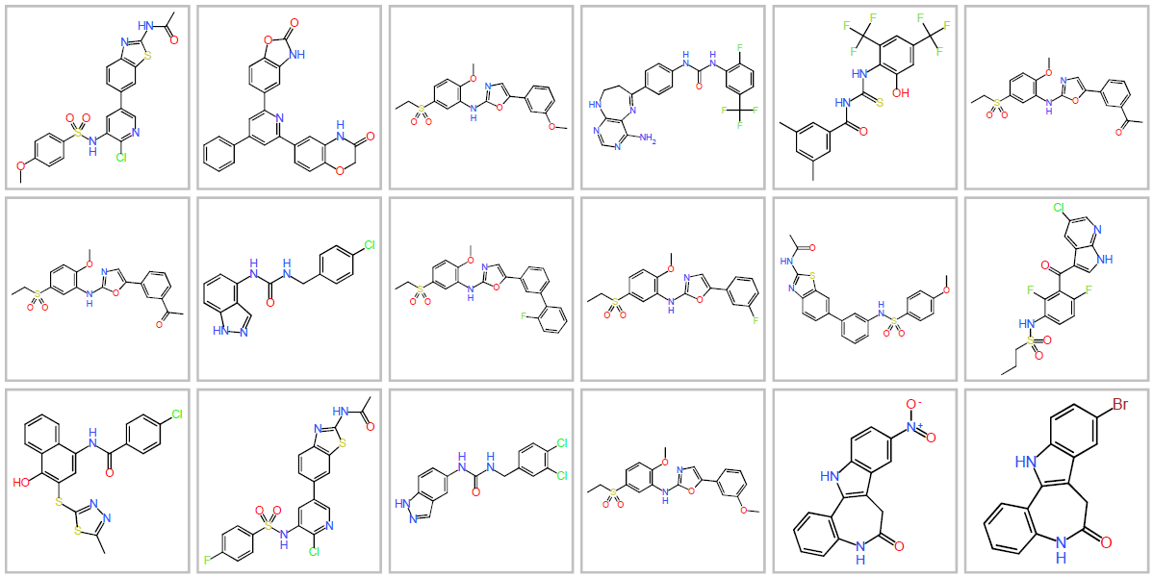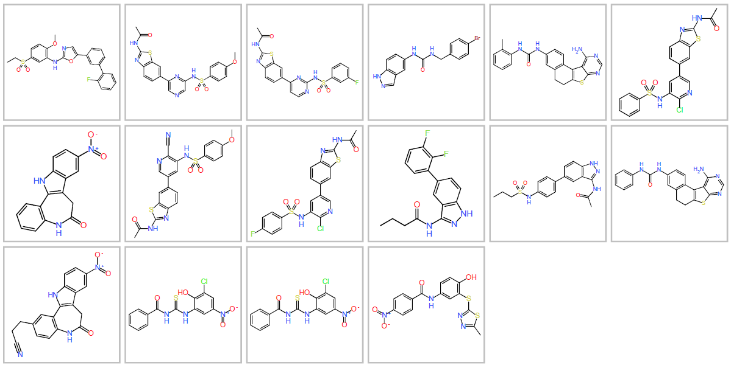

PathFp
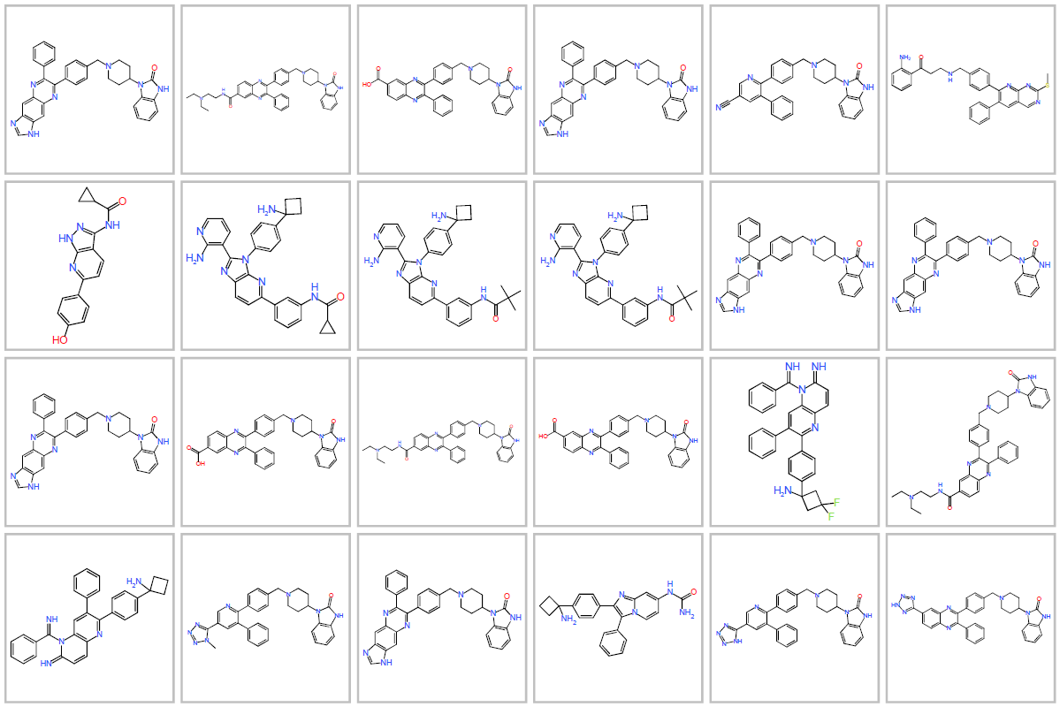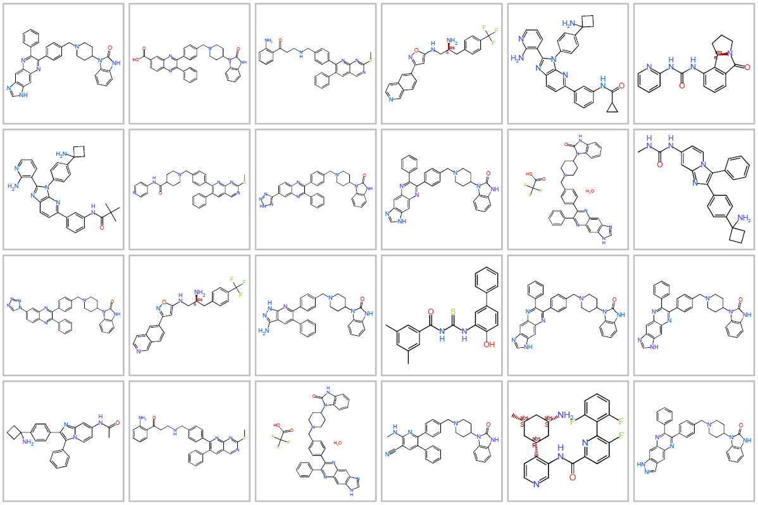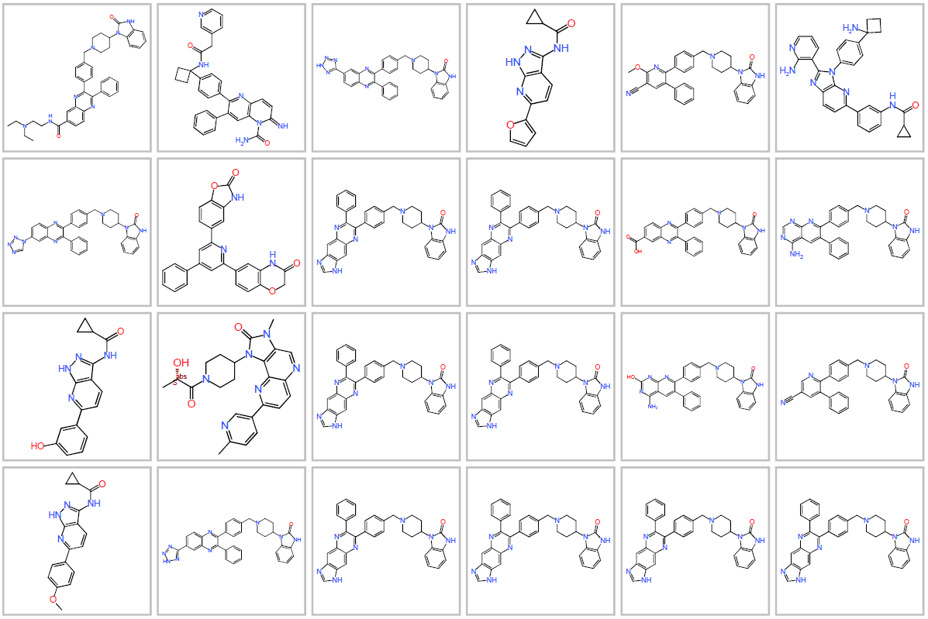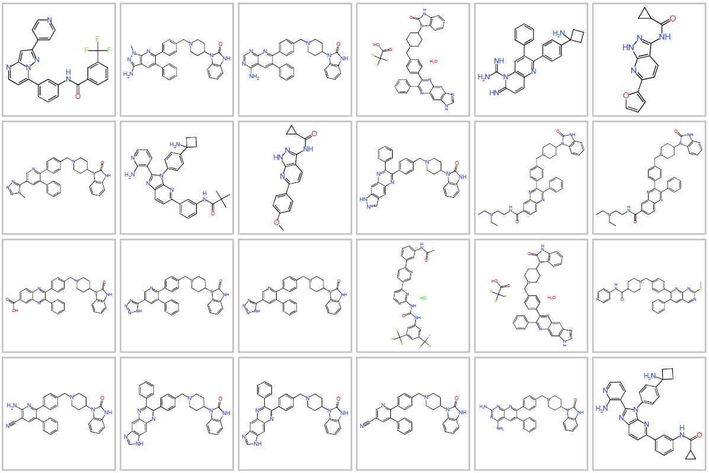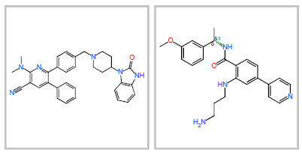
Figura S3.3. Structures with a Tanimoto coefficient of 0.6 for series D using FragFp and PathFp.
FragFp
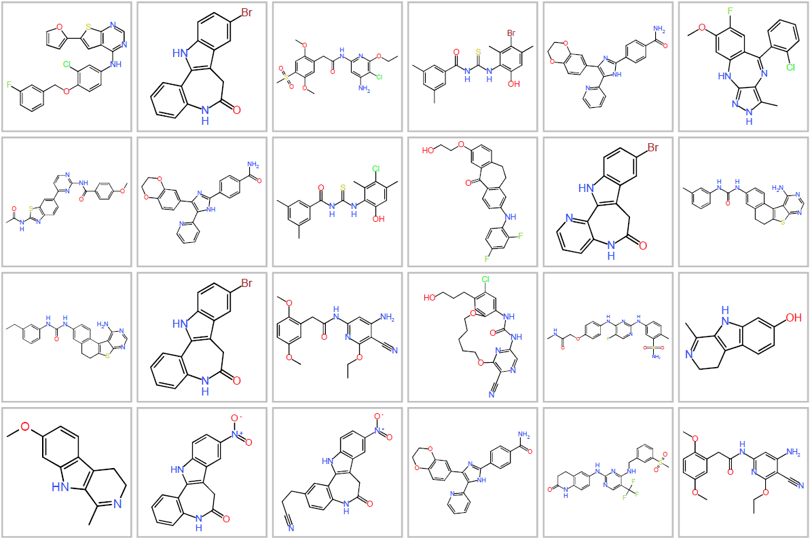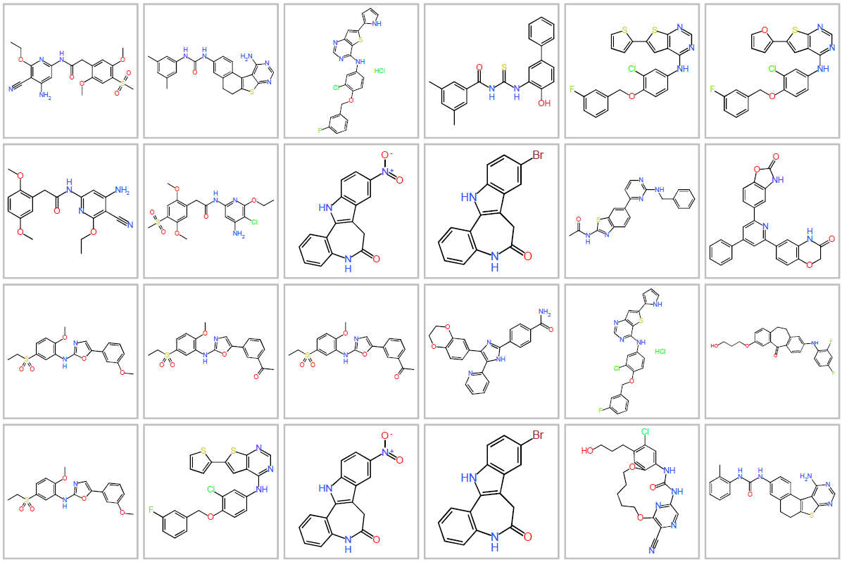
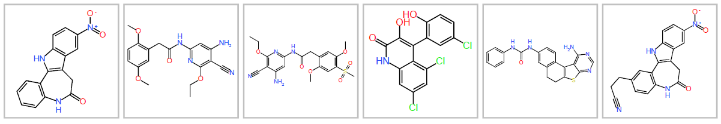
PathFp
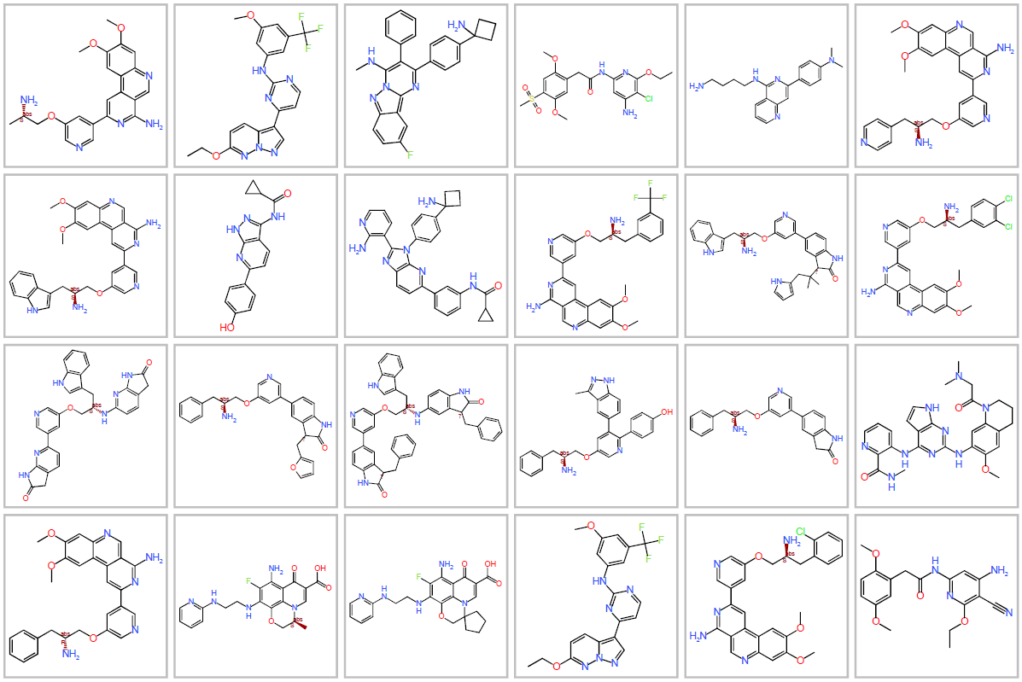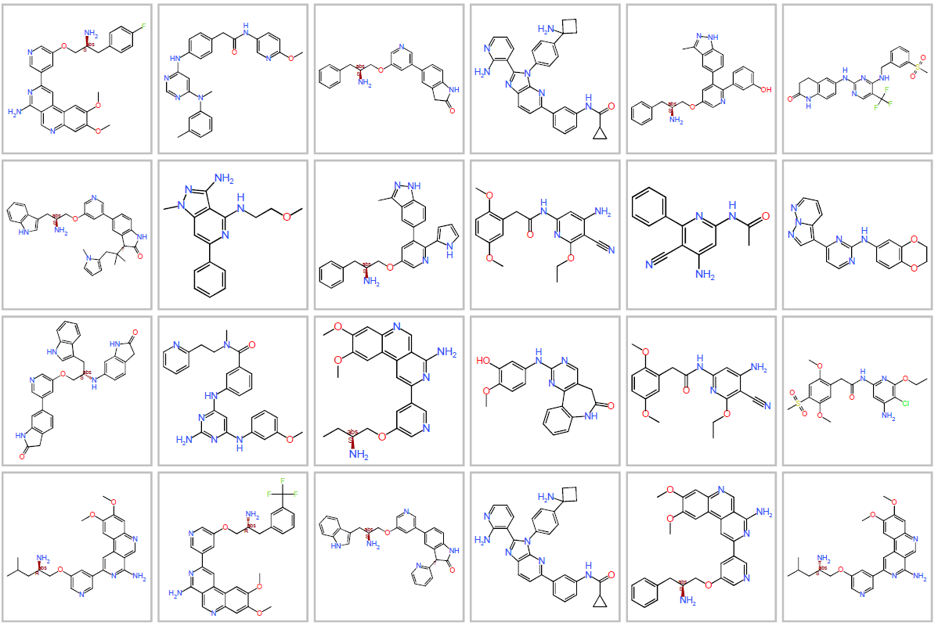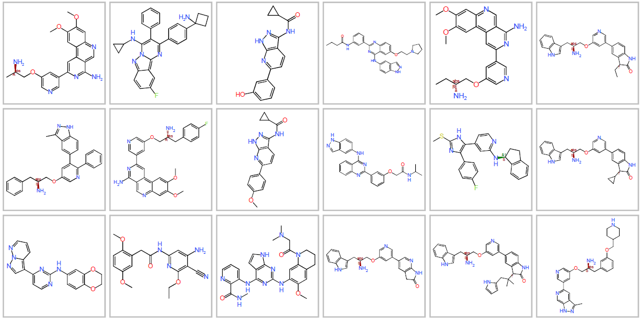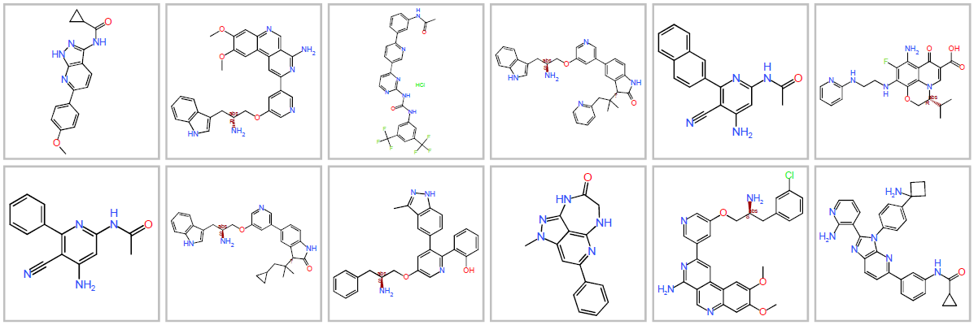
Figura S3.4. Structures with a Tanimoto coefficient of 0.6 for series E using FragFp and PathFp.

