Supporting Information for
Preparation of Gelatin/Genipin Nanofibrous Membrane for Tympanic Member Repair
Longfei Li¹, Weizheng Zhang¹, Mengjia Huang¹, Jie Li¹, Jia Chen^{2,*}, Mi Zhou^{1,*}, Jianguo He²
¹College of Materials Science and Engineering, Zhejiang University of Technology, Hangzhou, China
²Departments of Otolaryngology, The Second Affiliated Hospital, School of Medicine, Zhejiang University, Hangzhou, China

*Corresponding Author: Mi Zhou, zhoumi@zjut.edu.cn; Jia Chen, chenjia212c@zju.edu.cn

Instrumentation: The morphology of and gelatin nanofibers was investigated by scanning electron microscopy (SEM, S-4700, Hitachi, Japan). The randomly selected fiber areas were cut into squares and coated with a thin layer of gold. The diameter of nanofibers was determined by using the image analysis software, Nano Measurer. 50 different nanofibers were randomly measured from SEM images and the average diameter of the nanofiber membranes was analyzed. The mechanical properties of the crosslinked films in dry state were determined by all-purpose testing machine (INSTRON, INSTRON 5966, USA) with a load cell of 500 N. The test temperature was room temperature and the stretch speed was 2 mm/min. The films with different amount of genipin (1 wt%、2 wt%、3 wt%、4 wt%、5 wt%) and uncrosslinked were cut to a size of 3×1 cm and its thickness was measured by using a digital caliper with precision of 0.01 mm.

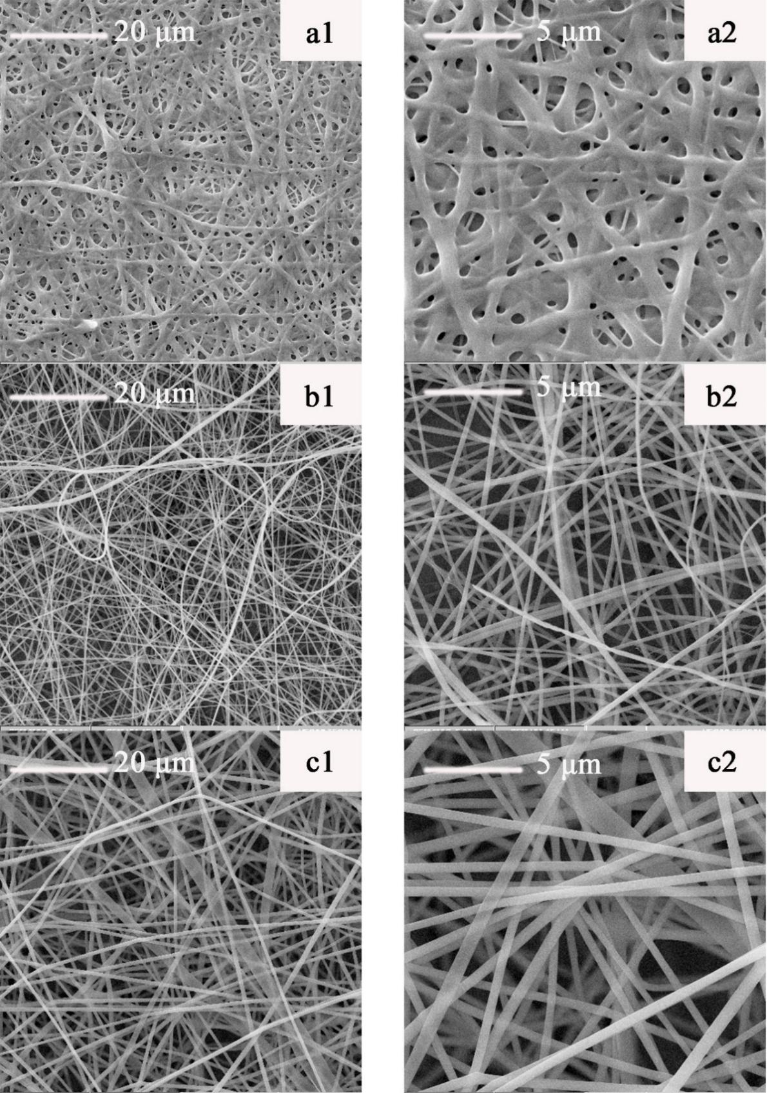
Figure S1 SEM photographs of non-crosslinked gelatin fiber membranes with different gelatin concentrations of gelatin = (a) 15%, (b) 20%, (c) 25%.

Table S1. The diameter of uncrosslinked gelatin fiber membranes with the different gelatin concentration of spinning solution.
Spinning liquid gelatin concentration | 15% | 20% | 25%
Average fiber diameter | 1150.5±131.6 nm | 388.7±69.4 nm | 735.2±107.6 nm

Figure S2. Tensile strength curves of the films with (a) crosslinked by 1wt% genipin, (b) crosslinked by 2wt% genipin, (c) crosslinked by 3wt% genipin, (d) crosslinked by 4wt% genipin and (e) crosslinked by 5wt% genipin in dry state.

