Supplementary online material

Breeding populations of Little Ringed Plover Charadrius dubius and Ringed Plover Charadrius hiaticula in the United Kingdom in 2007

Greg J. Conway, Graham E. Austin, Markus Handschuh, Allan L. Drewitt and Niall H. K. Burton.

APPENDIX S1. Details of methods

Sample tetrads and stratification classes

For Little Ringed Plover, the initial stratification was based on freshwater cover data derived from the CEH Land-class 2000 database (Fuller et al. 2002), an upland / lowland classification, and the species’ distribution data derived from the 1984 survey.

For Ringed Plover, the initial stratification was based on the freshwater cover data, the upland / lowland classification and coastal proximity, as well as country or dependency (England, Wales, Scotland, Northern Ireland, the Isle of Man and Channel Islands).

The Centre for Ecology and Hydrology 2000 Land-class data cover the whole of the UK at a 1-km resolution. The freshwater cover data from this dataset were imported into a Geographic Information System (GIS) project, summarised to a tetrad resolution, and re-classified according to percentage water cover into ‘No Water’, ‘Low Water’ (0% to 5%) and ‘High Water’ (over 5%).

The upland / lowland classification was based on the CEH land-class stratification, which classifies each 1-km square into one of 32 land-class types (see Benefield & Bunce 1982). Land-class descriptions were used to derive two classes of land characteristic for this survey: primarily upland and primarily lowland (Table S1). For our tetrad stratification, a tetrad was considered to be ‘upland’ if over 25% of it (two to four 1-km² units) were classified as upland land-class type; otherwise it was classified as ‘lowland’. The upland class is characterised by nutrient poor and acidic soils, where breeding densities are substantially lower. Therefore, the upland/lowland classification is important to account for substantial differences in breeding densities within the other strata.

For Little Ringed Plover, areas were further split regionally into a ‘core area’ encompassing an arbitrary 30 km buffer around the breeding records from the 1984 survey. Outside the core area, a larger region beyond the 30 km buffer, but within an arbitrary 200 km of the 1984 breeding distribution, was also defined. This second ‘outer area’ represented a region (including lowland parts of Wales and Scotland) where Little Ringed Plover had not been recorded in 1984, though were known to have spread to subsequently (see Gibbons et al. 1993), but where densities were expected to be lower than in the core area.

As the majority of Ringed Plovers in the UK breed on the coast (Prater 1976, Prater 1989, Gibbons et al. 1993), all tetrads that contained any coastline were classified in separate ‘coastal’ strata while those which did not were classified in ‘inland’ strata.

During subsequent analyses the strata were simplified. In the case of Little Ringed Plover, there were only two positive records from tetrads classified as ‘upland’ despite extensive sampling. These records were thus subsequently treated as supplementary, and extrapolation of data from sample tetrads restricted to lowland habitat. There were no apparent differences between the densities on High Water and Low Water tetrads within the outer area and thus these categories were combined to create a single stratum.

For Ringed Plover, there were no apparent differences between the densities on upland and lowland tetrads (except on the coast in Scotland). Thus, these inland categories were combined within countries. In Scotland, the coastal tetrads were divided into two regional strata comprising upland northwest Scotland (from Fort William round to John O’Groats including all islands) and lowland southeast Scotland. Freshwater cover strata were only retained for inland areas. The area distributions of sample tetrads across the final strata used in analyses (outwith key sites) for both species are given in Table S2 and shown in Figure S1a & S1b.

Coverage of sample tetrads and strata

For Little Ringed Plover, the highest percentage coverage was obtained for the stratum with high freshwater cover in the core area of the species’ distribution (Table S4). A higher absolute area was covered in the stratum with low freshwater cover in the core area.

For Ringed Plover, the highest percentage coverage was obtained for coastal strata, particularly in Northern Ireland, Wales and the Isle of Man (Table S4). In inland areas, good coverage was obtained for strata with high freshwater cover, particularly in England. No Ringed Plover were recorded on sample tetrads in inland strata in Northern Ireland, Wales and the Isle of Man and thus no extrapolation was made in these cases. The highest absolute area covered was in the inland stratum with low freshwater cover in England. Although a high number of tetrads were covered in inland strata, percentage coverage for Ringed Plover was low in the no or low freshwater cover, inland strata, particularly in Scotland, due to the extent of these habitats. Confidence limits on population estimates may thus have been reduced in these strata, as small samples may not fully capture actual variation in number of pairs.

REFERENCES

Benefield, C.B. & Bunce, R.G.H. 1982. A Preliminary Visual Presentation of Land Classes in Britain. Merlewood Research and Development Paper No. 91. Institute of Terrestrial Ecology, Grange-over-Sands, UK.

Fuller, R.M., Smith, G.M., Sanderson, J.M., Hill, R.A., Thomson, A.G., Cox, R., Brown, N.J., Clarke, R.T., Thothery, P. & Gerard, F.F. 2002. Countryside Survey 2000 Module 7 Land Cover Map 2000. Centre for Ecology and Hydrology, UK.

Prater, A.J. 1989. Ringed Plover Charadrius hiaticula breeding population of the United Kingdom in 1984. Bird Study 36: 154-159.

Table S1. Land-class types used to assign tetrads to lowland and upland categories (See Benefield & Bunce (1982) for detailed descriptions of land class types).
Land type classification for the 2007 Breeding Plover Surveys | Land class Type
Lowland Land-class Types | 1, 2, 3, 4, 5, 6, 7, 8, 9, 10, 11, 12, 13, 14, 15, 16, 25, 26, 27
Upland Land-class Types | 17, 18, 19, 20, 21, 22, 23, 24, 28, 29, 30, 31, 32

Table S2. Area (km²) distribution across the five-class stratification used for Little Ringed Plover in Great Britain and 12-class stratification used for Ringed Plover in the United Kingdom and Isle of Man.
Species | Country |  |  | Inland Freshwater Cover  (from CEH2000) | Region
 |  |  |  |  | Core area (within 30 km of 1984 records) |  |  |  |  | Outer area
Little Ringed Plover |  |  | - | None | INL | 74,776 |  |  | ONL |  |  | 40,681
 |  |  | - | Low (≤5%) | ILL | 20,166 |  |  | OXL |  |  | 8,227
 |  |  | - | High (>5%) | IHL | 1,426
 |  |  |  |  | Coastal |  |  | Inland
Ringed Plover |  | England |  | None | ENCX |  | 3,979 | ENIN |  |  | 98,025
 |  | England |  | Low (≤5%) |  |  |  | ENIL |  |  | 23,226
 |  | England |  | High (>5%) |  |  |  | ENIH |  |  | 2,134
 |  | Wales |  | All | WACX |  | 1,235 | - |  |  | -
 |  | Scotland |  | None | SCLCX |  | 2,525 | SCIN |  |  | 46,343
 |  | Scotland |  | Low (≤5%) | SCHCX |  | 4,788 | SCIL |  |  | 15,584
 |  | Scotland |  | High (>5%) |  |  |  | SCIH |  |  | 5,358
 |  | Northern Ireland |  | All | NICX |  | 510 | - |  |  | -
 |  | Isle of Man |  | All | IMCX |  | 80 | - |  |  | -

Note these figures exclude sites covered as key sites; no Little Ringed Plovers were recorded in Northern Ireland, the Isle of Man or the Channel Islands and no Ringed Plovers were recorded in the Channel Islands or, out with key sites, in inland Wales, Northern Ireland or the Isle of Man. Freshwater coverage is classified as None, Low or High based on the percentage coverage for the four 1-km grid squares comprising the tetrad as recorded in the CEH2000 Land Classification. Sample data were only extrapolated across lowland habitat. INL = In Core Area, No Water; ILL = In Core Area, Low Water; ILL = In Core Area, Low Water; ONL = Outer Area, No Water; OXL = Outer Area, Low or High Water; ENCX = England Coastal; WACX = Wales Coastal; SCLCX = southeast Scotland Coastal; SCHCX = northwest Scotland Coastal; NICX = Northern Ireland Coastal; IMCX = Isle of Man Coastal; ENIN = England Inland No Water; ENIL = England Inland Low Water; ENIH = England Inland High Water; SCIN = Scotland Inland No Water; SCIL = Scotland Inland Low Water; SCIH = Scotland Inland High Water.
Table S3. Mean numbers of pairs of Little Ringed Plover and Ringed Plover recorded on survey sites, where three or more visits were completed, in relation to the number of visits made, with upper and lower 95% confidence limits in parentheses.

 | Number of visits |  |  | Number of sites
Species | 1 | 2 | 3 or more
Little Ringed Plover | 0.28 (0.19-0.37) | 0.67 (0.50-0.84) | 0.76 (0.66-0.86) | 1,216
Ringed Plover | 0.66 (0.56-0.76) | 1.24 (1.09-1.39) | 1.32 (1.07-1.57) | 2,761

Table S4. Coverage of all sample tetrads by stratum for Little Ringed Plover and Ringed Plover.
Species | Stratum | Area targeted (km²) | Area covered (km²) | % covered
Little Ringed Plover | INL | 74774 | 505 | 0.7
 | ILL | 20162 | 1277 | 6.3
 | IHL | 1426 | 248 | 17.4
 | ONL | 40681 | 301 | 0.7
 | OXL | 8227 | 712 | 8.7
Ringed Plover | ENCX | 3979 | 312 | 7.8
 | WACX | 1235 | 179 | 14.5
 | SCLCX | 2522 | 124 | 4.9
 | SCHCX | 4776 | 237 | 5.0
 | NICX | 510 | 108 | 21.2
 | IMCX | 76 | 11 | 14.6
 | ENIN | 98026 | 867 | 0.9
 | ENIL | 23223 | 232 | 1.0
 | ENIH | 2134 | 150 | 7.0
 | SCIN | 46343 | 192 | 0.4
 | SCIL | 15588 | 120 | 0.8
 | SCIH | 5358 | 100 | 1.9
INL = tetrads in the core area with no freshwater; ILL = tetrads in the core area with low freshwater cover; IHL = tetrads in the core area with high freshwater cover; ONL = tetrads in the outer area with no freshwater; OXL = tetrads in the core area with low or high freshwater cover. ENCX = coastal tetrads in England; WACX = coastal tetrads in Wales; SCLCX = coastal tetrads in southeast Scotland; SCHCX = coastal tetrads in northwest Scotland; NICX = coastal tetrads in Northern Ireland; IMCX = coastal tetrads in the Isle of Man; ENIN = inland tetrads in England with no freshwater; ENIL = inland tetrads in England with low freshwater cover; ENIH = inland tetrads in England with high freshwater cover; SCIN = inland tetrads in Scotland with no freshwater; SCIL = inland tetrads in Scotland with low freshwater cover; SCIH = inland tetrads in Scotland with high freshwater cover.

Table S5. Summary of Little Ringed Plover and Ringed Plover breeding pairs counted in 2007 with comparative figures for 1984 and percentage change between surveys.
County | Little Ringed Plover |  |  | Ringed Plover
 | 1984ª | 2007 | % change | 1984 |  |  |  |  |  | 2007 |  |  |  |  |  | % change from 1984 to 2007
 |  |  |  | Total | Inland |  | Coastal |  |  | Total | Inland |  | Coastal |  |  | Total | Inland |  |  | Coastal
ENGLAND | 705 | 735 | 3 | 2,389 | 406 | (316) | 1,983 |  | (1,866) | 1,184 | 159 | (46) | 1,023 | (952) |  | -50 | -61 |  | (-85) | -48 |  | (-49)
Avon | 6 | 4 | -33 | 4 | 0 | (0) | 4 |  | (4) | 11 | 0 | (0) | 11 | (11) |  | 175 | . |  | (.) | 175 | (175)
Bedfordshire | 4 | 13 | 225 | 12 | 12 | (10) | 0 |  | (0) | 12 | 12 | (0) | 0 | (0) |  | 0 | 0 |  | (-100) | . | (.)
Berkshire | 36 | 25 | -31 | 11 | 11 | (4) | 0 |  | (0) | 3 | 3 | (0) | 0 | (0) |  | -73 | -73 |  | (-100) | . | (.)
Buckinghamshire | 17 | 9 | -47 | 3 | 3 | (3) | 0 |  | (0) | 1 | 1 | (1) | 0 | (0) |  | -33 | -33 |  | (-67) | . | (.)
Cambridgeshire | 43 | 22 | -49 | 22 | 22 | (22) | 0 |  | (0) | 3 | 3 | (0) | 0 | (0) |  | -86 | -86 |  | (-100) | . | (.)
Cheshire & Wirral | 20 | 31 | 55 | 12 | 12 | (12) | 0 |  | (0) | 13 | 13 | (4) | 0 | (0) |  | 8 | 8 |  | (-67) | . | (.)
Cleveland | 5 | 7 | 40 | 53 | 12 | (2) | 41 |  | (9) | 32 | 8 | (1) | 24 | (20) |  | -28 | -33 |  | (-50) | -41 | (-49)
Cumbria | 2 | 12 | 500 | 190^{b} | 26 | (7) | 164 | (121) |  | 159 | 11 | (3) | 148 | (141) |  | -16 | -58 | (-57) |  | -10 | (17)
Derbyshire | 27 | 42 | 56 | 3 | 3 | (2) | 0 | (0) |  | 4 | 4 | (0) | 0 | (0) |  | 33 | 33 | (-100) |  | . | (.)
Devon | 0 | 1 | [+] | 5 | 0 | (0) | 5 | (5) |  | 3 | 0 | (0) | 3 | (1) |  | -40 | . | (.) |  | -40 | (-80)
Dorset | 0 | 1 | [+] | 30 | 0 | (0) | 30 | (30) |  | 18 | 0 | (0) | 18 | (18) |  | -40 | . | (.) |  | -40 | (-40)
Durham | 8 | 15 | 88 | 9 | 4 | (1) | 5 | (2) |  | 17 | 6 | (0) | 11 | (11) |  | 89 | 50 | (-100) |  | 120 | (450)
East Yorkshire | 8 | 21 | 163 | 29 | 0 | (0) | 29 | (29) |  | 20 | 1 | (0) | 19 | (19) |  | -31 | . | (.) |  | -34 | (-34)
Essex | 35 | 16 | -54 | 285 | 36 | (36) | 249 | (220) |  | 93 | 4 | (4) | 89 | (88) |  | -67 | -89 | (-89) |  | -64 | (-60)
Gloucestershire | 13 | 6 | -54 | 2 | 2 | (2) | 0 | (0) |  | 0 | 0 | (0) | 0 | (0) |  | -100 | -100 | (-100) |  | . | (.)
Greater London | 22 | 9 | -59 | 5 | 5 | (5) | 0 | (0) |  | 1 | 1 | (1) | 0 | (0) |  | -80 | -80 | (-80) |  | . | (.)
Greater Manchester | 2 | 29 | 1,350 | 0 | 0 | (0) | 0 | (0) |  | 14 | 14 | (0) | 0 | (0) |  | [+] | [+] | (.) |  | . | (.)
Hampshire | 18 | 32 | 78 | 166 | 16 | (15) | 150 | (149) |  | 85 | 2 | (2) | 83 | (82) |  | -49 | -88 | (-87) |  | -45 | (-45)
Herefordshire | 0 | 10 | [+] | 0 | 0 | (0) | 0 | (0) |  | 0 | 0 | (0) | 0 | (0) |  | . | . | (.) |  | . | (.)
Hertfordshire | 20 | 13 | -35 | 2 | 2 | (2) | 0 | (0) |  | 2 | 2 | (1) | 0 | (0) |  | 0 | 0 | (-50) |  | . | (.)
Isle of Wight | 0 | 0 | . | 4 | 0 | (0) | 4 | (0) |  | 0 | 0 | (0) | 0 | (0) |  | -100 | . | (.) |  | -100 | (.)
Isles of Scilly | 0 | 0 | . | 40^{c} | 0 | (0) | 40 | (23) |  | 16 | 0 | (0) | 16 | (16) |  | -60 | . | (.) |  | -60 | (-30)
Kent | 16 | 21 | 31 | 158 | 22 | (4) | 136 | (140) |  | 104 | 0 | (0) | 104 | (89) |  | -34 | -100 | (-100) |  | -24 | (-36)
Lancashire & North Merseyside | 20 | 38 | 90 | 81 | 51 | (46) | 30 | (30) |  | 67 | 16 | (7) | 51 | (22) |  | -17 | -69 | (-85) |  | 70 | (-27)
Leicestershire & Rutland | 24 | 26 | 8 | 3 | 3 | (3) | 0 | (0) |  | 2 | 2 | (1) | 0 | (0) |  | -33 | -33 | (-67) |  | . | (.)
Lincolnshire | 36 | 22 | -39 | 242 | 43 | (40) | 199 | (186) |  | 71 | 4 | (0) | 67 | (67) |  | -71 | -91 | (-100) |  | -66 | (-64)
Norfolk | 39 | 19 | -51 | 541 | 18 | (18) | 523 | (522) |  | 277 | 4 | (4) | 273 | (270) |  | -49 | -78 | (-78) |  | -48 | (-48)
North Yorkshire | 20 | 50 | 150 | 12 | 12 | (8) | 0 | (0) |  | 18 | 17 | (6) | 1 | (0) |  | 50 | 42 | (-25) |  | . | (.)
Northamptonshire | 21 | 0 | -100 | 10 | 10 | (8) | 0 | (0) |  | 0 | 0 | (0) | 0 | (0) |  | -100 | -100 | (-100) |  | . | (.)
Northumberland | 1 | 28 | 2,700 | 95 | 25 | (18) | 70 | (68) |  | 55 | 15 | (9) | 40 | (39) |  | -42 | -40 | (-50) |  | -43 | (-43)
Nottinghamshire | 45 | 13 | -71 | 23 | 23 | (22) | 0 | (0) |  | 2 | 2 | (1) | 0 | (0) |  | -91 | -91 | (-95) |  | . | (.)
Oxfordshire | 12 | 19 | 58 | 7 | 7 | (7) | 0 | (0) |  | 4 | 4 | (0) | 0 | (0) |  | -43 | -43 | (-100) |  | . | (.)
Shropshire | 8 | 9 | 13 | 0 | 0 | (0) | 0 | (0) |  | 0 | 0 | (0) | 0 | (0) |  | . | . | (.) |  | . | (.)
Somerset | 0 | 2 | [+] | 0 | 0 | (0) | 0 | (0) |  | 6 | 0 | (0) | 6 | (0) |  | [+] | . | (.) |  | [+] | (.)
South Yorkshire | 44 | 30 | -32 | 9 | 9 | (9) | 0 | (0) |  | 4 | 2 | (0) | 0 | (0) |  | -56 | -78 | (-100) |  | . | (.)
Staffordshire | 40 | 23 | -43 | 3 | 3 | (0) | 0 | (0) |  | 3 | 3 | (0) | 0 | (0) |  | 0 | 0 | (.) |  | . | (.)
Suffolk | 11 | 13 | 18 | 184 | 8 | (4) | 176 | (170) |  | 38 | 0 | (0) | 38 | (38) |  | -79 | -100 | (-100) |  | -78 | (-78)
Surrey | 27 | 14 | -48 | 3 | 3 | (3) | 0 | 0) |  | 1 | 1 | (1) | 0 | (0) |  | -67 | -67 | (-67) |  | . | (.)
Sussex | 8 | 6 | -25 | 128 | 0 | (0) | 128 | (128) |  | 20 | 0 | (0) | 20 | (18) |  | -84 | . | (.) |  | -84 | (-86)
Warwickshire | 15 | 19 | 27 | 2 | 2 | (2) | 0 | (0) |  | 0 | 0 | (0) | 0 | (0) |  | -100 | -100 | (-100) |  | . | (.)
West Midlands | 6 | 4 | -33 | 0 | 0 | (0) | 0 | (0) |  | 0 | 0 | (0) | 0 | (0) |  | . | . | (.) |  | . | (.)
West Yorkshire | 15 | 30 | 100 | 1 | 1 | (1) | 0 | (0) |  | 4 | 4 | (0) | 0 | (0) |  | 300 | 300 | (-100) |  | . | (.)
Wiltshire | 2 | 12 | 500 | 0 | 0 | (0) | 0 | (0) |  | 0 | 0 | (0) | 0 | (0) |  | . | . | (.) |  | . | (.)
Worcestershire | 9 | 19 | 111 | 0 | 0 | (0) | 0 | (0) |  | 0 | 0 | (0) | 0 | (0) |  | . | . | (.) |  | . | (.)
WALES | 6 | 144 | 2,300 | 224 | 3 | (3) | 221 | (206) |  | 214 | 8 | (0) | 198 |  | (134) | -4 | 167 | (-100) |  | -10 | (-35)
Anglesey | 0 | 0 | . | 49^{d} | 0 | (0) | 49 | (42) |  | 17 | 0 | (0) | 23 | (20) |  | -65 | . | (.) |  | -53 | (-52)
Breconshire | 0 | 11 | [+] | 1 | 1 | (1) | 0 | (0) |  | 0 | 0 | (0) | 0 | (0) |  | -100 | -100 | (-100) |  | . | (.)
Carmarthenshire | 1 | 77 | 7,600 | 20 | 0 | (0) | 20 | (20) |  | 14 | 0 | (0) | 0 | (0) |  | -30 | . | (.) |  | -100 | (-100)
Caernarfon | 0 | 0 | . | 61 | 0 | (0) | 61 | (61) |  | 79 | 0 | (0) | 79 | (73) |  | 30 | . | (.) |  | 30 | (20)
Ceredigion | 0 | 1 | [+] | 7 | 0 | (0) | 7 | (7) |  | 4 | 0 | (0) | 4 | (4) |  | -43 | . | (.) |  | -43 | (-43)
Denbigh & Flint | 0 | 5 | [+] | 8e | 0 | (0) | 8 | (0) |  | 42 | 0 | (0) | 42 | (0) |  | 425 | . | (.) |  | 425 | (.)
East Glamorgan | 0 | 9 | [+] | 17 | 2 | (0) | 15 | (15) |  | 5 | 1 | (0) | 4 | (2) |  | -71 | 0 | (.) |  | -73 | (-87)
Gower | 0 | 3 | [+] | 25 | 0 | (0) | 25 | (25) |  | 23 | 1 | (0) | 22 | (16) |  | -8 | 0 | (.) |  | -12 | (-36)
Gwent | 3 | 6 | 100 | 0 | 0 | (0) | 0 | (0) |  | 4 | 4 | (0) | 0 | (0) |  | [+] | [+] | (.) |  | . | (.)
Meirionnydd | 0 | 4 | [+] | 36 | 0 | (0) | 36 | (36) |  | 24 | 0 | (0) | 24 | (19) |  | -33 | . | (.) |  | -33 | (-47)
Montgomeryshire | 2 | 23 | 1,050 | 0 | 0 | (0) | 0 | (0) |  | 0 | 0 | (0) | 0 | (0) |  | . | . | (.) |  | . | (.)
Pembrokeshire | 0 | 0 | . | 0 | 0 | (0) | 0 | (0) |  | 2 | 2 | (0) | 0 | (0) |  | [+] | [+] | (.) |  | . | (.)
Radnorshire | 0 | 5 | [+] | 0 | 0 | (0) | 0 | (0) |  | 0 | 0 | (0) | 0 | (0) |  | . | . | (.) |  | . | (.)
SCOTLAND | 0 | 22 | [+] | 5,796 | 794 | (505) | 5,002 | (2,447) |  | 2,672 | 218 | (96) | 1,256 |  | (1,049) | -54 | -73º | (-81) |  | -75º | (-57)
Angus & Dundee | 0 | 3 | [+] | 15 | 4 | (4) | 11 | (11) |  | 10 | 5 | (0) | 5 | (5) |  | -33 | 25 | (-100) |  | -55 | (-55)
Argyll (mainland) | 0 | 0 | . | 649^{f} | 1 | (1) | 648 | (518) |  | 366 | 0 | (0) | 366 | (340) |  | -44 | -100 | (-100) |  | -44 | (-34)
Ayrshire | 0 | 0 | . | 80^{g} | nc | (15) | nc | (43) |  | 48 | 1 | (0) | 47 | (41) |  | -40 | . | (-100) |  | . | (-5)
Borders | 0 | 3 | [+] | 13 | 13 | (13) | 0 | (0) |  | 13 | 13 | (8) | 0 | (0) |  | 0 | 0 | (-38) |  | . | (.)
Caithness | 0 | 0 | . | 90^{h} | 31 | (31) | 59 | (32) |  | 24 | 5 | (5) | 19 | (12) |  | -73 | -84 | (-84) |  | -68 | (-63)
Inverness | 0 | 0 | . | 90^{i} | 73 | (.) | 17 | (15) |  | 3 | 3 | (.) | 0 | (0) |  | -97 | -96 | (.) |  | -100 | (-100)
Lothian | 0 | 0 | . | 111 | 12 | (11) | 99 | (99) |  | 25 | 10 | (1) | 15 | (15) |  | -77 | -17 | (-91) |  | -85 | (-85)
Moray & Nairn | 0 | 1 | [+] | 45^{i} | 1 | (1) | 44 | (44) |  | 17 | 0 | (0) | 17 | (15) |  | -62 | -100 | (-100) |  | -61 | (-66)
Clyde | 0 | 3 | [+] | 122 | 120 | (116) | 2 | (2) |  | 59 | 52 | (35) | 7 | (4) |  | -52 | -57 | (-70) |  | 250 | (+100)
Dumfries and Galloway | 0 | 0 | . | 177 | 24 | (24) | 153 | (153) |  | 55 | 5 | (5) | 50 | (44) |  | -69 | -79 | (-79) |  | -67 | (-71)
Fife | 0 | 4 | [+] | 26 | 2 | (2) | 24 | (24) |  | 37 | 14 | (0) | 23 | (12) |  | 42 | 600 | (-100) |  | -4 | (-50)
North-east Scotland | 0 | 7 | [+] | 62 | 8 | (8) | 54 | (54) |  | 20 | 3 | (1) | 17 | (15) |  | -68 | -63 | (-88) |  | -69 | (-72)
Orkney | 0 | 0 | . | 552 | 23 | (23) | 529 | (529) |  | 29 | 0 | (0) | 29 | (29) |  | -95 | -100 | (-100) |  | -95 | (-95)
Perth & Kinross | 0 | 0 | . | 43 | 43 | (43) | 0 | (0) |  | 27 | 27 | (9) | 0 | (0) |  | -37 | -37 | (-79) |  | . | (.)
Ross & Cromarty | 0 | 0 | . | 205^{i} | 0 | (0) | 205 | (31) |  | 112 | 18 | (0) | 94 | (14) |  | -45 | [+] | (.) |  | -54 | (-55)
Shetland | 0 | 0 | . | 900^{j} | 133 | (133) | 767 | (767) |  | 389 | 0 | (0) | 389 | (373) |  | -57 | -100 | (-100) |  | -49 | (-51)
Sutherland | 0 | 0 | . | 160^{k} | 58 | (55) | 102 | (75) |  | 136 | 36 | (31) | 100 | (85) |  | -15 | -38 | (-44) |  | -2 | (13)
Outer Hebrides | 0 | 0 | . | 2,324^{l} | nc | (nc) | nc | (nc) |  | 1,198^{m} | nc | (nc) | nc | (nc) |  | -48 | nc | (nc) |  | nc | (nc)
Clyde Islands | 0 | 0 | . | 50^{i} | 0 | (0) | 50 | (nc) |  | 11 | 0 | (0) | 11 | (nc) |  | -78 | . | (.) |  | -78 | (nc)
Upper Forth | 0 | 1 | [+] | 31 | 16 | (16) | 15 | (15) |  | 5 | 5 | (0) | 0 | (0) |  | -84 | -69 | (-100) |  | -100 | (-100)
Badenoch & Strathspey | 0 | 0 | . | 9 | 9 | (9) | 0 | (0) |  | 19 | 19 | (1) | 0 | (0) |  | 111 | 111 | (-89) |  | . | (.)
Lochaber | 0 | 0 | . | 17^{f} | 0 | (0) | 17 | (12) |  | 39 | 2 | (0) | 37 | (33) |  | 129 | [+] | (.) |  | 118 | (175)
Skye & Lochalsh | 0 | 0 | . | 25^{f} | 0 | (0) | 25 | (23) |  | 30 | 0 | (0) | 30 | (12) |  | 20 | . | (.) |  | 20 | (-48)
NORTHERN IRELAND | 0 | 0 | . | 134 | 47 | (27) | 87 | (87) |  | 62 | 1 | (0) | 61 | (25) |  | -54 | -98 | (-100) |  | -30 | (-71)
Antrim | 0 | 0 | . | 48 | 30 | (10) | 18 | (18) |  | 13 | 0 | (0) | 13 | (3) |  | -73 | -100 | (-100) |  | -28 | (-83)
Down | 0 | 0 | . | 59 | 0 | (0) | 59 | (59) |  | 48 | 0 | (0) | 48 | (22) |  | -19 | . | (.) |  | -19 | (-63)
Fermanagh | 0 | 0 | . | 17 | 17 | (17) | 0 | (0) |  | 1 | 1 | (0) | 0 | (0) |  | -94 | -94 | (-100) |  | . | (.)
Londonderry | 0 | 0 | . | 10 | 0 | (0) | 10 | (10) |  | 0 | 0 | (0) | 0 | (0) |  | -100 | . | (.) |  | -100 | (-100)
ISLE OF MAN | 0 | 0 | . | 70^{n} | 0 | (0) | 70 | (49) |  | 116 | 0 | (0) | 116 | (65) |  | 66 | . | (.) |  | 66 | (33)
CHANNEL ISLANDS | 0 | 0 | . | 4 | 0 | (0) | 4 | (4) |  | 0 | 0 | (0) | 0 | (0) |  | -100 | . | (-100) |  | . | (.)
GREAT BRITAIN | 711 | 901 | 25 | 8,409 | 1,203 | (824) | 7,206 | (4,517) |  | 4,070 | 385 | (142) | 2,478 | (2,133) |  | -52 | -68 | (-83) |  | -66 | (-53)
UNITED KINGDOM | 711 | 901 | 25 | 8,543 | 1,250 | (851) | 7,293 | (4,606) |  | 4.132 | 386 | (142) | 2,539 | (2,158) |  | -52 | -69 | (-83) |  | -65 | (-53)
GRAND TOTAL | 711 | 901 | 25 | 8,613 | 1,250 | (851) | 7,363 | (4,655) |  | 4,248 | 386 | (142) | 2,655 | (2,223) |  | -51 | -69 | (-83) |  | -64 | (-52)
For Ringed Plover, totals are included for Coastal and Inland sites/tetrads and figures in parenthesise indicate change in numbers at a subset of sites covered in both the 1984 and 2007 surveys. Note: ‘[+]’ denotes positive change relative to zero, as percent change infinite; ‘.’ denotes no percentage changes where 1984 and 2007 counts are zero; ‘nc’ = no count available.
ª County totals were not presented in Parrinder 1989, however, for the purposes of comparison with 2007, County totals have been derived for 1984 from the original data. Note: a revised total of 711 pairs was interpreted from the original 1984 data (608-631 pairs) using an approach consistent with that used in 2007.
^{b} Estimated total based on count of 124 pairs;
^{c} Estimated total based on count of 20 pairs;
^{d} Estimated total based on 1982 count;
^{e} Estimated total based on 1973/74 count of eight pairs;
^{f} Recording areas share an additional combined estimate of 82 pairs;
^{g} Estimated total based on count of 58 pairs;
^{h} Estimated total based on count of 63 pairs;
^{i} Estimated count.
^{j} Estimated total based on count of 624 pairs;
^{k} Estimated total based on count of 129 pairs;
^{l} Includes an estimated total 100 for Lewis and Harris, based on a count of 58 pairs;
^{m} Coastal and inland pairs were not explicitly differentiated in 2007, so inland/coastal comparisons were not made;
^{n} Estimated total based on count of 50 pairs.
º Percentage change figures exclude the Outer Hebrides.

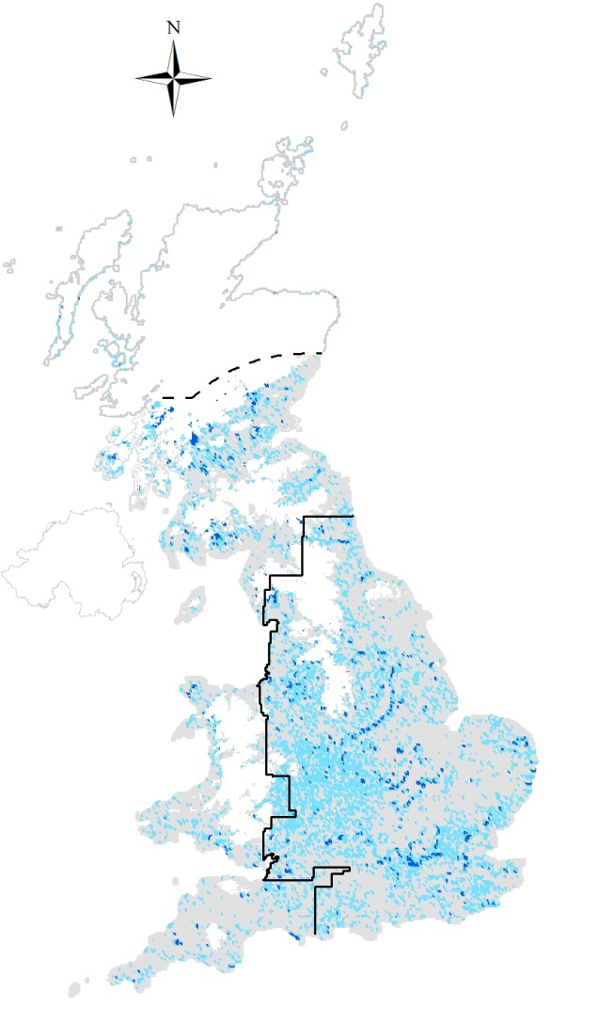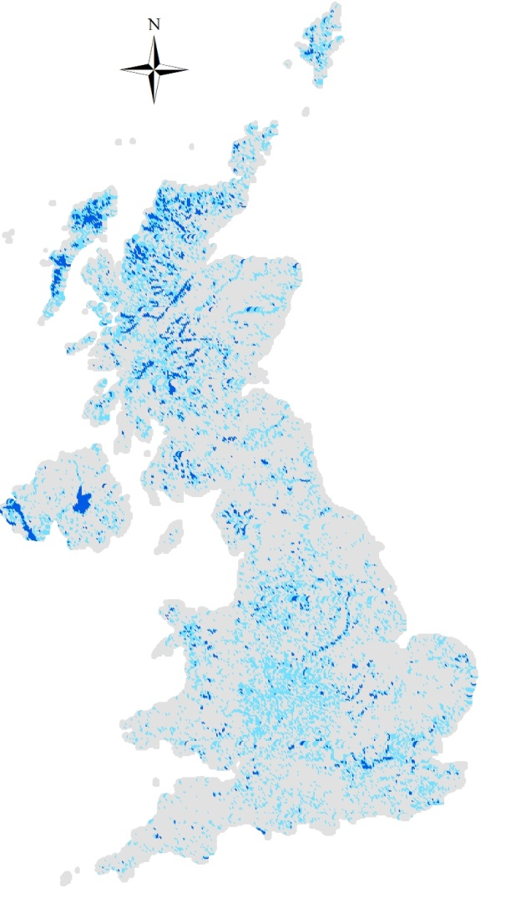
a)
b)

Figure S1. Distribution of tetrads in Great Britain across the stratification used for a) Little Ringed Plover and b) Ringed Plover. Light grey = with no freshwater; pale blue = with low freshwater cover; dark blue = with high freshwater cover; white = no tetrads surveyed (upland habitat or falling outside sampling area); solid line marks the boundaries of the core (east) range and the dashed line marks the extent of the 200km buffer. For Little Ringed Plover sample data were only extrapolated across lowland habitat. For Ringed Plover all tetrads containing coast form a separate stratum and tetrads were further stratified by country and in Scotland, into Highland and non-Highland regions.

