Supplementary Material
“Oxidation of 1,4-disubstituted-1,2,3-triazoles with H₂O₂-CF₃CO₂H: efficient synthesis of 1,2,3-triazole 3-oxides”

Norberto González-Mojica, Leticia Almazán-Sánchez, Jesús G. García-Torres, Diego Martínez-Otero, Miguel A. Sánchez-Carmona, and Erick Cuevas-Yañez*

Centro Conjunto de Investigación en Química Sustentable UAEM-UNAM. Carretera Toluca-Atlacomulco Km. 14.5, Toluca, Estado de México, 50200, México.

*Corresponding autor, e-mail: ecuevasy@uaemex.mx

CONTENTS:

- General considerations

- General procedure for the synthesis of 1,2,3-triazole-3-oxides

- References.

- Spectroscopic data of compounds

- ¹H NMR and ¹³C NMR spectra for compounds

- Crystallographic data of compound 2

1. - General Considerations
The starting materials were purchased from Aldrich Chemical Co. and were used without further purification. 1,2,3-triazoles were prepared according to the literature.^{[1-3]} Solvents were distilled before use. Silica gel (230–400 mesh) was purchased from Merck. Silica plates of 0.20 mm thickness were used for thin layer chromatography. Melting points were determined with a Krüss Optronic melting point apparatus and they are uncorrected.
¹H and ¹³C NMR spectra were recorded using a Bruker Avance 300 MHz, and a Varian 500 MHz, The chemical shifts (δ) are given in ppm relative to TMS as internal standard (0.00). For analytical purposes the mass spectra were recorded on a Shimadzu GCMS-QP2010 Plus in the EI mode, 70 eV, 200 °C via direct inlet probe. Only the molecular and parent ions (m/z) are reported. IR spectra were recorded on a Bruker TENSOR 27 FT instrument.

For the X-ray diffraction studies, crystals of compounds 5 and 8 were obtained by slow evaporation of a dilute MeOH solution, and the reflections were acquired with a Bruker APEX DUO diffractometer equipped with an Apex II CCD detector using CuKa (k = 1.54178 Å) for Incoatec IlS microsource and Helios optic monochromator. Frames were integrated with SAINT. Multi-scan absorption correction (SADABS) was applied. The structures were solved by using direct methods (SHELXT) and refined using fullmatrix least-squares on F2 with SHELXL using the ShelXle GUI. Weighted R factors, Rw and all goodness-of-fit indicators are based on F2. All non-hydrogen atoms were refined anisotropically. The hydrogen atoms of the CAH bonds were placed in idealized positions, whereas the hydrogen atoms from the NH, NH₂ and OH moieties were localized from the difference electron density map; their position was refined with Uiso tied to the parent atom with distance restraints (DFIX or SADI). Three standard reflections every 97 reflections were used to monitor the crystal stability. The structure was solved by direct methods; missing atoms were found by difference-Fourier synthesis, and refined on F2 by a full-matrix least-squares procedure using anisotropic displacement parameters using SHELX-97. Crystallographic data for the structures reported herein have been deposited with the Cambridge Crystallographic Data Centre (CCDC). Copies of available materials can be obtained free of charge on application to the Director, CCDC, 12 Union Road, Cambridge CB2 IEZ, UK (facsimile: (44) 01223 336033); e-mail: deposit@ccdc.ac.uk.

2. - General procedure for the synthesis of 1,2,3-triazole 3-oxides

Typical procedure. A 30% aqueous solution of H₂O₂ (5 mL) was added to a pre-cooled solution of the appropriate 1,2,3-triazole (300 mg) in CF₃CO₂H (4 mL) at 0 °C. The resulting reaction mixture was stirred at room temperature during 1 h and additional aliquot of 30% H₂O₂ solution (5 mL) was added. The resulting mixture was heated at 40 °C for 2 h. If necessary, 30% H₂O₂ solution (2 mL) was added every hour (maximum 5 hours) to total disappearance of starting material monitored by TLC. The mixture was cooled to room temperature and A saturated solution of NaHCO₃ (10 mL) was added and the organic layer was extracted with AcOEt (3 X 20 mL). The combined organic layers were dried over anhydrous Na₂SO₄, the solvent was removed under reduced pressure and the final product was purified by column chromatography (SiO₂, hexane/AcOEt 7:3).

3. - References.
1.- Tornoe, C. W.; Christensen, C.; Meldal, M. J. Org. Chem. 2002, 67, 3057-3064.
2.- Velasco, B. E.; López-Téllez, G.; González-Rivas, N.; García-Orozco, I.; Cuevas-Yañez, E. Can. J. Chem. 2013, 91, 292-299.
3.- Velasco, B. E.; Fuentes, A.; Gonzalez, C.; Corona, D.; García-Orozco, I.; Cuevas Yañez, E. Synth. Commun. 2011, 41, 2966-2973.
4. Spectroscopic data of compounds
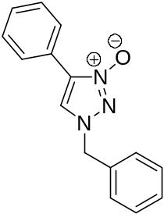
1-Benzyl-4-phenyl-1,2,3-triazole 3-oxide (2):

1-Benzyl-4-phenyl-1,2,3-triazole afforded 1-benzyl-4-phenyl-1,2,3-triazole 3-oxide 2 as a white solid m.p. 193-195ºC. Yield: 283mg (88.8%).

IR (ATR, cm⁻¹): 3056, 2958, 1496, 1466, 1394 (N-O), 1164, 760.
HRMS (EI): for C₁₅H₁₃N₃O calcd. 251.1059, found 251.1063.
MS [EI+] m/z (%): 251 [M]⁺ (32), 234 [M-O]⁺ (5), 116 [M-C₇H₇N₂O]⁺ (23), 102 [M-C₈H₉N₂O]⁺ (30), 91 [C₆H₅ –CH₂]⁺ (100), 65 [C₅H₅]+ (25)
¹H NMR: (300 MHz, CDCl₃) δ 7.93 (d, 2H), 7.55 (s, 1H), 7.39-7.28 (m, 8H), 5.22 (s, 2H)
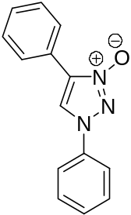¹³C NMR: (75 MHz, CDCl₃) 130.8, 129.4, 127.4, 127.0, 127.2, 126.7, 126.7, 124.4, 123.4, 119.8, 53.6.

1,4-Diphenyl-1,2,3-triazole 3-oxide (3):
1,4-Diphenyl-1,2,3-triazole afforded 1,4-diphenyl-1,2,3-triazole 3-oxide 3 as a white solid m.p. 196-198 ºC. Yield: 204mg (63.7%).
IR (ATR, cm⁻¹): 3090, 1736, 1581, 1500, 1485, 1423, 1395 (N-O), 1305, 1206, 1058, 757.
HRMS (EI): for C₁₄H₁₁N₃O calcd. 237.0902, found 237.0909.
MS [EI+] m/z (%): 237 [M]⁺ (50), 193 [M-N₂O]⁺ (5), 180 [M-N₃O]⁺ (22), 77 [C₆H₅]⁺ (100), 51 [C₄H₃]⁺ (35).
¹H NMR: (300 MHz, CDCl₃) δ ): 8.28 (s, 1H), 8.10 (d, 2H), 7.71 (d, 2H), 7.56-7.38 (m, 6H).
¹³C NMR: (75 MHz, CDCl₃) δ 31.1, 127.8, 125.8, 124.8, 124.0, 121.9, 120.3, 114.5, 114.4.

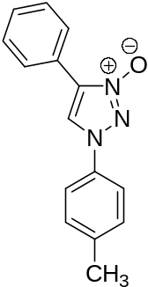

4-Phenyl-1-p-tolyl-1,2,3-triazole 3-oxide (4) :
4-Phenyl-1-p-tolyl-1,2,3-triazole afforded 4-phenyl-1-p-tolyl-1,2,3-triazole 3-oxide 4 as a white solid m.p. 198-200 ºC. Yield: 184mg (57.7%).
IR (ATR, cm⁻¹): 3058, 2921, 1733, 1518, 1456, 1395 (N-O), 1236, 1018, 807, 758.
HRMS (EI): for C₁₅H₁₃N₃O calcd. 251.1059, found 251.1048.
MS [EI+] m/z (%):251 [M]⁺ (100), 194 [M-N₃O]⁺ (65), 180 [M-CH₂N₃O]⁺ (22), 92 [C₆H₅ –CH₃]⁺ (52), 65 [C₅H₅]⁺ (83), 51 [C₄H₃]⁺ (20).
¹H NMR: (300 MHz, CDCl₃) δ 9.42 (s, 1H), 8.23 (d, 2H), 7.76 (d, 2H), 7.54-7.45 (m, 5H), 2.40 (s, 3H).
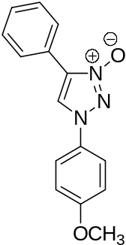¹³C NMR: (75 MHz, CDCl₃) δ 138.7, 133.9, 130.8, 129.4, 127.8, 126.4, 120.4, 119.9, 114.3, 21.0.

1-(4-Methoxy-phenyl)-4-phenyl-1,2,3-triazole 3-oxide (5) :
1-(4-Methoxy-phenyl)-4-phenyl-1,2,3-triazole afforded 1-(4-methoxy-phenyl)-4-phenyl-1,2,3-triazole 3-oxide 5 as a white solid m.p. 208-210 ºC. Yield: 278 mg (87.5%).
IR (ATR, cm⁻¹): 3060, 2958, 1729, 1517, 1443, 1382 (N-O), 1251, 1086, 1033, 829, 760.
HRMS (EI): for C₁₅H₁₃N₃O₂ calcd. 267.1008, found 267.1012.
MS [EI+] m/z (%): 267 [M]⁺ (100), 210 [M-CH₃N₂O]⁺ (5), 196 [M-C₂H₅N₂O]⁺ (22), 92 [C₆H₅ -CH₃]⁺ (42), 77 [C₆H₅]⁺ (8), 51 [C₄H₃]⁺ (12).
¹H NMR: (300 MHz, CDCl₃) 9.32 (s, 1H), 8.21 (dd, 2H), 7.76 (dd, 2H), 7.53-7.41 (m, 3H,) 7.15 (dd, 2H) 3.81 (s, 3H).
¹³C NMR:(75 MHz, CDCl₃) 159.7, 130.8, 129.6, 129.4, 129.0, 126.4, 126.3, 122.5, 121.4, 115.5, 55.1.
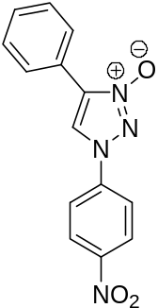

1-(4-Nitrophenyl)-4-phenyl-1,2,3-triazole 3-oxide (6) :
1-(4-Nitrophenyl)-4-phenyl-1,2,3-triazole afforded 1-(4-nitrophenyl)-4-phenyl-1,2,3-triazole 3-oxide 6 as a white solid m.p. 292 ºC. Yield: 158.1 mg (49.5 %).
IR (ATR, cm⁻¹): 3092, 1593, 1554, 1385 (N-O); 1343 (NO₂), 1476, 1152, 874, 769.
HRMS (EI): for C₁₄H₁₀N₄O₃ calcd. 282.0753, found 282.0757.
MS [EI+] m/z (%): 282 [M]⁺ (10), 266 [M-O]⁺ (5), 238 [M-N₂O]⁺ (65), 192 [M-C₇H₆]⁺ (100), 165 [M- C₇H₇N₃O₂]⁺ (30).
¹H NMR: (300 MHz, DMSO-d₆) δ 8.52-8.49 (d, 2H), 8.45 (s, 1H), 8.29-8.26 (d, 2H), 7.98-7.95 (d, 2H), 7.55-7.41 (m, 3H).
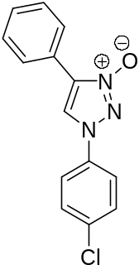¹³C NMR: (75 MHz, DMSO-d₆) δ = 147.8, 146.6, 140.8, 129.7, 129.0, 128.5, 125.6, 125.1, 120.4, 119.9.

1-(4-Chloro-phenyl)-4-phenyl-1,2,3-triazole 3-oxide (7):
1-(4-Chloro-phenyl)-4-phenyl-1,2,3-triazole afforded 1-(4-chloro-phenyl)-4-phenyl-1,2,3-triazole 3-oxide 7 as a white solid m.p. 197 ºC. Yield: 161 mg (72 %).
IR (ATR, cm⁻¹): 3055, 1533, 1499, 1476, 1387 (N-O), 1092; 1035, 826; 765.
HRMS (EI): for C₁₄H₁₀ClN₃O calcd. 271.0512, found 271.0517.
MS [EI+] m/z (%):271 [M]⁺ (5), 255 [M-O]⁺ (5), 227 [M-N₂O]⁺ (100), 192 [C₁₀H₁₄N₃O]⁺ (70), 165 [C₈H₁₁N₃O]⁺ (55).
¹H NMR: (300 MHz, DMSO-d₆) 8.31 (s, 1H), 8.02-7.99 (d, 2H), 7.95-7.93 (d, 2H), 7.73-7.70 (d, 2H), 7.53-7.48 (t, 2H), 7.41-7.39 (t, 1H).
¹³C NMR: (75 MHz, DMSO-d₆) δ = 151.0, 137.4, 132.9, 131.0, 129.1, 128.8, 128.7, 126.3, 124.1, 120.8.
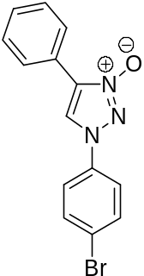

1-(4-Bromo-phenyl)-4-phenyl-1,2,3-triazole 3-oxide (8) :
1-(4-Bromo-phenyl)-4-phenyl-1,2,3-triazole afforded 1-(4-bromo-phenyl)-4-phenyl-1,2,3-triazole 3-oxide 8 as a white solid m.p. 178 ºC. Yield: 241.9 mg (75.4 %).
IR (ATR, cm⁻¹): 3095, 1553, 1496, 1454, 1386 (N-O), 1226, 765.
HRMS (EI): for C₁₄H₁₀BrN₃O calcd. 315.0007, found 315.0011.
MS [EI+] m/z (%):315 [M]⁺ (5), 299 [M-O]⁺ (5), 271 [M-N₂OH]⁺ (55), 191 [C₁₀H₁₃N₃O]⁺ (35), 165 [C₈H₁₁N₃O]⁺ (80), 116 [C₈H₆N]⁺ (90), 89 [C₇H₅]⁺ (100).
¹H NMR: (300 MHz, DMSO-d₆) δ 8.21 (s, 1H), 7.93-7.85 (m, 6H), 7.50-7.36 (m, 3H).
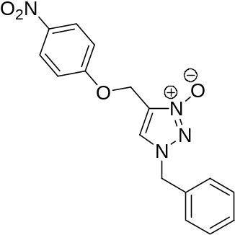¹³C NMR: (75 MHz, DMSO-d₆) δ = 150.0, 136.7, 132.3, 131.0, 128.8, 128.7, 126.3, 124.1, 121.7, 114.8.

1-Benzyl-4-(4-nitrophenoxymethyl)-1,2,3-triazole 3-oxide (9):
1-Benzyl-4-(4-nitrophenoxymethyl)-1,2,3-triazole afforded 1-benzyl-4-(4-nitrophenoxymethyl)-1,2,3-triazole 3-oxide 9 as white solid m.p. 108-110 ºC. Yield: 284 mg (90.0%).
IR (ATR, cm⁻¹): ): 3116, 3074, 1679 , 1592, 1496, 1340 (N-O), 1183, 1139, 705.
HRMS (EI): for C₁₆H₁₄N₄O₄ calcd. 326.10915, found 326.1019.
MS [EI+] m/z (%): 326 [M]⁺ (5), 188 [M-C₆H₄NO₄]⁺ (20), 91 [C₆H₅-CH₂]⁺ (100).
¹H NMR: (300 MHz, CDCl₃) δ 8.54, 8.23 (dd, 2H.), 7.42-7.36 (m, 5H), 7.27 (dd, 2H), 5.41 (s, 2H), 5.22 (s, 2H).
¹³C NMR: (75 MHz, CDCl₃) 163.4, 141.76, 135.2, 129.3, 129.18, 129.0, 128.7, 128.4, 128.0, 126.6, 126.6, 115.7, 58.4, 54.7.

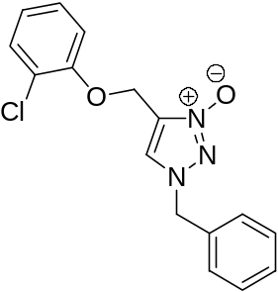

1-Benzyl-4-(2-chlorophenoxymethyl)-1,2,3-triazole 3-oxide (10):
1-Benzyl-4-(2-chlorophenoxymethyl)-1,2,3-triazole afforded 1-benzyl-4-(2-chlorophenoxymethyl)-1,2,3-triazole 3-oxide 10 as white solid m.p. 106 ºC. Yield: 1.270 g (84.9 %).
IR (ATR, cm⁻¹): 3053, 1584, 1464, 1389 (N-O), 1278, 1066, 747.
HRMS (EI): for C₁₆H₁₄ClN₃O₂ calcd. 315.0775, found 315.0778.
MS [EI+] m/z (%): 315 [M]⁺ (5), 280 [M-Cl]⁺ (20), 188 [M-C₆H₄OClN₂]⁺ (100), 144 [M-C₆H₄O₂ClN₂]⁺ (39), 91 [C₆H₅ –CH₃]⁺ (45).
¹H NMR: (300 MHz, CDCl₃) δ 7.55 (s, 1H), 7.40-7.10 (m, 8H), 6.94 (t, 1H), 5.27 (s, 2H), 5.20 (s, 2H).
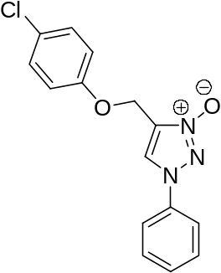¹³C NMR: (75 MHz, CDCl₃) δ 153.1, 132.6, 130.4, 129.4, 129.3, 128.8, 128.5, 128.1, 127.7, 124.1, 122.6, 114.2, 59.8, 55.7.

4-(4-Chlorophenoxymethyl)-1-phenyl-1,2,3-triazole 3-oxide (11):
4-(4-Chlorophenoxymethyl)-1-phenyl-1,2,3-triazole afforded 4-(4-chlorophenoxymethyl)-1-phenyl-1,2,3-triazole 3-oxide 11 as white solid m.p. 318 ºC. Yield: 204.2 mg (58.7 %).
IR (ATR, cm⁻¹): 3101, 2922, 1597, 1468, 1301, 1024, 795.
HRMS (EI): for C₁₅H₁₂ClN₃O₂ calcd. 301.0618, found 301.0625.
MS [EI+] m/z (%): 315 [M]⁺ (5), 280 [M-Cl]⁺ (20), 188 [M-C₆H₄OClN₂]⁺ (100), 144 [M-C₆H₄O₂ClN₂]⁺ (39), 91 [C₆H₅ –CH₃]⁺ (45).
¹H NMR: (500 MHz, DMSO-d₆) δ 7.81-7.78 (d, 2H), 7.60-7.58 (d, 2H,), 7.55 (s, 1H), 7.50-7.35 (m, 3H), 7.13-7.10 (d, 2H), 5.14 (s, 2H).
¹³C NMR: (125 MHz, DMSO-d₆) δ 156.8, 136.2, 133.9, 130.9, 130.3, 128.6, 123.4, 119.1, 116.9, 57.9.
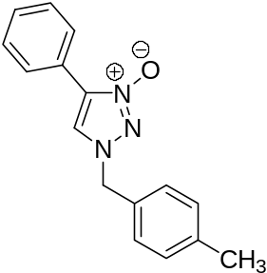

1-(4-Methylbenzyl)-4-phenyl-1,2,3-triazole 3-oxide (12):
1-(4-Methylbenzyl)-4-phenyl-1,2,3-triazole afforded 1-(4-methylbenzyl)-4-phenyl-1,2,3-triazole 3-oxide 12 as white solid m.p. 122-124 ºC. Yield: 179 mg (56.4%).
IR (ATR, cm⁻¹): 3095, 2984, 1680, 1515, 1466, 1392 (N-O), 1329, 1179, 755.
HRMS (EI): for C₁₆H₁₅N₃O calcd. 265.1215, found 265.01218.
MS [EI+] m/z (%): 265 [M]⁺ 10), 105 [C₈H₉]+ (100), 77 [C₆H₅]⁺ (10).
¹H NMR: (300 MHz, CDCl₃) δ 8.0 (d, 2H), 7.60 (s, 1H), 7.43-7.20 (m, 7H), 5.24 (s, 2H), 2.37 (s, 3H).
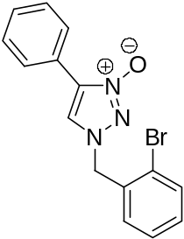¹³C NMR: (75 MHz, CDCl₃) δ 131.2, 130.0, 129.6, 129.1, 128.7, 128.6, 126.4, 125.4, 121.6.5, 55.3, 21.2.

1-(2-Bromobenzyl)-4-phenyl-1,2,3-triazole 3-oxide (13):
1-(2-Bromobenzyl)-4-phenyl-1,2,3-triazole afforded 1-(2-bromobenzyl)-4-phenyl-1,2,3-triazole 3-oxide 13 as white solid m.p. 126-128ºC. Yield: 264 mg (85.0 %).
IR (ATR, cm⁻¹): 3095, 2852, 1731, 1561, 1441, 1391 (N-O), 1177, 760.
HRMS (EI): for C₁₅H₁₂BrN₃O calcd. 329.0164, found 329.0166.
MS [EI+] m/z (%): 265 [M]⁺ 10), 105 [C₈H₉]+ (100), 77 [C₆H₅]⁺ (10).
¹H NMR: (300 MHz, CDCl₃) δ 7.80 (d, 2H), 7.76 (s, 1H), 7.62 (d, 1H) 7.46-7.28 (m, 6H), 5.43 (s, 2H).
¹³C NMR: (75 MHz, CDCl₃) δ 133.43, 132.3, 131.4, 131.2, 131.1, 129.2, 128.7, 128.4, 126.4, 125.3, 124.0, 122.3, 55.2.

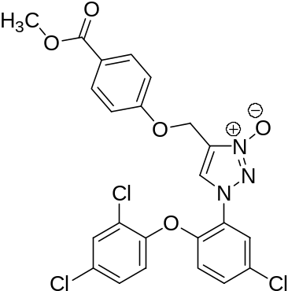

4-{1-[5-Chloro-2-(2,4-dichlorophenoxy)-phenyl]-3-oxy-1,2,3-triazol-4-ylmethoxy}-benzoic acid methyl ester (14):
4-{1-[5-Chloro-2-(2,4-dichlorophenoxy)-phenyl]-1,2,3-triazol-4-ylmethoxy}-benzoic acid methyl ester afforded 4-{1-[5-chloro-2-(2,4-dichlorophenoxy)-phenyl]-3-oxy-1,2,3-triazol-4-ylmethoxy}-benzoic acid methyl ester 14 as white solid m.p. 129 ºC. Yield: 706.4 mg (67.6 %).
IR (ATR, cm⁻¹): = 3085, 2923, 1729, 1531, 1494, 1256; 1129, 762.
HRMS (EI): for C₂₃H₁₆Cl₃N₃O₅ calcd. 519.0156, found 519.0160.
MS [EI+] m/z (%): 519 [M]⁺ (5), 503 [M-O]⁺ (5), 355 [M-C₉H₉O₃]⁺ (15), 236 [C₁₂H₅OCl₂]⁺ (25), 149 [C₈H₅O₃]⁺ (40), 43 [CNOH]⁺ (100).
¹H NMR: (300 MHz, CDCl₃) δ 8.4 (s, 1H), 8.31 (s, 1H), 8.0-7.97 (d, 1H), 7.87 (s, 1H), 7.52-7.48 (d, 1H), 7.31-7.27 (d, 2H), 7.04-6.95 (m, 2H), 6.82-6.77 (d, 2H), 5.28 (s, 2H), 3.88 (s, 3H).
¹³C NMR: (75 MHz, CDCl₃) δ 166.4, 160.9, 148.5, 146.5, 146.3, 131.6, 130.9, 129.8, 129.1, 128.6, 127.5, 126.5, 125.0, 124.9, 123.6, 121.8, 121.1, 118.5, 114.2, 58.2, 51.8.

5. - ¹H NMR and ¹³C NMR spectra for compounds
1-Benzyl-4-phenyl-1,2,3-triazole 3-oxide (2)

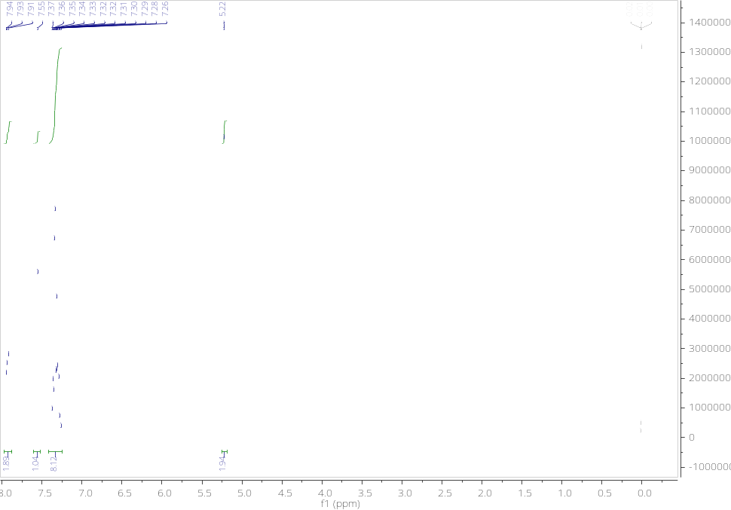

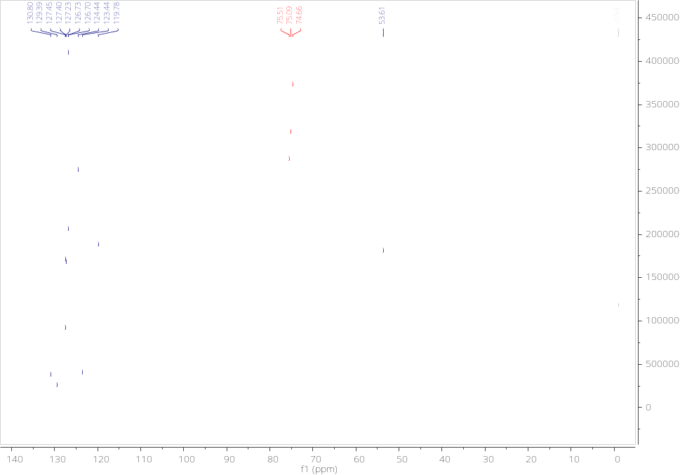

1,4-Diphenyl-1,2,3-triazole 3-oxide (3)

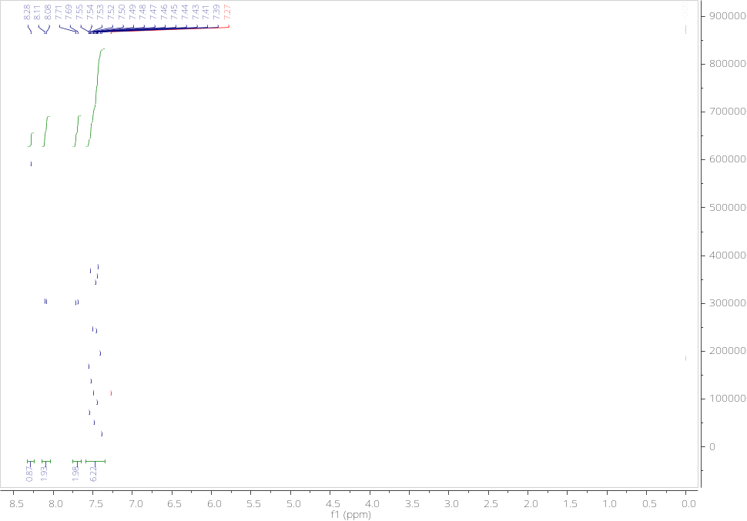

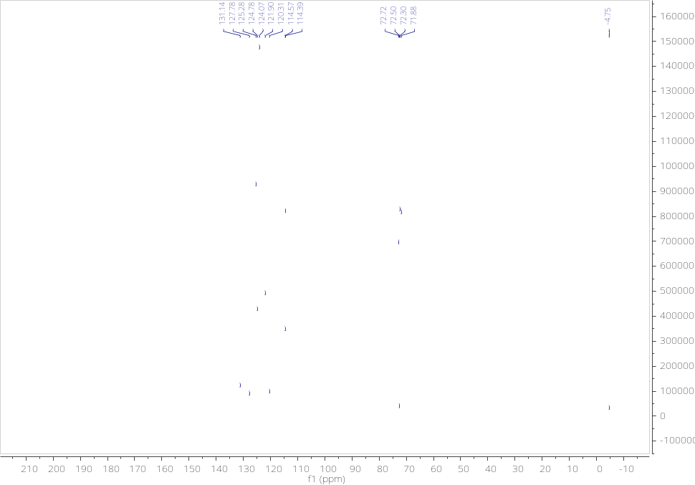

4-Phenyl-1-p-tolyl-1,2,3-triazole 3-oxide (4)

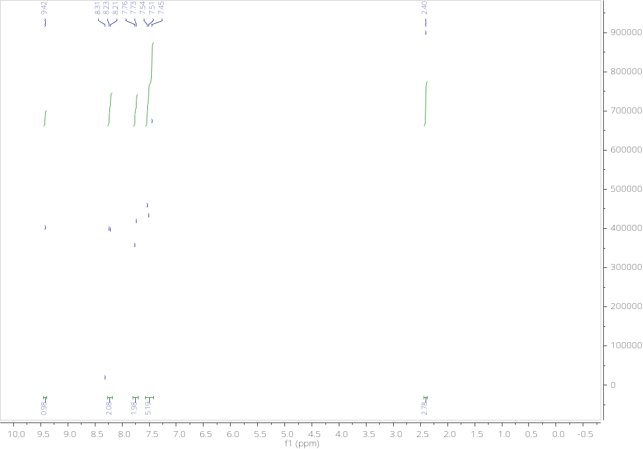

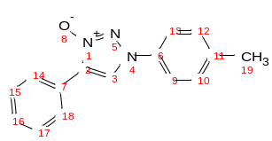

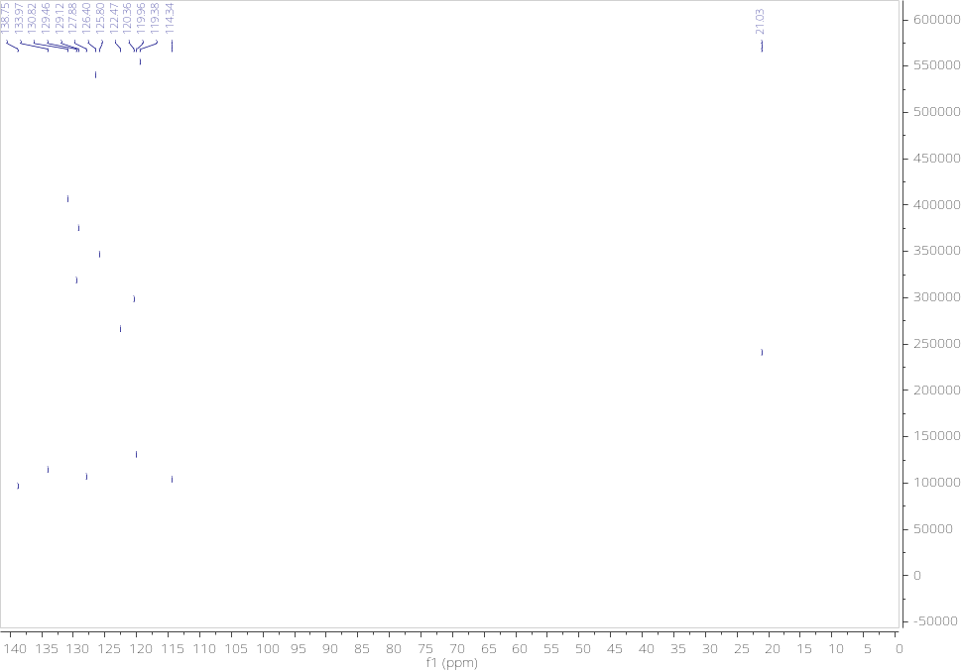

1-(4-Methoxy-phenyl)-4-phenyl-1,2,3-triazole 3-oxide (5)

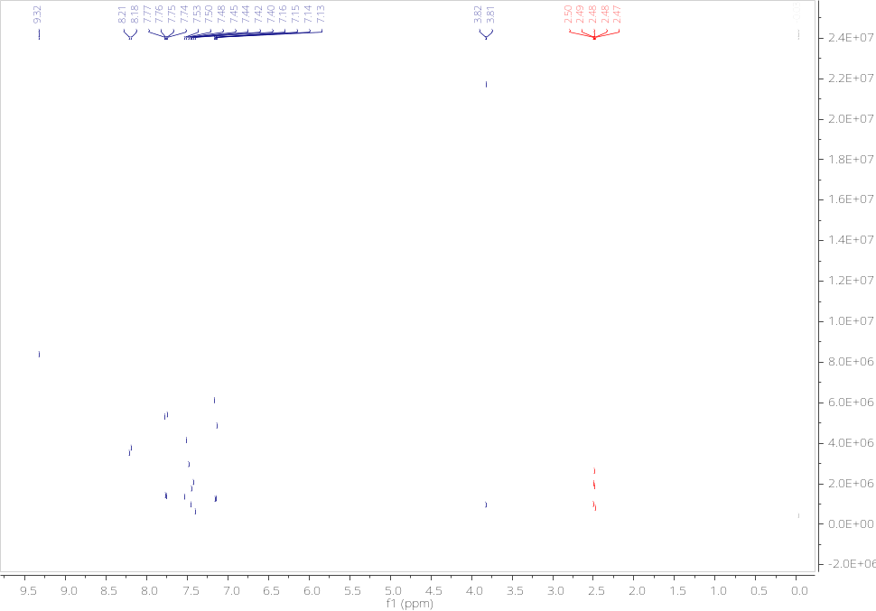

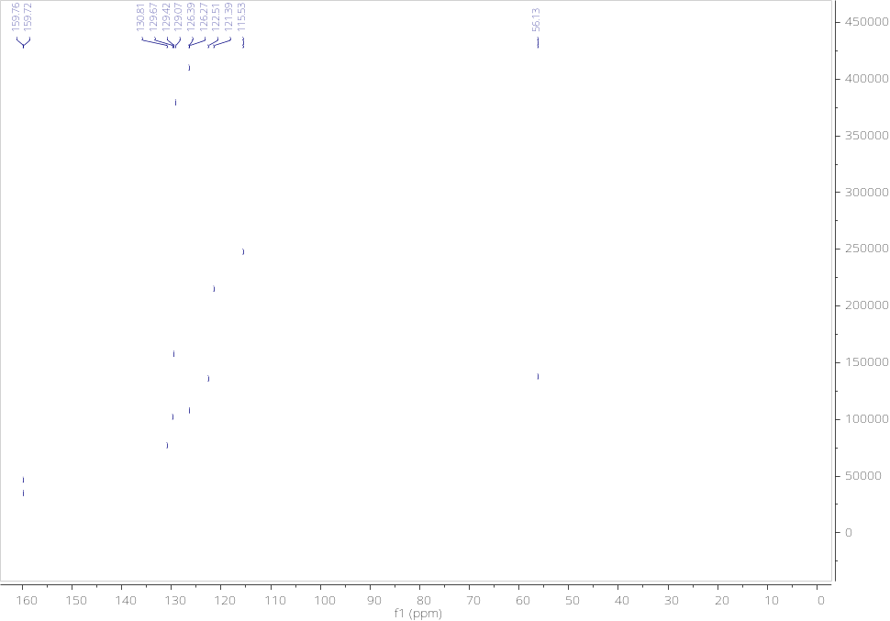

1-(4-Nitrophenyl)-4-phenyl-1,2,3-triazole 3-oxide (6)

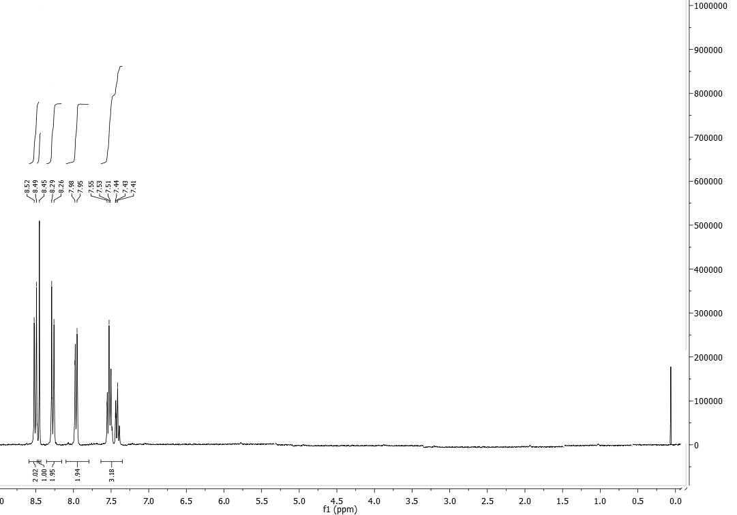
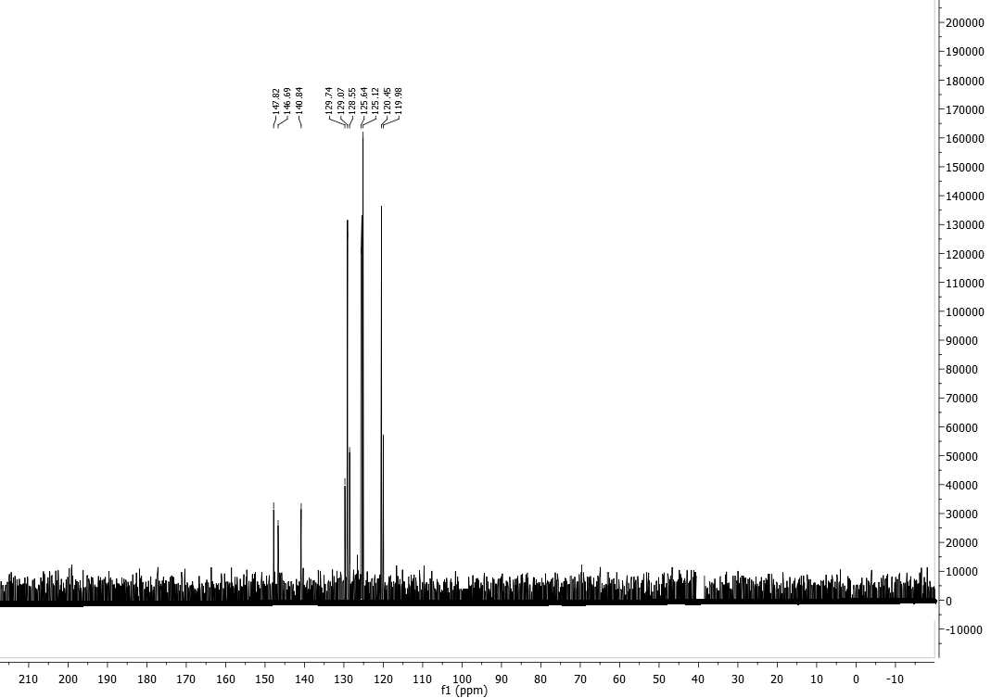

1-(4-Chloro-phenyl)-4-phenyl-1,2,3-triazole 3-oxide (7)

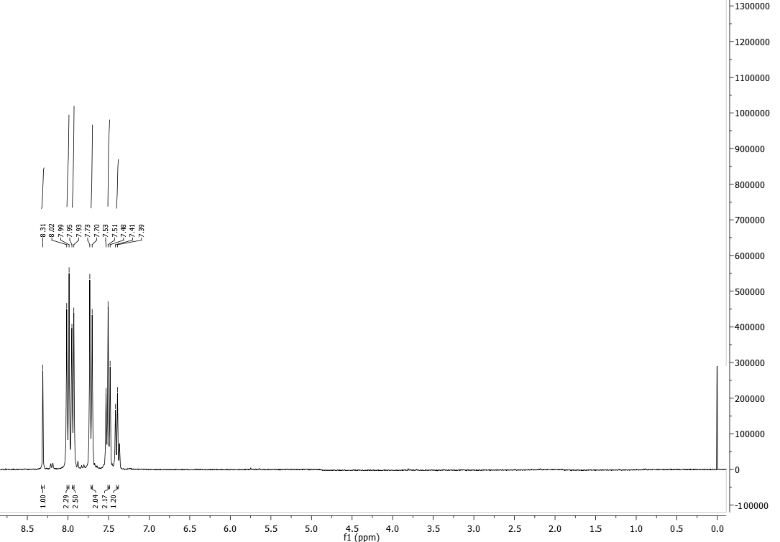

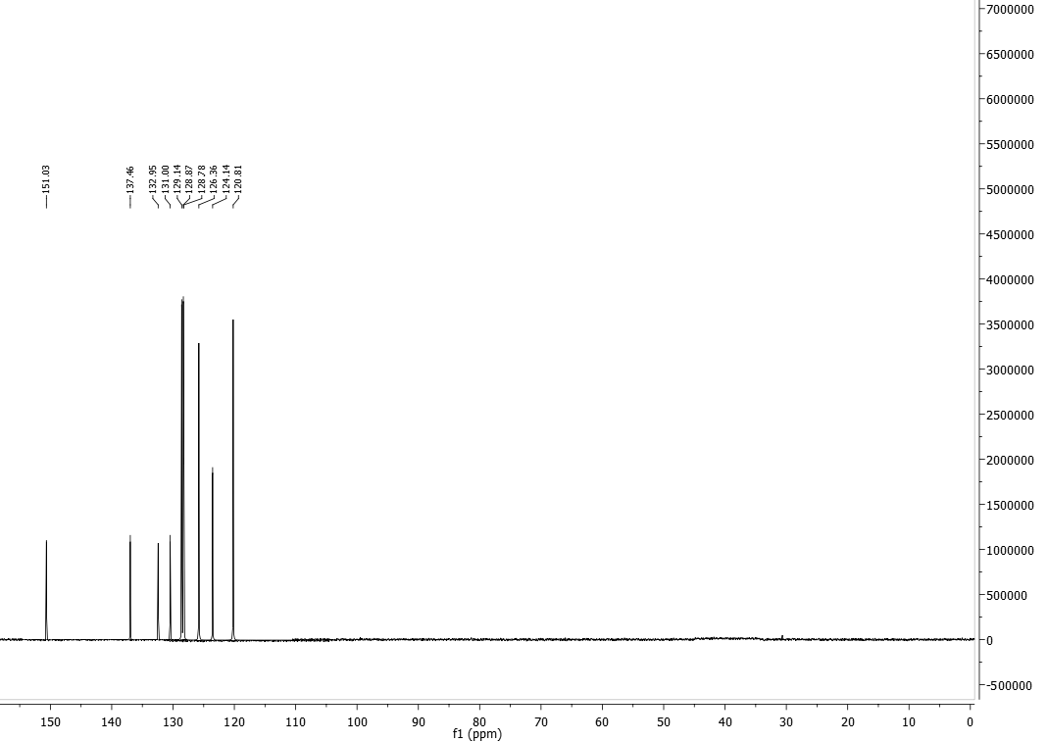
1-(4-Bromo-phenyl)-4-phenyl-1,2,3-triazole 3-oxide (8)

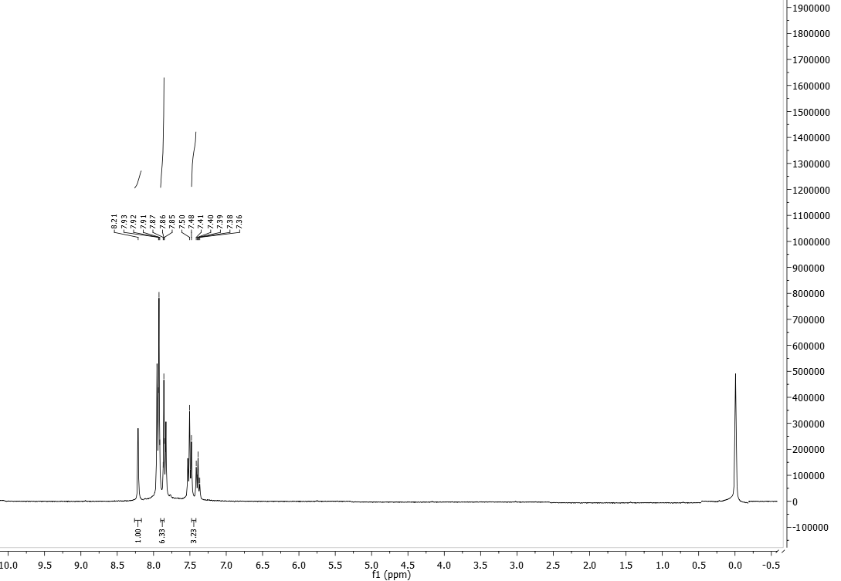

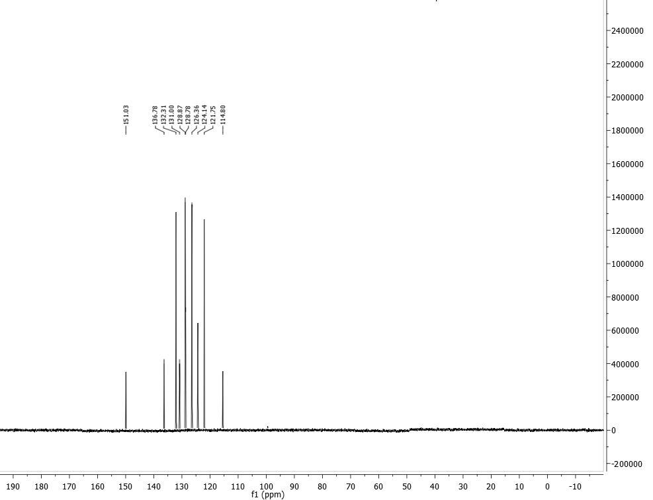
1-Benzyl-4-(4-nitrophenoxymethyl)-1,2,3-triazole 3-oxide (9)

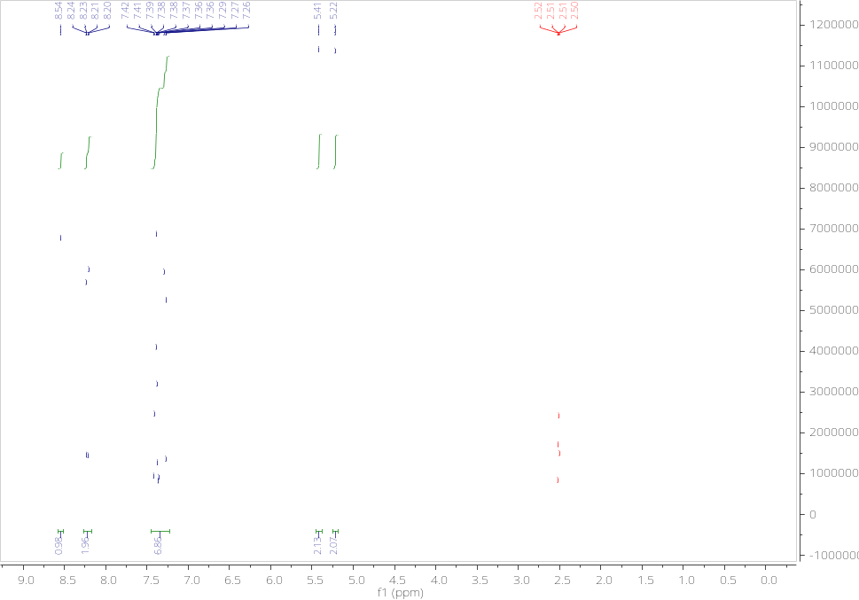

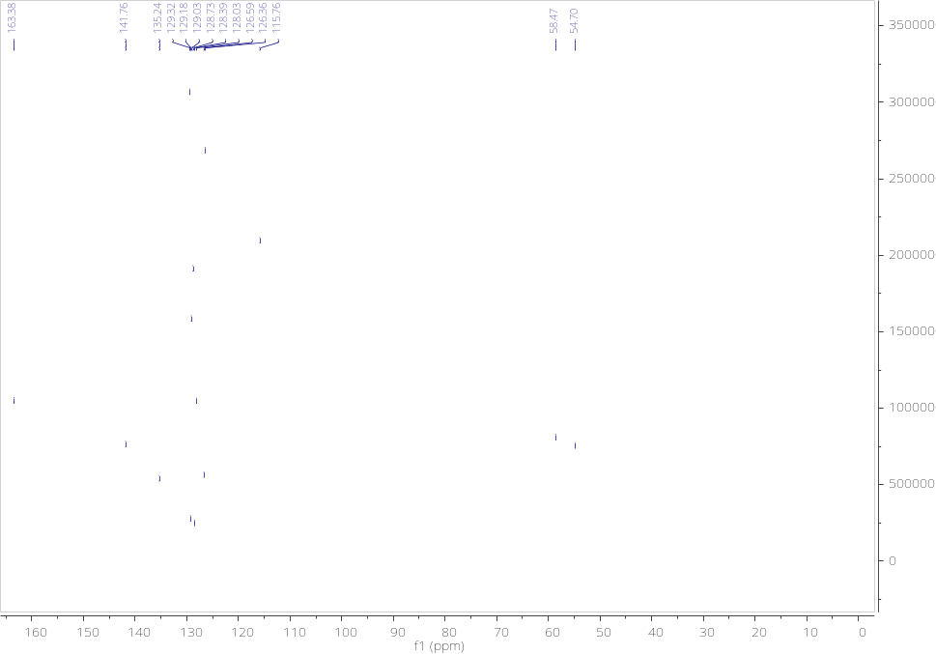

1-Benzyl-4-(2-chlorophenoxymethyl)-1,2,3-triazole 3-oxide (10)

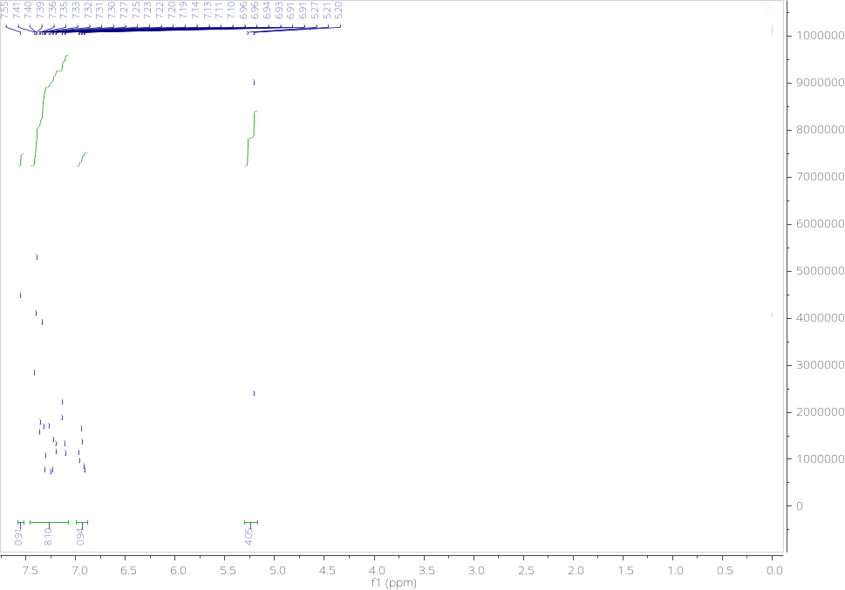

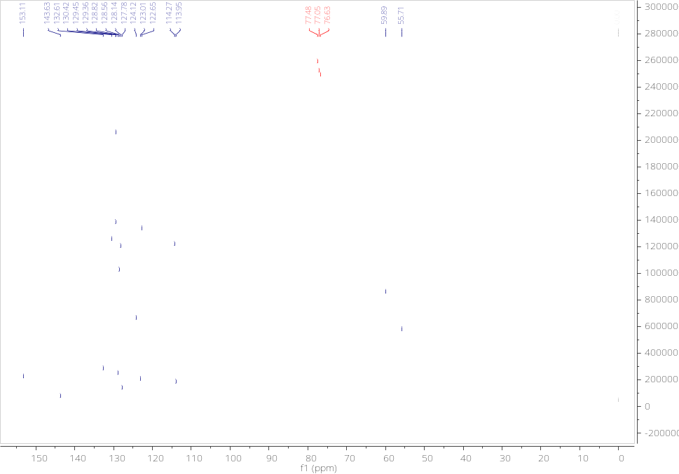

4-(4-Chlorophenoxymethyl)-1-phenyl-1,2,3-triazole 3-oxide (11)

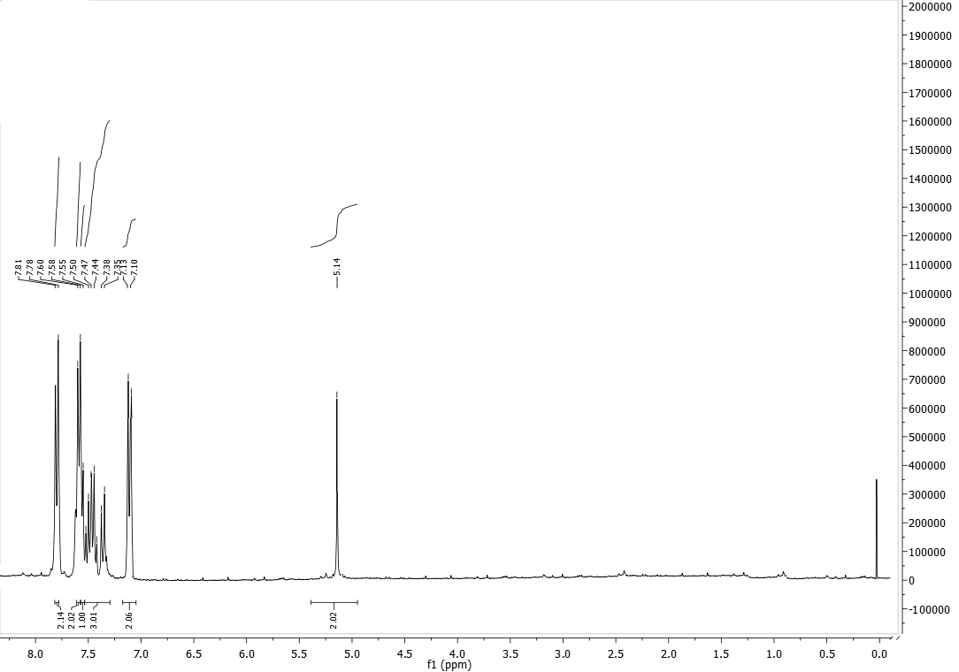

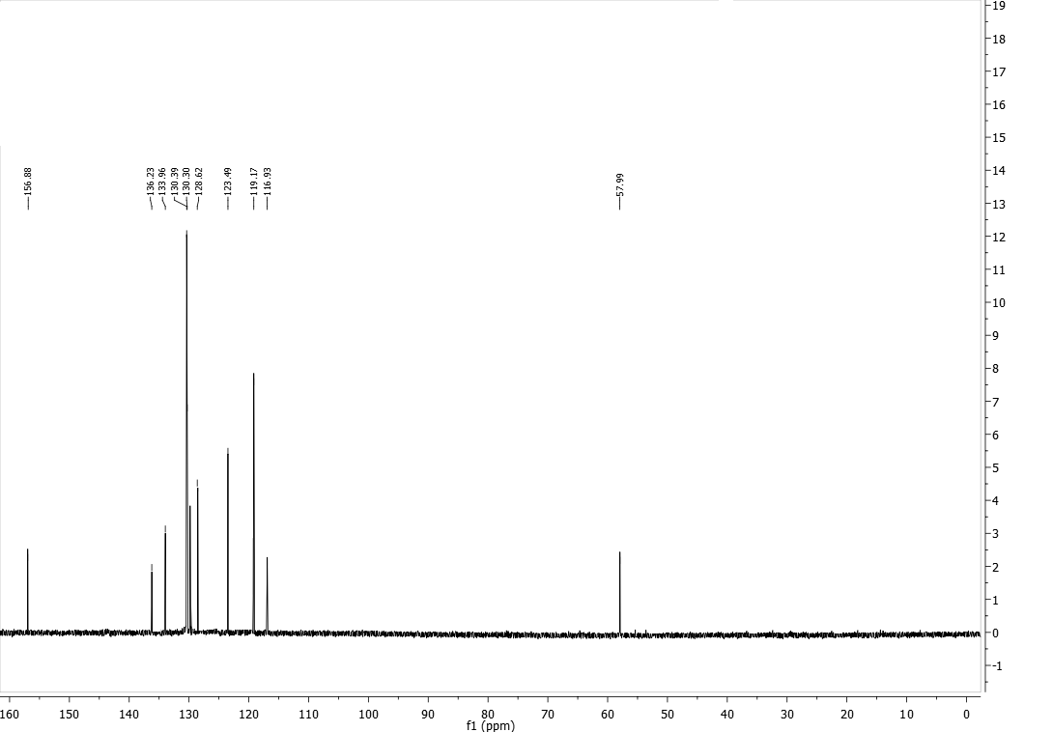
1-(4-Methylbenzyl)-4-phenyl-1,2,3-triazole 3-oxide (12)

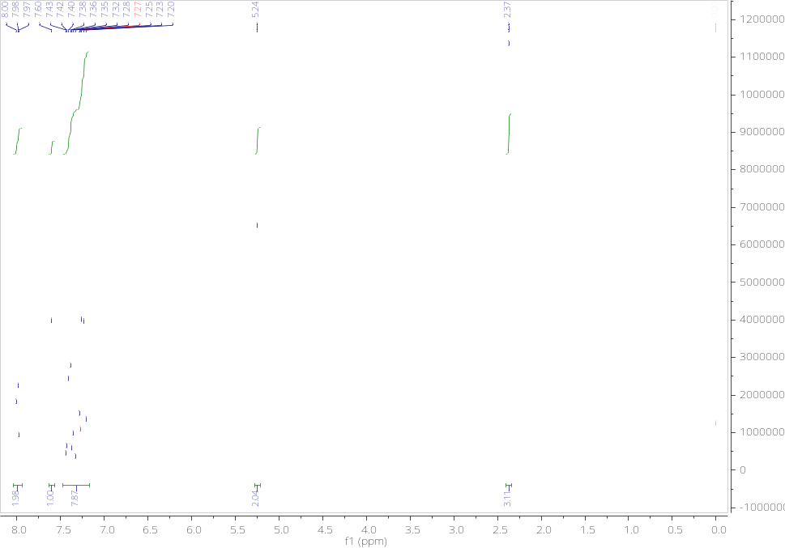

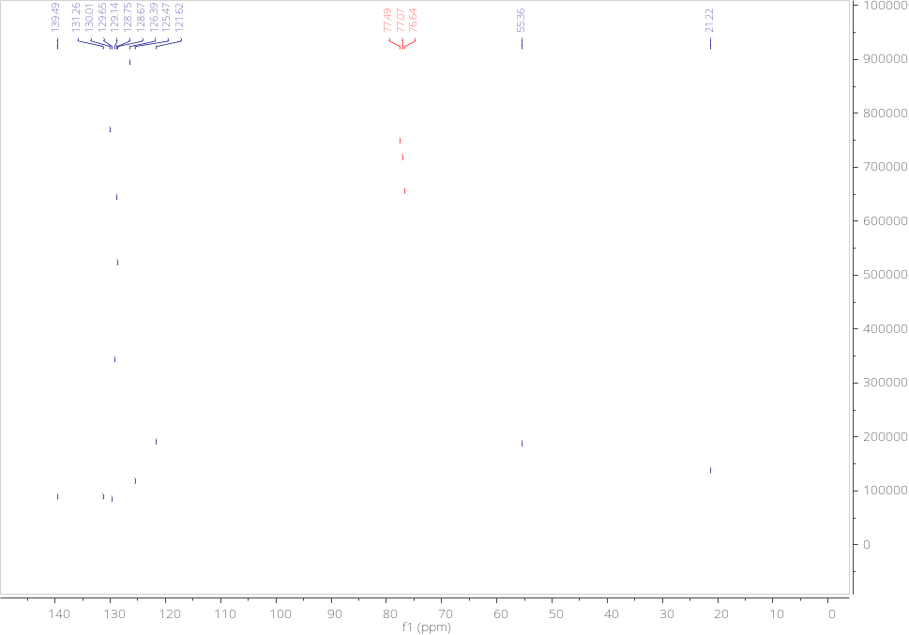

1-(2-Bromobenzyl)-4-phenyl-1,2,3-triazole 3-oxide (13)

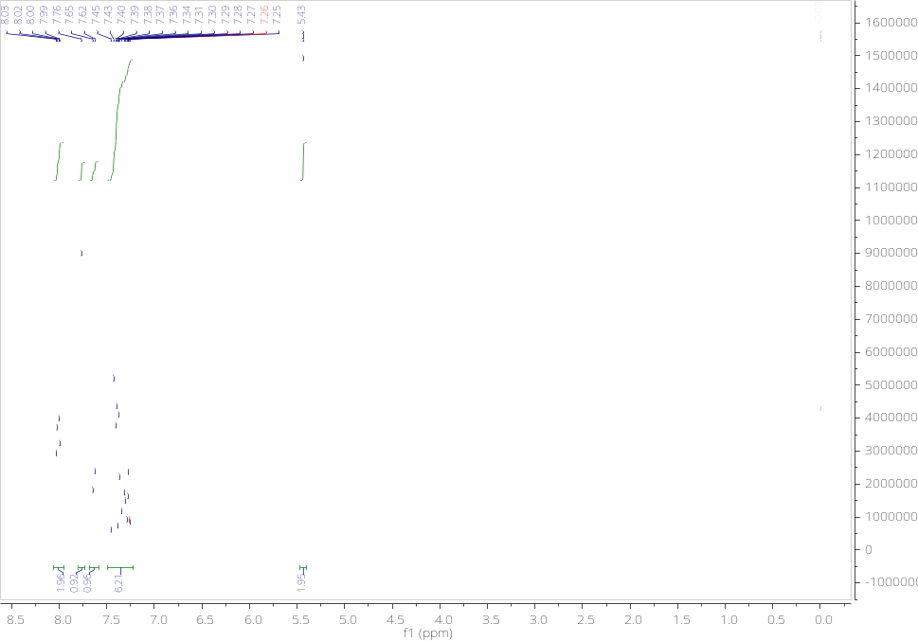

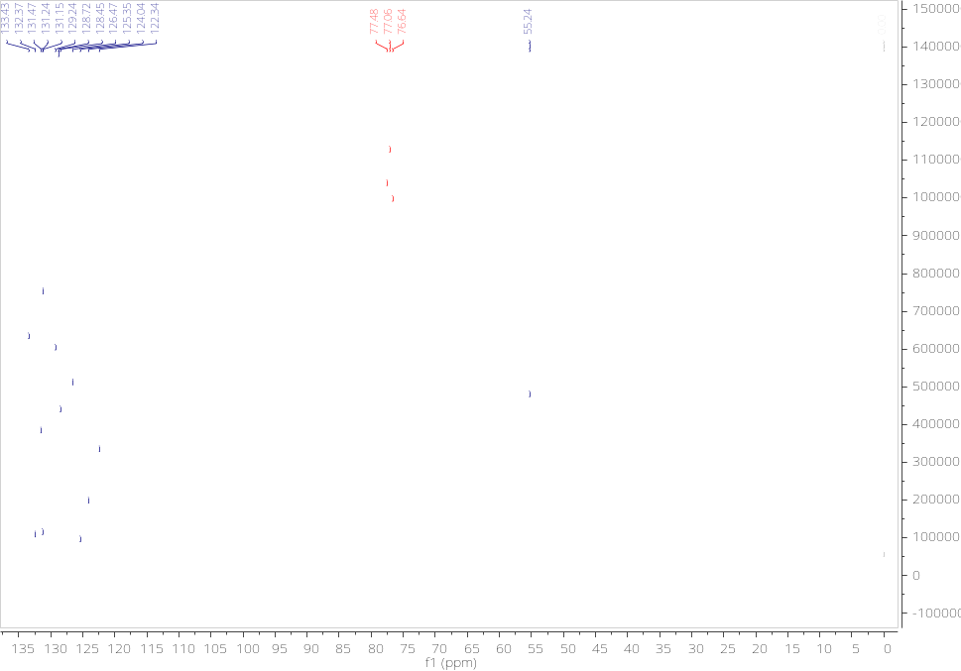

4-{1-[5-Chloro-2-(2,4-dichlorophenoxy)-phenyl]-3-oxy-1,2,3-triazol-4-ylmethoxy}-benzoic acid methyl ester (14)

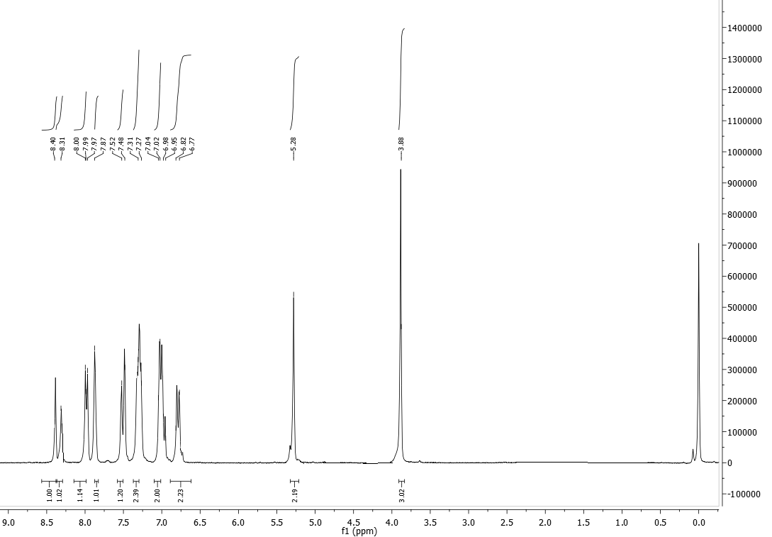

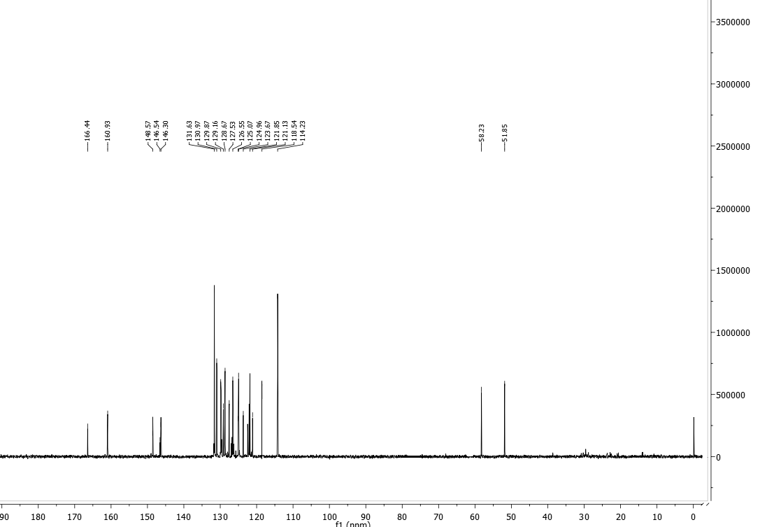

6.- Crystallographic data of compound 2

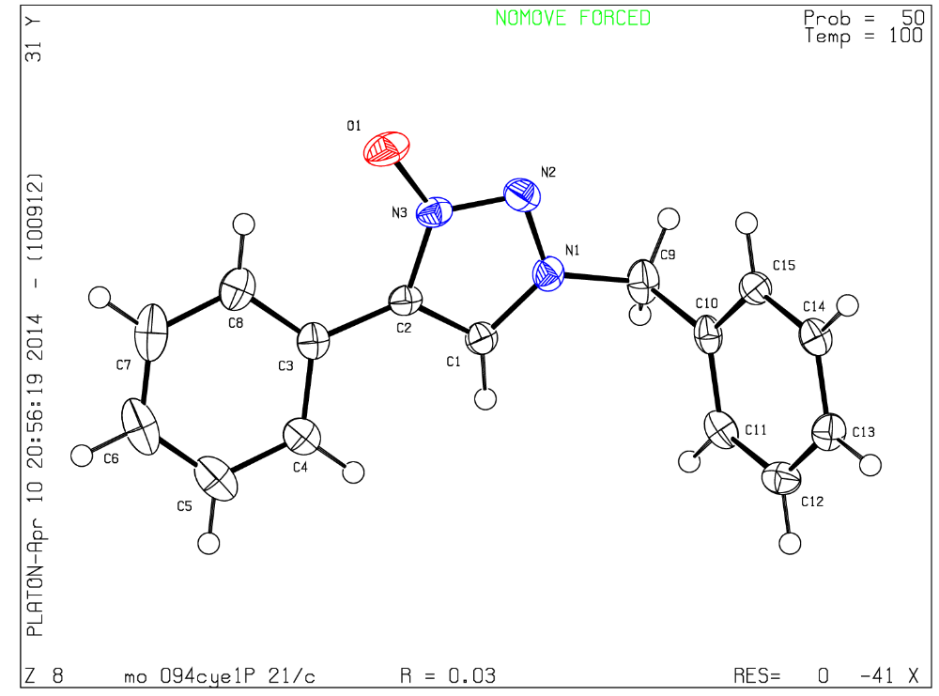

Figure 1. ORTEP diagram and atom labelling system for compound 2

Table 1. Crystal data and structure refinement for Compound 2.
Identification code mo_094cye14_0m
Empirical formula C15 H13 N3 O
Formula weight 251.28
Temperature 100(2) K
Wavelength 0.71073 Å
Crystal system Monoclinic
Space group P 21/c
Unit cell dimensions a = 9.2438(3) Å α= 90°.
b = 6.2011(2) Å β= 91.5434(7)°.
c = 21.7126(7) Å γ = 90°.
Volume 1244.15(7) Å3
Z 4
Density (calculated) 1.342 Mg/m3
Absorption coefficient 0.087 mm-1
F(000) 528
Crystal size 0.440 x 0.171 x 0.080 mm3
Theta range for data collection 1.877 to 25.349°.
Index ranges -11<=h<=11, -7<=k<=7, -26<=l<=26
Reflections collected 15819
Independent reflections 2282 [R(int) = 0.0163]
Completeness to theta = 25.242° 99.9 %
Absorption correction None
Refinement method Full-matrix least-squares on F2
Data / restraints / parameters 2282 / 0 / 172
Goodness-of-fit on F2 1.036
Final R indices [I>2sigma(I)] R1 = 0.0327, wR2 = 0.0822
R indices (all data) R1 = 0.0352, wR2 = 0.0842
Extinction coefficient n/a
Largest diff. peak and hole 0.202 and -0.229 e.Å-3
Table 2. Atomic coordinates ( x 104) and equivalent isotropic displacement parameters (Å2x 103)
for mo_094CYE14_0m. U(eq) is defined as one third of the trace of the orthogonalized Uij tensor.
________________________________________________________________________________
x y z U(eq)
________________________________________________________________________________
N(1) 1008(1) 4035(2) 3188(1) 24(1)
O(1) -475(1) 8578(1) 3683(1) 36(1)
N(2) 842(1) 6174(2) 3148(1) 27(1)
N(3) -52(1) 6633(2) 3601(1) 23(1)
C(1) 271(1) 3176(2) 3648(1) 23(1)
C(2) -437(1) 4838(2) 3930(1) 21(1)
C(3) -1400(1) 4792(2) 4456(1) 22(1)
C(4) -1478(1) 2873(2) 4792(1) 26(1)
C(5) -2392(1) 2706(2) 5285(1) 35(1)
C(6) -3233(2) 4444(3) 5451(1) 41(1)
C(7) -3158(1) 6348(3) 5126(1) 39(1)
C(8) -2246(1) 6543(2) 4628(1) 30(1)
C(9) 1942(1) 2900(2) 2755(1) 30(1)
C(10) 3426(1) 2434(2) 3034(1) 23(1)
C(11) 3707(1) 455(2) 3312(1) 26(1)
C(12) 5068(1) 10(2) 3565(1) 28(1)
C(13) 6158(1) 1538(2) 3539(1) 26(1)
C(14) 5883(1) 3520(2) 3266(1) 24(1)
C(15) 4521(1) 3971(2) 3013(1) 23(1)
________________________________________________________________________________
Table 3. Bond lengths [Å] and angles [°] for mo_094CYE14_0m.
_____________________________________________________
N(1)-C(1) 1.3339(15)
N(1)-N(2) 1.3384(15)
N(1)-C(9) 1.4721(16)
O(1)-N(3) 1.2815(13)
N(2)-N(3) 1.3323(14)
N(3)-C(2) 1.3745(15)
C(1)-C(2) 1.3748(17)
C(2)-C(3) 1.4661(17)
C(3)-C(8) 1.3954(17)
C(3)-C(4) 1.3987(17)
C(4)-C(5) 1.3856(18)
C(5)-C(6) 1.383(2)
C(6)-C(7) 1.378(2)
C(7)-C(8) 1.3937(19)
C(9)-C(10) 1.5123(16)
C(10)-C(11) 1.3880(18)
C(10)-C(15) 1.3922(16)
C(11)-C(12) 1.3875(17)
C(12)-C(13) 1.3855(17)
C(13)-C(14) 1.3856(18)
C(14)-C(15) 1.3882(16)

C(1)-N(1)-N(2) 112.59(10)
C(1)-N(1)-C(9) 127.34(11)
N(2)-N(1)-C(9) 120.07(10)
N(3)-N(2)-N(1) 103.66(9)
O(1)-N(3)-N(2) 120.00(10)
O(1)-N(3)-C(2) 127.31(10)
N(2)-N(3)-C(2) 112.68(10)
N(1)-C(1)-C(2) 107.07(10)
N(3)-C(2)-C(1) 103.99(10)
N(3)-C(2)-C(3) 126.26(10)
C(1)-C(2)-C(3) 129.74(11)
C(8)-C(3)-C(4) 119.03(12)
C(8)-C(3)-C(2) 123.35(11)
C(4)-C(3)-C(2) 117.61(11)
C(5)-C(4)-C(3) 120.50(13)
C(6)-C(5)-C(4) 120.17(13)
C(7)-C(6)-C(5) 119.81(12)
C(6)-C(7)-C(8) 120.81(13)
C(7)-C(8)-C(3) 119.67(13)
N(1)-C(9)-C(10) 112.13(9)
C(11)-C(10)-C(15) 119.51(10)
C(11)-C(10)-C(9) 119.96(11)
C(15)-C(10)-C(9) 120.54(11)
C(12)-C(11)-C(10) 120.29(11)
C(13)-C(12)-C(11) 120.09(11)
C(12)-C(13)-C(14) 119.86(11)
C(13)-C(14)-C(15) 120.19(11)
C(14)-C(15)-C(10) 120.05(11)
_____________________________________________________________
Symmetry transformations used to generate equivalent atoms:

Table 4. Anisotropic displacement parameters (Å2x 103) for mo_094CYE14_0m. The anisotropic
displacement factor exponent takes the form: -2π2[ h2 a*2U11 + ... + 2 h k a* b* U12 ]
______________________________________________________________________________
U11 U22 U33 U23 U13 U12
______________________________________________________________________________
N(1) 17(1) 28(1) 25(1) 1(1) -1(1) 0(1)
O(1) 43(1) 18(1) 48(1) 3(1) -2(1) 3(1)
N(2) 22(1) 32(1) 26(1) 6(1) -3(1) -3(1)
N(3) 22(1) 21(1) 27(1) 3(1) -5(1) 0(1)
C(1) 18(1) 22(1) 28(1) 2(1) 0(1) -2(1)
C(2) 16(1) 20(1) 25(1) 2(1) -5(1) -3(1)
C(3) 16(1) 27(1) 22(1) -4(1) -4(1) -4(1)
C(4) 23(1) 32(1) 24(1) 0(1) -4(1) -6(1)
C(5) 32(1) 49(1) 24(1) 0(1) -2(1) -17(1)
C(6) 30(1) 66(1) 27(1) -14(1) 6(1) -18(1)
C(7) 23(1) 54(1) 41(1) -23(1) 3(1) -3(1)
C(8) 22(1) 33(1) 34(1) -8(1) -4(1) -1(1)
C(9) 21(1) 46(1) 23(1) -6(1) -1(1) 2(1)
C(10) 19(1) 33(1) 16(1) -6(1) 2(1) -1(1)
C(11) 26(1) 30(1) 22(1) -2(1) 4(1) -8(1)
C(12) 34(1) 26(1) 23(1) 3(1) -1(1) 0(1)
C(13) 22(1) 34(1) 21(1) -2(1) -4(1) 2(1)
C(14) 22(1) 28(1) 23(1) -3(1) 1(1) -6(1)
C(15) 25(1) 25(1) 19(1) -1(1) 1(1) 1(1)
______________________________________________________________________________
Table 5. Hydrogen coordinates ( x 104) and isotropic displacement parameters (Å2x 10 3)
for mo_094CYE14_0m.
________________________________________________________________________________
x y z U(eq)
________________________________________________________________________________

H(1) 241 1695 3758 27
H(4) -899 1675 4681 32
H(5) -2441 1394 5510 42
H(6) -3862 4327 5789 49
H(7) -3734 7541 5243 47
H(8) -2201 7863 4407 36
H(9A) 2046 3791 2381 36
H(9B) 1476 1524 2630 36
H(11) 2963 -599 3328 31
H(12) 5253 -1344 3756 34
H(13) 7093 1228 3709 31
H(14) 6627 4573 3251 29
H(15) 4336 5330 2824 27
________________________________________________________________________________
Table 6. Torsion angles [°] for mo_094CYE14_0m.
________________________________________________________________
C(1)-N(1)-N(2)-N(3) -0.64(12)
C(9)-N(1)-N(2)-N(3) -179.96(9)
N(1)-N(2)-N(3)-O(1) -178.09(10)
N(1)-N(2)-N(3)-C(2) 0.79(12)
N(2)-N(1)-C(1)-C(2) 0.26(13)
C(9)-N(1)-C(1)-C(2) 179.52(10)
O(1)-N(3)-C(2)-C(1) 178.14(11)
N(2)-N(3)-C(2)-C(1) -0.65(12)
O(1)-N(3)-C(2)-C(3) -1.28(18)
N(2)-N(3)-C(2)-C(3) 179.93(10)
N(1)-C(1)-C(2)-N(3) 0.22(12)
N(1)-C(1)-C(2)-C(3) 179.61(10)
N(3)-C(2)-C(3)-C(8) 10.97(17)
C(1)-C(2)-C(3)-C(8) -168.29(11)
N(3)-C(2)-C(3)-C(4) -169.97(10)
C(1)-C(2)-C(3)-C(4) 10.77(17)
C(8)-C(3)-C(4)-C(5) 0.60(17)
C(2)-C(3)-C(4)-C(5) -178.49(10)
C(3)-C(4)-C(5)-C(6) -0.26(18)
C(4)-C(5)-C(6)-C(7) -0.19(19)
C(5)-C(6)-C(7)-C(8) 0.29(19)
C(6)-C(7)-C(8)-C(3) 0.06(18)
C(4)-C(3)-C(8)-C(7) -0.50(17)
C(2)-C(3)-C(8)-C(7) 178.54(11)
C(1)-N(1)-C(9)-C(10) -80.00(15)
N(2)-N(1)-C(9)-C(10) 99.21(13)
N(1)-C(9)-C(10)-C(11) 94.53(14)
N(1)-C(9)-C(10)-C(15) -85.84(14)
C(15)-C(10)-C(11)-C(12) -0.10(17)
C(9)-C(10)-C(11)-C(12) 179.54(11)
C(10)-C(11)-C(12)-C(13) -0.28(18)
C(11)-C(12)-C(13)-C(14) 0.60(18)
C(12)-C(13)-C(14)-C(15) -0.54(18)
C(13)-C(14)-C(15)-C(10) 0.16(17)
C(11)-C(10)-C(15)-C(14) 0.16(16)
C(9)-C(10)-C(15)-C(14) -179.48(10)
________________________________________________________________
Symmetry transformations used to generate equivalent atoms:

