APPENDIX 1

Members of the Working Group :
- ALSTOM,
- CAF,
- NTL,
- RATP,
- SNCF.

A complete list of all participants names can be obtained in the Annex 1 of (Guesset 2016).

APPENDIX 2

Injury Criteria and thresholds used for the study

The full list of the injury criteria calculated from outputs available for the MADYMO pedestrian with corresponding thresholds is provided in Table A2

Table A2: Injury criteria with corresponding thresholds (EEVC WG17 2002), (Schmitt K.-U. et al. 2004)
Region | Criterion |  | Threshold | Units | Injury risk
Head | HIC 15ms | Head Injury Criterion | 1000 | - | 15% AIS4+
 | Cum3ms | Head 3ms Criterion | 80 | [g]
Thorax | V*C | Viscous criterion | 0.85 | [m.s⁻¹] | 25% AIS4+  half thorax
 | Compression | Thorax compression | 33 | %
 | TTI | Thorax trauma Index | 85 | [g]
Femur | Force | Sum of the lateral femur forces | 5 | [kN] | 20% AIS2+
 | Bending | Lateral femur bending moment | 300 | [Nm]
Knee | Bending | Lateral knee bending angle | 15 | [°]
 | Shearing | Lateral knee shearing displacement | 6 | [mm]
Tibia | Acceleration | Lateral tibia acceleration | 150 | [g]

APPENDIX3

HIC values for the M50 impacted at 20 km/h

The effects of the six parameters describing tramway geometry on the HIC values for the M50 impacted at 20 km/h are shown in the Figure A1

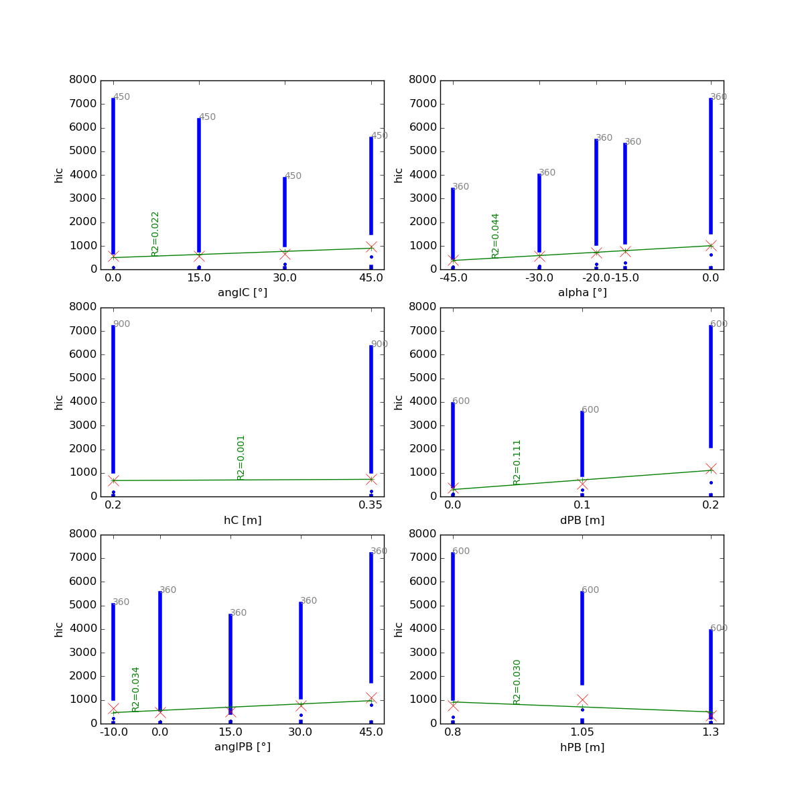
d_{W}(m)
h_{W}(m)
h_{F}(m)
α (°)
β_{F}(°)
β_{W}(°)
Figure A1: Effects of the parameters describing tramway geometry on the HIC values (M50, 20 km/h)

