Supplementary material

Structural and energetic basis for the inhibitory selectivity of both catalytic domains of dimeric HDAC6

ªLaboratorio de Desarrollo de Nuevos Fármacos e Innovación Biotecnológica (Laboratory of Drug development and biotechnology innovation), Sección de Estudios de Posgrado e Investigación, Escuela Superior de Medicina, Instituto Politécnico Nacional, Mexico city, Mexico, 11340.

E-mail addresses: mbellor@ipn.mx, bellomartini@gmail.com (M.Bello), jcorrea-b@ipn.mx, corrjose@gmail.com (J.Correa-Basurto)

Figure S1. Structure model validation using molprobity¹.

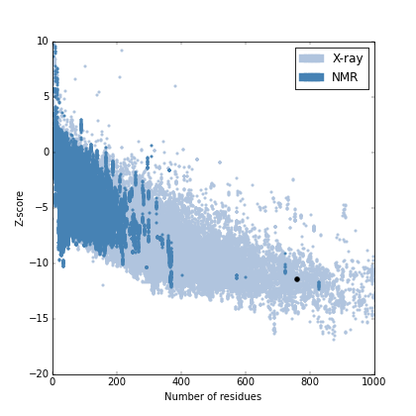

Figure S2. Structure model validation using ProSa Server².

Figure S3. Binding poses obtained by molecular docking among DD1-, DD2-HDAC6 and the following ligands: A) 9-peptide- DD1,B) 9-peptide-DD2; C)CAY10603-DD1, D) CAY10603-DD2; E)HPOB-DD1, F) HPBO-DD2; G) Nexturastat-DD1, H) Nexturastat-DD2. Ligands are shown as blue ball and sticks, Residues as pink sticks, Zinc as green sphere.

Figure S4. Binding poses obtained by molecular docking among DD1-, DD2-HDAC6 and following ligands, : A) Rocilinostat-DD1,B) Rocilinostat-DD2; C) Tubacin-DD1, D) Tubacin-DD2; E) Tubastatin-DD1, F) Tubastatin-DD2. Ligands are shown as blue ball and sticks, Residues as pink sticks, Zinc as green sphere.

References
1. Hintze, B. J.; Lewis, S. M.; Richardson, J. S.; Richardson, D. C., Molprobity's ultimate rotamer-library distributions for model validation. Proteins 2016, 84, 1177-89.
2. Wiederstein, M.; Sippl, M. J., ProSA-web: interactive web service for the recognition of errors in three-dimensional structures of proteins. Nucleic acids research 2007, 35, W407-10.

