SUPPLEMENTARY MATERIAL



Figure S1. Picloram molecular structure

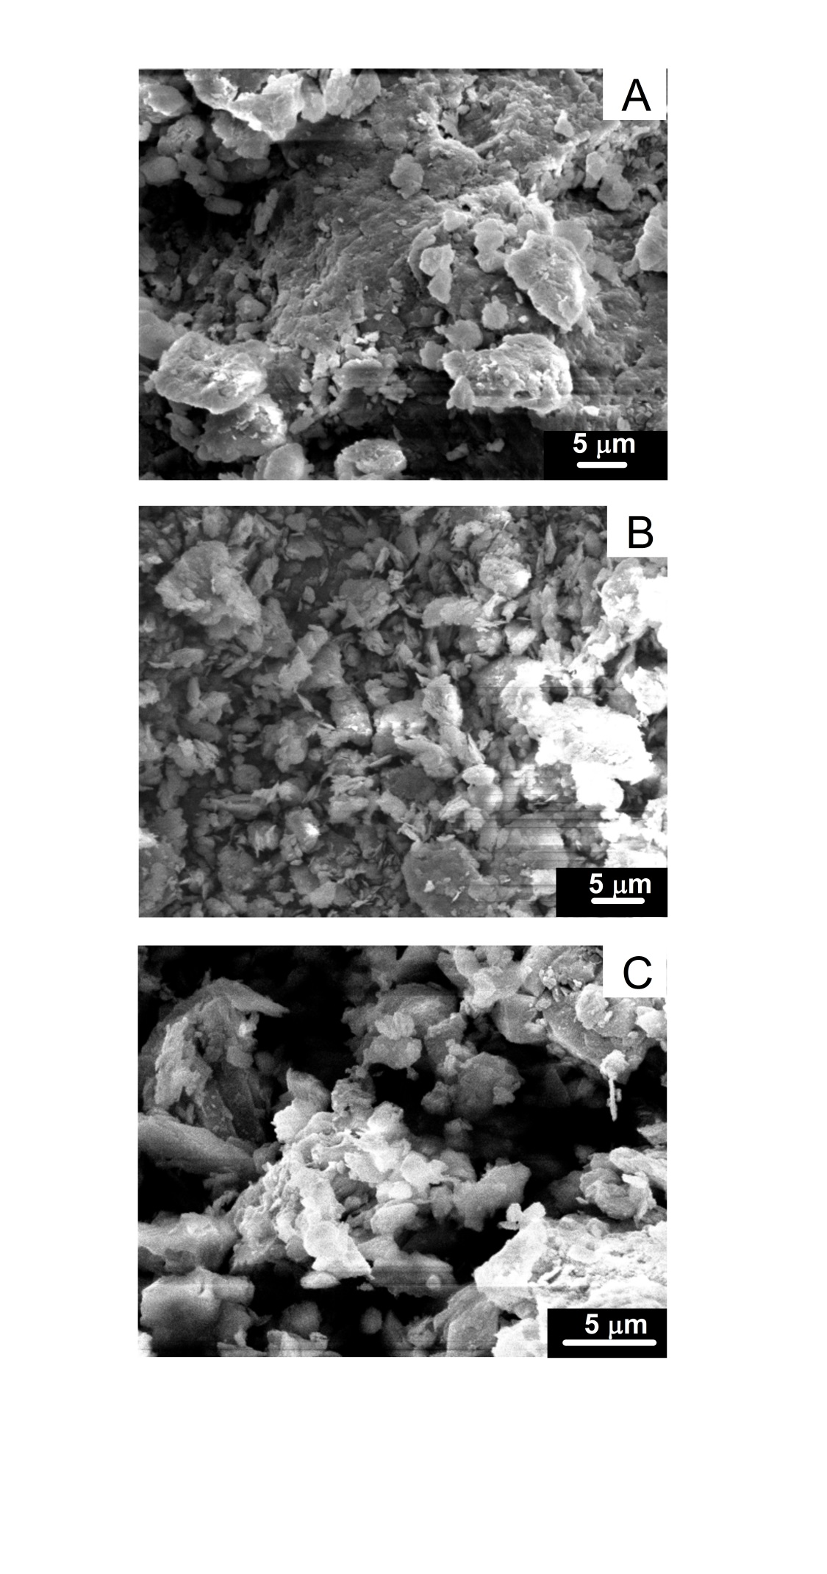

Figure S2. Scanning electron microscopy (SEM) for nontronite (A), illite (B) and kaolinite (C).

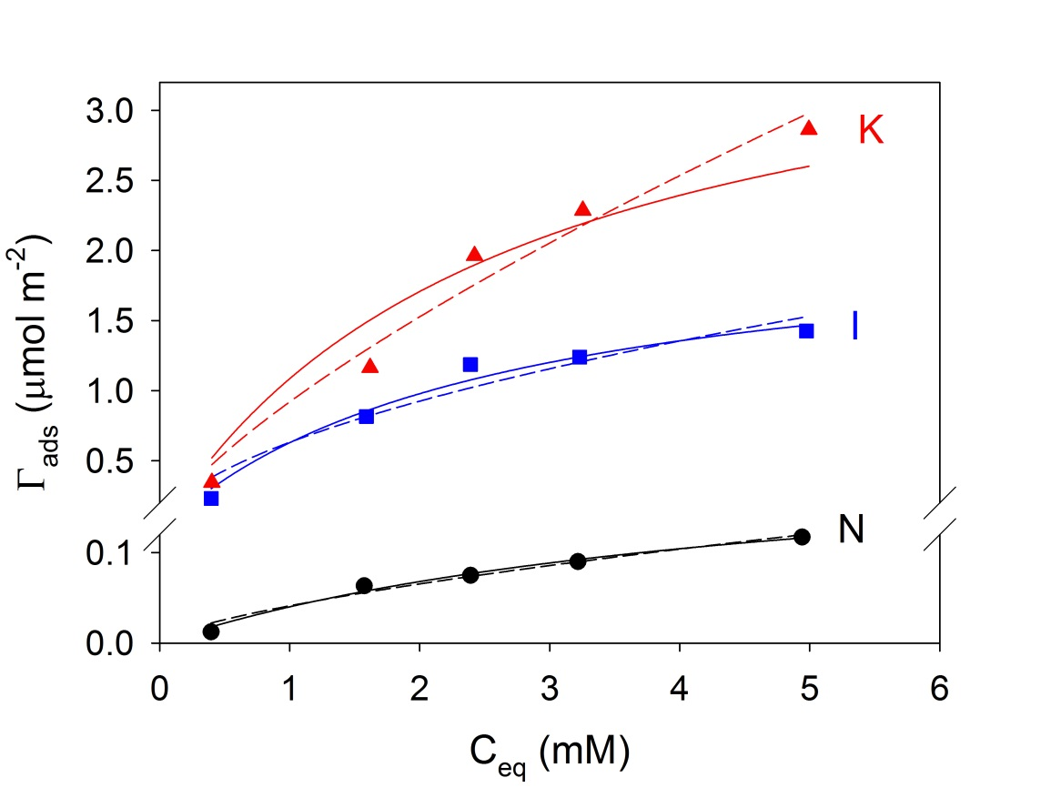

Figure S3. PCM adsorption isotherms at pH 5 and normalized by SN2. The solid and dotted lines were obtained from Equations (1) and (2) using Langmuir and Freundlich models, respectively.

Table S1. Langmuir and Freundlich parameters for PCM adsorption on nontronite, illite and kaolinite at different pH values for the normalization of Γads by SN2.

|  |  |  |  |  |  |  |  |
| --- | --- | --- | --- | --- | --- | --- | --- |
| Mineral | pH | Langmuir | | | Freundlich | | |
| pKL  (L µmol-1) | Γmax  (µmol m-2) | R2 | KF x10-3  (*) | 1/n | R2 |
| N | 3 | 3.51 | 0.23 | 0.9740 | 0.35 | 1.38 | 0.9792 |
| 5 | 3.52 | 0.22 | 0.9873 | 0.41 | 1.50 | 0.9731 |
| 7 | 3.75 | 0.21 | 0.9840 | 0.28 | 1.44 | 0.9725 |
| I | 3 | 3.35 | 2.47 | 0.9816 | 4.6 | 1.36 | 0.9740 |
| 5 | 3.40 | 2.21 | 0.9774 | 14 | 1.82 | 0.9317 |
| 7 | 3.70 | 2.10 | 0.9161 | 0.79 | 1.17 | 0.9478 |
| K | 3 | 3.24 | 5.29 | 0.9576 | 17 | 1.47 | 0.9458 |
| 5 | 3.43 | 4.00 | 0.9413 | 5.9 | 1.37 | 0.9731 |
| 7 | 3.63 | 20.53 | 0.9890 | 44.7 | 1.53 | 0.9719 |

The experimental error was less than 5% in all cases. KL: Langmuir equilibrium constant; Γmax: maximum uptake; (*) KF: Freundlich constant (${\text{L}}^{{\text{1}}/{\text{n}}}{\text{mmol}}^{\text{(1-}{\text{1}}/{\text{n}}\text{)}}{\text{m}}^{\text{-2}}\text{x1000}$); 1/n: an irrational fraction that varies between 0.1 and 1 and is a measure of the adsorption intensity.

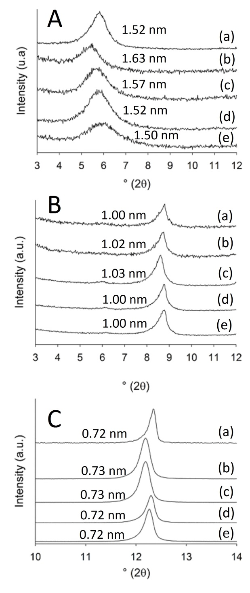

Figure S4. XRD diffraction patterns of oriented and at rh = 0.47 samples: (A) nontronite, (B) illite and (C) kaolinite. (a) raw clay, (b) clay equilibrated at pH 3, (c) PCM-clay, pH 3, (d) PCM-clay, pH 5 and (e) PCM-clay, pH7.

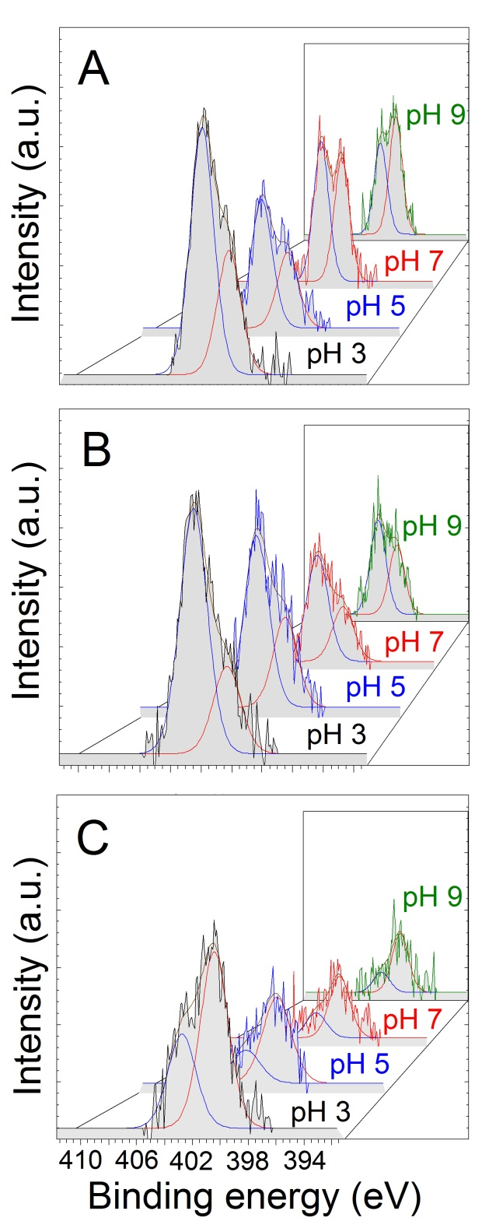

Figure S5. XPS spectra of N 1s signal of: (A) PCM-N, (B) PCM-I and (C) PCM-K samples at pH values indicated



A

B



**I**

**II**

**III**

Figure S6. (A) Resonance structures of PCM. (B) Orientation of the lone electron pair of PCM nitrogen atoms.



Figure S7. N1s XPS peak of PCM.