Appendix 1: Model output of research

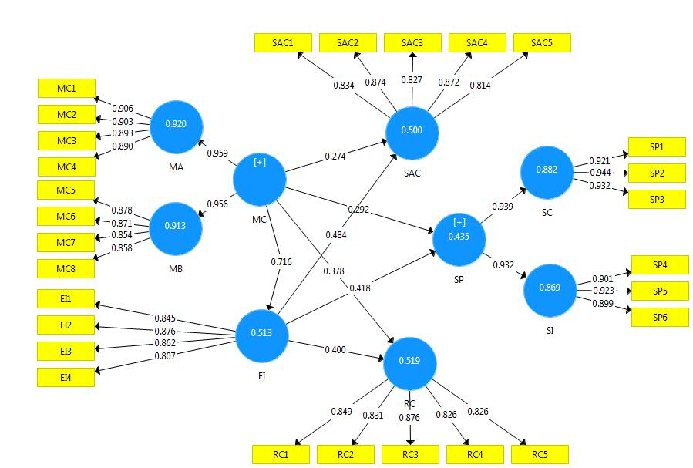

Note: EI = employees’ involvement; MA = managers’ attitude; MB = managers’ behaviour; MC = managers’ commitment; RC = reporting culture; SAC = safety awareness and competency; SI = safety involvement; SC = safety compliance; SP = safety performance.

