Appendix 1

Table A1.1 Complete list of groups, codes, and key words
Group | Code | Keywords
A1 | *GIAHS | Globally+Important+Agricultural+Heritage+Systems, GIAHS
 | *SEPLS | SEPL, SEPLS, socio-ecological+production+landscape social+ecological+production+landscape
 | *Cultural landscape | cultural+landscape, biocultural+landscape, high-nature-value+farmland
A2 | *traditional natural resource management | Dehesa, ahupua'a, Satoyama,Satoumi, Muyong, Chakra, Kebun, Pekarangan, kebun-talun ,maeulsoop, mauel, maeulsup, milpa, ngunda, chitemine, fadana, hima | hima+system, kaya, agras, montado, qunat, owita+system, sacred+forest, tank+irrigation+system, small+tank+system, alpeggio, coltura+promiscua, maremme, camarque, tuli, coltura+mista community+forestry, transhumance, agroforestry, homegarden, fruit+garden
A3 | *Landscape approach | Landscape+approach, integrated+landscape+management
B | *Dynamic mosaics of habitats and land and sea uses | ( dynamic & ( mosaic | habitat | land+use | sea+use ) ), ( mosaic & ( land+use | sea+use | habitat ) ), heterogeneous & land | landscape
 | *Harmonious interaction between people and nature maintains biodiversity | ( ( harmonious | nature | ( people & landscape ) ) & interaction ), ( human & influenced & ( landscape | area ) ), ( society & harmony+with+nature ), ( human & nature & relationship ), ( safeguard & ecosystem )
 | *Providing humans with the goods and services in a sustainable matter | ( self & contained & circulation & resource ), ( wise & use & natural & resource ), ( sustainable & ( manner | provision | ( natural & resource & use ) ) ),
 | *Be deeply linked to local culture and knowledge | ( local & ( knowledge | culture | technique | rule | inhabitant ) ), ( traditional & ( management | practice | knowledge | custom | living ) ),
C | *Ecosystem Approach | ecosystem+approach
D | *Landscape | Landscape
 | *Seascape | seascape
The symbols used in this list (*, +, &, | and ( )) are a delimiter and logical operators of the coding rules in KH Coder (http://khc.sourceforge.net/en/manual_en_v2.pdf). The operations of each symbol are as follows:
*: Name of code.
+: The delimiter for specifying a phrase, rather than a single word. For example, if one wishes to provide a code “*Graduation thesis” for a phrase including “graduation” and “thesis” successively, the protocol can be written as follows: graduation+thesis
&: The logical operator of “and”. For example, if one wishes to provide a code “When “communication”, “interception”, and “bill” appear in a document together, a code “*Wiretapping Law” is applied”. This coding rule can be written as:
1 *Wiretapping_Law
2 communication & interception & bill
| : The logical operator of “or”. For example, if one wishes to provide a code “When either “arrest” or “suspicion” or “investigation” exist in a document, then a code “*Crime1” is applied to it”. One can write this rule using logical operators, as follows:
1 *Crime1
2 arrest | suspicion | investigation
( ): Parentheses. For example, if one wishes to provide a code “When either of three words “communication”, “interception”, or “bill” appear together with “arrest” or “suspicion” or “investigation” appears in the same document, then a code *Crime2 is applied to it”. One can write this rule using parentheses, as follows:
1 Crime2
2 ( arrest | suspicion | investigation ) & ( communication & interception & bill )

Appendix 2

Figure A2.1 Global map for the Satoyama Index (SI)
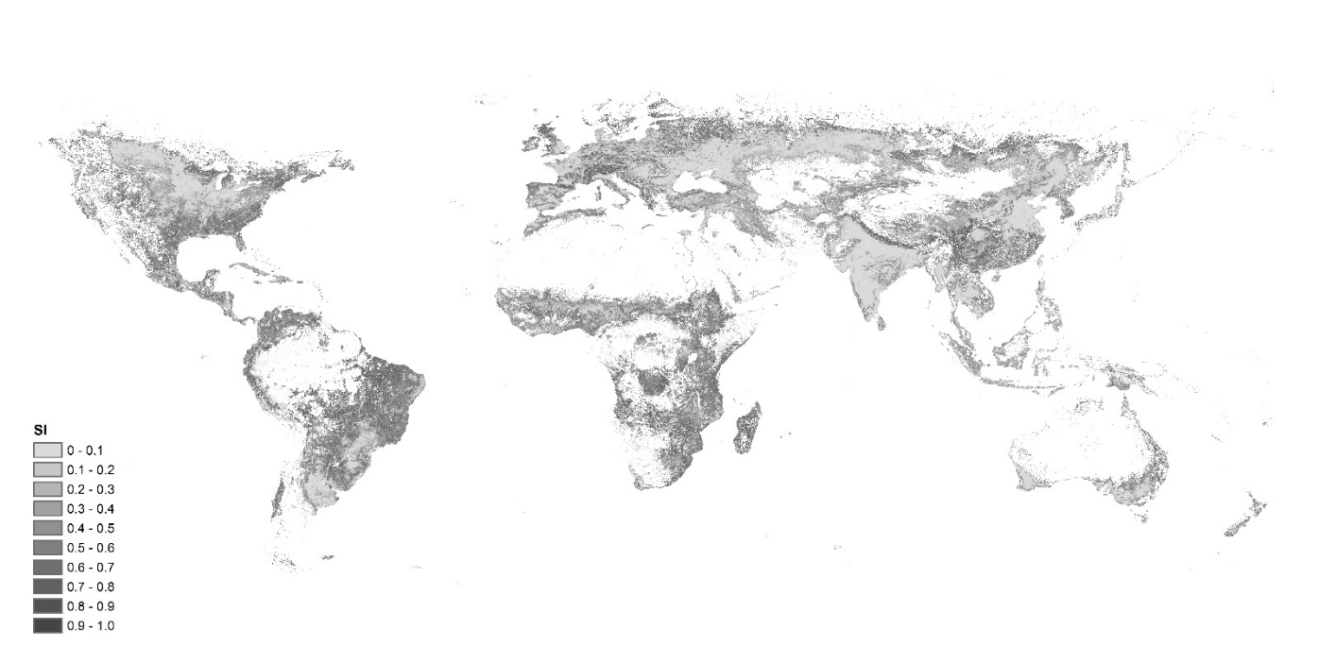
Note: The original land-use data in 2013 in grids of 500-m intervals were obtained from the Global Map data archives (https://globalmaps.github.io/) and then resized to 1-km intervals to compute the SI.

