Supplementary figure caption
Figure S1. FT-IR spectrum of 4BBTH
Figure S2. (a-c) Packing projection along a, b, c- axes of 4BBTH
Figure S3. (a) Quantities of molecular interactions represented in a bar chart

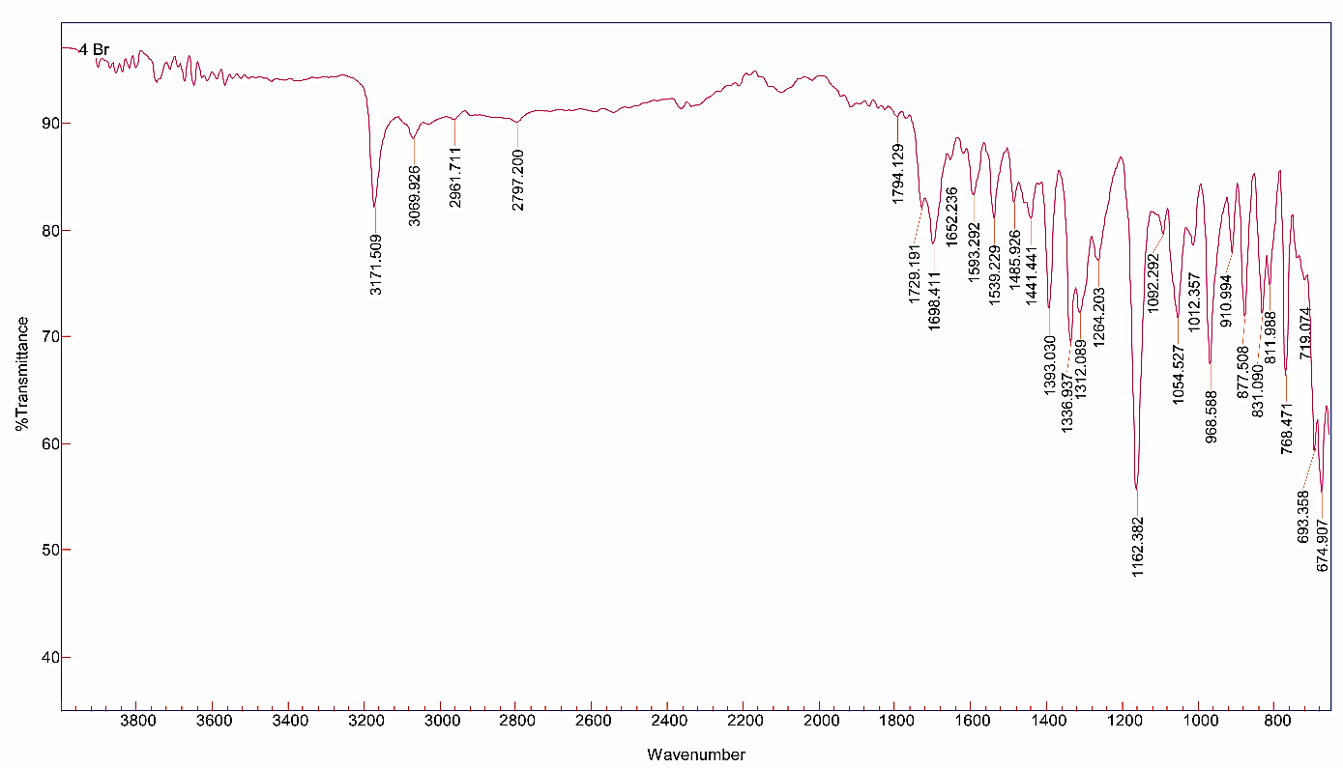
Figure S1. FT-IR spectrum of 4BBTH

.

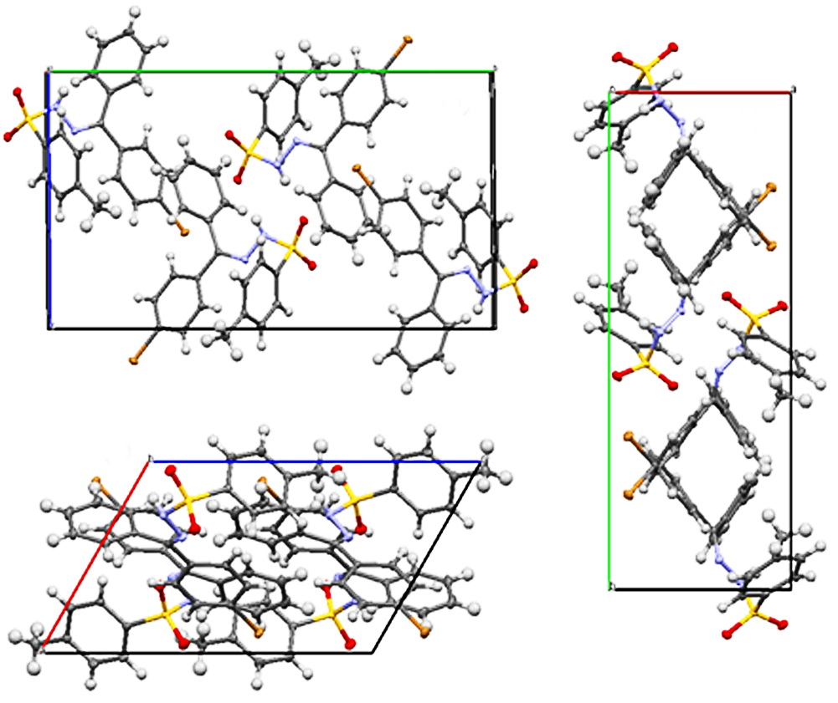
Figure S2. (a-c) Packing projection along a, b, c- axes of 4BBTH.
a
b
c

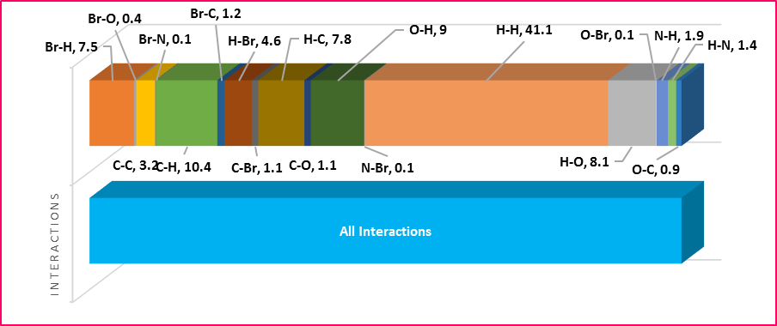
Figure S3. (a) Quantities of molecular interactions represented in a bar chart .

