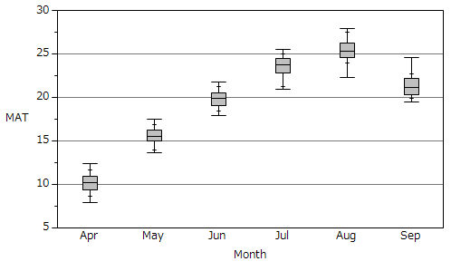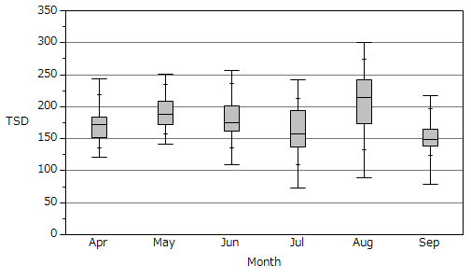

Figure S1. Box-and-whisker plots showing the scatter of mean air temperature (a) and total sunshine hours (b) in Shonai across the study period. The box spans from 25th to 75th percentiles, whereas the vertical bar in the middle of the box shows 50th percentile. The whiskers stretch from the box to the minimum and the maximum, respectively, while the small ticks on the whiskers show 10th and 90th percentiles, respectively.

b

a

Mean air temperature (°C)

Total sunshine hours (h)

300

250

200

150

100

0

50

Month

Sep

Aug

Jul

Jun

May

Apr

5

10

15

20

25

30