Supplementary Information
Table S1.
Ph. Eur. method - comparison of results with (n = 5) and without sonication (n = 2).
Ph. Eur. methodology | Process time (h) | Mean (%) | Standard deviation 1σ
Without sonication | ~72 | 1.19 | 0.086
With sonication | ~48 | 1.05 | 0.007

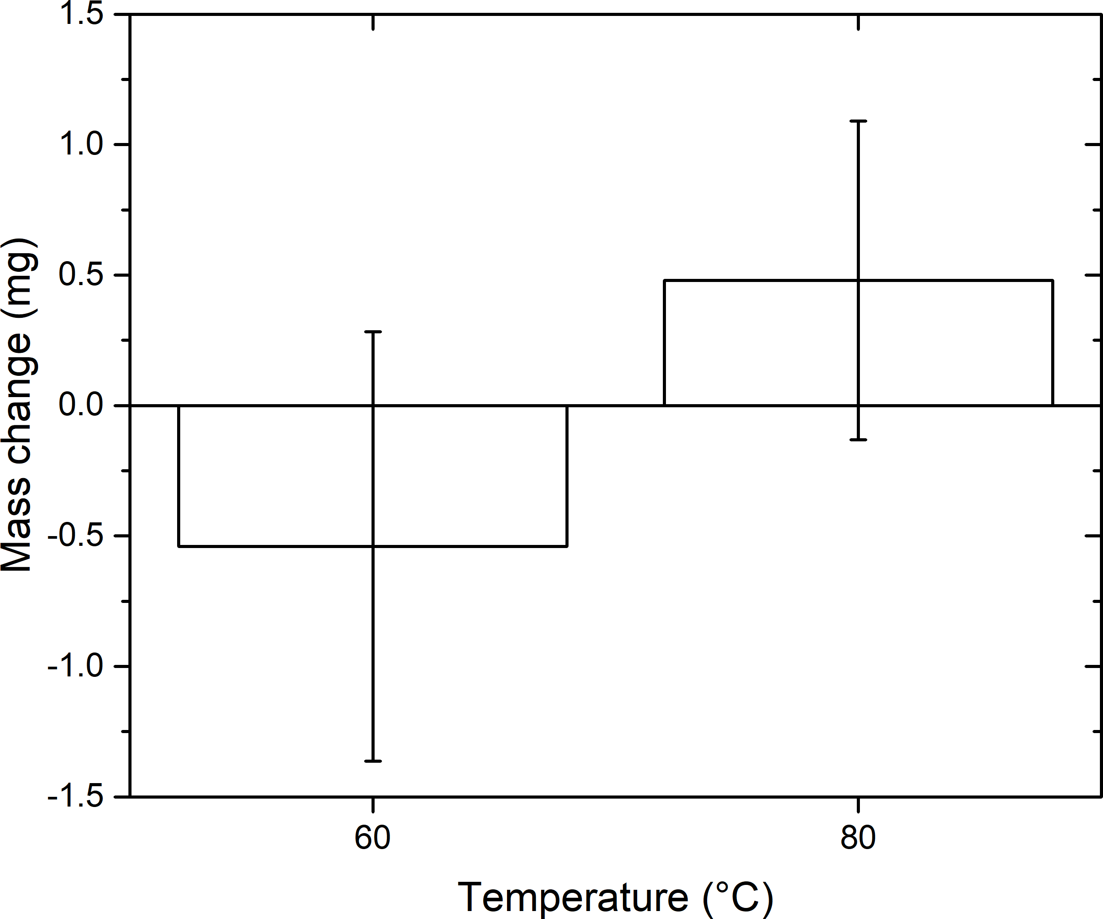
Figure S1.
Weight loss from empty falcon tubes after 2 h at 60 and 80 °C. Error bars represent 1σ standard deviation.
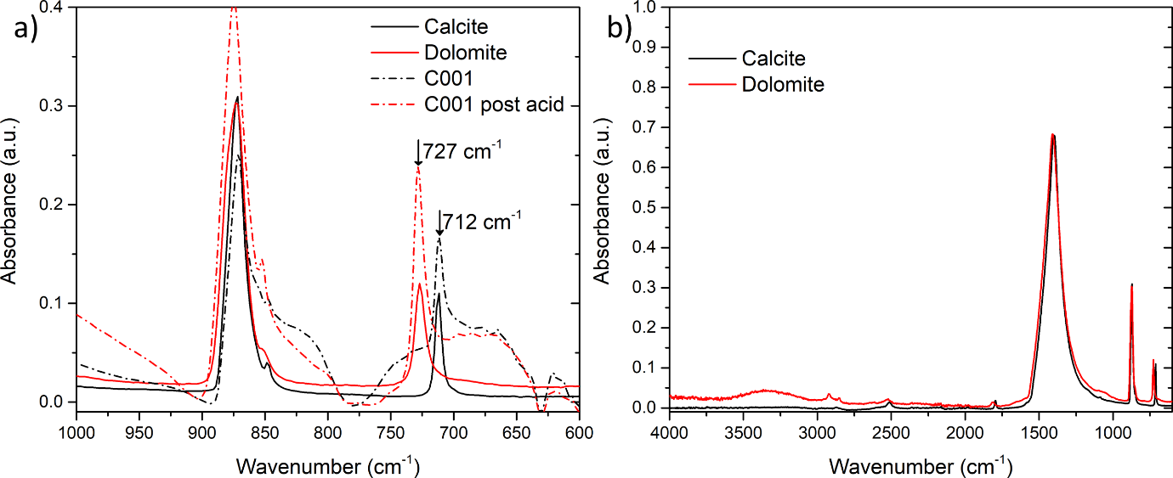
Figure S2.
ATR-FTIR spectra (S2a) of C001 before and after acid treatment in comparison with reference spectra of calcite and dolomite, noting the frequency shift from 712 to 727 cm⁻¹. The full reference spectra (S2b) were compiled from the RRUFF mineral database. ^{[S1]}
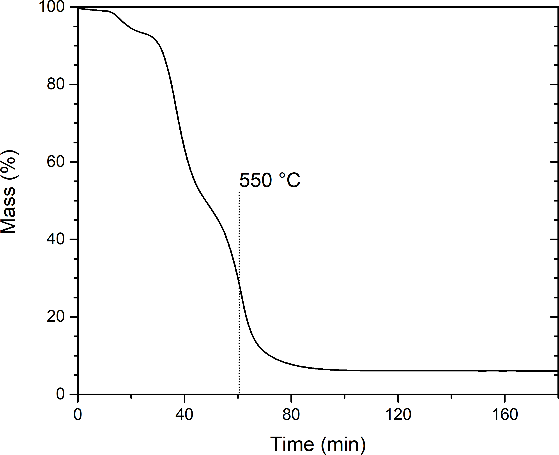
Figure S3.
Full isotherm for the biogenic sample C005, including a 2 h isothermal (550 °C) stage to constant weight.
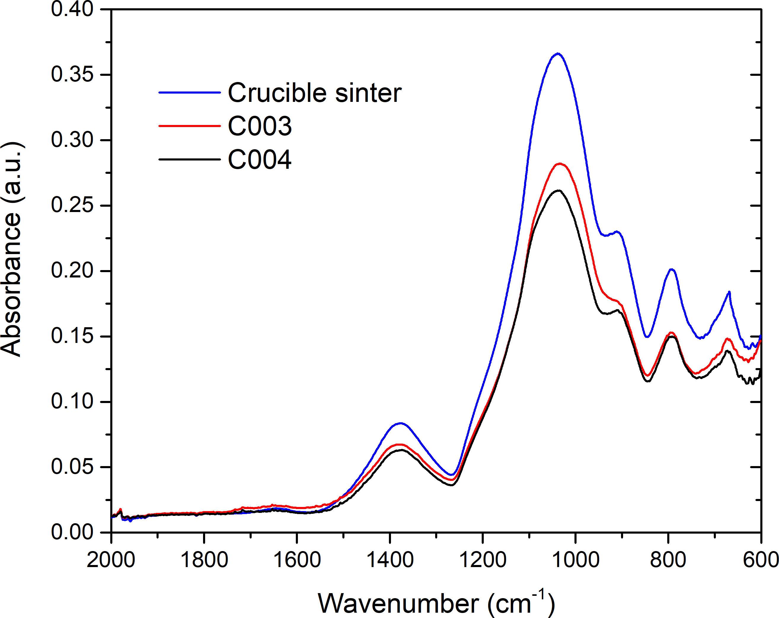
Figure S4.
Infrared spectra of acid insoluble residues obtained from 20 g of C003 and C004 processed according to a scaled up Ph. Eur. method. Despite the large quantity of sample used the spectra of the recovered residues show significant contamination from the sinter glass filters stipulated in the Ph. Eur. method.
References
S1. Lafuente B, Downs RT, Yang H, Stone N. 2015. The power of databases: the RRUFF project. In: Armbruster T, Danisi RM editors. Highlights in mineralogical crystallography. Berlin: W. De Gruyter, p. 1-30.

