Sharma et al., Supplemental Information.
Extraction of LINE-1 (L1) repeats in POTE genes, and presentation Illumina 450K coordinates in POTE genes: To extract L1 repeats in POTEs, we determined the start/end coordinates of each POTE using the genome annotation file (hg38 assembly). We then wrote a Python script to find L1 elements within -/+ 10K of each POTE . We generated a .BED file containing all L1 coordinates that span POTE genes, which allowed visualization in the genome browser along with CpG islands (CGI). We also visualized 450K Illumina Infinium probe coordinates.

Table: POTE family gene coordinates (hg38 assembly).
gene_name | ensembl_id | gene_biotype | chromosome | start | end | strand
POTEA | ENSG00000188877 | polymorphic_pseudogene | chr8 | 43292483 | 43363518 | +
POTEB | ENSG00000233917 | protein_coding | chr15 | 21846329 | 21877703 | -
POTEB2 | ENSG00000230031 | protein_coding | chr15 | 20835372 | 20866314 | -
POTEB3 | ENSG00000278522 | protein_coding | chr15 | 21408243 | 21440451 | -
POTEC | ENSG00000183206 | protein_coding | chr18 | 14507339 | 14543585 | -
POTED | ENSG00000166351 | protein_coding | chr21 | 13609858 | 13641585 | +
POTEE | ENSG00000188219 | protein_coding | chr2 | 131218067 | 131265278 | +
POTEF | ENSG00000196604 | protein_coding | chr2 | 130074030 | 130129222 | -
POTEG | ENSG00000187537 | protein_coding | chr14 | 19402486 | 19434341 | -
POTEH | ENSG00000198062 | protein_coding | chr22 | 15690026 | 15721631 | +
POTEI | ENSG00000196834 | protein_coding | chr2 | 130459455 | 130509666 | -
POTEJ | ENSG00000222038 | protein_coding | chr2 | 130611481 | 130658091 | +
POTEKP | ENSG00000204434 | unprocessed_pseudogene | chr2 | 131591752 | 131627266 | +
POTEM | ENSG00000222036 | protein_coding | chr14 | 18967434 | 18999012 | +

Figure: Steps performed for extracting L1 elements in POTE genes:

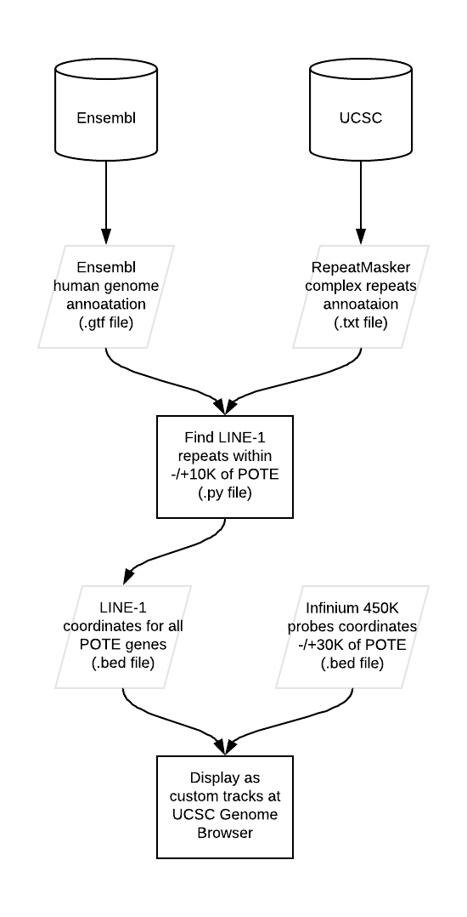

Figure. Visualization of POTEs in the UCSC genome browser, including L1 sequences and Illumina 450K CpG sites within POTE genes or 30kb flanking regions.
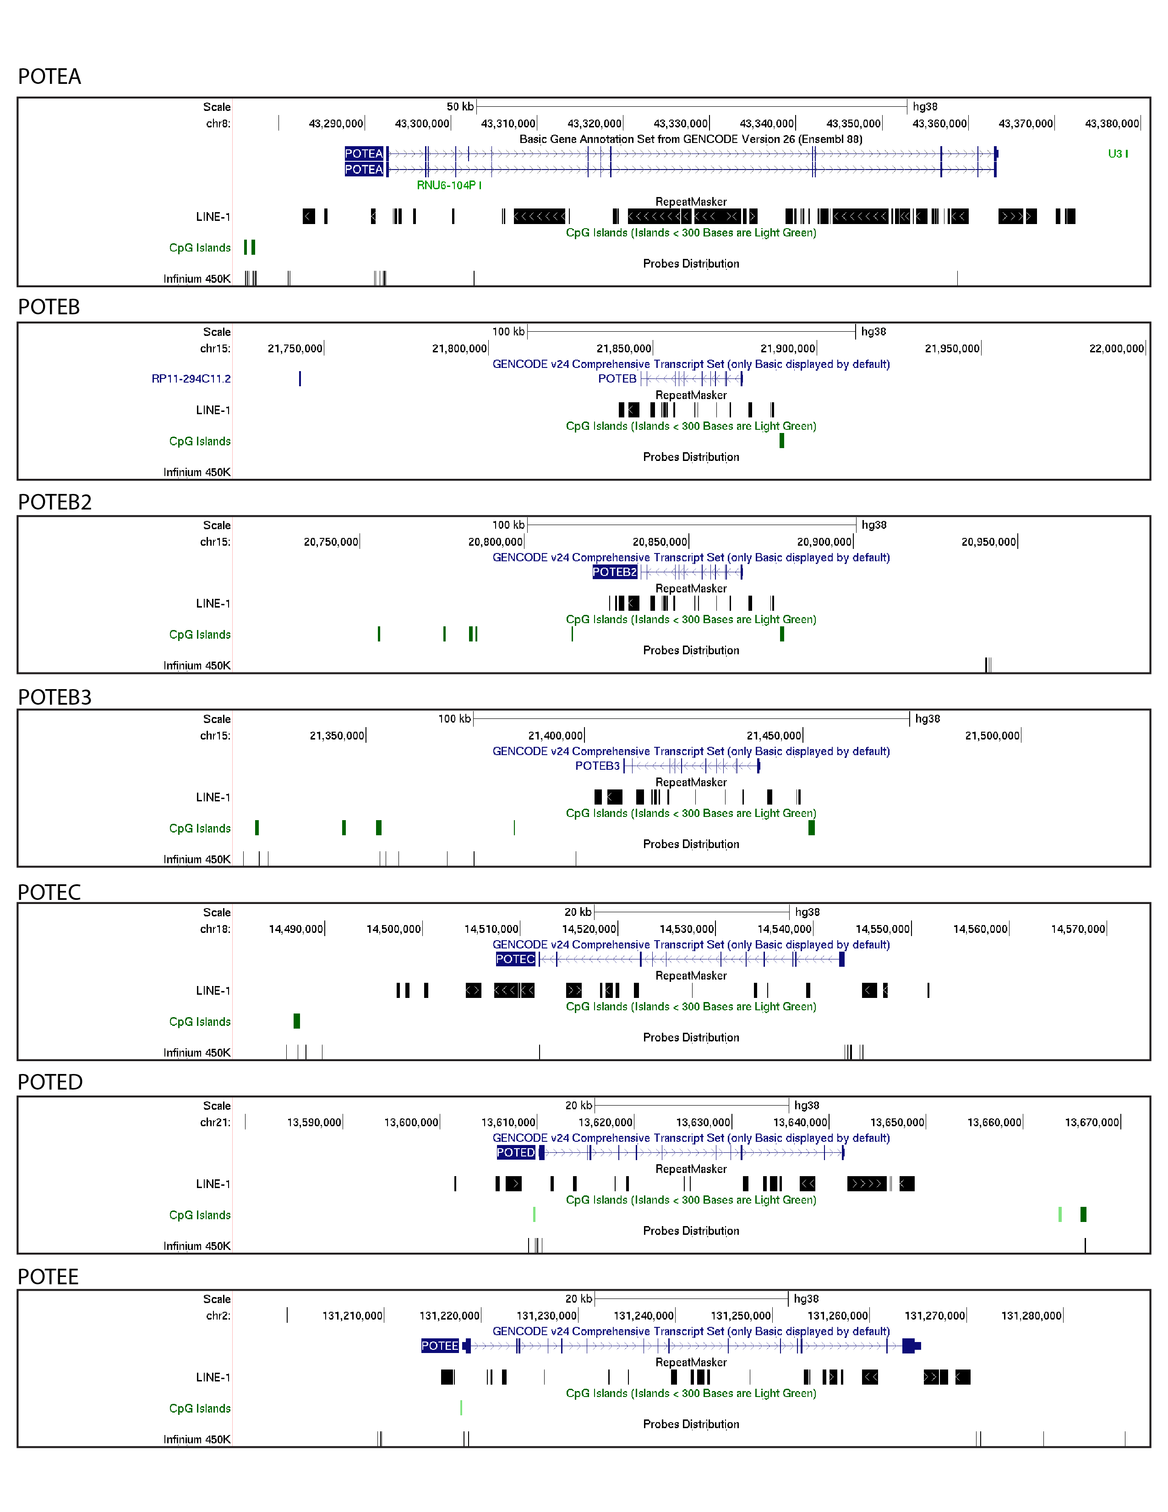

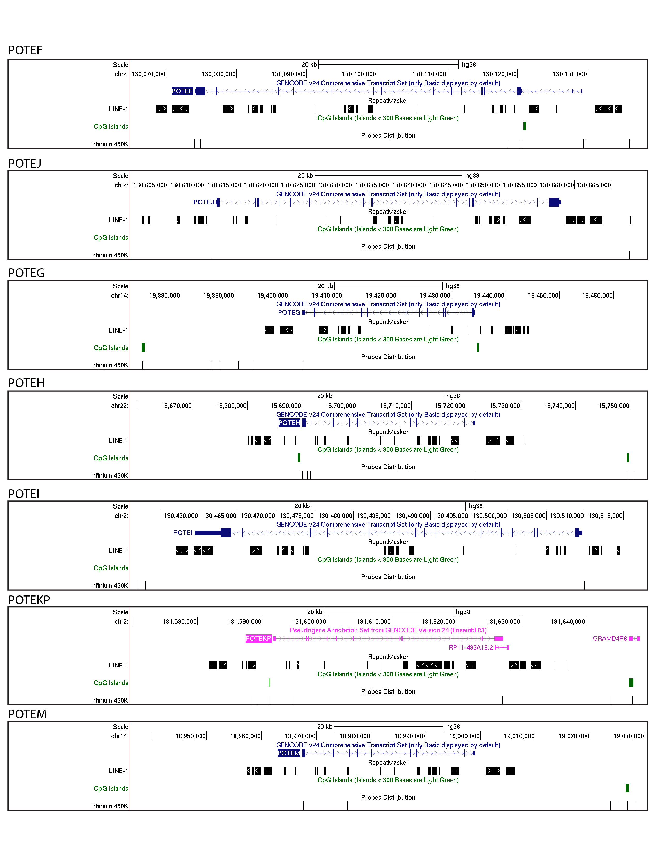

Table. Ilumina 450K CpG probes within POTE genes or 10kb flanking regions.

 |  | Ilumina 450K CpG sites
 | Ensembl ID | −10kb transcription start site (TSS) | TSS transcription end site (TES) | 10kb downstream TES
POTEA | ENSG00000188877 | 29 | 2 | N/A
POTEB | ENSG00000233917 | N/A | N/A | N/A
POTEB2 | ENSG00000230031 | N/A | N/A | N/A
POTEB3 | ENSG00000278522 | N/A | N/A | N/A
POTEC | ENSG00000183206 | 5 | 3 | N/A
POTED | ENSG00000166351 | 2 | 4 | N/A
POTEE | ENSG00000188219 | 3 | 4 | 2
POTEF | ENSG00000196604 | 20 | 7 | N/A
POTEG | ENSG00000187537 | N/A | 1 | N/A
POTEH | ENSG00000198062 | 3 | 4 | N/A
POTEI | ENSG00000196834 | 3 | N/A | N/A
POTEJ | ENSG00000222038 | 2 | N/A | 1
POTEKP | ENSG00000204434 | 6 | 3 | N/A
POTEM | ENSG00000222036 | 2 | 2 | N/A

The file was downloaded from ensembl and currently stored in the following path: ~/POTE_project/data/ensembl_downloads/hg38/genes/raw/Homo_sapiens.GRCh38.92.chr.gtf
For more detail about the script and the data used, go back to the script file: ~/POTE_project/[Active]LINE_coverage_with_POTEs.py
The path to the .BED file is: ~/POTE_project/data/outputs/hg38_LINEs_within_POTEs_10K_flankings.bed

