Supporting Information:

An efficient heterogeneous gold(I)-catalyzed intermolecular cycloaddition of 2-aminoaryl carbonyls and internal alkynes leading to polyfunctionalized quinolines

Wenli Hu,ª Weisen Yang,^{a,b} Tao Yanª and Mingzhong Caiª*

ª Key Laboratory of Functional Small Organic Molecule, Ministry of Education and College of Chemistry & Chemical Engineering, Jiangxi Normal University, Nanchang 330022, China
^{b} Fujian Key Laboratory of Eco-Industrial Green Technology, College of Ecology and Resources Engineering, Wuyi University, Wuyishan 354300, China
E-mail: caimzhong@163.com

General procedure for the heterogeneous Au(I)-catalyzed synthesis of quinolines:
To a solution of 2-aminoaryl carbonyl 1 (0.5 mmol), MCM-41-PPh₃-AuCl (128 mg, 0.05 mmol), AgOTf (12.9 mg, 0.05 mmol) in DMF (5 mL) was added internal alkyne 2 (0.75 mmol) under Ar. The reaction mixture was stirred at 100 ºC for 4 h (TLC monitored). The resulting mixture was then diluted with ethyl acetate (20 mL) and filtered. The gold catalyst was washed with NH₃·H₂O (2 × 5 mL), distilled water (5 mL), and acetone (2 × 5 mL) and reused in the next run. The filtrate was washed with water (2 × 10 mL) and brine (2 × 10 mL), and the organic layers were dried over MgSO₄, filtered, and concentrated under reduced pressure. The residue was purified by chromatography on silica gel (eluent: petroleum ether/ethyl acetate = 15/1) to afford the desired product 3.

Ethyl 2-phenylquinoline-3-carboxylate (3a).^{[1]} Light yellow oil. Yield: 86%. ¹H NMR (400 MHz, CDCl₃): δ 8.65 (s, 1H), 8.19 (d, J = 8.4 Hz, 1H), 7.92 (d, J = 8.0 Hz, 1H), 7.83-7.81 (m, 1H), 7.66-7.57 (m, 3H), 7.52-7.42 (m, 3H), 4.19 (q, J = 7.2 Hz, 2H), 1.08 (t, J = 7.0 Hz, 3H); ¹³C NMR (100 MHz, CDCl₃): δ 168.0, 158.2, 148.4, 140.8, 139.1, 131.5, 129.6, 128.6, 128.5, 128.2, 128.1, 127.2, 125.9, 125.6, 61.5, 13.7.

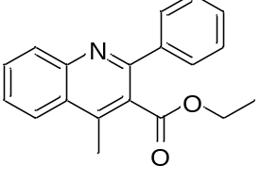
Ethyl 4-methyl-2-phenylquinoline-3-carboxylate (3b).^{[2]} Light yellow solid. Yield: 91%. Mp 59–61 °C. ¹H NMR (400 MHz, CDCl₃): δ 8.17 (d, J = 8.4 Hz, 1H), 8.08 (d, J = 8.0 Hz, 1H), 7.80-7.73 (m, 1H), 7.70-7.66 (m, 2H), 7.63-7.58 (m, 1H), 7.50-7.40 (m, 3H), 4.15 (q, J = 7.2Hz, 2H), 2.76 (s, 3H), 1.01 (t, J = 7.2 Hz, 3H); ¹³C NMR (100 MHz, CDCl₃): δ 169.1, 156.3, 147.3, 142.7, 140.7, 130.3, 128.7, 128.4, 128.3, 127.5, 127.0, 126.1, 124.1, 61.6, 15.7, 13.6.

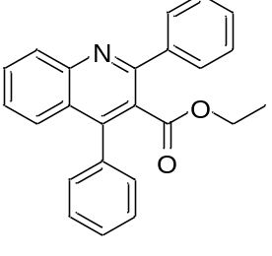
Ethyl 2,4-diphenylquinoline-3-carboxylate (3c).^{[2]} Light yellow solid. Yield: 90%. Mp 85–87 °C. ¹H NMR (400 MHz, CDCl₃): δ 8.23 (d, J = 8.4 Hz, 1H), 7.79-7.73 (m, 3H), 7.61 (d, J = 8.4 Hz, 1H), 7.52-7.39 (m, 9H), 3.87 (q, J = 7.2 Hz, 2H), 0.81 (t, J = 7.2 Hz, 3H); ¹³C NMR (100 MHz, CDCl₃): δ 168.2, 156.0, 147.9, 147.1, 140.3, 135.6, 130.5, 129.8, 129.4, 128.9, 128.6, 128.5, 128.4, 128.2, 127.2, 127.1, 126.6, 125.6, 61.3, 13.4.

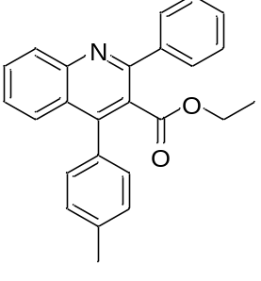
Ethyl 2-phenyl-4-(p-tolyl)quinoline-3-carboxylate (3d).^{[2]} Light yellow solid. Yield: 87%. Mp 86–88 °C. ¹H NMR (400 MHz, CDCl₃): δ 8.22 (d, J = 8.4 Hz, 1H), 7.76-7.72 (m, 2H), 7.67-7.63 (m, 1H), 7.56 (d, J = 8.4 Hz, 1H), 7.51-7.43 (m, 4H), 7.30 (s, 4H), 3.88 (q, J = 7.2 Hz, 2H), 2.45 (s, 3H), 0.83 (t, J = 7.2 Hz, 3H); ¹³C NMR (100 MHz, CDCl₃): δ 168.3, 156.0, 147.9, 147.3, 140.3, 138.3, 132.5, 130.4, 129.8, 129.3, 128.9, 128.8, 128.7, 128.6, 128.4, 127.0, 126.7, 125.8, 61.2, 21.4, 13.4.

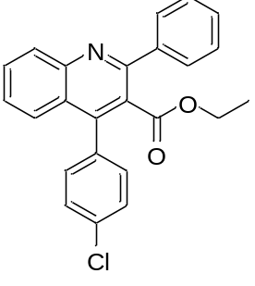
Ethyl 4-(4-chlorophenyl)-2-phenylquinoline-3-carboxylate (3e).^{[2]} Light yellow oil. Yield: 81%. ¹H NMR (400 MHz, CDCl₃): δ 8.23 (d, J = 8.4 Hz, 1H), 7.78-7.72 (m, 3H), 7.56 (d, J = 8.0 Hz, 1H), 7.52-7.43 (m, 6H), 7.36 (d, J = 8.4 Hz, 2H), 3.90 (q, J = 7.2 Hz, 2H), 0.85 (t, J = 7.2 Hz, 3H); ¹³C NMR (100 MHz, CDCl₃): δ 168.0, 156.0, 147.8, 145.8, 140.1, 134.8, 134.0, 130.9, 130.6, 130.5, 130.0, 129.0, 128.6, 128.5, 128.4, 127.3, 126.2, 125.3, 61.4, 13.5.

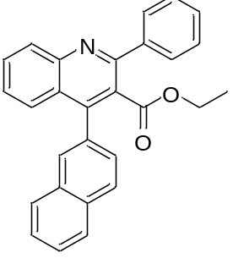
Ethyl 4-(naphthalen-2-yl)-2-phenylquinoline-3-carboxylate (3f). Light yellow oil. Yield: 78%. ¹H NMR (400 MHz, CDCl₃): δ 8.25 (d, J = 8.4 Hz, 1H), 7.98 (d, J = 8.4 Hz, 1H), 7.96-7.92 (m, 1H), 7.90-7.85 (m, 2H), 7.79-7.74 (m, 3H), 7.65-7.60 (m, 1H), 7.59-7.52 (m, 3H), 7.50-7.42 (m, 4H), 3.80 (q, J = 7.2, 2H), 0.71 (t, J = 7.2 Hz, 3H); ¹³C NMR (100 MHz, CDCl₃): δ 168.2, 156.1, 147.9, 147.1, 140.3, 133.1, 133.0, 132.9, 130.5, 129.9, 128.9, 128.7, 128.6, 128.4, 128.2, 127.9, 127.8, 127.5, 127.3, 127.1, 126.7, 126.6, 125.7, 61.3, 13.4. HRMS calcd for C₂₈H₂₂NO₂⁺ [M+H]⁺: 404.1651, found 404.1648.

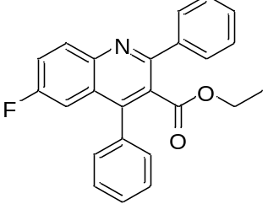
Ethyl 6-fluoro-2,4-diphenylquinoline-3-carboxylate (3g). Light yellow solid. Yield: 83%. Mp 75–77 °C. ¹H NMR (400 MHz, CDCl₃): δ 8.23 (dd, J = 9.2, 5.2 Hz, 1H), 7.75-7.72 (m, 2H), 7.54-7.37 (m, 9H), 7.24-7.20 (m, 1H), 3.88 (q, J = 7.2 Hz, 2H), 0.82 (t, J = 7.2 Hz, 3H); ¹³C NMR (100 MHz, CDCl₃): δ 168.0, 160.9 (d, ¹J_{C-F} = 247.3 Hz), 155.4, 146.6 (d, ⁴J_{C-F} = 5.7 Hz), 145.0, 140.0, 135.1, 132.4 (d, ³J_{C-F} = 9.1 Hz), 129.3, 129.0, 128.8, 128.6, 128.5, 128.4, 127.8, 126.6 (d, ³J_{C-F} = 9.6 Hz), 120.8 (d, ²J_{C-F} = 25.7 Hz), 109.9 (d, ²J_{C-F} = 23.3 Hz), 61.4, 13.4. HRMS calcd for C₂₄H₁₉FNO₂⁺ [M+H]⁺: 372.1400, found 372.1408.

Ethyl 6-chloro-2,4-diphenylquinoline-3-carboxylate (3h).^{[2]} Light yellow solid. Yield: 82%. Mp 106–108 °C. ¹H NMR (400 MHz, CDCl₃): δ 8.16 (d, J = 9.2 Hz, 1H), 7.74 (d, J = 7.6 Hz, 2H), 7.71 (d, J = 8.8 Hz, 1H), 7.57 (d, J = 2.0 Hz, 1H), 7.54-7.49 (m, 3H), 7.48-7.44 (m, 3H), 7.42-7.37 (m, 2H), 3.88 (t, J = 7.2 Hz, 2H), 0.81 (t, J = 7.2 Hz, 3H); ¹³C NMR (100 MHz, CDCl₃): δ 167.8, 156.3, 146.4, 146.3, 139.8, 134.9, 133.1, 131.5, 131.4, 129.4, 129.1, 128.9, 128.6, 128.5, 128.4, 128.0, 126.4, 125.3, 61.4, 13.4.

Ethyl 2-(p-tolyl)quinoline-3-carboxylate (3i).^{[1]} Light yellow solid. Yield: 91%. Mp 55–57 °C. ¹H NMR (400 MHz, CDCl₃): δ 8.61 (s, 1H), 8.17 (d, J = 8.4 Hz, 1H), 7.90 (d, J = 8.0 Hz, 1H), 7.82-7.77 (m, 1H), 7.58 (t, J = 7.6 Hz, 1H), 7.54 (d, J = 8.0 Hz, 2H), 7.27 (d, J = 8.4 Hz, 2H), 4.22 (q, J = 7.2 Hz, 2H), 2.42 (s, 3H), 1.13 (t, J = 7.2 Hz, 3H); ¹³C NMR (100 MHz, CDCl₃): δ 168.2, 158.1, 148.4, 138.9, 138.5, 137.8, 131.4, 129.5, 128.9, 128.6, 128.2, 127.1, 125.8, 125.6, 61.5, 21.4, 13.8.

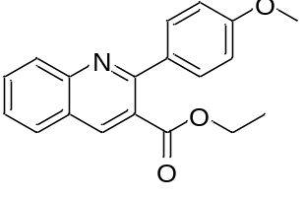
Ethyl 2-(4-methoxyphenyl)quinoline-3-carboxylate (3j).^{[1]} Light yellow oil. Yield: 92%. ¹H NMR (400 MHz, CDCl₃): δ 8.59 (s, 1H), 8.16 (d, J = 8.4 Hz, 1H), 7.89 (d, J = 8.4 Hz, 1H), 7.82-7.76 (m, 1H), 7.61 (d, J = 8.8 Hz, 2H), 7.57 (t, J = 7.6 Hz, 1H), 7.00 (d, J = 8.8 Hz, 2H), 4.24 (q, J = 7.2 Hz, 2H), 3.87 (s, 3H), 1.16 (t, J = 7.2 Hz, 3H); ¹³C NMR (100 MHz, CDCl₃): δ 168.3, 160.2, 157.5, 148.4, 138.9, 133.2, 131.4, 130.1, 129.5, 128.2, 127.0, 125.7, 125.5, 113.7, 61.6, 55.4, 13.9.

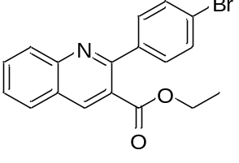
Ethyl 2-(4-bromophenyl)quinoline-3-carboxylate (3k).^{[1]} Light yellow solid. Yield: 84%. Mp 68–70 °C. ¹H NMR (400 MHz, CDCl₃): δ 8.68 (s, 1H), 8.17 (d, J = 8.4 Hz, 1H), 7.93 (d, J = 8.0 Hz, 1H), 7.83-7.80 (m, 1H), 7.65-7.57 (m, 3H), 7.54-7.49 (m, 2H), 4.23 (q, J = 7.2 Hz, 2H), 1.16 (t, J = 7.2 Hz, 3H); ¹³C NMR (100 MHz, CDCl₃): δ 167.6, 157.0, 148.4, 139.8, 139.5, 131.8, 131.3, 130.3, 129.5, 128.3, 127.5, 126.0, 125.0, 123.1, 61.7, 13.8.
Ethyl 2-(4-nitrophenyl)quinoline-3-carboxylate (3l).^{[2]} Light yellow solid. Yield: 79%. Mp 147–149 °C. ¹H NMR (400 MHz, CDCl₃): δ 8.80 (s, 1H), 8.34 (d, J = 8.8 Hz, 2H), 8.19 (d, J = 8.4 Hz, 1H), 7.98 (d, J = 8.0 Hz, 1H), 7.90-7.86 (m, 1H), 7.81-7.76 (m, 2H), 7.71-7.65 (m, 1H), 4.25 (q, J = 7.2 Hz, 2H), 1.17 (t, J = 7.2 Hz, 3H); ¹³C NMR (100 MHz, CDCl₃): δ 166.7, 156.2, 148.4, 147.8, 147.3, 140.1, 132.3, 129.8, 129.7, 128.5, 128.1, 126.2, 124.5, 123.3, 61.8, 13.9.

Ethyl 2-(naphthalen-1-yl)quinoline-3-carboxylate (3m). Light yellow solid. Yield: 83%. Mp 77–80 °C. ¹H NMR (400 MHz, CDCl₃) δ 8.87 (s, 1H), 8.23 (d, J = 8.4 Hz, 1H), 8.02 (d, J = 7.6 Hz, 1H), 7.94-7.83 (m, 3H), 7.69-7.64 (m, 1H), 7.62-7.50 (m, 3H), 7.49-7.43 (m, 1H), 7.40-7.34 (m, 1H), 3.85 (q, J = 7.2 Hz, 2H), 0.65 (t, J = 7.2 Hz, 3H); ¹³C NMR (100 MHz, CDCl₃): δ 166.8, 158.1, 148.7, 139.5, 139.1, 133.4, 131.9, 131.8, 129.6, 128.5, 128.4, 128.3, 127.5, 126.5, 126.3, 126.2, 125.8, 125.3, 125.1, 61.2, 13.1. HRMS calcd for C₂₂H₁₈NO₂⁺ [M+H]⁺: 328.1338, found 328.1335.

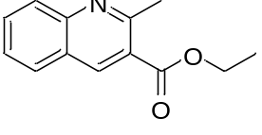
Ethyl 2-methylquinoline-3-carboxylate (3n).^{[3]} Light yellow solid. Yield: 87%. Mp 65–68 °C. ¹H NMR (400 MHz, CDCl₃): δ 8.73 (s, 1H), 8.04 (d, J = 8.4 Hz, 1H), 7.86 (d, J = 8.0 Hz, 1H), 7.80-7.76 (m, 1H), 7.56-7.51 (m, 1H), 4.45 (q, J = 7.2 Hz, 2H), 3.00 (s, 3H), 1.46 (t, J = 7.2 Hz, 3H); ¹³C NMR (100 MHz, CDCl₃): δ 166.6, 158.5, 148.7, 139.9, 131.7, 128.6, 128.5, 126.5, 125.8, 124.0, 61.4, 25.7, 14.3.
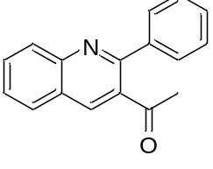
1-(2-Phenylquinolin-3-yl)ethan-1-one (3o).^{[2]} Light yellow solid. Yield: 75%. Mp 77–79 °C. ¹H NMR (400 MHz, CDCl₃): δ 8.38 (s, 1H), 8.20 (d, J = 8.4 Hz, 1H), 7.93 (d, J = 8.0 Hz, 1H), 7.84-7.80 (m, 1H), 7.70-7.65 (m, 2H), 7.63-7.57 (m, 1H), 7.53-7.47 (m, 3H), 2.15 (s, 3H); ¹³C NMR (100 MHz, CDCl₃): δ 203.1, 156.9, 148.3, 140.3, 137.0, 134.8, 131.4, 129.5, 129.4, 129.2, 128.9, 128.4, 127.3, 126.1, 30.4.
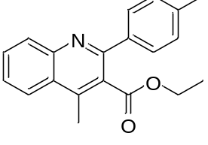
Ethyl 4-methyl-2-(p-tolyl)quinoline-3-carboxylate (3p). Light yellow oil. Yield: 90%. ¹H NMR (400 MHz, CDCl₃): δ 8.15 (d, J = 8.4 Hz, 1H), 8.07 (d, J = 8.4 Hz, 1H), 7.78-7.72 (m, 1H), 7.62-7.56 (m, 3H), 7.28-7.24 (m, 2H), 4.18 (q, J = 7.2 Hz, 2H), 2.75 (s, 3H), 2.40 (s, 3H), 1.07 (t, J = 7.2 Hz, 3H); ¹³C NMR (100 MHz, CDCl₃): δ 169.3, 156.2, 147.3, 142.5, 138.6, 137.8, 130.3, 130.2, 129.1, 128.3, 127.5, 126.8, 126.0, 124.1, 61.5, 21.3, 15.7, 13.7. HRMS calcd for C₂₀H₂₀NO₂⁺ [M+H]⁺: 306.1494, found 306.1492.
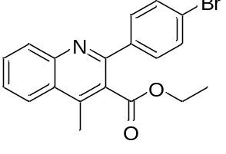
Ethyl 2-(4-bromophenyl)-4-methylquinoline-3-carboxylate (3q). Light yellow oil. Yield: 83%. ¹H NMR (400 MHz, CDCl₃): δ 8.14 (d, J = 8.8 Hz, 1H), 8.08 (d, J = 8.4 Hz, 1H), 7.79-7.75 (m, 1H), 7.65-7.55 (m, 5H), 4.19 (q, J = 7.2 Hz, 2H), 2.76 (s, 3H), 1.09 (t, J = 7.2 Hz, 3H); ¹³C NMR (100 MHz, CDCl₃): δ 169.0, 154.9, 147.3, 143.0, 139.6, 131.5, 130.5, 130.3, 130.1, 127.2, 126.2, 124.2, 123.2, 61.7, 15.7, 13.8. HRMS calcd for C₁₉H₁₇BrNO₂⁺ [M+H]⁺: 370.0443, found 370.0438.

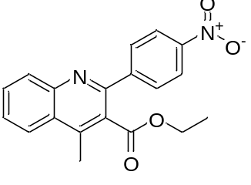
Ethyl 4-methyl-2-(4-nitrophenyl)quinoline-3-carboxylate (3r). Light yellow solid. Yield: 76%. Mp 88–90 °C. ¹H NMR (400 MHz, CDCl₃): δ 8.35-8.31 (m, 2H), 8.16 (d, J = 8.4 Hz, 1H), 8.11 (t, J = 8.4 Hz, 1H), 7.90-7.86 (m, 2H), 7.84-7.79 (m, 1H), 7.70-7.65 (m, 1H), 4.20 (q, J = 7.2 Hz, 2H), 2.80 (s, 3H), 1.09 (t, J = 7.2 Hz, 3H); ¹³C NMR (100 MHz, CDCl₃): δ 168.6, 153.8, 148.0, 147.2, 146.9, 143.7, 130.9, 130.4, 129.6, 129.3, 127.8, 126.5, 124.3, 123.6, 61.9, 15.8, 13.8. HRMS calcd for C₁₉H₁₇N₂O₄⁺ [M+H]⁺: 337.1188, found 337.1196.
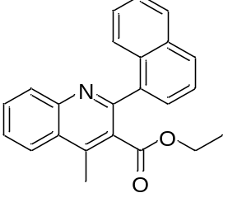
Ethyl 4-methyl-2-(naphthalen-1-yl)quinoline-3-carboxylate (3s). Light yellow solid. Yield: 85%. Mp 116–118 °C. ¹H NMR (400 MHz, CDCl₃): δ 8.20 (d, J = 8.4 Hz, 1H), 8.15 (dd, J = 8.4, 0.8 Hz, 1H), 7.93-7.85 (m, 2H), 7.81-7.78 (m, 1H), 7.71-7.64 (m, 2H), 7.54-7.50 (m, 2H), 7.48-7.44 (m, 1H), 7.42-7.39 (m, 1H), 3.79 (q, J = 7.2 Hz, 2H), 2.81 (s, 3H), 0.53 (t, J = 7.2 Hz, 3H); ¹³C NMR (100 MHz, CDCl₃): δ 168.3, 156.3, 147.1, 142.8, 137.9, 133.7, 131.8, 130.5, 130.4, 129.0, 128.8, 128.0, 127.2, 126.7, 126.4, 126.3, 126.1, 126.0, 124.9, 124.2, 61.2, 15.8, 13.1. HRMS calcd for C₂₃H₂₀NO₂⁺ [M+H]⁺: 342.1494, found 342.1483.

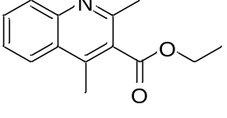
Ethyl 2,4-dimethylquinoline-3-carboxylate (3t).^{[4]} Light yellow oil. Yield: 89%. ¹H NMR (400 MHz, CDCl₃): δ 8.02 (d, J = 8.4 Hz, 1H), 8.00-7.98 (m, 1H), 7.73-7.68 (m, 1H), 7.56-7.52 (m, 1H), 4.49 (q, J = 7.2 Hz, 2H), 2.71 (s, 3H), 2.66 (s, 3H), 1.44 (t, J = 7.2 Hz, 3H); ¹³C NMR (100 MHz, CDCl₃): δ 169.2, 154.4, 147.2, 141.4, 130.0, 129.3, 128.0, 126.3, 125.8, 124.0, 61.7, 23.8, 15.7, 14.3.

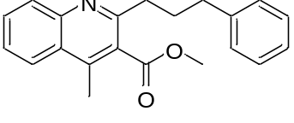
Methyl 4-methyl-2-(3-phenylpropyl)quinoline-3-carboxylate (3u). Light yellow oil. Yield: 88%. ¹H NMR (400 MHz, CDCl₃): δ 8.04 (d, J = 8.4 Hz, 1H), 8.00-7.98 (m, 1H), 7.73-7.69 (m, 1H), 7.56-7.52 (m, 1H), 7.30-7.17 (m, 5H), 3.85 (s, 3H), 2.96-2.91 (m, 2H), 2.74 (t, J = 7.6 Hz, 2H), 2.62 (s, 3H), 2.18-2.10 (m, 2H); ¹³C NMR (100 MHz, CDCl₃): δ 169.7, 157.7, 147.3, 142.1, 141.6, 130.0, 129.5, 128.6, 128.3, 127.7, 126.3, 125.8, 124.0, 52.4, 36.8, 35.9, 31.1, 15.8. HRMS calcd for C₂₁H₂₂NO₂⁺ [M+H]⁺: 320.1651, found 320.1657.
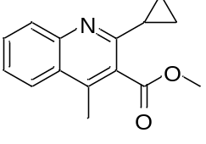
Methyl 2-cyclopropyl-4-methylquinoline-3-carboxylate (3v). Light yellow oil. Yield: 80%. ¹H NMR (400 MHz, CDCl₃): δ 7.96-7.91 (m, 2H), 7.67-7.62 (m, 1H), 7.49-7.44 (m, 1H), 4.01 (s, 3H), 2.62 (s, 3H), 2.11-2.05 (m, 1H), 1.31-1.26 (m, 2H), 1.04-0.98 (m, 2H); ¹³C NMR (100 MHz, CDCl₃): δ 170.0, 158.0, 147.5, 140.6, 129.8, 129.5, 128.0, 125.8, 125.6, 123.9, 52.5, 15.8, 15.6, 9.9. HRMS calcd for C₁₅H₁₆NO₂⁺ [M+H]⁺: 242.1181, found 242.1175.
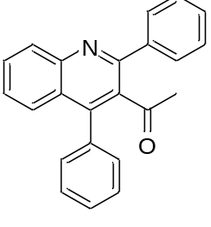
1-(2,4-Diphenylquinolin-3-yl)ethan-1-one (3w).^{[5]} Light yellow solid. Yield: 73%. Mp 103–105 °C. ¹H NMR (400 MHz, CDCl₃): δ 8.23 (d, J = 8.4 Hz, 1H), 7.78-7.74 (m, 1H), 7.70-7.65 (m, 2H), 7.59-7.56 (m, 1H), 7.54-7.42 (m, 7H), 7.39-7.35 (m, 2H), 1.90 (s, 3H); ¹³C NMR (100 MHz, CDCl₃): δ 204.6, 155.2, 147.6, 145.4, 140.1, 135.3, 130.4, 129.8, 129.2, 129.1, 129.0, 128.7, 128.6, 128.5, 128.1, 127.1, 126.6, 125.9, 32.8.

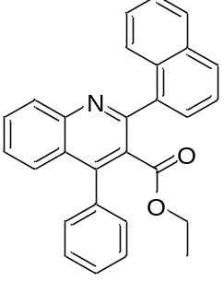
Ethyl 2-(naphthalen-1-yl)-4-phenylquinoline-3-carboxylate (3x). Light yellow solid. Yield: 82%. Mp 126–128 °C. ¹H NMR (400 MHz, CDCl₃): δ 8.25 (d, J = 8.4 Hz, 1H), 7.92 (d, J = 8.0 Hz, 1H), 7.88 (d, J = 8.0 Hz, 1H), 7.81-7.74 (m, 2H), 7.73 (d, J = 7.6 Hz, 1H), 7.61-7.58 (m, 1H), 7.56-7.42 (m, 9H), 3.56 (q, J = 7.2 Hz, 2H), 0.46 (t, J = 7.2 Hz, 3H); ¹³C NMR (100 MHz, CDCl₃): δ 167.4, 156.2, 147.7, 147.0, 137.5, 135.6, 133.7, 131.8, 130.6, 129.9, 129.5, 129.0, 128.6, 128.3, 128.1, 127.3, 127.0, 126.7, 126.3, 126.1, 125.9, 125.7, 124.9, 60.9, 13.1. HRMS calcd for C₂₈H₂₂NO₂⁺ [M+H]⁺: 404.1651, found 404.1647.

References
[1] Zheng, J.; Li, Z.; Huang, L.; Wu, W.; Li, J.; Jiang, H. Org. Lett. 2016, 18, 3514-3517.
[2] Cai, S.; Zeng, J.; Bai, Y.; Liu, X.-W. J. Org. Chem. 2012, 77, 801-807.
[3] Sridharan, V.; Ribelles, P.; Ramos, M. T.; Menendez, J. C. J. Org. Chem. 2009, 74, 5715-5718.
[4] Genovese, S.; Epifano, F.; Marcotullio, M. C.; Pelucchini, C.; Curini, M. Tetrahedron Lett. 2011, 52, 3474-3477.
[5] Enugala, R.; Nuvvula, S.; Kotra, V.; Varala, R.; Adapa, S. R. Heterocycles 2008, 75, 2523-2533.

Copies of ¹H NMR and ¹³C NMR spectra of compounds 3a-3x.

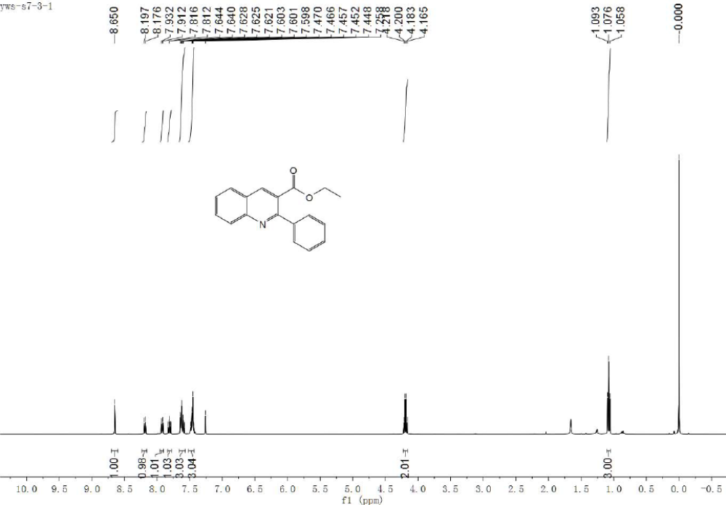
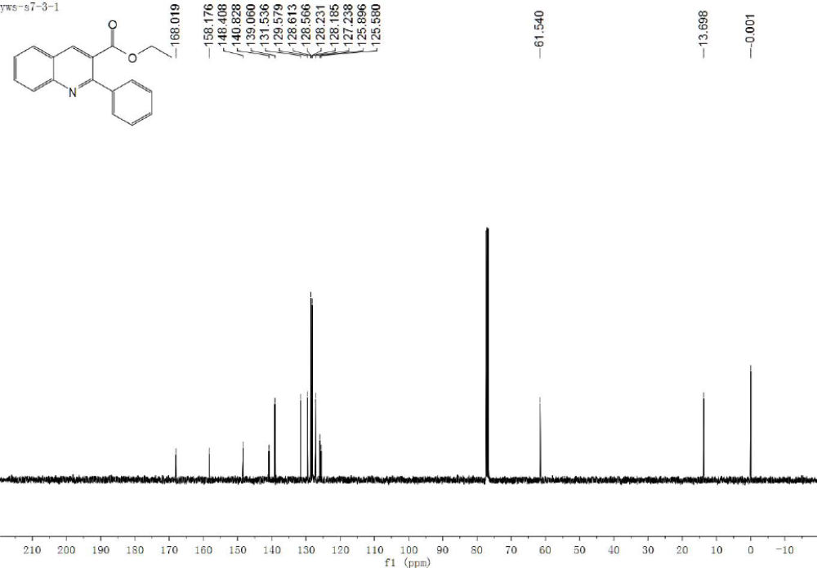
¹H NMR and ¹³C NMR spectra of compound 3a
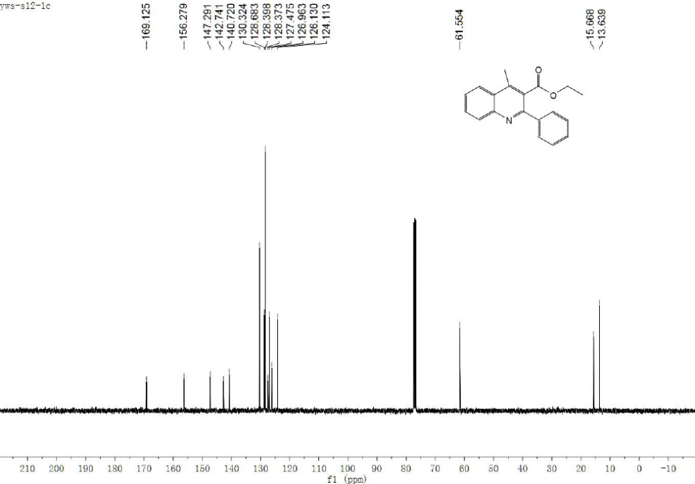
¹H NMR and ¹³C NMR spectra of compound 3b
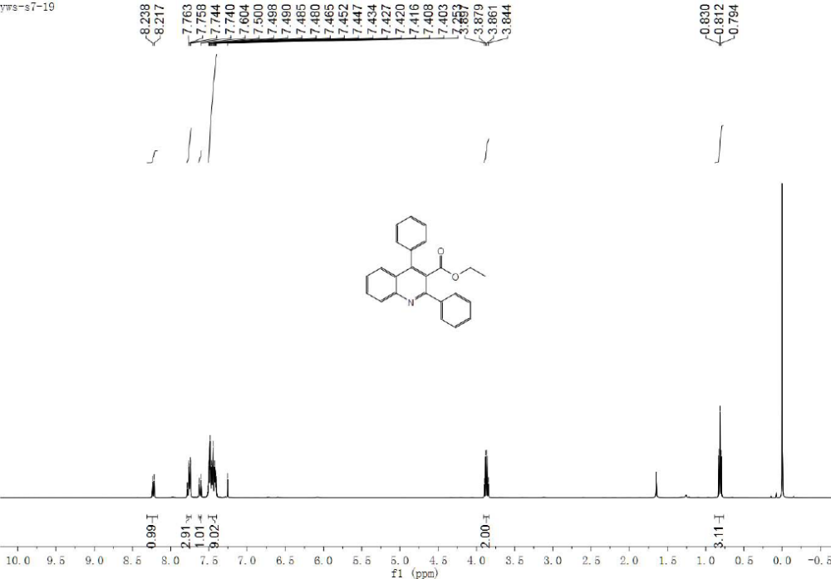
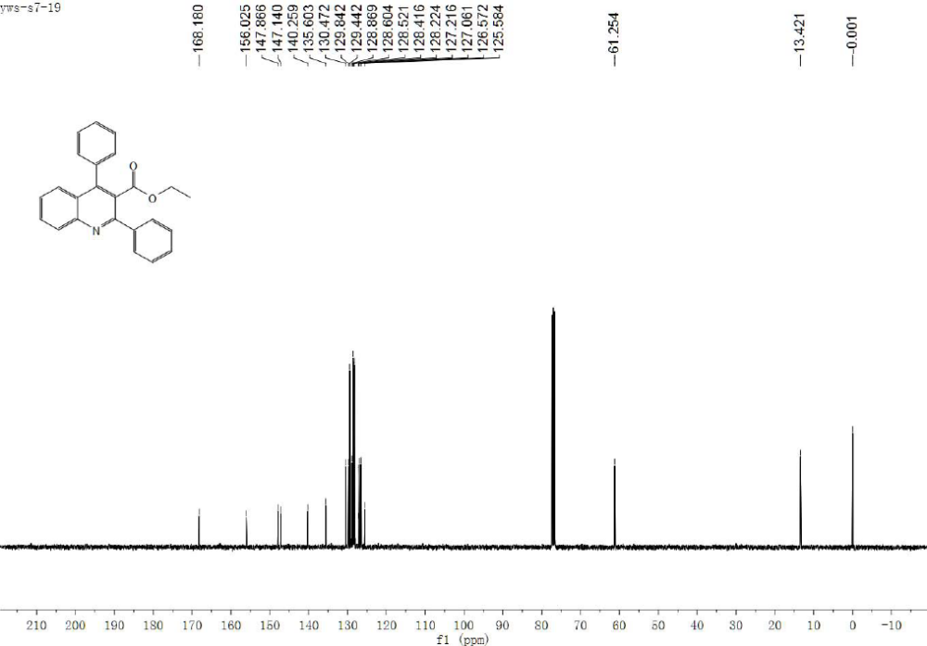
¹H NMR and ¹³C NMR spectra of compound 3c
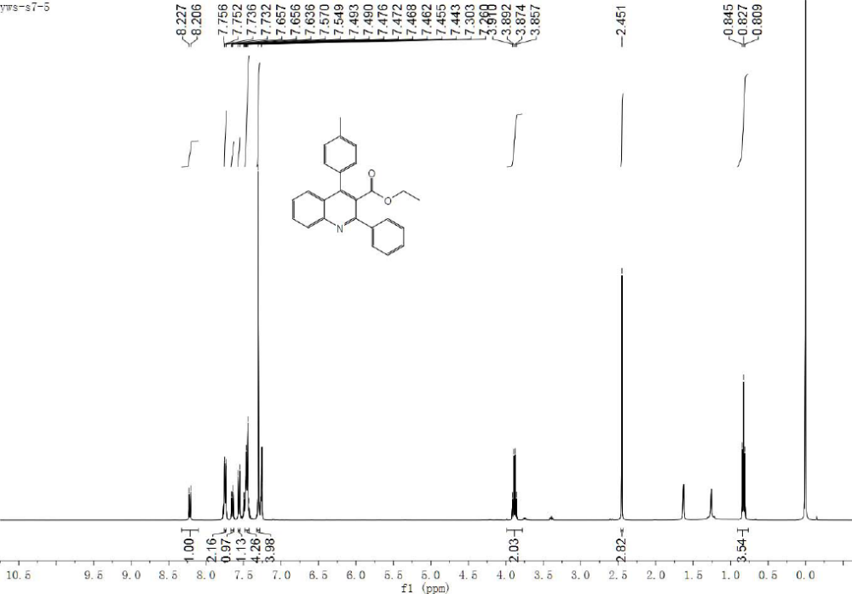
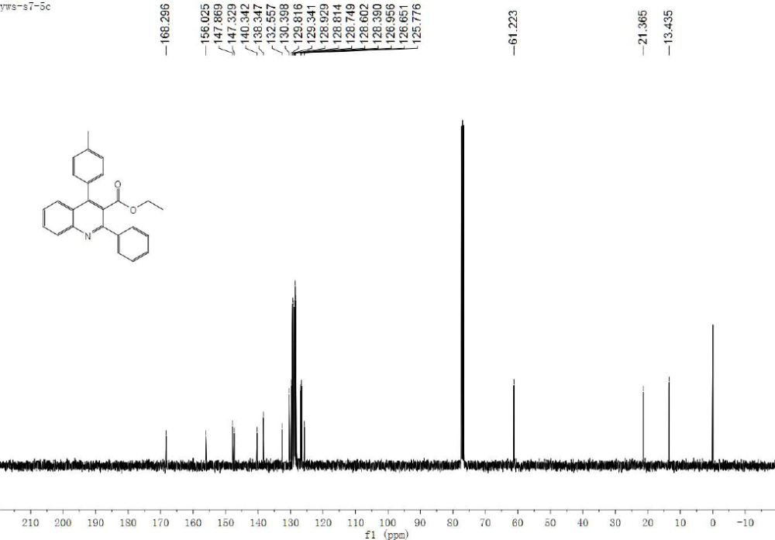
¹H NMR and ¹³C NMR spectra of compound 3d
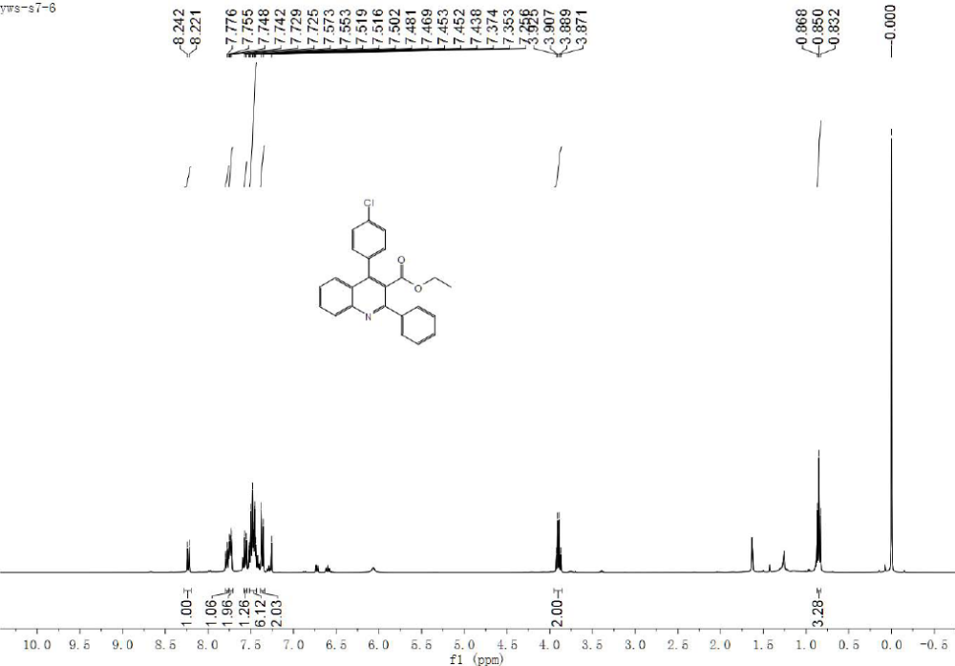
¹H NMR and ¹³C NMR spectra of compound 3e
¹H NMR and ¹³C NMR spectra of compound 3f
¹H NMR and ¹³C NMR spectra of compound 3g
¹H NMR and ¹³C NMR spectra of compound 3h
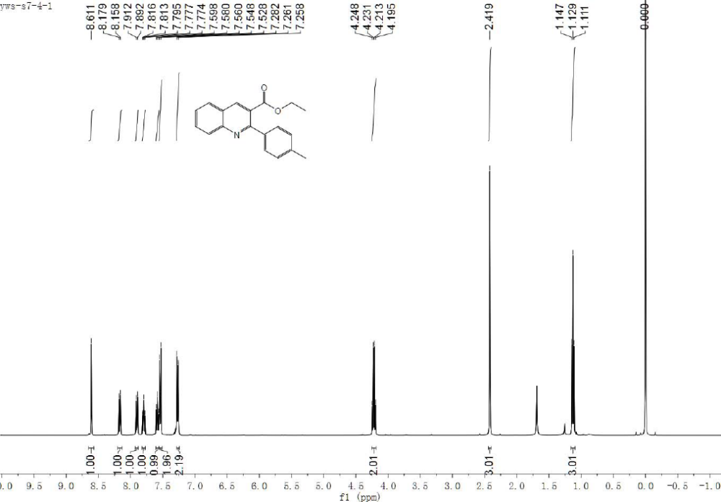
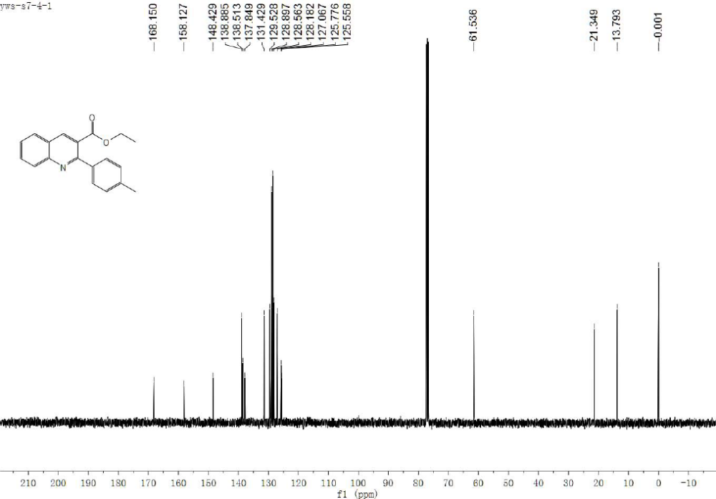
¹H NMR and ¹³C NMR spectra of compound 3i
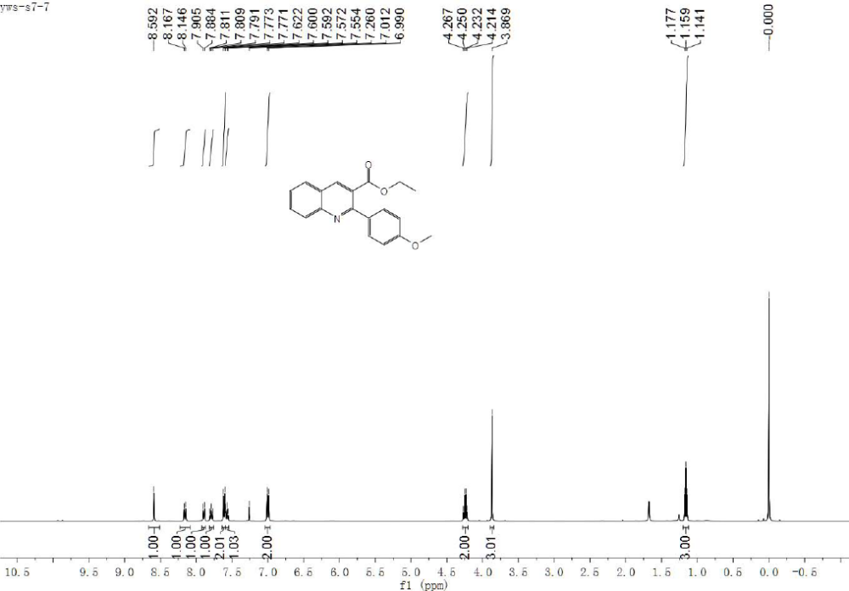
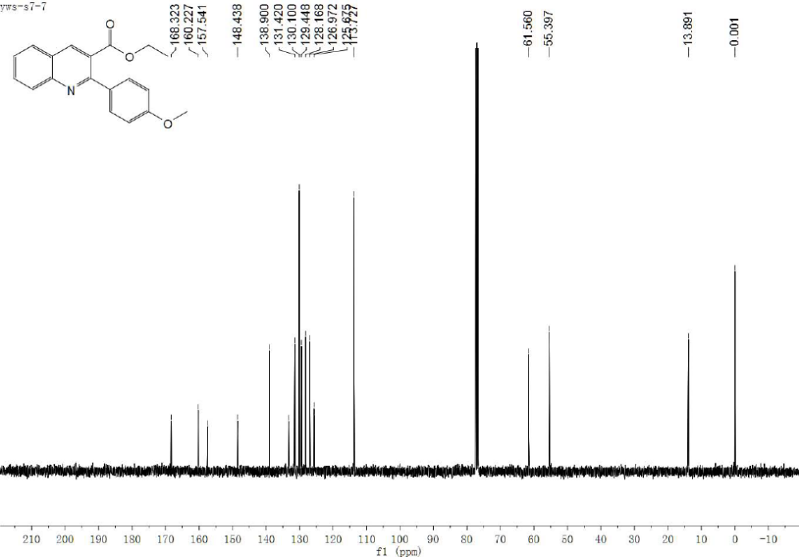
¹H NMR and ¹³C NMR spectra of compound 3j
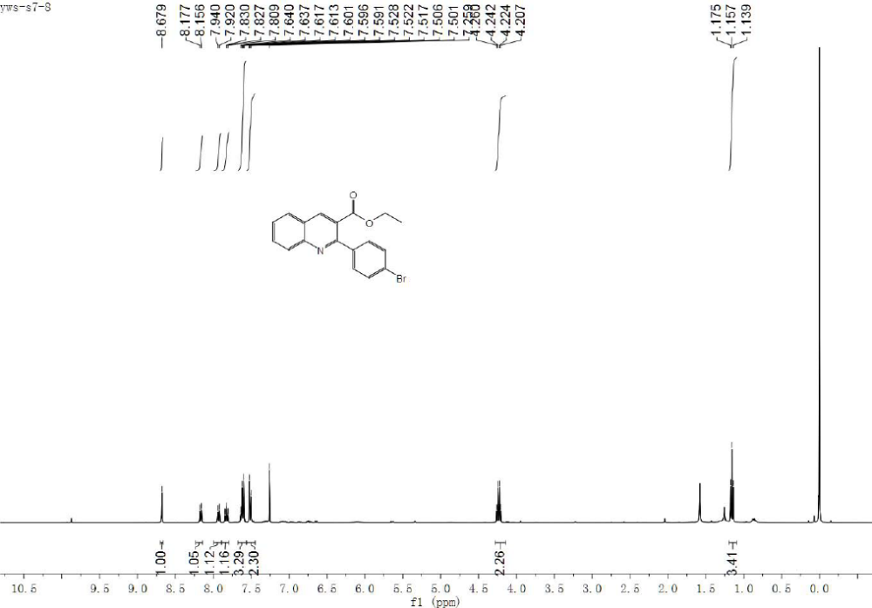
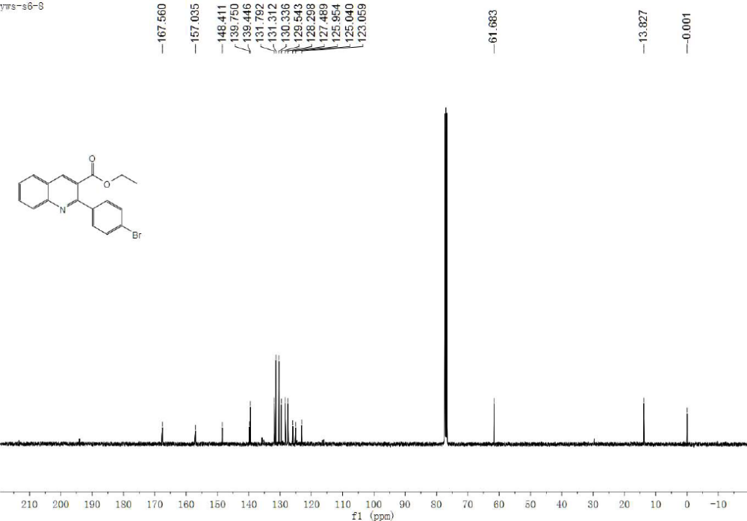
¹H NMR and ¹³C NMR spectra of compound 3k
¹H NMR and ¹³C NMR spectra of compound 3l
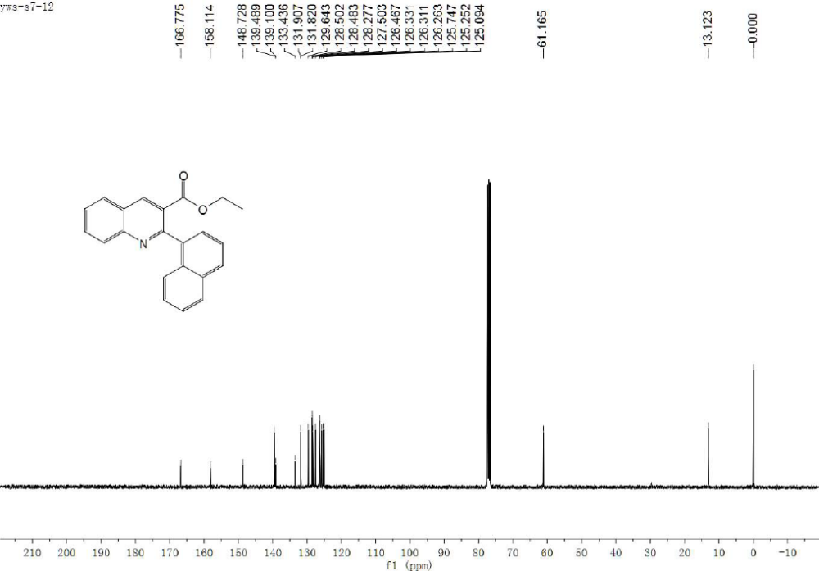
¹H NMR and ¹³C NMR spectra of compound 3m
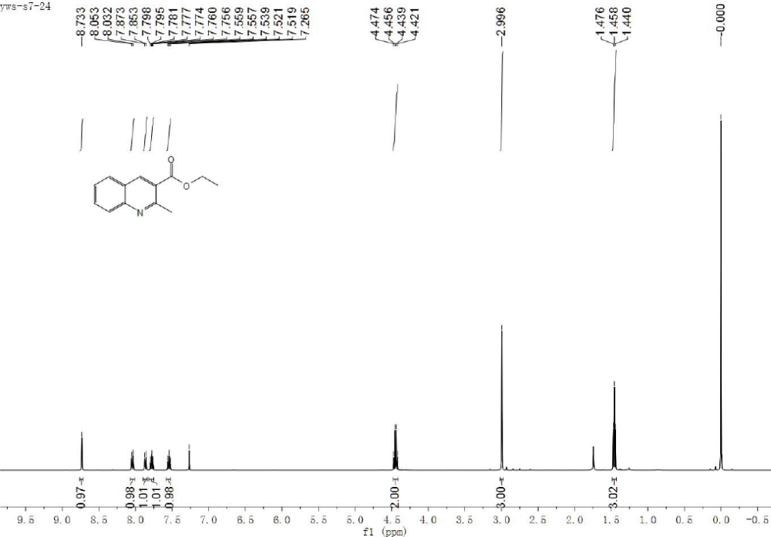
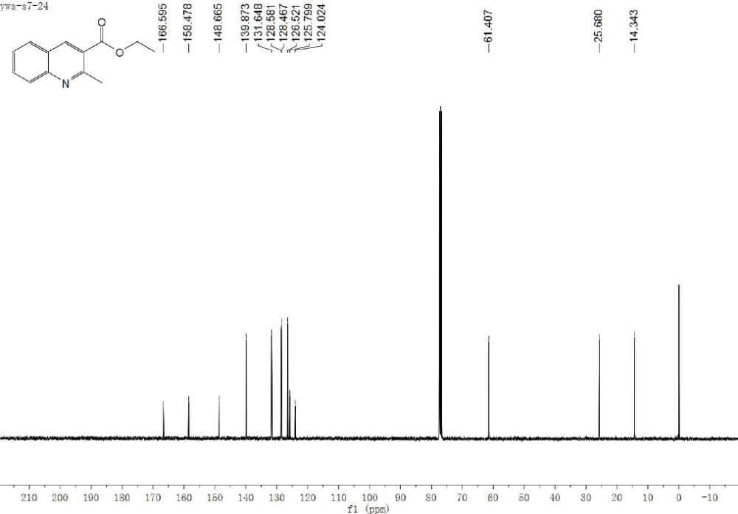
¹H NMR and ¹³C NMR spectra of compound 3n
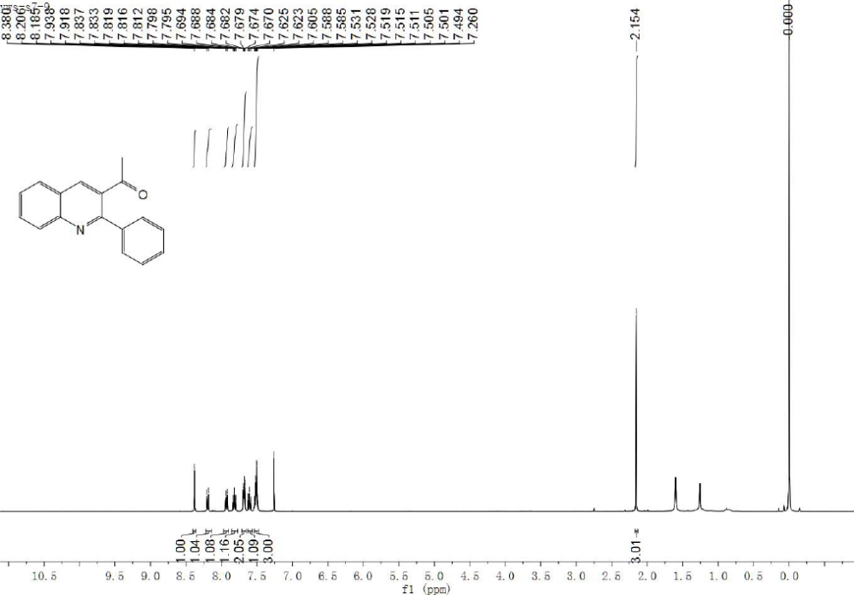
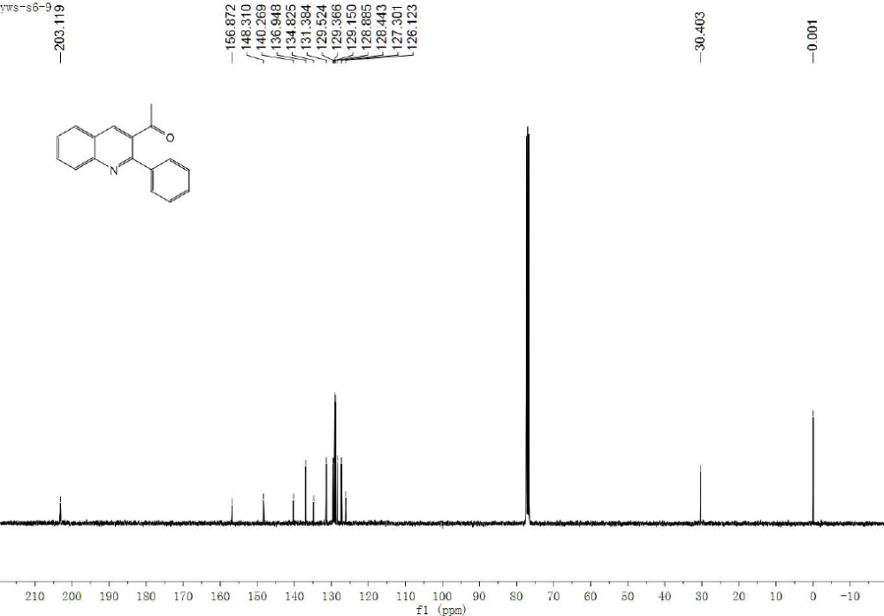
¹H NMR and ¹³C NMR spectra of compound 3o
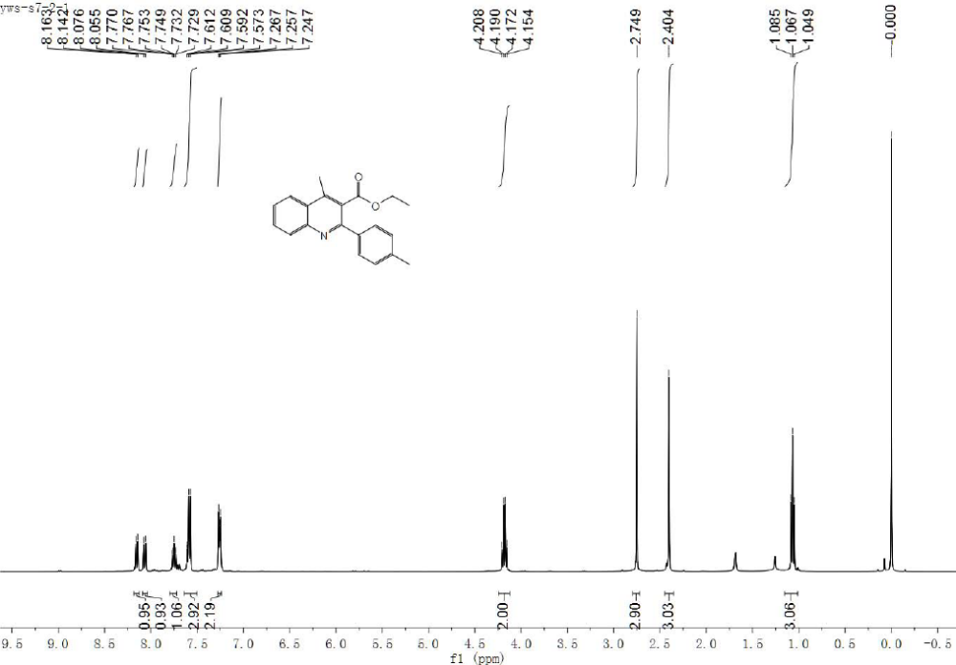
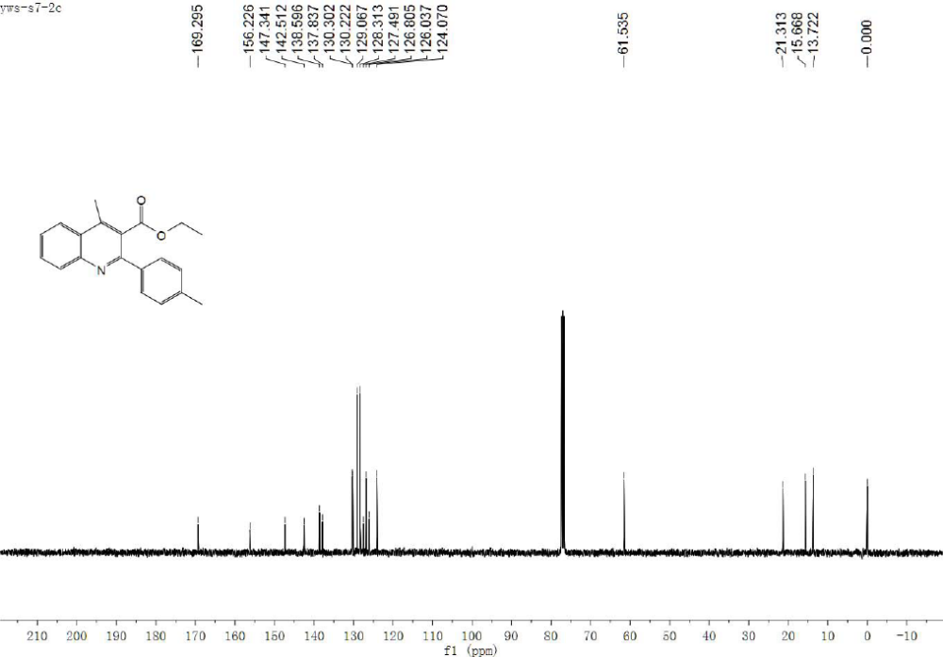
¹H NMR and ¹³C NMR spectra of compound 3p
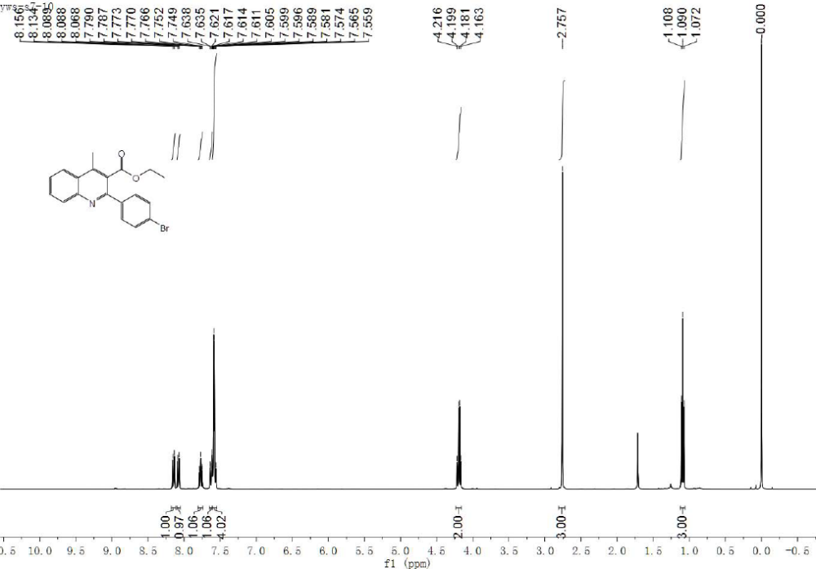
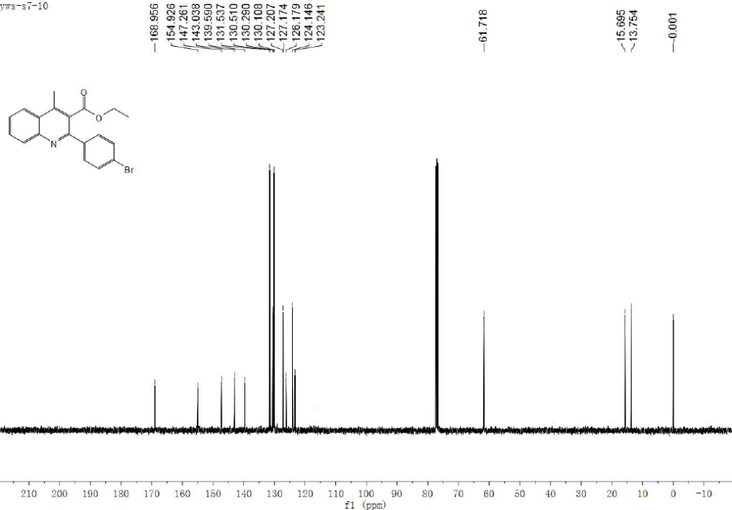
¹H NMR and ¹³C NMR spectra of compound 3q
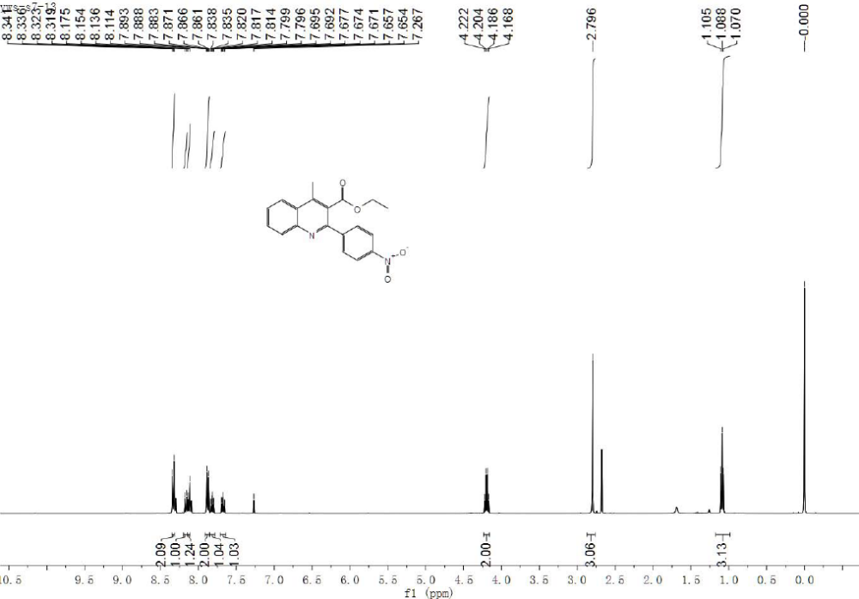
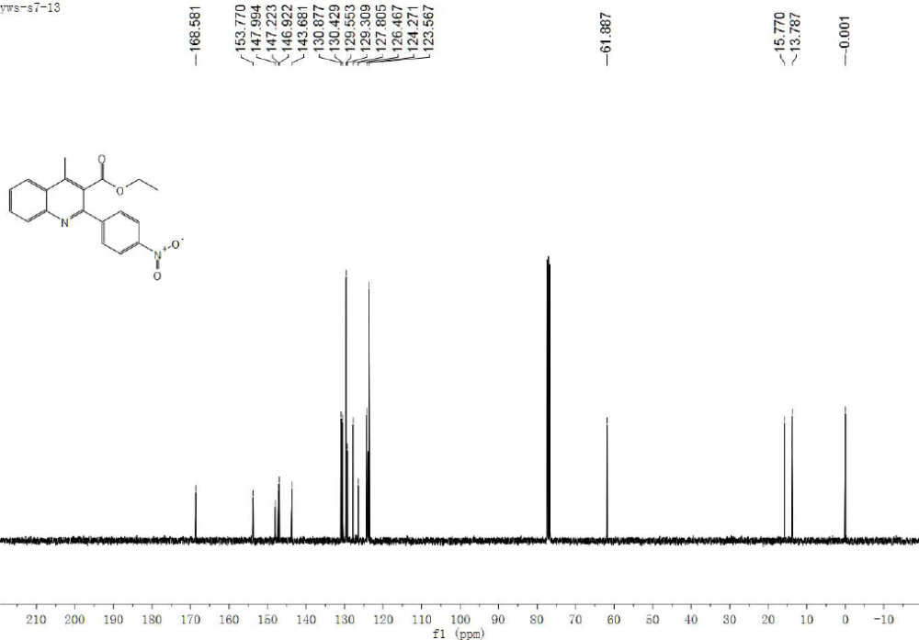
¹H NMR and ¹³C NMR spectra of compound 3r
¹H NMR and ¹³C NMR spectra of compound 3s
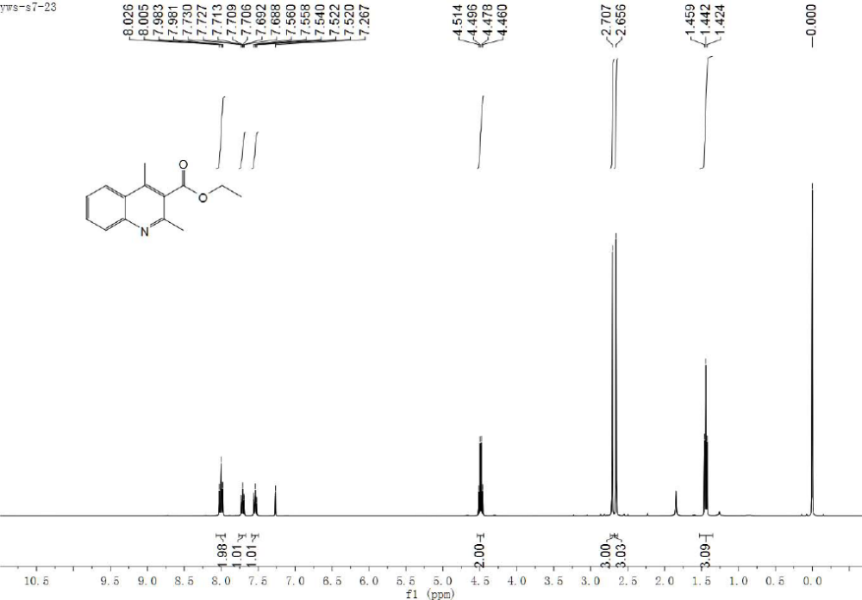
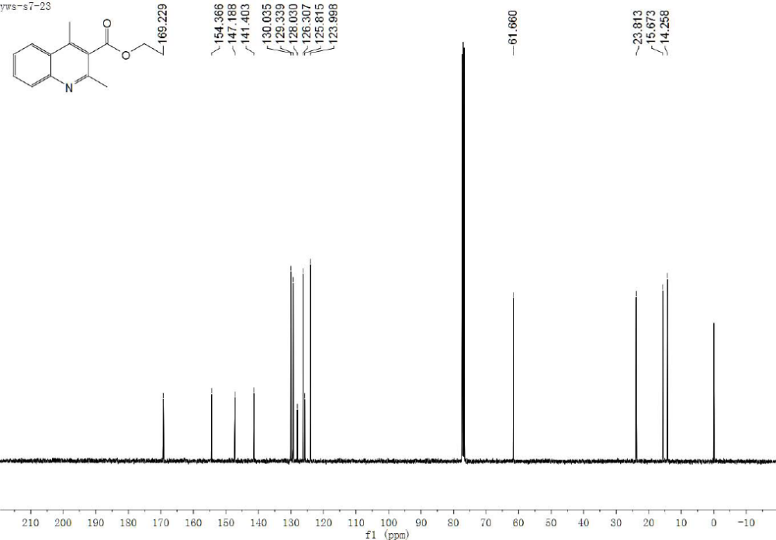
¹H NMR and ¹³C NMR spectra of compound 3t
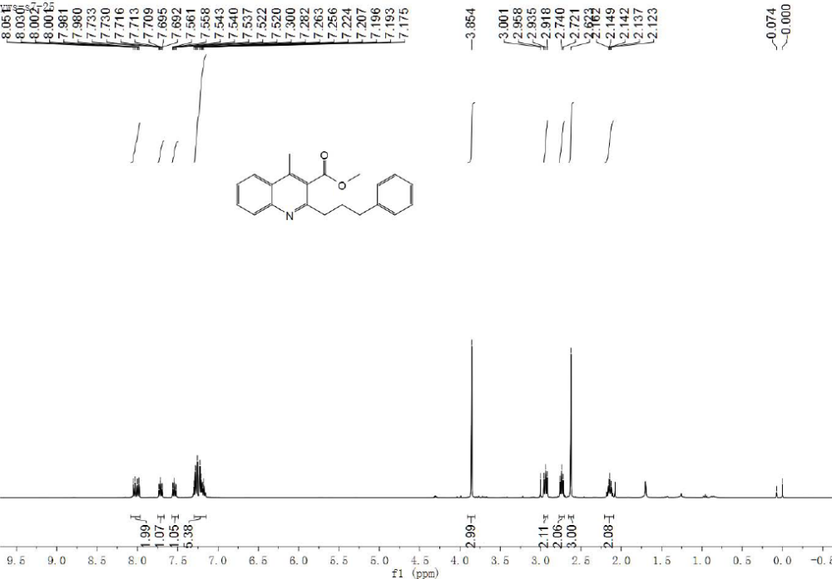
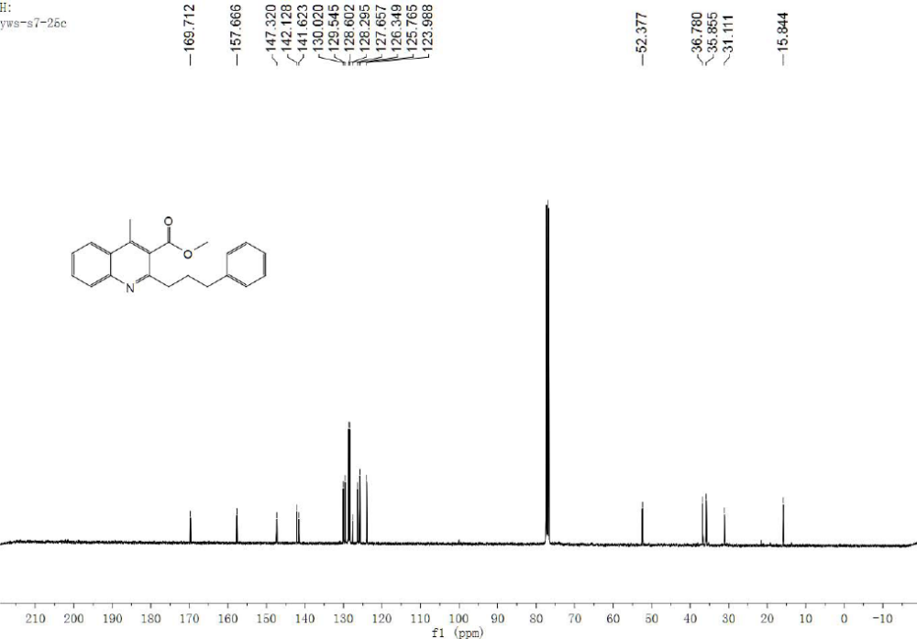
¹H NMR and ¹³C NMR spectra of compound 3u
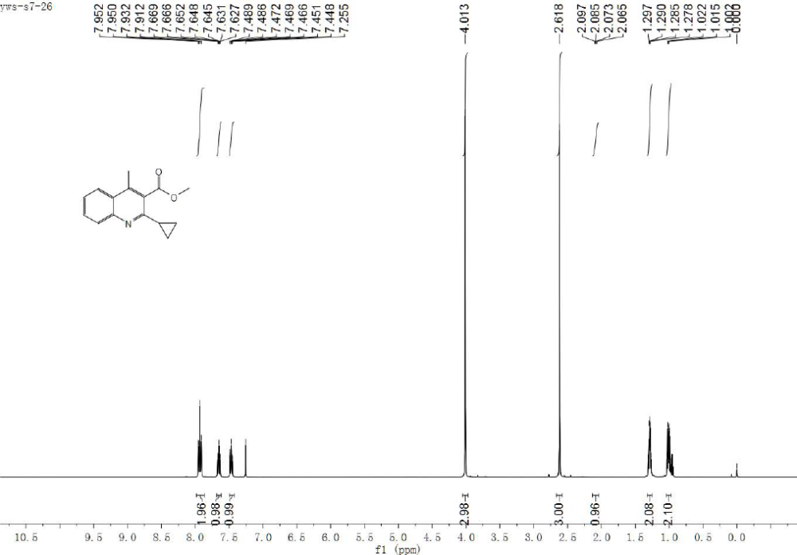
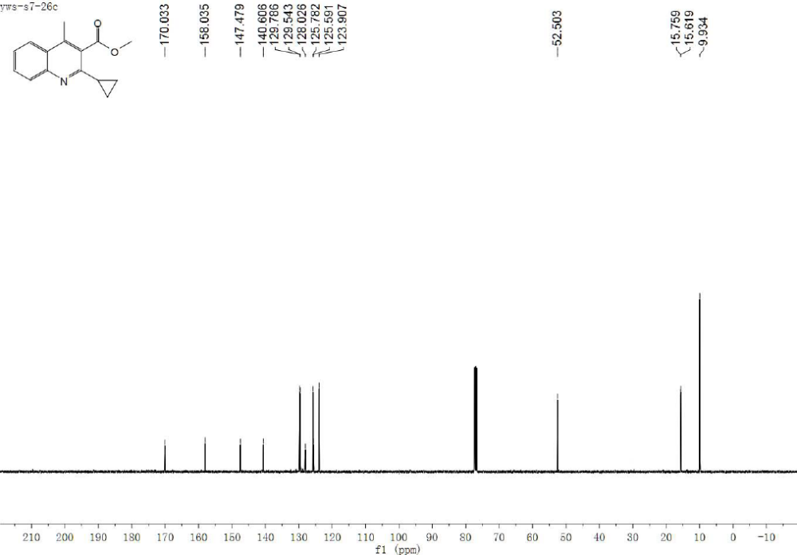
¹H NMR and ¹³C NMR spectra of compound 3v
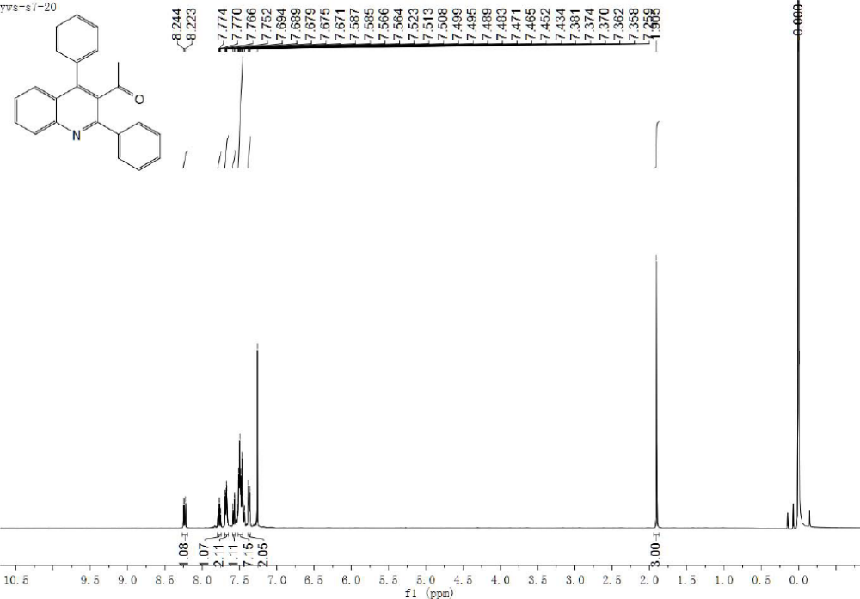
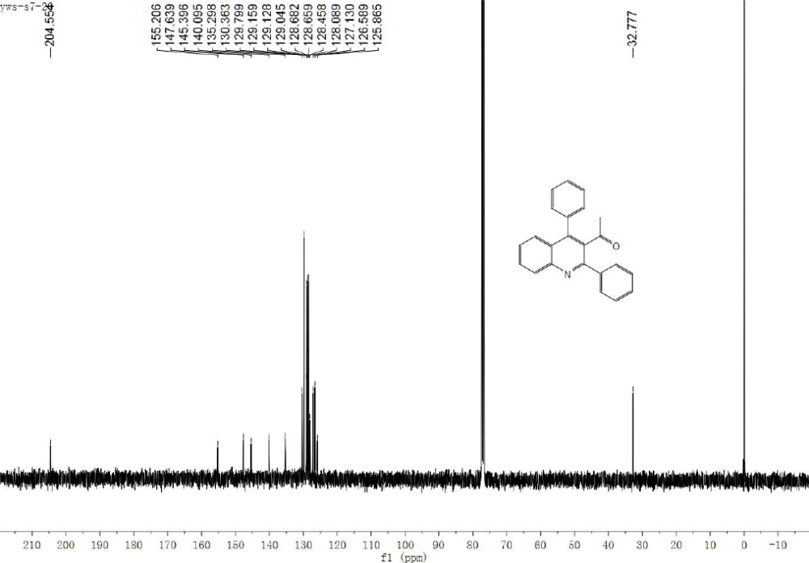
¹H NMR and ¹³C NMR spectra of compound 3w
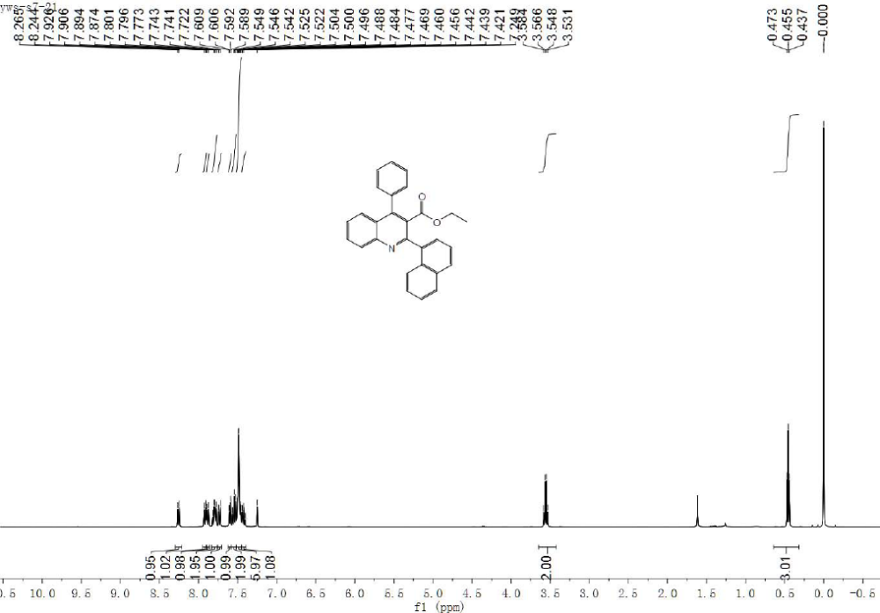
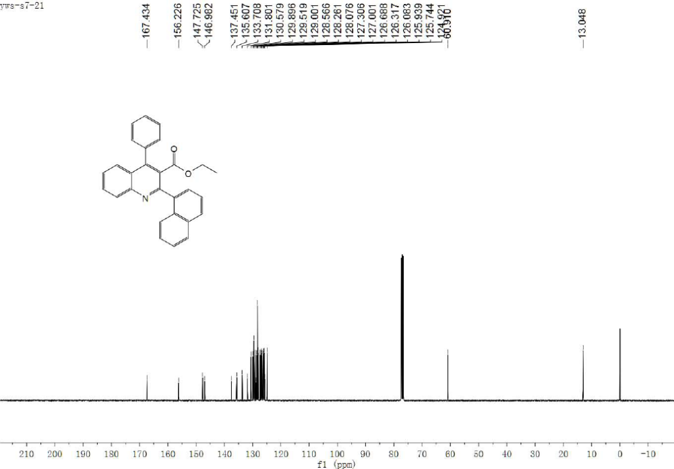
¹H NMR and ¹³C NMR spectra of compound 3x

