Synthesis and Biological Evaluation of Novel Fused Indolo [3, 2-c] [1, 8] Naphthyridine Derivatives as Potential Antibacterial Agents

TR Makhanya^{1*}, RM Gengan^{1*} and A Ata²

¹Department of Chemistry, Faculty of Applied Science, Durban University of Technology, Durban, South Africa – 4000
²Department of Chemistry, Richardson College for the Environmental Science Complex, The University of Winnipeg, 599 Portage Avenue, Winnipeg, Manitoba R3B2G3, Canada.

* Corresponding author. Tel.: +27-031-373-2313/2309; fax: +0-000-000-0000; e-mail: makhanyatalent7@gmail.com / genganrm@dut.ac.za

Supporting Information
Characterization data of compound 4a-i listed in Scheme 1:
1-methyl-6-phenyl-6, 7-dihydro-5H-indolo [3, 2-c] [1, 8] naphthyridine (4a)
Yield 88%, reddish brown solid, mp 184 - 186 ⁰C. IR (KBr): ѵ 3390-3271 (N-H), 2854 (CH), 1675-1618 (N-H & C=C), 1479 (C-N) and 744 (N-H) cm ⁻¹. ¹H NMR (400 MHz, DMSO-d₆): δ 10.80 (s, N-H) , 7.37-7.39 (3H, d, J = 8.1 Hz, H-5, H-8 & H-15), 7.32 (2H, d, J = 8.1 Hz, H-2’& H-6’), 7.24 -7.29 (2H, t, J = 7.4 Hz, H-3’ & H-5’), 7.17 (1H, t, J = 8.2 Hz, H-4’), 7.07 (1H, t, J = 8.0 Hz, H-7), 6.89 (1H, t, J = 7.8 Hz, H-6), 6.85 (1H, d, J = 7.2 Hz, H-14), 5.87 (s, H-2), 2.0 (s, CH₃). ¹³C NMR (400 MHz, DMSO-d₆): δ 20.7, 39.7, 111.1, 111.4, 118.0, 118.2, 119.1, 120.9, 123.5, 125.8, 127.9, 128.2, 128.4, 131.0, 136.6, 138.4, 144.9 ppm. TOF-MS m/z: 311.2 [M⁺]. Anal. calcd for C₂₁H₁₇N₃: C, 80.00; H, 5.50; N, 13.49; found: C, 80.06; H, 5.48; N, 13.46.

1-methyl-6-(p-tolyl)-6, 7-dihydro-5H-indolo [3, 2-c] [1, 8] naphthyridine (4b)
Yield 83%, reddish brown solid, mp 188 - 190 ⁰C. IR (KBr): ѵ 3419-3277 (N-H), 1618 (N-H & C=C), 1454 (C-N) and 744 (N-H) cm ⁻¹. ¹H NMR (400 MHz, DMSO-d₆): δ 10.8 (s, N-H) , 7.40 (3H, d, J = 7.3 Hz, H-5, H-8 & H-15), 7.33 (2H, d, J = 7.3 Hz, H-2’& H-6’),7.27 (2H, d, J = 8.0 Hz, H-3’ & H-5’), 7.08 (1H, t, J = 7.3 Hz, H-7), 6.9 (1H, t, J = 7.3 Hz, H-6), 6.85 (1H, d, J = 7.2 Hz, H-14), 5.83 (s, H-2), 2.26 (s, CH₃) ppm.¹³C NMR (400 MHz, DMSO-d₆): δ 20.6, 39.5, 111.1, 118.2, 118.3, 119.1, 120.9, 123.5, 126.7, 128.5, 134.5, 136.6, 141.9 ppm. TOF-MS m/z: 325.2 [M⁺]. Anal. calcd for C₂₂H₁₉N₃: C, 81.20; H, 5.89; N, 12.91; found: C, 81.08; H, 5.82; N, 12.87.

6-(4-chlorophenyl)-1-methyl-6, 7-dihydro-5H-indolo [3, 2-c] [1, 8] naphthyridine (4c)
Yield 88%, reddish brown solid, mp 194-196 ⁰C. IR (KBr): ѵ 3401-3262 (N-H), 1618 (N-H & C=C), 1465 (C-N) and 744 (N-H) cm ⁻¹. ¹H NMR (400 MHz, DMSO-d₆): δ 10.89 (s, N-H) , 7.40-7.39 (3H, d, J = 8.8 Hz, H-5, H-8 & H-15), 7.33 (2H, d, J = 8.5 Hz, H-2’ & H-6’), 7.32 (2H, d, J = 8.4 Hz, H-3’& H-5’), 7.08 (1H, t, J = 7.2 Hz, H-7), 6.92 (1H, d, J = 7.3 Hz, H-6), 6.88 (1H, d, J = 7.6 Hz, H-14), 5.90 (s, H-2), 2.0 (s, CH₃) ppm. ¹³C NMR (400 MHz, DMSO-d₆): δ 20.7, 39.8, 111.5, 117.6, 118.3, 119.0, 120.9, 123.6, 127.9, 130.1, 130.3, 136.6, 143.9 ppm. TOF-MS m/z: 347.1 [M⁺]. Anal. calcd for C₂₁H₁₆ClN₃: C, 72.93; H, 4.66; N, 12.15; found: C, 72.51; H, 5.20; N, 12.08.

6-(4-fluorophenyl)-1-methyl-6, 7-dihydro-5H-indolo [3, 2-c] [1, 8] naphthyridine (4d)

Yield 79%, reddish brown solid, mp 189-191 ⁰C. IR (KBr): ѵ 3408 (N-H), 1519 (N-H), 1454 (C-N), 1005 (C-F) and 742 (N-H) cm ⁻¹. ¹H NMR (400 MHz, DMSO-d₆): δ 10.85 (s, N-H), 7.38 (3H, d, J = 8.6 Hz, H-5, H-8 & H-15), 7.30 (2H, d, J = 8.9 Hz, H-2’& H-6’), 7.08 (1H, t, J = 6.5 Hz, H-7), 7.03 (2H, d, J = 8.2 Hz, H-3’ & H-5’), 6.89 (1H, d, J = 7.3 Hz, H-6), 6.83 (1H, d, J = 7.6 Hz, H-14), 5.87 (s, H-2), 1.99 (s, CH₃) ppm. ¹⁹F NMR (400 MHz, DMSO-d₆): δ -117.6 ppm (Ar-F). ¹³C NMR (400 MHz, DMSO-d₆): δ 20.9, 38.7, 111.5, 114.5, 117.9, 118.2, 119.0, 120.9, 123.5, 125.6, 126.5, 129.9, 136.6, 141.1, 159.3, 161.7 ppm. TOF-MS m/z: 340.1 [M⁺+1]. Anal. calcd for C₂₁H₁₆FN₃: C, 76.58; H, 4.90; N, 12.76; found: C, 76.56; H, 4.95; N, 12.68.

1-methyl-6-(4-(trifluoromethyl) phenyl)-6, 7-dihydro-5H-indolo [3, 2-c] [1, 8] naphthyridine (4e)
Yield 86%, pink solid, mp 184-186 ⁰C. IR (KBr): ѵ 3244 (N-H), 1615 (N-H & C=C), 1438 (C-N), 1339 (C-F) and 745 (N-H) cm ⁻¹. ¹H NMR (400 MHz, DMSO-d₆): δ 10.89 (s, N-H), 7.64 (1H, d, J = 8.3 Hz, H-15), 7.58 (3H, d, J = 8.2 Hz, H-5, H-3’& H-5’), 7.37 (2H, d, J = 8.1 Hz, H-2’& H-6’), 7.30 (1H, d, J = 8.0 Hz, H-8), 7.07 (1H, t, J = 7.0 Hz, H-7), 6.90 (1H, d, J = 8.1 Hz, H-6), 6.86 (1H, d, J = 7.6 Hz, H-14), 5.97 (s, H-2), 1.98 (s, CH₃) ppm. ¹⁹F NMR (400 MHz, DMSO-d₆): δ -60.6 ppm (Ar-CF₃). ¹³C NMR (400 MHz, DMSO-d₆): δ 20.7, 39.7, 111.5, 117.1, 118.3, 118.9, 120.9, 123.7, 124.9, 126.4, 128.9, 136.6, 149.8 ppm. TOF-MS m/z: 380.1 [M⁺+1]. Anal. calcd for C₂₂H₁₆F₃N₃: C, 69.65; H, 4.25; N, 11.08; found: C, 69.62; H, 4.28; N, 11.11.

1-methyl-6-(4-nitrophenyl)-6, 6a, 7, 11b-tetrahydro-5H-indolo [3, 2-c] [1, 8] naphthyridine (4f)
Yield 84%, yellow solid, mp 238-240 ⁰C. IR (KBr): ѵ 3386-3455 (N-H), 1594 (N-H & C=C), (C-N), 1340 (N-O) and 745 (N-H) cm ⁻¹. ¹H NMR (400 MHz, DMSO-d₆): δ 10.93 (s, N-H), 8.15 (2H, d, J = 8.8 Hz, H-3’ & H-5’), 7.61 (2H, d, J = 8.7 Hz, H-15 & H-5), 7.37 (2H, d, J = 8.1 Hz, H-2’& H-6’), 7.30 (1H, d, J = 7.9 Hz, H-8), 7.07 (1H, t, J = 7.1 Hz, H-7), 6.90 (1H, t, J = 7.0 Hz, H-6), 6.87 (1H, d, J = 7.9 Hz, H-14), 6.03 (s, H-2), 2.00 (s, CH₃) ppm. ¹³C NMR (400 MHz, DMSO-d₆): δ 20.7, 39.6, 111.6, 116.6, 118.4, 118.9, 121.1, 123.3, 123.8, 126.3, 129.4, 136.6, 145.7, 151.3 ppm. TOF-MS m/z: 357.1 [M⁺+1]. Anal. calcd for C₂₁H₁₆N₄O₂: C, 70.77; H, 4.53; N, 15.72; found: C, 70.81; H, 5.76; N, 15.76.

6-(4-methoxyphenyl)-1-methyl-6, 6a, 7, 11b-tetrahydro-5H-indolo [3, 2-c] [1, 8]naphthyridine (4g)
Yield 70%, orange solid, mp 181-183 ⁰C. IR (KBr): ѵ 3396 (N-H), 1610 (N-H & C=C), 1509 (C-N), 1093 (C-O-C) and 724 (N-H) cm ⁻¹. ¹H NMR (400 MHz, DMSO-d₆): ): δ 10.79 (s, N-H) , 7.35 (2H, d, J = 8.1 Hz, H-15 & H-5), 7.29 (1H, d, J = 8.0 Hz, H-8), 7.26 (2H, d, J = 8.4 Hz, H-2’ & H-6’), 7.04 (1H, t, J = 7.2 Hz, H-7), 6.88 (1H, t, J = 7.2 Hz, H-6), 6.83 (2H, d, J = 8.7 Hz, H-3’ & 5’), 6.81 (1H, d, J = 7.6 Hz, H-14), 5.78 (s, H-2), 3.69 (s, OCH₃), 2.00 (s, CH₃) ppm. ¹³C NMR (400 MHz, DMSO-d₆): δ 20.7, 39.7, 54.9, 111.1, 113.3, 118.0, 118.4, 119.1, 120.8, 123.4, 126.6, 129.2, 136.6, 136.9, 157.2 ppm. TOF-MS m/z: 342.1 [M⁺+1]. Anal. calcd for C₂₂H₁₉N₃O: C, 77.40; H, 5.61; N, 12.31; found: C, 77.37; H, 5.58; N, 12.29.

2-methoxy-4-(1-methyl-6, 6a, 7, 11b-tetrahydro-5H-indolo [3, 2-c] [1, 8] naphthyridin-6-yl) phenol (4h)
Yield 73%, reddish brown solid, mp 195-197 ⁰C. IR (KBr): ѵ 3485 (N-H), 3412 (OH), 1591 (N-H & C=C), 1454 (C-N), 1028 (C-O-C) and 745 (N-H) cm ⁻¹. ¹H NMR (400 MHz, DMSO-d₆): δ 10.77 (s, N-H), 8.71 (s, OH), 7.36 (2H, d, J = 8.1 Hz, H-15 & H-5), 7.31 (1H, d, J = 7.9 Hz, H-8), 7.05 (1H, t, J = 7.1 Hz, H-7), 6.98 (1H, d, J = 7.6 Hz, H-5’), 6.87 (1H, t, J = 7.1 Hz, H-6), 6.83 (1H, d, J = 8.5 Hz, H-2’), 6.73 (1H, d, J = 7.6 Hz, H-14), 6.69 (1H, d, J = 7.6 Hz, H-6’), 5.75 (s, H-2), 3.67 (s, OCH₃), 2.21 (s, CH₃) ppm. ¹³C NMR (400 MHz, DMSO-d₆): δ 20.9, 39.7, 55.6, 111.4, 112.8, 115.0, 118.0, 118.6, 119.1, 120.5, 120.8, 123.4, 126.7, 135.9, 136.6, 144.5, 147.2 ppm. TOF-MS m/z: 358.1 [M⁺+1]. Anal. calcd for C₂₂H₁₉N₃O₂: C, 73.93; H, 5.36; N, 11.76; found: C, 73.89; H, 5.42; N, 11.78.

2-bromo-6-methoxy-4-(1-methyl-6, 7-dihydro-5H-indolo [2, 3-c] [1, 8] naphthyridin-6-yl) phenol (4i)

Yield 81%, reddish brown solid, mp 205-207 ⁰C. IR (KBr): ѵ 3283 (OH), 1603 (N-H & C=C), 1494 (C-N), 1038 (C-O-C) and 741 (N-H) cm ⁻¹. ¹H NMR (400 MHz, DMSO-d₆): δ 10.81 (s, N-H), 9.19 (s. OH), 7.38 (2H, d, J = 8.2 Hz, H-15 & H-5), 7.33 (1H, d, J = 7.9 Hz, H-8), 7.08 (1H, t, J = 8.0 Hz, H-7), 7.04 (1H, d, J = 7.6 Hz, H-2’), 6.99 (1H, d, J = 7.6 Hz, H-6’), 6.91 (1H, t, J = 7.1 Hz, H-6), 6.87 (1H, d, J = 7.2 Hz, H-14), 5.79 (s, H-2), 3.74 (s, OCH₃), 2.0 (s, CH₃) ppm. ¹³C NMR (400 MHz, DMSO-d₆): δ 20.7, 39.7, 56.1, 108.9, 111.5, 111.8, 117.9, 118.2, 119.0, 120.9, 123.5, 126.6, 136.6, 137.1, 141.8, 148.2 ppm. TOF-MS m/z: 435.1 [M⁺]. Anal. calcd for C₂₂H₁₈BrN₃O₂: C, 60.56; H, 4.16; N, 9.63; found: C, 60.59; H, 4.18; N, 9.59.

Appendix 1: FT-IR spectra for compound 4a

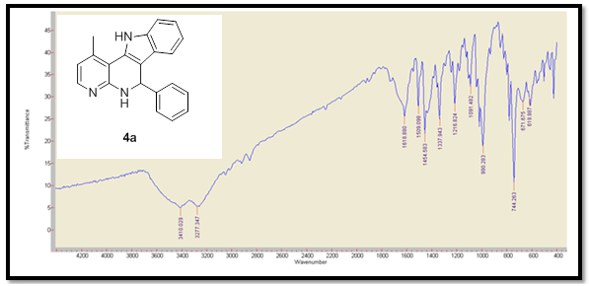
Appendix 2: ¹H NMR spectra for compound 4a

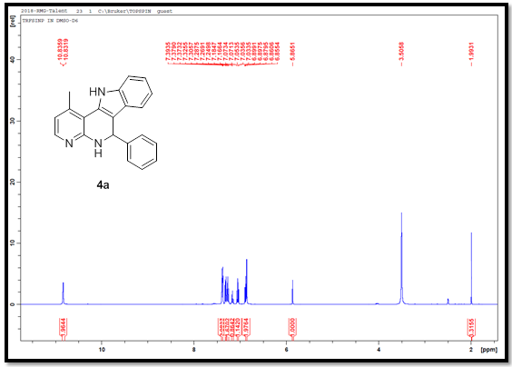

Appendix 3: Expanded ¹H NMR spectra for compound 4a
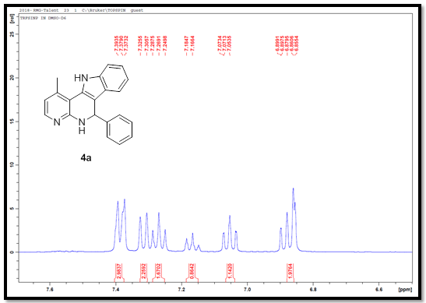
Appendix 4: ¹³C NMR spectra for compound 4a
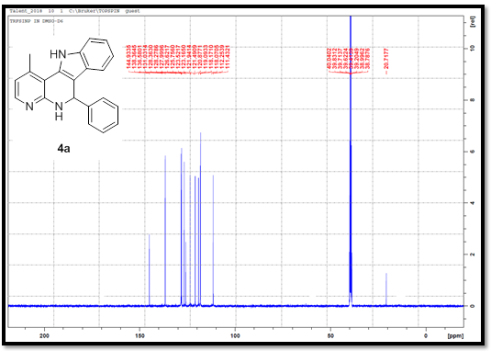
Appendix 5: 90⁰ DEPT NMR spectra for compound 4a
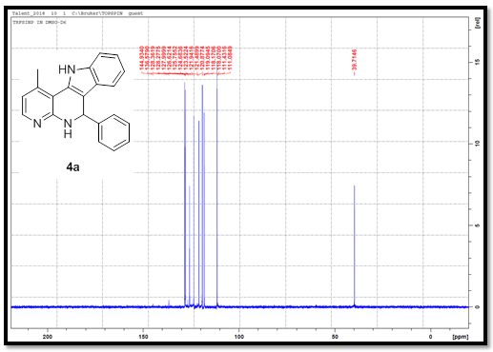
Appendix 6: 135⁰ DEPT NMR spectra for compound 4a
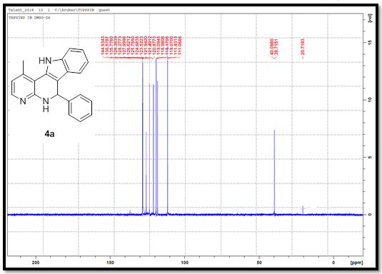

Appendix 7: ¹H COSY NMR spectra for compound 4a
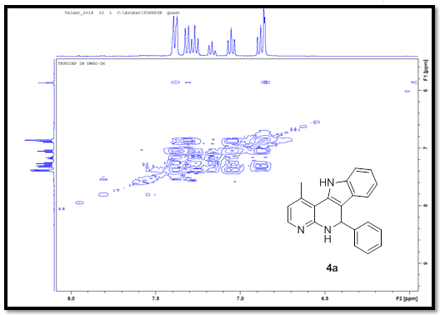
Appendix 8: NOESY NMR spectra for compound 4a
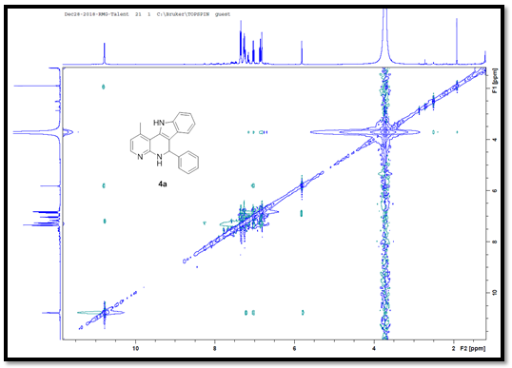

Appendix 9: HSQC NMR spectra for compound 4a

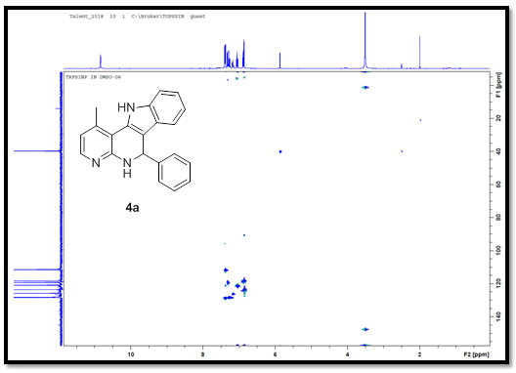
Appendix 10: HMBC NMR spectra for compound 4a
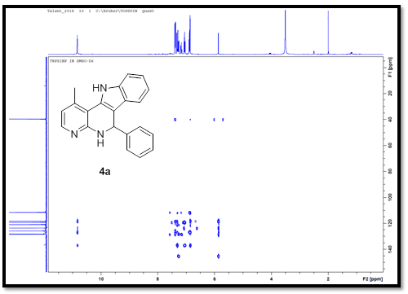
Appendix 11: TOF-MS spectra for compound 4a
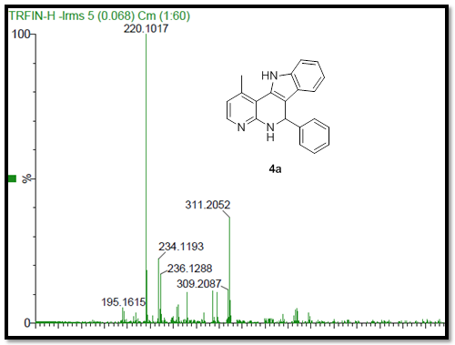

Appendix 12: FT-IR spectra for compound 4b
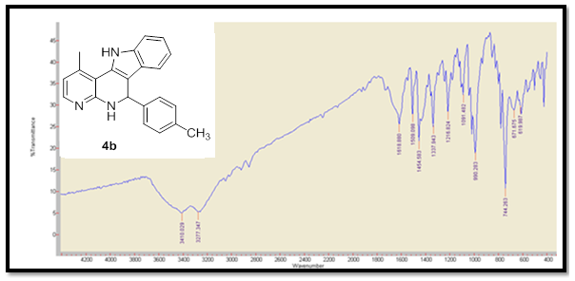

Appendix 13: ¹H NMR spectra for compound 4b
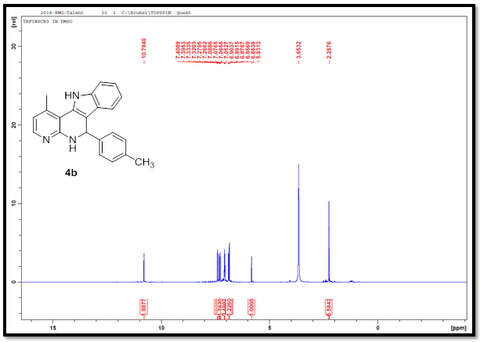
Appendix 14: ¹H NMR expanded spectra for compound 4b
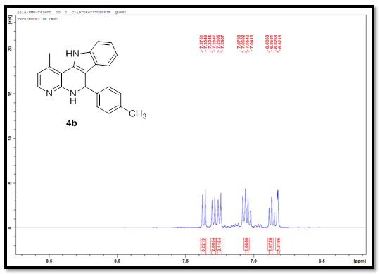
Appendix 15: ¹³C NMR spectra for compound 4b
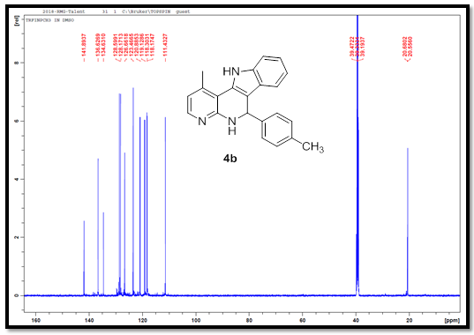
Appendix 16: TOF-MS spectra for compound 4b
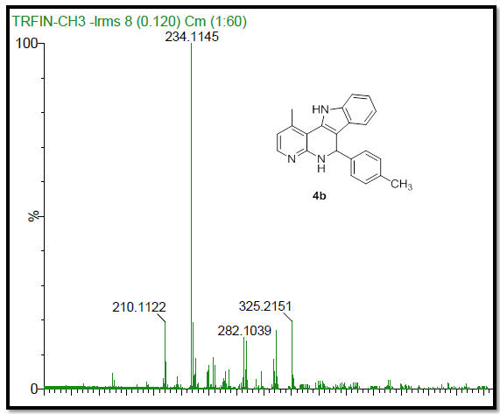
Appendix 17: FT-IR spectra for compound 4c
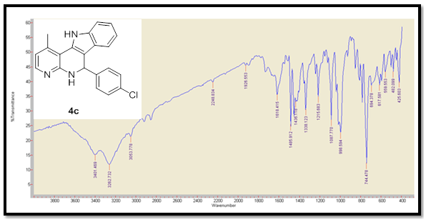
Appendix 18: ¹H NMR spectra for compound 4c
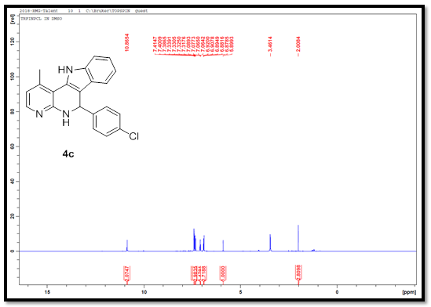

Appendix 19: ¹H NMR expanded spectra for compound 4c
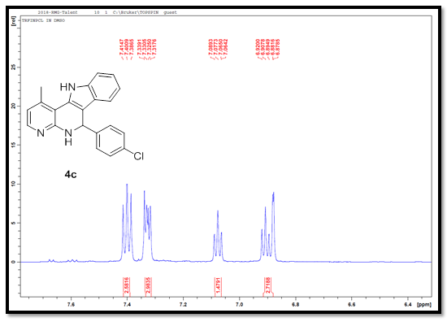
Appendix 20: ¹³C NMR spectra for compound 4c
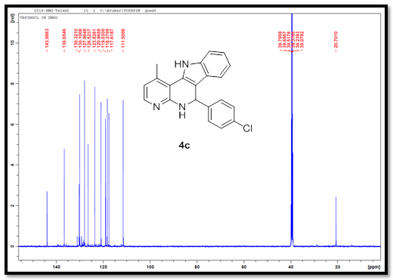
Appendix 21: TOF-MS spectra for compound 4c
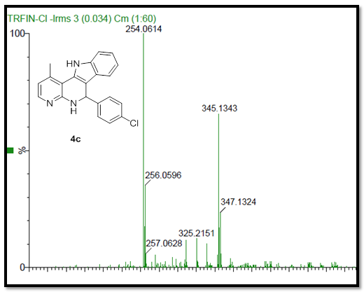
Appendix 22: FT-IR spectra for compound 4d
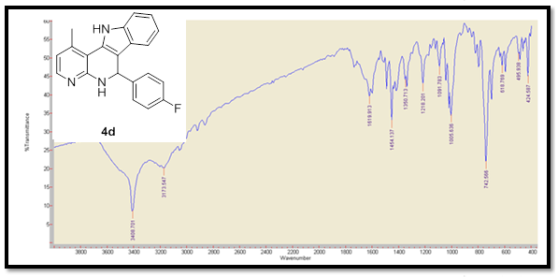

Appendix 23: ¹H NMR spectra for compound 4d
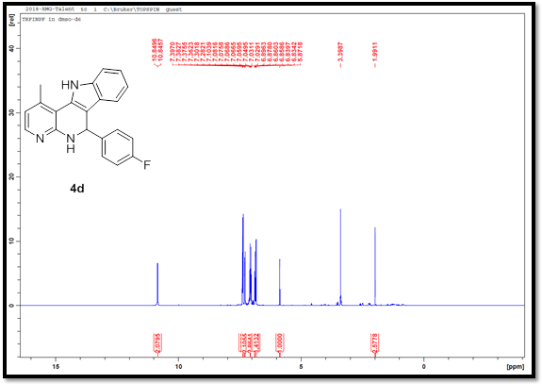
Appendix 24: ¹H NMR expanded spectra for compound 4d
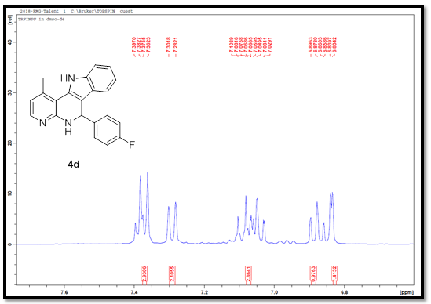
Appendix 25: ¹³C NMR spectra for compound 4d
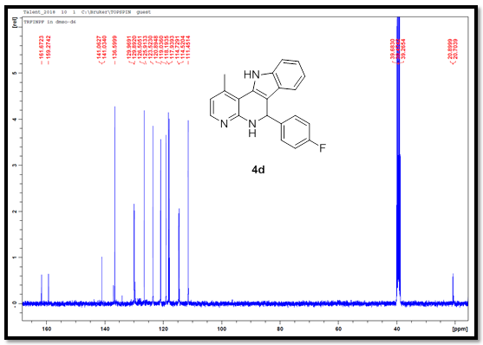
Appendix 26: ¹⁹F NMR spectra for compound 4d
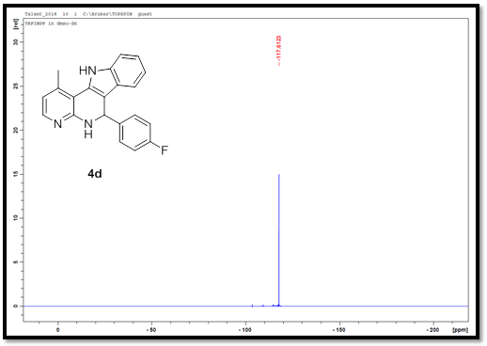
Appendix 27: TOF-MS spectra for compound 4d
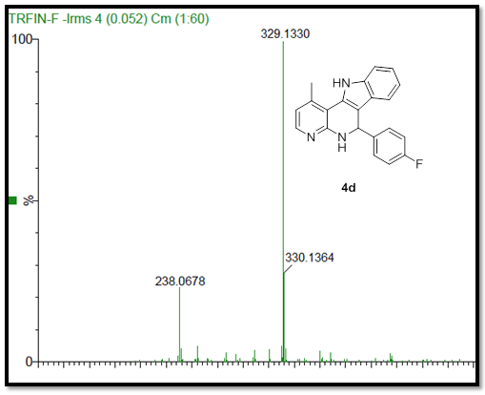
Appendix 28: FT-IR spectra for compound 4e
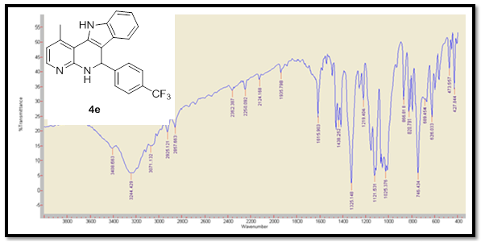

Appendix 29: ¹H NMR spectra for compound 4e
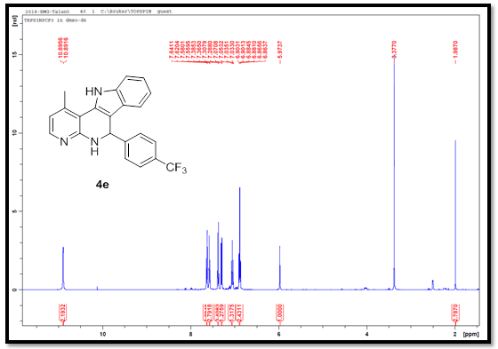
Appendix 30: ¹H NMR expanded spectra for compound 4e
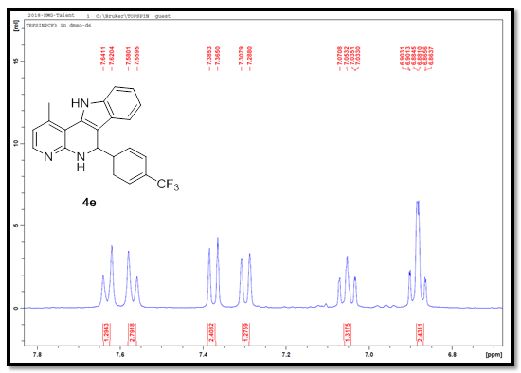
Appendix 31: ¹³C NMR spectra for compound 4e
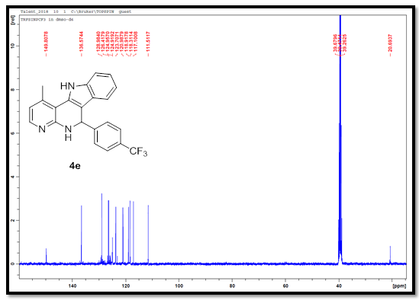
Appendix 32: ¹⁹F NMR spectra for compound 4e
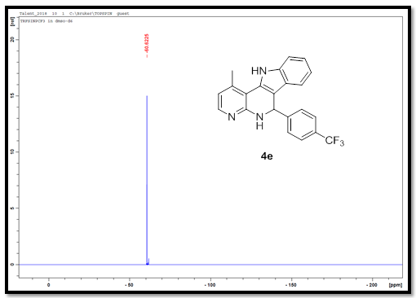
Appendix 33: TOF-MS spectra for compound 4e
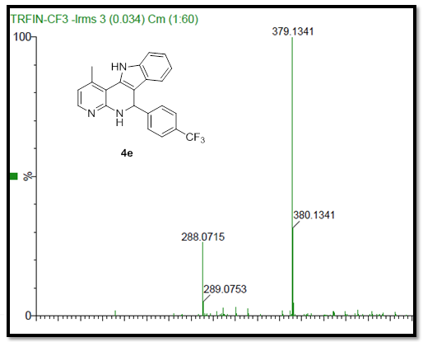
Appendix 34: FT-IR spectra for compound 4f
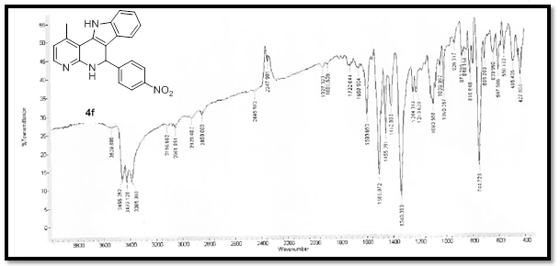

Appendix 35: ¹H NMR spectra for compound 4f
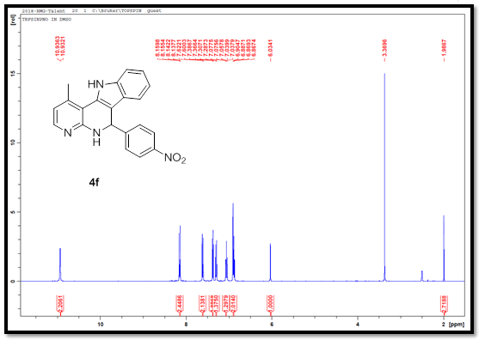
Appendix 36: ¹H NMR expanded spectra for compound 4f
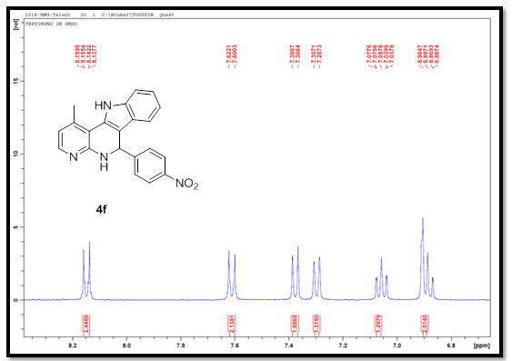
Appendix 37: ¹³C NMR spectra for compound 4f
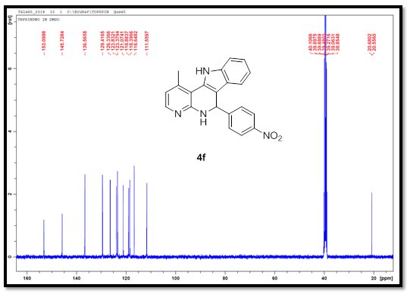
Appendix 38: TOF-MS spectra for compound 4f
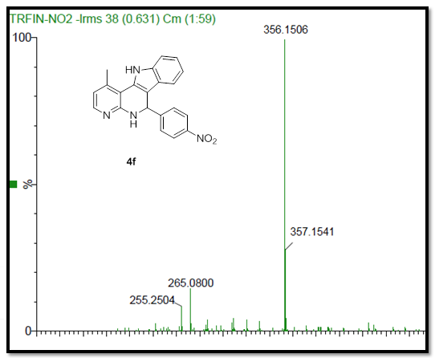
Appendix 39: FT-IR spectra for compound 4g
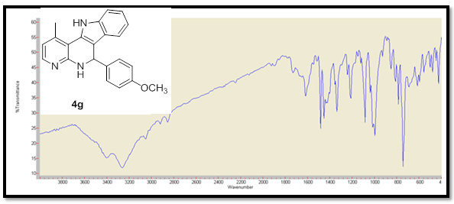

Appendix 40: ¹H NMR spectra for compound 4g
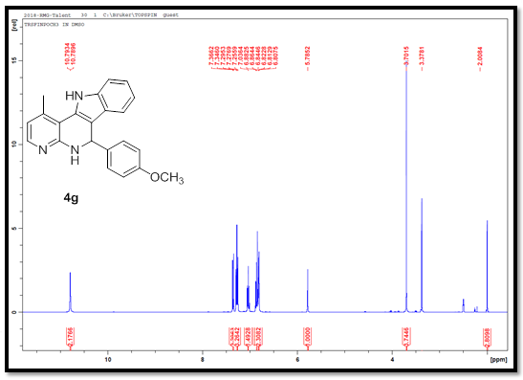

Appendix 41: ¹H NMR expanded spectra for compound 4g
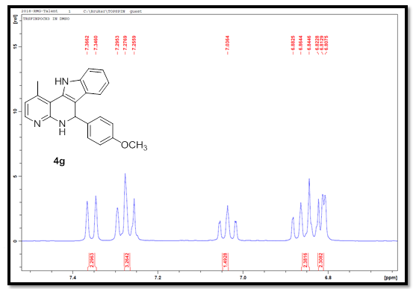
Appendix 42: ¹³C NMR spectra for compound 4g
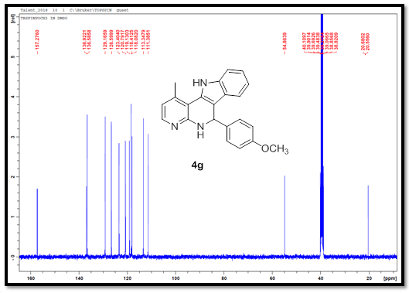
Appendix 43: TOF-MS spectra for compound 4g
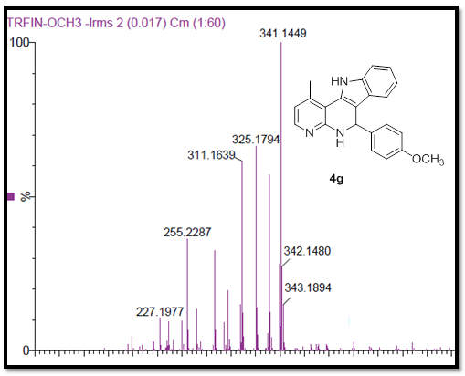
Appendix 44: FT-IR spectra for compound 4h
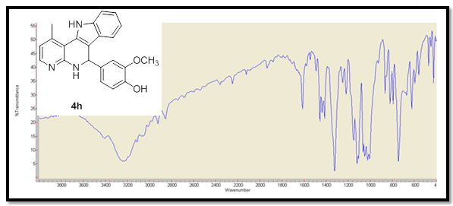

Appendix 45: ¹H NMR spectra for compound 4h
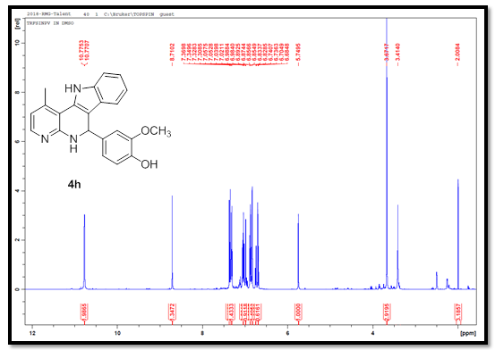
Appendix 46: ¹H NMR expanded spectra for compound 4h
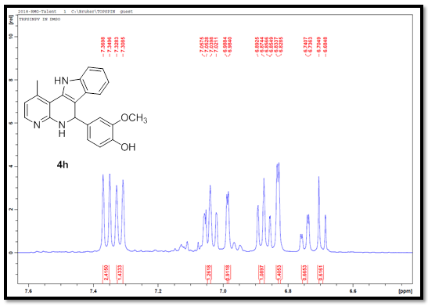
Appendix 47: ¹³C NMR spectra for compound 4h
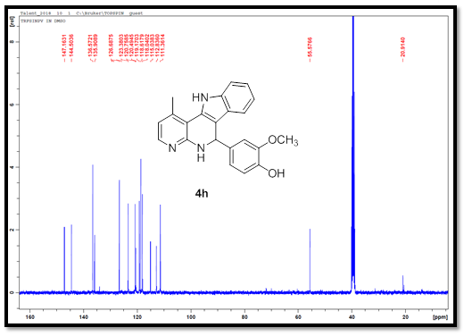
Appendix 48: TOF-MS spectra for compound 4h
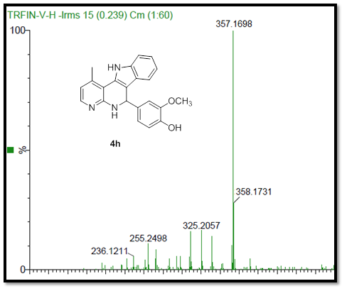
Appendix 49: FT-IR spectra for compound 4i
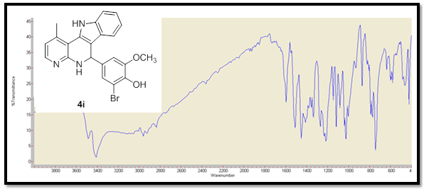
Appendix 50: ¹H NMR spectra for compound 4i
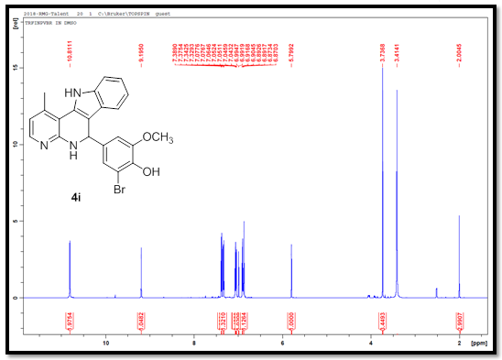

Appendix 51: ¹H NMR expanded spectra for compound 4i
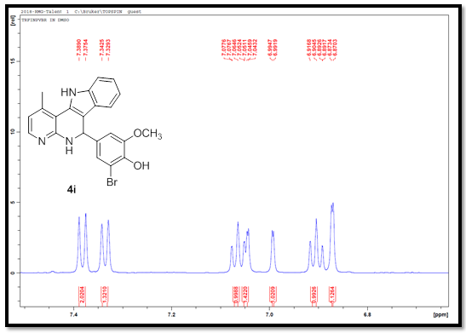
Appendix 52: ¹³C NMR spectra for compound 4i
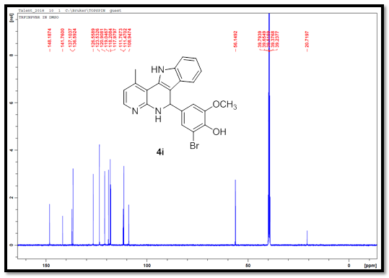
Appendix 53: TOF-MS spectra for compound 4i
