**Supporting Information**

**Synthesis, Characterization and Docking studies of novel Cyanopyridones analogues with Serotonin 5-HT1B Receptor agonists**

Amresh Baitha a, Manish Upadhyay b, Ajay Gopinathan a, Karthik Krishnan a, Vijay V Dabholkar a, *

aOrganic Research Laboratory, Dept of Chemistry, Guru Nanak College, Mumbai-400037, India

bDepartment of Bioinformatic, Guru Nanak Khalsa College, Mumbai-400019, India

University of Mumbai, Maharashtra, India

E-mail: [vijaydabholkar@gmail.com](mailto:vijaydabholkar@gmail.com)

**Table of Contents**

1. General Procedure for the synthesis of **3, 6(a-e) & 8(a-e)**

……………………………………………...………......…......**2-4**

1. Spectral analysis of6-amino-4-(2,3-dihydrobenzo[b][1,4]dioxin-6-yl)-2-oxo-1-phenyl-1,2-dihydropyridine-3,5-dicarbonitrile(**8a)**

..………………………………………………………….. …. **5-8**

1. Spectral analysis of 6-amino-1-(4-chlorophenyl)-4-(2,3-dihydrobenzo[b][1,4]dioxin-6-yl)-2-oxo-1,2-dihydropyridine-3,5-dicarbonitrile (**8b**)

……………………...……………………………………...**9-12**

1. Spectral analysis of 6-amino-4-(2,3-dihydrobenzo[b][1,4]dioxin-6-yl)-2-oxo-1-(p-tolyl)-1,2-dihydropyridine-3,5-dicarbonitrile (**8e**)

…………………………...…...…………… ………………. **13**-**16**

**Materials and Methods**

All chemicals used were of commercial grade and they were used without any further purification. The progress of reaction was monitored by thin layer chromatography using aluminium sheets precoated with silica gel 60 F254 (Merck) using either iodine vapours or UV light as visualizing agent. Melting points of all synthesized compounds were determined in open capillary tubes on an electro thermal apparatus and are uncorrected. IR spectra was recorded on Bruker FTIR spectrophotometer. 1H-NMR and 13C-NMR spectra were recorded on Bruker FTNMR (600 MHz) spectrophotometer using DMSO-d6 as solvent and TMS as an internal standard (chemical shifts in δ ppm). Mass Spectra were recorded on Agilent Technologies-6530 (MS QTOF LC/MS).

**General experimental procedures**

**Synthesis of 2,3-dihydrobenzo[b][1,4]dioxine-6-carbaldehyde**(**3**)[15]

2.00g (14.5mmol) of 3,4-dihydroxybenzaldehyde **1** was dissolved in DMF (30 mL), after which 4.00g (29mmol) of K2CO3 was added and stirred for 1 hour. At 10 oC 3.2ml (17.38 mmol) of 1,2-dibromoethane was added dropwise. The reaction was refluxed, while being stirred, until the starting materials were consumed. The progress of the reaction was monitored by TLC. After completion of the reaction, the reaction mixture was cooled to room temperature; the crude product was dumped in ice cold water, solid was separated and filtered outto achieve 2,3-dihydro[1,4]benzodioxin-6- carbaldehyde **3** (1.54 g, 81% yield, m.p-50-520C (reported)).

**Synthesis of 2-cyano-N-phenylacetamide** (**6a-e**) [16]

0.94ml (10 mmol) of aniline and 2.13ml (20mmol) of Ethyl cyanoacetate were refluxed for 8−10 hours in an oil bath in solvent free condition. The progress of the reaction was monitored by TLC. After completion of the reaction, the reaction mixture was cooled to room temperature; separated product was filtered, washed with methanol and crystallized from methanol to desired products **(6a)** (1.48 g, 92% yield, m.p-198-2020C (reported))**.**

**Synthesis of 6-amino-4-(2,3-dihydrobenzo[b][1,4]dioxin-6-yl)-2-oxo-1-phenyl-1,2-dihydropyridine-3,5-dicarbonitrile**(**8a-e)**

A catalytic amount of triethylamine (0.2ml) was added to a solution of 1.64g (10mmol) of 2,3-dihydrobenzo[b][1,4]dioxine-6-carbaldehyde **3** and malononitrile **7** in 20 ml of methanol. The reaction mixture was refluxed on water bath for 2-3 hours, after which 1.60g (10mmol) of 2-cyano-N-phenylacetamides was added. The reaction was refluxed on water bath for 12-16 hours. The progress of the reaction was monitored by TLC. After completion of the reaction, the reaction mixture was cooled to room temperature; separated product was filtered, washed with methanol and crystallized from DMF to give product (**8a**)**.**

**6-amino-4-(2,3-dihydrobenzo[b][1,4]dioxin-6-yl)-2-oxo-1-phenyl-1,2-dihydropyridine-3,5-dicarbonitrile**(**8a**)

Buff solid; M.p= 312-314oC; Yield: 82% (3.03g); IR (cm-1): 3215 (NH2), 2216 (C≡N), 1635(C=O).1H NMR (DMSO-d6, 600 MHz, δ/ ppm): 4.35(t, *J*=4.8 Hz, 4H; CH2), 7.03-7.07(m, 3H; ArH), 7.37-7.61(m, 5H; ArH), 7.79(s, 2H; NH2). 13C NMR (DMSO-d6, 150 MHz, δ/ ppm): 64.44, 64.66, 75.57, 88.37, 116.25, 116.89, 117.36, 117.68, 121.75, 127.70, 128.90, 130.32, 130.73, 134.21, 143.47, 145.56, 157.48, 159.97, 160.86. Anal.calcd forC21H14N4O3 (370.11); C, 68.10; H, 3.81; N, 15.13 found C, 68.03; H, 3.78; N, 15.13; Mass spectrum; m/z: 371.11.

**6-amino-1-(4-chlorophenyl)-4-(2,3-dihydrobenzo[b][1,4]dioxin-6-yl)-2-oxo-1,2-dihydropyridine-3,5-dicarbonitrile** (**8b**)

White solid in 78% yield; mp:301-303°C: IR (cm-1): 3208 (-NH2), 2212 (-C≡N), 1613(-C=O). 1H NMR (DMSO-d6, 600 MHz, δ/ ppm): 4.34(t, *J*=4.8 Hz, 4H; CH2), 7.01-7.06(m, 3H; ArH), 7.42-7.65(m, 4H; ArH), 7.93(s, 2H; NH2). 13C NMR (DMSO-d6, 150 MHz, δ/ ppm): 64.44, 64.63, 75.63, 88.15, 116.22, 116.85, 117.33, 117.71, 118.31, 121.72, 122.54, 127.63, 129.02, 130.86, 131.02, 133.23, 135.09, 143.47, 145.56, 157.51, 159.94, 160.95. Anal.calcd forC21H13ClN4O3(404.07); C, 62.31; H, 3.24; N, 13.84 found C, 62.27; H, 3.19; N, 13.87; Mass spectrum; m/z: 405.07.

**6-amino-4-(2,3-dihydrobenzo[b][1,4]dioxin-6-yl)-2-oxo-1-(p-tolyl)-1,2-dihydropyridine-3,5-dicarbonitrile** (**8e**)

White solid in 88% yield; mp**:**305-307°C; IR (cm-1): 3211 (-NH2), 2921(-CH3), 2218 (-C≡N), 1626(-C=O).1H NMR (DMSO-d6, 700 MHz, δ/ ppm): 2.40(s, 3H; CH3), 4.34(t, *J*=4.2 Hz, 4H; CH2), 7.01-7.05(m, 3H; ArH), 7.23-7.39(m, 4H; ArH), 7.93(s, 2H; NH2). 13C NMR (DMSO-d6,175 MHz, δ/ ppm): 20.85, 64.04, 64.24, 75.05, 87.94, 115.80, 116.50, 116.96, 117.26, 121.34, 127.29, 128.17, 130.85, 131.13, 139.39, 143.06, 145.13, 157.16, 159.58, 160.37. Anal.calcd forC22H16N4O3(384.12); C, 68.74; H, 4.20; N, 14.58 found C, 68.69; H, 4.18; N, 14.62; Mass spectrum; m/z: 385.13.

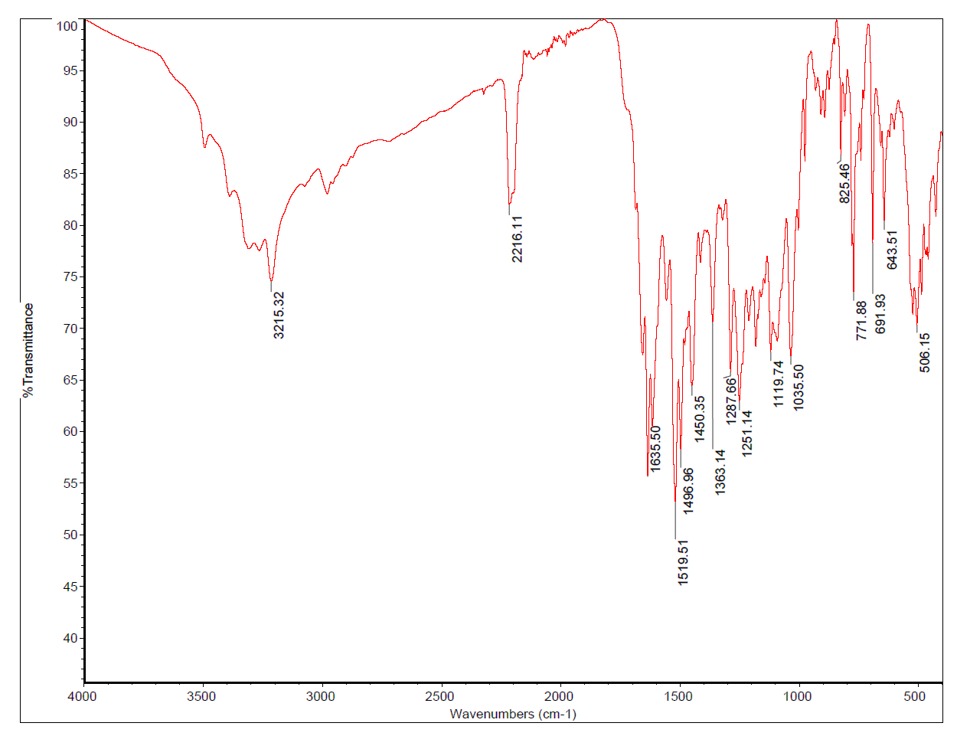

IR spectrum of 6-amino-4-(2,3-dihydrobenzo[b][1,4]dioxin-6-yl)-2-oxo-1-phenyl-1,2-dihydropyridine-3,5-dicarbonitrile(**8a)**

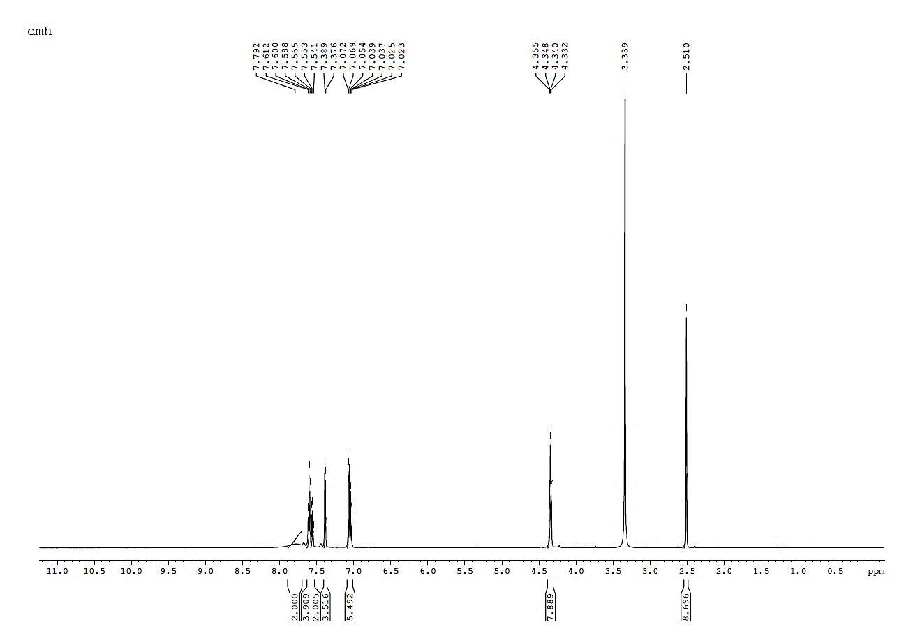

1H NMR Spectrum of 6-amino-4-(2,3-dihydrobenzo[b][1,4]dioxin-6-yl)-2-oxo-1-phenyl-1,2-dihydropyridine-3,5-dicarbonitrile(**8a)**

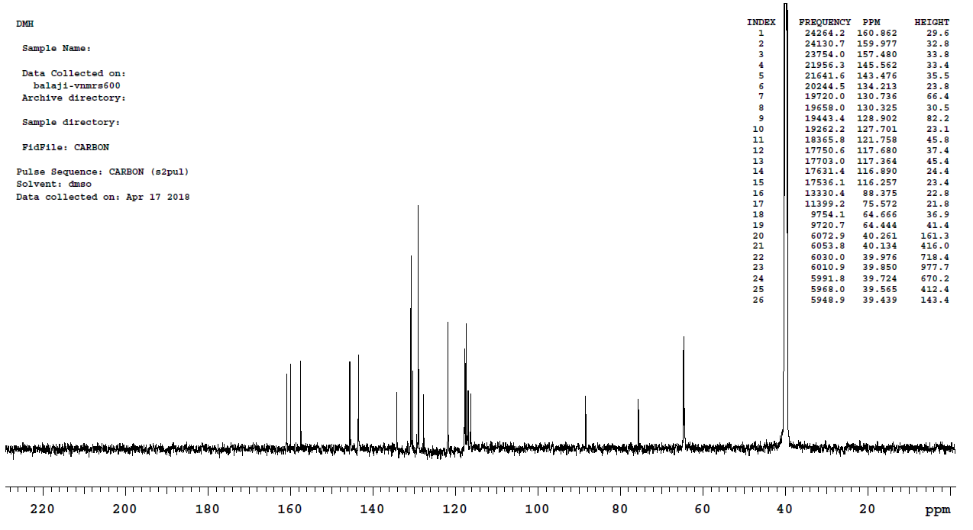

13C NMR Spectrum of 6-amino-4-(2,3-dihydrobenzo[b][1,4]dioxin-6-yl)-2-oxo-1-phenyl-1,2-dihydropyridine-3,5-dicarbonitrile(**8a)**







Mass Spectrum of 6-amino-4-(2,3-dihydrobenzo[b][1,4]dioxin-6-yl)-2-oxo-1-phenyl-1,2-dihydropyridine-3,5-dicarbonitrile(**8a)**

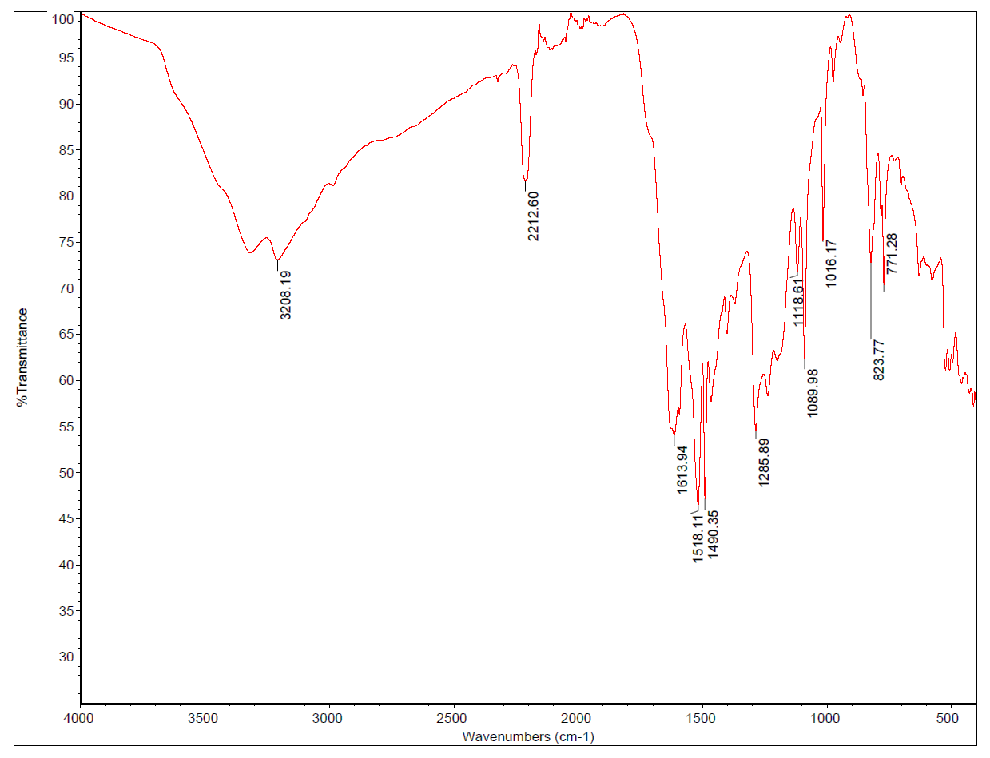

IR spectrum of 6-amino-1-(4-chlorophenyl)-4-(2,3-dihydrobenzo[b][1,4]dioxin-6-yl)-2-oxo-1,2-dihydropyridine-3,5-dicarbonitrile(**8b**)

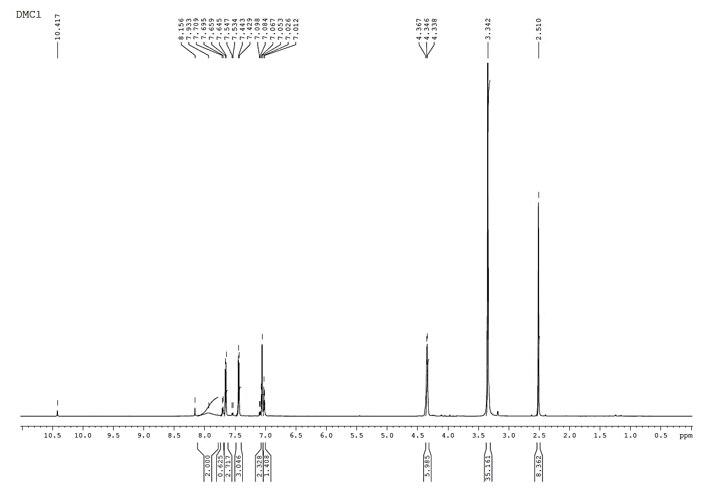

1H NMR Spectrum of 6-amino-1-(4-chlorophenyl)-4-(2,3-dihydrobenzo[b][1,4]dioxin-6-yl)-2-oxo-1,2-dihydropyridine-3,5-dicarbonitrile(**8b**)

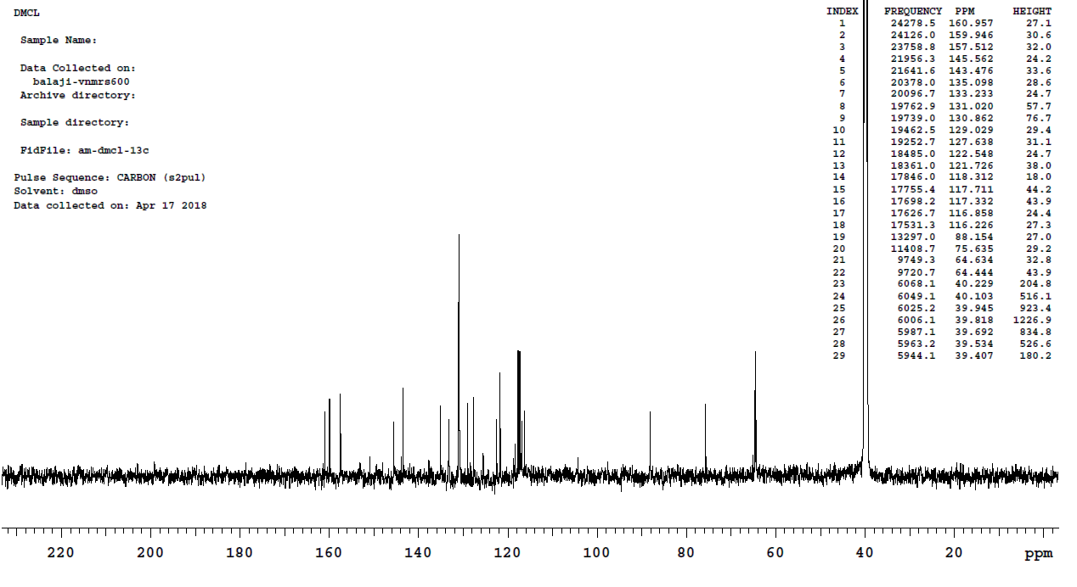

13C NMR Spectrum of 6-amino-1-(4-chlorophenyl)-4-(2,3-dihydrobenzo[b][1,4]dioxin-6-yl)-2-oxo-1,2-dihydropyridine-3,5-dicarbonitrile(**8b**)

Analysis on +ve mode







Mass spectrum of 6-amino-1-(4-chlorophenyl)-4-(2,3-dihydrobenzo[b][1,4]dioxin-6-yl)-2-oxo-1,2-dihydropyridine-3,5-dicarbonitrile(**8b**)

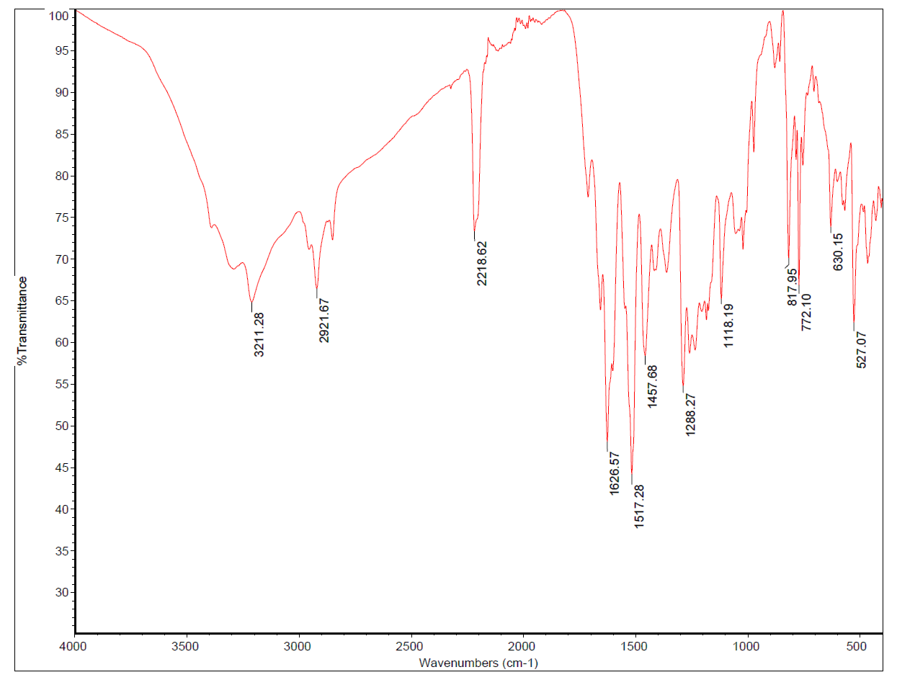

IR spectrum of 6-amino-4-(2,3-dihydrobenzo[b][1,4]dioxin-6-yl)-2-oxo-1-(p-tolyl)-1,2-dihydropyridine-3,5-dicarbonitrile(**8e**)

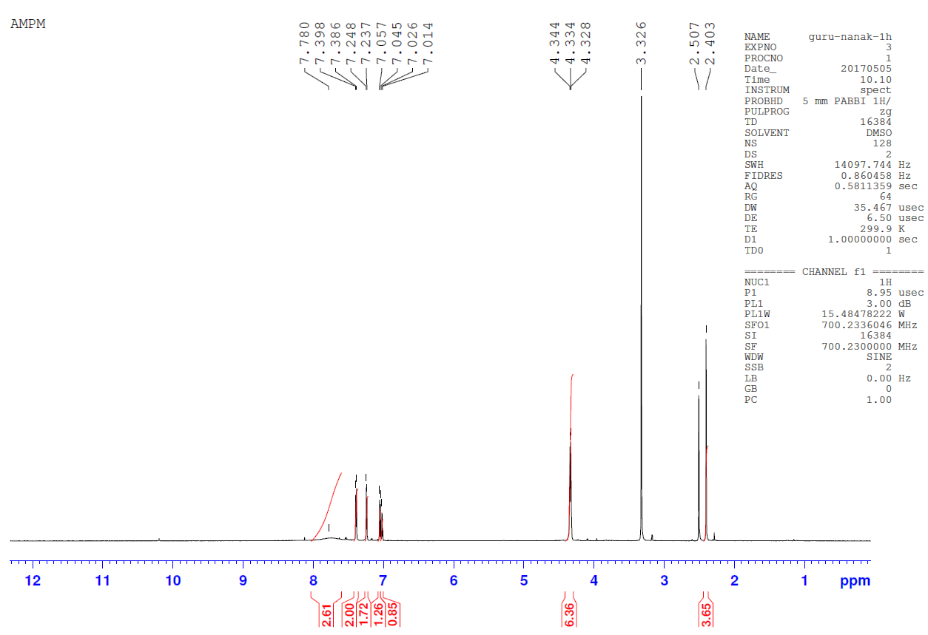

1H NMR Spectrum of 6-amino-4-(2,3-dihydrobenzo[b][1,4]dioxin-6-yl)-2-oxo-1-(p-tolyl)-1,2-dihydropyridine-3,5-dicarbonitrile(**8e**)



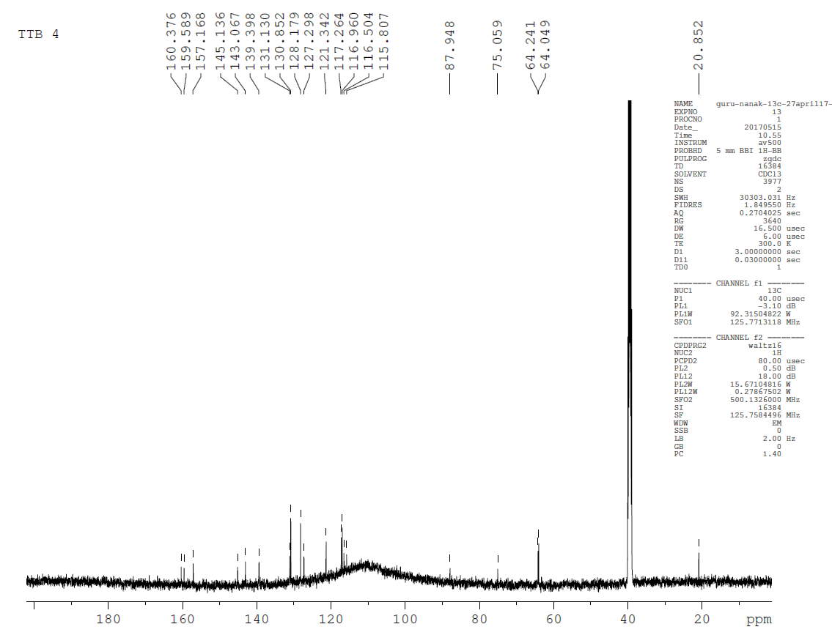

13C NMR Spectrum of 6-amino-4-(2,3-dihydrobenzo[b][1,4]dioxin-6-yl)-2-oxo-1-(p-tolyl)-1,2-dihydropyridine-3,5-dicarbonitrile(**8e**)

Analysis on +ve mode



Mass spectrum of 6-amino-4-(2,3-dihydrobenzo[b][1,4]dioxin-6-yl)-2-oxo-1-(p-tolyl)-1,2-dihydropyridine-3,5-dicarbonitrile(**8e**)