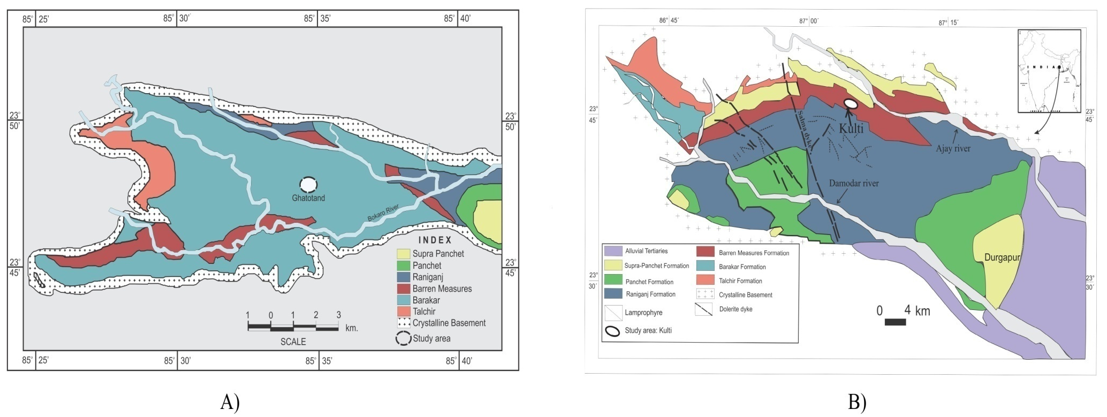
Supplementary Figure 1: Geological maps of West Bokaro (1A) and Raniganj (1B) basins, India

Supplementary Figure 2: Pore size distribution (PSD) calculated using nitrogen-gas adsorption and desorption isotherm data utilizing BJH model for sample SWB1.

