Appendix: Supplemental Material

Figure A.1 Determination of Costs for Four Sub-Groups of Sepsis ICU Patients

- Given the marginal cost of AKI, the estimated cost for survivor and non-survivor cohorts and the distribution of patients in each sub-group (shares) we calculate the cost for each of the four sub-groups: AKI/Death, AKI/Live, no AKI/Death, no AKI/Live
- For non-survivors (we do the analogous exercise for survivors):

$$\left(1\right) {\text{Avg. Cost}}_{\text{Non-Survivor}}=\frac{\left[{\text{Share}}_{\text{No AKI | Death}}*{\text{Cost}}_{\text{No AKI | Death}}\right]+\left[{\text{Share}}_{\text{AKI | Death}}*{\text{Cost}}_{\text{AKI | Death}}\right]}{{\text{Share}}_{\text{No AKI | Death}}+{\text{Share}}_{\text{AKI | Death}}}$$

$$\left(2\right) {\text{Cost}}_{\text{AKI | Death}}={\text{Cost}}_{\text{No AKI | Death}}+{\text{Marginal Cost}}_{\text{AKI }}$$

$$\left(3\right) {\text{Cost}}_{\text{No AKI | Death}}={\text{Avg. Cost}}_{\text{Non-Survivor}}-\left[\frac{{\text{Share}}_{\text{AKI | Death}}\text{*}{\text{Marginal Cost}}_{\text{AKI}}}{{\text{Share}}_{\text{No AKI | Death}}\text{+}{\text{Share}}_{\text{AKI | Death}}}\right]$$

Figure A.2: Joint Probabilities and Hospitalization Costs for ICU Sepsis Patients

Figure A.3 Sensitivity Analysis Tornado Diagram for 65 vs. 60 mmHg

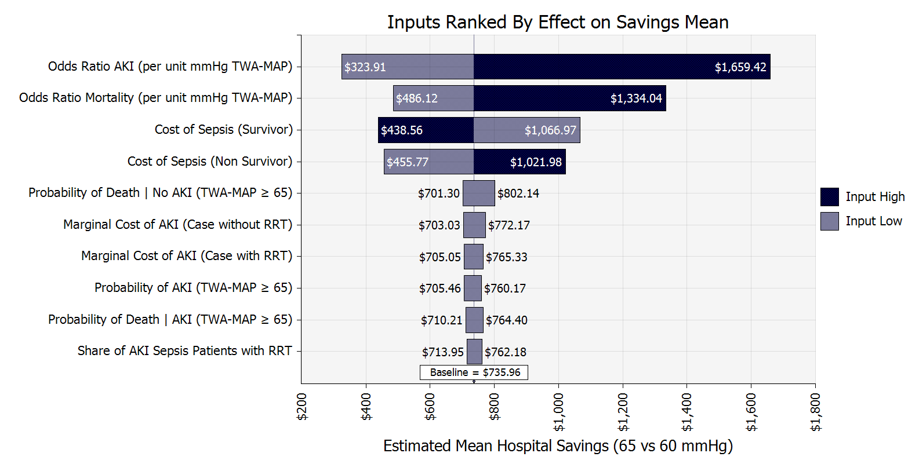

AKI=Acute Kidney Injury
mmHg=Millimeters Mercury

RRT=Renal Replacement Therapy

MAP= Mean Arterial Pressure

Table A.1: Expected Savings for 5 mmHg Increased in MAP

Expected Blood Pressure Level | Expected Mean Hospital Cost Savings for 5 mmHg Increase (95% CI)
60 mmHg | $699 ($342-$1,116)
55 mmHg | $974 ($432-$1,647)
50 mmHg | $1,263 ($524-$2,176)
45 mmHg | $1,493 ($611-$2,536)

Table A.2: ICU Hospitalization Sepsis Costs for Survivors and Non-Survivors

Description | Mean  (Assumed Distribution Type) | Source
ICU Provider Costs per Patient (Severe Sepsis) - Mean (2001 USD) | $34,436 | Ernst et al, 2006
2001 (June) PCE Index for Healthcare Services | 78.2 | US PCE
2017 (Oct) PCE Index for Healthcare Services | 113.347 | US PCE
Est 2018 ICU Provider Costs per Patient (Sepsis) - Mean (2018 USD) | $49,936 [A] | Calculation
ICU Provider Costs per Survivor (Mean) | $29,195 | Adrie et al., 2005
ICU Provider Costs per Non-Survivor (Mean) | $35,774 | Adrie et al., 2005
ICU Provider Costs per Both (Mean) | $31,251 | Adrie et al., 2005
Ratio of Survivor/Both Mean Costs | 0.93 [B] | Calculation
Ratio of Non-Survivor/Both Mean Costs | 1.14 [C] | Calculation
Mean Sepsis LOS 2001 | 8.23 | HCUP
Mean Sepsis LOS 2016 | 7.34 | HCUP
Ratio of LOS 2016/LOS 2001 | .89 [D] | Calculation
Est. ICU Provider Costs per Survivor (Sepsis) | $41,575 [A*B*D]  (gamma) | Calculation
Est. ICU Provider Costs per Non-Survivor (Sepsis) | $50,944  [A*C*D]  (gamma) | Calculation

Table A.3: Acute Kidney Injury Costs

Description | Mean  (Distribution Type) | Source
Marginal Cost of AKI hospitalized patient | $1,795 | Silver et al.
Marginal Cost of AKI hospitalized patient with dialysis | $11,016 | Silver et al.
2012 (July) PCE Index for Healthcare Services | 106.6 | US PCE
2017 (Oct) PCE Index for Healthcare Services | 113.3 | US PCE
2018 Est. Marginal Cost of AKI hospitalized patient (adjusting for patient and hospital characteristics) | $1,908  (Gamma) | Calculation
2018 Est. Marginal Cost of AKI hospitalized patient with dialysis (adjusting for patient and hospital characteristics) | $11,711  (Gamma) | Calculation
Share of AKI|Sepsis requiring RRT (renal replacement therapy) | 0.72  (Beta) | Bagshaw et al., 2007

