**Supplementary Data**

**Pharmacological properties of dicyanidoaurate(I)-based complexes: Characterization and single crystal X-ray analysis**

AHMET KARADAĞ*, ALI AYDIN, ŞABAN TEKIN, HÜSEYIN AKBAŞ and SÜREYYA DEDE

|  |
| --- |
| **TABLE OF CONTENTS** |
| **Scheme S1**.................................................................................................................p2 |
| **Anticancer Studies**....................................................................................................p3 |
| **Figure S1**……………………………………………………………………………….........p7 |
| **Data S1**………………………………………………………………………………............p8 |
| **Data S2**………………………………………………………………………..………………p8 |
| **Table S1**………………………………………………………………………..……………..p9 |
| **Figure S2**……………………………………………......……………………….................p9 |
| **Figure S3**…………………………………………………………………………….……….p10 |
| **Figure S4**………………………………………………………………………………….....p10 |
| **Figure S5**………………………………………………………………………………….….p11 |
| **Figure S6**………………………………………………………………………………….….p11 |
| **Figure S7**……………………………………………......……………………....................p12 |
| **Figure S8**………………………………………………………………………………….….p12 |
| **Figure S9**…………………………………………………………………………………......p13 |
| **Figure S10**……………………………………………......……………………...................p14 |





**Scheme S1**. Possible molecular structures of **1** and **2**.

**Anticancer Studies**

*Cell culture maintenance, cell proliferation assay (CPA) and calculation of IC50*

The anticancer potential of the complexes was investigated on cancerous HT29 (ATCC® HTB-38™), HeLa (ATCC® CCL-2™), and C6 cells (ATCC® CCL-107™) and nontumorigenic Vero cells (ATCC® CCL-81™). The cell lines were cultured in a cell medium (Dulbecco’s modified eagle’s) enriched with 10% (v/v) fetal bovine serum and 2% (v/v) Penicillin-Streptomycin (10,000 U/mL). First, old medium was removed out of the flask while cells had reached approximately 80% confluence. Next, cells were taken from the flasks surface using 4-5 mL of trypsin-EDTA solution and then subjected to centrifugation. Following, the cell pellet was suspended with 4 mL of DMEM working solution and was counted to obtain a final concentration of 5 × 104 cells/mL, and inoculated into wells (100 μL cells/well). A cell suspension containing approximately 5 × 103 cells in 100 µL was seeded into the wells of 96-well culture plates. The cells were treated with complexes and control drug dissolved in sterile DMSO (max 0.5% of DMSO) at final concentrations of 0.25, 0.50, 1.00, 1.50, 2.00, 2.50, 3.75, and 5.00 µg/mL at 37°C with 5% CO2 for overnight. The final volume of the wells was set to 200 µL by medium. Cell proliferation assay was evaluated by ELISA BrdU methods as described previously [21]. IC50 value is a concentration that inhibits half of the cells in vitro. The half maximal inhibitory concentration (IC50) of the test and control compounds was calculated using excel spreadsheet and represent in µM at 95% confidence intervals. The proliferation assay results were expressed as the percent inhibition according to the following formula: % inhibition = [1 − (Absorbance of Treatments / Absorbance of DMSO) × 100].

***Cytotoxic activity assay***

The cytotoxicity of the compounds on HeLa, C6, HT29, and Vero cells was determined through a Lactate Dehydrogenase Assay Kit according to the manufacturer’s instructions. Approximately 5 × 103 cells in 100 µL were placed into 96-well plates as triplicates and treated with IC50 (µg/mL) concentrations of test compounds at 37°C with 5% CO2 for 24 h. LDH activity was obtained bydetermining absorbance at 492 - 630 nm using a microplate reader. The percentage cytotoxicity were obtained by using the equation, experimental value - low control / high control - low control x 100, where experimental value is the test-compound treated cells, high control (maximum LDH release) is Triton X-100 treated cells, low control (spontaneous LDH release) is the untreated cells.

***Terminal deoxynucleotidyl transferase dUTP nick end labeling (TUNEL) assay***

The apoptosis were evaluated on HT29 cells using a TUNEL assay kit according to the manufacturer’s protocol. The cells (30.000 /well) were seeded in a poly-L-lysine covered chamber slide and treated with the IC50 concentrations of test compounds at 37oC for 24 hours. The assay was conducted guidance on the relevant method described by the literature [21]. Fluorescent signal was detected by a Leica fluorescent microscope (Leica DMIL LED fluo, Germany).

***Analysis of DNA fragmentation (DNA laddering test)***

A DNA laddering activity of the test compounds was performed by using DNA laddering assay, it was described in accordance with the literature methods [29]. Briefly, 7.5 x 105 cells were placed into 25 cm2 culture flasks, and treated with IC50 concentrations of test compounds at 37°C with 5% CO2 for overnight. First, DNA-containing precipitate was extracted from digest with a 50 µL phosphate-citrate buffer, centrifuged at 1500 xg for 5 min, and then 40 µL supernatant was transferred to a micro centrifuge tube. Tween20 (5 µL) solution (0.25% in ddH2O) and RNase A (5 µL) solution added to the supernatant, and then incubated at 37°C for 28 min. Next, proteinase K (5 µL) was added to each tube and re-incubated at 37°C for 8 min. Finally, DNA-containing precipitate of the micro centrifuge tube was added 2 μL of loading buffer and loaded to 2% agarose gel containing 0.5 μg/mL ethidium bromide and electrophoresed at 200 mA for 40 min. After electrophoresis, DNA fragmentation on gels was imaged using UVP gel imagined system.

***Cell migration assay***

The migration feature of treated cells was conducted using the migration assay as described previously [21]. Briefly, the HeLa cells in equal number (3.5 x 104 cells in 70 μL DMEM) were plated into the two same reservoirs of the silicone pool. When cell density reaches to 80% confluence, the reservoir wall was throw and 2 mL of cell culture medium including IC30 concentrations of the compounds added, and then incubated at 37°C with 5% CO2. The movement of the cells into a wounded area was photographed until the gap covered by control cells.

***DNA topoisomerase I inhibition assay***

The anti-topoisomerase I activity of test compounds was found using topoisomerase I assay as described previously [21].In brief, 0.25 µg/µL of plasmid pHOT1 DNA, 2 U recombinant human topoisomerase I enzyme, and IC50 concentrations of the compounds were added to reaction tube. The mixture was incubated at 37°C for 30 min and then the reaction terminated through adding stop solution. The mixture was loaded 1% agarose gel and electrophoresed for 60 min. DNA bands staining ethidium bromide photographed through a gel imaging system.

***Cell imaging***

Cells were plated in 96-well plates at a density of 5.000 cells per well and allowed 24 h. IC50 values of the test compounds were administered and morphology alters of the cells were screened by phase contrast microscopy for 24 h every 6 h. Images of control and test compounds treated cells were photographed at the end of the process using a digital camera attached to an inverted microscope.

***DNA/BSA binding and gel electrophoresis studies***

The binding constants (𝐾𝑏) and the interaction of the compounds with Calf thymus-DNA (CT-DNA) were evaluated UV spectroscopy. A CT-DNA solution was prepared by dissolving 2.5 mg CT-DNA in 10.0 mL Tris–HCl buffer and it was immediately used. The concentration of CT-DNA was found spectrophotometrically with the aid of Ɛ value of 6600 M−1 cm−1 at 260 nm. After dissolving the CT-DNA fibers in Tris–HCl buffer, the purity of this solution was checked from the absorbance ratio A260/A280. The DNA was pure enough to use while the CT-DNA solution in the buffer displayed an A260/A280 ratio of 1.83. Both compounds dissolving in DMSO re-diluted with Tris–HCl buffer to obtain 25 µM concentrations. Test compounds in the solutions were incubated at 20°C for about 30 min before measurements. The UV absorption spectrum data were conducted through unchanging the concentration of both compounds with increasing the CT–DNA concentrations (6.25 - 800 μM). Absorption spectra were recorded using 1-cm-path quartz cuvettes at room temperature [28].

To evaluate the interaction of the compounds with BSA UV spectroscopy was used. A BSA solution was prepared by dissolving 2.5 mg BSA in 10.0 mL in Tris–HCl buffer and it was immediately used. The scans of the BSA solutions (6.25 - 800 μM) with a fixed concentration of the complexes (25 μM) were screened in the wavelength range 250-320 nm.

Ethidium bromide (EB) displacement situation was carried out by tracking alters in the quenching severity of a constant concentration of EB-DNA solutions with test compounds (25–75 μM). The quenching severity of EB was screened using an excitation wavelength of 295 nm and the emission range was adjusted between 200 and 600 nm. The spectral data were examined with the Stern–Volmer equation, *I0*/*I* = 1 + *Ksv* [Q], where *I0* is the fluorescence severity in the absence of quencher, *I* is the fluorescence severity in the presence of quencher, *KSV* is the Stern–Volmer quenching constant, and [Q] is the quencher concentration. *Ksv* can be calculated from the slope of the plot of *I0*/*I* vs. *[DNA]*.

The restriction enzyme inhibition assay was conducted to evaluate both specific and nonspecific binding and enzyme inhibition by complexes. Supercoiled pTOLT (10 μM) plasmid DNA was incubated with the complexes (25 μM) and restriction enzymes *Kpn*I and *Bam*HI (2 units) at 37 °C in Tris–HCl/NaCl buffer (50/18 mM, pH 7.2) for 4 h. The digestion products were observed by using 1.5% (wt/vol) agarose gels with ethidium bromide.

***Immunohistochemistry***

Immunohistochemistry (IHC) techniques were used to localize antigens with different expression levels following test compound treatment. Accordingly, HT29 and HeLa cells (15.000 cells/well) were seeded to μ-Slide with poly-L-lysine. The cells were subjected to IC50 concentrations of the test compounds and allowed incubation for 24 h. There was a negative control that had no test compounds. The IHC study of test compounds was evaluated using a Ventana IHC system according to manufacturer's directions. IHC was performed using Bcl-2 (mouse monoclonal, clone 124), CK7 (mouse monoclonal, clone OV-TL 12/30), CK20 (mouse monoclonal, clone Ks20.8), and P53 (mouse monoclonal, clone D07) on the VENTANA Bench-Mark XT System. The slides scores were rated as follows: 0 (<5% positive cells), 1 (5–24% positive cells), 2 (25-49% positive cells), 3 (>50% positive cells). The positive for relevant expression noted 2 or 3 while the negative stated 0 or 1.

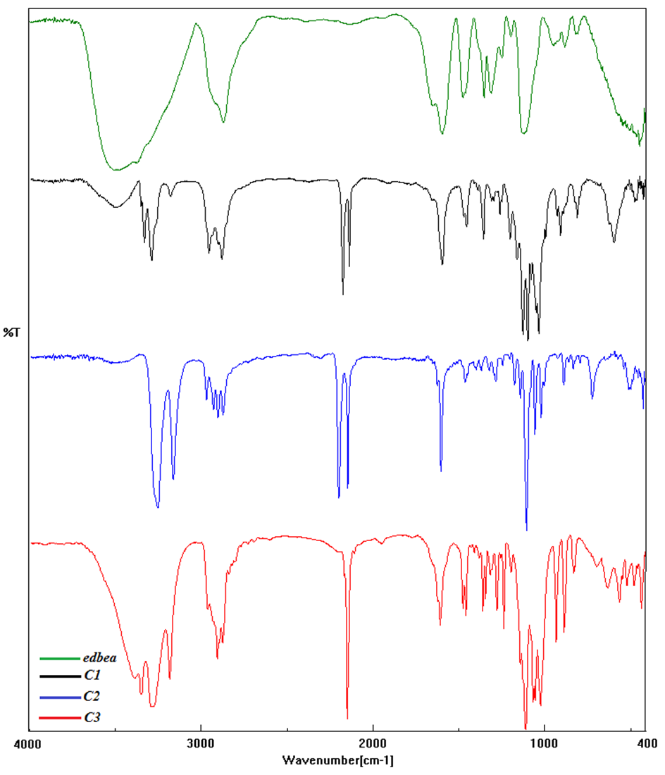

**Figure S1**. IR Spectrums of **1**, **2** and **3**.

**Data S1.** The GPC analysis results for **1**.

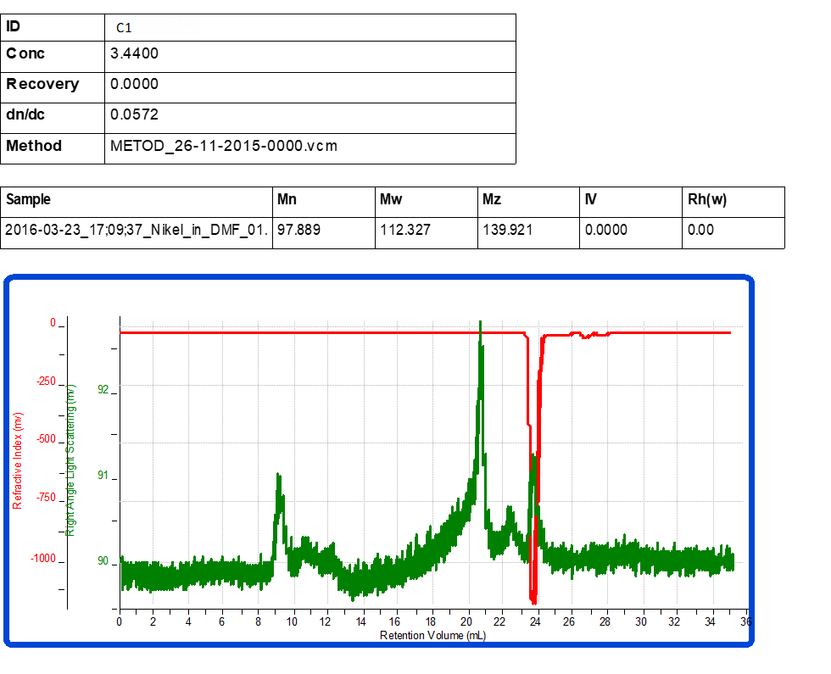

**Data S2.** The GPC analysis results for **2**.



Table S1. The bond angles used to determine of the [Cd(*edbea*)2]2+ complex ion geometry.

|  |  |  |  |  |  |
| --- | --- | --- | --- | --- | --- |
| *Numbered bond angles (o)* | | | | | |
| **1*th*** | O1—Cd1—O2 | 60.58 (10) | **10*th*** | N3—Cd1—O1 | 79.29 (11) |
| **2*th*** | O4—Cd1—O3 | 60.70 (8) | **11*th*** | N4—Cd1—O1 | 86.72 (11) |
| **3*th*** | N1—Cd1—O1 | 67.66 (13) | **12*th*** | N3—Cd1—O2 | 88.16 (11) |
| **4*th*** | N2—Cd1—O2 | 68.05 (12) | **13*th*** | N4—Cd1—N1 | 89.68 |
| **5*th*** | N4—Cd1—O3 | 68.41 (10) | **14*th*** | N2—Cd1—O4 | 89.70 (11) |
| **6*th*** | N3—Cd1—O4 | 68.51 (11) | **15*th*** | N1—Cd1—O3 | 91.12 (11) |
| **7*th*** | N2—Cd1—O3 | 74.90 (11) | **16*th*** | N3—Cd1—N1 | 91.32 |
| **8*th*** | N1—Cd1—O4 | 77.16 (12) | **17*th*** | N4—Cd1—N2 | 91.54 |
| **9*th*** | N4—Cd1—O2 | 78.91 | **18*th*** | N3—Cd1—N2 | 91.66 |

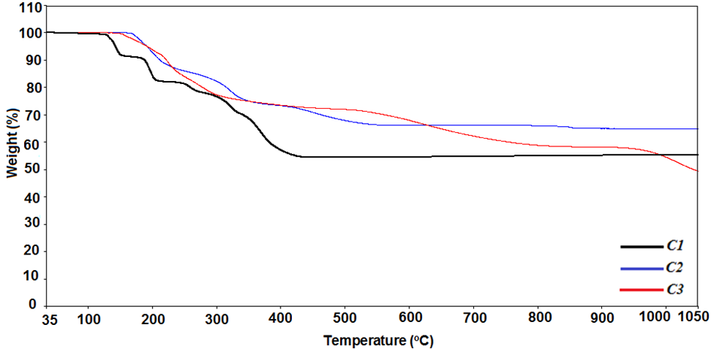**Figure S2.** TG Curves of **1**, **2** and **3**.

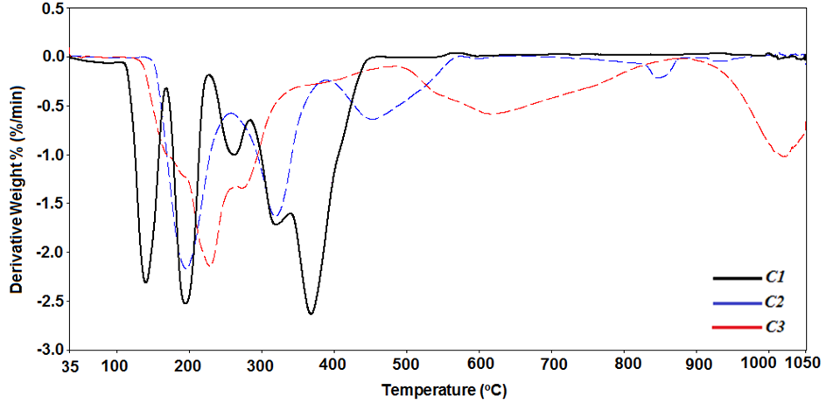**Figure S3**. DTG Curves of **1**, **2** and **3**.

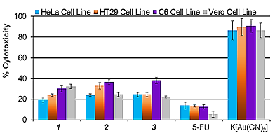

**Figure S4.** The cytotoxic activity of **1**,**2**,**3**and K[Au(CN)2] on HeLa, HT29, C6, and Vero cells. Cell lines were incubated with IC50 concentrations of the compounds for 24 hours, and cytotoxicity was determined by LDH Cytotoxicity Assay Kit. Percent cytotoxicity was noted as mean values *±* SDs of three independent assays.

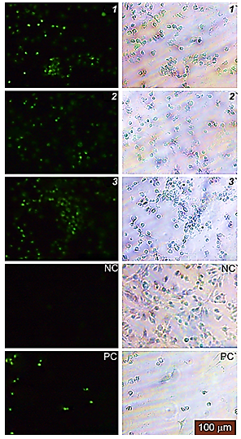

**Figure S5.** The photograph represents the fluorescence (**1**,**2**,**3***,* NC, and PC) and phase-contrast (***1′****,* ***2′***, ***3′****,* NC*′,* and PC*′*) images of the HT29 cells. NC: Negative control, PC: Positive control.

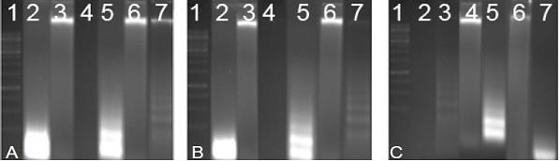 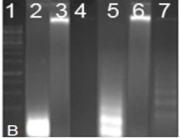 

**Figure S6.** The image represent the effects of **1**, **2**, and **3**on DNA fragmentation in cells. A) Lane 1: DNA standard; Lane 2: HeLa + **1**; Lane 3: HeLa Control; Lane 4: C6 cells Control; Lane 5: C6 cells + **1**; Lane 6: HT29 Control; Lane 7: HT29 + **1**. B) Lane 1: DNA standard; Lane 2: HeLa + **2**; Lane 3: HeLa Control; Lane 4: C6 cells Control; Lane 5: C6 cells + **2**; Lane 6: HT29 Control; Lane 7: HT29 **2**. C) Lane 1: DNA standard; Lane 2: HT29 + Control; Lane 3: HT29 + **3**; Lane 4: C6 cells Control; Lane 5: C6 cells + **3**; Lane 6: HeLa Control; Lane 7: HeLa + **3**.

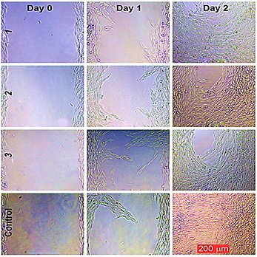

**Figure S7.** Effect of **1**, **2**, and **3**on the migration of HeLa cell line. The closure of the HeLa cell line was photographed 0, 1 and 2 days after incubation with **1**, **2**, and **3**at IC50 concentrations using a phase contrast microscope (Leica DMIL, Germany) until complete cell closure was observed in the untreated control. Note that anti-migration effect of **1**, **2**, and **3**on the cells was more obvious at day 2.

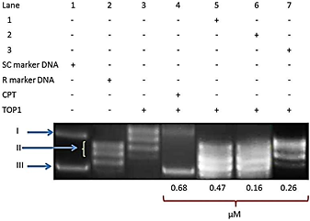

**Figure S8.** Inhibition of recombinant human topoisomerase I relaxation activity. A DNA unwinding assay was performed with 250 ng pHOT-1 supercoiled DNA, 2U TOP1 and IC50 concentrations of **1**, **2**, and **3**. The forms of DNA are denoted as I (Nicked DNA), II (Relaxed DNA), and III (Supercoiled DNA). Lane 1 is the supercoiled (SC) marker DNA; Lane 2 represents the relaxed (R) marker DNA; Lane 3 represents the negative control (Supercoiled DNA + TOP1); Lane 4 is the positive control (Supercoiled DNA + TOP1 + Camptothecin), and Lanes 5-7 represent test compounds over an IC50-concentration titration.

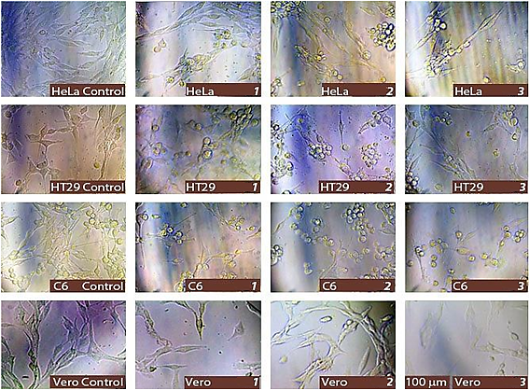

**Figure S9.** The effect of **1**, **2**, and **3**on the morphology of HeLa, HT29 and C6 cells. Exponentially growing cells were incubated with IC50 concentrations of **1**, **2**, and **3**at 37 °C for overnight and visualized by digital camera attached inverted microscope (Leica IL10, Germany). DMSO treated cells as controls. All scales are 100 µm.

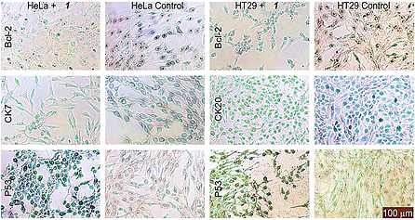

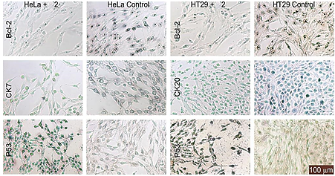

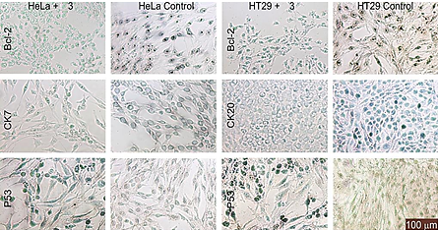

**Figure S10**. Representative images of the cells examined by immunohistochemical staining for functional protein group (Bcl-2 and P53) and for marker protein group (CK7 and CK20). The specific signals are shown as brown staining.