Supporting information

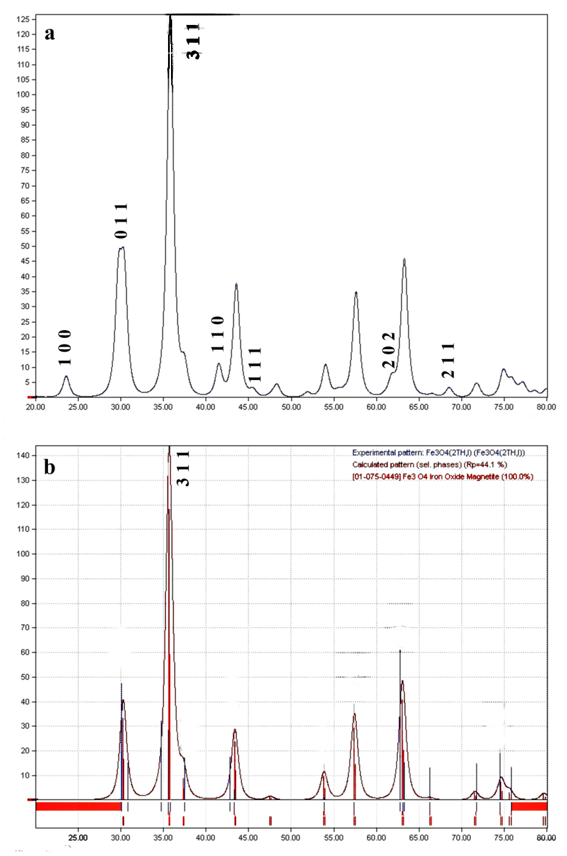
Figure S1. XRD patterns of: (a) Fe₃O₄ nanoparticles and (b) MMSNs together with the characteristic peaks of the standard JCPDS pattern.
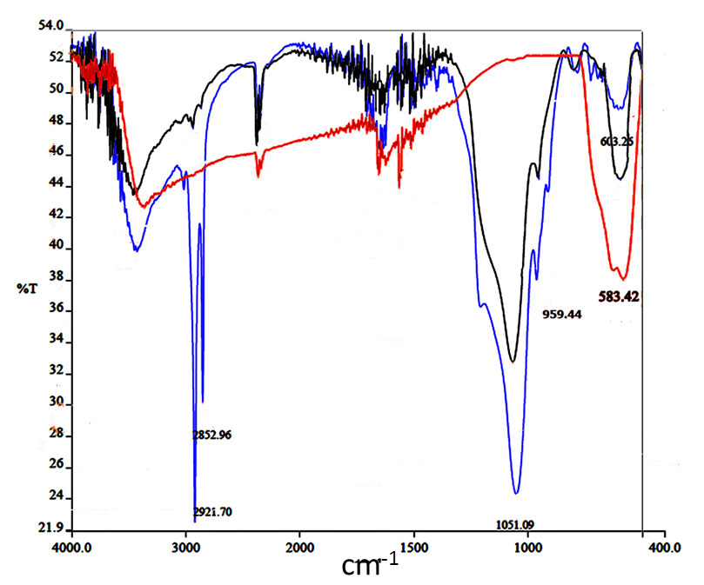
Figure S2. FTIR spectra of Fe₃O₄ (red), MMSNs before surfactant removal (blue), and MMSNs after surfactant removal (black).
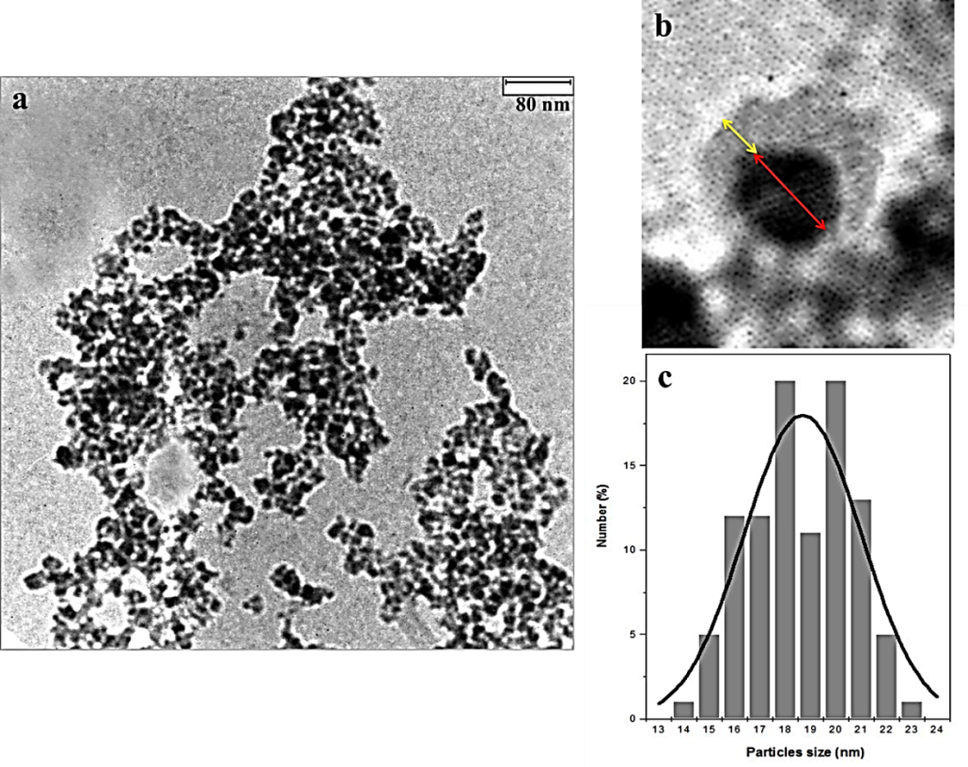
Figure S3. TEM images together with size distribution histogram of MMSNs.
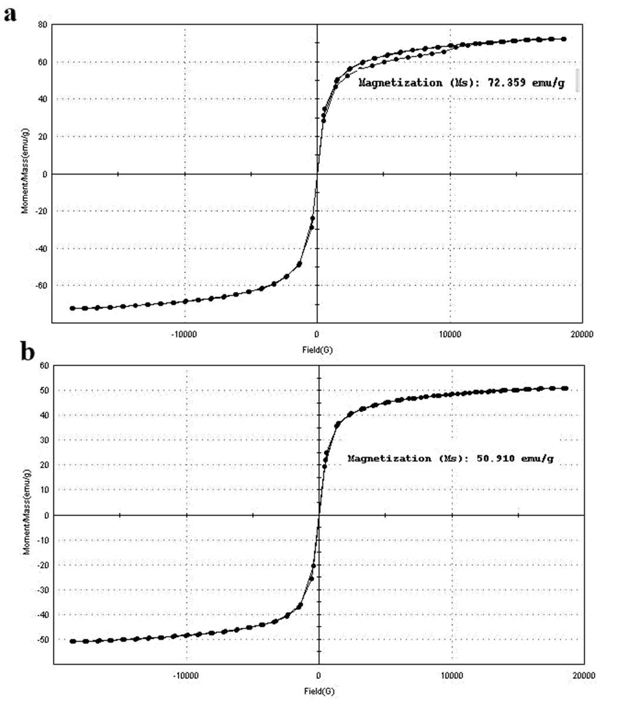
Figure S4. Hysteresis loops of the Fe₃O₄ nanoparticles (a) and MMSNs (b), recorded at a temperature of 300 K.

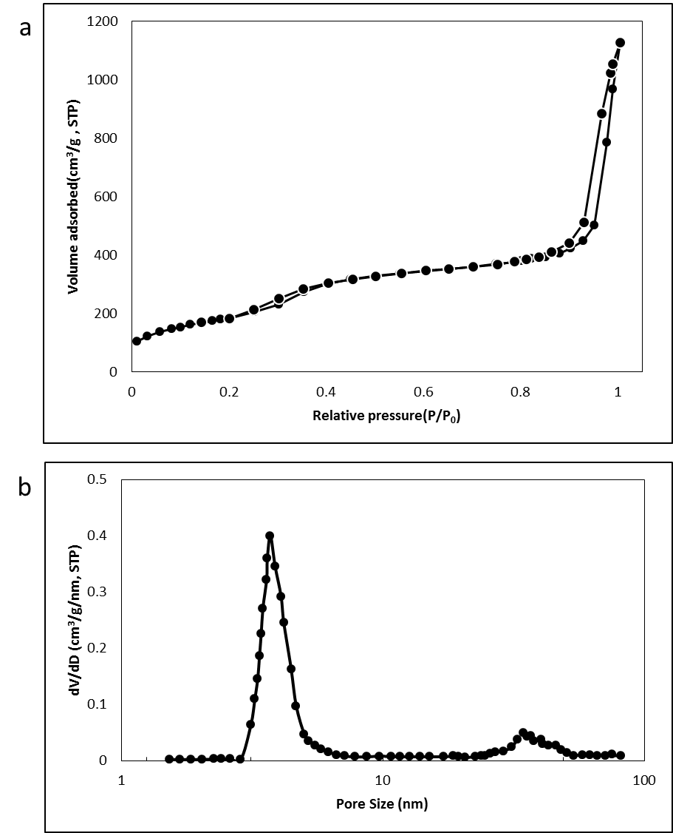
Figure S5. (a) N₂ adsorption-desorption isotherms and (b) pore size distributions of
MMSNs.

Figure S6. Hemolysis assay of MMSNs. Every experimental condition was repeated three times in triplicate. All hemolysis data are presented as mean±SD.

