Formation of Diaryl Sulfides and Sulfoxides: Synthesis, Characterization and Structure Activity Correlation Studies
Devappa S. Lamani*ª, S. G. Badigerª, Mamata Singh^{b}
ª Department of Chemistry, Basaveshawar Science College, Bagalkot, Rani Channamma University, Karnataka, India
^{b}Department of Chemistry, GITAM Bangalore (Deemed to be University), Karnataka, India
Email: kattimani.devaraj67@gmail.com
Supplemental Materials
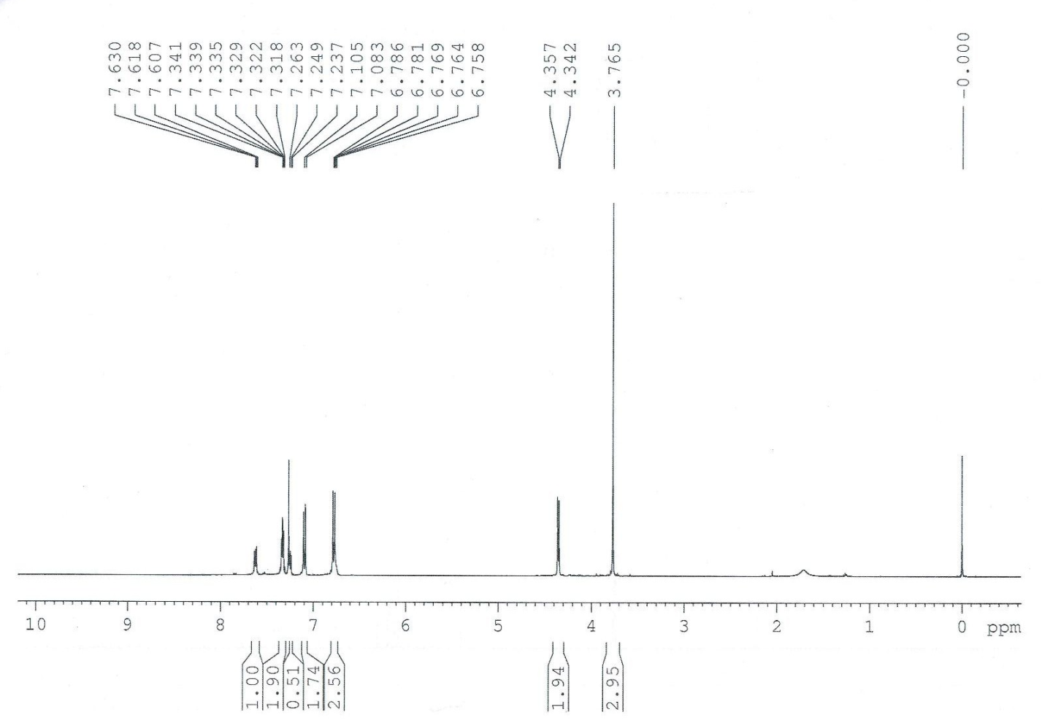
Figure S 1. ¹H-NMR spectra of pure sulfurane oxide 21 in CDCl₃

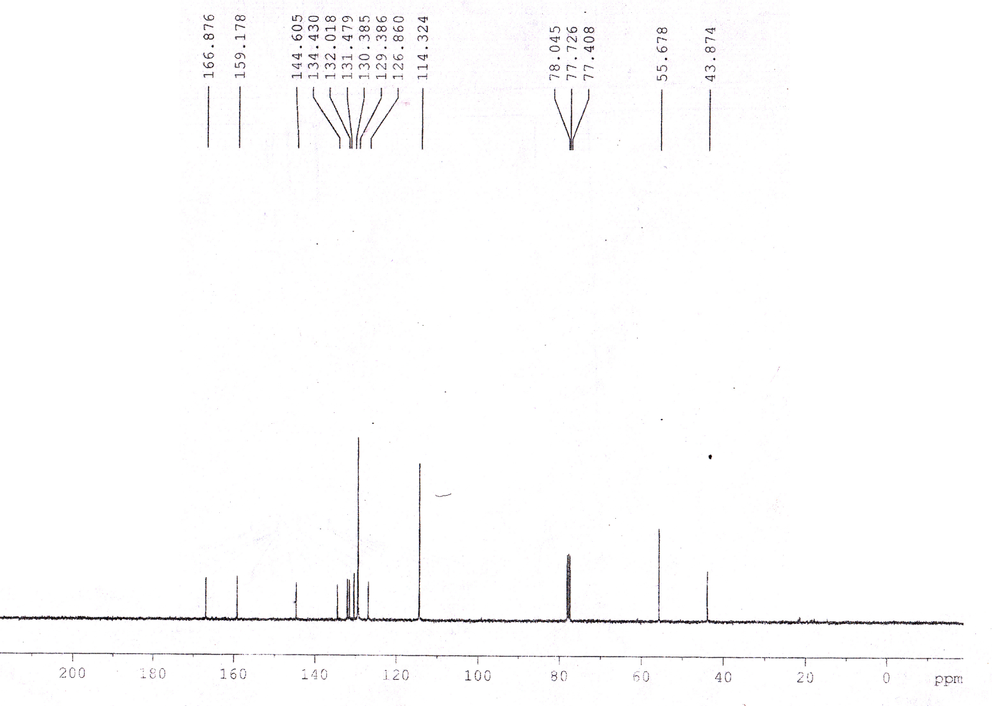

Figure S 2. ¹³C-NMR spectra of pure sulfurane oxides 21 in CDCl₃

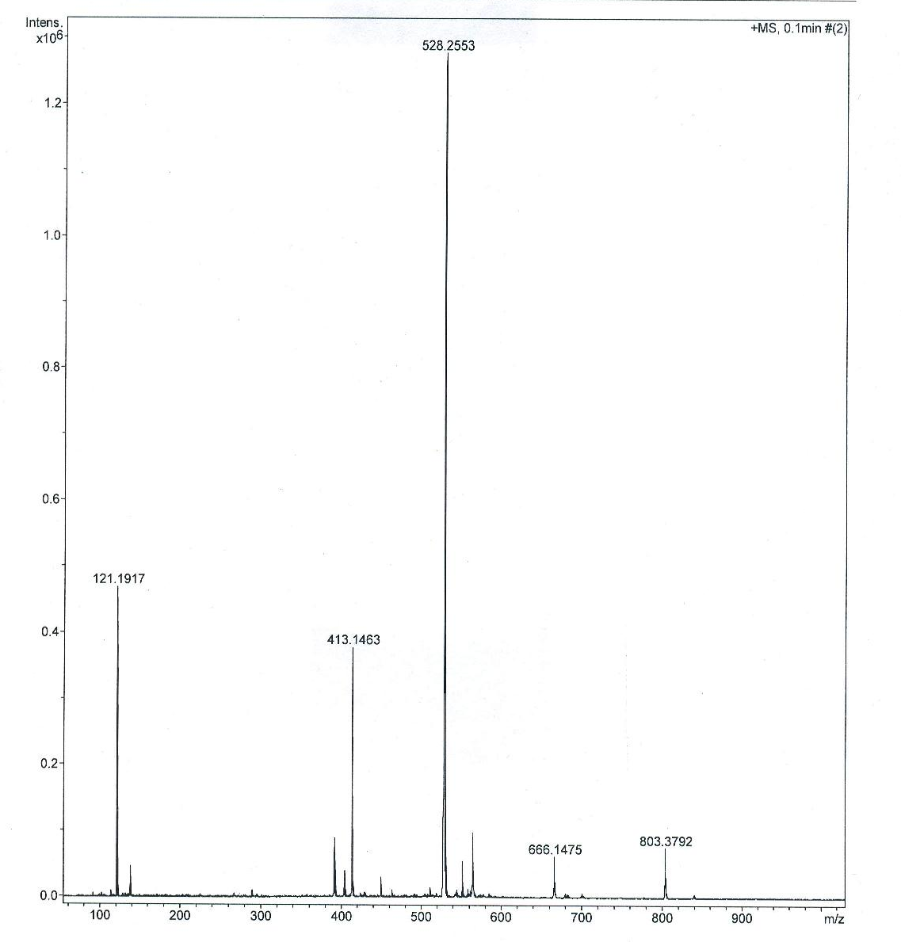
Figure S 3. ESI-Mass spectrum of compound 21. ESI-MS (m/z) Calcd, C₃₀H₂₈N₂O₅S: 528.0,
found: 528.2 [M ⁺].

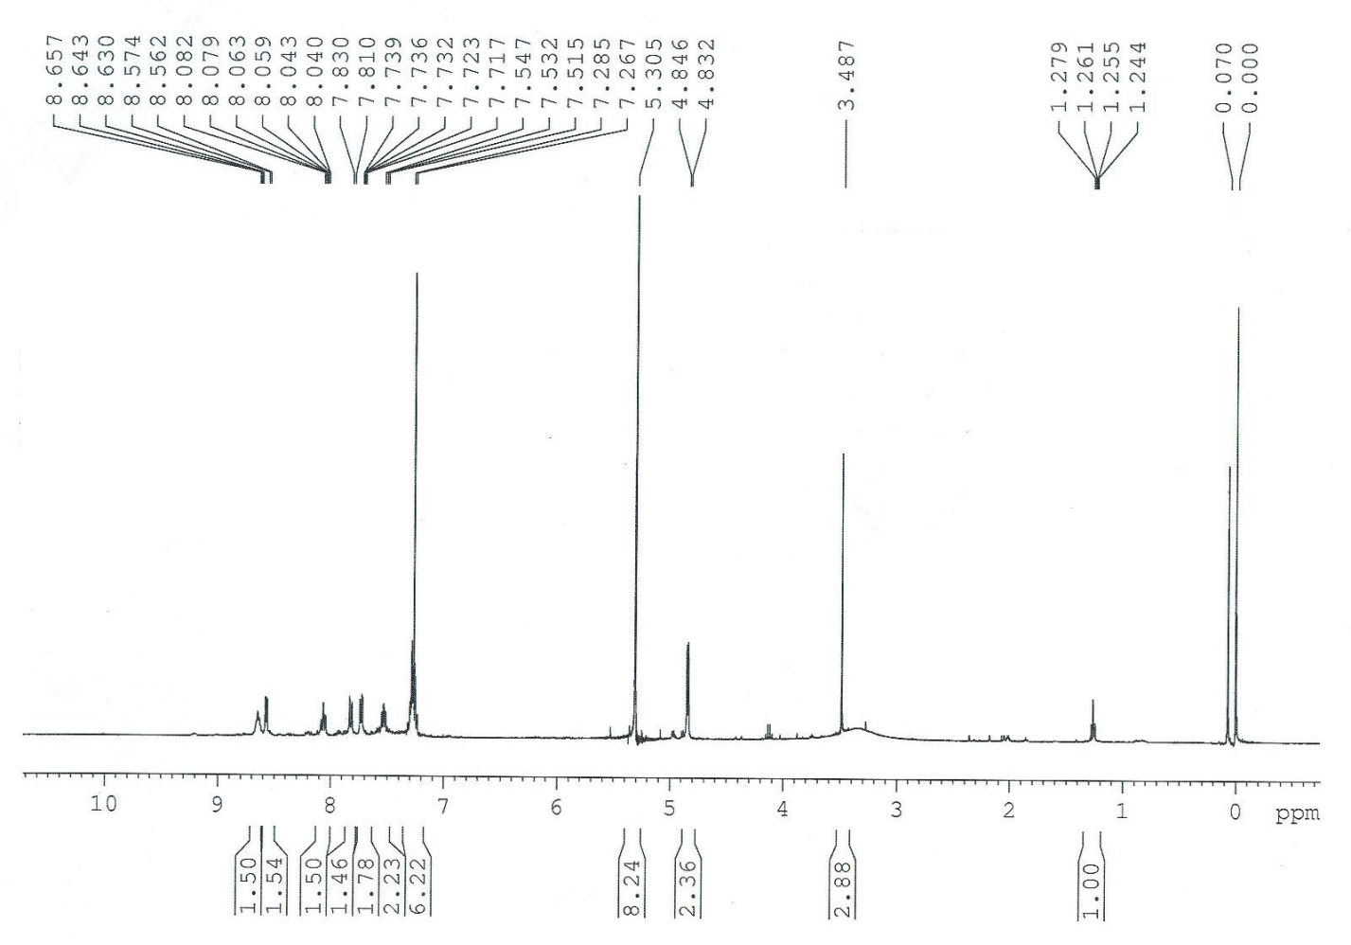
Figure S 4. ¹H-NMR spectra of pure sulfurane oxide 22 in CDCl3

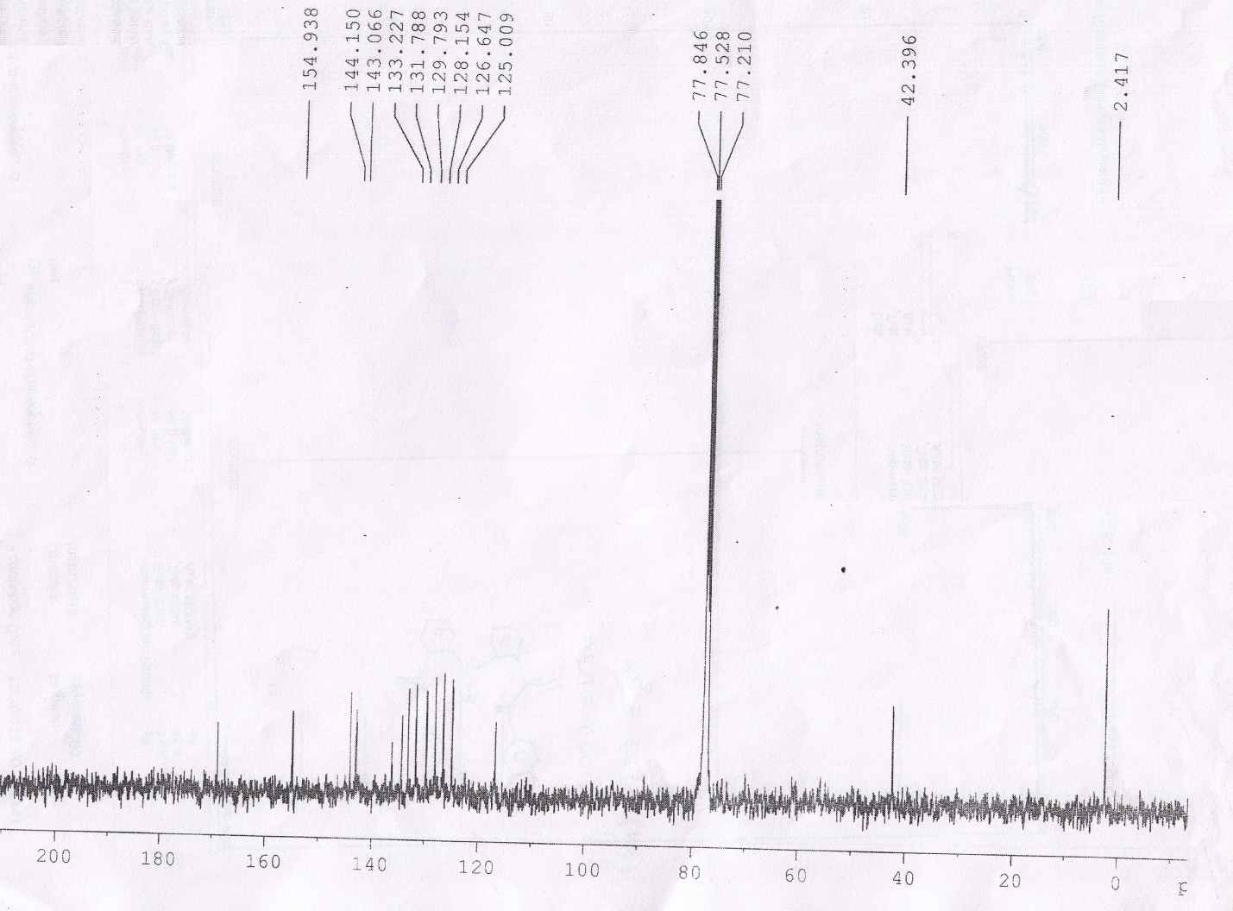
Figure S 5. ¹³C-NMR spectra of pure sulfurane oxides 22 in CDCl₃

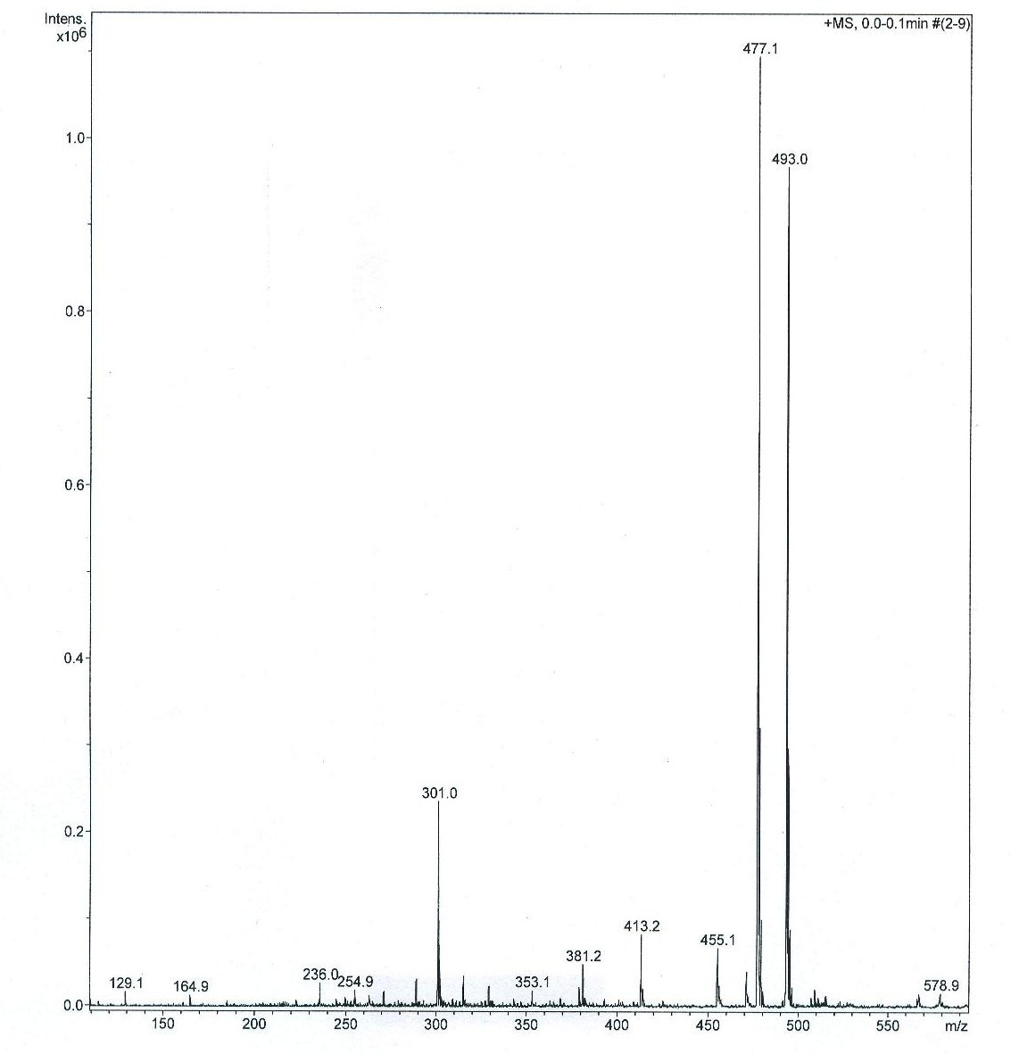
Figure S 6. ESI-Mass spectrum of compound 22. ESI-MS (m/z) Calcd, C₂₆H₂₂N₄O₃S: 474.5,
found: 493.0 [M+ Na⁺].

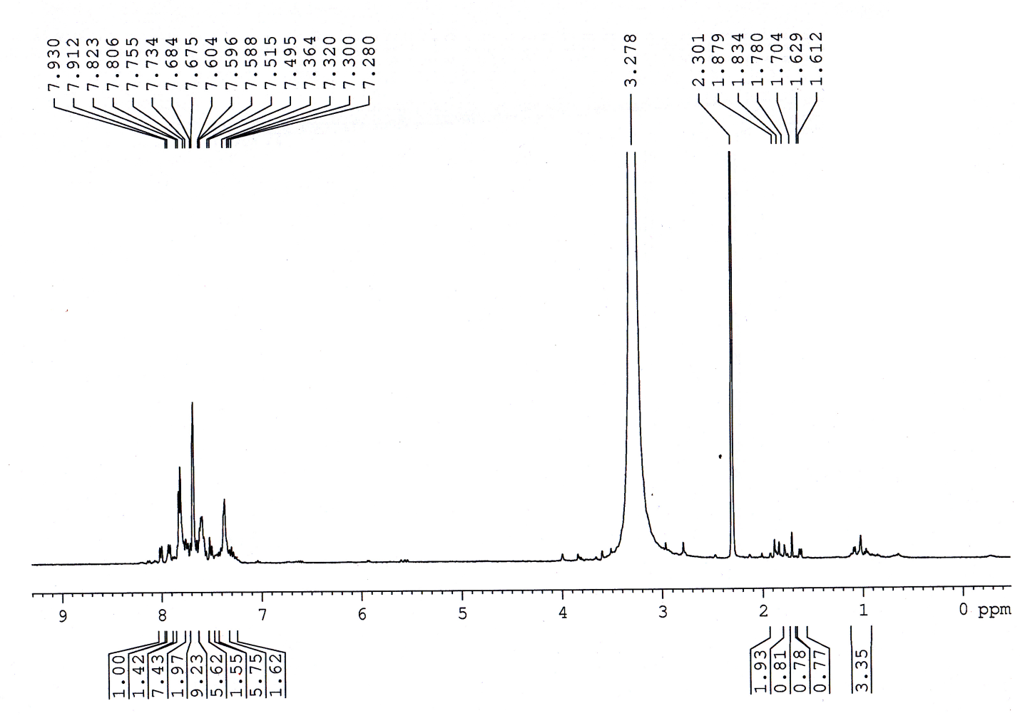
Figure S 7. ¹H-NMR spectra of pure Sulfurane oxide 25 in DMSO-d₆

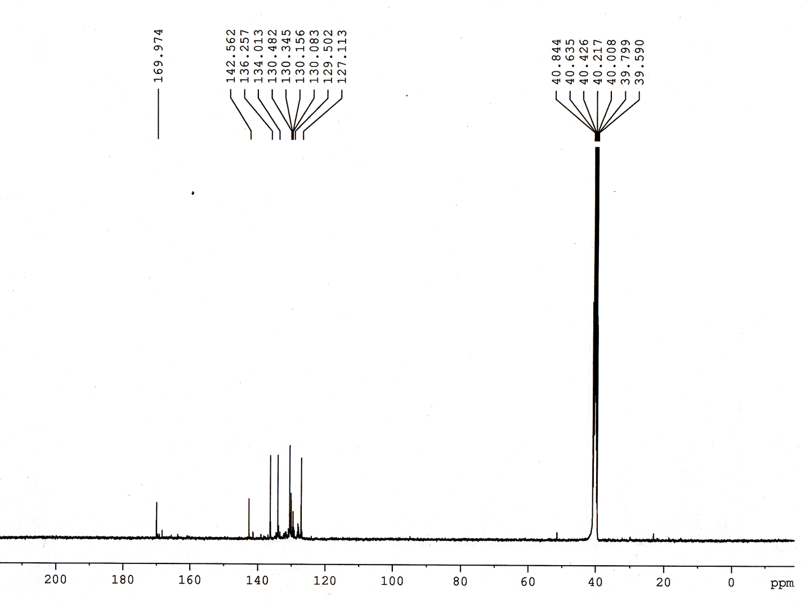
Figure S 8. ¹³C-NMR spectra of pure sulfurane oxides 25 in DMSO-d₆

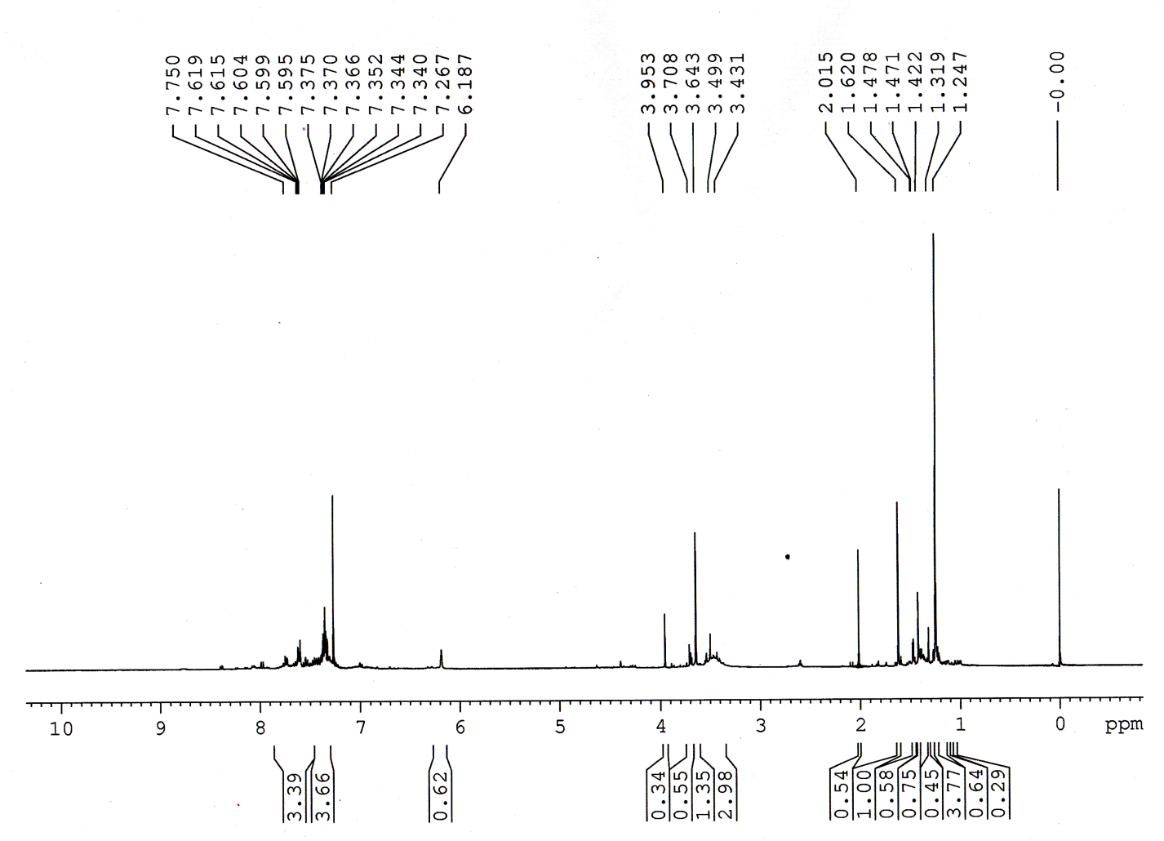
Figure S 9. ¹H-NMR spectra of pure Sulfurane oxide 26 in CDCl₃

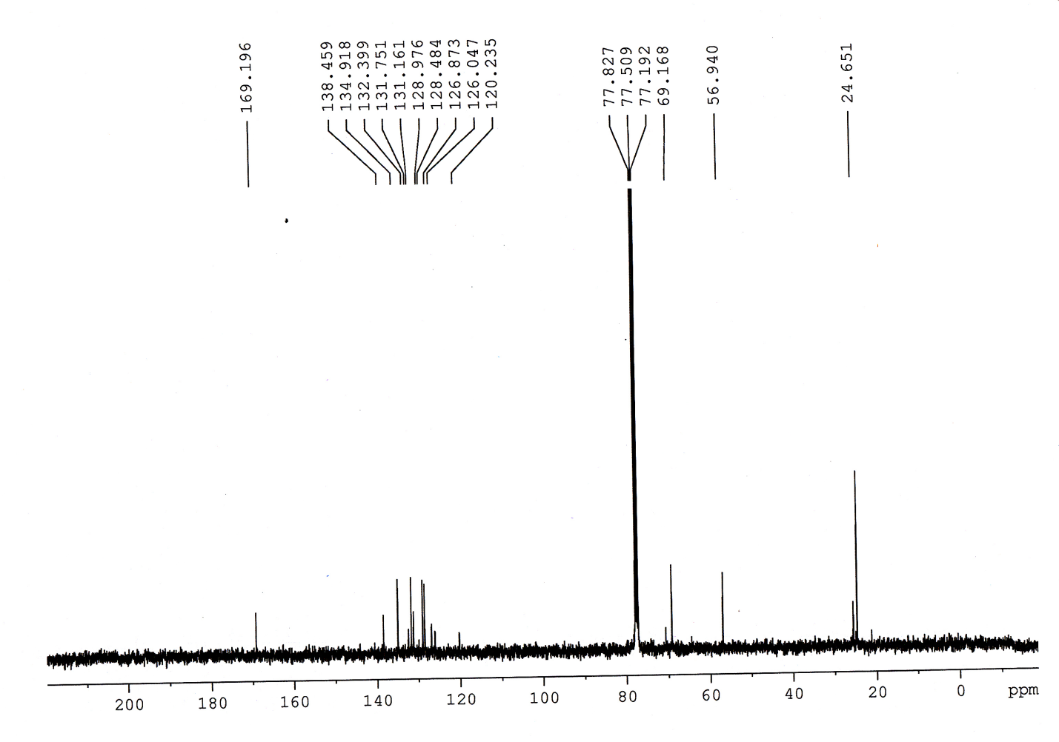

Figure S 10. ¹³C-NMR spectra of pure sulfurane oxides 26 in CDCl₃

