Synthesis and Redox Properties of Sterically Crowded Triarylphosphine Bearing Two Phenothiazine Moieties
Shigeru Sasaki,*¹ Midori Murakami,¹ and Masaaki Yoshifuji^{1,2}
¹Department of Chemistry, Graduate School of Science, Tohoku University, Sendai 980-8578, Japan
²Department of Chemistry, The University of Alabama, Tuscaloosa, Alabama 35487-0336, USA
Email: ssasaki@m.tohoku.ac.jp
Supplemental Materials
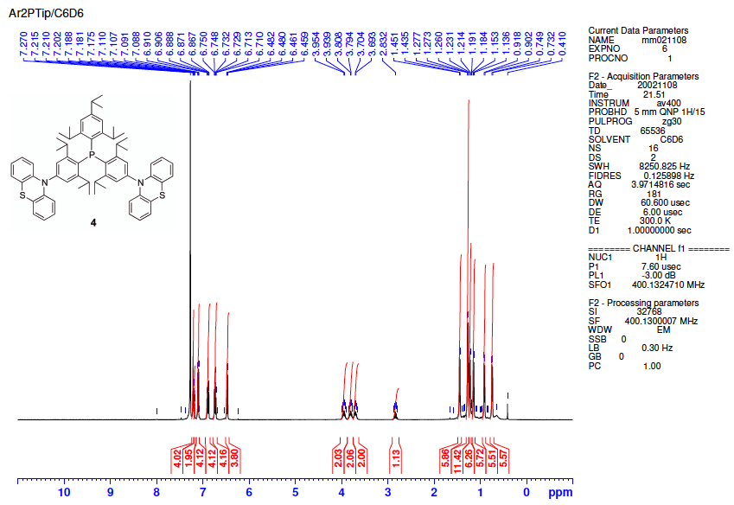
Figure S 1. ¹H NMR (400 MHz, C₆D₆, 300 K) spectrum of 4.
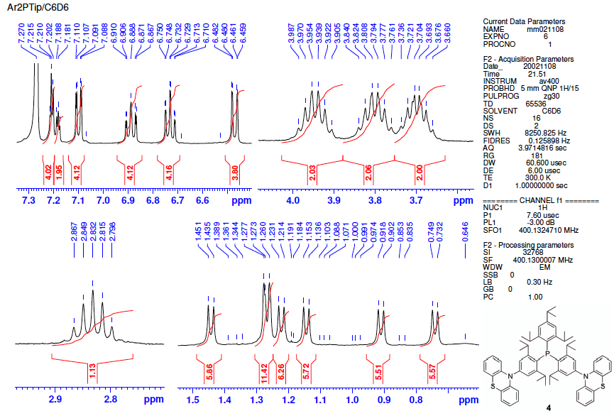
Figure S 2. ¹H NMR (400 MHz, C₆D₆, 300 K) spectrum of 4 (expanded plots).

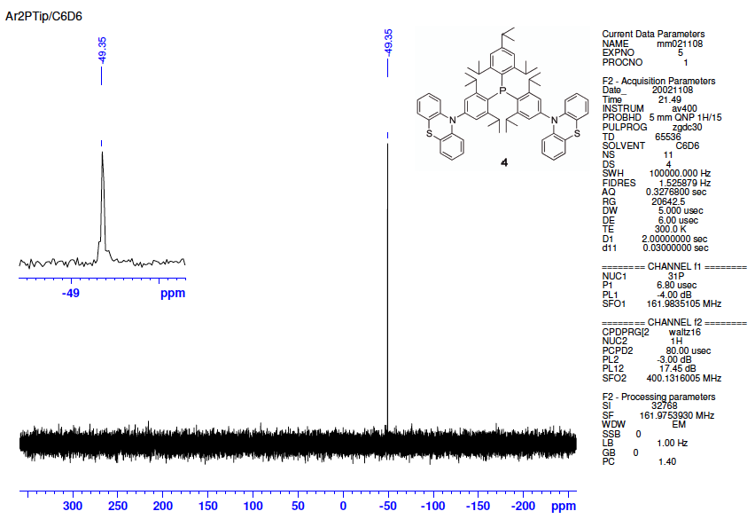
Figure S 3. ³¹P NMR (162 MHz, C₆D₆, 300 K) spectrum of 4.

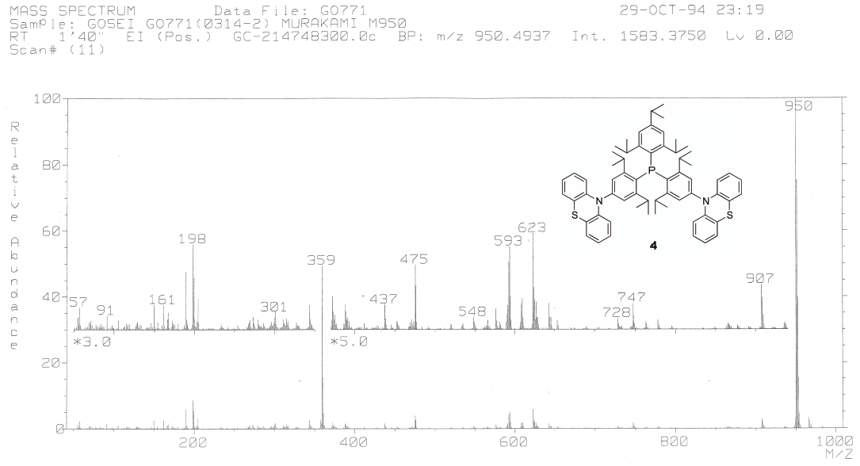
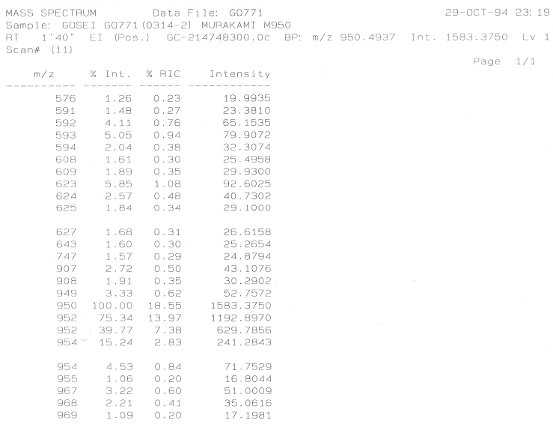
Figure S 4. Mass spectrum (EI, 70 eV) of 4.

