**Appendices**

This supplementary material explicitly develops the derivations of the solutions and the proof of the conclusions. If the paper is deemed publishable, these Appendices need not be published but can be supplied to interested readers by authors separately.

**Appendix A. Derivation of Solution 1.**

Since  and , we have

.

With the first order condition, we can get . Additionally, since , we know  when  and  when , which indicates that  is a quasi-concave function with respect to . Therefore,  is the unique maximizer of the profit .

Substituting Eq. (3) into (4), we have

 (A.1)

The first derivative of  with respect to  is

.

With the first order condition, we have

. (A.2)

Since , , , and , we know when  and when , which indicates that  is a quasi-concave function with respect to . Substituting  into Eq. (A.1), we have

.

The first derivative of  with respect to  is:

.

Define  and , resorting to Lemma 1 in Ru and Wang (2010), we know that  and  is increasing in . Thus, we have , which indicates that  is also increasing in . Since  and ,  implies that the optimal stocking factor satisfies , which is Eq. (6). Meanwhile, for any given ,  for all  and  for all . Therefore,  is the unique maximizer of . Substituting  back into Eq. (A.2), and using , we can get the solutions determined in Eqs. (5), (6), and (7). Therefore, we complete the proof.

**Appendix B. Proof of Proposition 1.**

To ease of exposition, we truncate the superscript and subscript of the parameters and variables. First, we prove the selling price and stocking factor are both decreasing in inventory availability . We prove the second part of Proposition 1 in the first place.

(2) Since  is increasing in  as [1], if the failure rate function  is increasing in , according to the monotonicity of compound function that  is increasing in  if  is increasing in  and  is increasing in , we have that  is increasing in  such that the first derivative of  is , which implies . Therefore, the first derivative of  with respect to  is  as  represents the demand and it satisfies . Thus,  is increasing in  and .

To prove the conclusion, for any given , we rearrange Eq. (6) as

.

Define

,

where

.

In the first place, we need to prove that  is increasing in . Resorting to Lemma 1 in Ru and Wang (2010), we know that  is increasing in . Since ,  is increasing in . According to the monotonicity of compound function, we have that  is increasing in . Thus,  is increasing in  and .

Next, we need to prove that  is increasing in . Taking the first derivative of  with respect to  and with some algebra, we have

.

Define , then the above equation can be rewritten as

.

The first factor in the expression is always positive as ,  and . Thus, if ,  is increasing in . To verify this, we take the first derivative of  with respect to  as



It is ease to verify that, for any  where , ,  and  in the above expression are all nonnegative. In addition, , we have , which shows that  is increasing in  and . Therefore, , meaning that  is increasing in . We have



The first inequality holds as  and the second inequality holds as  is increasing in  such that . The inequality indicates that, for ***any given*** ,  holds. Additionally, from the assumption of stocking factor, we know . To keep the valid of the above inequality, we have .

Finally, according to the derivative rule of the implicit function, we have  such that  is decreasing with respect to inventory availability . Therefore,  is increasing in  as  is decreasing in .

(1) The first derivative of retail price with respect to inventory availability is

.

The inequality holds as , , , ,  and . Thus, the selling price is decreasing in  such that it increases in  as  is decreasing in .

With the same procedure, one can prove that both stocking factor and selling price are increasing in .

(3) Since , we know the optimal wholesale price is independent of shrinkage rate and misplacement rate.

Therefore, we complete the proof.

**Appendix C. Derivation of Solution 2.**

Since  and , we have

.

With the first order condition, we can get . Additionally, since , we know  when  and  when , which indicates that  is a quasi-concave function with respect to . Therefore,  is the unique maximizer of the profit .

Substituting Eq. (8) into (9), we have

 (A.3)

The first derivative of  with respect to  is

.

With the first order condition, we have

.

Since , , , and , we know when  and when , which indicates that  is a quasi-concave function with respect to . Therefore, we have

. (A.4)

Substituting  into Eq. (A.3), we have

.

The first derivative of  with respect to  is:

.

Similarly, according to the proof of Proposition 1,  is the unique maximizer of  and it can be determined by , which is Eq. (11). Substituting  back into Eq. (A.4), we can get the solutions determined in Eqs. (10), (11), and (12). Therefore, we complete the proof.

**Appendix D. Proof of Proposition 2.**

Following the same procedure in the proof of Proposition 1, rewrite Eq. (11),

.

Define , where . According to the proof of Proposition 1, we know that  is increasing in  and . Therefore,

.

With the similar process, we know  is increasing in  and decreasing in  as  is increasing in . In terms of the tag price, from the proof of Proposition 1, we know that the right hand side of Eq. (11) is increasing in ; however the left hand side of Eq. (11) is decreasing in . Thus,  is decreasing in . Additionally,

.

The selling price is decreasing in  such that it increases in  and decreases in  as  is decreasing in  and increasing in . It is straightforward to see that  is increasing in .

To prove the third part of Proposition 2, we know that  and

.

The second equality holds as  from the rearrangement of Eq. (11). Thus,

.

We derive

.

Thus, the profit is increasing in  such that it decreases in  and increases in  as  is decreasing in  and increasing in . On the other hand,

.

The inequality holds as  and . Therefore, the profit is decreasing in . We complete the proof.

**Appendix E. Derivation of Solution 3.**

Since , and , taking the first derivative of this function with respect to  as

.

Since ,  implies that . Meanwhile, for any given , , for all  and, for all . Thus,  is the unique maximizer of . Substituting  back into Eq. (13), we have . The first derivative of  with respect to  is:

.

According to the proof of Proposition 1, we know that the expression in the bracket is increasing in . Since , , and ,  implies that the optimal stocking factor satisfies . Meanwhile, for any given ,  for all  and  for all . Therefore,  is the unique maximizer of  and it is determined by Eq. (16). Substituting  into , we get , which is Eq. (15).

Substituting  and  into Eq. (14), we have

.

Taking the first derivative of the above function with respect to , we get

.

Following the same procedure, since the first term in the above expression is always positive, let  we get . Meanwhile, for any given ,  for all  and  for all , thus,  is the unique maximizer of . Additionally, , we have the equilibrium price shown in Eq. (15). The proof is complete.

**Appendix F. Proof of Proposition 3.**

The proof of the first two parts in Proposition 3 is analogous to the proof of Proposition 1 and the proof of the third part of Proposition 3 is similar to the proof of the first and second parts. Therefore, to save the space, we omit the proof.

**Appendix G. Derivation of Solution 4.**

Since , and , taking the first derivative of this function with respect to  as

.

Since ,  implies that . Meanwhile, for any given , , for all  and, for all . Thus,  is the unique maximizer of . Substituting  back into Eq. (18), we have . The first derivative of  with respect to  is:

.

According to the proof of Proposition 1, we know that the expression in the bracket is increasing in . Since , , and ,  implies that the optimal stocking factor satisfies . Meanwhile, for any given ,  for all  and  for all . Therefore,  is the unique maximizer of  and it is determined by Eq. (21). Substituting  into , we get , which is Eq. (22).

Substituting  and  into Eq. (19), we have

.

Taking the first derivative of the above function with respect to , we get

.

Following the same procedure, since the first term in the above expression is always positive, let  we get . Meanwhile, for any given ,  for all  and  for all , thus,  is the unique maximizer of . Additionally, , we have the equilibrium price shown in Eq. (20). The proof is complete.

**Appendix H. Proof of Proposition 4.**

The proof of the first two parts in Proposition 4 is analogous to the proof of Proposition 2 and the proof of the third part of Proposition 4 is similar to the proof of the first and second parts. Therefore, to save the space, we omit the proof.

**Appendix I. Some Analytical and Numerical Results for the Linear Demand Case**

In the following, we present the procedures and part of the numerical results when the linear demand function is adopted. To better present the analysis procedure, both non-RFID case and RFID case are developed to analyze the optimal decisions.

We assume that the demand for product is price-dependent and stochastic during the decision period and it takes the widely-used additive model as stated in Petruzzi and Dada (1999)

**,

where  is deterministic and decreasing in selling price , and  is a random scaling factor to capture the demand uncertainty and defined on the range  with mean .

Let  take the following form:

, ,

where  is the potential demand in the market. This model indicates that the expected demand is decreasing in retailer’s retail price . We also assume . The stocking factor is defined by .

**I. Non-RFID case**

**1. Wholesale price contract scenario**

(1) The supplier’s decision

The supplier’s objective function is

.

The first derivative of the above equation with respect to  is:

.

The second derivative of  with respect to  is:

.

Therefore, with the first order condition, we have

 and thus .

Obviously, the supplier’s pricing decision now is sensitive to the retailer’s decision under the linear demand case.

(2) The retailer’s decision

The retailer’s objective function is

.

Since the random variable  is defined on the range , we know  is defined on the range . Rewriting the above objective function as:

,

where  and the first derivative of  with respect to  is . Hence, the first derivative of the retailer’s objective function with respect to  is:

.

Unfortunately, we cannot solve the above equation analytically. However, the optimal *U\** can be found easily through numerical method. Once *U\** is found, other optimal solutions and profits can be obtained by substituting *U\** into the corresponding functions.

**2. Consignment contract scenario**

The supplier’s objective function is

.

where  and the first derivative of  with respect to  is . Thus, the first derivative of the supplier’s objective function with respect to  is:

.

Letting , we may have the wholesale price . But the equation is complicated and it is intractable to verify that when , , and when , . Thus, we cannot get the optimal wholesale price as we did in Eq. (17). Even worse, we cannot obtain the corresponding optimal selling price and stocking factor in this case.

**II. With-RFID case**

When RFID technology is applied, the misplacement inventory and some of the shrinkage inventory can be recovered for sale instantly, and some of the shrinkage inventory cannot be recovered. We assume that the inventory availability in RFID case is . The RFID tag cost is shared between the retailer () and the supplier ().

**1. Wholesale price contract scenario**

(1) The supplier’s decision

The supplier’s objective function is

.

The first derivative of the above equation with respect to  is:

.

The second derivative of  with respect to  is:

.

Therefore, with the first order condition, we have

 and thus .

Again, in RFID case, the supplier’s pricing decision depends on the retailer’s decision under the linear demand case.

(2) The retailer’s decision

The retailer’s objective function is

.

Since the random variable  is defined on the range , we know  is defined on the range . Rewriting the above objective function as:

,

where . From the previous analysis, we know the first derivative of  with respect to  is . Therefore, the first derivative of the retailer’s objective function with respect to  is:

.

Again, letting , we may have the markup price . But the equation is complicated and it is intractable to verify that when , , and when , . Therefore, we cannot obtain the retailer’s optimal selling price as we did in Eq. (10).

**2. Consignment contract scenario**

The supplier’s objective function is

.

where . Additionally, it is ease to verify that the first derivative of  with respect to  is . Thus, the first derivative of the supplier’s objective function with respect to  is:

.

Letting , we may have the wholesale price . But the equation is complicated and it is intractable to verify that when , , and when , . Thus, we cannot get the optimal wholesale price as we did in Eq. (17). Furthermore, we cannot obtain the corresponding optimal selling price and stocking factor either.

Despite the infeasibility, to further investigate the impact of the inventory inaccuracy and RFID technology on the contract preference, we conduct some numerical study using the same parameter-values set in the manuscript. The impact of the parameters on the retailer’s and the supplier’s profits are shown in Fig. A.1 and Fig. A.2, where the superscript *AW (AC)* represents the *A*dditivelinear demand function in the *W*holesale price contract (*C*onsignment contract), the first letter in the subscript (*R* or *S*) refers to the *R*etailer or the *S*upplier and the second letter (*N* or *R*) refers to *N*on-RFID case or *R*FID case. The retailer’s and the supplier’s preferences for the contract type are summarized in Fig. A.3.

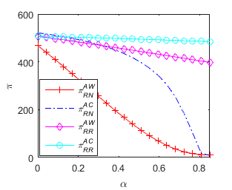 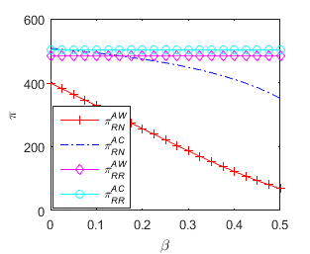

a) On shrinkage rate b) On misplacement

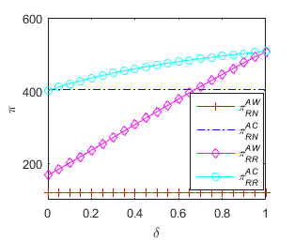 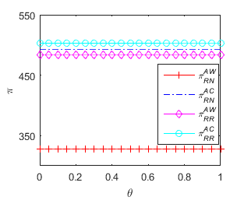

c) On inventory recovery rate d) On RFID tag cost sharing rate

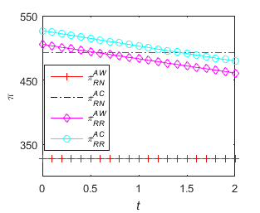 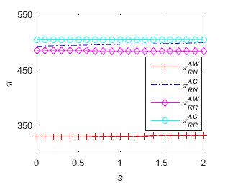

e) On RFID tag price f) On salvage value

**Fig. A.1.** Sensitivity analysis on the retailer when the linear demand is used

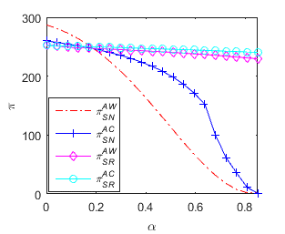 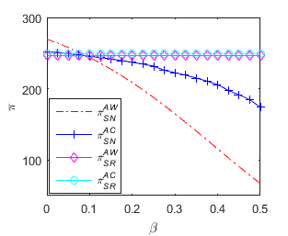

a) On shrinkage rate b) On misplacement

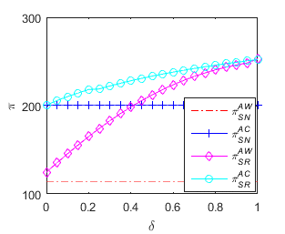 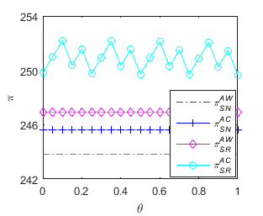

c) On inventory recovery rate d) On RFID tag cost sharing rate

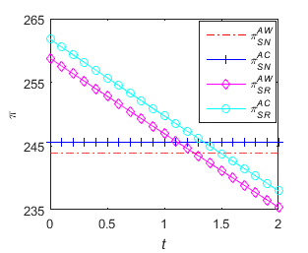 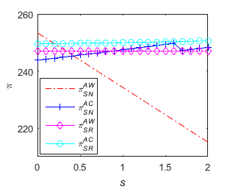

e) On RFID tag price f) On salvage value

**Fig. A.2.** Sensitivity analysis on the supplier when the linear demand is used

Wholesale price contract

Supplier

Retailer

Consignment contract





**Fig. A.3.** Contract selection for the supplier and the retailer

b) With inventory availability

a) With RFID cost



Wholesale price contract

Supplier

Retailer

Consignment contract

Consignment contract





1. If , there is no need to operate the supply chain as all the inventory are lost permanently.