Determination of ractopamine residue in tissues and urine
from swine fed meat and bone meal

Carolina N. Aroeiraª, Vivian Feddern^{b,}, Vanessa Gressler^{b}, Luciano Molognoni^{c}, Heitor Daguer^{c}, Osmar A. Dalla Costa^{b}, Gustavo J. M. M. de Lima^{b} and Carmen J. C. Castilloª

ª Escola Superior de Agricultura Luiz de Queiroz, USP/Esalq, Av. Pádua Dias 11, 13418-900 Piracicaba/SP, Brazil
^{b} Embrapa Suínos e Aves, BR 153, km 110, 89715-899 Concórdia/SC, Brazil
^{c} Ministério da Agricultura, Pecuária e Abastecimento, Laboratório Nacional Agropecuário (Lanagro/RS), Rua João Grumiché 117, 88102-600 São José/SC, Brazil

Supplementary material
Urine method extraction. Urine samples were homogenised and transferred into 50 mL polyethylene tubes. Aliquots of known negative urine were used for spiking and to provide blank chromatograms. A summary of the procedure used for urine sample pre-treatment and subsequent extraction and clean-up is illustrated in Figure S1.
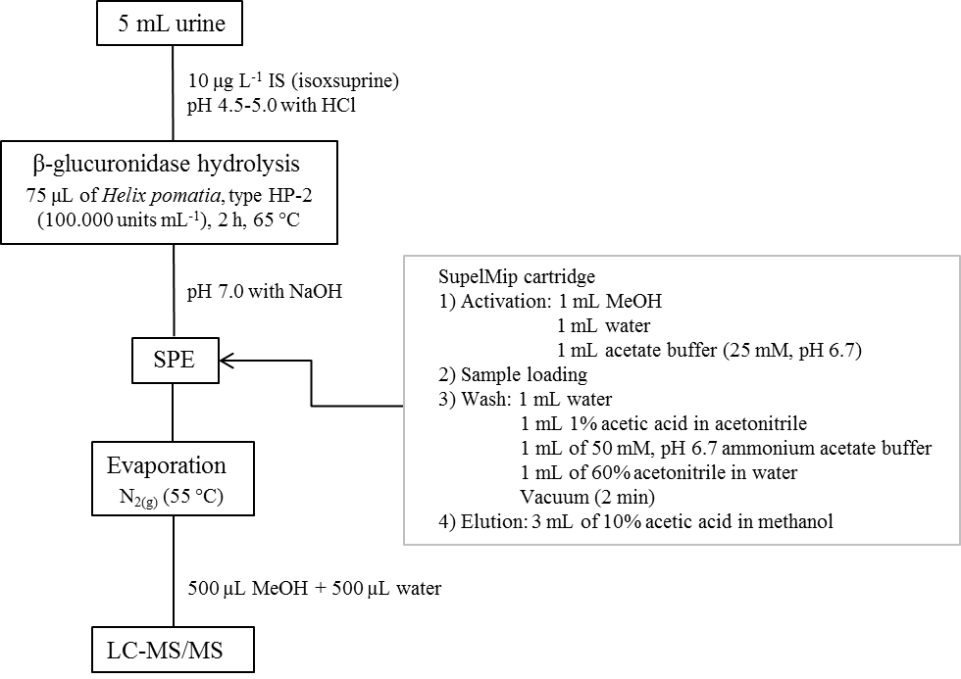
Figure S1. Overview of the complete sample-preparation and clean-up procedure for analysis of ractopamine in swine urine.
LC-MS/MS analysis. The HPLC system consisted of a Surveyor Plus (Thermo Scientific). The LC column was a Kinetex C18 100A (150 x 4.6 mm, 5 μm; Phenomenex) with a C18 guard column. The mobile phase was 0.1% formic acid in methanol (A) and 0.1% formic acid in water (B). The gradient elution was: 15% A (0 to 0.5 min), 100% A (0.5 to 3.0 min), 100% A (3.0 to 7.0 min), 15% A (7.0 to 7.5 min), and 15% A (7.5 to 10.0 min). Injection volume of 10 μL, flow rate of 1.0 mL min⁻¹, and column temperature of 30 ºC were also set. The LC was coupled via an ESI probe to a MS/MS system (Quantum Access Max, Thermo Scientific). The source was maintained at 305 ºC and vaporised capillary temperature was carried out at 300 ºC. Nitrogen was used as the sheath gas and auxiliary gas at 45 and 20 psi, respectively. Spray voltage was set at 4.5 kV. Multiple reaction monitoring (MRM) was used for sample analysis. For RAC, the positive ion m/z 302.2 were selected as the monitor ion and three product ions m/z 284.2 (9 eV), m/z 164.2 (12 eV) and m/z 107.2(30 eV) for confirmation and one ion m/z 164.2 for quantification. Regarding IS (isoxsuprine hydrochloride), the m/z 302.1 ion was selected as the monitor ion and two product ions m/z 284.1 (9 eV) and m/z 150.1 (21 eV) for confirmation and one m/z 150.1 ion for quantification.
Urine method validation. The validation parameters evaluated were according the parameters established by the Ministry of Agriculture, Livestock and Food Supply (Portuguese acronym MAPA: Ministério da Agricultura, Pecuária e Abastecimento). Specificity was investigated in 20 blank samples by the identification and quantification of possible interferences close to RAC and IS retention times. No interference peaks were found close to RAC (5.32 min) and IS (5.70 min) retention times. The linearity of the method was evaluated in a matrix-matched calibration curve (n=3) with eight RAC concentration points (0, 1.0, 2.5, 5.0, 10.0, 25.0, 50.0 and 75.0 μg L⁻¹) and IS (10 μg L⁻¹). The equation (y = 0.885x + 0.045) obtained showed a coefficient of determination R² of 0.9987. Recovery was assayed by the blank sample fortification in three levels of concentration (2.5, 10.0, and 50.0 μg L⁻¹) in six replicates. The recovery rates obtained were 106.2, 102.3, and 109.7%, respectively. Repeatability (intra-day precision) were 2.67 (± 0.11), 10.72 (± 0.54) and 48.48 (± 2.76) μg L⁻¹, for 2.5, 10 and 50 μg L⁻¹ respectively. Reproducibility (inter-day precision, within-laboratory) were 2.61 (± 0.32), 10.70 (± 0.50) and 48.35 (± 1.14) μg L⁻¹, for 2.5, 10.0 and 50.0 μg L⁻¹ respectively. The limits of detection (LOD) were established based on a 3:1 signal to baseline noise ratio in a low-level matrix containing standard and limits of quantification (LOQ) were established based on a 10:1 signal to baseline noise ratio. LOD and LOQ levels were determined to be 0.05 and 0.15 μg L⁻¹ for RAC, respectively.
A typical chromatogram of RAC residues (10 μg L⁻¹) and the internal standard isoxsuprine (10 μg L⁻¹) in urine is shown in Figure S2.

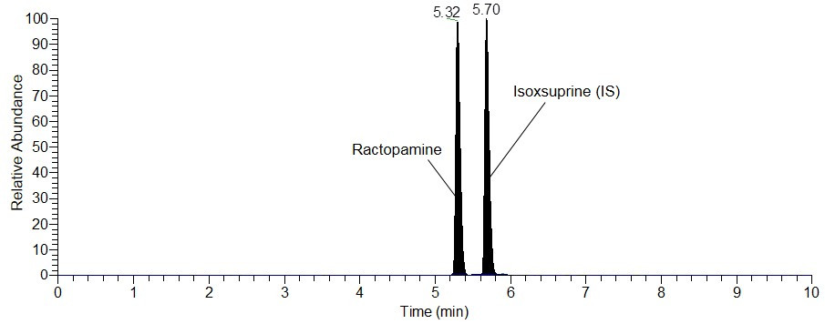
Figure S2. Chromatogram of RAC residues in spiked urine (10 μg L⁻¹), as well as the internal standard isoxsuprine (10 μg L⁻¹).

Address correspondence to: vivian.feddern@embrapa.br
MAPA. (2011). Guia de Validação e Controle de Qualidade Analítica: fármacos em produtos para alimentação e medicamentos veterinários. (Ministério da Agricultura Pecuária e Abastecimento, Ed.), Toxicologia Analítica (1st ed.). Brasília: MAPA/ACS. Retrieved from: http://www.agricultura.gov.br/assuntos/laboratorios/arquivos-publicacoes-laboratorio/guia-de-validacao-controle-de-qualidade-analitica.pdf

