Supplemental Table 1. Summary of studies used in the meta-regression for 6M-CDP reported at 24 months
Study | Treatment 1 | Event 1 | Total 1 | Treatment 2 | Event 2 | Total 2 | Treatment 3 | Event 3 | Total 3 | Arms
AFFIRM trial | Placebo | 72 | 315 | Natalizumab | 69 | 627 | NA | NA | NA | 2
BECOME trial | Glatiramer acetate | 6 | 39 | IFN-β1a 250mcg | 4 | 36 | NA | NA | NA | 2
BRAVO trial | Placebo | 46 | 450 | IFN -β1a 44mcg | 35 | 447 | NA | NA | NA | 2
CAMMS223 trial | Alemtuzumab 12mg | 4 | 113 | IFN -β1a 44mcg | 19 | 111 | NA | NA | NA | 2
CARE-MS I trial | Alemtuzumab 12mg | 30 | 386 | IFN -β1a 44mcg | 21 | 195 | NA | NA | NA | 2
CARE-MS II trial | Alemtuzumab 12mg | 54 | 436 | IFN -β1a 44mcg | 43 | 231 | NA | NA | NA | 2
CONFIRM trial | Placebo | 45 | 363 | Dimethyl fumarate | 28 | 362 | Glatiramer acetate | 38 | 360 | 3
Decide Trial | Daclizumab | 83 | 919 | IFN -β1a 30mcg | 111 | 922 | NA | NA | NA | 2
DEFINE | Placebo | 69 | 410 | Dimethyl fumarate | 52 | 411 | NA | NA | NA | 2
FREEDOMS II trial | Placebo | 63 | 355 | Fingolimod | 49 | 358 | NA | NA | NA | 2
FREEDOMS trial | Placebo | 79 | 418 | Fingolimod | 53 | 425 | NA | NA | NA | 2
MSCRG trial | Placebo | 50 | 143 | IFN -β1a 30mcg | 35 | 158 | NA | NA | NA | 2
REGARD trial | Glatiramer acetate | 33 | 378 | IFN -β1a 44mcg | 45 | 386 | NA | NA | NA | 2
TEMSO trial | Placebo | 68 | 363 | Teriflunomide 14mg | 49 | 359 | Teriflunomide 7mg | 51 | 366 | 3
TOWER trial | Placebo | 46 | 389 | Teriflunomide 14mg | 43 | 372 | Teriflunomide 7mg | 61 | 408 | 3
CLARITY trial | Placebo | 73 | 437 | Cladribine Tablets | 41 | 433 | NA | NA | NA | 2
OPERA I trial | IFN -β1a 44mcg | 44 | 411 | Ocrelizumab | 27 | 410 | NA | NA | NA | 2
OPERA II trial | IFN -β1a 44mcg | 57 | 418 | Ocrelizumab | 36 | 417 | NA | NA | NA | 2
PRISMS trial (unpublished data) | Placebo | 113 | 187 | IFN -β1a 44mcg | 80 | 184 | NA | NA | NA | 2
Note. 6M-CDP: 6-month confirmed disability progression; IFN: interferon; mcg: microgram; mg: milligram; NA: not applicable.

Supplemental Table 2. Summary of studies used in the meta-regression for 3M-CDP reported at 24 months
Study | Treatment 1 | Event 1 | Total 1 | Treatment 2 | Event 2 | Total 2 | Treatment 3 | Event 3 | Total 3 | Arms
AFFIRM trial | Placebo | 91 | 315 | Natalizumab | 107 | 627 | NA | NA | NA | 2
BEYOND trial | Glatiramer acetate | 92 | 448 | IFN -β1b 250mcg | 244 | 897 | NA | NA | NA | 2
Bornstein 1987 | Placebo | 11 | 25 | Glatiramer acetate | 5 | 25 | NA | NA | NA | 2
BRAVO trial | Placebo | 60 | 450 | IFN -β1a 30mcg | 47 | 447 | NA | NA | NA | 2
CAMMS223 trial | Alemtuzumab 12 mg | 11 | 113 | IFN -β1a 44mcg | 24 | 111 | NA | NA | NA | 2
CONFIRM trial | Placebo | 62 | 363 | Dimethyl fumarate | 47 | 362 | Glatiramer acetate | 56 | 360 | 3
Copolymer1 trial | Placebo | 31 | 126 | Glatiramer acetate | 27 | 125 | NA | NA | NA | 2
Decide Trial | Daclizumab | 118 | 919 | IFN -β1a 30mcg | 138 | 922 | NA | NA | NA | 2
DEFINE Trial | Placebo | 89 | 410 | Dimethyl fumarate | 57 | 411 | NA | NA | NA | 2
FREEDOMS II trial | Placebo | 103 | 355 | Fingolimod | 91 | 358 | NA | NA | NA | 2
FREEDOMS trial | Placebo | 101 | 418 | Fingolimod | 75 | 425 | NA | NA | NA | 2
IFNB MS trial | Placebo | 56 | 123 | IFN -β1b 250mcg | 43 | 124 | NA | NA | NA | 2
PRISMS trial | Placebo | 68 | 187 | IFN -β1a 22mcg | 49 | 189 | IFN -β1a 44mcg | 47 | 184 | 3
TEMSO trial | Placebo | 99 | 363 | Teriflunomide 14 mg | 72 | 359 | Teriflunomide 7 mg | 79 | 366 | 3
TOWER trial | Placebo | 76 | 389 | Teriflunomide 14 mg | 58 | 372 | Teriflunomide 7 mg | 86 | 408 | 3
CLARITY trial | Placebo | 103 | 437 | Cladribine Tablets | 65 | 433 | NA | NA | NA | 2
OPERA I trial | IFN -β1a 44mcg | 53 | 411 | Ocrelizumab | 34 | 410 | NA | NA | NA | 2
OPERA II trial | IFN -β1a 44mcg | 73 | 418 | Ocrelizumab | 46 | 417 | NA | NA | NA | 2
Note. 3M-CDP: 3-month confirmed disability progression; IFN: interferon; mcg: microgram; mg: milligram; NA: not applicable.

Supplemental Table 3. Summary of studies used in the meta-regression for ARR
Study | Treatment 1 | Event 1 | Patient-time at risk 1 | Treatment 2 | Event 2 | Patient-time at risk 2 | Treatment 3 | Event 3 | Patient-time at risk 3 | Arms
ADVANCE trial | Placebo | 181 | 445 | Peg-IFN-β1a 125mcg | 116 | 436 | NA | NA | NA | 2
AFFIRM trial | Placebo | 472 | 738 | Natalizumab | 294 | 1,338 | NA | NA | NA | 2
BECOME trial | Glatiramer acetate 20mg | 23 | 70 | IFN-β1b 250mcg | 25 | 68 | NA | NA | NA | 2
BEYOND trial | Glatiramer acetate 20mg | 374 | 1,100 | IFN-β1b 250mcg | 814 | 2,260 | NA | NA | NA | 2
Bornstein 1987 | Placebo | 62 | 46 | Glatiramer acetate 20mg | 16 | 47 | NA | NA | NA | 2
BRAVO trial | Placebo | 275 | 809 | IFN-β1a 30mcg | 215 | 827 | NA | NA | NA | 2
Calabrese 2012 | Glatiramer acetate 20mg | 52 | 103 | IFN-β1a 30mcg | 51 | 102 | IFN-β1a 44mcg | 40 | 101 | 3
CARE-MS I trial | Alemtuzumab 12mg | 119 | 661 | IFN-β1a 44mcg | 122 | 313 | NA | NA | NA | 2
CARE-MS II trial | Alemtuzumab 12mg | 236 | 908 | IFN-β1a 44mcg | 201 | 387 | NA | NA | NA | 2
CombiRx trial | Glatiramer acetate 20mg | 70 | 651 | IFN-β1a 30mcg | 97 | 604 | NA | NA | NA | 2
CONFIRM trial | Placebo | 212 | 561 | Dimethyl fumarate | 124 | 553 | Glatiramer acetate 20mg | 163 | 570 | 3
Copolymer1 trial | Placebo | 210 | 250 | Glatiramer acetate 20mg | 161 | 273 | NA | NA | NA | 2
Decide Trial | Daclizumab | 500 | 2,274 | IFN-β1a 30mcg | 873 | 2,238 | NA | NA | NA | 2
DEFINE Trial | Placebo | 246 | 612 | Dimethyl fumarate | 128 | 629 | NA | NA | NA | 2
Etemadifar 2006 | IFN-β1a 30mcg | 57 | 60 | IFN-β1a 44mcg | 66 | 60 | IFN-β1b 250mcg | 65 | 60 | 3
European and Canadian Glatiramer trial | Placebo | 91 | 75 | Glatiramer acetate 20mg | 61 | 75 | NA | NA | NA | 2
EVIDENCE trial | IFN-β1a 30mcg | 195 | 304 | IFN-β1a 44mcg | 165 | 305 | NA | NA | NA | 2
FREEDOMS II trial | Placebo | 246 | 615 | Fingolimod | 131 | 624 | NA | NA | NA | 2
FREEDOMS trial | Placebo | 359 | 898 | Fingolimod | 172 | 956 | NA | NA | NA | 2
Gala trial | Placebo | 215 | 446 | Glatiramer acetate 40mg | 290 | 901 | NA | NA | NA | 2
Gate trial | Placebo | 24 | 62 | Glatiramer acetate 20mg | 182 | 512 | NA | NA | NA | 2
IFNB MS trial | Placebo | 266 | 209 | IFN-β1b 250mcg | 173 | 207 | NA | NA | NA | 2
IMPROVE trial | Placebo | 6 | 18 | IFN-β1a 44mcg | 5 | 36 | NA | NA | NA | 2
INCOMIN trial | IFN-β1a 30mcg | 126 | 180 | IFN-β1b 250mcg | 95 | 190 | NA | NA | NA | 2
Kappos 2011 | Placebo | 16 | 24 | IFN-β1a 30mcg | 9 | 25 | NA | NA | NA | 2
Knobler 1993 | Placebo | 5 | 3 | IFN-β1b 250mcg | 2 | 2 | NA | NA | NA | 2
MSCRG trial | Placebo | 235 | 286 | IFN-β1a 30mcg | 212 | 316 | NA | NA | NA | 2
O`Connor 2006 | Placebo | 33 | 41 | Teriflunomide 14mg | 19 | 35 | Teriflunomide 7mg | 24 | 41 | 3
PRISMS trial | Placebo | 479 | 364 | IFN-β1a 22mcg | 344 | 366 | IFN-β1a 44mcg | 318 | 363 | 3
REFORMS trial | IFN-β1a 44mcg | 10 | 14 | IFN-β1b 250mcg | 7 | 15 | NA | NA | NA | 2
REGARD trial | Glatiramer acetate 20mg | 194 | 670 | IFN-β1a 44mcg | 201 | 670 | NA | NA | NA | 2
Saida 2012 | Placebo | 27 | 27 | Fingolimod | 13 | 26 | NA | NA | NA | 2
SELECT trial | Placebo | 88 | 191 | Daclizumab | 43 | 205 | NA | NA | NA | 2
TEMSO trial | Placebo | 335 | 620 | Teriflunomide 14mg | 227 | 614 | Teriflunomide 7mg | 233 | 630 | 3
TENERE Trial | IFN-β1a 44mcg | 29 | 126 | Teriflunomide 14mg | 39 | 144 | Teriflunomide 7mg | 63 | 143 | 3
TOWER trial | Placebo | 296 | 592 | Teriflunomide 14mg | 177 | 553 | Teriflunomide 7mg | 235 | 603 | 3
TRANSFORMS trial | Fingolimod | 89 | 424 | IFN-β1a 30mcg | 179 | 416 | NA | NA | NA | 2
CLARITY trial | Placebo | 252 | 741 | Cladribine Tablets | 109 | 767 | NA | NA | NA | 2
OPERA I trial | IFN-β1a 44mcg | 218 | 753 | Ocrelizumab | 124 | 778 | NA | NA | NA | 2
OPERA II trial | IFN-β1a 44mcg | 214 | 739 | Ocrelizumab | 124 | 777 | NA | NA | NA | 2
Saida 2017 | Placebo | 36 | 21 | Natalizumab | 11 | 21 | NA | NA | NA | 2
Note. ARR: annualised relapse rate; IFN: interferon; mcg: microgram; mg: milligram; NA: not applicable; PEG-IFN: pegylated interferon.

Supplemental Figure 1. Hazard ratios relative to placebo for key comparators by subpopulation from the meta-regression for 6M-CDP
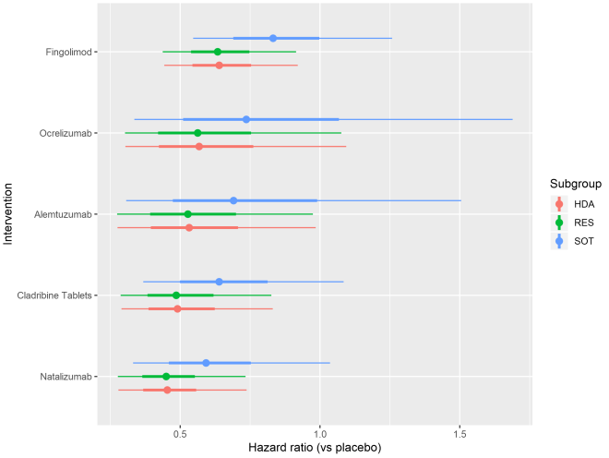
6M-CDP: 6-month confirmed disability progression; HDA: high disease activity; RES: rapidly evolving severe; SOT: sub-optimal therapy; light lines represent range; dark lines represent 95% CI.

Supplemental Figure 2. Rate ratios relative to placebo for key comparators by subpopulation from the meta-regression for ARR
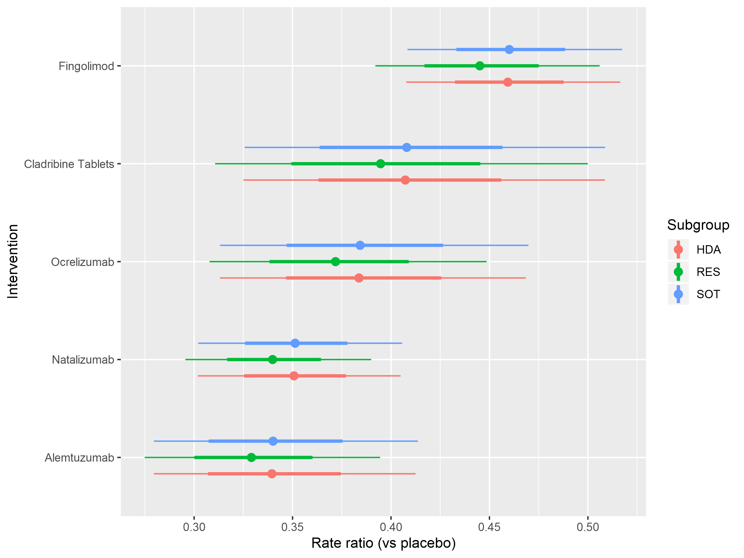
ARR: annualised relapse rate; HDA: high disease activity; RES: rapidly evolving severe; SOT: sub-optimal therapy; light lines represent range; dark lines represent 95% CI.

Supplemental Figure 3. Hazard ratios relative to cladribine tablets for key comparators overall from the meta-regression for 3M-CDP
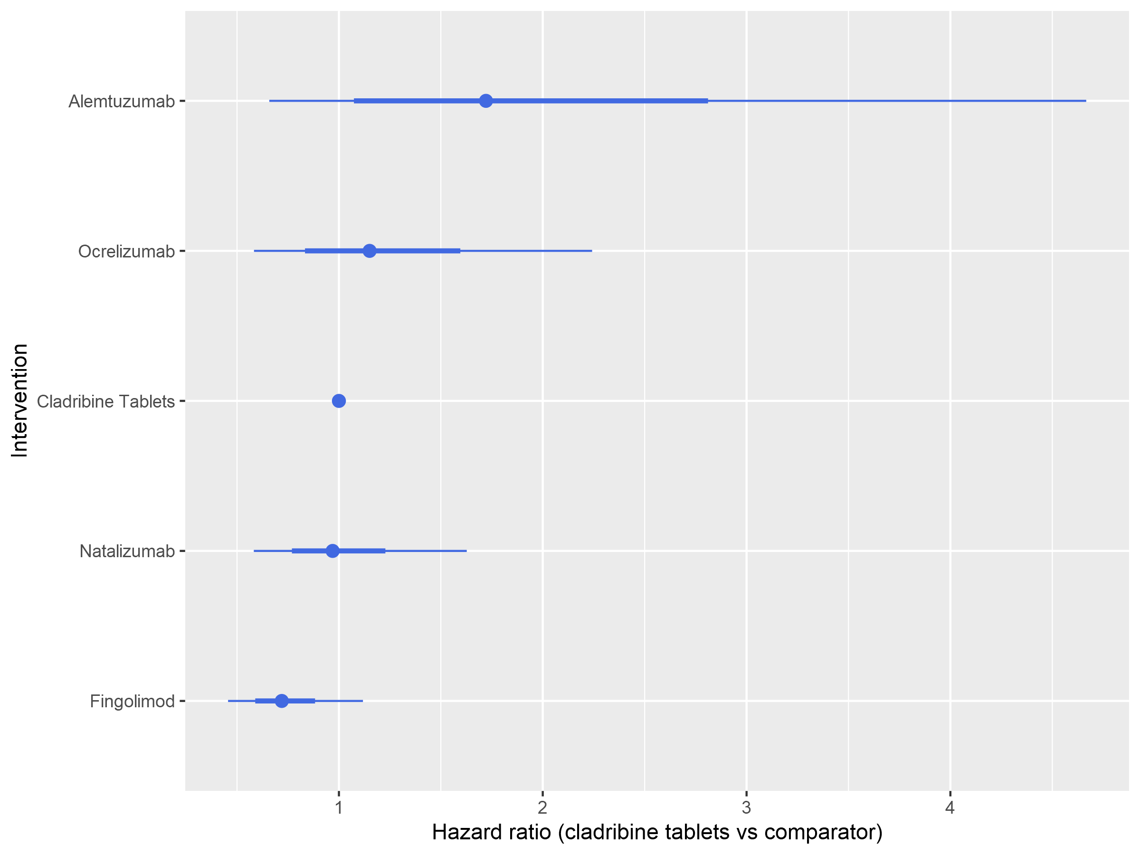
3M-CDP: 3-month confirmed disability progression; light lines represent range; dark lines represent 95% CI.
Supplemental Figure 4: Hazard ratios relative to placebo for key comparators by subpopulation from the meta-regression for 3M-CDP
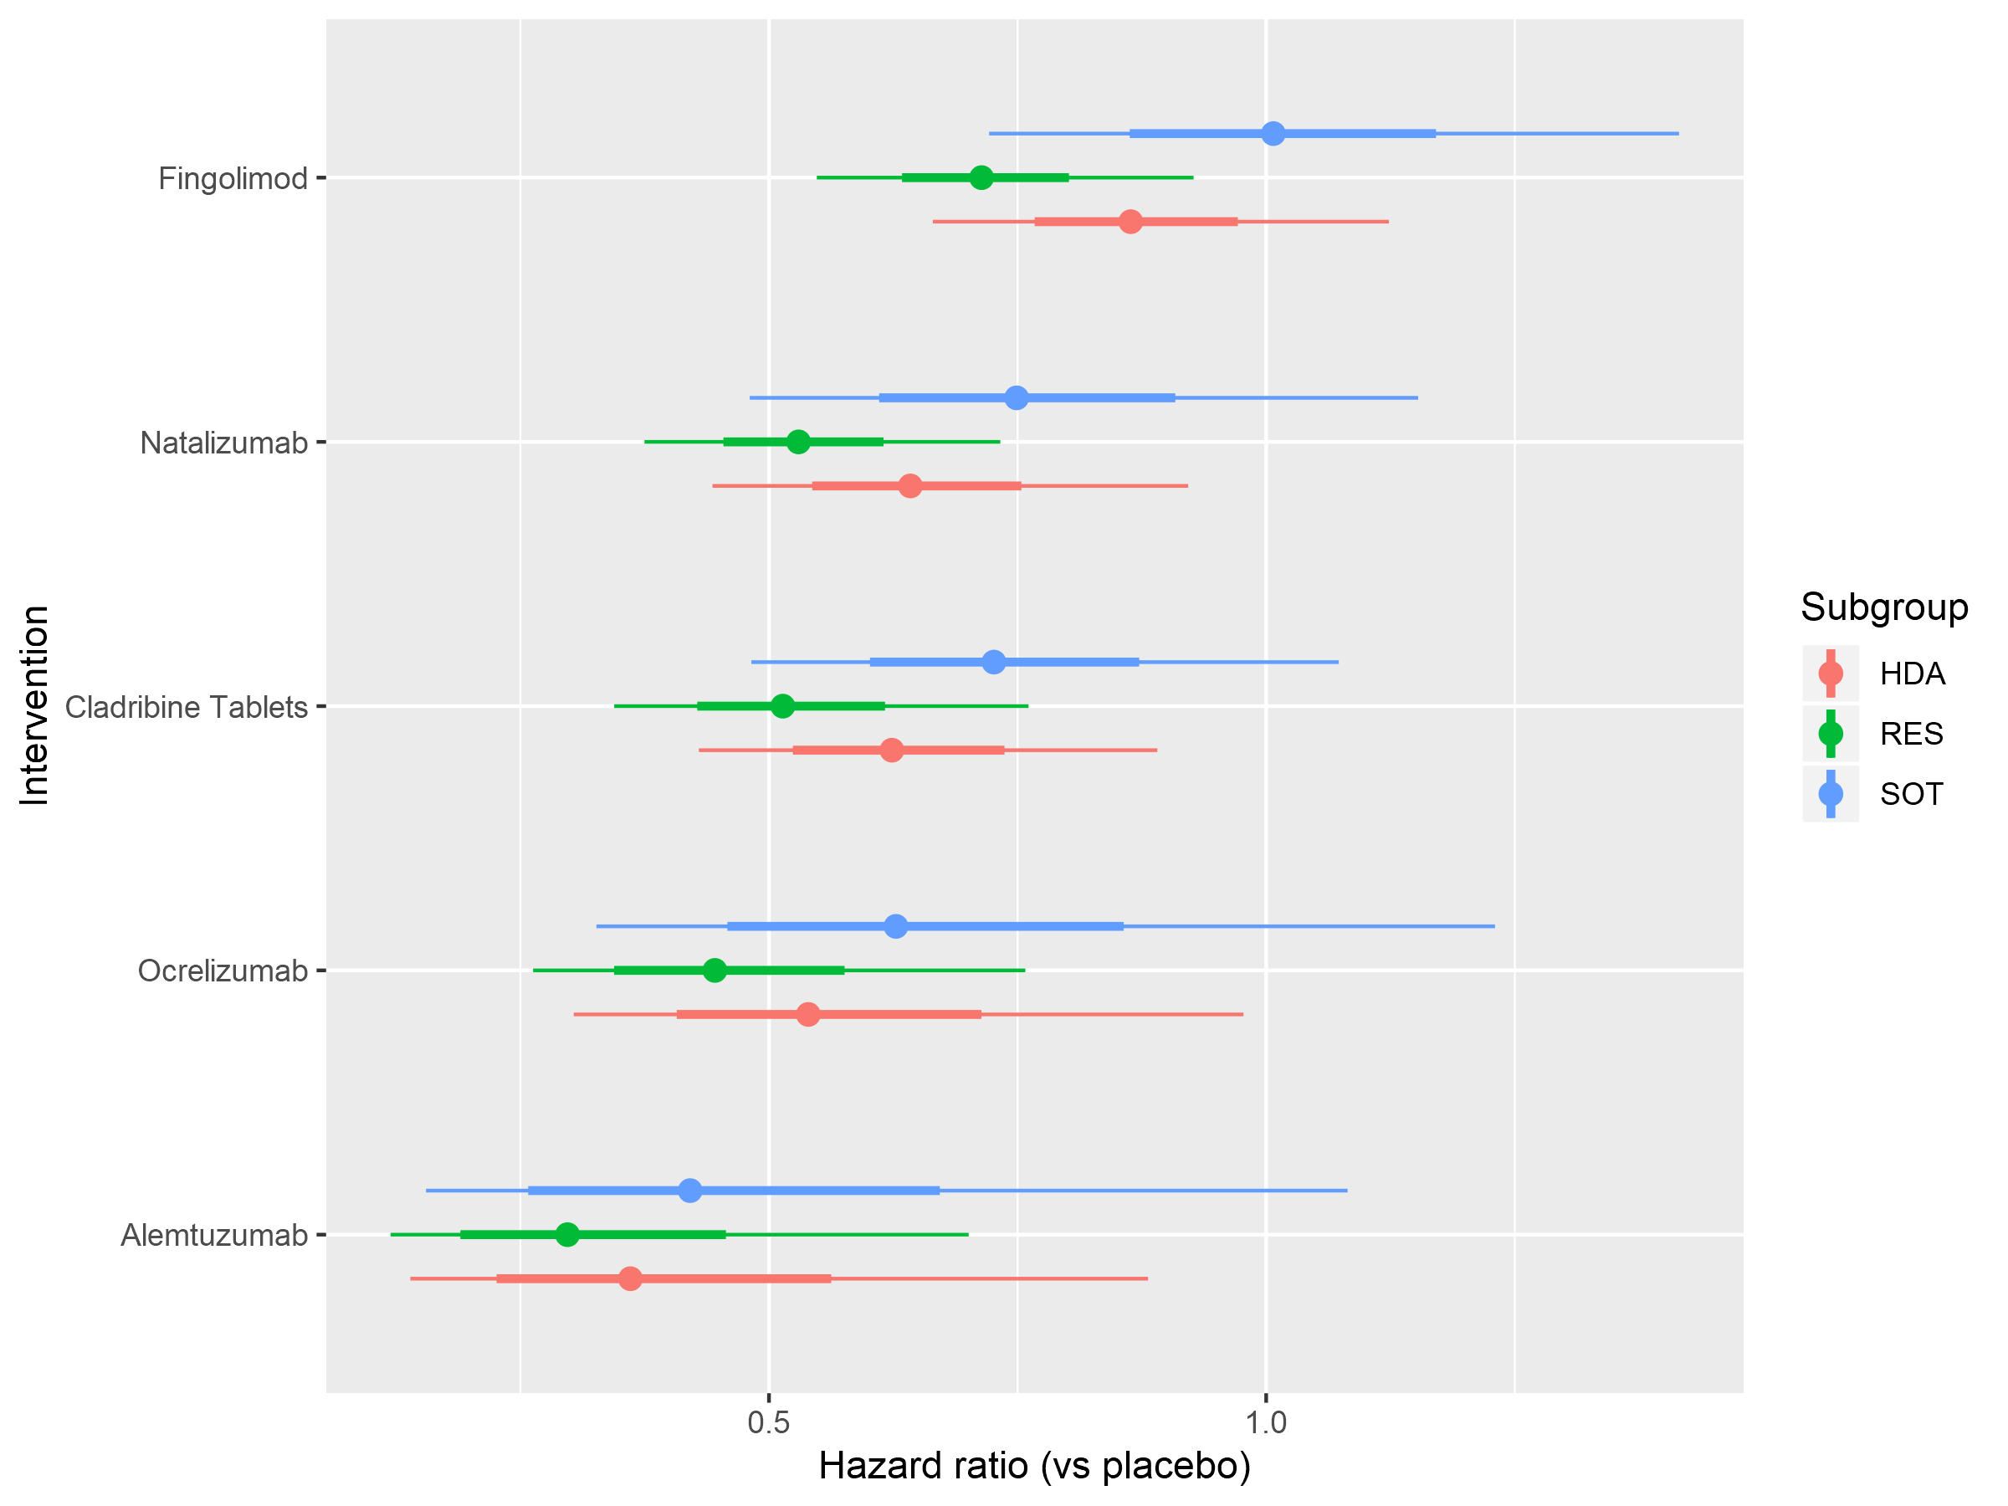
3M-CDP: 3-month confirmed disability progression; HDA: high disease activity; RES: rapidly evolving severe; SOT: sub-optimal therapy; light lines represent range; dark lines represent 95% CI.

