Colonization and growth of dehalorespiring biofilms on carbonaceous sorptive amendments

Staci L. Capozzi^{1,4} Coline Bodenreider¹, Ana Prieto², Rayford B. Payne³, Kevin R. Sowers³, Birthe Veno Kjellerup^{1*}

¹ Department of Civil and Environmental Engineering, University of Maryland, College Park, MD (coline.bodenreider@laposte.net, bvk@umd.edu)
² Department of Civil Engineering, Universidad de Chile, Santiago, Chile (ana.prieto@uchile.cl)
³ Department of Marine Biotechnology, Institute of Marine and Environmental Technology, University of Maryland Baltimore County, Baltimore, MD (payner@umbc.edu, sowers@umbc.edu)
⁴ Geosyntec Consultants, Columbia, Maryland 21046 (scapozzi@geosyntec.com)

*Corresponding author. bvk@umd.edu
1147 Glenn L. Martin Hall
4298 Campus Dr.
College Park MD, 20742
Office: 301-314-1535
Email: bvk@umd.edu

Keywords

Dehalorespiring biofilms; Activated carbon; Polychlorinated biphenyls (PCBs); Quantitative Confocal laser scanning microscopy (Q-CLSM); Contaminated sediment.

Journal: Biofouling

Supporting Information

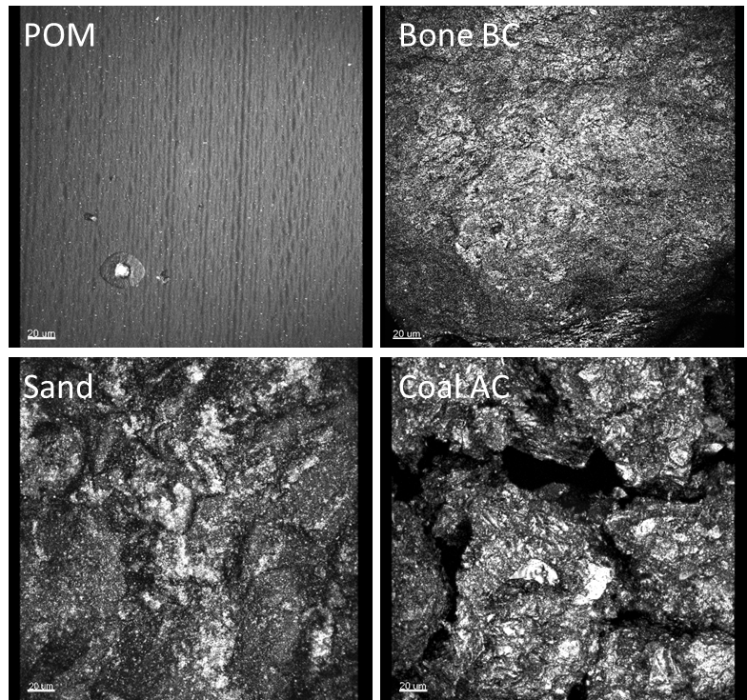

Figure S1. CLSM imaging of the negative controls of the applied materials: POM, Bone BC, sand and coal AC. The results showed that non-selective binding of SYBR Green nucleic acid stain to cellular materials and materials did not occur (n=5). Scale bar = 20 µm.

Figure S2. Scanning Electron Microscopy image showing Dehalobium chlorocoercia DF-1 biofilm formed on applied materials: POM, Bone BC, sand and coal AC. Images from Left to Right: The scale bar is 10 µm for Coal AC, 1 µm for Bone BC, 1 µm for Sand, and 1 µm for POM.

