One-pot Synthesis, theoretical study and antimicrobial activity of
5,5`-(1,4-phenylenebis-(methanylylidene))bis(3-aryl(alkyl)-2-thioxoimidazolidin-4-one) derivatives
Raafat M. Shaker*, Hisham A. Abd El-Naby, Essam Kh. Ahmed, Mahmoud A. A. Ibrahim and Sageda A. Gedamy
Department of Chemistry, Faculty of Science, Minia University, 61519 El-Minia, Egypt
Email: rshaker63@yahoo.com

Table S 1. Relative energies for Z- and E-isomer of 4a, calculated at B3LYP/6-31+G* level of theory.
Conformer | Electronic energy (au) | ΔE (kcal/mol)
4a-1 | -2167.534460 | 0.00
4a-2 | -2167.534328 | 0.08
4a-3 | -2167.531661 | 1.76
4a-4 | -2167.531494 | 1.86
4a-5 | -2167.528627 | 3.66
4a-6 | -2167.527312 | 4.49

Table S 2. Relative energies for thioamide-4α and iminothiol-4β forms of 4a, calculated at B3LYP/6-31+G* level of theory.

Conformer | Electronic energy (au) |  | ΔE (kcal/mol)
 | E_{thioamide-4α form} | E_{iminothiol-4β form}
4a-1 (Z,Z) | -2167.53446 | -2167.49805 | -22.85
4a-3 (E,Z) | -2167.53166 | -2167.49288 | -24.34
4a-5 (E,E) | -2167.52863 | -2167.48838 | -25.26

Table S 3. Relative energies for Z- and E-isomer of 6a, calculated at B3LYP/6-31+G* level of theory.
Conformer | Electronic energy (au) | ΔE (kcal/mol)
6a-1 | -2246.135813 | 0.00
6a-2 | -2246.135402 | 0.26
6a-3 | -2246.130759 | 3.17
6a-4 | -2246.130718 | 3.20
6a-5 | -2246.126039 | 6.13
6a-6 | -2246.124809 | 6.91

Table S 4. Relative energies for Z- and E-isomer of 8a, calculated at B3LYP/6-31+G* level of theory.
Conformer | Electronic energy (au) | ΔE (kcal/mol)
8a-1 | -2246.153108 | 0.00
8a-2 | -2246.151548 | 0.98
8a-3 | -2246.148737 | 2.74
8a-4 | -2246.148544 | 2.86
8a-5 | -2246.144289 | 5.53
8a-6 | -2246.144075 | 5.67

Table S 5. In-vitro antimicrobial activity of the synthesized compounds.
Compounds | MIC in 1mg/mL (zone of inhibition in mm)
 | Gram-positive bacteria  B. cereus |  | Gram-negative bacteria  E. coli |  | Fungi  F. oxysporum
4a | 2 |  | - |  | 2
4b | - |  | - |  | 8
6a | - |  | - |  | 2
6b | 2 |  | - |  | 2
8a | - |  | - |  | 4
8b | 3 |  | - |  | 2
8c | 2 |  | - |  | 4

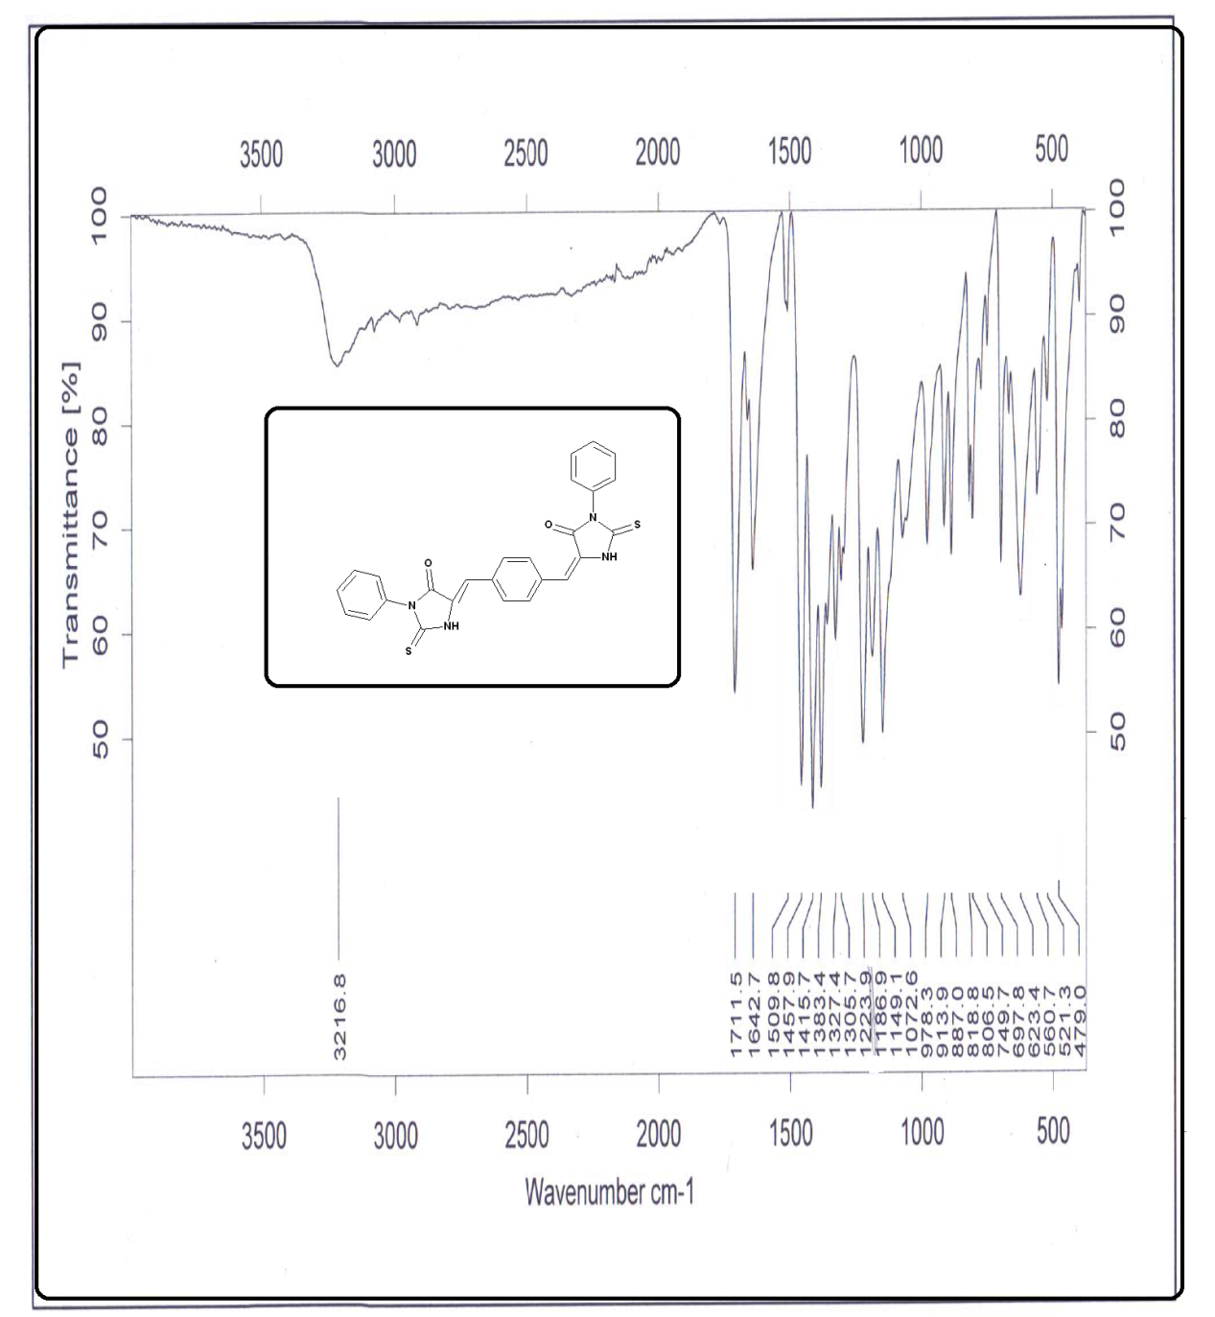
Figure S 1. IR spectrum of compound 4a.

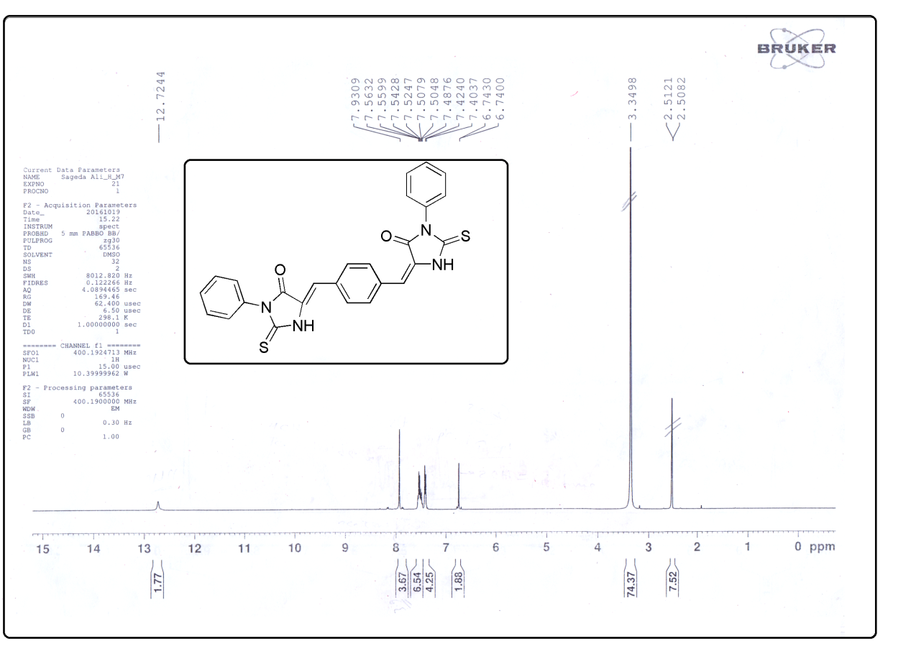
Figure S 2. ¹H NMR of compound 4a.

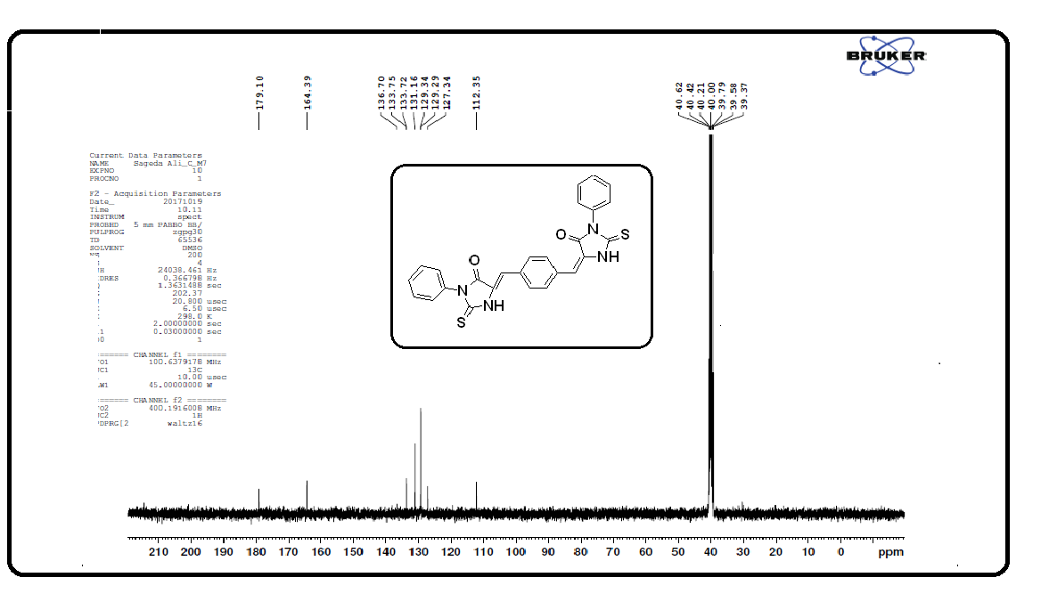
Figure S 3. ¹³C NMR of compound 4a.

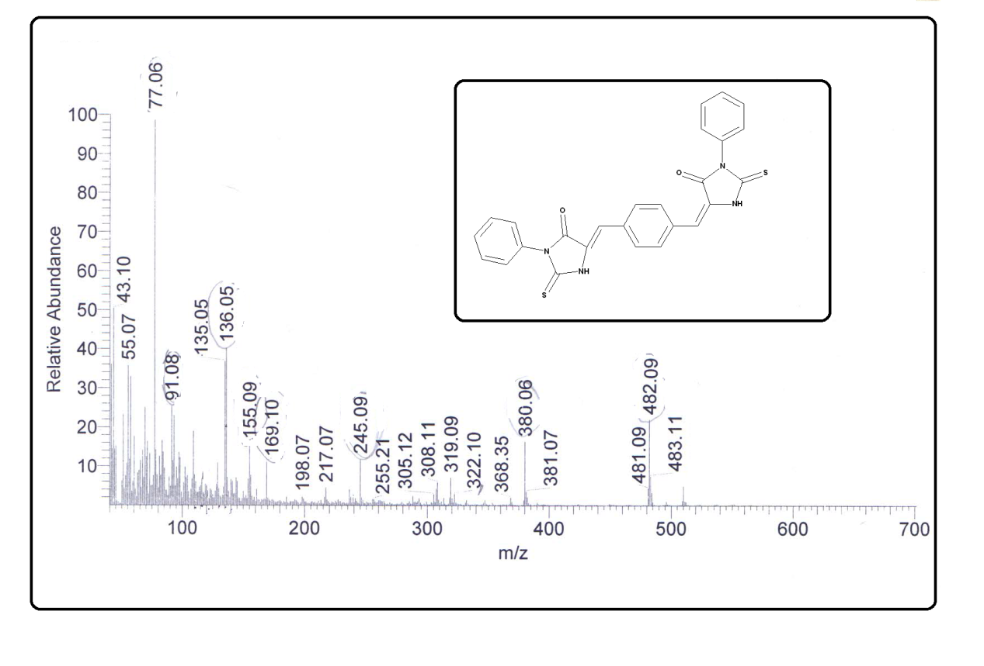
Figure S 4. Mass spectrum of compound 4a.

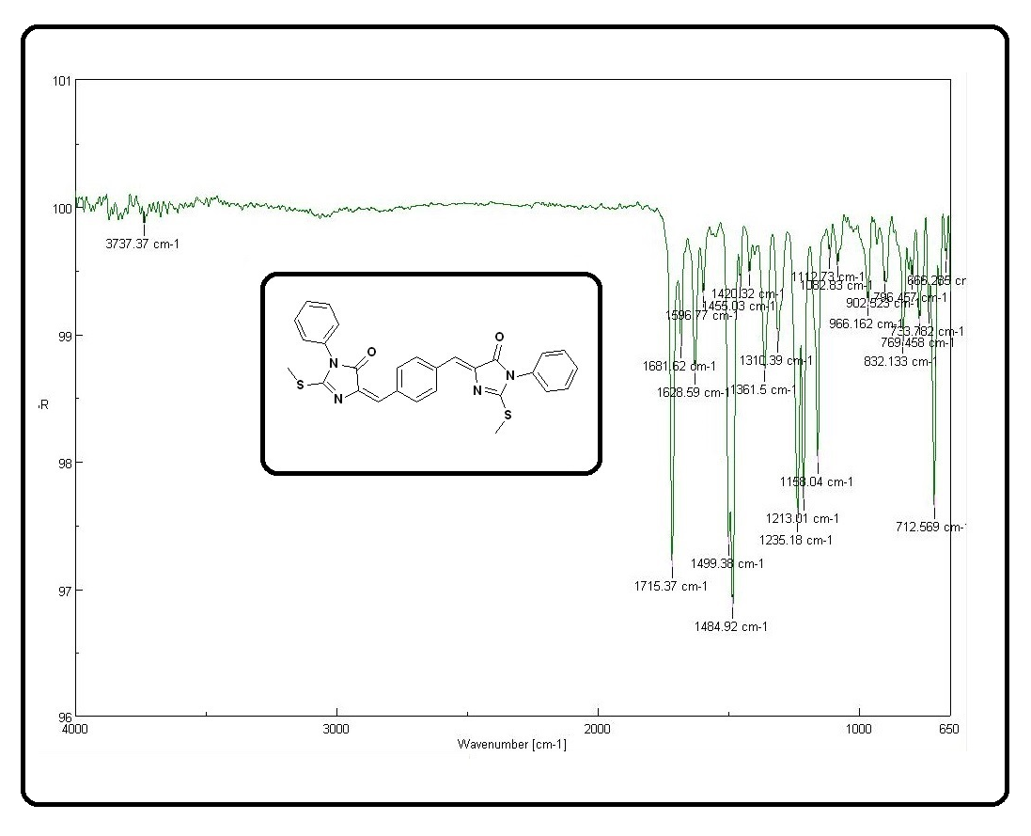
Figure S 5. IR spectrum of compound 6a.

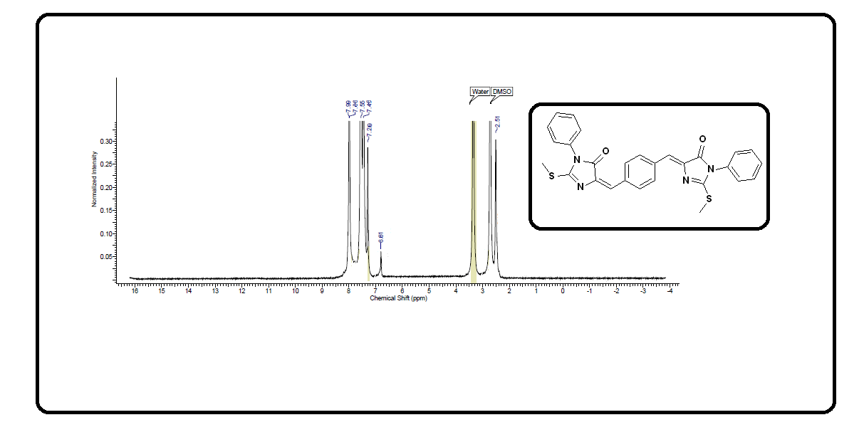
Figure S 6. ¹H NMR of compound 6a.

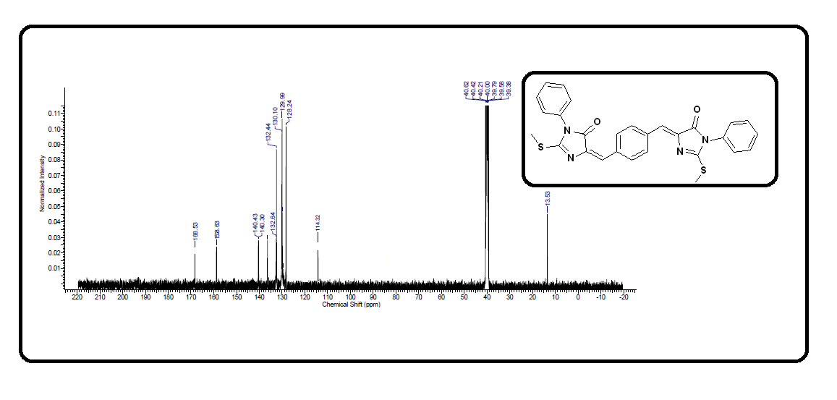
Figure S 7. ¹³C NMR of compound 6a.

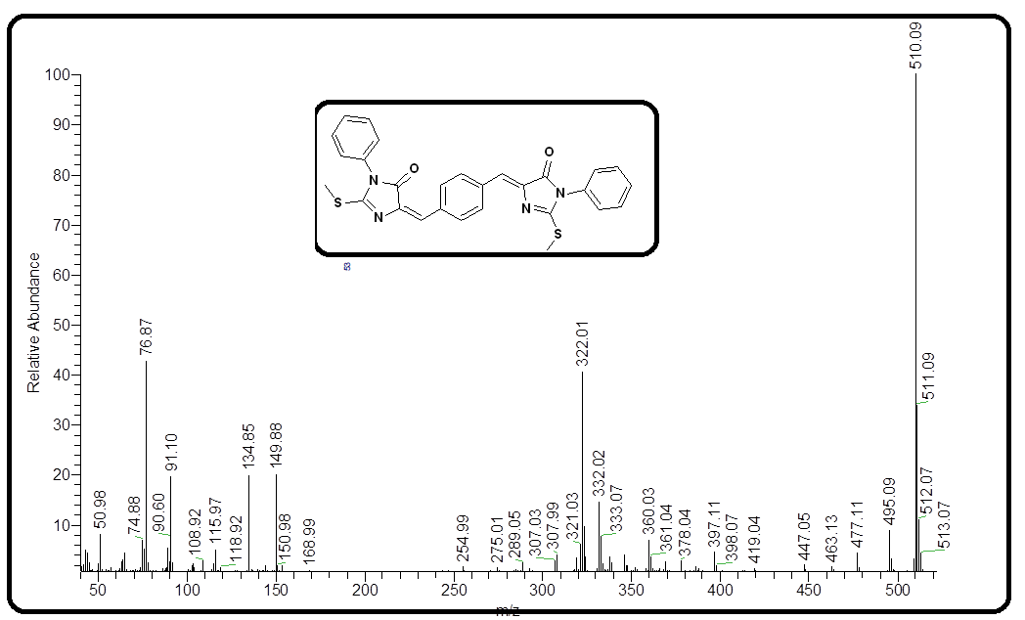
Figure S 8. Mass spectrum of compound 6a.

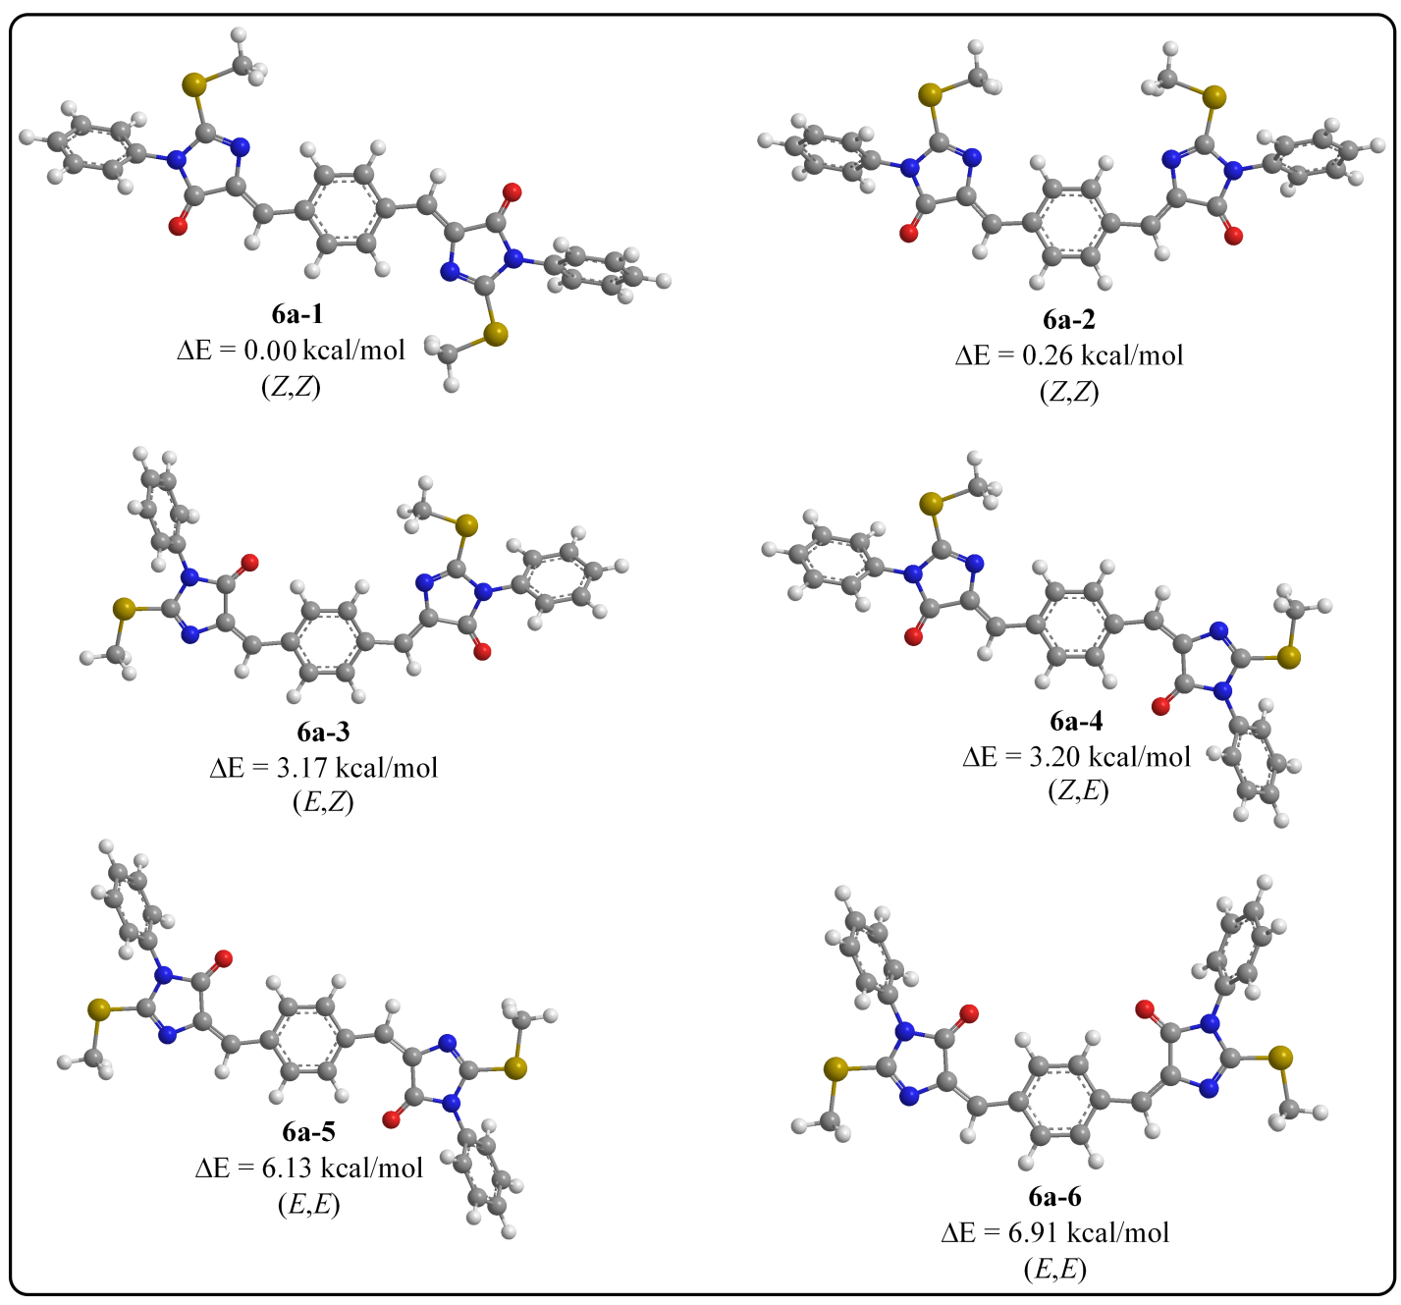
Figure S 9. 3D optimized structures and relative energies calculated at B3LYP/6-31+G* of Z- and E-isomers for 6a.

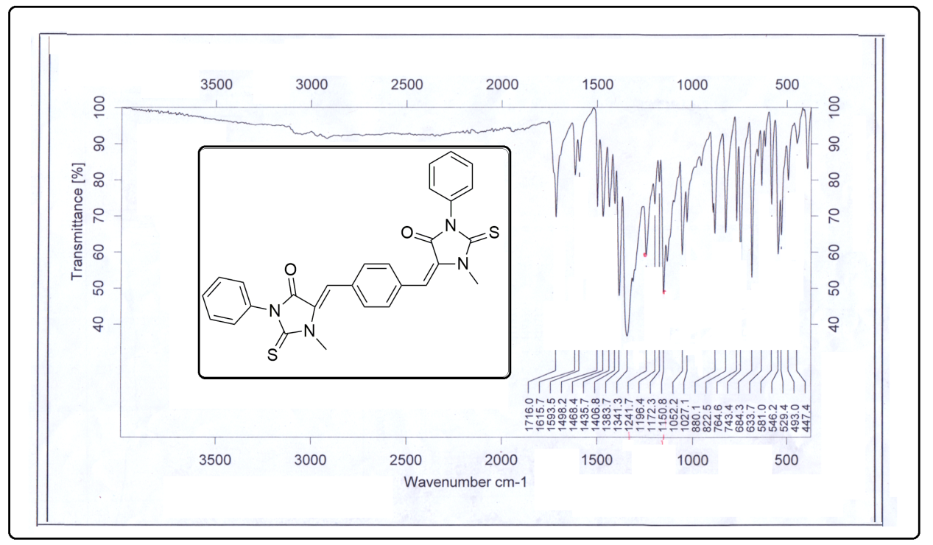
Figure S 10. IR spectrum of compound 8a.

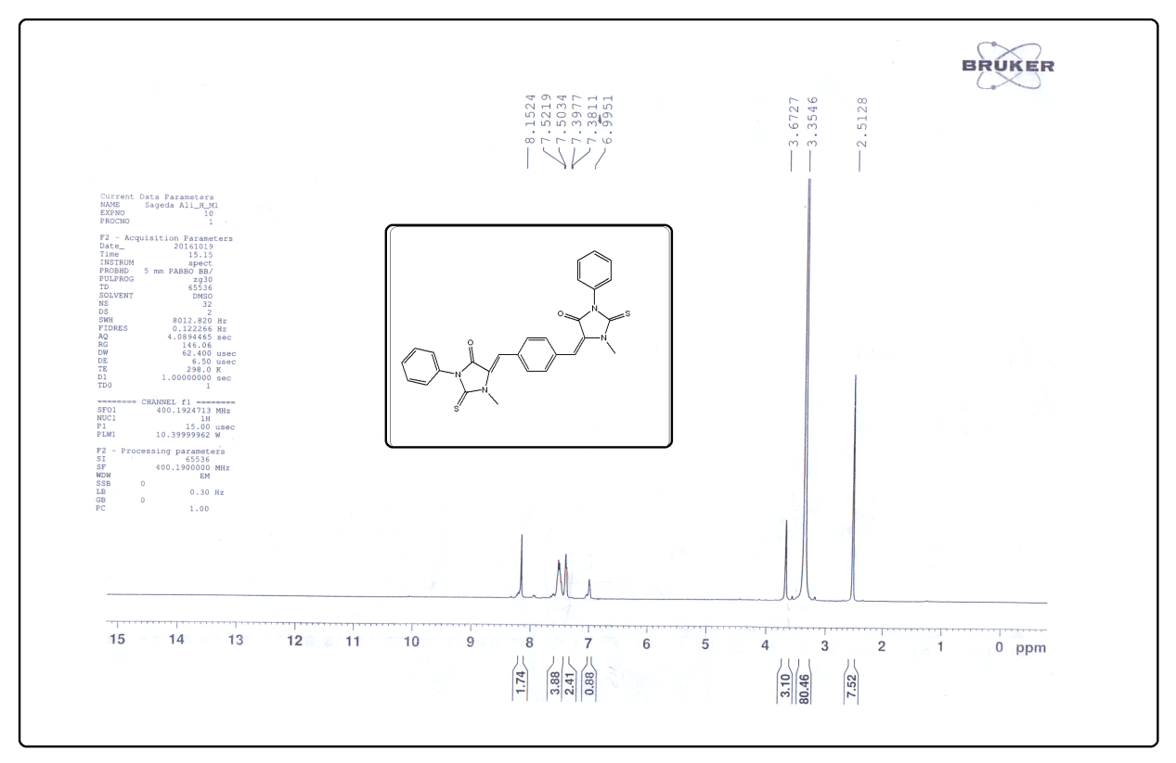
Figure S 11. ¹H-NMR of compound 8a.

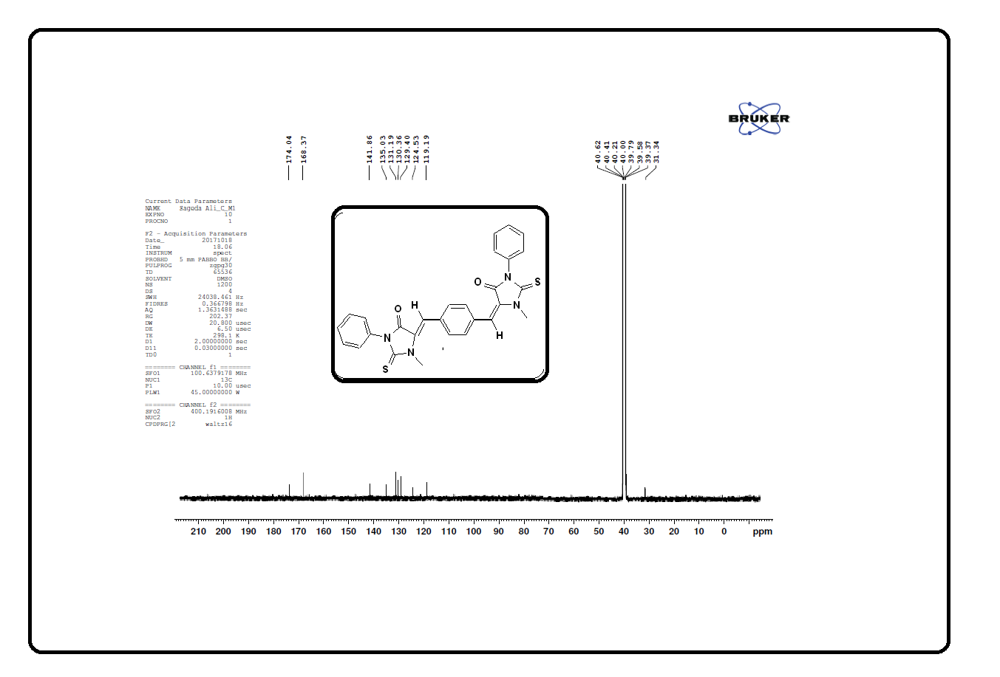
Figure S 12. ¹³C-NMR of compound 8a.

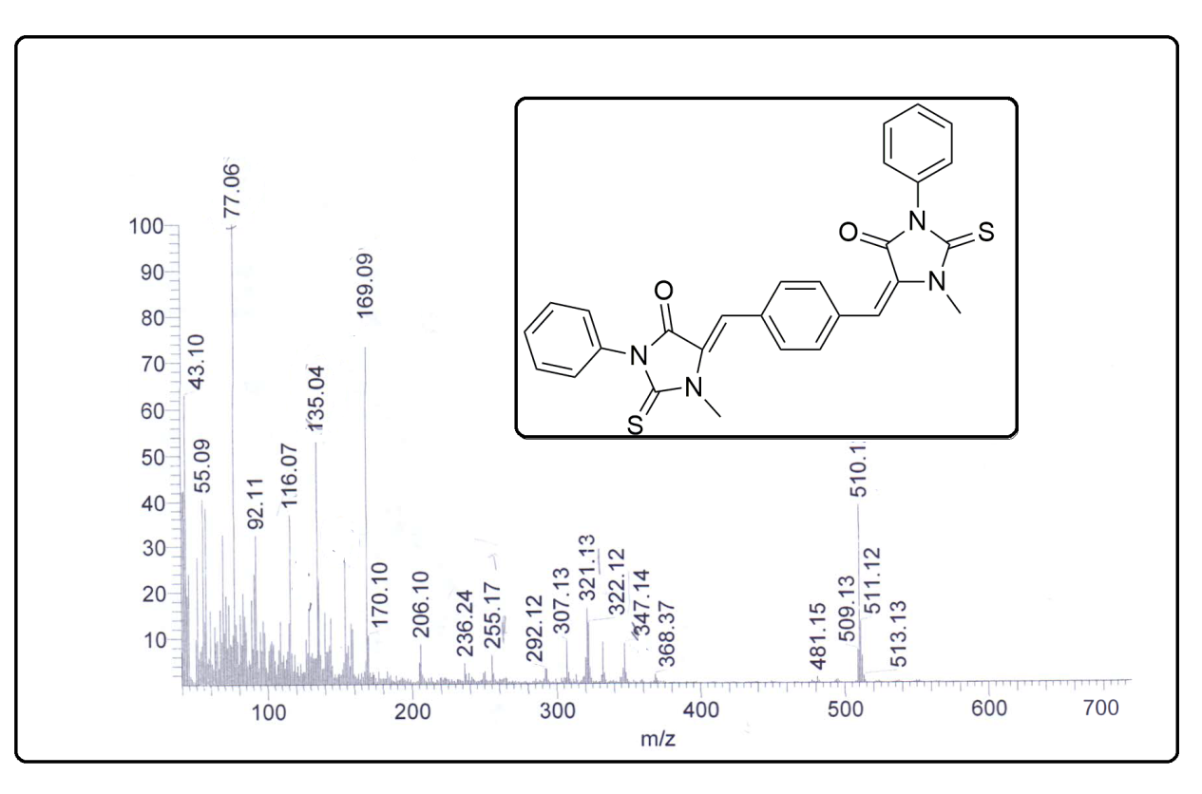
Figure S 13. Mass spectrum of compound 8a.

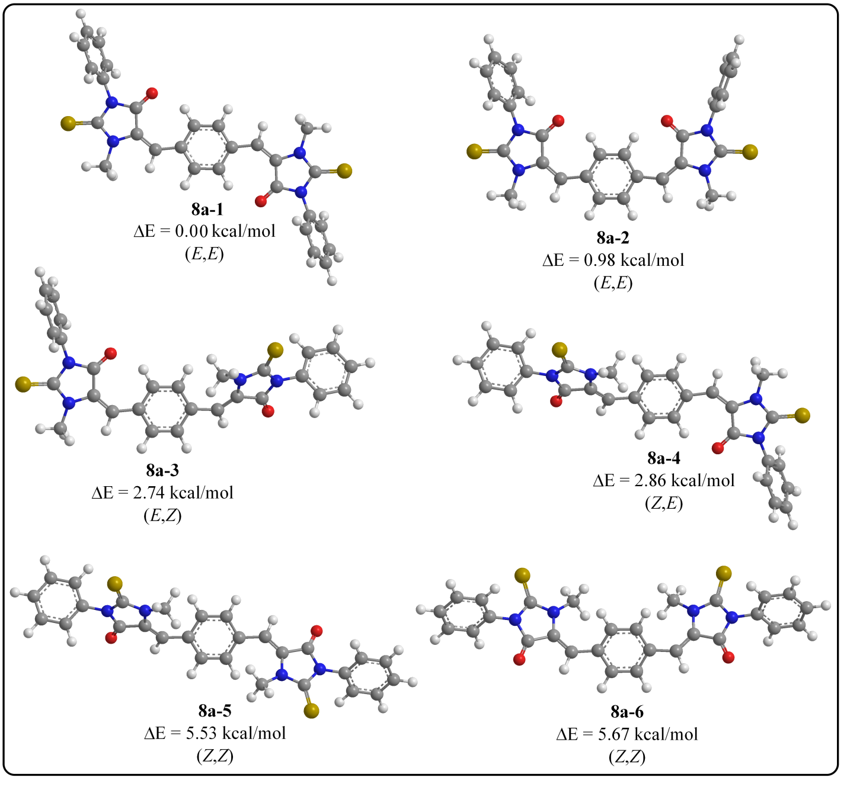
Figure S 14. 3D optimized structures and relative energies calculated at B3LYP/6-31+G* of Z- and E-isomers for 8a.

