Supplementary Information for
An RNA aptamer to HP1/Swi6 facilitates heterochromatin formation at an ectopic locus in S.pombe
Rita Rani, Abdul Mohd. Yaseen, Akshay Malwade and Aarti Sevilimedu
This file includes:
Supplementary text
Figures S1 to S10
Tables S1 to S8

Supplementary Material and Methods

Chemicals and reagents:
The single stranded template DNA library was synthesized at 1μmol scale and purchased from Integrated DNA Technologies [Template sequence: (5’- GTAATACGACTCACTATAGGGAGAATTCA ACTGCCATCTA - [N 50] – ACCGAGTCCAGAAGTTGTAGT-3’]. All the primers used in the study were purchased from Bioserve Biotechnologies, India. Plasmids constructs for GST-tag swi6 domains CD, CSD, CDH, and MH (full length swi6 with mutated hinge region) were a gift from the labs of Marc Bühler and Janet Partridge. The Hi-scribe in vitro transcription kit was purchased from NEB. Yeast media components were purchased from Sunrise Science Products, USA (EMM-Glucose Powder, Histidine, Lysine, Leucine and Uracil powder) and HiMedia Laboratories Pvt. Limited, India. 5-FOA was purchased from US Biologicals, USA. G418 (Kan), Hygromycin (Hph) and Nourseothricin (Nat) were purchased from HiMedia Laboratories Pvt. Limited, India and Jena Bioscience, Germany (Nat). Swi6 antibody was a generous gift from the Moazed lab. Mighty reagent set for blunt end cloning was purchased from Takara Bio USA, Inc.

Plasmids and Strains:
All strains and plasmids used in this study are listed in Tables S3 and S5, respectively. Plasmids for in vivo expression and tethering of RNA were constructed using pREP41 as the backbone. The rrk promoter was amplified from the S.pombe genomic DNA and cloned into pREP41 using PstI and XhoI sites (replacing nmt41) to create pAS72. The MS2-2X DNA was amplified from pAS17 and cloned into NcoI/XhoI of pAS72 to create pAS86. The AS06-3’CRΔ-hammerhead construct was generated by using overlap PCR with the primers (listed in Table S4). This was cloned using the Blunt cloning kit at the SmaI site on pAS72 or pAS86 to create pAS81 or pAS88. pAS86 containing 2 head-to-head inserts was also isolated and labelled “dimer” aptamer construct (pAS89).
SPA24 was constructed by insertion of the 400bp cen-dg10 fragment, 41bp downstream of the ura4 ORF (using Kan as the marker) in the parent strain of wild type S.pombe SPA07. SPA36 is the same as SPA24, containing the Nat marker in place of Kan. SPA35 was constructed from SPA07 with the following genomic changes: integration of the LexA operator sequence 500bp upstream of the ura4 gene (using KanMX as the marker); integration of the fusion gene for Lex-DBD-MS2 protein from the S.cerevisiae strain YBZ1 [1] at the his3 locus (using Hph as the marker); and integration of 400bp of cen-dg10 sequence from SPA24, 41bp downstream of the ura4 ORF (using nat as the marker).
All yeast strains were grown at 32°C. Antibiotics used for selection and strain construction were used at the following concentrations: Kan (200µg/ml), Hph (200µg/ml), Nat (100µg/ml).

Protein purification:
Full length His-tagged yeast Swi6, the GST-tagged deletion constructs of Swi6 (CD, CSD, CDH, and MH) were all purified from BL21-DE3 cells following standard protocols (Figure S10).

In vitro evolution:
SELEX was carried out as described earlier [2]. The template DNA library contains on the order of 1X1014 sequences. It consists of a central 50bp long randomized region flanked by two constant regions that contain the 5’T7 promoter and facilitate amplification by PCR. RNA was made from this DNA library by in vitro transcription with T7 RNAP and 8 rounds of selection were carried out with bacterially expressed yeast Swi6 protein. For each cycle, the RNA protein mixture was incubated in 1X binding buffer (20mM HEPES pH7.5, 150-200mM NaCl, 1-10mM MgCl2, 1mM DTT), partitioned using a nitrocellulose filter, the bound RNA was recovered by extraction with Phenol-urea and amplified to yield an enriched pool for the next cycle. The concentrations of NaCl and MgCl2 and Swi6 were decreased gradually with each cycle to increase the stringency of the selection (detailed list of conditions used are listed in Table S1). Negative selection (without protein) was included from the 3rd round. Filter was pre-soaked in yeast tRNA treated for the 4th and 5th round of selection to block the nonspecific binding of RNA to nitrocellulose filter paper. In the 6th and 7th round, the filter was washed with 0.5M urea to remove non-specific binding. In round 8, both the modifications of the 4th and 6th rounds were included to increase stringency of selection. The final DNA pool after 8 rounds of SELEX (G8) was cloned into the pUC19 vector and 34 individual clones were sequenced. Secondary structure prediction were carried out by RNAfold web server.

RNA labelling:
For electrophoretic mobility shift assay, RNA was labelled at 3’end with fluorescein according to previously described procedure [3]. Briefly, the in vitro transcribed RNA was first subjected to periodate oxidation and then reacted with fluorescein-5-thiosemicarbazide (FTSC). The labelling reaction was carried out in dark at 25°C. The RNA was then ethanol precipitated and excess, unincorporated FTSC was removed by 2-3 washes with 70% ethanol.

Binding assays
RNA binding experiments were carried using fluorescein labelled RNA. Fluorescein labelled RNA, present at a final concentration of 22nM, was incubated with indicated amounts of protein in 1X B Binding buffer (12mM HEPES pH 7.9, 150mM NaCl, 2mM MgCl2, 1mM DTT, 5ng/μl yeast tRNA, 0.1μg/μl BSA, 10% glycerol) for 30 minutes followed by gel electrophoresis (0.5X TBE, 6% Acrylamide). Fluorescently labelled RNA was detected by Typhoon gel scanner with blue laser at 473nm. For competitive EMSA 20ng of labelled RNA and 1μg of unlabelled competitor RNA were used.
Binding affinity was quantified by Scatchard plot analysis as described in [4]. For filter binding experiments, aptamer RNA (22nM) was incubated with increasing amounts of Swi6 protein (100-800nM) in a 30μl binding reaction in 1X binding buffer. The complex was filtered through a nitrocellulose filter, washed with 5 volumes of 1X binding buffer, and bound RNA was recovered by phenol extraction. Bound RNA and input RNA were quantified by RT-PCR, in comparison with a standard curve and used to determine KD. For magnetic bead binding experiments, the RNA-protein complex was prepared as described above, using His-tagged Swi6. The complexes were partitioned using Ni-charged magnetic resin (Qiagen) and the bound RNA was recovered and processed as described above. A summary of the KD measurements is shown in Table S2.

Silencing Assays
For silencing assay cells were grown in Emm-Leu media to logarithmic phase, 108 cells were collected for each strain being tested. This was resuspended in 100μl media, and 10-fold serial dilutions were made. 7μl of each dilution, for each strain were spotted on Emm-Leu, EMM-Leu-Ura and on EMM-Leu plates containing 1 mg/ml 5-Fluorooratic acid (5-FOA). Plates were incubated at 32°C for 3-6 days and then imaged.

RNA expression, Chromatin/RNA immunoprecipitation (ChIP/RIP):
Total RNA was isolated from an actively growing yeast culture using hot phenol method [5]. Reverse transcription was carried out using the SuperScript reverse transcriptase kit (Invitrogen) with 0.5-5μg input RNA and gene specific primers. Quantitative PCR was carried out using Abcam a q-PCR kit (Abcam) on the Applied Biosystems StepOnePlus real-time PCR machine. The changes in RNA expression were quantified based on results from three independent colonies (experiments). Act1 mRNA was used as an internal control. Fold changes were calculated by comparing each strain containing the aptamer to the strain expressing the vector alone. The primers used in this study are listed in Table S4.
Chromatin immunoprecipitation was performed as described previously [6] using 2.0μl of the anti-Swi6 antibody, or 1.5 μl of the H3K9me2 antibody (ab1220) per tube. Immuno-precipitated DNA was analyzed by real-time PCR using a q-pCR kit (Abcam) for results shown in Figures 5D,E and 6B,C. The IP and input (10%) material were diluted as required (1:10 to 1:40) and 1-2μl of the dilution was used for a 10μl qPCR. The act1 amplicon was used as the internal control. The results for Swi6 enrichment and H3K9me2 enrichment were calculated from data collected from three independent experiments for each condition, using the ΔΔCT method (IP/Input, reporter/control). Statistical significance was assessed using the Student t-test and p-values are reported where significant. For the Swi6 ChIP shown in Figure 6E, the experiment was carried out as described above and the PCR products were resolved on a 8% native polyacrylamide gel to ensure identity of the expected amplicons. Quantification of the gel image was carried out using the ImageJ application and results shown are IP/(10%)Input. Statistical significance was assessed using the Student t-test and p-values are reported where significant. The primers used in this study are listed in Table S4.
For RIP in Figure 4, samples were processed in the same manner as for ChIP, substituting RNase with DNase treatment. The eluted IP material was extracted with Trizol, resuspended in the reverse transcription mix with specific primers. 0.2-1μl of the cDNA was used for a 10μl PCR, resolved and imaged on a 8% native polyacrylamide gel. Quantification of the gel image was done using the ImageJ application for Figure 4E, results from two independent experiments are summarized.

References:
[1] Hook B, Bernstein D, Zhang B, et al. RNA-protein interactions in the yeast three-hybrid system: affinity, sensitivity, and enhanced library screening. RNA. 2004/12/23. 2005;11:227–233.
[2] Sevilimedu A, Shi H, Lis JT. TFIIB aptamers inhibit transcription by perturbing PIC formation at distinct stages. Nucleic Acids Res. 2008;36:3118–3127.
[3] Qiu C, Liu W-Y, Xu Y-Z. Fluorescence Labeling of Short RNA by Oxidation at the 3′-End. 2015. p. 113–120.
[4] Ryan RF, Darby MK. The role of zinc finger linkers in p43 and TFIIIA binding to 5S rRNA and DNA. 1998;26:703–709.
[5] Schmitt ME, Brown TA, Trumpower BL. A rapid and simple method for preparation of RNA from Saccharomyces cerevisiae. Nucleic Acids Res. 1990;18:3091–3092.
[6] Bühler M, Verdel A, Moazed D, et al. Tethering RITS to a nascent transcript initiates RNAi- and heterochromatin-dependent gene silencing. Cell. 2006;125:873–886.

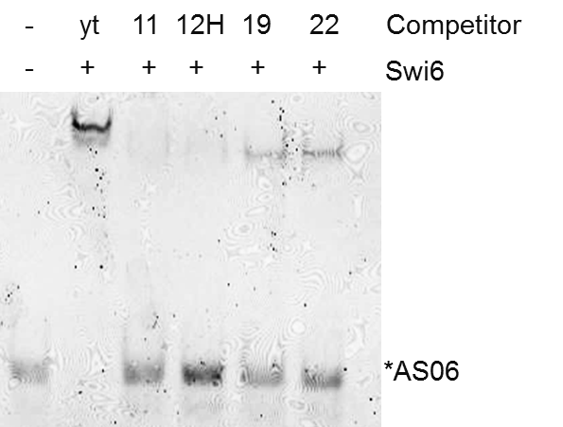
Figure. S1. Selected aptamers bind to an overlapping site on Swi6. Competition EMSA with labelled AS06 RNA (25nM), Swi6 (200nM) and unlabeled competitor RNA (2μM)..

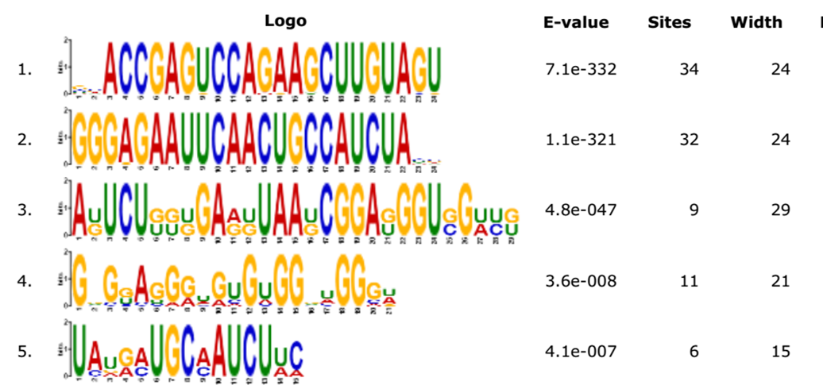

Figure S2. List of motifs found in G8 aptamers of the Swi6 SELEX using MEME. The full length RNA aptamer sequences (34) were used as input for the MEME software and the motifs found to be “significant” by E-value, are shown. [As defined, “the E-value of a motif is based on its log likelihood ratio, width, sites, the background letter frequencies (given in the command line summary), and the size of the training set. The E-value is an estimate of the expected number of motifs with the given log likelihood ratio (or higher), and with the same width and site count, that one would find in a similarly sized set of random sequences” (23)

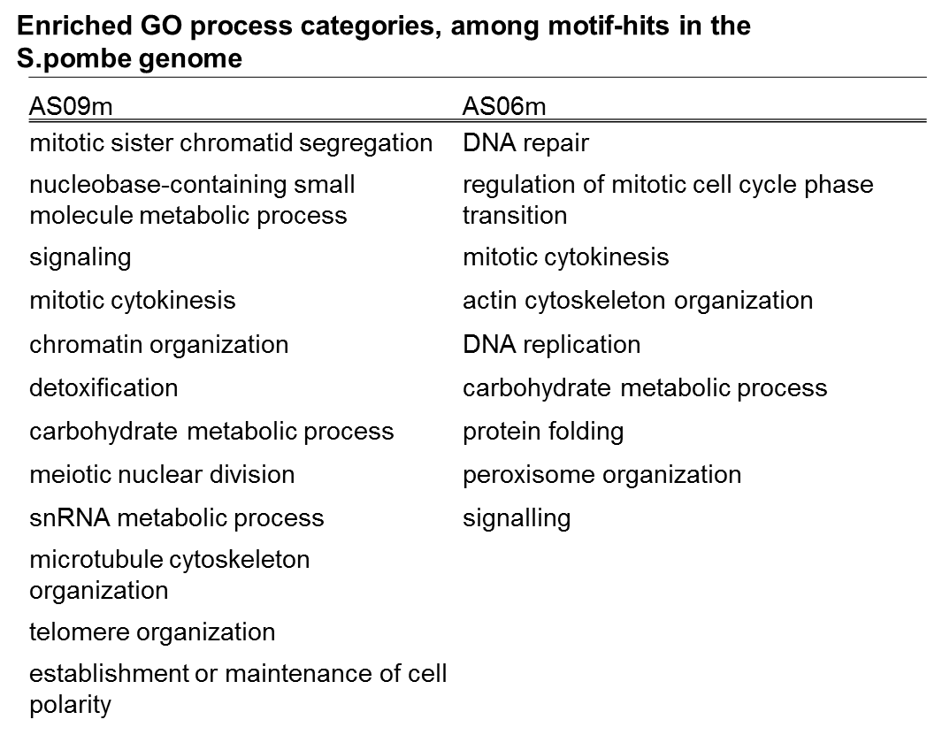
Figure S3: List of GO categories enriched in the FIMO hits identified (fold enrichment over total genome >1.5). FIMO software was used to identify hits corresponding to the two motifs in the S.pombe genome and the hits were classified into GO categories. The categories which were enriched more than 1.5 fold in the list of FIMO hits, as compared to the whole genome are listed.

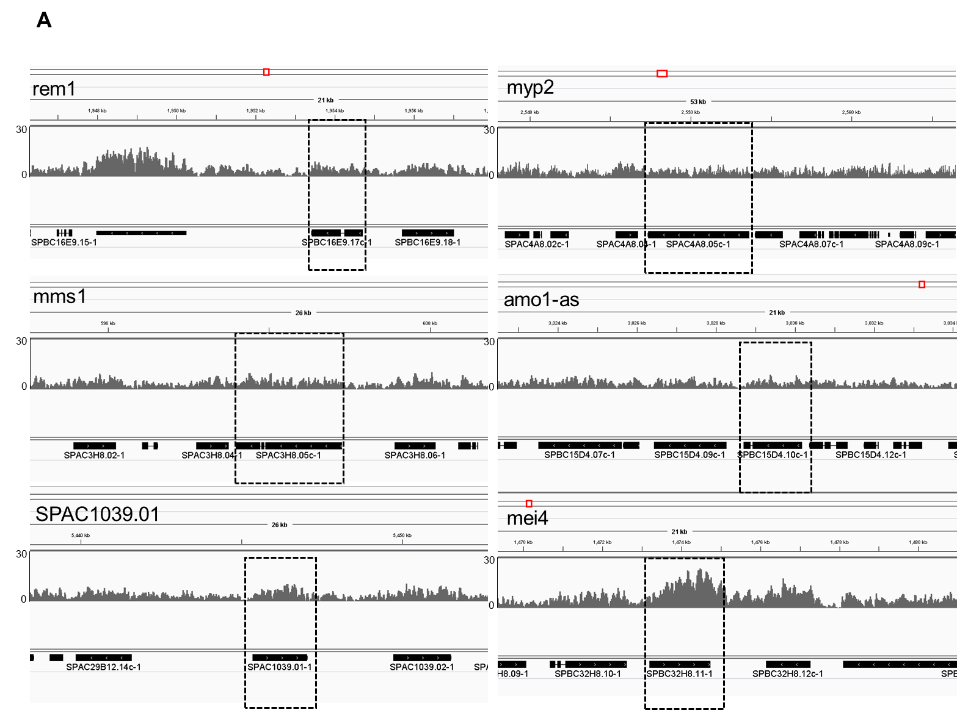

Figure S4: Swi6 enrichment at motif containing loci. A. Snapshot of Swi6 localization at select motif containing loci based on data from ChIP-seq studies carried out by Jih et al. mei4 locus is shown as an example of a Swi6 containing euchromatic site (25). B. Transcription status of the candidate loci based on RNA-seq experiments by Rhind et al (26). The transcript information of the strand containing the motif alone is shown. Rem1 is not transcribed. C. Swi6 enrichment at the intergenic loci containing the motif is shown (Data range is the same as in A). The list of loci and their transcription status is also indicated.
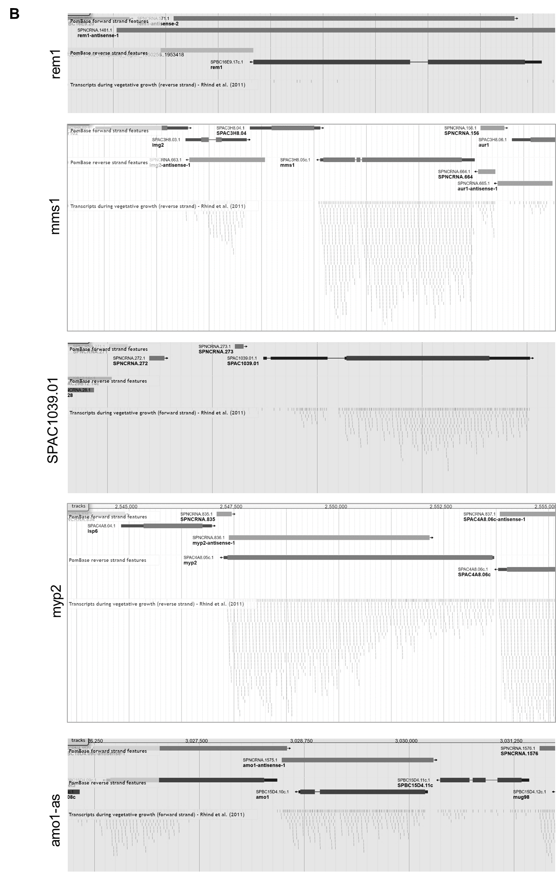
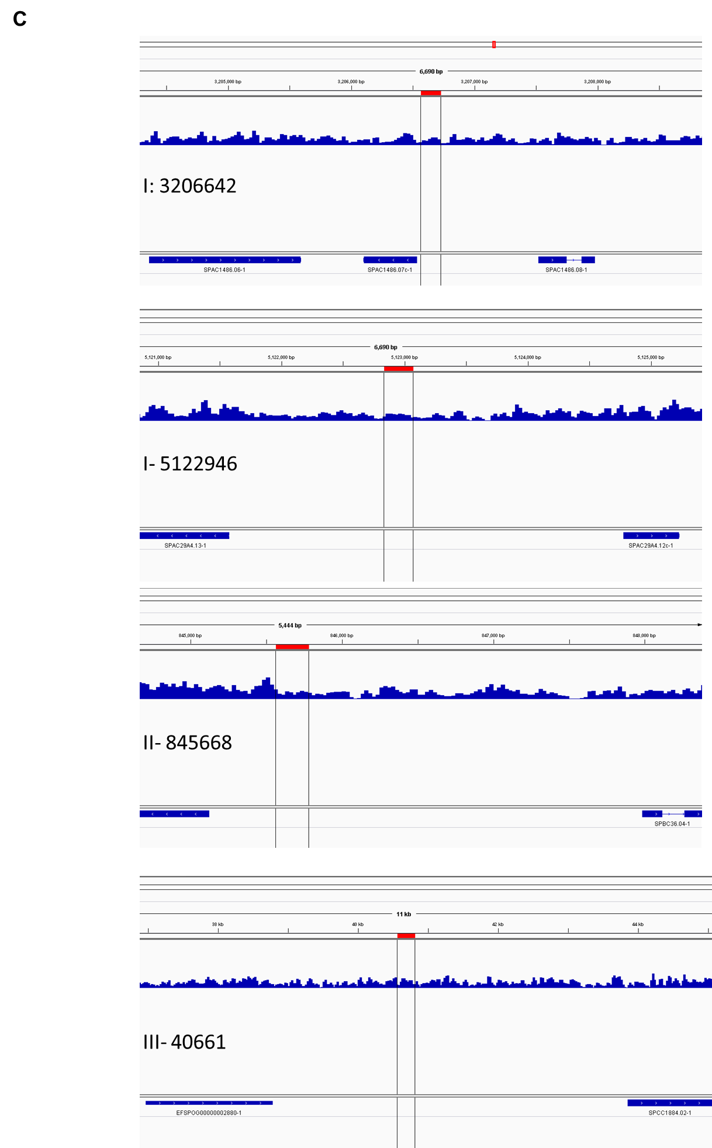
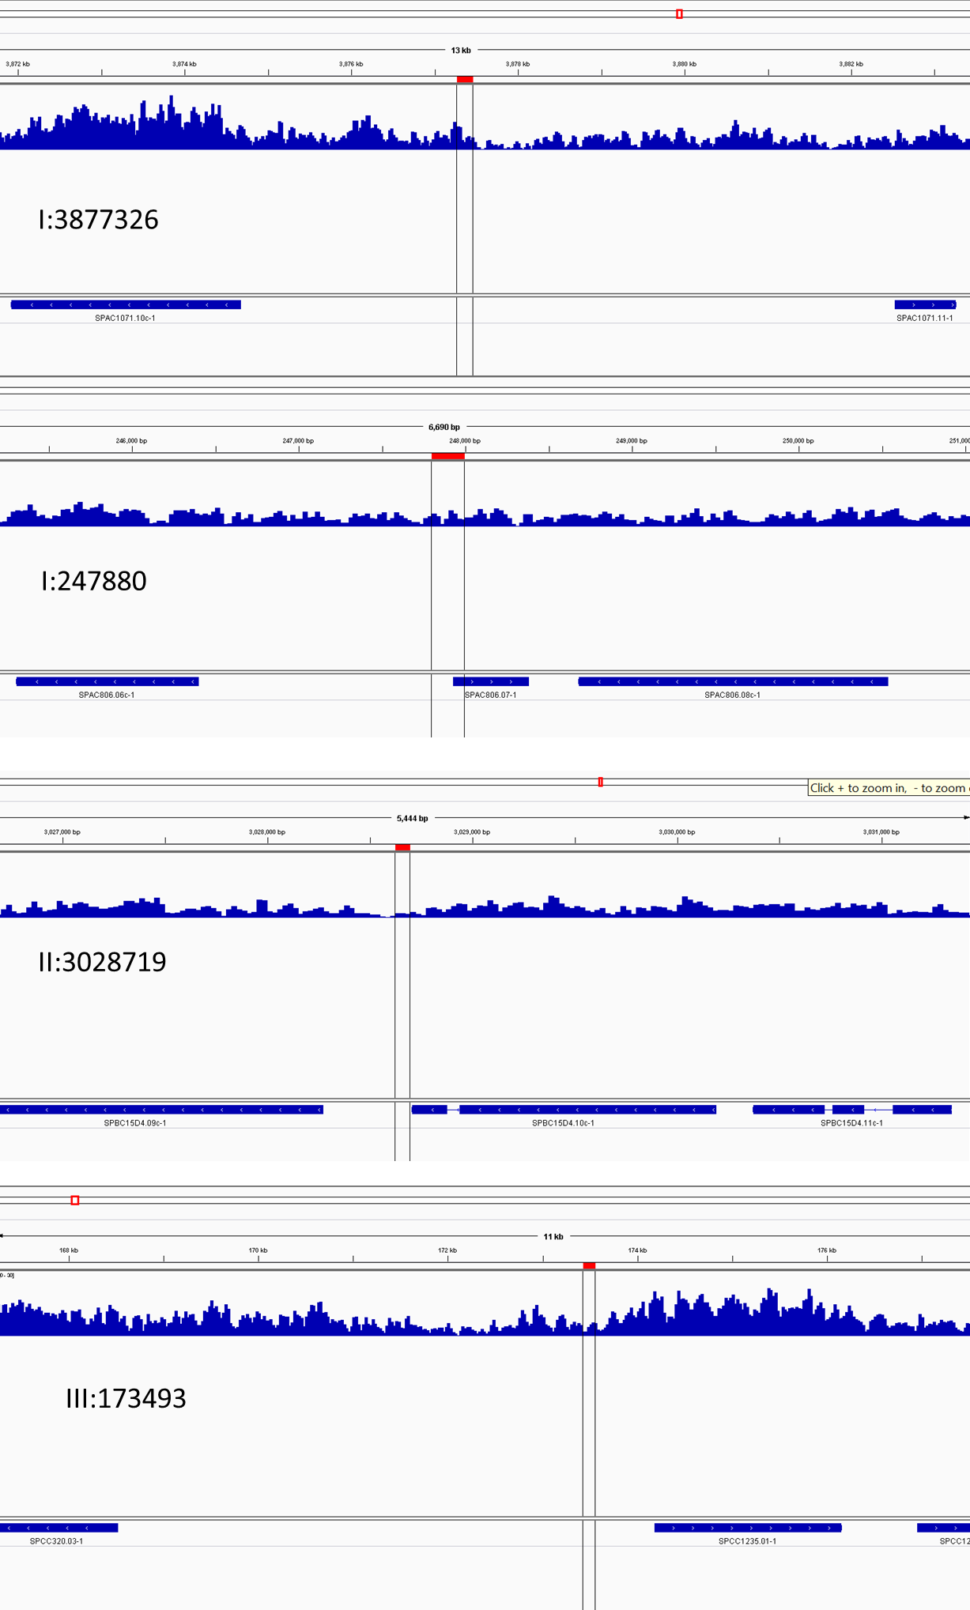
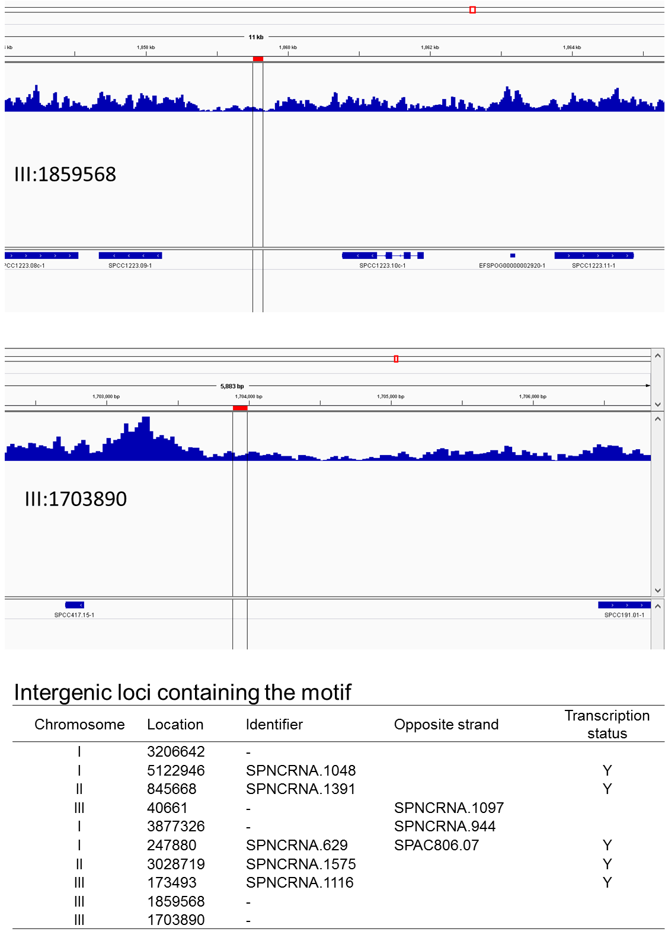
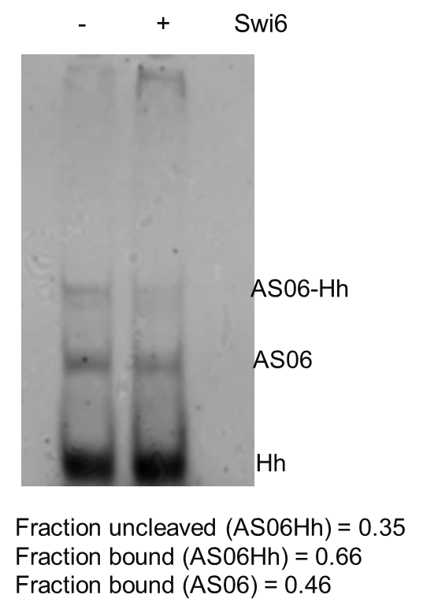

Fig. S5: Processing and EMSA with AS06Hh RNA: Labelled AS06Hh RNA (80ng) with Swi6 (300nM) and unlabelled competitor RNA (3μM). The positions in the gel of unprocessed (AS06Hh) RNA, processed RNA hammerhead RNA and Swi6-RNA complex, are indicated.

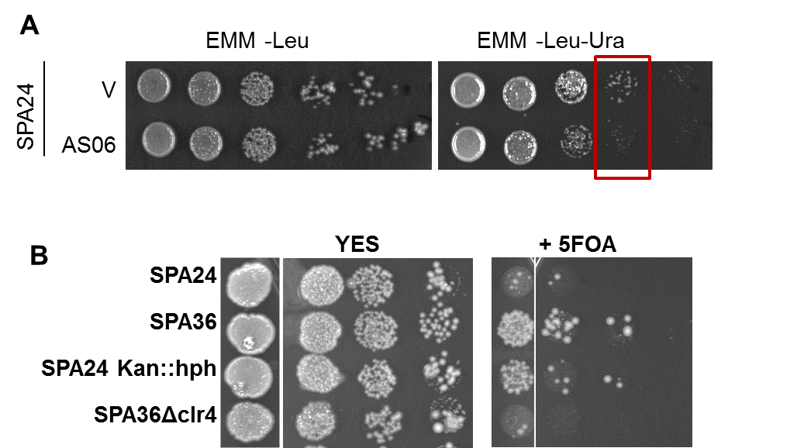

Fig. S6: Silencing assay to measure effect on aptamer expression on ectopic ura4 silencing A. in aptamer overexpression strains. B. in reporter strains where dg10R fragment is inserted in the 3’UTR of ura4 with various markers, as well as in a Clr4 deletion background.

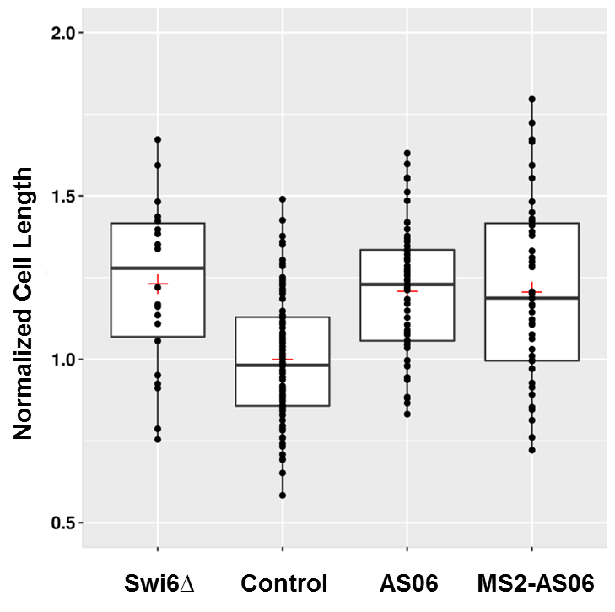

Fig. S7: Effect of AS06 expression on cell size, represented as a box plot. Center lines show the medians; box limits indicate the 25th and 75th percentiles as determined by R software package easyGgplot2; whiskers extend 1.5 times the interquartile range from the 25th and 75th percentiles; red crosses represent sample means; data points are plotted as filled circles. n = 22, 88, 61, 47 sample points.

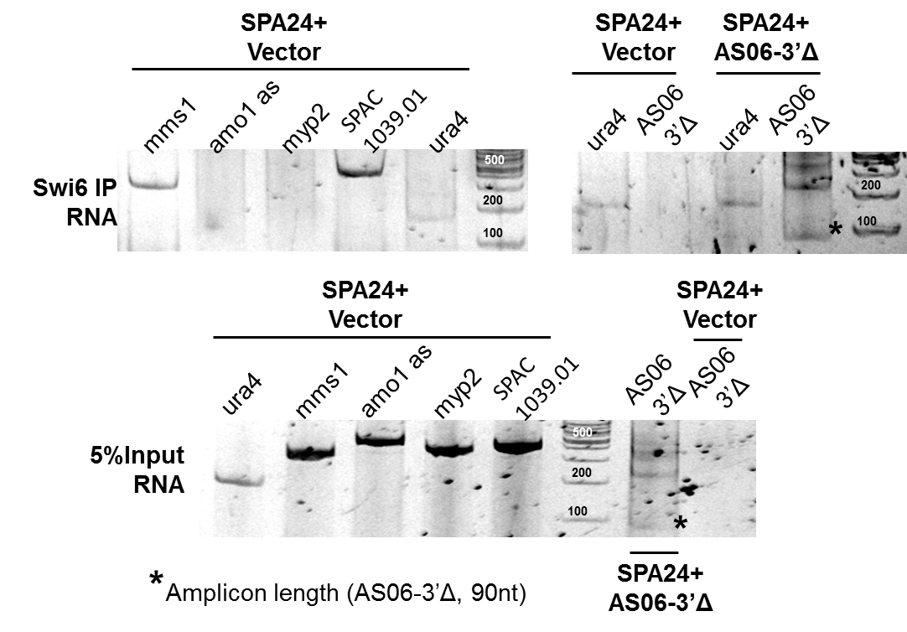

Fig. S8: Association of RNA transcripts with Swi6 as measured by RNA-IP. The RNA fraction associated with Swi6 in a Swi6-IP was extracted by Trizol extraction, and the presence of various transcripts was determined by reverse transcription-PCR (RT-PCR). The strains from which the IP was performed are indicated above the lanes in bold. The amplicons detected are indicated above each lane. The PCR products were visualized on a 8% polyacrylamide gel.

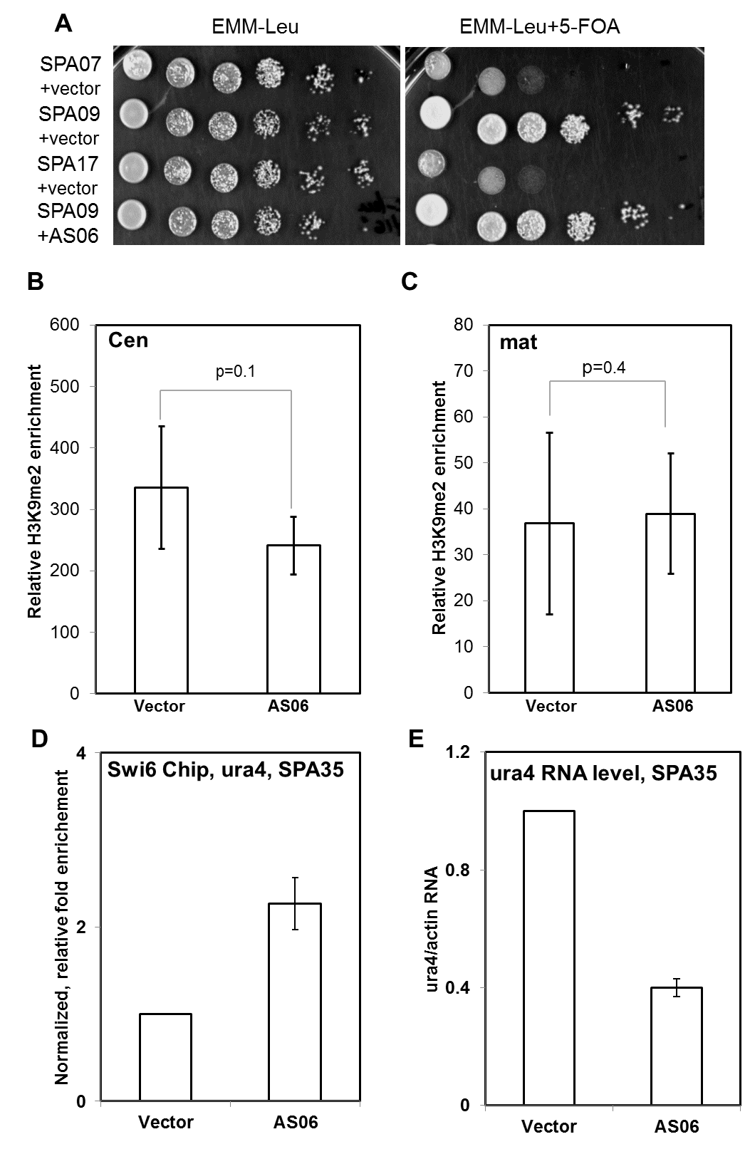

Fig. S9: Effect of aptamer on centromeric heterochromatin. A. Silencing assay on 5-FOA containing plates with the strain containing centromeric ura4 and controls. B and C. H3K9me2 enrichment at the cen (B) and mat(C) loci in SPA24 without or with aptamer expression. D. Swi6 enrichment at the modified ura4 locus, with AS06 tethering. E. ura4 RNA level as measured by RT-PCR from the modified ura4 locus with AS06 tethering

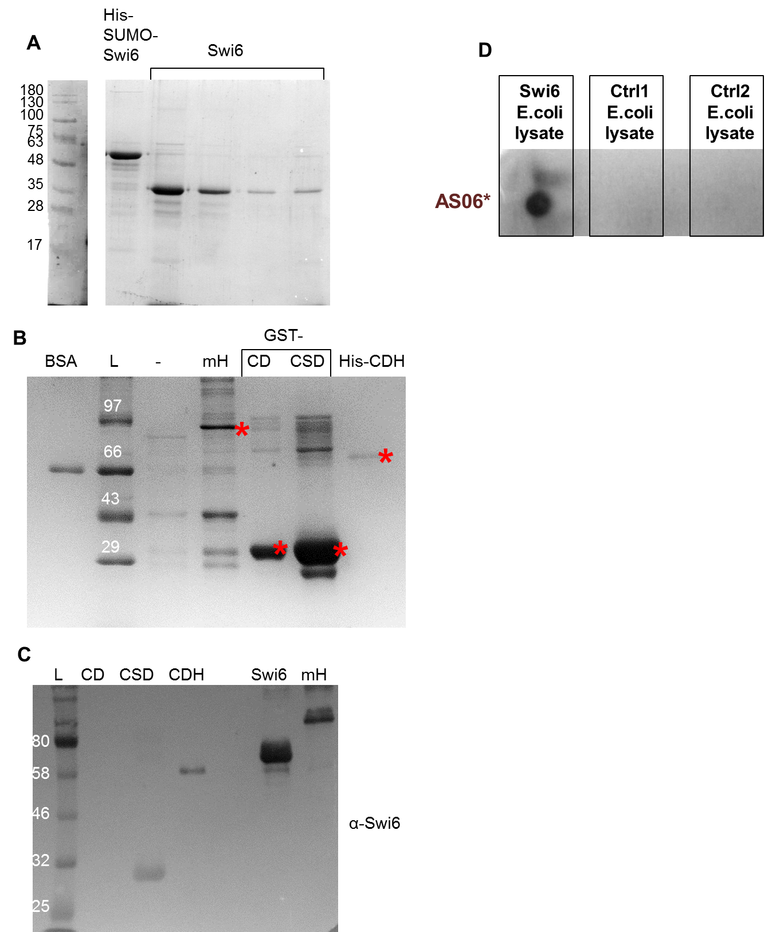

Fig. S10: Recombinant proteins used in this study. A. Recombinant Swi6 was purified as His-SUMO-Swi6, and the tag was removed by digestion with the Ulp1 protease, and uncut and cut proteins were run on SDS-PAGE (10%). B. Various fragments of Swi6 (GST-CD, GST-CSD and His-SUMO-CDH) and the mutant Swi6 protein (GST-mH) C. Western blot using the anti-Swi6 antibody to confirm the identity of the recombinant proteins (GST-CD, GST-CSD, His-SUMO-CDH, His-SUMO-Swi6, GST-mH Swi6). D. Total protein lysate (equal amounts) from E.coli cells expressing recombinant Swi6 and E.coli cells with no recombinant protein expression, were air dried on nitrocellulose membrane. Dot blot was performed with labelled aptamer AS06 to confirm specificity of the aptamer-protein interaction.

Table S1. Conditions and parameters used for rounds of SELEX with Swi6.
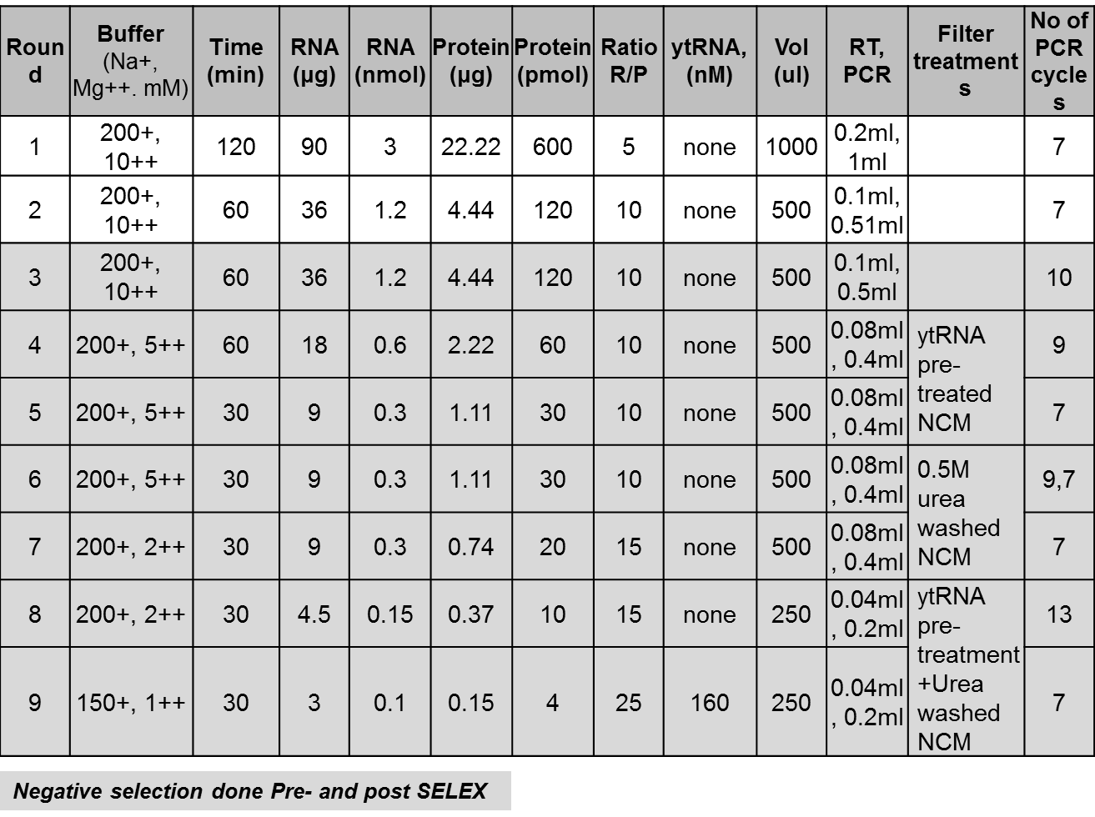

Table S2. KD measurements of aptamer-Swi6 binding.

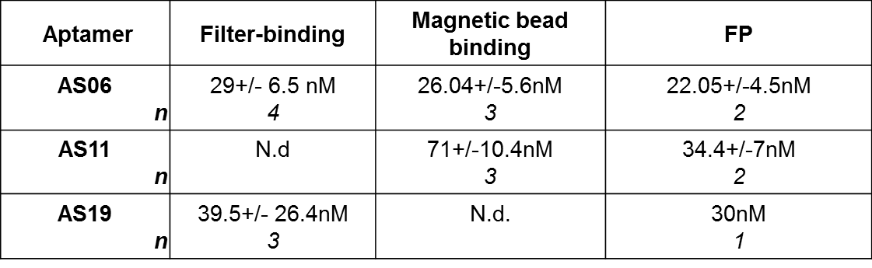

Table S3: Strains used in this study
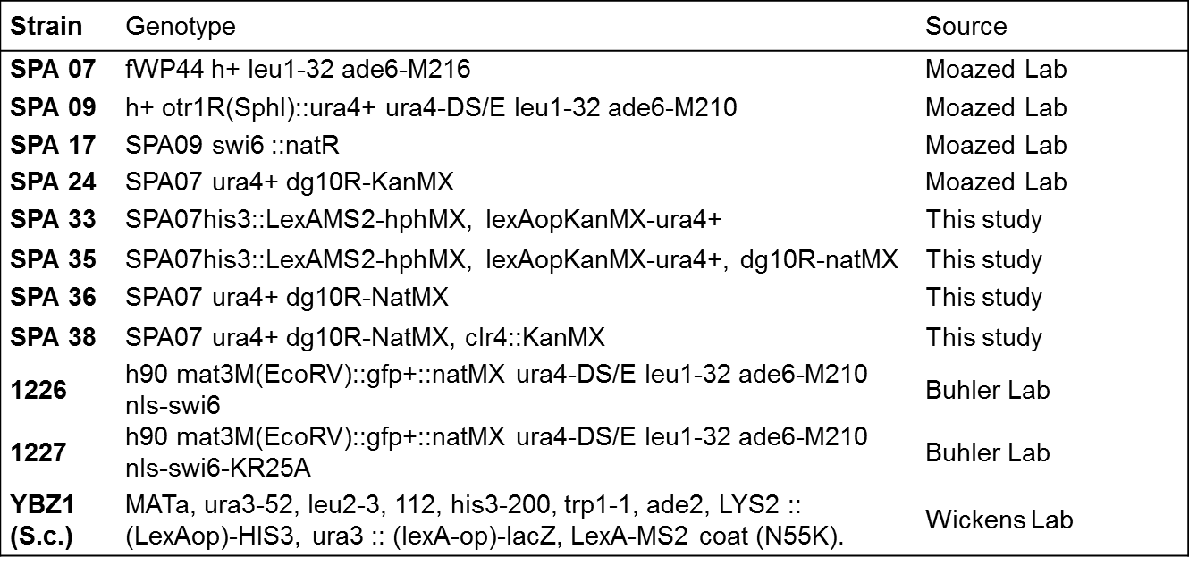

Table S4: Primers used in this study
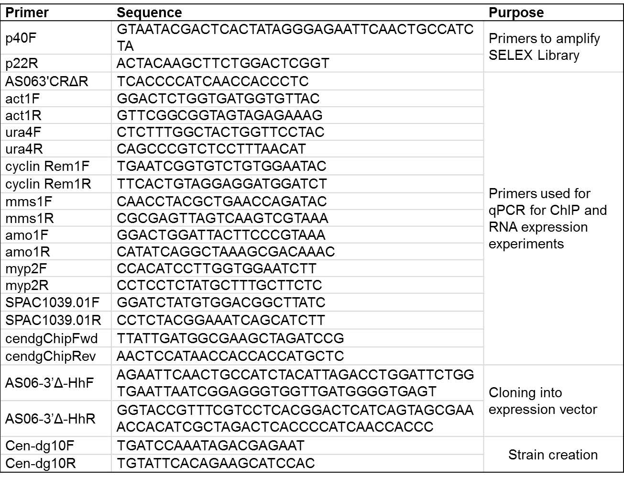

Table S5: Plasmids used in this study
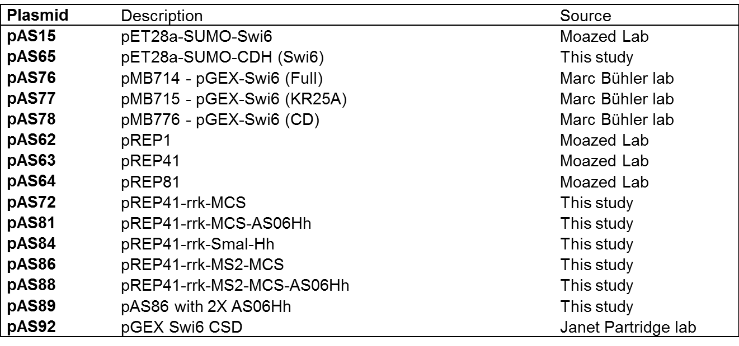

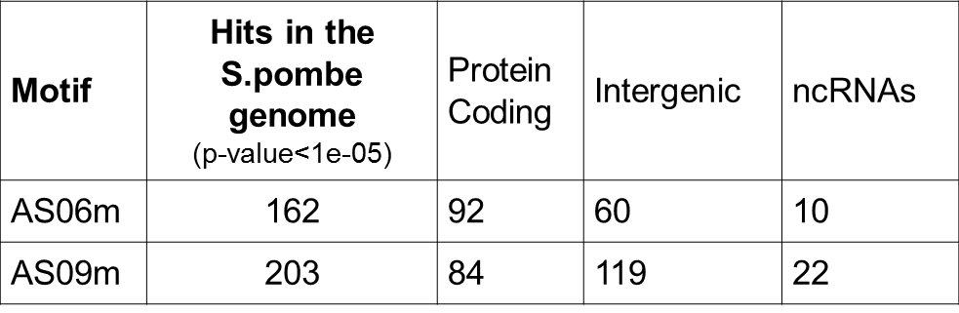
Table S6: Motif hits in the S.pombe genome. Distribution of hits according to function.

Table S7: Motif hits in the S.pombe genome. Top 5 hits on each chromosome for motif AS06. (-) indicates that the gene and motif are not on the same strand.

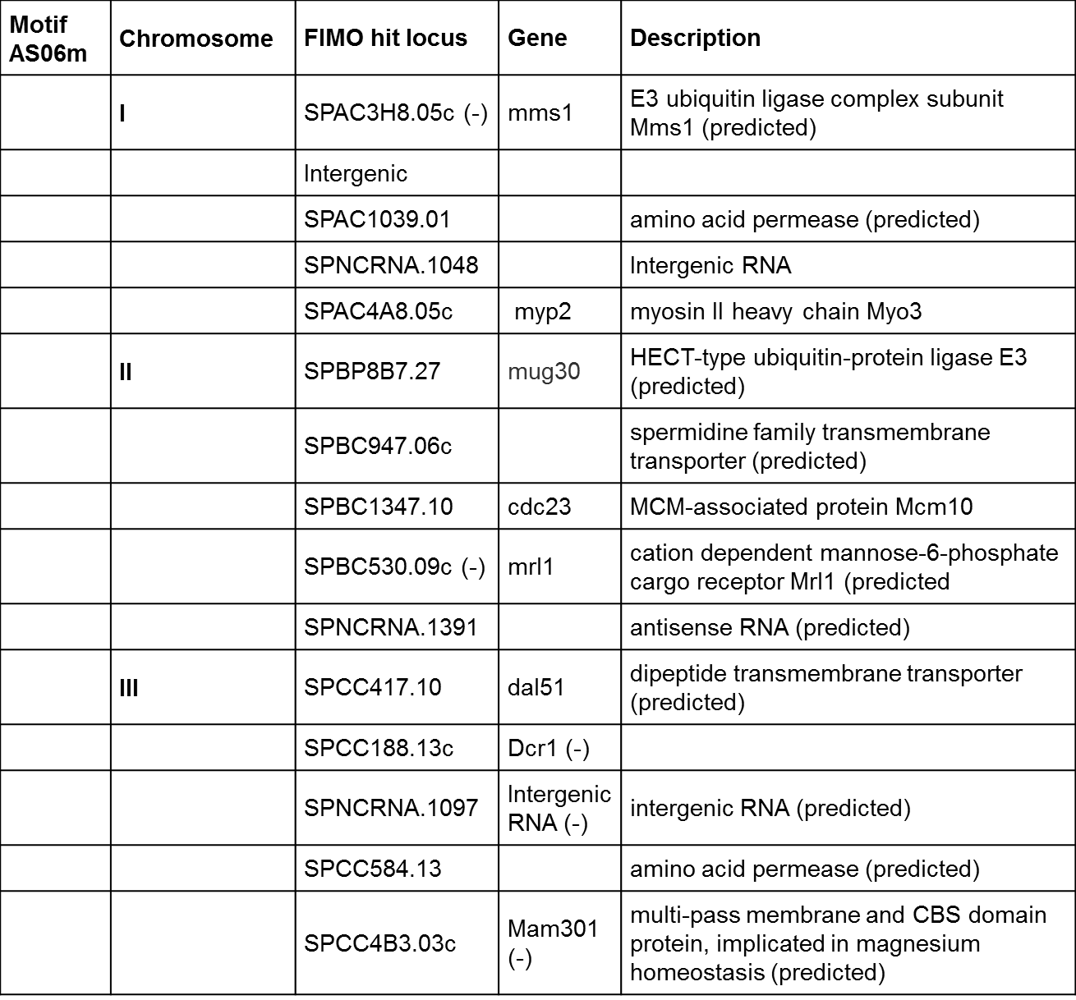

Table S8: Motif hits in the S.pombe genome. Top 5 hits on each chromosome for motif AS09. (-) indicates that the gene and motif are not on the same strand.

